Midpoint Draft

Lechuan Huang

March 3, 2022

**Abstract**

This draft reiterate the introduction and motivation of the Capstone project, reviews the steps already done, and propose the next possible steps based on the results given in the literature review: especially identified a better way to weight the MCDA models.

**Question**:

To develop a method to comprehensively analyze the potential of TOD opportunities in Philadelphia MSA (Delaware River Valley) that’s actually feasible and benefits local communities using Multi-Criteria Decision Analysis and Machine Learning.

**Introduction and Motivation** (from Proposal 1)

<https://urbanspatial.github.io/PublicPolicyAnalytics/TOD.html>

Philadelphia has its own subway and regional rail systems built over a century ago. However, according to analysis, only certain parts of the city served by rail transit had a positive impact brought by TOD. Other parts of the city served by subways, like West and North Philly remains unchanged compared to non-TOD communities.

<https://www.dvrpc.org/webmaps/TOD/>

DVRPC did produce a map showing the TOD indexes for all major rail transit stations in the Philadelphia MSA. However, it does not include the factors like safety, existing demography that will affect the feasibility of transition and may cause gentrification.

**Current Process**

* See File Proposal01_LH
* Joined the parcel data into TOD-tract and calculate the proportion by land use (didn’t weight by size of parcels)

The following is the map showing the proportion of residential parcels among TOD tracts. We can see areas outside the city boundary has relatively high proportion of residential parcels. Downtown Philly, Camden, and Trenton do not have high rates of residential parcels.

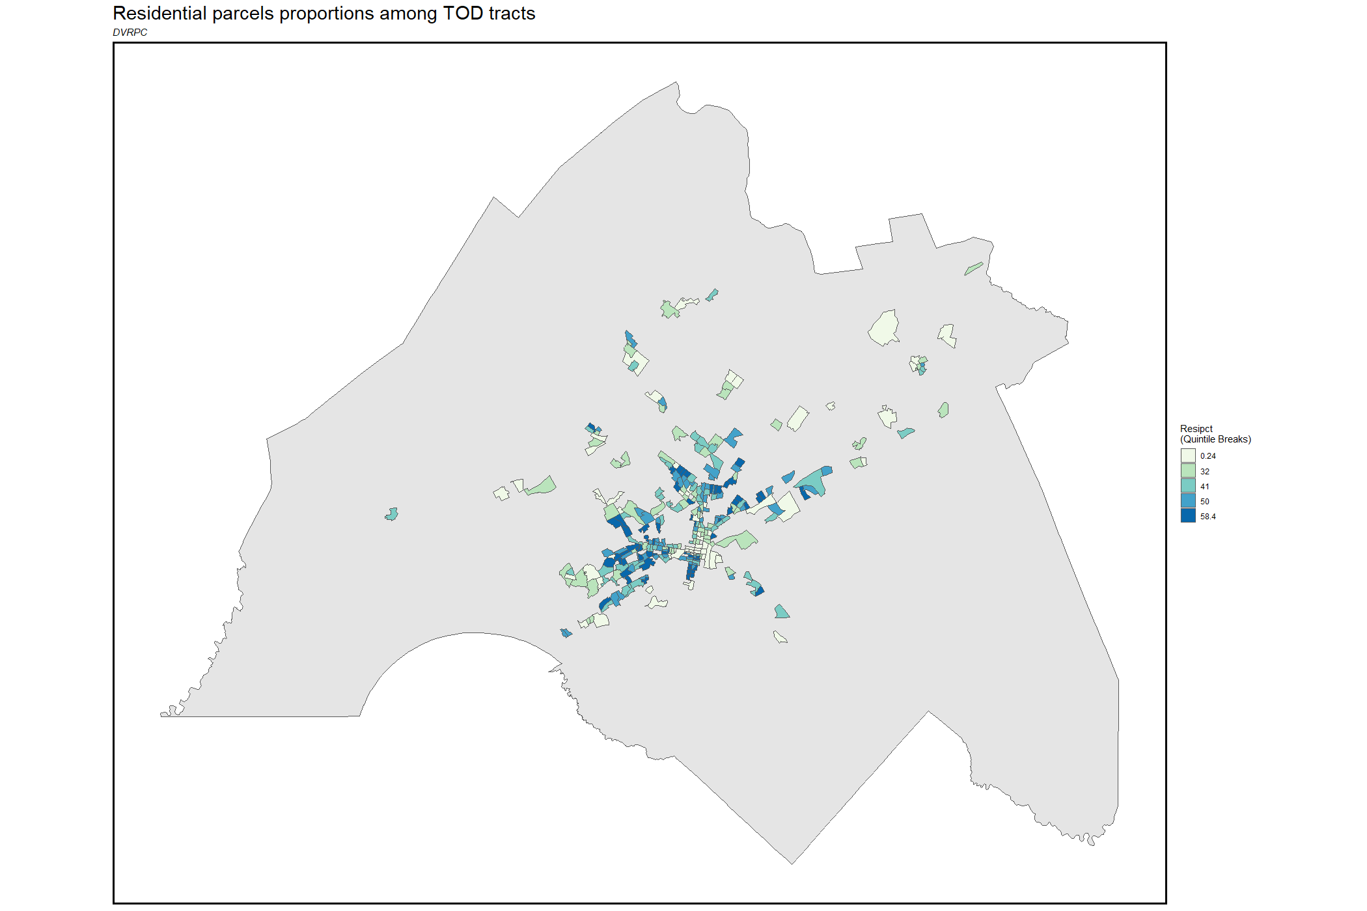

This is the map showing proportions of Mixed-use Parcels. We can see despite they are mostly clustered in Downtown Philly, Trenton, the highest quintile is still less than 10%. Thus, we can say the amount of mixed-use in the entire Philadelphia Metropolitan Area is still very low.

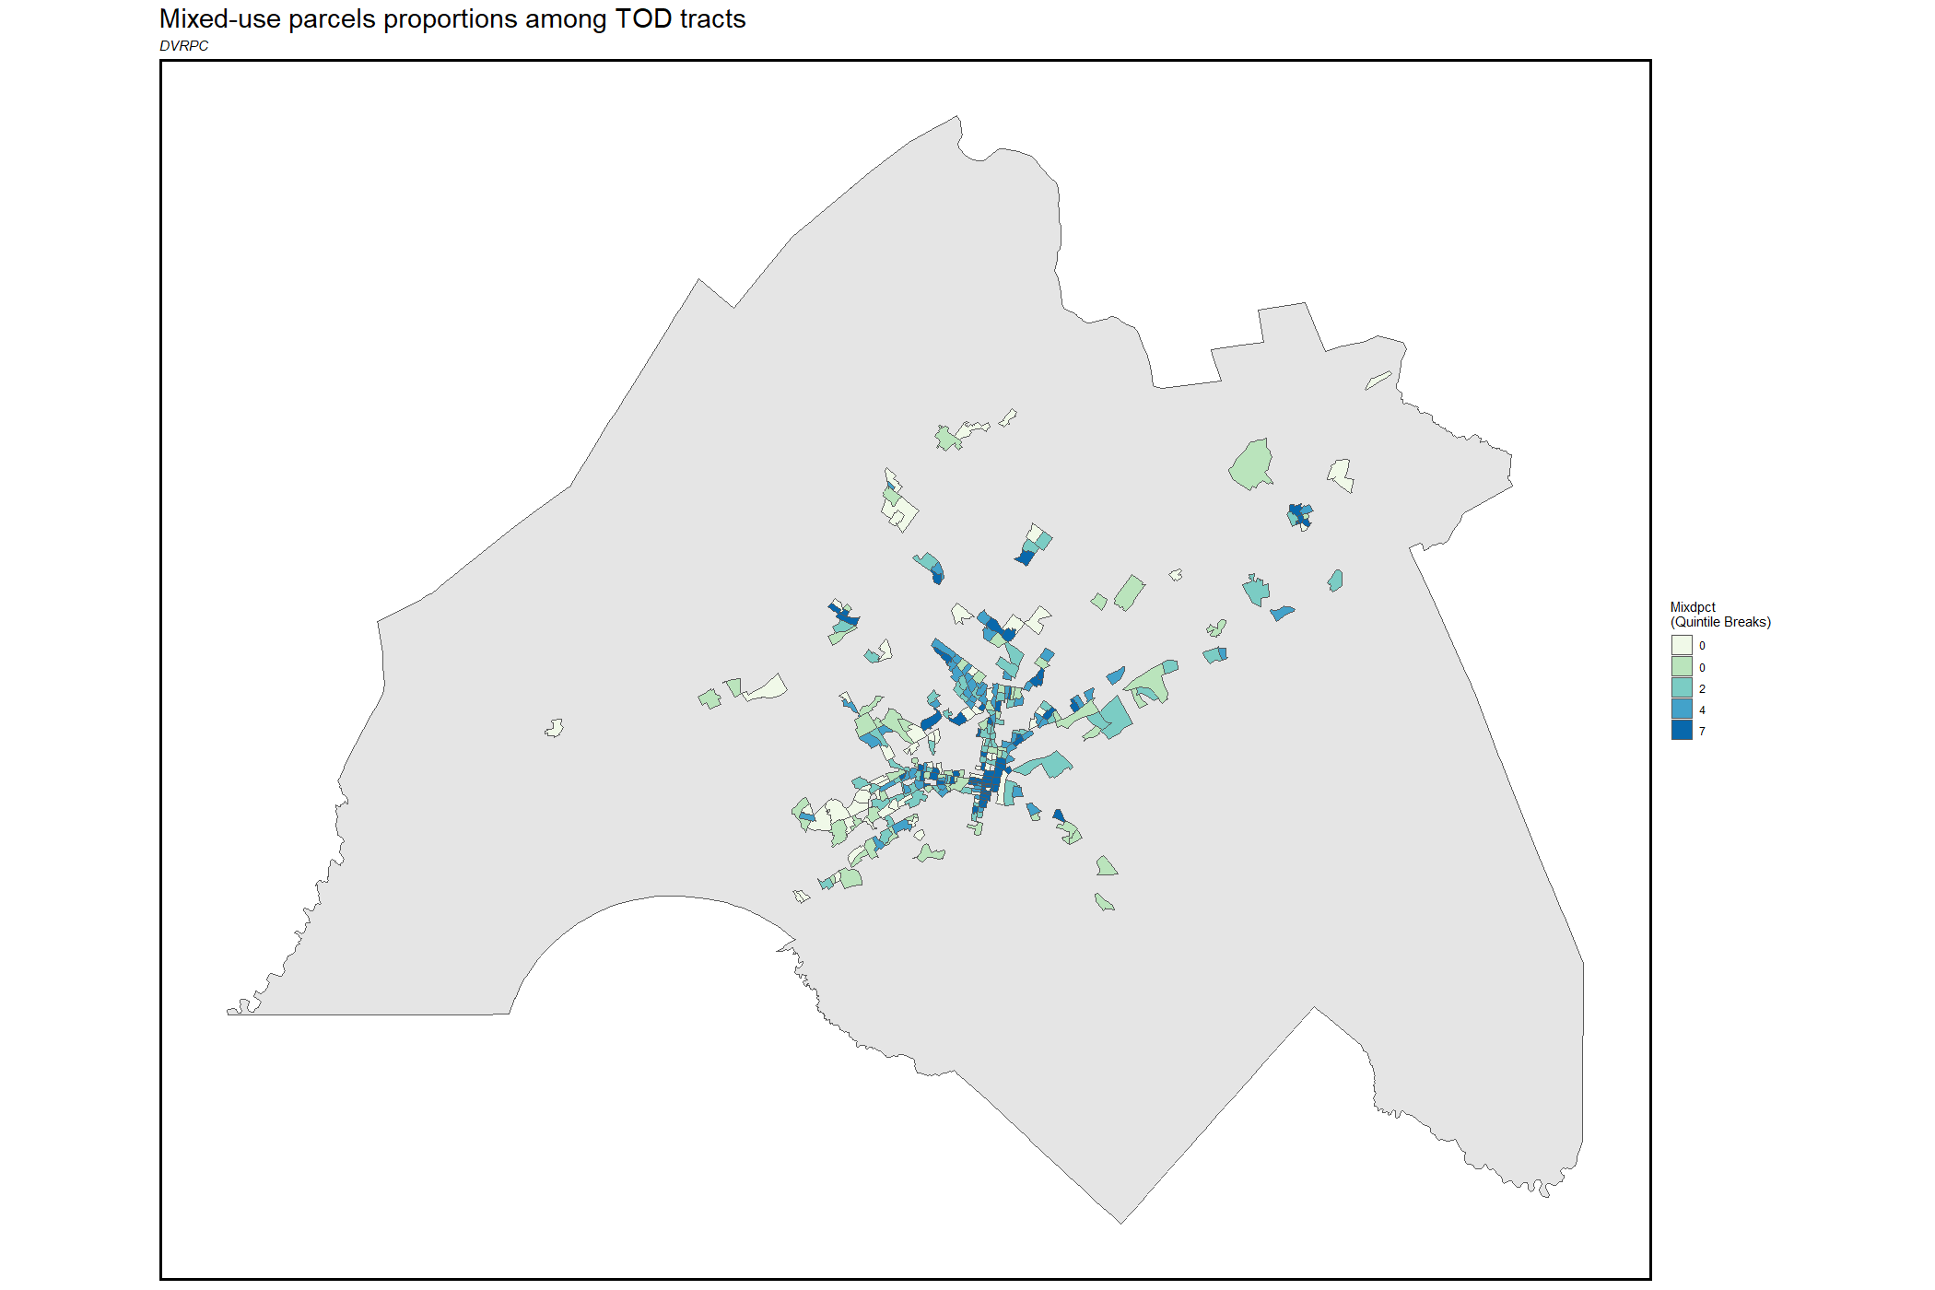

This is the map showing the proportion of underused parcels (agriculture, forest, undeveloped). It’s surprising to see that Center-North Philadelphia, Yeadon has relatively high underused rates. While the underused rates in outer parcels are not as high as expected. Probably because it was not weighted by size of parcels.

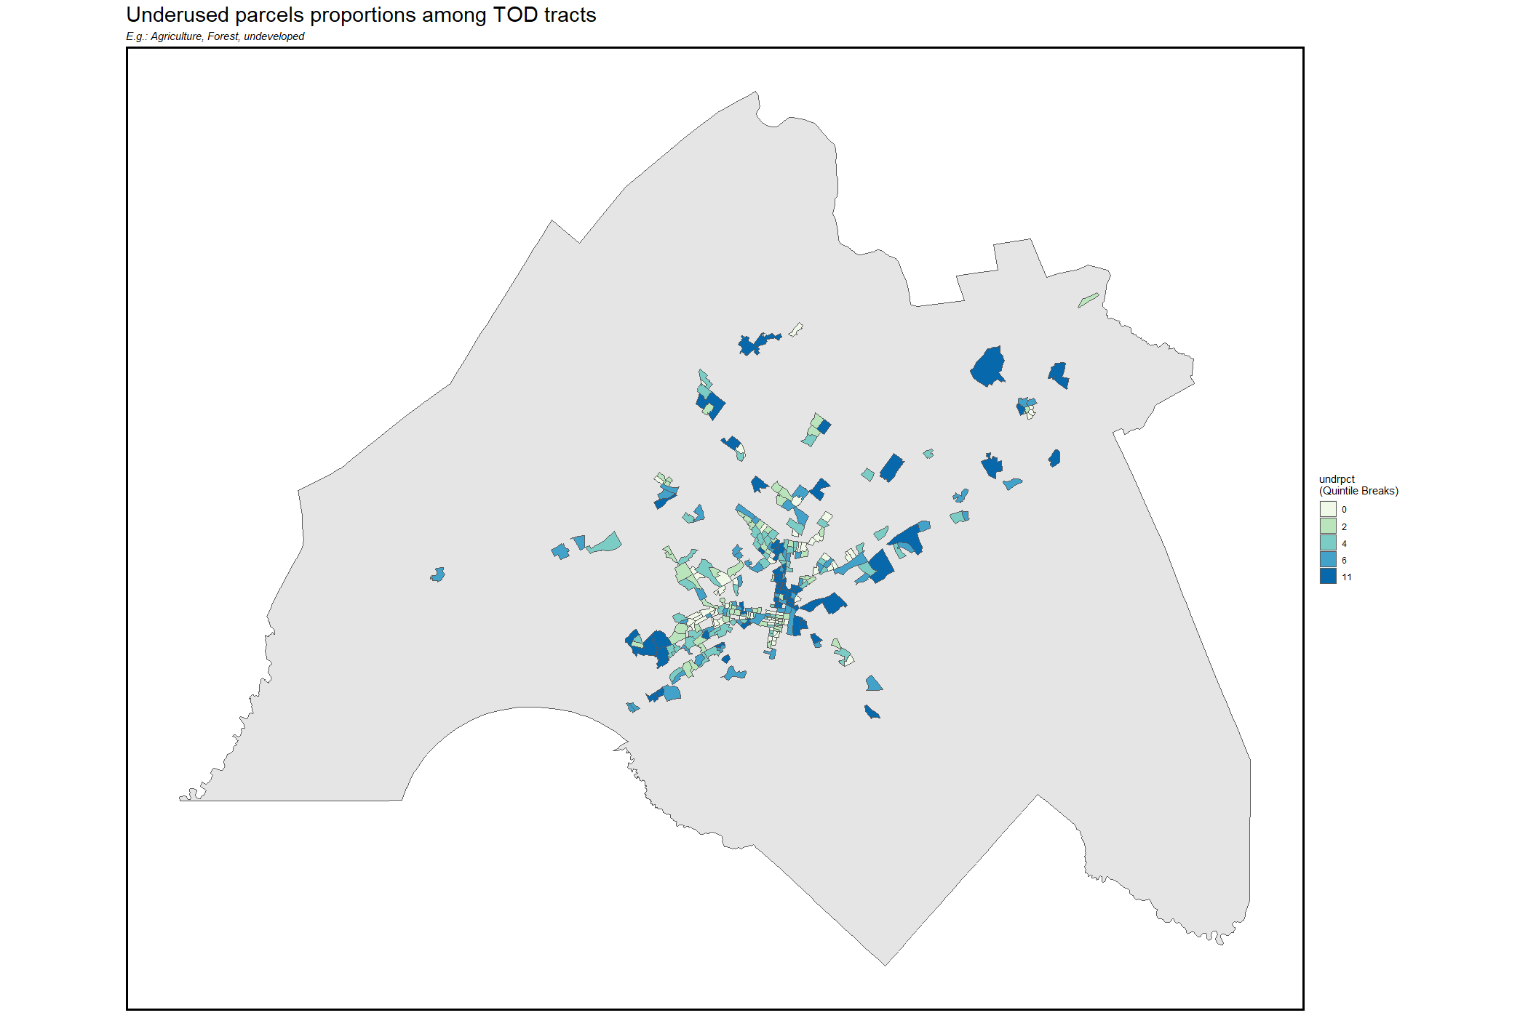

**Literature Review**

DVRPC’s TOD Index: <https://www.dvrpc.org/webmaps/TOD/#map>

Again, reviewing of this preliminary source make me confident that it still can be used as a useful data source in terms of transit accessibility, land-use (partial).

Montgomery County’s TOD Study: <https://www.montcopa.org/DocumentCenter/View/33039/Transit-Oriented-Dev-Book_web>

Montgomery County, PA actually has already conducted a TOD analysis for all rail stations within its jurisdiction. Rather than being quantitative, it assesses all the existing land-use pattern, building conditions, and literature background one by one. However, it provides a map at page 11 indicating the existing station surroundings, which is being categorized as “Regional Mixed-Use Center”, “Town Center”, “Suburban Employment Center”. And “Neighborhood Village Center”.

This information is critical to analyze whether those areas are suitable for TOD – although the DVRPC’s TOD index does provides some data about the existing land-use, literature analysis of all stations’ surrounding land-use outside the Montgomery County is necessary in order to expand to the entire study area.

Németh, B., Molnár, A., Bozóki, S., Wijaya, K., Inotai, A., Campbell, J. D., & Kaló, Z. (2019). Comparison of weighting methods used in multicriteria decision analysis frameworks in healthcare with focus on low-and middle-income countries. Journal of comparative effectiveness research, 8(4), 195-204. <https://www.futuremedicine.com/doi/10.2217/cer-2018-0102>

Multi-Criteria Decision Analysis (MCDA) is a common model used in social science; it helps researchers to generate decisions by quantitatively taking account of factors with different assigned weights. However, one of the biggest tradeoffs of such model is the process of weighting: it sometimes based on the subjective assumptions from the researchers rather in order to intentionally generate the “preferred” results. Thus, it is important to have a more scientific weighting methods in MCDA analysis.

Németh et al introduced a few weighting methods that could be used in this project. He lists a few weighting methods, like Direct Weighting, Swing Weighting, Scoring Functions, SMART etc. Among them, the method of Analytic Hierarchy Process (AHP) is the most appropriate one for this project: In this method, weights are calculated based on its relationship of importance with other factors, known as Pairwise Comparison in a Preference Matrix. Compared to other weighting methods, it has strengths in both resource requirement, low chance of bias, and overall complexity.

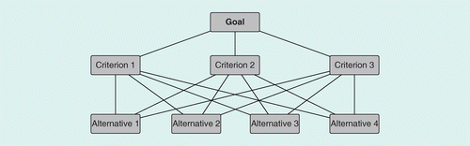

In addition, we are also going to use MCDA model based on AHP to build alternative scenario, in addition to identify stations “suitable for TOD development”. Other scenarios outcomes include “do nothing”, “mixed-use rezone”, “little bit more commercial is enough”.

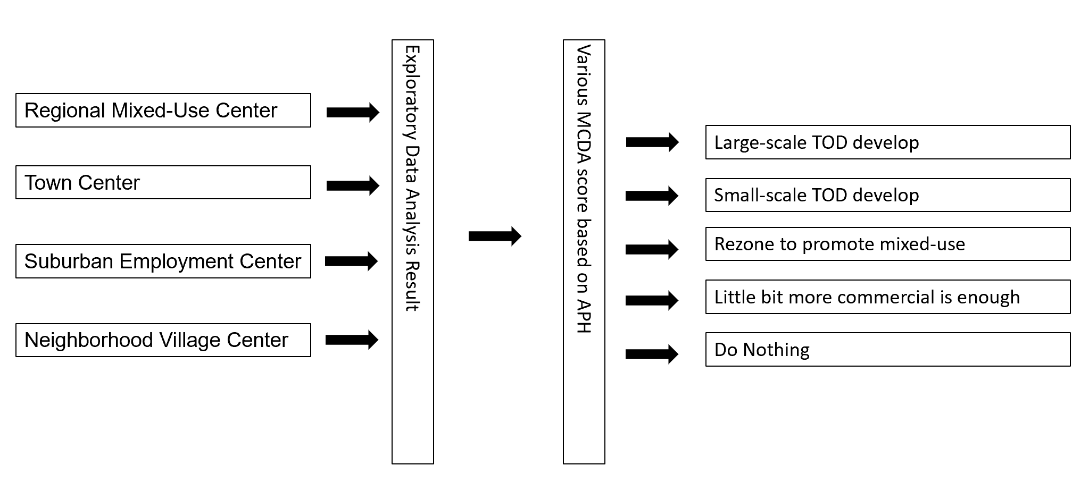

**Possible Next Step**

* Existing Land-use analysis through literature/field trip
* Calculate median parcel sizes by tract, and compared to typical TOD parcel sizes
* Obtain station ridership data
* Join parcels to un-unioned station buffers and analyze land-use (with weights?)
* Build MCDA models using AHP