TOD in Philadelphia

Lechuan Huang

**Topic**: develop a method to analyze the existence or potential of TOD opportunities in Philadelphia MSA (DVRPC) using Multi-Criteria Decision Analysis and Machine Learning.

**Background**

<https://urbanspatial.github.io/PublicPolicyAnalytics/TOD.html>

Philadelphia has its own subway and regional rail systems built over a century ago. However, according to analysis, only certain parts of the city served by rail transit had a positive impact brought by TOD. Other parts of the city served by subways, like West and North Philly remains unchanged compared to non-TOD communities.

<https://www.dvrpc.org/webmaps/TOD/>

DVRPC did produce a map showing the TOD indexes for all major rail transit stations in the Philadelphia MSA.

Factors includes:

* Transit Service Quality: in TCI Score
* Job Access: number of jobs accessible within 30-minute transit ride
* Travel Time to Philly: transit time to auto travel time ratio
* Population density in half-mile radius
* Car Ownership
* Non-Car Commuters
* Walk Score

It also measures stations’ future potential to develop new TODs

* Recent Development Activity
* Commercial rent and residential rent
* Available Land

However, it does not include the factors like safety, existing demography that will affect the feasibility of transition and may cause gentrification.

<https://whyy.org/articles/council-proposes-zoning-changes-to-drive-transit-oriented-development/>

This map shows possible stations could be used for TOD-development in Center City, but it only considers rail accessibility.

**Assumptions**

* I can rezone, upzone, redevelop parcels based on my analysis of parcels’ existing conditions
* New TOD projects will require affordable housing quotas
* TOD buffers will have perfect walking and cycling infrastructure eventually
* The transit service to Center PHL will be improved (more frequencies, express services) if I choose to do suburban counties

**Criterias (TBD) and Deliverables**

Before the analysis for TOD, a prediction of potential population trend in the future will be conducted.

The TOD index will be calculated based on a combination of differently weighted factors.

For assessing TOD potentials:

* Factors used by DVRPC (mentioned above)
* With existing high-density housing (apartment) but limited commercials
* stations with large vacant/underused parcels (e.g. parking lot, buildings in bad conditions)
* served by high-frequency bus routes/with a lot of bus routes
* For BSL, stops with express services will be weighted more.

Once the potential study is finished, I am also going to conduct feasibility study that will identify which potential TOD-stations will take least governments’ effort to redevelop/having minimum gentrification.

* Safety (Crimes and Police Station)
* Demography (race, income etc.) within and outside TOD buffer
* School Districts
* Gaps in walking and biking infrastructure

**Data Sources**

* DVRPC (for their TOD index and factor score)
* OpenPhillyData
  + ACS/Decennial Census/Tidycensus
  + Parcel (zoning, building type and age)
  + Crime Incidents
  + Schools
  + INDEGO stations

**Software**: R, ArcGIS, Excel (for simple projections)

**User Case**: a memo/report for local government to identify possible TOD locations and their feasibility to be redeveloped and renewed.

**Exploratory Data Analysis**

As of Feb 17, I have:

* Filtered existing census tracts within the TOD-radius
* Obtained the original TOD-index shapefile used by DVRPC
* Obtain the parcel data, converted to point data to save energy when analyzing, and filtered those within the TOD-tracts.
* Exploratory Analysis of Parcels (TOD comparing to non-TOD)
* Exploratory Analysis using census data.
* See [Presentation](https://github.com/CPLN-680-Spring-2022/Huang_lechuan_todphilly/blob/main/Captsone%20Presentation.pdf) about previous explanatory data.

I look at ACS data for all of the TOD-tracts: they represent a very different pattern in terms of race, wealth, and housing, as our background study suggested.

First thing I noticed is the inconsistency between Median Income data and Poverty Rate data, I am surprising to find out that areas like Media/Elwyn, Further North and Northeast Philly have high median income but high poverty rate; while periphery areas close to Center Philadelphia and Camden Downtown has lower median income but low poverty rate.

Most of the suburban area are wealthy, but there are outliers like Pennsauken, NJ (Atlantic City Line), Berwyn, PA (Paoli/Thorndale Line), Norristown, PA (Norristown Line and High-Speed Line), Bristol, PA (Trenton Line), Chester, PA (Wilmington Line), Norristown HSL west of 69th St.

Median Income vs. Poverty

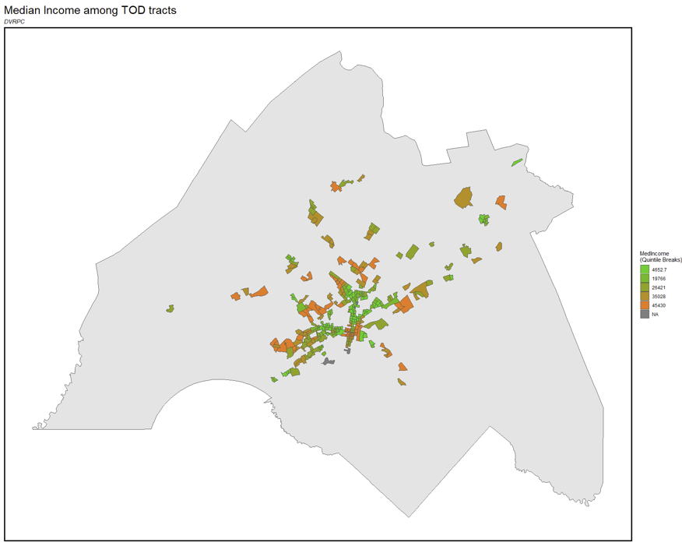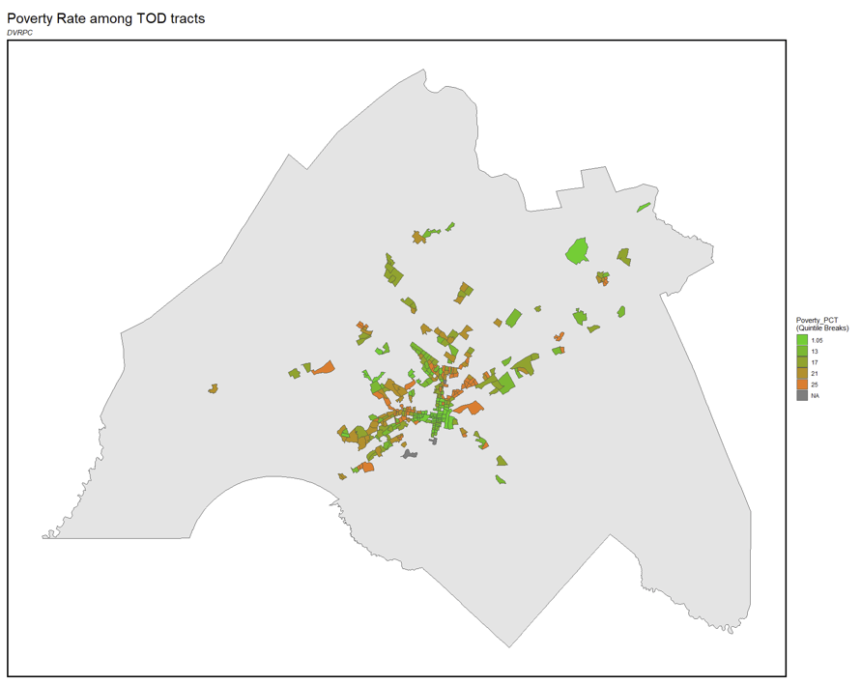

Areas with high house-ownership: not in Norristown, Center City, West and North Philly Media-Elwyn, again, has high house ownership despite high poverty rates:

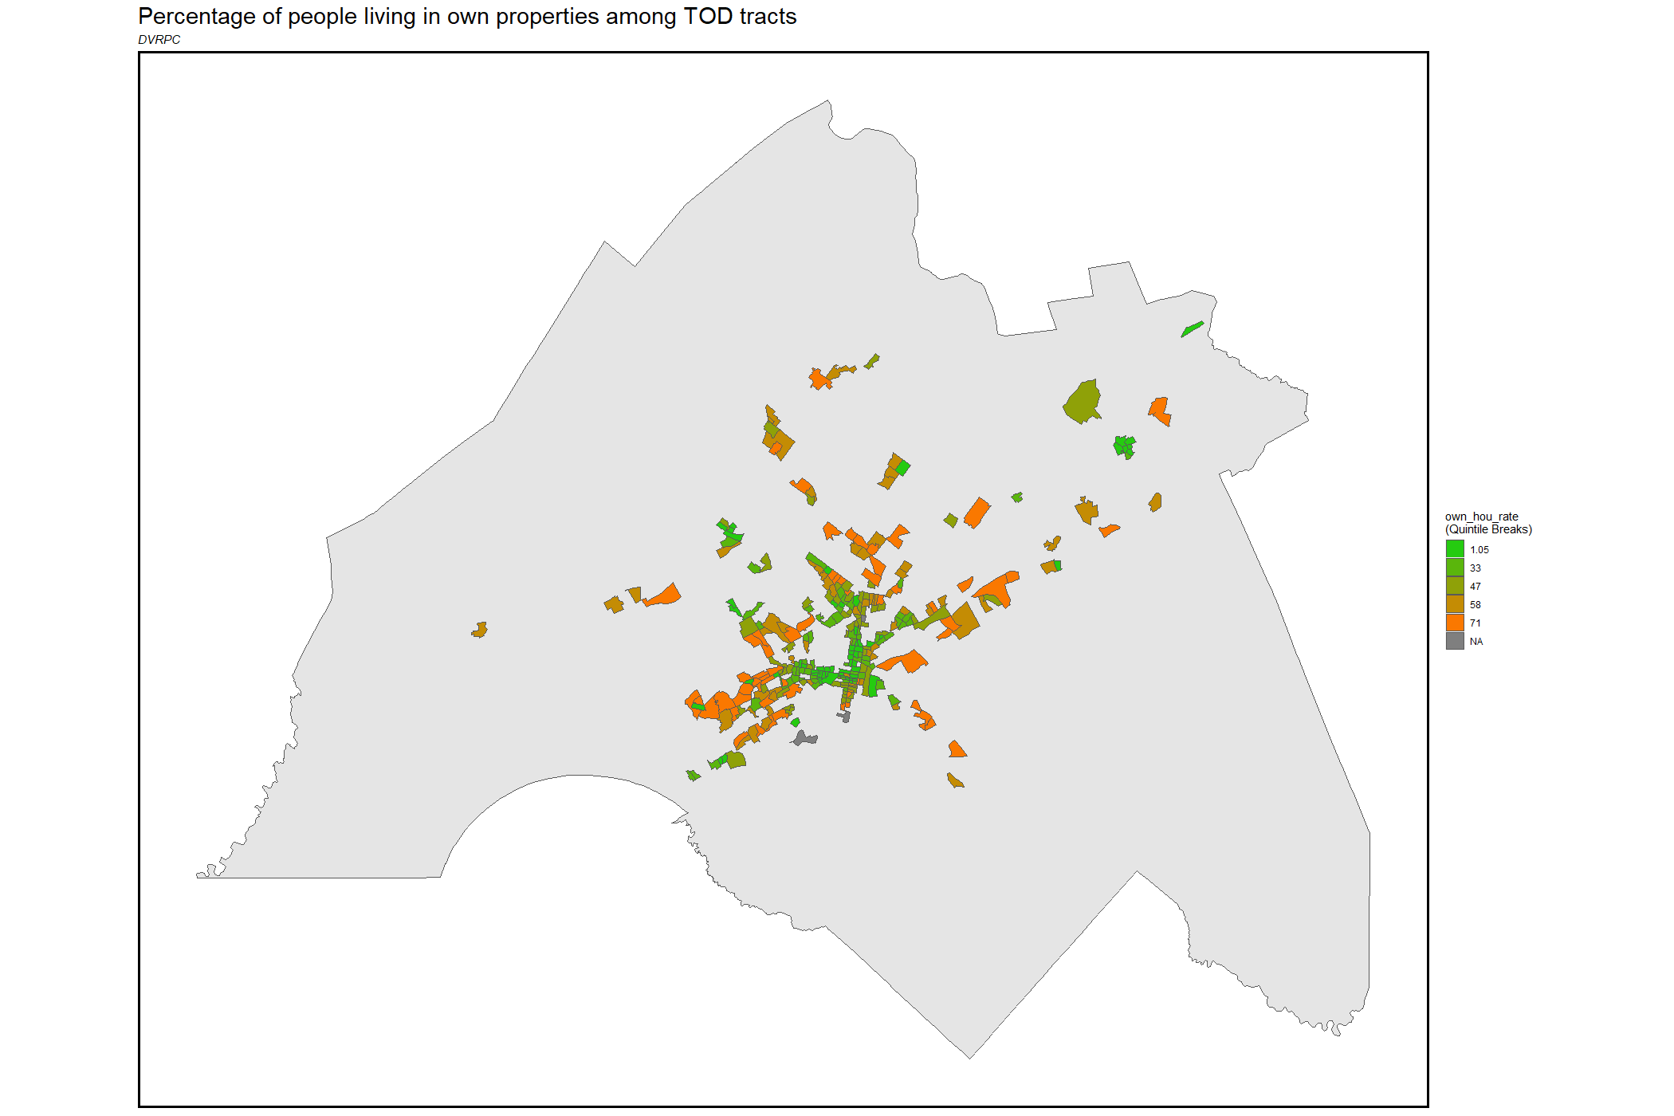

Areas with low-median rent: MFL west, MFL northeast, BSL north, Media-Elwyn Line, Trenton Line, PACTO middle, Trenton Line

Areas with high-median rent: Center City, Cinnaminson, West Trenton (surprising compared to Trenton), Media-Elwyn Terminus, Woodcrest:

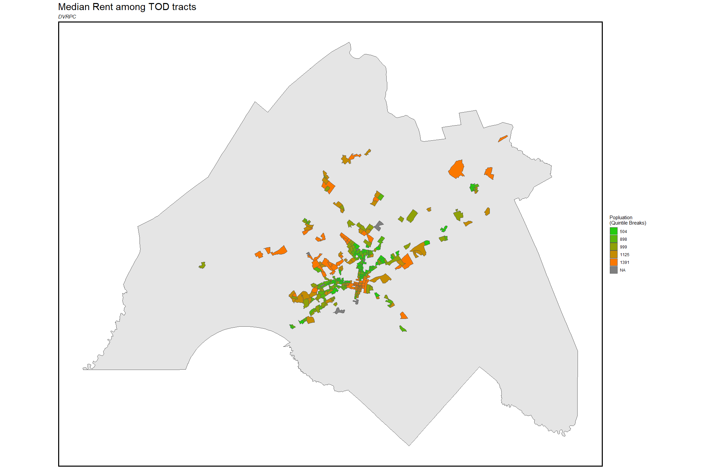

Second thing I noticed about is the inconsistency between the poverty rates, median rents and house ownership. A lot of areas have high house ownership and high poverty rates. The following is the table of areas where such inconsistency is observed:

Low – Green; High – Grey to Orange

|  |  |  |  |  |  |
| --- | --- | --- | --- | --- | --- |
|  | Suburban | Median Income | Poverty Rate | Median Rent | Ownership |
| Norristown, PA | Yes |  |  |  |  |
| North Philadelphia | No |  |  |  |  |
| West Philadelphia | No |  |  |  |  |
| Camden DT, NJ | No |  |  |  |  |
| Cinnaminson, NJ | Yes |  |  |  |  |
| Trenton, NJ | No |  |  |  |  |
| Media/Elwyn, PA | Yes |  |  |  |  |
| NHSL eastern | Yes |  |  |  |  |

Hypothesis: for area with low median income but low poverty rate, is that because it is also more affordable housing (due to low median rent or high ownership)? Thus, implementing new development would instead gentrify the area.

Next Step:

* Join Parcel data into TOD-tracts/TOD-buffer and analyze differences
* Determine Decision Factors
* Study about the “Affordability Hypothesis”

Other materials:

* Predicting Gentrification: <http://urbanspatialanalysis.com/portfolio/predicting-gentrification-using-longitudinal-census-data/>
* Measuring Gentrification: <https://bookdown.org/fis/social-life-of-neighborhoods/mapping-gentrification.html>