# Geographic Analysis of Asian American College Access Landscapes

# Abstract

*Asian Americans comprise of a panoply of differing ethnic national origins, it is important to recognize the power in a shared political identity; however, a shared racial identity, can minimize the differences between ethnic groups by consolidating Asian American statistics into one consolidated group. To address this, I analyze census tracts in Philadelphia where South Asian, Southeast Asians, East Asians and Filipinos, are highly clustered and have high frequency utilizing Local Indices of Spatial Autocorrelation (LISA). I use college access indicators such as median income, frequency of college attainment, and racial indicators to argue that Asian Americans have different experiences based on ethnic background related to their geographic boundaries, which shape their college access opportunities.*

# Objectives

Asian Americans comprise a panoply of differing and unique intersectional identities, histories, and experiences, yet Asian Americans are essentialized as a group and broadly stereotyped as the model minority. Within Asian American populations there are differences across ethnic group such as information to college access and campus resources (Museus & Truong, 2009; Palmer & Maramba, 2015; O. A. Poon & Byrd, 2013). Teranishi et al. (2004) found in their study that Chinese and Korean Americans had the greatest representation in selective institutions; however, even within ethnic groups there exist differences across socioeconomic status. Because of such cases, scholars and researchers have frequently called for the disaggregation of Asian American data to ensure that ethnic minorities are supported within the Asian American racial category (Museus & Truong, 2009). Although existing literature has shown that there are differences across ethnic group and socio-economic status, I expand upon this literature by including a geographic component utilizing geographic information systems (GIS) to map the socioeconomic and racial indicators in areas that are highly clustered and high frequency.

# Theoretical Framework

## Asian American Disaggregation

In 1989 Hsia and Hirano-Nakanishi wrote that Asian Americans, “…[were the] fastest-growing group of college goers” (1989, p. 20), and that Asians could comprise of 10% of the total U.S. population by 2080. The rapid growth of Asian Americans into the United States was related to passing the immigration act of 1965 which abolished policies such as the 1882 Chinese Exclusion act, and 1924 National Origins Act. Asians who immigrated after the passing of the 1965 immigration act immigrated with vastly different socioeconomic experiences. Southeast Asian communities, such as Vietnamese, Laotian, Cambodian, and Khmer, were escaping turmoil from war and conflict in contrast, to some Chinese immigrant scholars were looking for safety from the Chinese revolution. Despite the differing Asian cultural contexts, upon arrival in the U.S. all Asian immigrants became Asian. Although there is political power to a collective panethnic racial identifier (Okamoto, 2014), a panethnic racial identity can also render ethnic groups within the racial group unseen.

## Neighborhood Effects

Asian Americans often moved to places with other Asian Americans, whether that be explicitly named Chinatowns or other locations, as such it is important to analyze the neighborhood spaces that Asian Americans occupy. In Wilson’s (2012) work about the Black underclass, he argues that the construction of neighborhoods, their policies and broader social organization, are important factors to economic success. While racism has contributed to the displacement of the working class, race was not the only factor, but rather working-class conditions led to the growth of working-class Black people rather than becoming upwardly mobile. In making this argument, he compares black communities to Asian communities arguing that Asian immigrants also faced harsh discrimination; however, Asian immigrants were upwardly mobile. As such, Black poverty is not only about racism, but about proximal social conditions, joblessness, social isolation, and quality of local schools.

Wilson’s neighborhood effect’s argument has gone onto shape many other works, such as Anderson (2013), which addresses how formal institutions, such as local higher education institutions, and informal institutions, like the black market, shape neighborhoods. In Anderson’s case higher education institutions brought young professionals into the community; however, with the influx of new professionals also came new markets which raised the price of rent making it unaffordable to live in the neighborhood.

## Geographies of Opportunity

The United States is often hailed as a beacon for opportunity; however, opportunity varies based on geography and environment (Chetty et al., 2014). Some spaces have access to higher performing schools with more resources (Stewart et al., 2007), while other spaces schools treat students as criminals (Dache-Gerbino & White, 2016). The variability of opportunities based on geographies is not accidental, rather they are intentional decisions made by policy makers. In some spaces there is spatial clustering across the city, while in other spaces there is a concrete line of capital accumulation, leading to spatial mismatch and the intensification of capital accumulation (Florida, 2017; Harvey, 2001). Regardless of where capital accumulates they share the similar problem that cities become inaccessible to the working class, and hinders social mobility (Florida, 2017). These processes can be seen in the creation of cities across the U.S. such as Dallas, St. Louis, and Chicago (Dache & Mislán, 2019; Florida, 2017; Lipman, 2002, 2017; Tate, 2008).

The construction of cities and the development of higher education systems and capital accumulation often go head in hand. Tate (2008), argues that development of St. Louis and Dallas grew alongside higher education institutions and high-technology industry growth. Anderson’s (2013) ethnographic work shows how higher education institutions shape the landscape of local communities by bringing in residents who do not closely reflect the communities. The proximal relationship between higher education institutions and local urban communities, can also be found in Perna’s (2006) framework which conceptualizes college access in four layers: (1) habitus, (2) schools and community context, (3) higher education context, and (4) the social, economic and policy context.

This study focuses on the community and higher education context. Other scholars, like Turley (2009), found that geographic distance to higher education institutions may be a causal factor in explaining decisions to apply to college. Later Dache-Gerbino (2018), would argue that higher education institutions are spatially mismatched from the communities that require them. These studies suggest that proximity to higher education institutions does matter, in addition to socioeconomic status and broader neighborhood effects.

# Methods and Data Source

I use data from the 2019 American Community Survey (ACS), primarily relying on data that describes highest form of education attainment, Asian country of origin, and annual income. These variables were selected using Perna’s (2006) conceptual model of higher education particularly focusing on the school and community context. Broad Asian American racial categories were developed from research that addresses Asian American movements (Nadal, 2019; Yi et al., 2020). If the country of origin was not stated in the study, then geographic proximity was used to categorize the ethnic group. The broad Asian American racial groups include East Asian, Southeast Asian, South Asian, and Filipino. The category East Asian includes: Chinese, Japanese, Korean, Mongolian, Taiwanese and Thai. Southeast Asian includes: Burmese, Cambodian, Hmong, Indonesian, Laotian and Malaysian. The category South Asian includes: Asian Indian, Bangaldeshi, Bhutanese, Nepalese, Pakistani, and Sri Lankan. Filipinos were categorized as a separate group based on their history of colonization by Spain and thereafter the U.S. Because of Spanish colonization, the Philippines holds a unique historical context (Nadal, 2019; Ocampo, 2016).

## Spatial Autocorrelation Analysis: Moran’s I and LISA

Spatial autocorrelation describes how related geographic spaces are to each other, and one way to determine this is through Moran’s I. Moran’s I has been widely used to test for spatial autocorrelation or spatial dependencies and its value determines the strength of autocorrelation indicating how clustered values are. Values that are closer to 1 indicate strong positive autocorrelation, while values closer to -1 indicate negative autocorrelation that being how repelled values are. If the value is close to 0, then there is no spatial autocorrelation, indicating a random pattern. Although Moran’s I has been widely utilized, it does not identify local locations where there are high frequencies and high clustering. To identify these census tracts I use the Local Indicator of Spatial Association (LISA).

LISA is defined as having two properties. (1) the LISA for each observation gives an indication of the extent of significant spatial clustering of similar values around that observation and (2) the sum of LISAs for all observations is proportional to a global indicator of spatial association. In our case each census block is calculated individually and then summed to provide the I from Moran's I. The calculated LISA describes each blocks effects of the clustering within the data.

After these census tracts were identified, I then removed any census tracts where two or more Asian American populations had high frequencies and were highly clustered overlapped. This allowed me to identify census tracts that were unique to ethnic enclaves to understand how these ethnic enclaves’ conditions differed from other ethnic enclaves. After this, I ran a Kruskil-Wallis test, because the data is non-parametric. The null hypothesis for the Kruskil-Wallis test is that the mean ranks of all the groups are the same. While the alternate hypothesis is that the mean ranks of the groups are different. Next, to determine which groups were significantly different I used a pairwise Wilcox test to identify which racial/ethnic groups were different from each other.

# Results

## Asian American Clustering

Using LISA, I found that Asian American racial/ethnic groups are clustered in Philadelphia. Figure 1 through 4, show for each racial ethnic group the type of clustering that occurs. Broadly speaking, East Asians are distributed in the northeast, central, and south Philadelphia. In contrast to South Asian communities which are primarily found in northeast Philadelphia. Southeast Asians are found in North and South Philly, while Filipinos are clustered in South Philadelphia.

## Education Attainment and Income

Southeast Asians generally lived in areas with a higher frequency of people who attained a High School diploma or less, in contrast to South Asians and East Asians who generally live in areas where people attain a bachelor’s degree or more. Additionally Southeast Asians have statistically significant differences when comparing frequency of people who make $100k, and median income in the past 12 months. East Asians and South Asians lived in census tracts where the amount of people who made $100k were higher than Southeast Asians. Figures 9 and 10 shows the spread and means of Bachelor’s attainment and median income.

The differences between the different groups may be related to the historical contexts of immigration. The 1980 Refugee act allowed refugees to become permanent residence after a year in the country, which led to many Southeast Asian communities such as Vietnamese, Laotian, Cambodian, and Khmer populations to immigrate to the United States. Although the 1965 immigration act brought in many refugees, it also brought in Chinese scholars and students who were looking to escape the turbulence of the Chinese revolution (Okihiro, 2015). In addition to the Chinese revolution, from the Korean war, many Korean women immigrated to the United States with American service men. However, there were also many Korean-educated medical professionals who also immigrated to the United States (C.-S. Lee, 2011).

**Proximity to Whiteness**

Southeast Asians live in census tracts with significantly more black people, while East Asian and South Asian populations live in areas with significantly more white people. Asian Americans in white spaces is not a new finding, Cheng (2013) found that Asian Americans and Mexican Americans were able to move into white neighborhoods, and transformed these spaces to be multiracial communities. However, these findings also provide geographic context to other studies that argue Asian Americans are nearing “white status” and reinforcing the black and white divide (Bonilla-Silva, 2004; J. C. Lee & Kye, 2016).

In understanding the role that proximity has to whiteness, I heed warnings from other scholars who caution perpetuating the model minority myth (Angeles & Poon, 2017; J. C. Lee & Kye, 2016; O. Poon et al., 2016; O. Poon & Sihite, 2016; Yi et al., 2020). Despite quantitative findings that point to East Asians and South Asians being in areas with more White people, these data do not address experiences of Asian Americans in these spaces. Asian American identity development models, address how Asian Americans experience being in white spaces (Kim, 2001; Museus et al., 2021). However, proximity to geographic Blackness, should also be nuanced to better understand the experiences of Southeast Asians.

# Conclusions

This study found that when Asian American groups are aggregated into smaller ethnic/racial categories, significant clustering exists across Philadelphia. Additionally, based on these clusters there were significant differences across income, education attainment, and proximity to other racial groups. Specifically, Southeast Asians were in closer proximity to Black communities, while East Asians and South Asians were in closer proximity to White populations. These findings support past studies that have found differences between among Asian American populations; however, provides spatial nuances.

# References

Anderson, E. (2013). *Streetwise: Race, Class, and Change in an Urban Community*. University of Chicago Press. https://books.google.com/books?id=qbBbAAAAQBAJ

Angeles, L., & Poon, O. A. (2017). *Asian group tells Common Application to stop disaggregating Asian groups*. 12–13.

Bonilla-Silva, E. (2004). From bi-racial to tri-racial: Towards a new system of racial stratification in the USA. *Ethnic and Racial Studies*, *27*(6), 931–950. https://doi.org/10.1080/0141987042000268530

Cheng, W. (2013). The changs next door to the diazes: Suburban racial formation in Los Angeles’s San Gabriel Valley. *Journal of Urban History*, *39*(1), 15–35. https://doi.org/10.1177/0096144212463548

Chetty, R., Hendren, N., Kline, P., & Saez, E. (2014). WHERE IS THE LAND OF OPPORTUNITY? THE GEOGRAPHY OF INTERGENERATIONAL MOBILITY IN THE UNITED STATES. *The Quarterly Journal of Economics*, *129*(4), 1553–1624.

Dache, A., & Mislán, C. (2019). Defining the Struggle: Epistemological Explorations of Social Geography and Deigital Space in Ferguson. In A. Dache, S. J. Quaye, C. Linder, & K. M. McGuire (Eds.), *Rise up!: Activism as education*. Michigan State University Press. https://play.google.com/books/reader?id=SnqfDwAAQBAJ&printsec=frontcover&pg=GBS.PT182.w.0.0.84

Dache-Gerbino, A. (2018). College desert and oasis: A critical geographic analysis of local college access. *Journal of Diversity in Higher Education*, *11*(2), 97–116. https://doi.org/10.1037/dhe0000050

Dache-Gerbino, A., & White, J. A. (2016). College Students or Criminals? A Postcolonial Geographic Analysis of the Social Field of Whiteness at an Urban Community College Branch Campus and Suburban Main Campus. *Community College Review*, *44*(1), 49–69. https://doi.org/10.1177/0091552115616677

Florida, R. (2017). *The New Urban Crisis: How Our Cities Are Increasing Inequality, Deepening Segregation, and Failing the Middle Class-and What We Can Do About It*. Basic Books. https://books.google.com/books?id=UT82jgEACAAJ

Harvey, D. (2001). *Spaces of Capital: Towards a Critical Geography*. Taylor & Francis.

Hsia, J., & Hirano-Nakanishi, M. (1989). The Demographics of Diversity: Asian Americans and Higher Education. *Change: The Magazine of Higher Learning*, *21*(6), 20–27. https://doi.org/10.1080/00091383.1989.9937602

Kim, J. (2001). Asian American Identity Development Theory. In C. L. Wijeyesinghe & B. W. Jackson III (Eds.), *New Persepctives on Racial Identity Development: A theoretical and Paractical Anthology* (pp. 67–90). New York University Press.

Lee, C.-S. (2011). U.S. Immigration Act of 1965 and Asian Brain Drain. 영미연구, *25*(12), 311–344.

Lee, J. C., & Kye, S. (2016). Racialized Assimilation of Asian Americans. *Annual Review of Sociology*, *42*, 253–273.

Lipman, P. (2002). Making the global city, making inequality: The political economy and cultural politics of Chicago school policy. *American Educational Research Journal*, *39*(2), 379–419. https://doi.org/10.3102/00028312039002379

Lipman, P. (2017). The landscape of education “reform” in Chicago: Neoliberalism meets a grassroots movement. *Education Policy Analysis Archives*, *25*, 54. https://doi.org/10.14507/epaa.25.2660

Museus, S. D., Hyun White, H., & Na, V. S. (2021). A critical persepctive of Asian American Identity. In F. A. Bonner, R. M. Banda, S. L. Smith, & A. F. Marbley (Eds.), *Square pegs and round holes: Alternative student development frameworks and models for higher education and student affairs*. Stylus Publishing.

Museus, S. D., & Truong, K. A. (2009). Disaggregating Qualitative Data from Asian American College Students in Campus Racial Climate Research and Assessment. *New Directions for Institutional Research*, *Summer*(142), 17–26. https://doi.org/10.1002/ir

Nadal, K. L. (2019). The Brown Asian American Movement: Advocating for South Asian, Southeast Asian, and Filipino American Communities. *Asian American Policy Review*, *29*, 2-11,95.

Ocampo, A. (2016). *The Latinos of Asia: How Filipino Americans Break the Rules of Race*. Standford University Press.

Okamoto, D. G. (2014). *Redefining Race*. Russell Sage Foundation. http://www.jstor.org/stable/10.7758/9781610448451

Okihiro, G. Y. (2015). *American History Unbound: Asians and Pacific Islanders*. University of California Press. https://books.google.com/books?id=YlY0CgAAQBAJ

Palmer, R. T., & Maramba, D. C. (2015). The impact of social capital on the access, adjustment, and success of Southeast Asian American college students. *Journal of College Student Development*, *56*(1), 45–60. https://doi.org/10.1353/csd.2015.0007

Perna, L. W. (2006). Studying College Access and Choice: A proposed Conceptual Model. *Higher Education: Handbook of Theory and Research*, *XXI*, 99–157. https://doi.org/10.1016/0273-1177(93)90208-S

Poon, O. A., & Byrd, A. (2013). Beyond tiger mom anxiety: Ethnic, gender, and generational differences in Asian American college access and choices. *Journal of College Admission*, *Fall*(221), 22–31.

Poon, O., & Sihite, E. (2016). Racial Anxieties, Uncertainties, and Misinformation: A Complex Picture of Asian Americans and Selective College Admissions. In M. Zhou & A. C. Ocampo (Eds.), *Contemporary Asian America (third edition)* (pp. 508–528). NYU Press. http://www.jstor.org/stable/j.ctt18040wj.30

Poon, O., Squire, D., Kodama, C., Byrd, A., Chan, J., Manzano, L., Furr, S., & Bishundat, D. (2016). A Critical Review of the Model Minority Myth in Selected Literature on Asian Americans and Pacific Islanders in Higher Education. *Review of Educational Research*, *86*(2), 469–502. https://doi.org/10.3102/0034654315612205

Stewart, E. B., Stewart, E. A., & Simons, R. L. (2007). The Effect of Neighborhood Context on the College Aspirations of African American Adolescents. *American Educational Research Journal*, *44*(4), 896–919.

Tate, W. F. (2008). “Geography of Opportunity”: Poverty, Place, and Educational Outcomes. *Educational Researcher*, *37*(7), 397–411. https://doi.org/10.3102/0013189x08326409

Teranishi, R. T., Ceja, M., Antonio, A. L., Allen, W. R., & McDonough, P. M. (2004). The College-Choice Process for Asian Pacific Americans: Ethnicity and SocioEconomic Class in Context. *The Review of Higher Education*, *27*(4), 527–551. https://doi.org/10.1353/rhe.2004.0025

Turley, R. N. L. (2009). College proximity: Mapping access to opportunity. *Sociology of Education*, *82*(2), 126–146. https://doi.org/10.1177/003804070908200202

Wilson, W. J. (2012). *The truly disadvantaged: The inner city, the underclass, and public policy* (2nd ed.). University of Chicago Press.

Yi, V., Mac, J., Na, V. S., Venturanza, R. J., Museus, S. D., Buenavista, T. L., & Pendakur, S. L. (2020). Toward an Anti-Imperialistic Critical Race Analysis of the Model Minority Myth. *Review of Educational Research*, *90*(X), 1–38. https://doi.org/10.3102/0034654320933532

# Tables

|  |  |  |  |  |  |  |
| --- | --- | --- | --- | --- | --- | --- |
| **Group 1** | **Group 2** | **n1** | **n2** | **p.adj** | **p.adj.signif** | **variable** |
| Southeast_Asian_Asian_Cluster | South_Asian_Asian_Cluster | 20 | 16 | 6.12E-07 | ** | Bachelor_more_Edu_Attainment |
| Southeast_Asian_Asian_Cluster | South_Asian_Asian_Cluster | 20 | 16 | 8.16E-05 | ** | white_Race |
| Southeast_Asian_Asian_Cluster | South_Asian_Asian_Cluster | 20 | 16 | 9.92E-05 | ** | Black_Race |
| Southeast_Asian_Asian_Cluster | East_Asian_Asian_Cluster | 20 | 24 | 0.000151 | ** | Black_Race |
| Southeast_Asian_Asian_Cluster | East_Asian_Asian_Cluster | 20 | 24 | 0.000403 | ** | Bachelor_more_Edu_Attainment |
| Southeast_Asian_Asian_Cluster | South_Asian_Asian_Cluster | 20 | 16 | 0.000576 | ** | $100+K_Income |
| Southeast_Asian_Asian_Cluster | East_Asian_Asian_Cluster | 20 | 24 | 0.000602 | ** | white_Race |
| East_Asian_Asian_Cluster | Southeast_Asian_Asian_Cluster | 13 | 18 | 0.009 | ** | Median income in the past 12 months Total |
| East_Asian_Asian_Cluster | Southeast_Asian_Asian_Cluster | 13 | 18 | 0.015 | * | Median gross rent Total |
| Southeast_Asian_Asian_Cluster | East_Asian_Asian_Cluster | 20 | 24 | 0.016879 | * | $100+K_Income |
| Southeast_Asian_Asian_Cluster | South_Asian_Asian_Cluster | 20 | 16 | 0.018626 | * | Some_HS_or_less_Edu_Attainment |
| East_Asian_Asian_Cluster | Southeast_Asian_Asian_Cluster | 13 | 18 | 0.024 | * | Median earnings in the past 12 months Total |
| Southeast_Asian_Asian_Cluster | East_Asian_Asian_Cluster | 20 | 24 | 0.030792 | * | Some_HS_or_less_Edu_Attainment |
| South_Asian_Asian_Cluster | Southeast_Asian_Asian_Cluster | 7 | 18 | 0.031 | * | Median income in the past 12 months Total |

Table 1. Significant variables from pairwise test

# Figures

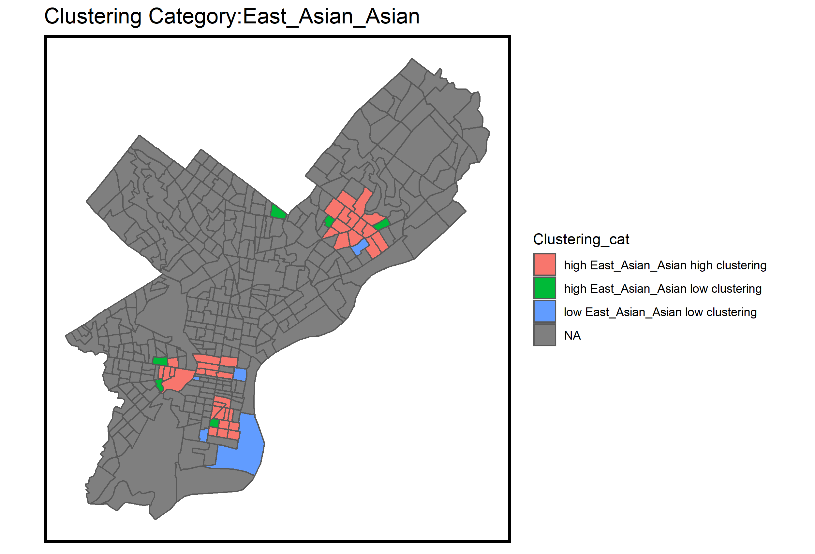

Figure 2. Clustering of East Asians

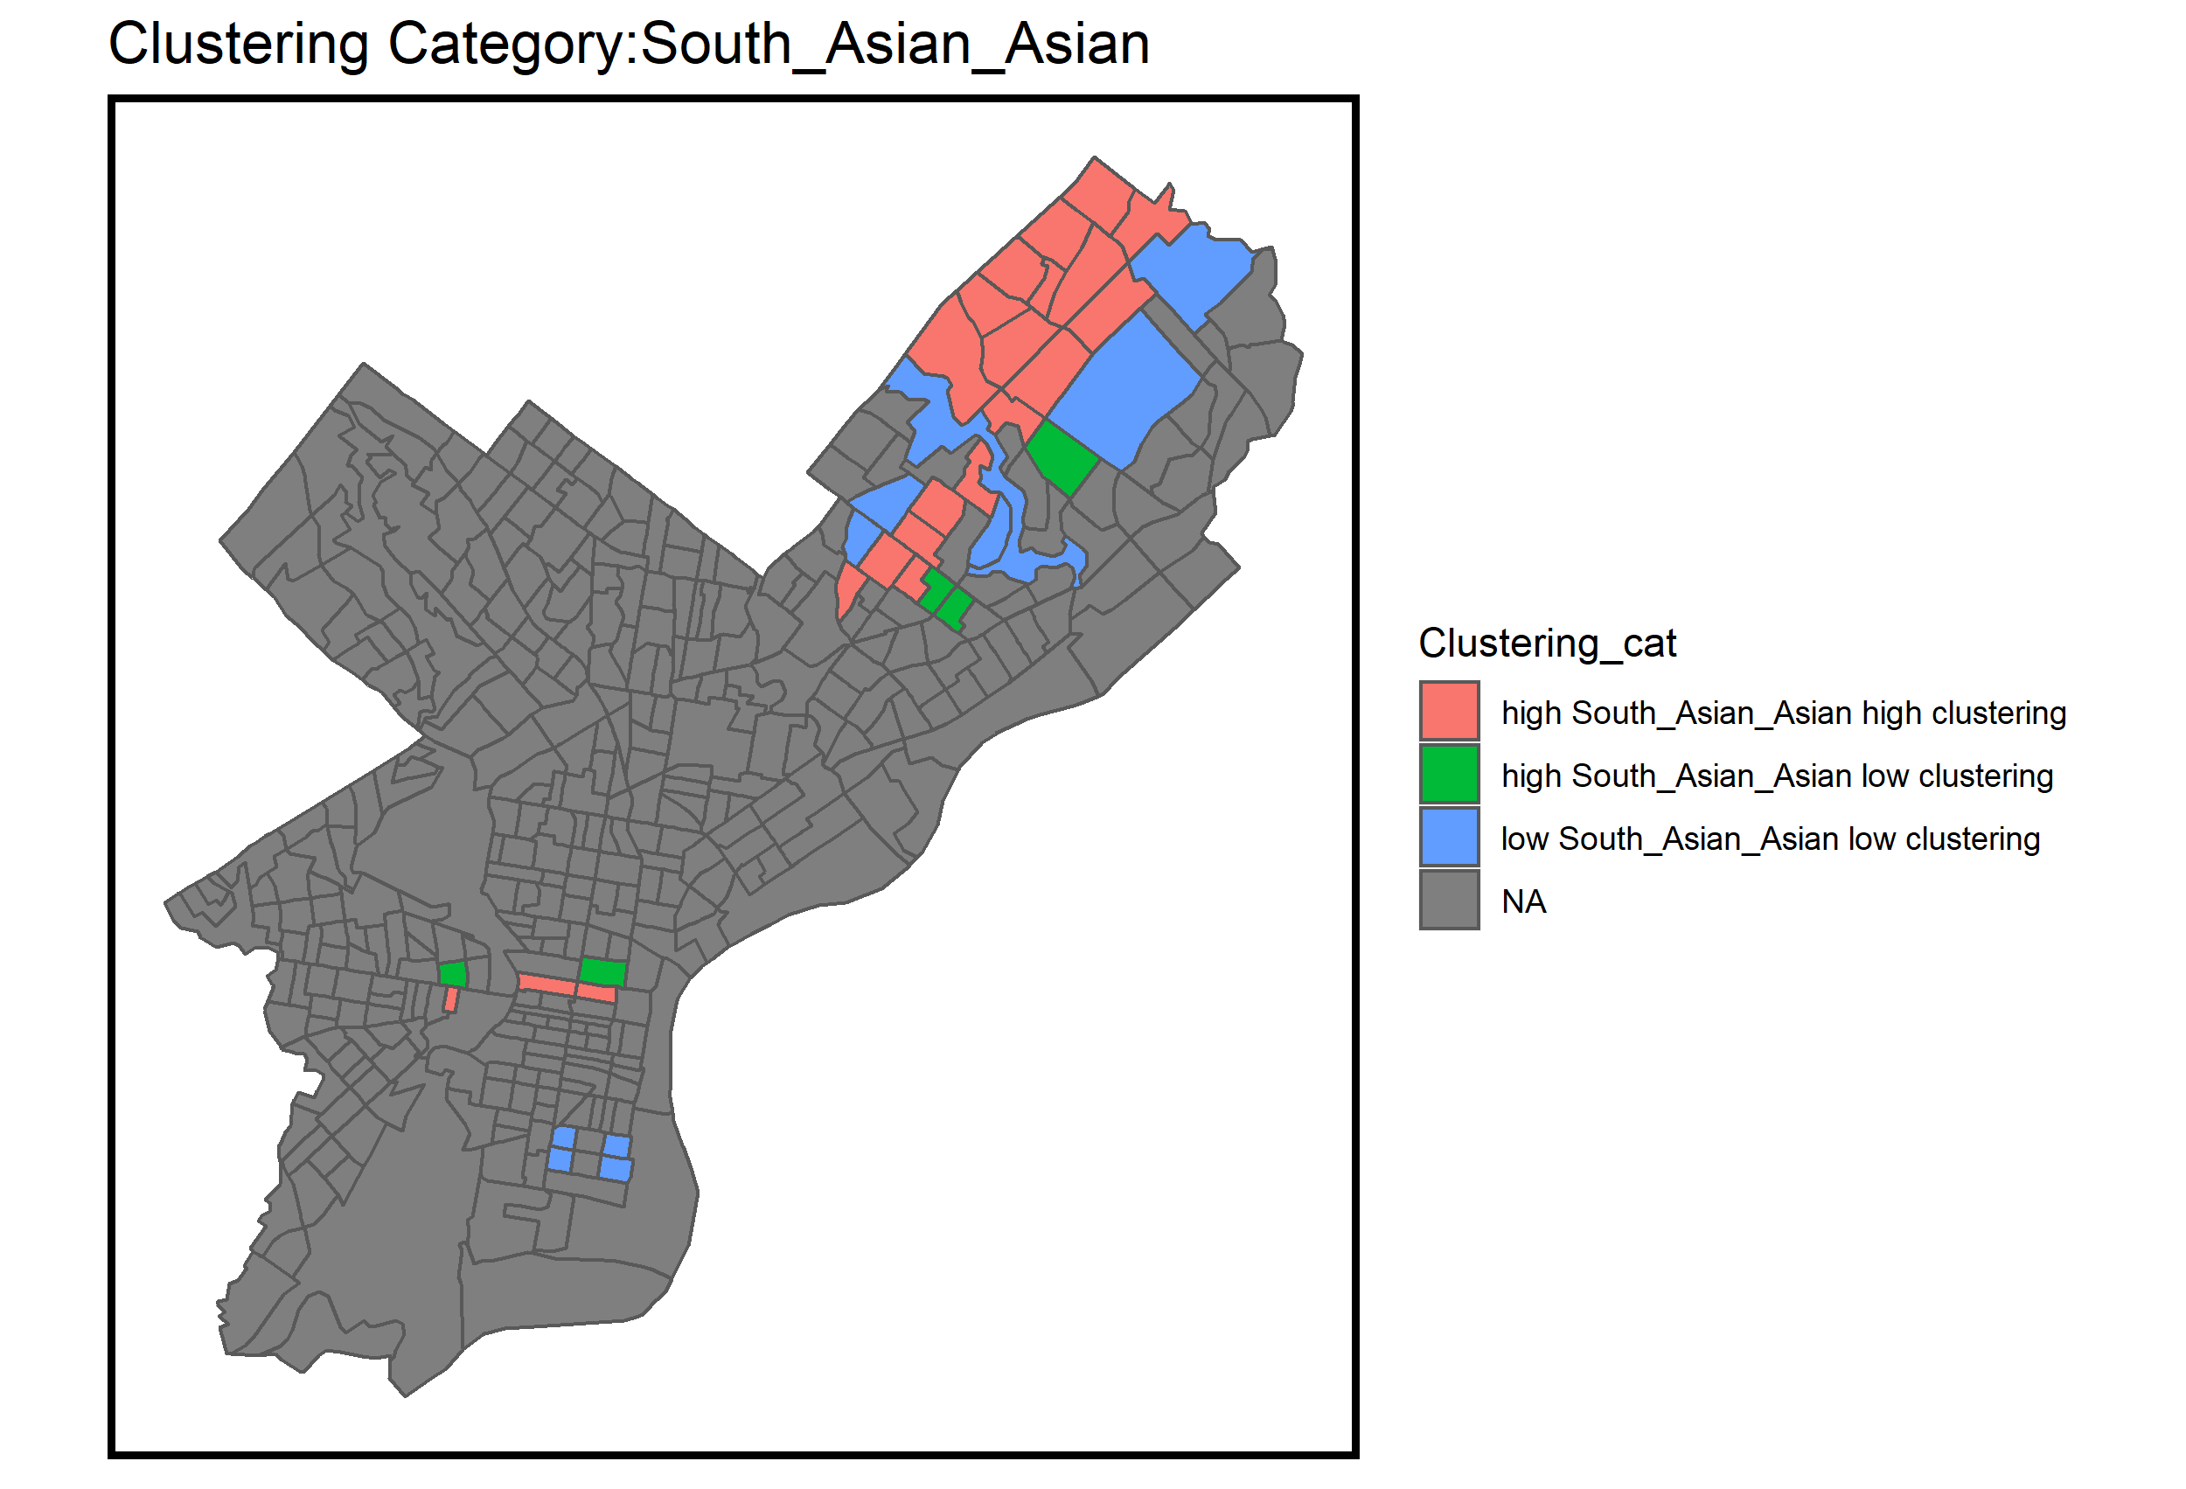

Figure 1. Clustering of South Asians

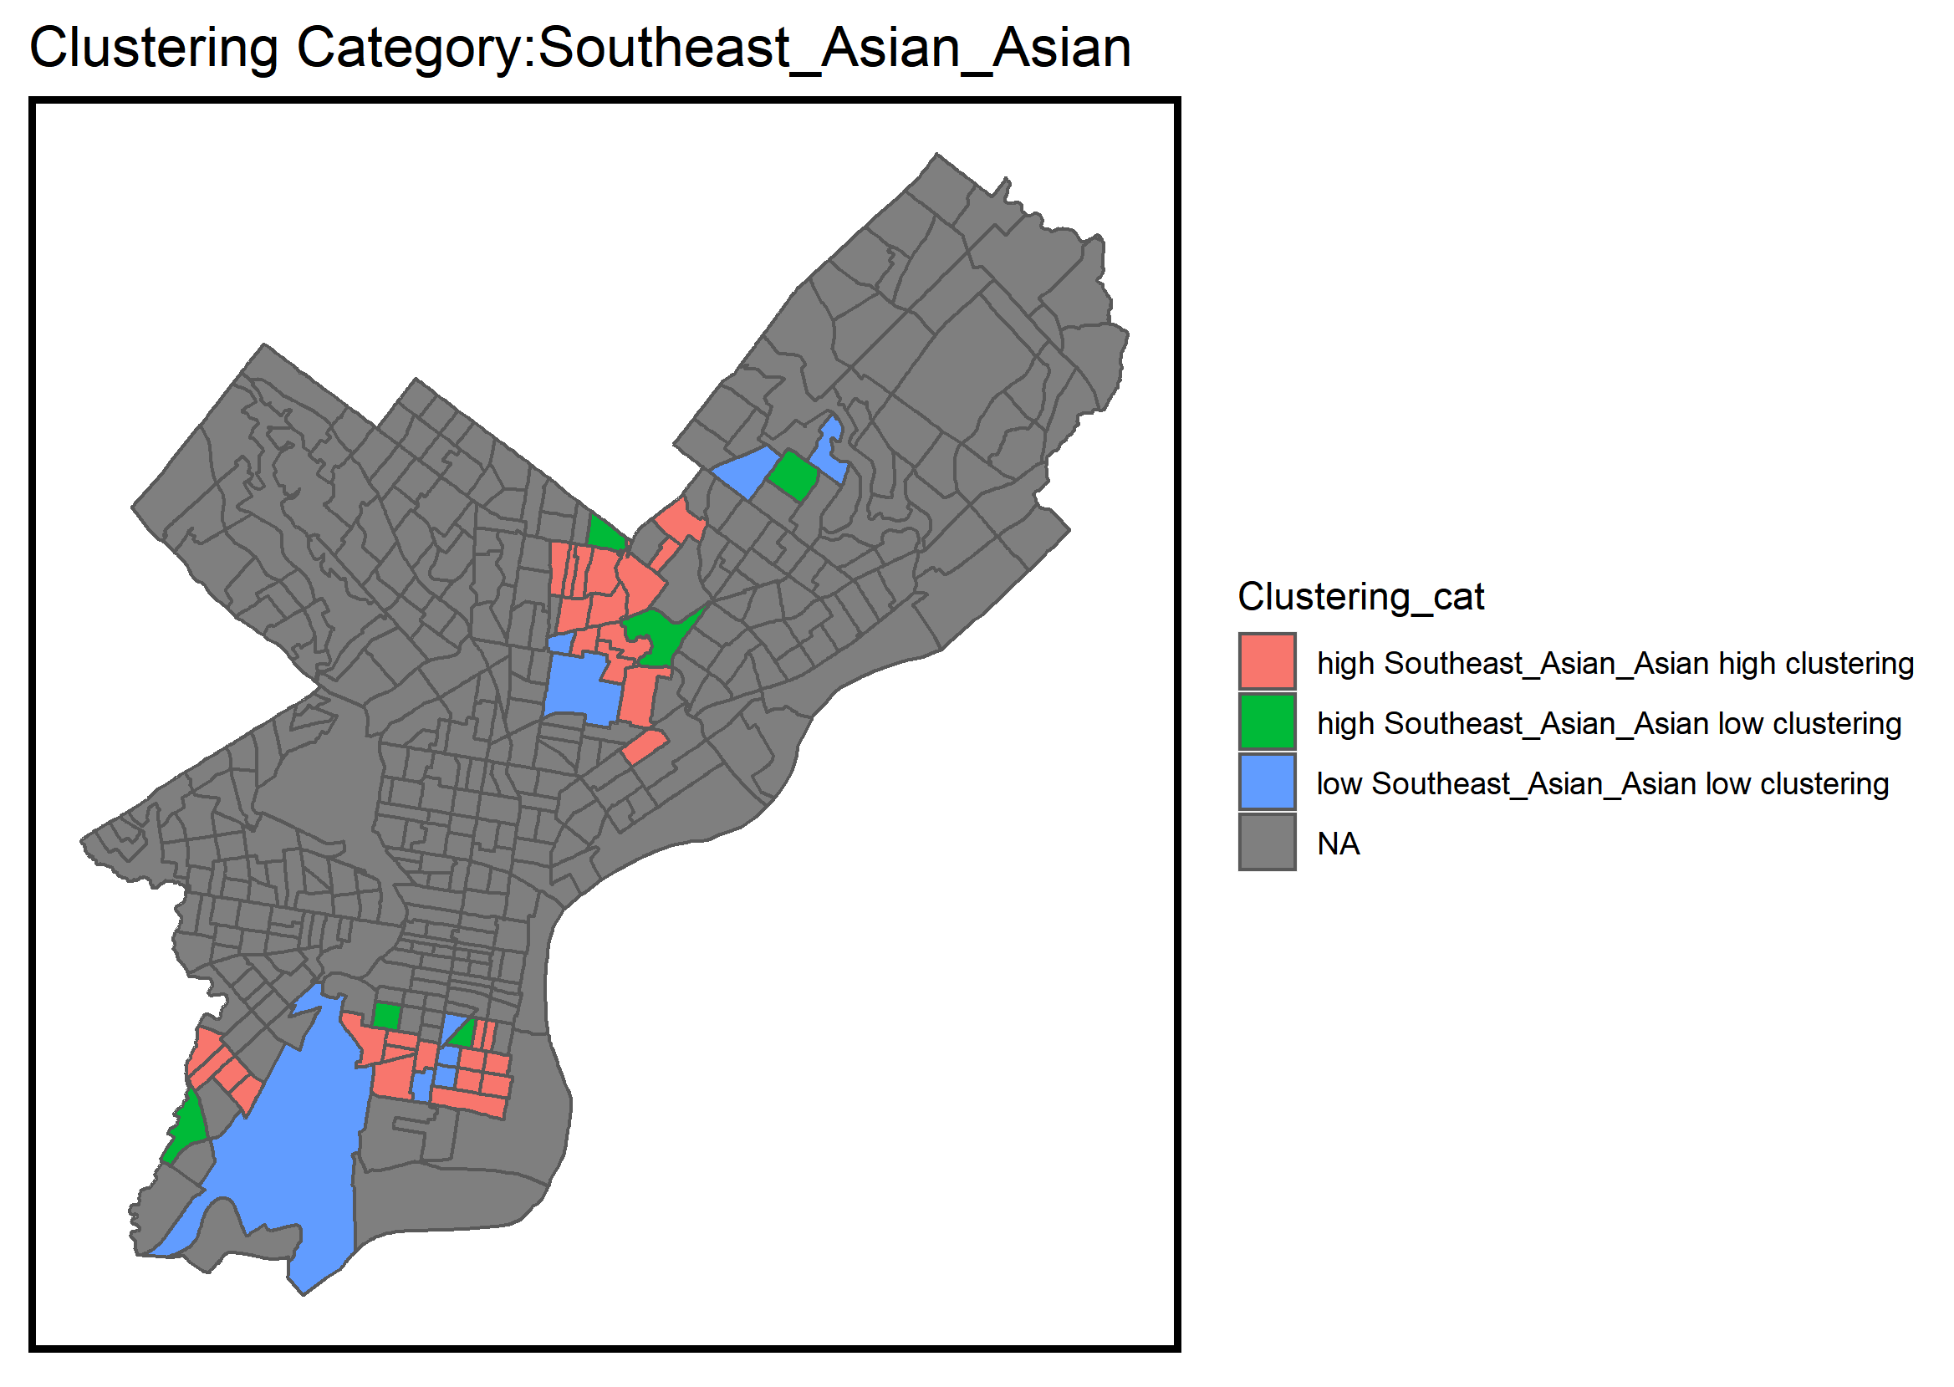

Figure 3. Clustering of Southeast Asians

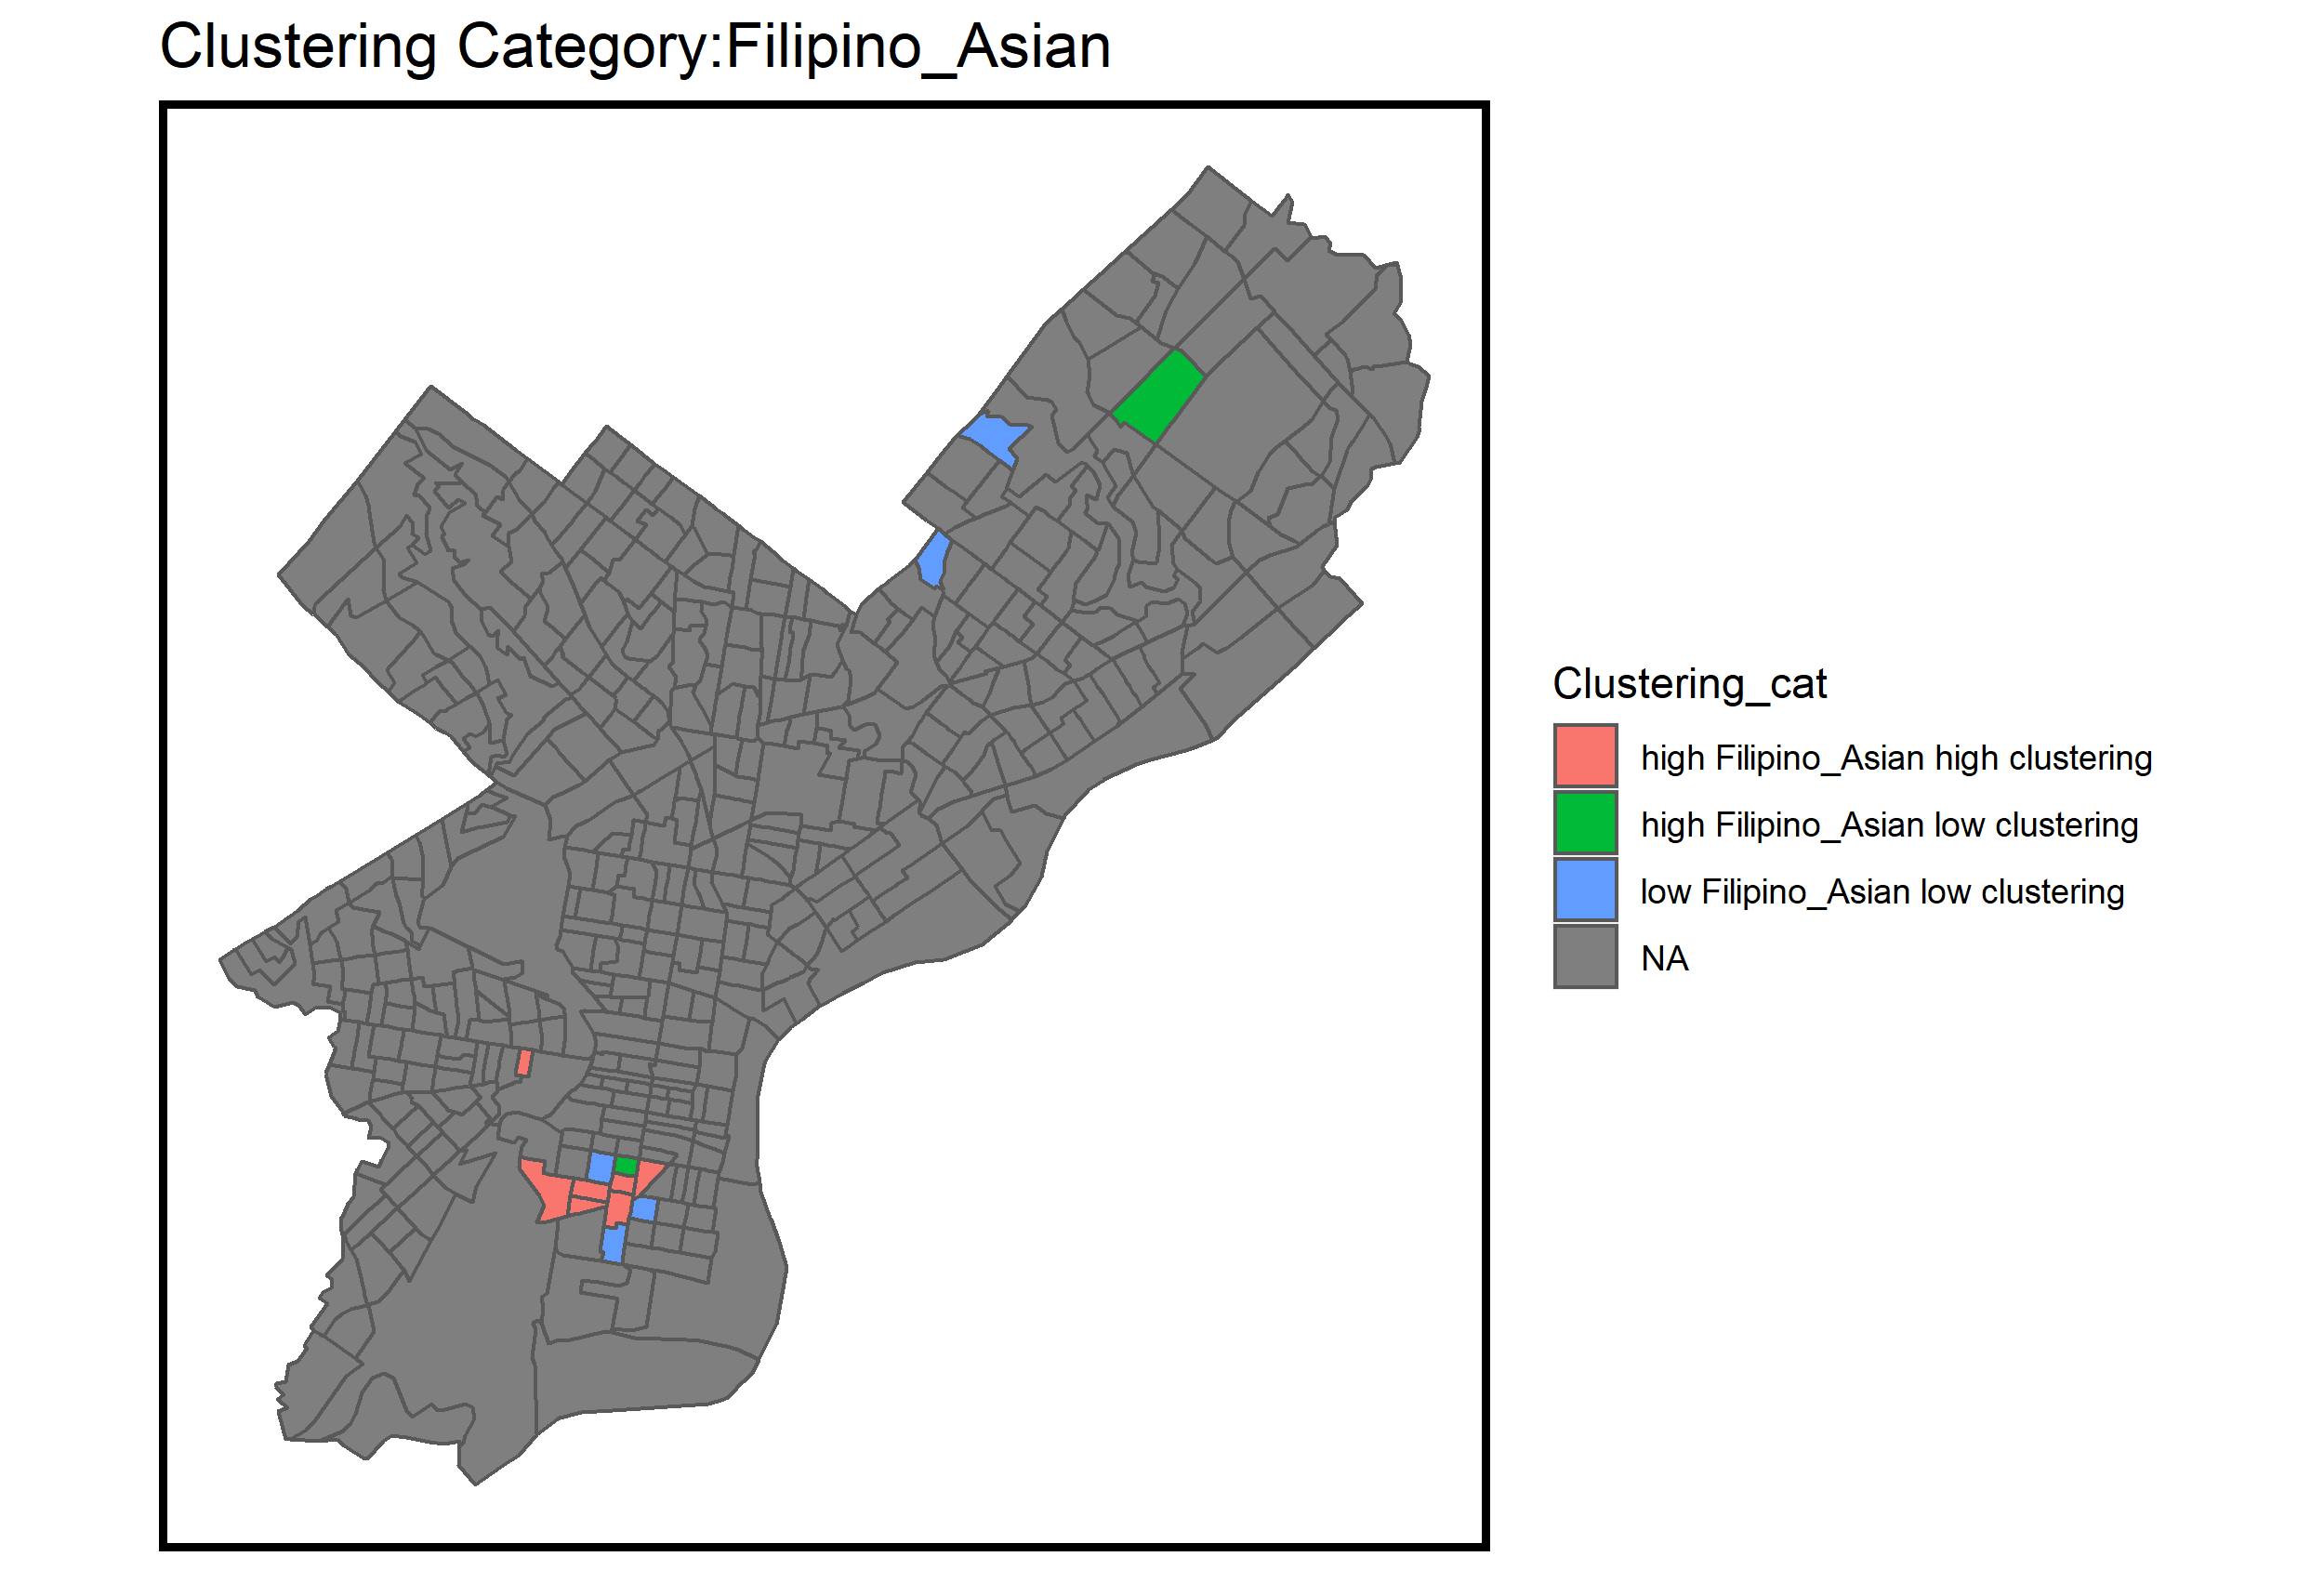

Figure 4. Clustering of Filipinos

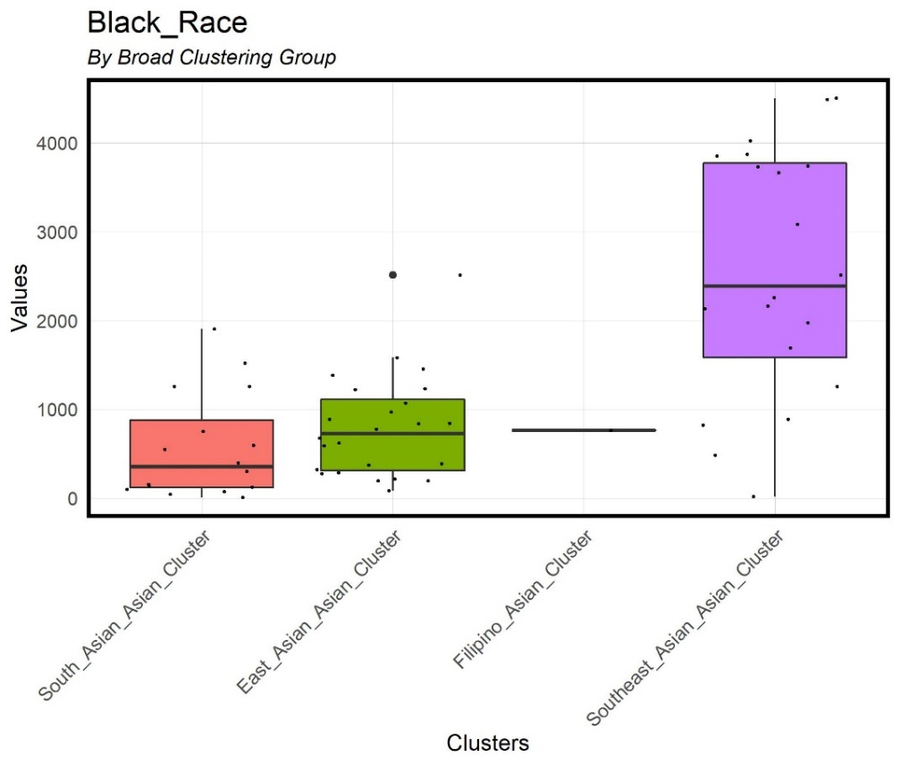

Figure 5. Box plot of Black population by cluster

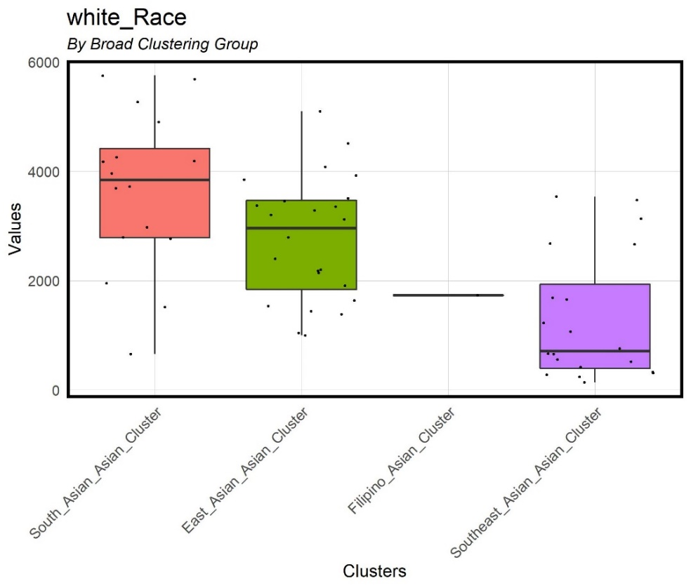

Figure 6. Box plot of White population by cluster

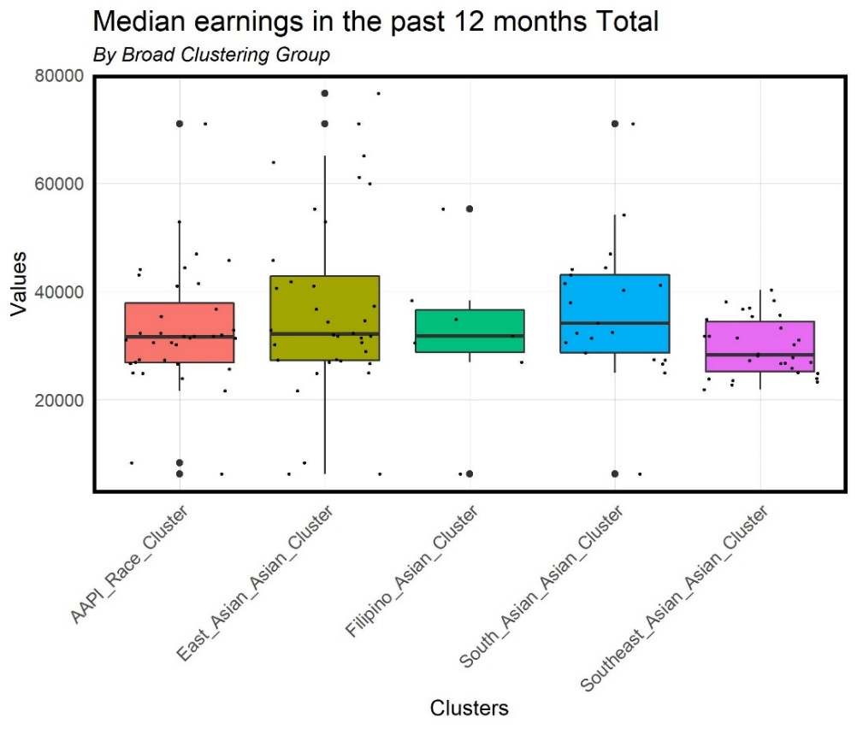

Figure 7. Box plot of median earnings by cluster

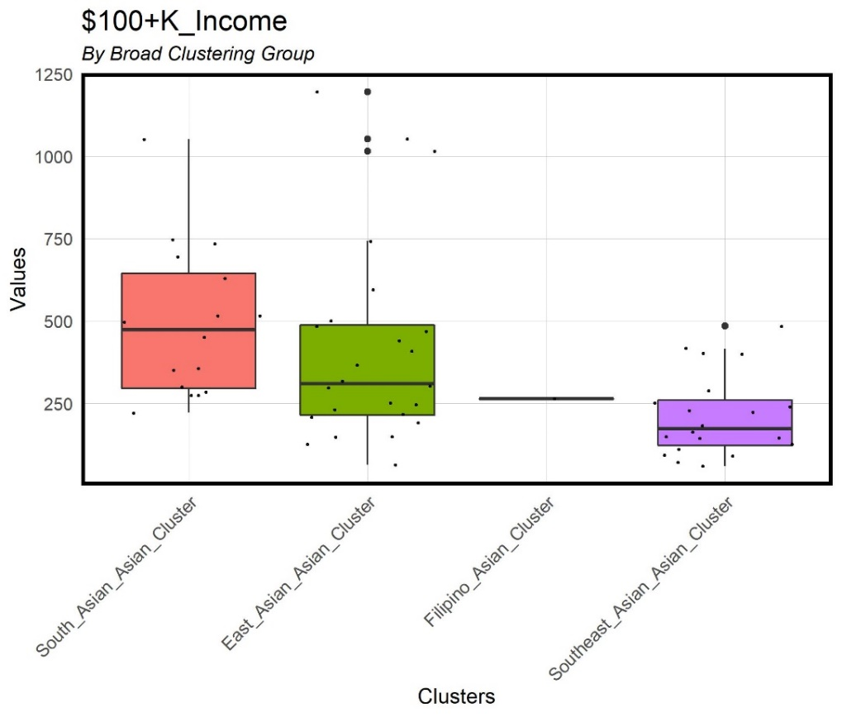

Figure 8. Box plot of $100k income by cluster

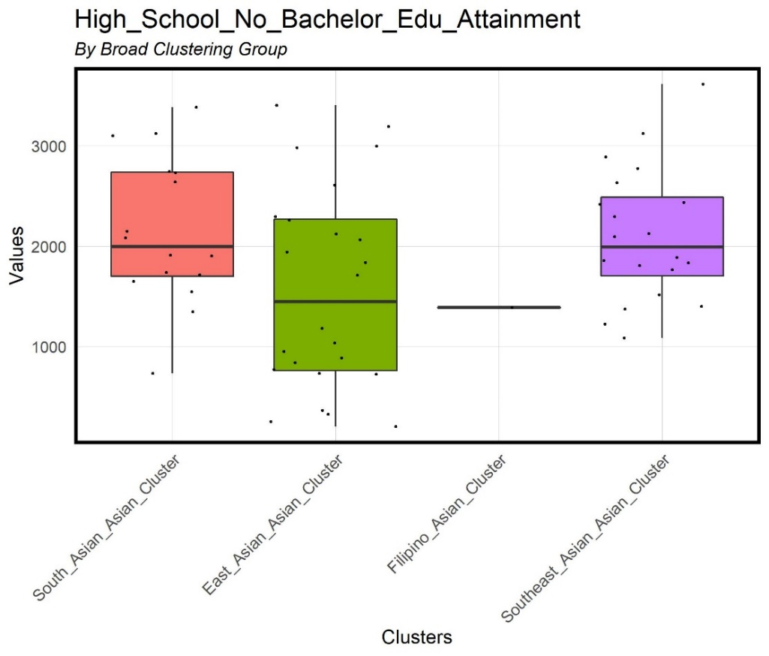

Figure 9. Box plot of High School attainment

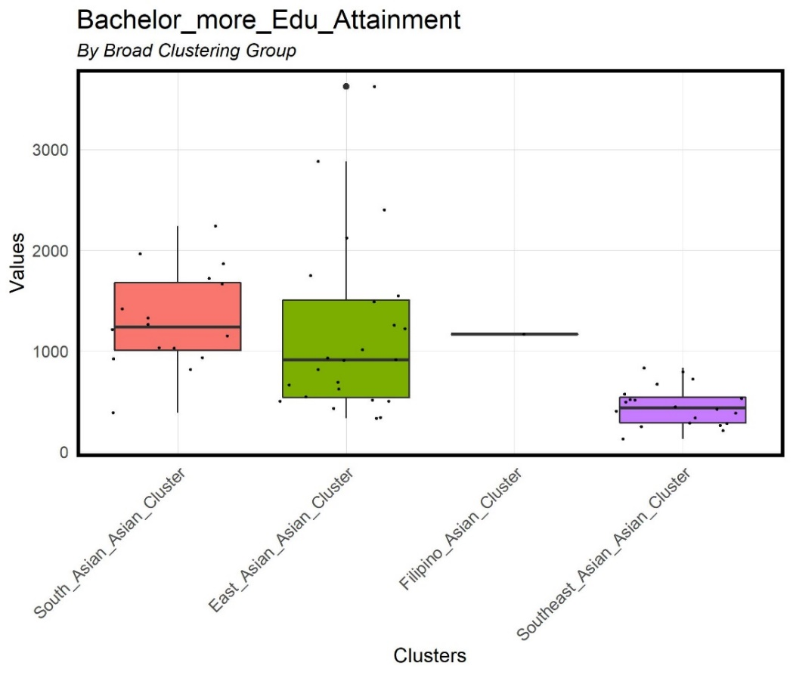

Figure 10. Box plot of Bachelor attainment by cluster