**Mid-point Draft**

Pokémon players currently locate themselves by switching back and forth between Pokémon Go game and Google Map, when they are not very familiar with their location. In that case, they will hardly know where to go to catch Pokémon safer and faster. So, I want to build an interface for the players to locate themselves and find their way to the best place to catch Pokémon.

I have done almost all the data acquiring and wrangling part except for the Pokéstops data. I got some problem when doing web scraping but I will figure it out, because at least, the last way of fetching the data is to copy it manually. For the analysis part, I have done cutting Philadelphia into 500 feet fishnet and get all the centroid of the grid as destination. Geospatial statistics have already realized for the destination by setting a buffer zone and counting the number of crimes, drink, food and bus stops. Also, I have already realized getting the shortest path between two points depend on the road network through OMS.

Then I will show some images to give an intuitive feeling.

This image is the destination point I set for the project. It’s the center of all fishnet grid.



This is a map of a factor in my analysis. I count the total crime from 2017-2021 in a 500 feet buffer zone of each destination.

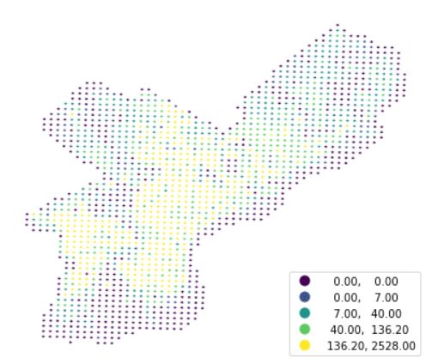

The image below is the result so far. According to the current influencing factors, if the starting point is given, the best ending position can be analyzed and a reference route can be given. Although it is difficult to see the specific path on this picture, it will be very clear when it can be enlarged in the formed web page.

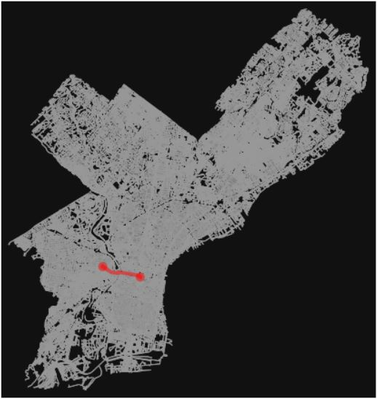

The next step for me will be solving the issue of web scraping, adding the Pokéstops data into my analysis part, implementing the analysis on the destination point and then integrating the results with the algorithm for the shortest path. The HTML part will also start soon.