IRIS data set

Background
In statistics there are a number of classical data sets which are used to test different methods and algorithms. IRIS is one of these historical data sets and has its origins in botany.

Objective
In this exercise you will make overview models of a full data set. You should be able to interpret loading plots in terms of the variables that contribute to patterns in the corresponding score plots.

Data
The data set contains petal (NL: bloemblad) and sepal (NL: kelkblad) lengths and widths of 50 specimens each of Iris setosa, Iris versicolor and Iris virginica. The great statistician Fisher introduced this data set as early as 1936. It is commonly known as "The Fisher Iris Data" (see below for table header and the first ten observations).

Table 1: First 10 observations of The Fisher Iris Data.
Primary ID | Species | Sepal.Length | Sepal.Width | Petal.Length | Petal.Width
1 | setosa | 5.1 | 3.5 | 1.4 | 0.2
2 | setosa | 4.9 | 3 | 1.4 | 0.2
3 | setosa | 4.7 | 3.2 | 1.3 | 0.2
4 | setosa | 4.6 | 3.1 | 1.5 | 0.2
5 | setosa | 5 | 3.6 | 1.4 | 0.2
6 | setosa | 5.4 | 3.9 | 1.7 | 0.4
7 | setosa | 4.6 | 3.4 | 1.4 | 0.3
8 | setosa | 5 | 3.4 | 1.5 | 0.2
9 | setosa | 4.4 | 2.9 | 1.4 | 0.2
10 | setosa | 4.9 | 3.1 | 1.5 | 0.1

Exercises
Read the data into SIMCA using “File”, “New Regular Project” and select the file iris.csv. A window will show you a table with your data (see figure 1). Simca tries to select a primary ID for the observations (rows) and variables (columns). In this case it selected the column ID as primary ID for the observations and the first rows as primary ID for the variables.
Simca also selected the column Species as secondary ID. Secondary ID’s can later be used for annotations or coloring in plots.

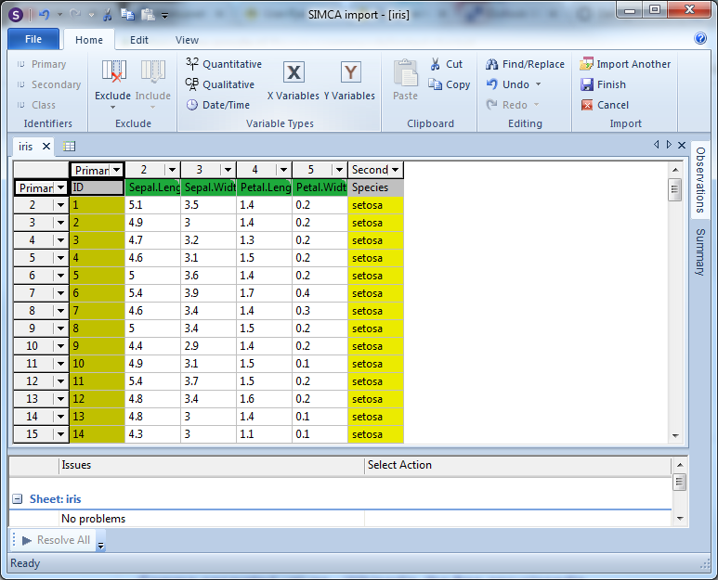
Figure 1: Importing data
- Click “Finish” in the ribbon tab “Home” to continue
- Select a filename and location to save your project

Create a PCA model by clicking on the button “Autofit” in the “Home” ribbon tab. SIMCA now tries to calculate a PCA model following certain quality rules. It will determine automatically the optimal number of principal components do describe your data.
If SIMCA doesn’t return a model, click on the button “Two First” in the “Home” ribbon tab. SIMCA will now always calculate a PCA model with 2 principal components (PC’s).
After fitting a model (“Autofit” or “Two First”) Simca will show you a “Summary of Fit”. If you close this screen and you want to get it back click on the “Summary of Fit” button in the “Home” ribbon tab.

Have a look at the summary of fit.
- What are the R2cum and Q2cum values of your model and what do these numbers tell you? Can you say something about the quality of the model?
- If you would force SIMCA to calculate more principal components how many components it will be able to calculate and why?

In the “Home” ribbon tab click on the “Scores” button to generate a scores plot. Have a look at the score plot.
- What does the score plot show you?
- In the score plot you can see 2 clusters. What do these clusters represent?
- Are there really 2 clusters or are there more?
TIP:
Add some more color to the scores plot. Right mouse click on the scores plot. Go to “Properties”. Go to tab “Color”.
- Coloring type select “by Identifiers”.
- Choose the ID to color by: select “Obs ID (Species).
- click “Ok”.

In the “Home” ribbon tab click on the button “Loadings” to generate a loadings plot. Have a look at the loadings plot.
- What does the loading plot show you?
- With the help of the loading plot can you explain what is causing the clusters in the score plot? Or in other words, what is the difference between the flowers?
TIP:
Double click on an Observation or Variable to see their behavior.

The PCA model containing the data of the 3 flowers doesn’t show a clear difference between Versicolor and Virginica. Maybe we can the difference more distinct if we remove the Setosa observations.
TIP:
To remove observations, first select the observations you want to remove.
- Left mouse click in the scores plot and hold. You can now draw a line around the observations you want to remove.
or
- In the legend click on the group of observations you want to remove. In this excersise click on Setosa.

Observations which are selected are highlighted in red. To remove them click on the button “Exclude” in the “Marked items” ribbon tab. A new model is created!

Click “Autofit” to calculate the PCA model.

- How many components did SIMCA calculate? How is the quality of the model?
- Can you see a more distinct difference between Versicolor and Virginica?

Sometimes SIMCA only calculate 1 principal component. Often a second component is added manually to get score / loadings plot which are easier to interpret.
- Looking at the scores / loadings plots, can you explain what is causing the difference between Versicolor and Virginica?

If you can not use a multivariate approach to see the differences between the flowers, how would you approach the problem?

Food data set

Background
Data were collected to investigate the consumption pattern of a number of provisions in different
European countries. The purpose of the investigation was to examine similarities and differences
between the countries and the possible explanations.

Objective
You should be able to explain why there are groupings in the plots. Data characteristics that
differentiate Portugal and Spain from Sweden and Denmark should be discussed.

Data
The data set consists of 20 variables (the different foods) and 16 observations (the European
countries). The values are the percentages of households in each country where a particular product
was found. For the complete data table, see below. This table is a good example of how to organise
your data.

Table 2: Table showing part of the Food data set.
Primary ID | Country | Geographic Location | Capitol Latitude | Ground Coffe | Instant Coffe | Tea | Sweetner | Biscuits | Powder Soup
1 | Germany | C | 3 | 90 | 49 | 88 | 19 | 57 | 51
2 | Italy | S | 1 | 82 | 10 | 60 | 2 | 55 | 41
3 | France | C | 2 | 88 | 42 | 63 | 4 | 76 | 53
4 | Holland | X | 3 | 96 | 62 | 98 | 32 | 62 | 67
5 | Belgium | X | 3 | 94 | 38 | 48 | 11 | 74 | 37
6 | Luxembou | X | 2 | 97 | 61 | 86 | 28 | 79 | 73
7 | England | U | 3 | 27 | 86 | 99 | 22 | 91 | 55
8 | Portugal | S | 1 | 72 | 26 | 77 | 2 | 22 | 34
9 | Austria | C | 2 | 55 | 31 | 61 | 15 | 29 | 33
10 | Switzerl | C | 2 | 73 | 72 | 85 | 25 | 31 | 69
11 | Sweden | N | 4 | 97 | 13 | 93 | 31 |  | 43
12 | Denmark | N | 4 | 96 | 17 | 92 | 35 | 66 | 32
13 | Norway | N | 4 | 92 | 17 | 83 | 13 | 62 | 51
14 | Finland | N | 5 | 98 | 12 | 84 | 20 | 64 | 27
15 | Spain | S | 1 | 70 | 40 | 40 |  | 62 | 43
16 | Ireland | U | 3 | 30 | 52 | 99 | 11 | 80 | 75

Exercises
Read the data into SIMCA using “File”, “New Regular Project” and select the file foods.xls.
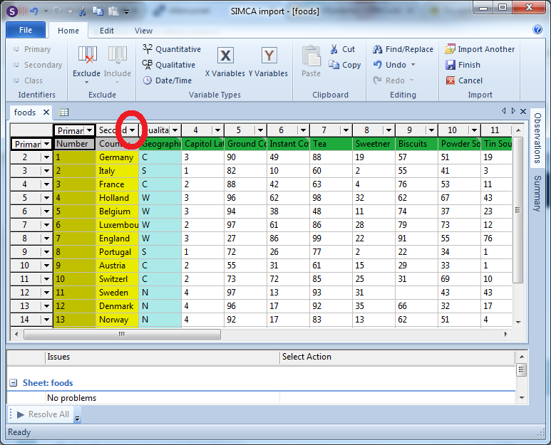
Figure 2: Import foods dataset.
Set the columns “Country”, “Geographic Location” and “Capital Latitude” to Secondary ID by clicking on the small triangle in the column header.

- Click “Finish” in the ribbon tab “Home” to continue.
- Select a filename and location to save your project.

Create a PCA model by clicking the button “Autofit”. SIMCA now tries to calculate a PCA model following certain quality rules. It will determine automatically the optimal number of principal components to describe your data.
- How many components did SIMCA calculate? What can you say about the quality of the model?
Have a look at the scores / loadings plot.
- Are there clusters present in the scores plot?
- What “food” is causing this clustering?
TIP:
Change the colors and labels of the points in the scores plot.
Right mouse click on the scores plot. Go to “Properties”. Go to tab “Label Types”.
- Use label select “Obs ID (Country)”.
- click “Ok”.

Compare PC1 vs PC3.
TIP:
Right mouse click on the scores plot. Go to “Properties”. Go to tab “Scores”. Select in the column “Comp” on row “Series” 3.
- Click “Ok”

- What is separating England and Ireland from the rest?
- How does their Garlic and Olive oil intake compare to the rest of Europe?
(HINT: double click on a country or food)

If you can not use a multivariate approach to see the difference, how would you approach the problem?

NMR Metabolomics

Background
A gene encoding MYB transcription factor, with unknown function, PttMYB76, was selected from a
library of poplar trees for metabolomic characterization of the growth process in Poplar trees.
The PttMYB76 gene is believed to affect different paths in the phenyl propanoid synthetic pathway. This pathway leads to the formation of S- and G-lignin, flavonoids and sinapate esters. Milled poplar samples collected at the internodes of the tree were analysed using NMR spectroscopy.
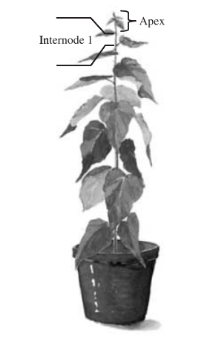
Figure 3: Poplar plant response vector (internodes). A poplar plant
illustrating the growth- or time-related response vector y, i.e. the
internode direction of the tree. The top of the plant (apex) was removed
prior to sampling.

Prior to sampling, the stem of the trees was divided into internodes, where each internode is located in between two subsequent leaves on the stem (Figure 6). Samples were collected from 12-week-old plants of poplar tree (Populus tremula L. x tremuloides Michx.) WT (clone T89) and one line (line 76V) of transgenic poplar plants expressing the 3′-part of the PttMYB76 gene in antisense orientation (n = 3). The sampling started at internode 1 (top of the tree) and ended at internode 8. Six trees were used in total, three of each genotype (WT and PttMYB76 modified), yielding a total of 46 samples, as two of the internodes were missing. Before sampling, the apex was removed.

Data
In total, the data set contains N = 57 observations, 6 trees divided into segments of 8 by the internode of the tree plus analytical replicates and K = 655 variables (1H-NMR chemical shift regions bucket with 0.02ppm). The internode represents the growth direction of a plant. Internode 1 is the top of the plant and 8 is the bottom. The observations (trees) are divided in two groups (“classes”):
- MYB76 poplar plant (Ai, Bi, Ci)- Class 1
- Wild type Poplar plant (Di, Ei, Fi)- Class 0
The name settings A, B, C corresponds to MYB76 plants and D, E, F to the wild type (control) plants.
The i after the letter corresponds to the internode number of the plant.

Objective
The objective of this exercise is to shed some light on how PCA and PLS-DA may be used in Metabolomics. In particular, the objectives are to:
- Demonstrate how to analyze metabolomics data from two sets of samples representing one control group and one treated group
  - Using PCA to review data, identify patterns and trends
- Demonstrate how to identify differences and putative biomarkers in different sample groups and compare the strength of PLS-DA compared to PCA
- Describe the model diagnostics of an PLS-DA model

Exercises
Read the data into SIMCA using “File”, “New Regular Project” and select the file metabolomics.xlsx. Only import Sheet1. Set the column “Class” to “Class ID”.

Simca will suggest to make PCA-Class models, but we will first start with PCA. Change the model type to PCA-X by clicking on “Change Model Type” in the “Home” ribbon tab.
Set the scaling to “pareto scaling” :
- Edit the model by right clicking on the model and select “Edit model 1”.
- Go to “Scale” tab.
- Select all variables
- “Set Scaling Type” to Par and click on “Set”
- Click “Ok”

Scaling
No scaling. Variables often have substantially different numerical ranges. A variable with a large range has a large variable, whereas a variable with a small range has a small variance. Since PCA is a maximum variance method, it follows that a variable with a large variance is more likely to be expressed in the modeliling than a low-variance variable.
Unit variance (UV) scaling, is commonly applied and uses the standard deviation as the scaling factor. After UV scaling, all variables have a standard deviation of one and therefore all variables become equally important. The data is analyzed on the basis of correlations instead of covariances.
Pareto (Par) scaling is very similar to autoscaling. However, instead of the standard deviation, the square root of the standard deviation is used as the scaling factor. Now, large variances are decreased more than small variances, thus the large variances will be less dominant compared to
original data.
Pareto scaling is an intermediate scaling between no scaling and UV scaling.

Create a PCA model by clicking the button “Autofit”. SIMCA now tries to calculate a PCA model following certain quality rules. It will determine automatically the optimal number of principal components to describe your data.

- How many components did SIMCA calculate? What can you say about the quality of the model? Are there any outliers which should be removed?

Have a look at the model. (TIP: double click on scores and loadings to get more information)
- Are there clusters and/or trends present in the score plot?
- What variables are causing what (primary ID name of the variable)?
- For each class, what causes the most variance? And 2nd?
- Do you think you can make a decent PLS-DA model, based on what you observed here?

Before we will do a PLS-DA model we need to check if the classes are homogeneous and spread significantly in the X-space. Perform a PCA-Class. Click “New As” and select model M1. Change the model type for M2, with “Change Model Type” to PCA-Class. Select model CM1 and click “Autofit”. Click “OK” to use autofit on both PCA-class models.

Have a look at the models.
- Are there clusters and/or trends present in the score plot?
- What variables are causing what (primary ID name of the variable)?
- For each class, what causes the most variance? And 2nd?
- Are there any outliers which should be removed?
- Do you think you can make a decent PLS-DA model, based on what you observed here?

Create a PLS-DA model by clicking on “New As” and select model M1. Change the model type for M4, with “Change Model Type” to PLS-DA. Click “Autofit” to calculate the PLS-DA model.

- How many components did SIMCA calculate? What can you say about the quality of the model?
- How much do you trust the model?
- Can you see trends/clusters which you saw in the PCA-class models in the PLS-DA model?

Compare PCA to PLS-DA.
- In what way you can get “better” information?
- Why is it easier to find the important information in PLS-DA?

