IRIS data set

Answers
- What are the R2cum and Q2cum values of your model and what do these numbers tell you? Can you say something about the quality of the model?

R2cum = 0.96 (2nd component), Q2cum = 0.74 (2nd component). With just 2 components already approx. 95% of your data is described. The high Q2 value means that the model is very good (in metabolomics a Q2 of approx. 0.5 is good). It describes the data accurately. Q2 is calculated by cross validation. 1/7th of the observations are left out. With the remaining observations a new model is build. The 1/7th left out are now predicted with this model. This is done until all samples are left out once. The distance between the prediction and the original model determines Q2. The higher the Q2 value the closer the prediction is to the original model.
Just using R2 and Q2 to describe or judge the quality of the model is not enough. You can only say something about how much data is described by the model and the predictibility. You can not say anything about possible outliers.

- If you would force SIMCA to calculate more principal components how many components it will be able to calculate and why?

Simca stops at 4 components. Looking at the summary of fit, the R2cum for the fourth component is 1. This means that the model describes all your data. There is no more data left to model.
The maximum number of components you can calculate is the numbers of variables or the number of observations – 1, whichever is the smallest.

- What does the score plot show you?

A summary of the samples. Which samples differ from each other and which samples are more similar.

- In the score plot you can see 2 clusters. What do these clusters represent?
One cluster are only Setosa and the other cluster are Virginica and Versicolor

- Are there really 2 clusters or are there more?

After coloring the scores by Species you can see that there is also some separation between Virginica and Versicolor. You could say there are 3 clusters.

- What does the loading plot show you?
The loadings plot is a summary of the variables. You can use the loadings plot to describe the separation in scores plot (i.e. which variables are causing this separation/have the most influence on this separation).

- With the help of the loading plot can you explain what is causing the clusters in the score plot? Or in other words, what is the difference between the flowers?

If you look at each variable.
  - Petal width and length are smaller in Setosa than in Virginica or Versicolor.
  - Sepal length is smaller in Setosa than in Virginica or Versicolor.
  - Sepal width is in the species Setosa larger than in Virginica or Versicolor.
Looking at the absolute value of PC1. Petal width and length have the most influence on the separating Setosa from Virginica and Versicolor.

Looking at the variable plots the biggest difference is visible for the variable plots petal length and width.

The PCA model containing the data of the 3 flowers doesn’t show a clear difference between Versicolor and Virginica. Maybe we can the difference more distinct if we remove the Setosa observations.
- How many components did SIMCA calculate? How is the quality of the model?
1 principal component is calculated. Approx. 74% of the data is described with just one component. The predictability is 0.52, which is quite good considering there is only 1 component calculated.

- Can you see a more distinct difference between Versicolor and Virginica?
Looking at the score plot, there is still quite some overlap.
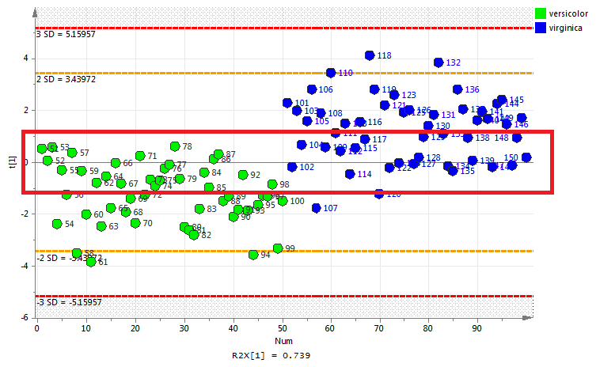

- Looking at the scores / loadings plots, can you explain what is causing the difference between Versicolor and Virginica?
With just one component it is maybe a bit more difficult to see, but the variables with the highest value for PC1 are the one which are the most important. Petal length, petal width and sepal length are the 3 most important variables.
In the variable plot you can see that there is overlap between the two groups, even for sepal length albeit small.

- If you can not use a multivariate approach to see the differences between the flowers, how would you approach the problem?
There are a few options :
  - one-way anova per variable
  - t-test per variable for 2 groups and use multiple testing correction for multiple tests you do.

Food data set

Answers
- How many components did SIMCA calculate? What can you say about the quality of the model?
Simca calculated 3 principal components. The model describes approx. 65% of the data. The Q2 is quite low 0.14. This means the model doesn’t describe the model accurately.

- Are there clusters present in the scores plot?
When you color the scores plot according to geographical location you can see that the Northern European countries are a little bit a way from the rest. Also the Southern European countries (incl. Austria) are a little bit a separated from the other countries. You could say there are three clusters.
  - North Europe (Finland, Norway, Denmark and Sweden)
  - Sourth Europe (Portugal, Italy, Spain and Austria)
  - The rest
- What “food” is causing this clustering?
In the scores plot the Northern European countries are in the upper right quadrant. In the loadings plot the variables (food) in the upper right quadrant are the ones which are consumed the most in the Northern European countries. The further away from the origin (0, 0) the more they are consumed.
  - Frozen fish, frozen vegetables, crisp bread are consumed more in North Europe than in the rest of Europe (see variable plots).

- If you look at the bottom left quadrant of the loadings plot. Olive oil and garlic are almost not consumed in the Northern European countries. The further away these variables are away from the origin, the less it is consumed in the Northern European.

Compare PC1 vs PC3.
- What is separating England and Ireland from the rest?
At a first look one would expect that jam, tea and tinned soup are causing this difference. But if you look more careful you can see that England and Ireland are separated from the rest in the PC3 direction (y-axis). If you take this to the loadings plot then grounded coffee has a bigger influence. Below the comparisson of the variable plots grounded coffee and jam (the most right bar is Ireland).
- How does their Garlic and Olive oil intake compare to the rest of Europe?
Ireland and England are one the countries which consume the least garlic. Their olive oil intake is about average.

- If you can not use a multivariate approach to see the difference, how would you approach the problem?

NMR Metabolomics

Answers
- How many components did SIMCA calculate? What can you say about the quality of the model? Are there any outliers which should be removed?
Simca calculated 7 principal components. From the R2 we can see that approx. 85% of the data is described by the model. The Q2 is 0.71 which means the predictability of the model is very good. For the outliers we look at the DmodX (moderate outliers) and Hotteling’s T2 (strong outliers). In the DmodX plot we can see a few samples above the critical value. A rule of thumb to classify them as outlier is that they need to be at least 2 times above the critical value. However, it can still be good idea to have a look at the raw data of these samples to check if nothing strange happened during the data pre-processing.
In the Hotteling’s T2 plot all sample are below the 99% critical value line.

Have a look at the model.
- Are there clusters and/or trends present in the score plot?
If you color the scores according to the class id you can see two clusters. They are not fully separated but there are clearly two clusters in the PC2 direction (y-axis direction). This means that the most class id is not the cause of the most variance in the data, otherwise the class separation would be in the PC1 direction. If you look more closely the segment is causing the separation in the PC1 direction. The top of the plant (segments 1-3) are more on the left side of the scores plot, while the bottom part of the plant (segments 6-8) are more on the right side, especially for class id 1 (MYB76). For class id 0 (wild type) this is less pronounced.
- What variables are causing what (primary ID name of the variable)?
If you look at the scores and loadings plot below the black line in the scores plot more or less shows where the separation is between the two classes. The same line is dropped on top of the loadings plot. The most interesting parts of the loadings plot are the bottom right and upper left quadrant.
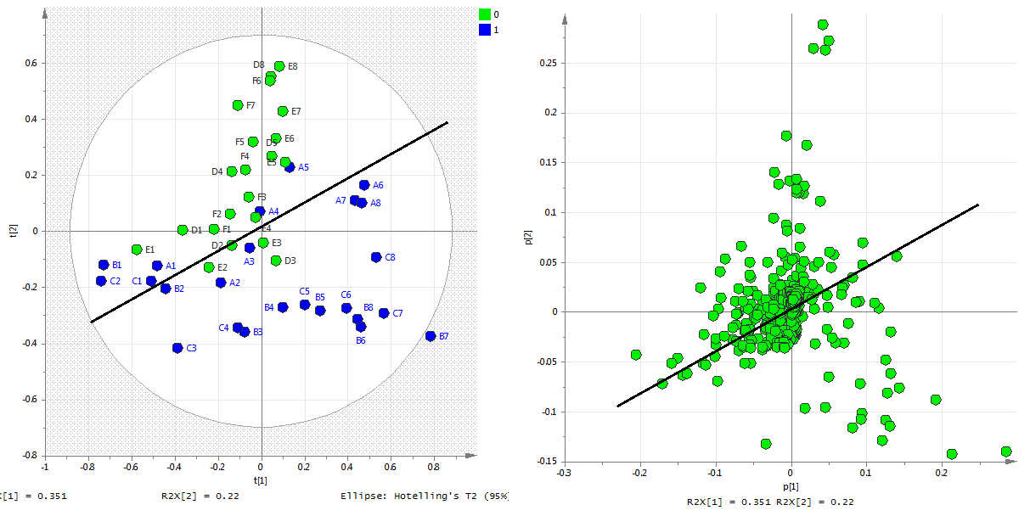
We’ll first have a look at the bottom right quadrant. From the black line we can see that the class separation is somewhere between the PC1 and PC2 direction. The most interesting variables are the ones which have a high absolute value for PC1 and PC2. Here the two variables with ID 3.82122 and 3.84135 are the most interesing. A variable plot is shown below.

On average there is a difference between the two classes. However, some samples from class 1 show a value similar to class 0. This could be a bucketing (binning) problem. We would need to check the raw data for this.
Because there are no variables far from the origin in the upper left part of the loadings plot we will focus on the 4 variables close to the PC2 axis in the top of the loadings plot. These four variables are also very important for the separation between the classes. Variable id’s are: 2.45239, 2.15044, 2.47252 and 2.13031. Variable plots for the first two are shown below.

Here you can see the same problem as in the 2 previous variable plots. It is a good idea to check the raw data to make sure there is no issue with the bucketing.
A second possibility (maybe even more likely) is that not all the segments are equal. For all interesting variables the “strange” behaviour is from the segments from the top of the plant. It could be that there is quite a big difference between the bottom and the top of plant which is causing this difference.

- For each class, what causes the most variance? And 2nd?
This is not that obivious to see.
For both classes the segment of the plant is causing the most variance. In class 1 this is very clear to see in class 0 this is much less obvious. In class 0 this is mainly in PC2, so the 2nd most variance.
In class 1 the 2nd most variance seems to be the different plant. Plant A seems to behave different from plant B and C.
A PCA-class model would be better to judge this.
- Do you think you can make a decent PLS-DA model, based on what you observed here?
Yes, if a PCA model already describes a class separation with the first two principal components a good PLS-DA can be made, because the most variance in X is the difference in class which in PLS-DA is the Y-variable.

Calculate a PCA-Class model. Have a look at the models.
We are calculating a PCA-class model to have a look at the separate classes. For a good PLS-DA model there should be no clusters/trends in the separate classes present.
- Are there clusters and/or trends present in the score plot?
First class 0:
In the score plot there are no clusters vissible, but you can see that in the PC1 direction (x-axis) there is trend visible based on the segment of the plant. From left to right you go from the top of the plant to the bottom (left scores plot the samples are labeled according to the segment). In the PC2 direction there is a small trend based on which plant. Below the x-axis more samples from plant D, above the x-axis more samples from plant F.

Class 1:
In the scores plot there is a cluster vissible. Plant A is in the PC2 direction quite different from plant B and C, escpecially for the lower segments. In the PC1 direction there is a similar trend vissible as for class 0. The top of the plant is on the left side and the bottom of the plant on the right side of the scores plot.
- What variables are causing what (primary ID name of the variable)?
Class 0:
The variable id’s 2.45239, 2.15044, 2.47252 and 2.13031 are mainly responsible for the trend in segment of the plant. A variable close to the PC2 axis and a high absolute value for PC2 is mainly responsible for the trend of which plant (albeit a small trend).
Class 1:
The variable id’s 3.82122, 3.84135, 3.64005 are mainly responsible for the trend in segment of the plant. Showing the variable plots of the undelined variables.
The clustering on which plant is in the PC2 direction, so variables with a high absolute value of PC2 are the most interesing ones. Below showing the variable plot of variable id 3.41862.
There are several more, but they all show the same. Plant A is different from B and C. Maybe something happened with plant A. You could try to leave plant Aout of the analysis.
- For each class, what causes the most variance? And 2nd?
See answer in the first question.
- Are there any outliers which should be removed?
Have a look at the DmodX and Hotteling’s T2 plot. No samples far above the critical value.
- Do you think you can make a decent PLS-DA model, based on what you observed here?
I think you can still make a decent PLS-DA model. There are some small trends present in both classes, but they are not really big trends or clusters. Even the clustering plant A vs B and C is not extreme.

PLS-DA model.
- How many components did SIMCA calculate? What can you say about the quality of the model?
Simca calculated 5 components. The model describes approx. 97% of the Y-data and 77% of the X-data. The Q2 is 0.952 which is extremely good. Looking at the DmodX and Hotelling’s T2 plot there are no outliers. All this indicates that the quality of the model is good!
- How much do you trust the model?
To answer this we would need to look at the scores plot vs the cross validate scores plot and the permutation test.
Because our data has much more variables than observations (samples) there is a risk of overfitting. This means that the model will always find a separation between the classes (remember the random data model). Instead of looking at the scores plot we will have a look at the cross validated scores plot. The cross validated scores plot shows a nice class separation, meaning we didn’t model a lot of noise. Left normal scores plot, right cross validate scores plot.

The permuation test is a second quality control.
The permuation test shows some overfitting. For the permutated model there is still quite a high R2. More importantly the Q2 values for the permutated models are really bad. This means we are not modeling noise.
I trust this model very much!

- Can you see trends/clusters which you saw in the PCA-class models in the PLS-DA model?
In class 1 you can still see the trend of segment of the plant, but also plant A is more at the bottom of the class 1 cluster. In the class 0 cluster there is a little trend vissible based on the segment of the plant (from left to right).

Compare PCA to PLS-DA.
- In what way you can get “better” information?
The class separation is now the most important varaince. The model shows now the variable responsible for the class separation as the most imporant ones!
Loadings plot colored according to VIP value.
The most important variables (top 5) are : 3.82122, 3.68031, 2.45239, 3.84135 and 2.43226
Looking at the variable plot, these variables show the segment trend!! If you compare these variables to the ones found in the PCA and PCA-class they are the same.

- Why is it easier to find the important information in PLS-DA?
Because the model is not looking only at the most variance in the X-data, but also takes the Y variable (in this case the class id) into account. But be carefull, underlying trends in the classes can influence the model.

