1-What is the truth table of HA+?

a) 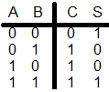 b) 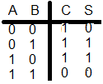 c) 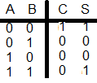d) 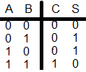e)?

2-What is the truth table of HA-?

a)  b)  c) d) e)?

3-What is the truth table of HA- --?

a)  b)  c) d) e)?

4-This truth table belongs to what?



a) HA b) HA+ c) HA- d) HA- - e)?

5- This truth table belongs to what?



a) HA b) HA+ c) HA- d) HA- - e)?

6-This truth table belongs to what?



a) HA b) HA+ c) HA- d) HA- - e)?

7-This truth table belongs to what?



a) HA b) HA+ c) HA- d) HA- - e)?

8- This truth table belongs to what?

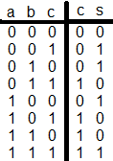

a) FA b) FA+ c) FA+ d) FA- - e)?

9-This truth table belongs to what?

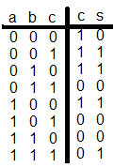

a) FA b) FA+ c) FA+ d) FA- - e)?

10- What is FA- ?

a)It doesn’t exist b)FA-1 c)FA-2 c)FA-3 e)?