1-What is Approximate Computation?

a)It doesn’t exist b)A non-exact solution c)A partially wrong solution d)a solution with less than 50% error e)?

2- Which one(s) is (are) example(s) of Approximate Computation applications?

a)Spy Fly b)Sensor Network c)Image Processing d)all e)?

3- Which one do you prefer as an approximate circuit?

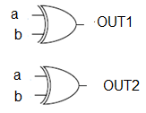 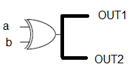

4- These truth tables belong to what?

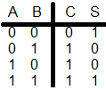 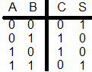

X Y

a)X is HA+, Y is HA b)X is HA, Y is HA+ c)X is HA+, Y is approximate HA+ d) Y is HA+, X is approximate HA+ e)?

5- These truth tables belong to what?

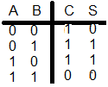 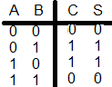

X Y

a)X is HA--, Y is HA- b)X is HA-, Y is HA-- c)X is approximate HA--, Y is HA-- d) Y is approximate HA--, X is HA--

6-Which truth table belongs to approximate HA-?

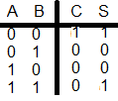 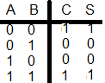

X Y

a)X b)Y c)Both d)Non e)?

7-Is it possible to design an Approximate FA- - using just one Majority gate?

a)Yes b)Non

a)X b)Y c)Both d)Non e)?

8- Is it possible to design an approximate FA using Majority and Minority gates?

a)Yes b)Non

9- Is it possible to design an approximate FA- using Majority and Minority?

a)Yes b)Non

10- Is it possible to design an approximate FA- - using Majority and Minority?

a)Yes b)Non