1-What is the truth table of HA+?

2-What is the truth table of HA-?

3-What is the truth table of HA---?

4-This truth table belongs to what?

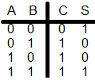

5- This truth table belongs to what?

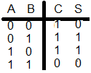

6-This truth table belongs to What?

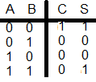

7-This truth table belongs to what?

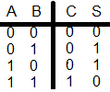

8- This truth table belongs to what?

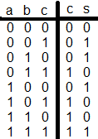

9-This truth table belongs to what?

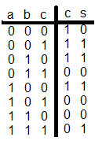

10- What is FA--

11- Does FA+ Exist?

12- Does FA- Exist?

13- How can we increment the content of a register using FA?

14- How can we increment the content of a register using HA?

15- What is this?

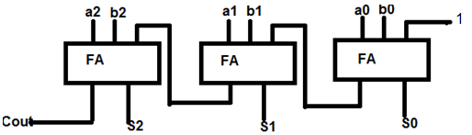

16- What is this?

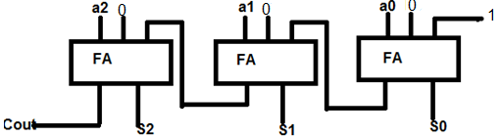

17-What is this?

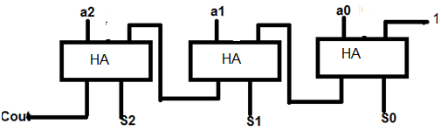

18-If one of the inputs of a full adder is 0 then it will be what?