1-What is Approximate Computation?

2-Which one do you prefer?

1- A scientific paper 2-A US Patent?

3- What is an approximate HA?

4- These truth tables belong to what?

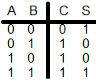 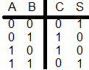

A B

5- These truth tables belong to what?

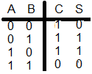 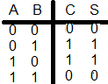

A B

6-- These truth tables belong to what?

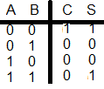 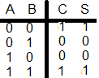

A B

7-- These truth tables belong to what?

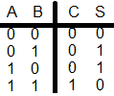 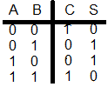

A B

8- Design an Approximate FA using Majority and Minority gates?

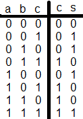

9- Design an Approximate FA-- using XOR and XNOR gates.

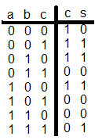

10- Design an Approximate FA-- Using Minority gates.

11- Design an Approximate FA-- Using just one Majority gate.

12- Design an Approximate FA-- Using XOR gates.

13- Design an Approximate FA-- Using just one XOR gate

14- Which one do you prefer?

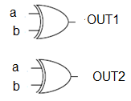 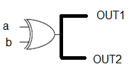

15- Give some example of Approximate computation applications.