1-Compressors are basic components used in many applications, especially in the partial product summation of multipliers. They are used to reduce the number of operands when partial products are added during the multiplication process.

1-Right 2-Wrong

2-A 3-2 (FA) compressor is used in Wallace tree to speed up the multiplication operation.

1-Right 2-Wrong

3- One of the compressors is called 2-3.

1-Right 2-Wrong

4-A compressor must have 2 properties:

1**) *Must do the addition operation*** **2) *The number of inputs < The number of outputs***

1-Right 2-Wrong

5- What is the name of this compressor?

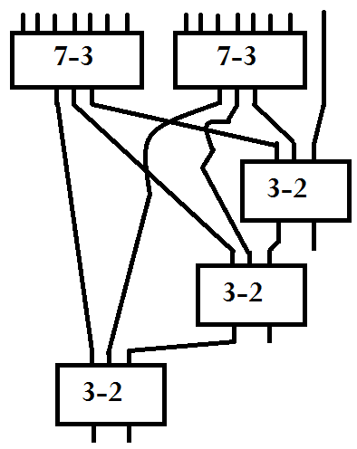

6- Do this division: 3/7

7- First step simplifying the Multiplication tree using 4-2s, 3-2s (FAs) and HAs. 1)Right 2)Wrong

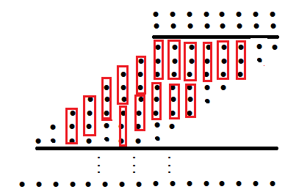

8-The process of reduction must be continued until achieving the maximum of two bits in each column. This figure is related to this fact.

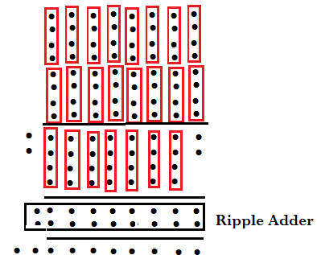

1-Right 2)Wrong

9-Which one is correct about “Binary Division” ?

* 1) Divide the suitable digits of the dividend and record the quotient.
* 2) Multiply the divisor by the quotient and write the product below.
* 3) Subtract the product from the dividend and write the difference below.
* 4) Bring down the next digit and repeat.

10-We can do he division by Repeated Subtraction.

1)Right 2)Wrong

11-We can do the division using multiplication.

1)Right 2)Wrong

12-Divide: 5/9

13-Divde: 9/5