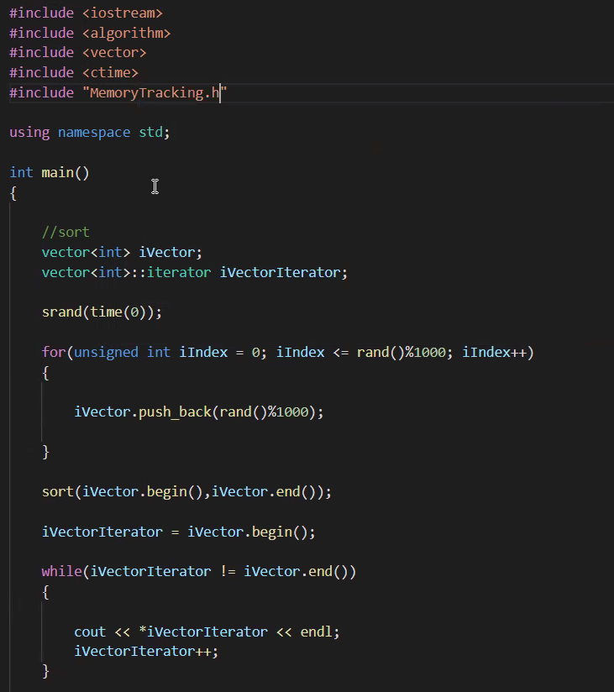

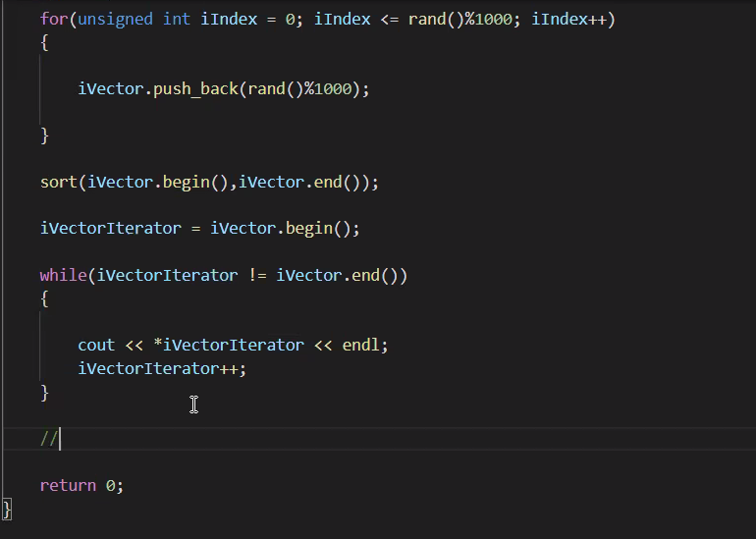

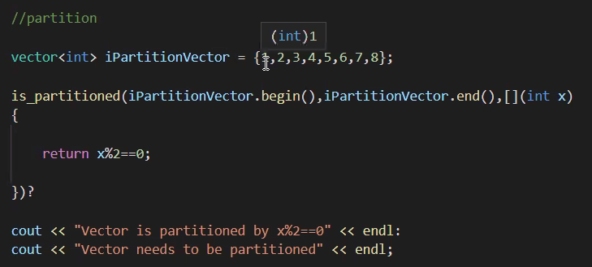

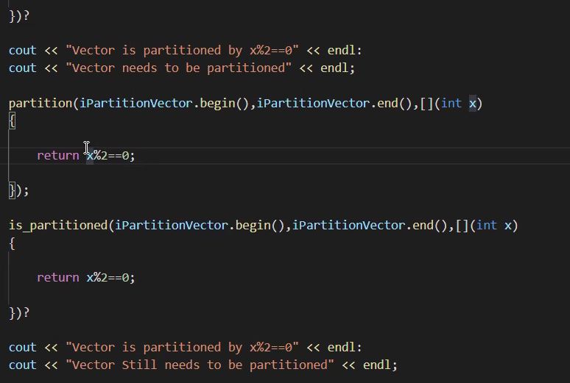



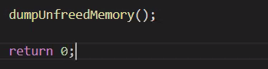

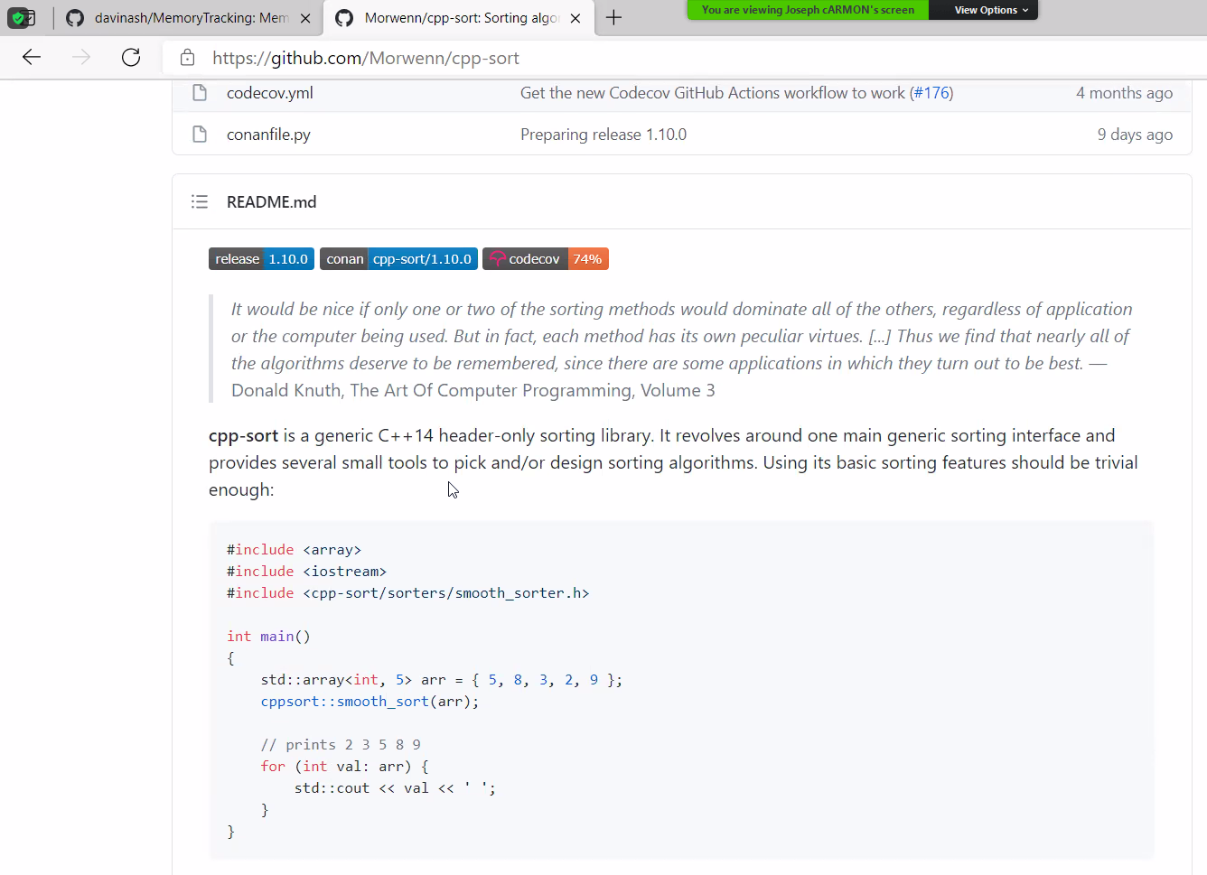

<QDir>

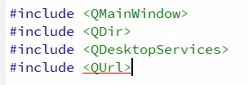

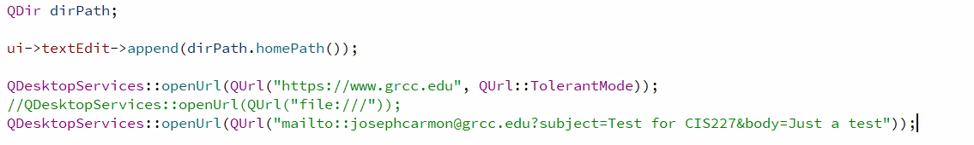

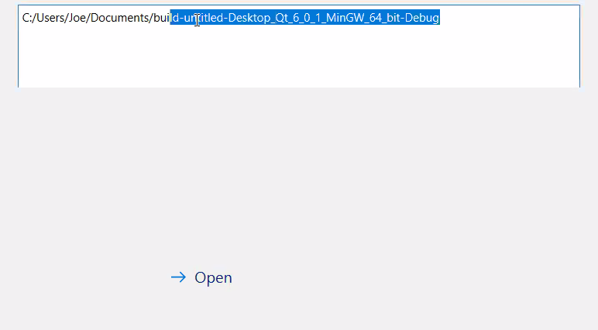

Ideas of Things to Add:

1. File Import System
2. Proper Data Types
3. Validate Everything
4. Clean up the console

Mandatory:

* Email to us
  + Must use QDesktopServices
* Status Bar file location?
* MEMORY LEAKS
* COMMENT