# Epigenetic clocks and cell proportions

I looked at the epigenome of male reproductive strategy/CoR in 99 men for which I had DNAm. I lose a few here and there for missingness for phenotypic variables. I kept as many as I could in all models. Outcomes were ‘clocks’ (DNAmAge, DNAmAge-Hannum, DNAmPhenoAge, DNAmGrimAge), and cell counts (CD4T, CD8T, Granulocytes, Monocytes, Natural Killer Cells, Plasma Blastocysts).

It’s all summarized below, but mostly there are no consistent findings. I suspect our measures are noisy (e.g. I had at least one guy with negative percent body fat) and our sample size is small.

Each figures shows each variable of interest (y-axis), effect size (x-axis), and colored by if the outcome was related to the variable or not (red < 0.05). The figures are faceted by the outcome of interest. It’s more self-explanatory than it seems.

## Anthropometric measures

~ value + smoke + drink + icpc1:icpc3 + SEAsum_83_05 +

## age_blood05 + age_interview98

Values: 2005: Height, fat-free mass, arm muscle area, whr, bmi, bodyfat percentage etc.

2005-2009: Height-accretion, fat-free mass accretion, arm muscle area accretion

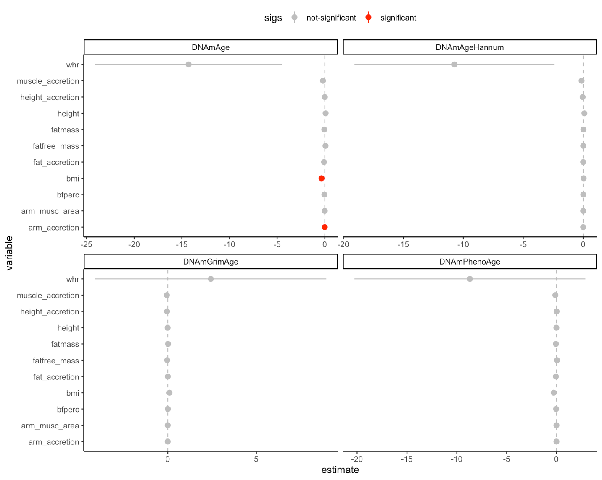

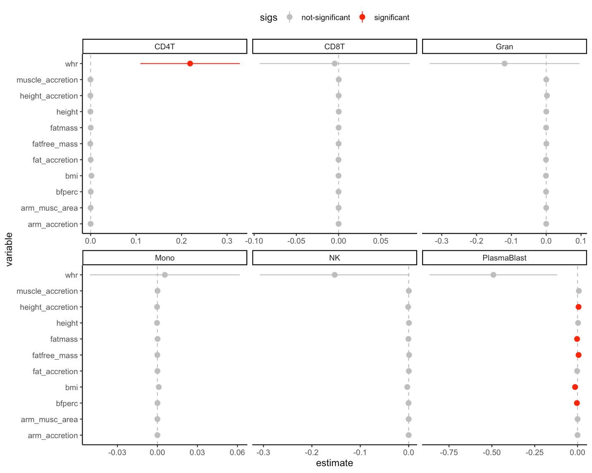

## Reproductive measures

value + smoke + drink + icpc1 + icpc2 + icpc3 +

## SEAsum_83_05 + age_blood05

Values: 2005: sexint, romantic, presrela, numbsex, numbpreg (0 for NA)

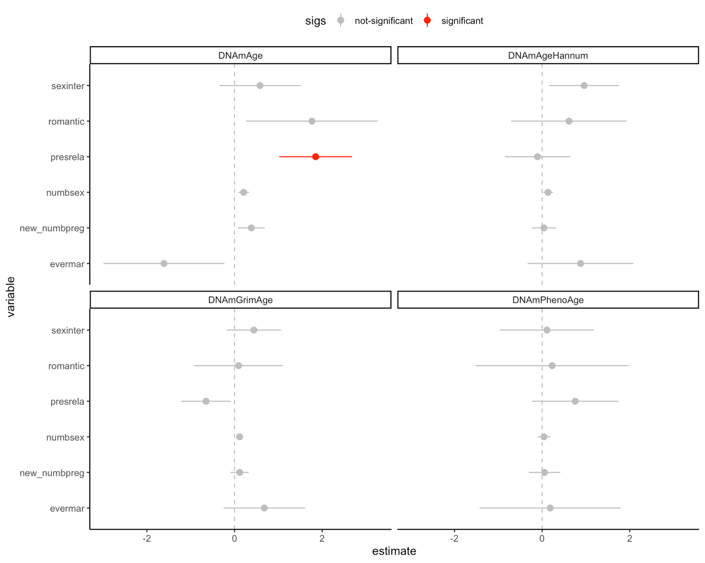

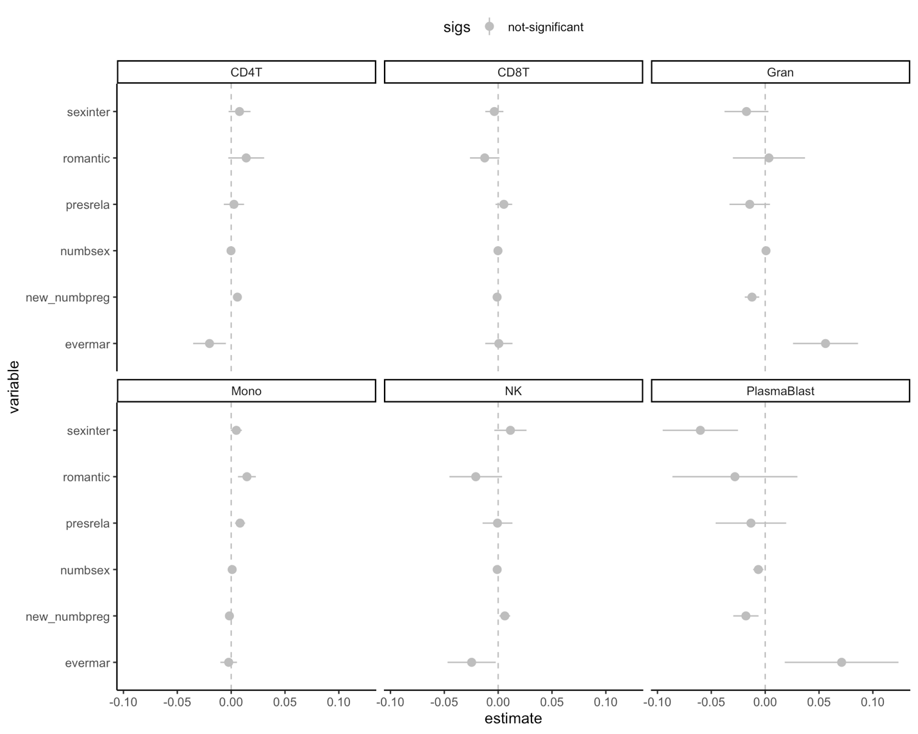

~ value + smoke + drink + icpc1 + icpc2 + icpc3 +

## SEAsum_83_05 + age_blood05 + ic_age09

Values: 2009: agesexin (sexint in 2009), agesexin_simul (added a random normal tail after 2009 to increase sample size), timesprg, steady (= presrela in 2009?)

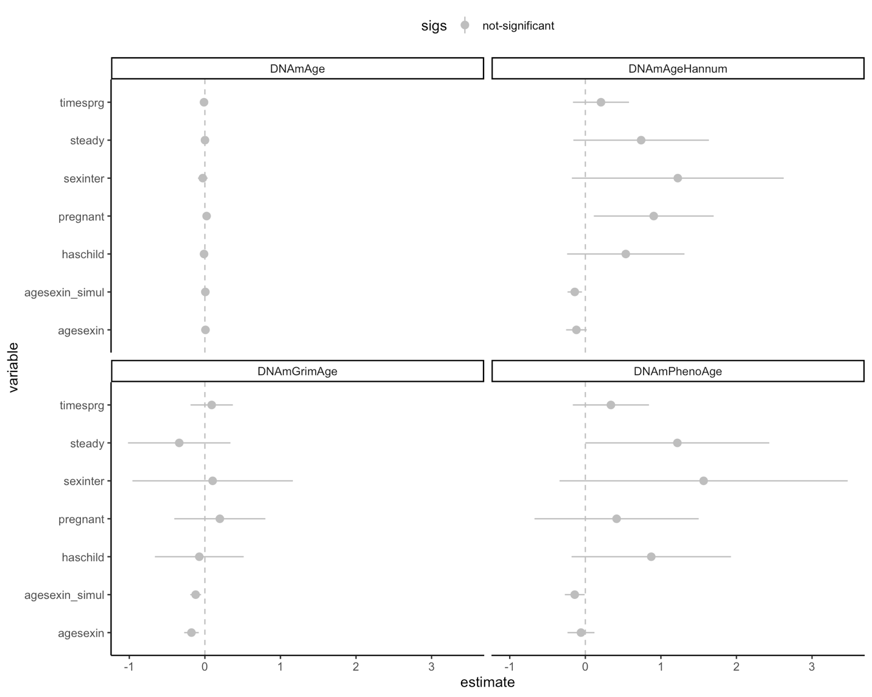

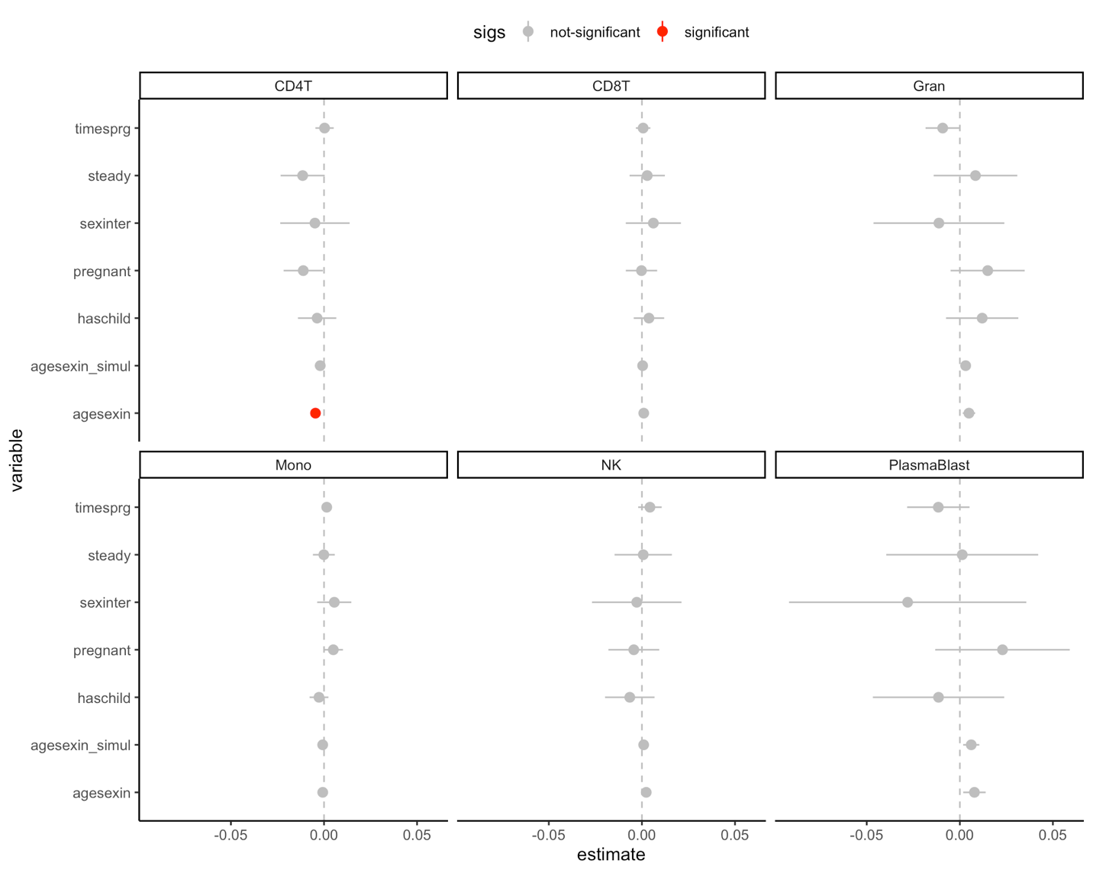

### Testosterone measures

value + smoke + drink + icpc1 + icpc2 + icpc3 +

## amtime05 + pmtime05 + age_saliva + SEAsum_83_05 + bmi

Values: 2005: rightgrip_mean, log_blood_t, pmt05, amt05, hholdkids05, fath05c, anyoffspring05

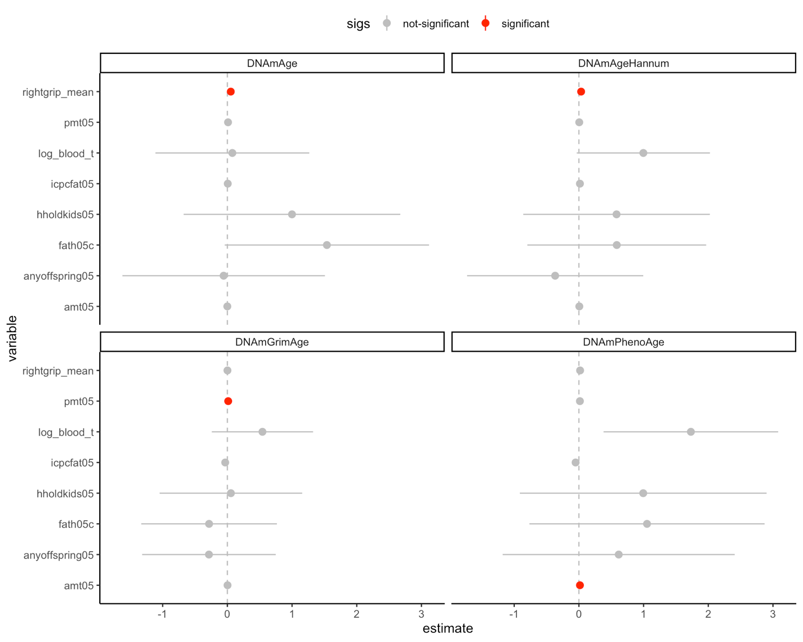

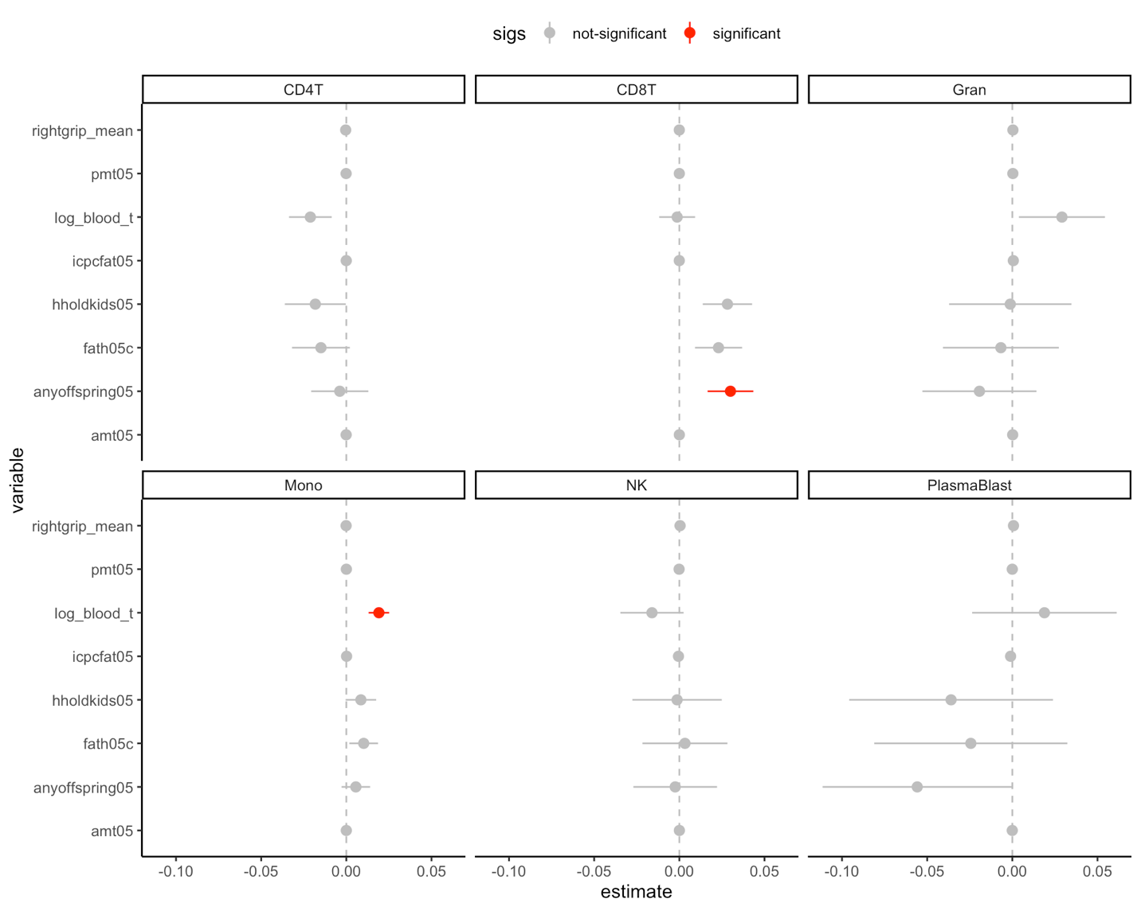

# Epigenome-Wide Association

I also looked at EWAS for almost all the same variables. I filtered out to only probes that varied between the men in our study (10-90th percentile > 0.05). Again, mostly nothing, so I won’t put them here. The one that did pop up a few is log-blood T. Here is a manhattan with significant hits and genes highlighted.

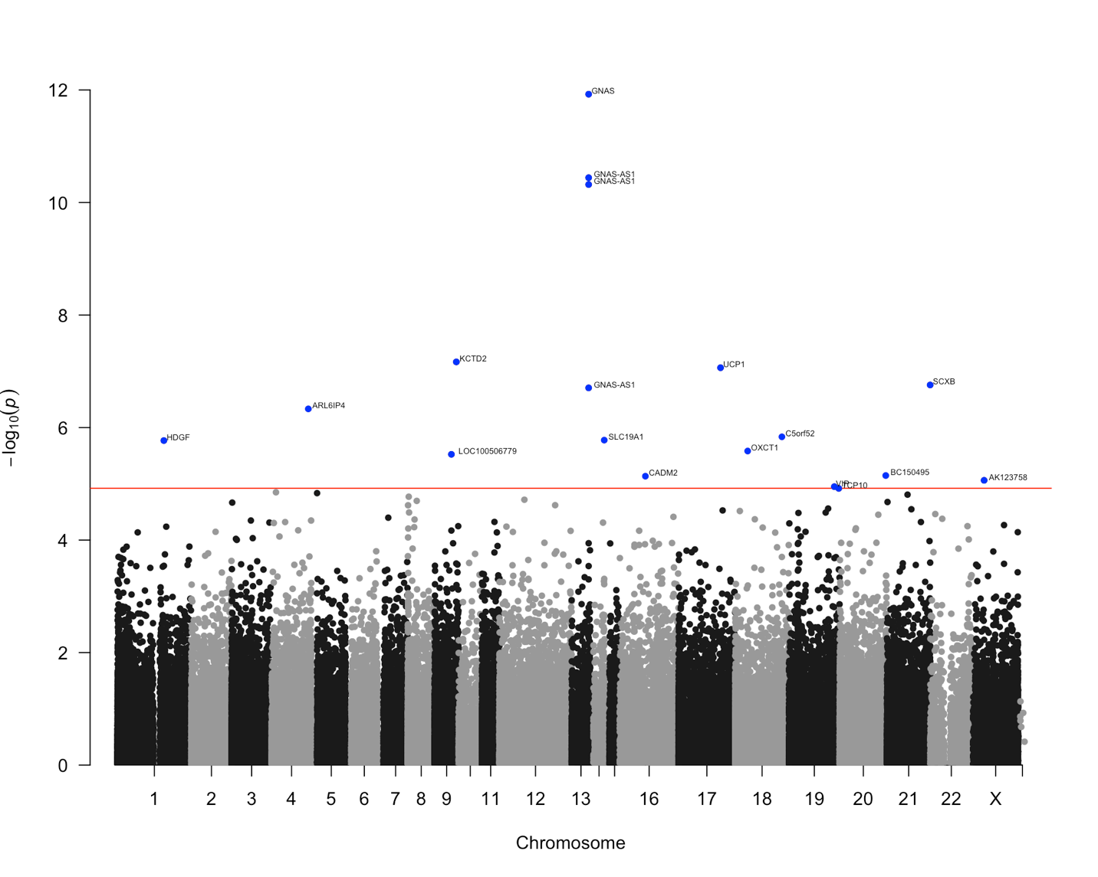

We might be worried that we have outliers, like we did when I first did this analysis. I have a few more men this time than last, and I logged the T, which helped.

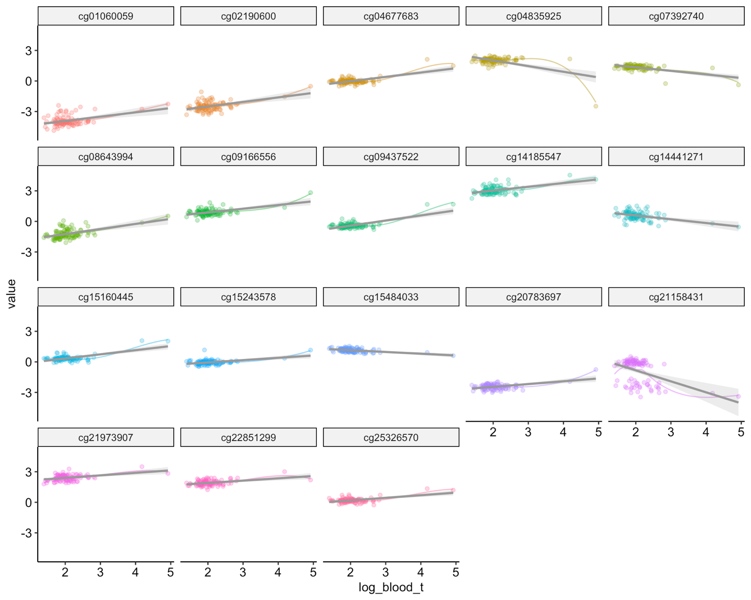

Some of the significant probes don’t look great (the loess line doesn’t at all match the straight regression line, e.g. cg04835925), but others look fine (cg14441271).

The other two that had a few hits was number of sexual partners, and number of pregnancies. Again, not a ton of great variation to work with.

That’s it for now.