**MyTomorrow App**

**Cincinnati Public Schools**

**Admin Manual**

**Version 3.0**

**Table of Contents**

1 Cincinnati Public Schools - CPS (Admin) 3

1.1 Logging in: 3

1.2 Admin Dashboard: 3

1.3 Search 3

2 Notifications: 4

2.1 Deleting Newsfeeds (Posts) 5

3 Menu 6

4 Newsfeed 6

4.1 Newsfeed Approvals tab 6

4.2 Approve Comments tab 7

5 Students 12

5.1 Edit Student 13

6 Teachers (Future Implementation) 15

7 Hall Pass 15

7.1 Published Hall Passes tab 15

7.2 Hall Pass Requests tab 15

8 Rewards: 18

8.1 Available Rewards tab 18

8.2 Assign Points Tab 18

8.3 Assign Rewards for Action Tab 20

9 Suggestions Box (Future Implementation) 20

10 Notification Control Center (Future Implementation) 20

11 Settings (Future Implementation) 20

12 User Management: (Future Implementation) 22

13 Help 22

# Cincinnati Public Schools - CPS (Admin)

## Logging in:

To log in to the Cincinnati Public Schools website as an Administrator, perform the following steps:

* Enter valid username and password in the respective text boxes and click the **Login** button.
* You will be redirected to the Admin Dashboard screen.

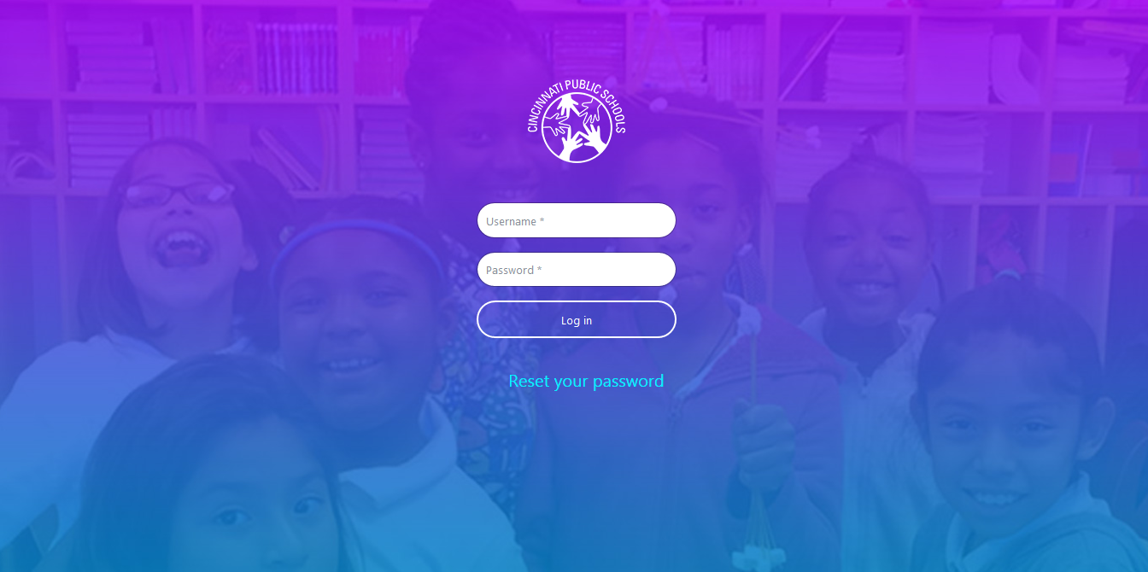

## Admin Dashboard:

When you log in as an Administrator, you can view the Newsfeeds posted by other Admin users, Students and Teachers on your Dashboard screen. You can also like posts, comment on posts, search for posts, delete posts, check notifications etc. You can also view the top 5 students’ list to the right of the screen.

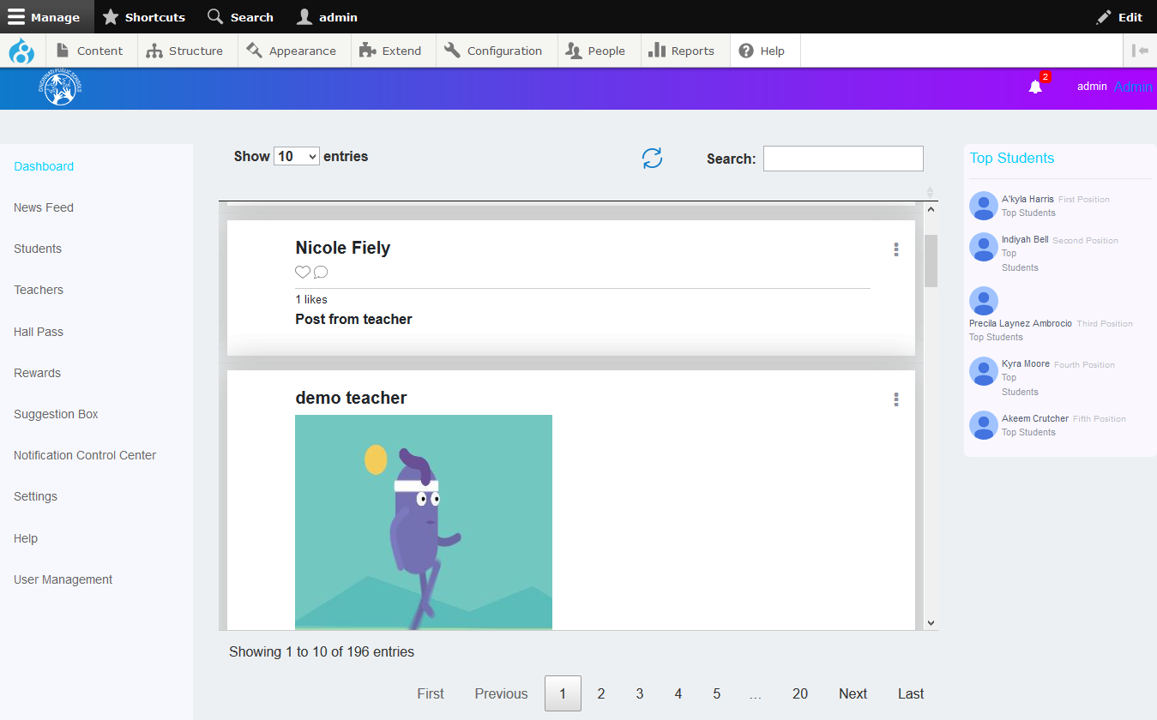

## Search

Admin users can search for information on the dashboard page based on certain key words. There is a **Search** text box available at the top of the feeds. They can type in their keyword and the search result will be displayed below the **Search** text box based on the keyword typed in.

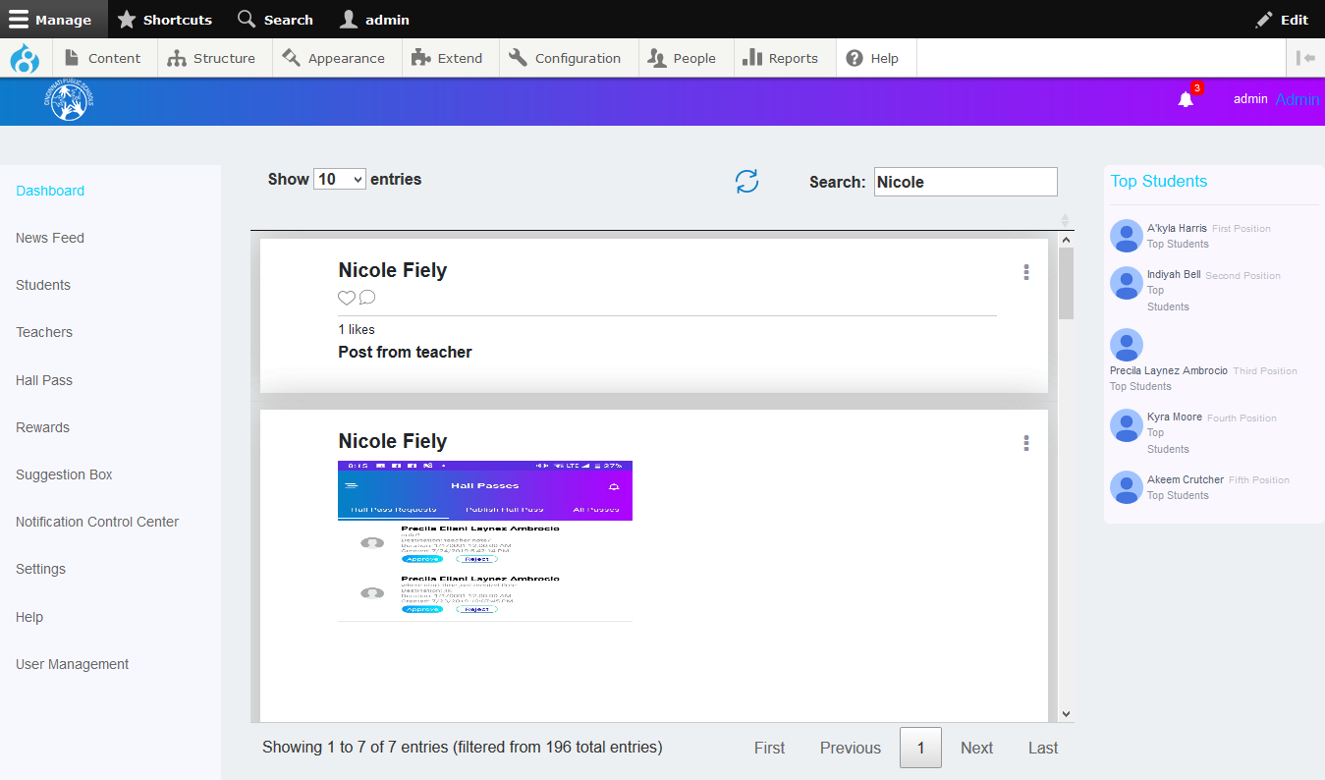

# Notifications:

The Notifications screen displays all the updates related to Students and Teachers. Click the bell icon displayed at the top of the Dashboard screen to access the Notifications screen. On this screen, you can view notifications such as new posts, hall pass requests, suggestions, and likes or comments which are created by Students and Teachers. You can click on any notification to access the details of that particular notification. You can view all notifications by clicking the **View All** link.

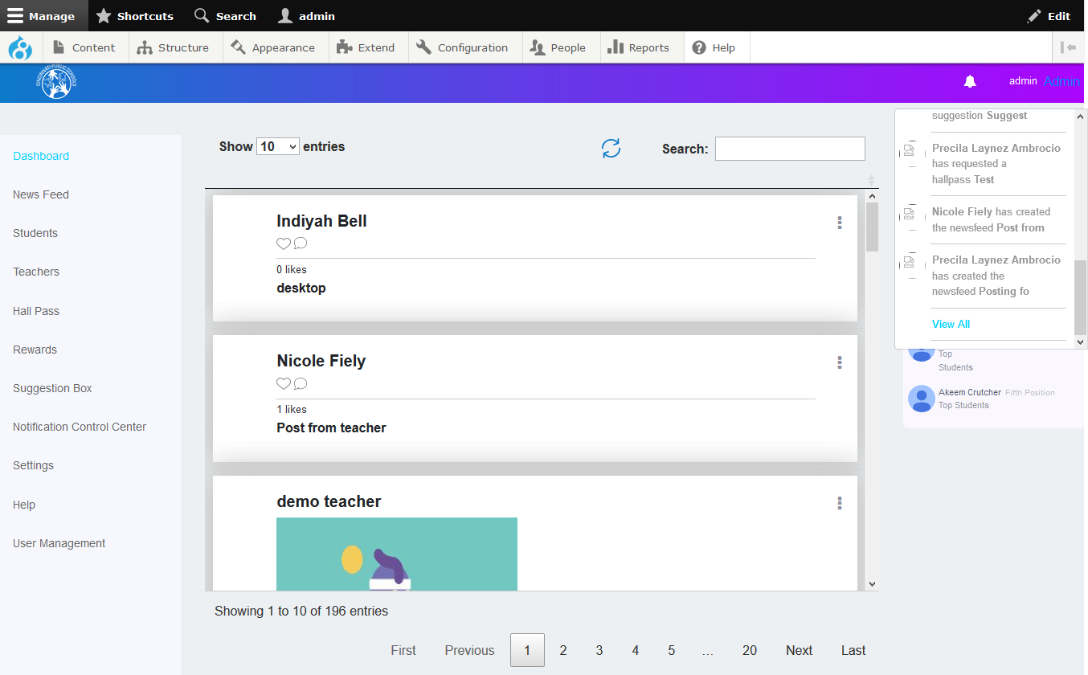

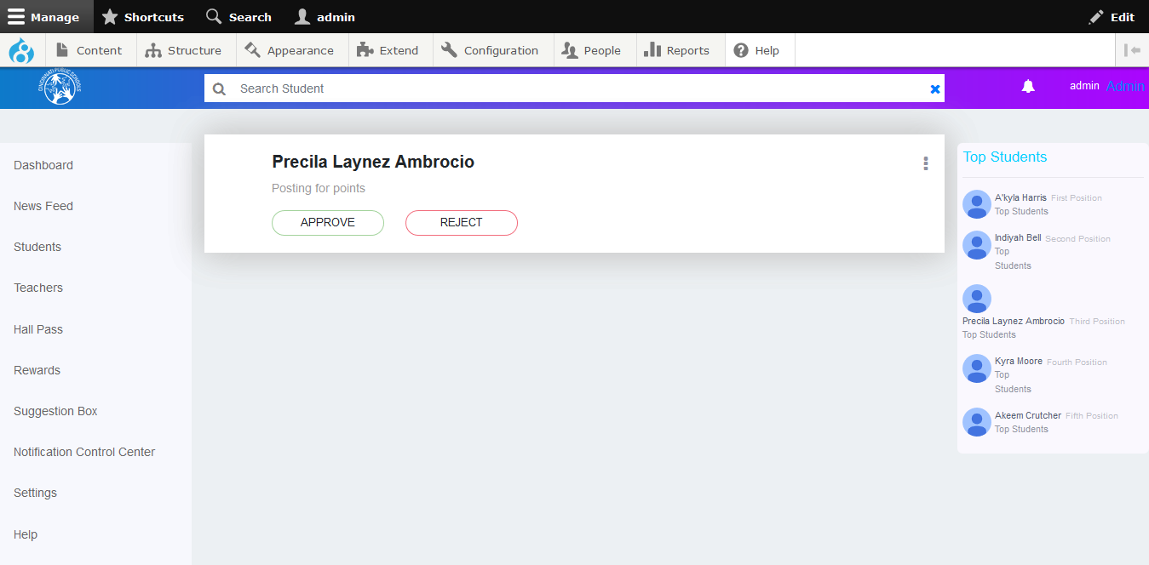

## Deleting Newsfeeds (Posts)

Admin users have the ability to delete newsfeeds or comment on particular newsfeeds.

**To delete a newsfeed:**

* Click on the newsfeed you want to delete.
* ON the newsfeed details window, click the  icon displayed at the top right corner of the newsfeed.
* Click the **Delete Newsfeed** button.

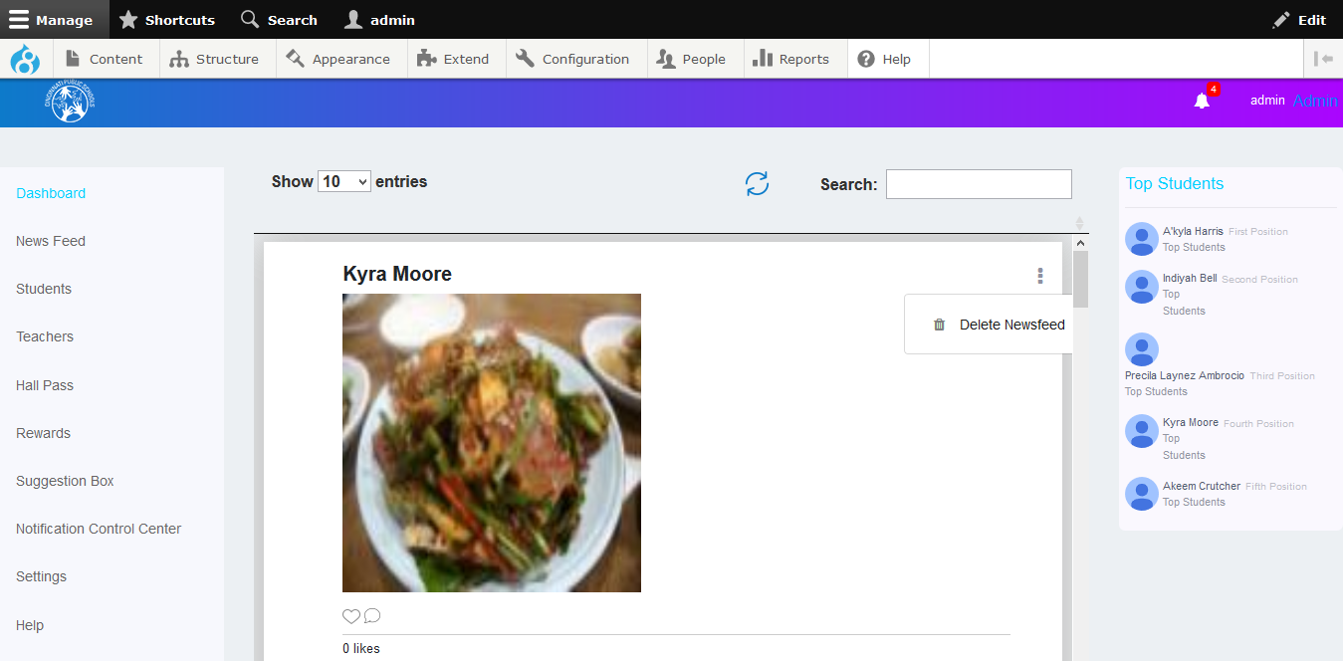

# Menu

There is a **Menu** displayed at the left side of the Dashboard screen. This menu displays all the screen and sections which you have access to. You can click the menu item you want to access and navigate to that particular screen.

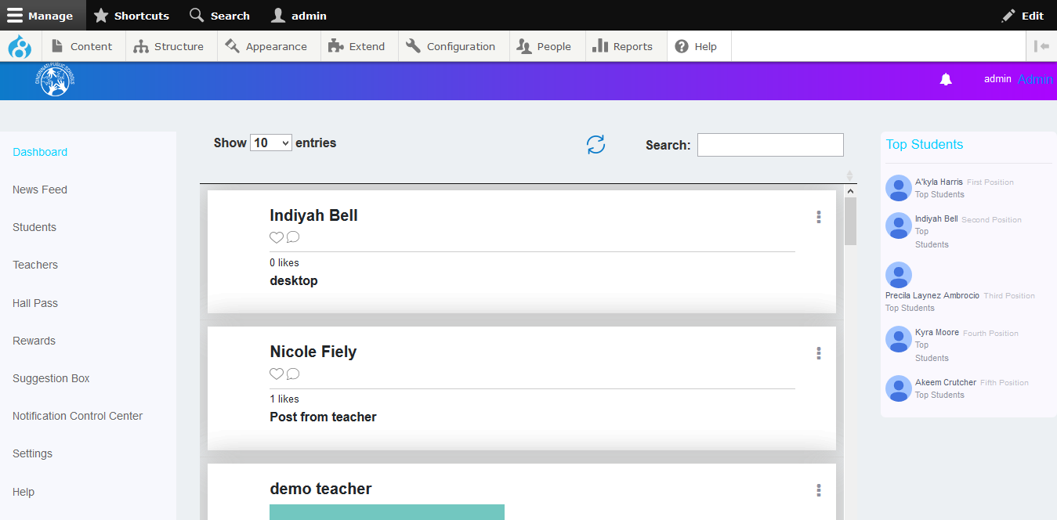

# Newsfeed

Admin users can view all the approved newsfeeds and comments posted by students and teachers. They can also create and post newsfeeds. On the Newsfeed screen, there are two tabs; **Newsfeed Approvals** and **Approve Comments**.

## Newsfeed Approvals tab

Admin users can view the Newsfeeds posted by Students and Teachers which are waiting to be approved. On this screen, you can approve or reject newsfeeds. You can also search for newsfeeds and approve, reject or delete them.

**To approve newsfeeds:**

* On the Newsfeed Approvals tab, select the newsfeed to be approved.
* Click the **Approve** button at the bottom of the newsfeed.

**To reject newsfeeds:**

* On the Newsfeed Approvals tab, select the newsfeed to be approved.
* Click the **Reject** button at the bottom of the newsfeed.

**Note:** The Students and Teachers associated with that newsfeed will receive a notification and a message from the administrator informing them of the approval or rejection of the newsfeed.

**To delete newsfeeds:**

* Click the icon displayed at the top right corner of the newsfeed.
* Click the **Delete Newsfeed** button.

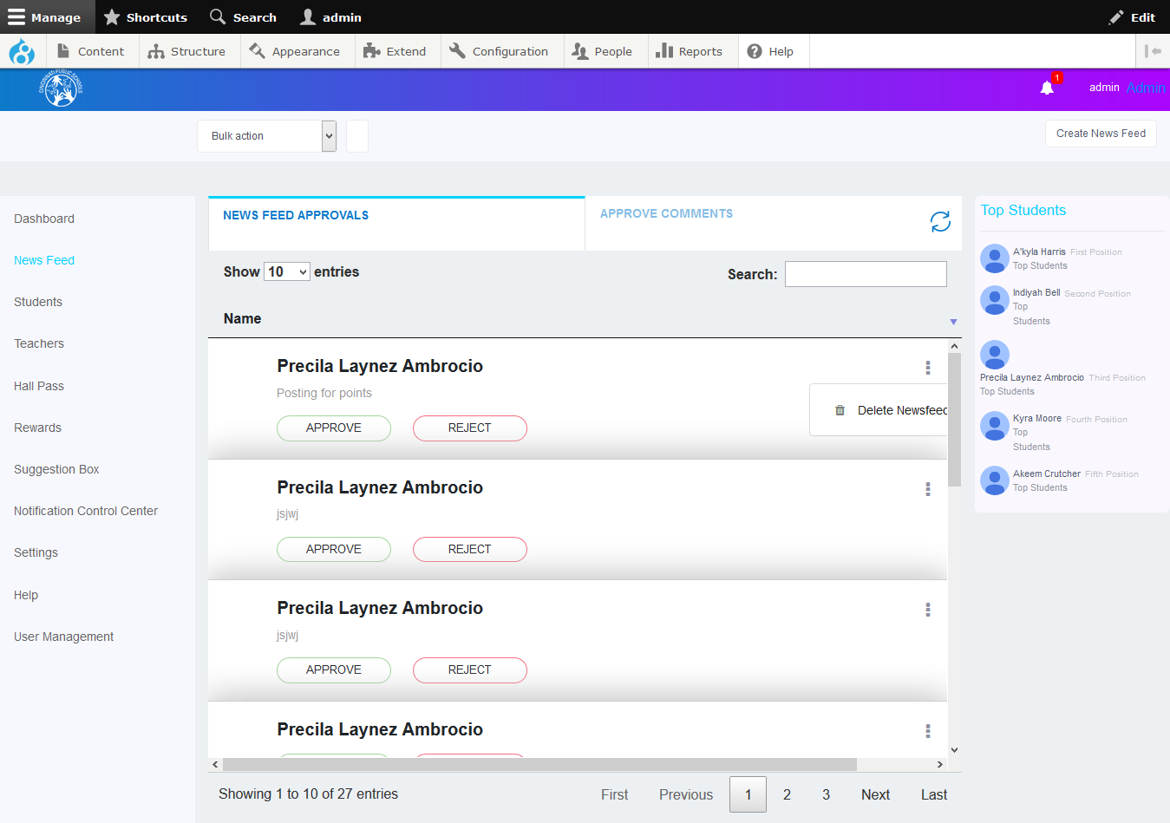

Click on ellipsis icon to delete Newsfeed

## Approve Comments tab

The Admin users can view all the comments which have been made on a particular newsfeed and approve or reject individual or multiple comments at once.

**To approve or reject multiple comments at once:**

* Select the corresponding checkboxes for the comments placed next to the comments.
* Click the **Approve** or **Reject** buttons below the comments list. .

**Note:** The users whose comments have been approved or rejected will receive a notification from the administrator informing them about the status of their comments.

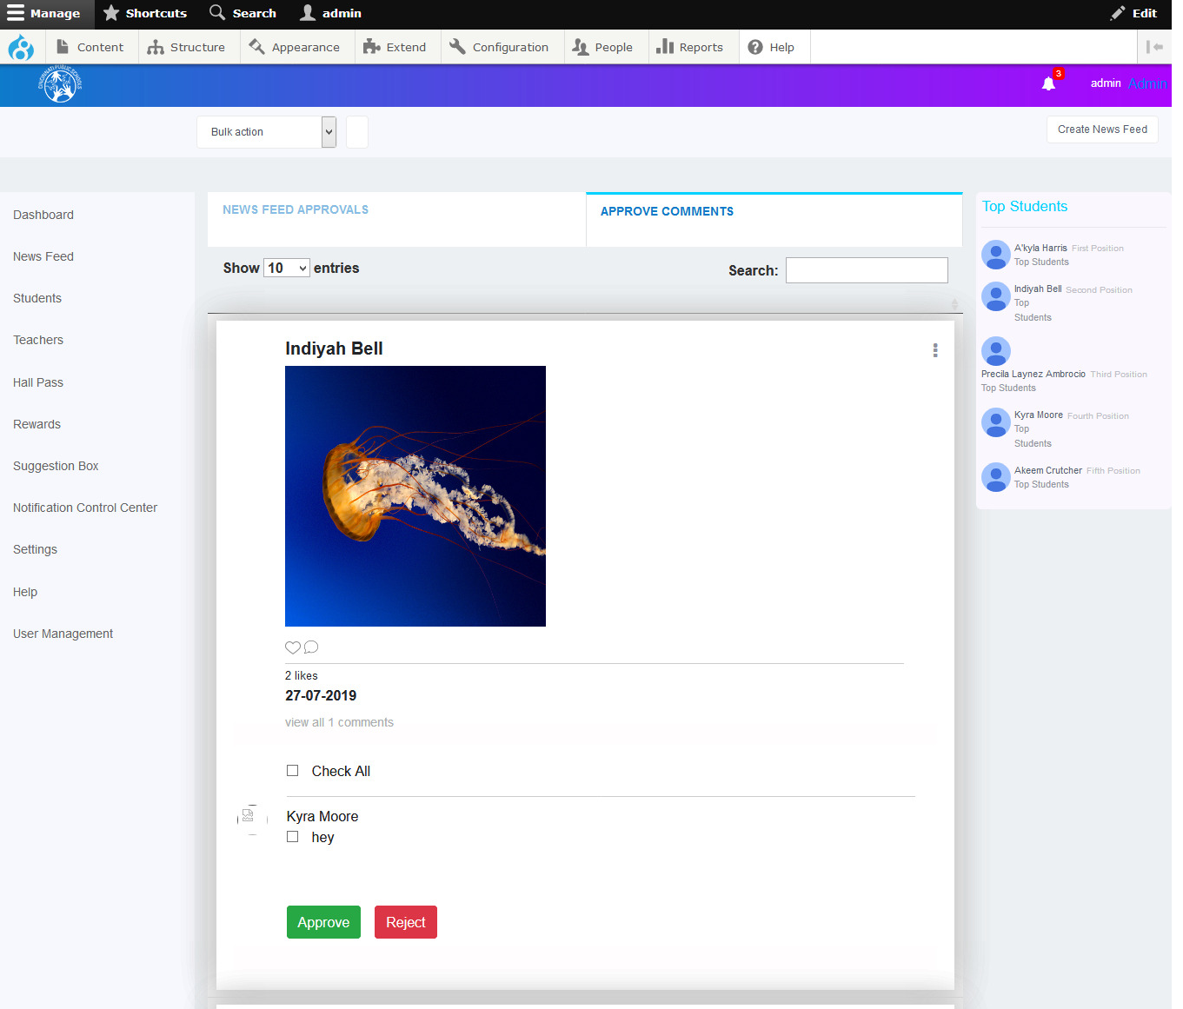

Click on ellipsis icon to delete Post With comments

Admin users can also publish a Newsfeed.

**To create a Newsfeed:**

* Click the **Create News Feed** button at the top right corner of the Newsfeed screen. The Create Newsfeed window is displayed.

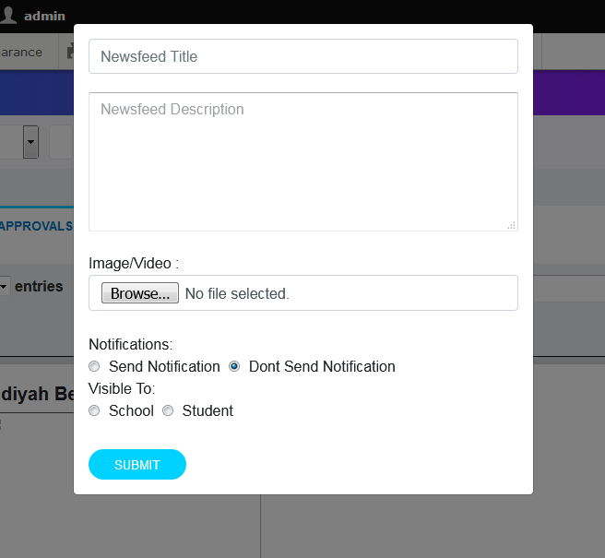

* Specify the title of the newsfeed and its description in the respective text boxes.
* Click the **Browse** button to upload an image or video if needed.
* Select the **Send Notification** radio button if you want so send a notification about the newsfeed to all students and teachers or select the **Don’t Send Notification** radio button if you do not want to send a notification to anyone.
* You can also choose to make the newsfeed visible to a set of schools. Select the **School** radio button under **Visible To** if you want to make the newsfeed visible to a particular school or a group of schools.

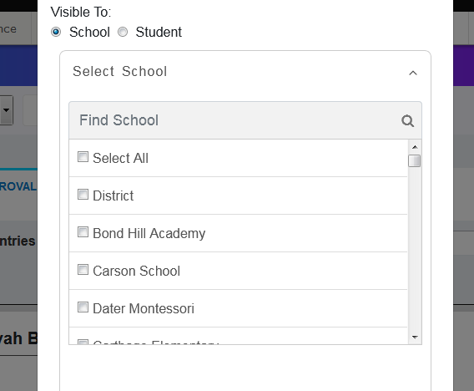

* Select the school or schools to which you want to make the newsfeed visible.

**Note:** You can also search for the particular school from the available list by typing in the name of that school and clicking the search icon.

* You can also choose to make the newsfeed visible to a particular set of schools based on their grades or upload a list of students. Select the **Student** radio button under **Visible To** if you want to make the newsfeed visible to a particular set of students as per their grades or to an uploaded list of students.

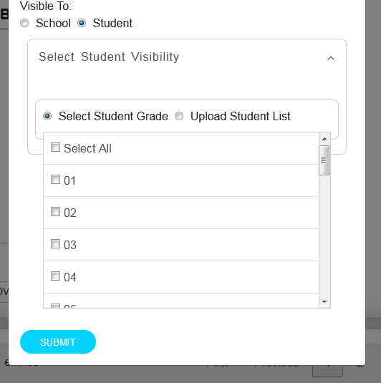

* Select the **Select Student Grade** radio button to select a grade. All the students who have achieved that grade will be able to view the newsfeed. Select the **Select All** option to make the newsfeed visible to students of all grades.

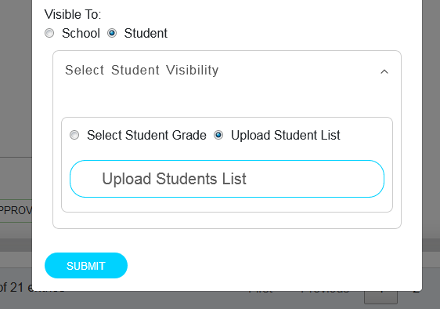

* Select the **Upload Student List** radio button to make the newsfeed visible to a particular set of students irrespective of their grades. Click the **Upload Students List** button to upload your list.
* Click the **Submit** button to create the newsfeed.

# Students

All the information of Students is displayed in this screen. You can filter the information by School, Student Name & Student ID.

You can also search for a particular student.

**To search for a student**:

* Type in the student’s name in the **Search Student** text box
* Click the Search button. The details of the particular student are displayed.

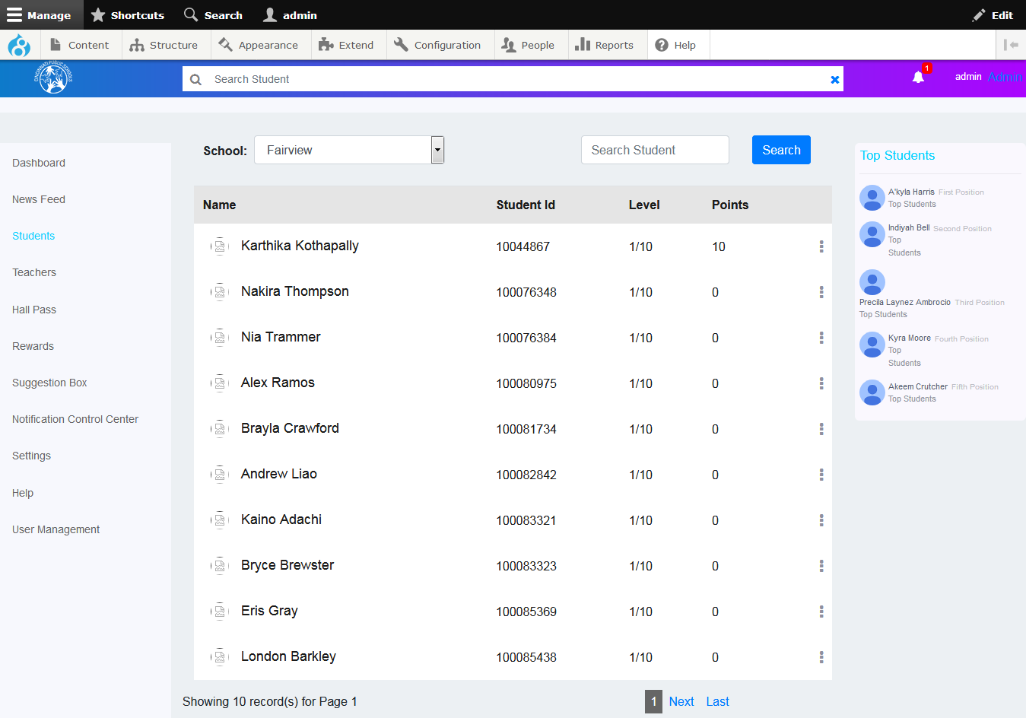

You can also edit the details of Students.

**To edit a student’s details:**

* Click the ellipsis icon as shown in the screen below.
* Click the **Edit Student** button.

## Edit Student

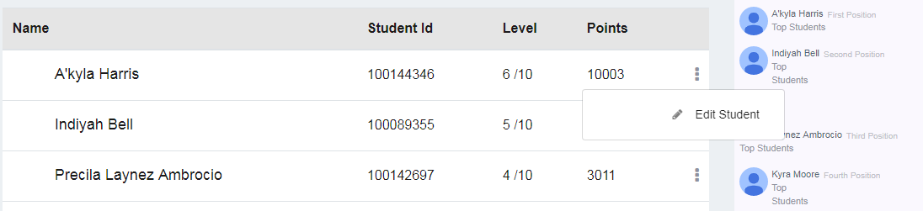

* The Edit Student window is displayed.

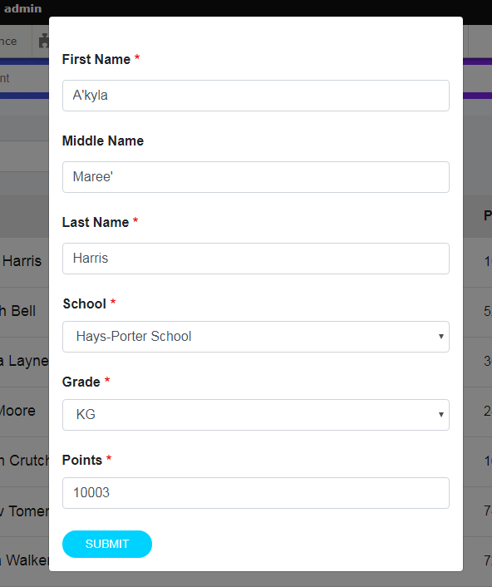

* In this window, you can edit the Student’s information such as First Name, Middle name, Last name, School, Grade and Points.
* Click the **Submit** button to save your changes .

# Teachers (Future Implementation)

Yet to be implemented.

# Hall Pass

In the Hall Pass screen, you can view the hall pass requests from the Students, and can approve or reject the hall passes. There are two tabs in this screen; Published Hall Passes and Hall Pass Requests.

## Published Hall Passes tab

The Published Hall Passes tab displays all the hall passes that have a status associated with them. You can view the details of the hall passes such as approved by, validity and destination hall.

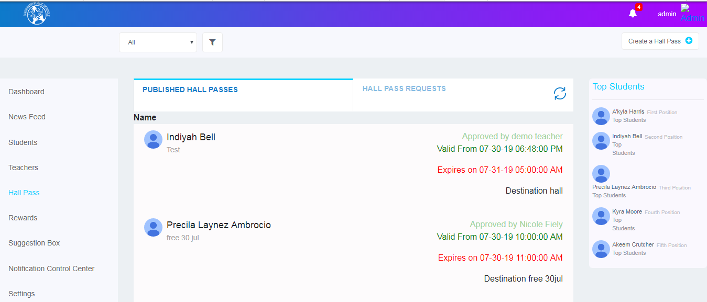

## Hall Pass Requests tab

In thistab, you can view all the hall pass requests along with their information such as description, destination, valid from, expires on etc. You can approve or reject a hall pass.

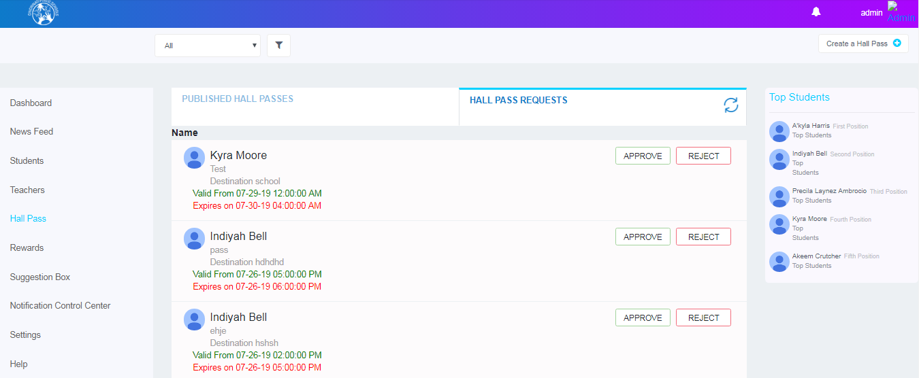

**To approve or reject a hall pass:**

* Select the hall pass from the list.
* Click the **Approve** or **Reject** buttons to approve or reject the hall pass.

You can also create and approve a hall pass for a Student.

**To creating a New Hall Pass:**

* Click the Create a Hall Pass button at the top right corner of the Hall Passes screen. Create Hall Pass window is displayed.

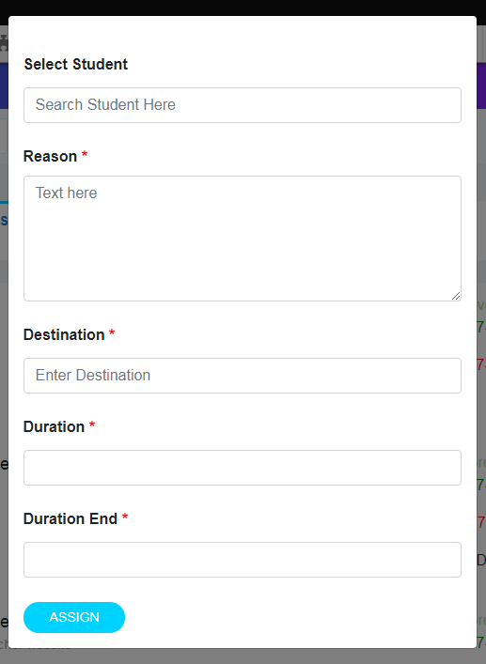

* Select the Student by searching for the student.
* Specify the reason and description in the respective text boxes.
* Specify the destination where the hall pass is to be used.
* Mention the start date and end date of the hall pass in the **Duration Start** and **Duration End** fields.
* click the **Assign** button to publish a hall pass for the Student.

# Rewards:

There are three tabs in the Rewards screen; Available Rewards, Assign Points and Assign Rewards for Action.

## Available Rewards tab

You can view the list of all the students who have rewards. Click on the Number under the Reward level to view their details.

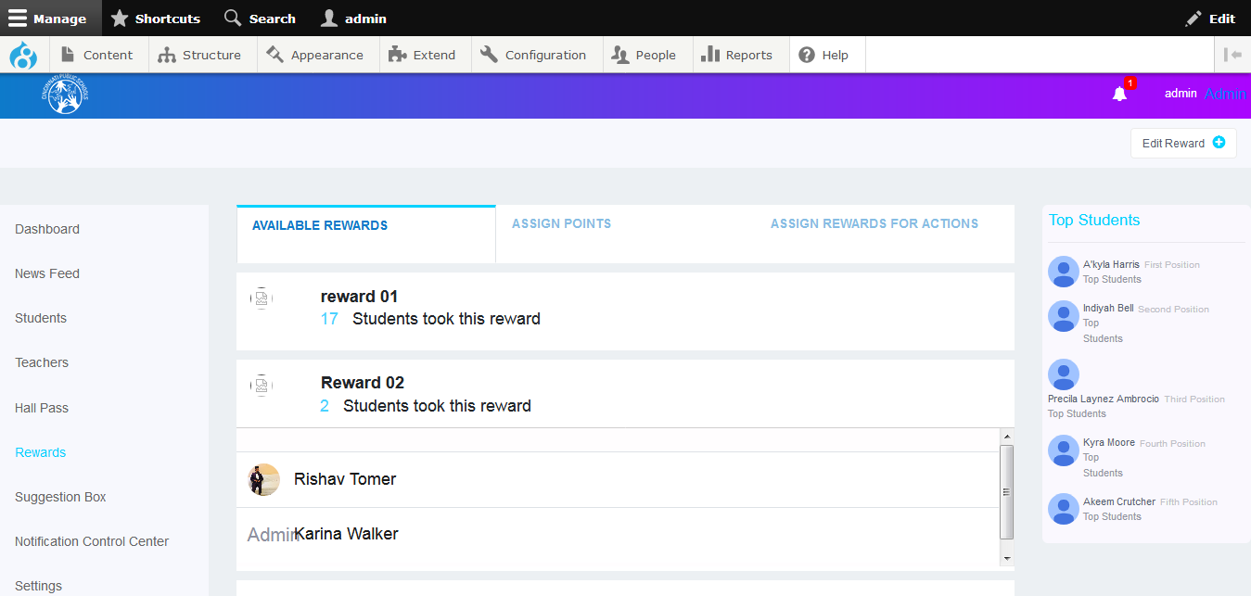

## Assign Points Tab

You can assign points to a single student or multiple students.

**To assign points to a single student:**

* Select the **For Single Student** radio button to assign rewards to a single student.
* Search for the student in the Select Student search field, assign the number of points and mention the reason for assigning the rewards.
* Click the **Assign** button.

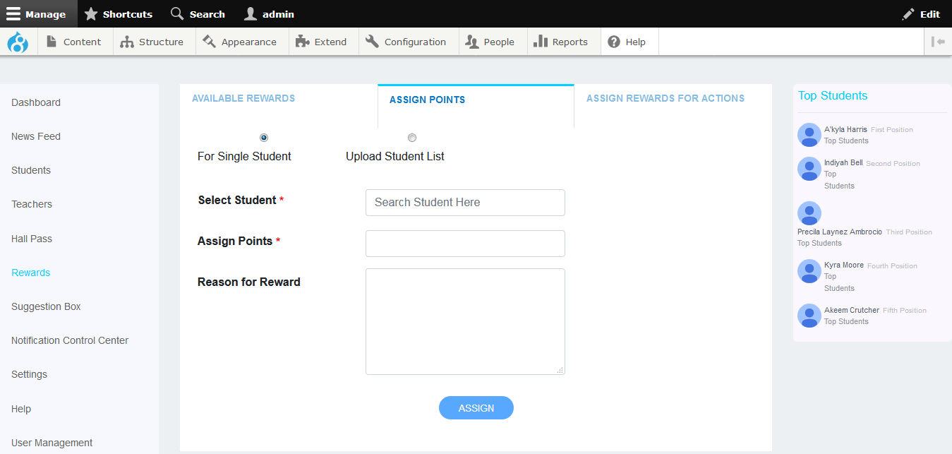

**To assign points to multiple students:**

* Select the **Upload Student List** radio button.
* Browse for the rewards file by clicking the Browse button.
* Click the **Submit** button.

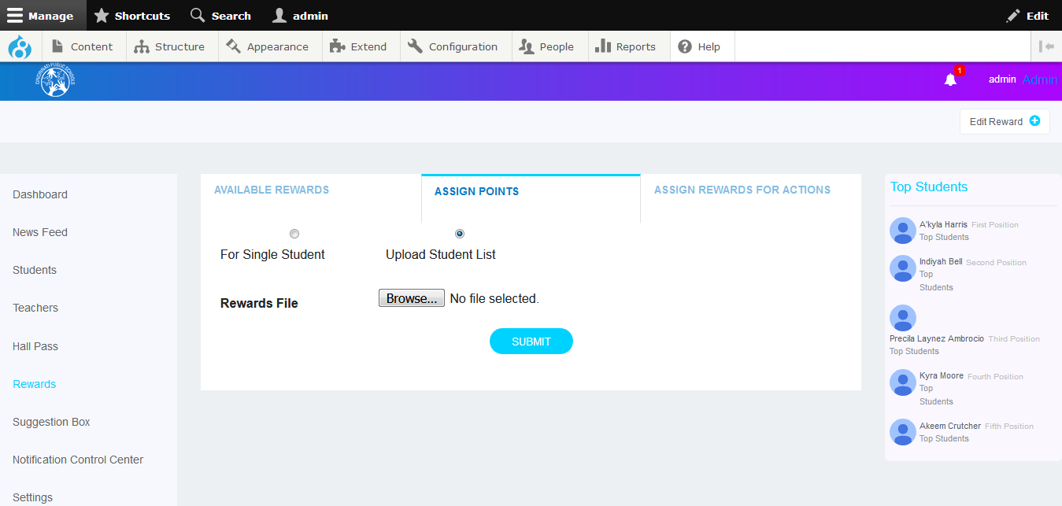

## Assign Rewards for Action Tab

You can assign bonus points for actions like News Feed Approval, Hall Pass Approvals, Delete Post, Like Post, Posting Comment Approval, Suggestion Comments Approval, Suggestion Like Post and Suggestions Feed Approval.

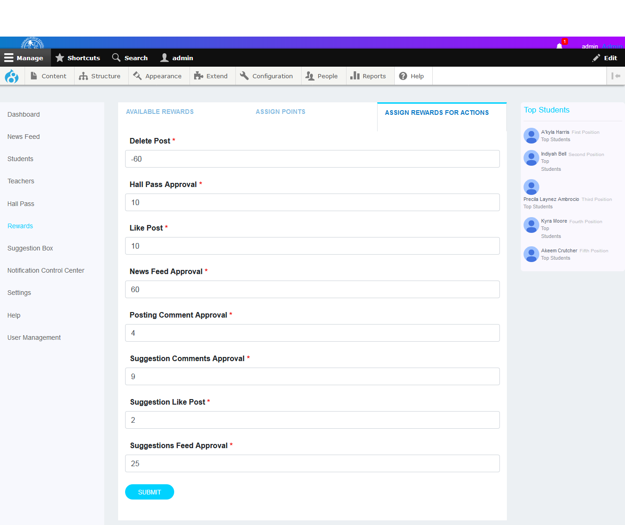

# Suggestions Box (Future Implementation)

# Notification Control Center (Future Implementation)

# Settings (Future Implementation)

From this screen, you can describe the various categories such as News Feeds, Notifications and Rules etc. These descriptions will be displayed the respective Student and Teacher Dashboard Help screens.

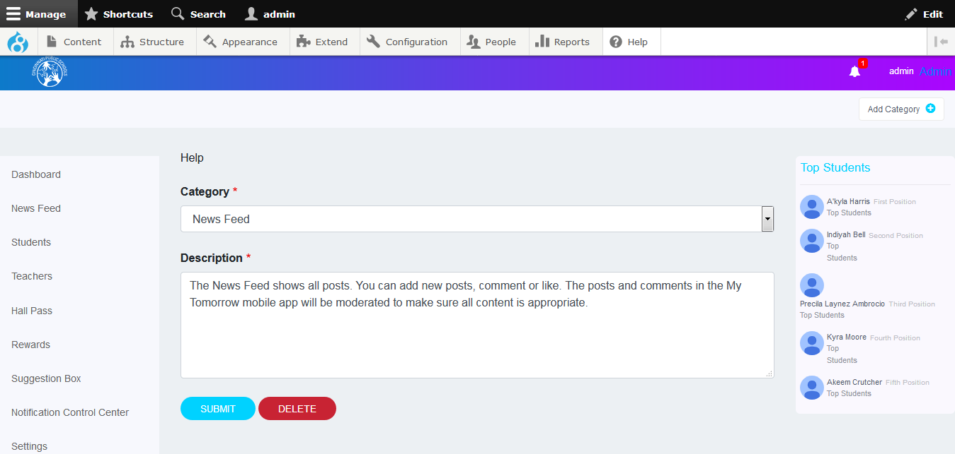

You can add a new Category from this screen.

**To add a new category:**

* Click the Add Category button which is at the top right corner of the screen.
* The Add Category window is displayed.
* Mention the name of the category and its description.
* Click the **Assign** button.

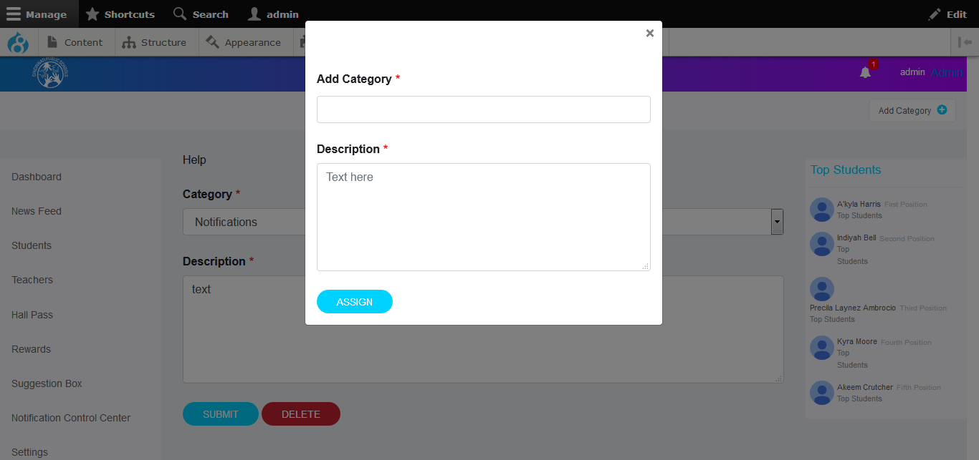

You can also delete a certain category.

**To delete a category:**

* Select the category from the **Category** drop-down list in the Help screen.
* Click the Delete button below the **Description** text box.

# User Management: (Future Implementation)

# 