User Manual
9-tap tour

User Manual
© 9-Tap Tour
PO Box 931
Sumner, WA 98390
Phone 253.987.7975
Email: rob1@9taptour.com

Table of Contents
About 9 Tap Tour INC 4
What is9-Tap? 5
A good place to start 5
Quick start guide 5
Troubleshooting 5
Menus guide 5
Quick Start Guide 7
What are the system requirements to run 9-Tap? 7
How do I install 9-Tap? 7
How do I Launch 9-Tap? 8
How do I import existing members? 9
How do I enter a new player? 9
How do I create a tournament? 9
How do I enter a bowler’s scores? 9
Start Menu 11
Member Info 12
Import Members 12
New Members 12
Updating a member. 13
Stats 14
Member Search 15
Print Recaps 16
Import 16
Member Scores 17
Tournament Stats 18
Print Recaps By Tournament 18
Tournament Place Standings 19
Create/Edit Tournament 20
To Update an Existing Tournament 20
Search Tournaments 21
Search by Location 21
Search by Event 21
Search by Date 21
List Tournaments by year 22
Reports 22
Finalize Tournament 22
Tools 23
Trouble Shooting 9-Tap 25
WARNINGS: 25
Screen “splitting” on resize 25
ReadMe File 26
Conversion Program 28
General Information 30
Main Menu 30
Member Info 30
Member Scores 31
Tools 32
Index 34

Chapter
1

9-tap tour

Welcome

About 9-Tap Tour INC
Welcome to the 9-Tap Tour Program. 9-Tap Tour, INC. is a unique, fun and professionally run tournament. Members enjoy our “Beat the Board” format, with four games per squad. Yet the fun, big payouts, special pots and the 9-Tap version of bowling itself, brings new excitement to tournaments.
Approximately one bowler in every 5 entries will cash. Other optional ways to cash are: 9-Tap Jackpot, Progressive Pot, high game pots, brackets, scratch game and series pot, and more depending on where & when you bowl these “Side Pots” may vary from time-to-time. 9-TAP TOUR also has BIG ‘Added money' Quarterly Championships, specials, promotions and doubles tournaments. Each Quarterly Tournament may have eligibility requirements for members who bowl during that Quarter.
Prize money is paid at the Tournament site at the conclusion of each tournament. The tournament winner, low to cash score, and new progressive pot totals will be posted on our web site, available immediately after each tournament. Past results are also available on our web site.
Our rules, which default to USBC in many areas, protect our members and ensure fair play. We are proud to be USBC Certified.
First place and prize fund moneys are based on the number of entries and will vary depending on where you bowl. Special Added money & Quarterly tournaments will pay higher amounts. Regional or National tournaments (in 9-Tap's future), will have much higher amounts.
Our goal is to provide an enjoyable experience for all of our members, with a fair opportunity for both low and higher average bowlers. 9-TAP TOUR INC appreciates your participation. We hope you will enjoy our tournaments and if you do please refer us to other bowlers. We ask for, and welcome comments and suggestions.
THANK YOU!
Rob Victor - Director
Steve Freeman – Director

Dedication:
Who did the work?

What is 9-Tap?
9-Tap is a purpose built, full feature bowling tournament management software system with a variety of functions.
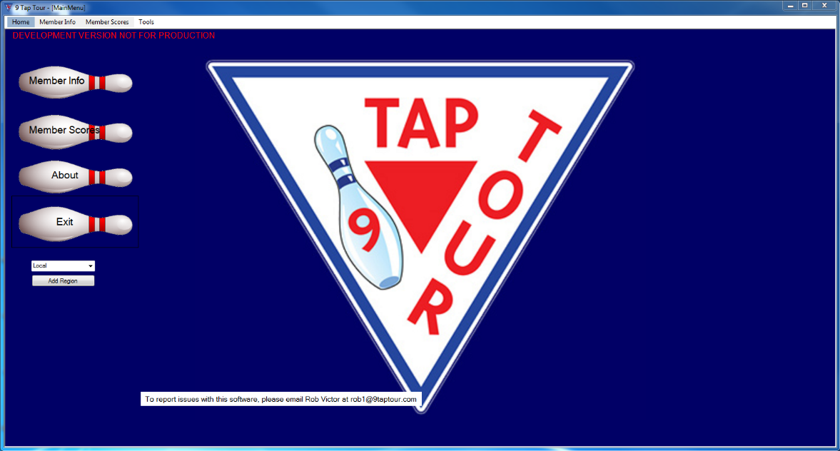
Figure 1: 9-Tap Main Menu

A good place to start

Quick start guide
You can find this on page 7.

Troubleshooting
You can find this on page 25.

Menus guide
An in-depth explanation of the program menus can be found starting on page 10.

Chapter
2

9-tap tour

Quick Start Guide

Quick Start Guide

hELPFUL Tips TO GET 9-tAP UP AND RUNNING.

What are the system requirements to run 9-Tap?
The system requirements: Windows 7 and above. 13MB free disk space. Optimized for 1366 X 768 screen resolution. USB port. Dot matrix and ink/laser-jet printers. Microsoft Excel must be installed on the computer for the 9-Tap Tour program to work.

How do I install 9-Tap?
- Start Windows and exit all other applications.
- Insert the 9-Tap Tour USB drive into your computer’s USB port. Or navigate to the download site. Download 9-Tap.exe.
- If the file manager dialog does not appear, click the Start button on your Windows taskbar, then click Run. Type D:\Setup and click on OK. (Note: If your removable USB drive is assigned a letter other than D, use that letter.)
- The installation wizard will now run.
- The next window will prompt you to shut down all other running programs before starting the 9-Tap Tour installation process. Do this and then click “Next” to continue.
- End User License agreement. Read the agreement, and if you agree to the terms and conditions chose “I agree.” Then click the “I Agree” button to continue the installation process.
- Next, chose an install location for the program. Either accept the default location or choose another location. Once you’re satisfied with your choice, click “Next” to continue installing.
- Select a Start Menu Folder for 9-Tap Tour. Either accept the default location or chose another. If you don’t want a Start Menu folder to be created check the box “Do Not Create A Start Menu Folder”. Once you are satisfied with your selection click the “Next” button to continue.
- Select the shortcuts you want created. Chose to create shortcuts on the Desktop, Quick Launch Toolbar, or neither. Once you are satisfied with your selection click on the “Next” button to continue.
- The 9-Tap Tour will now begin installing. When the “Install complete” message displays, click the “Next:” button to continue.
- The 9-Tap Tour program has now been successfully installed. Choose “Run 9 Tap Tour” to immediately launch the program, or “View ReadMe.txt” to view the ReadMe file where you can view updated program information made after the game manual was printed.
- Start Windows and exit all other applications.
- Insert the 9-Tap Tour USB drive into your computer’s USB port.
- If the file manager dialog does not appear, click the Start button on your Windows taskbar, then click Run. Type D:\Setup and click on OK. (Note: If your removable USB drive is assigned a letter other than D, use that letter.)
- The installation wizard will now run.
- The next window will prompt you to shut down all other running programs before starting the 9-Tap Tour installation process. Do this and then click “Next” to continue.
- End User License agreement. Read the agreement, and if you agree to the terms and conditions chose “I agree.” Then click the “I Agree” button to continue the installation process.
- Next, chose an install location for the program. Either accept the default location or choose another location. Once you’re satisfied with your choice, click “Next” to continue installing.
- Select a Start Menu Folder for 9-Tap Tour. Either accept the default location or chose another. If you don’t want a Start Menu folder to be created check the box “Do Not Create A Start Menu Folder”. Once you are satisfied with your selection click the “Next” button to continue.
- Select the shortcuts you want created. Chose to create shortcuts on the Desktop, Quick Launch Toolbar, or neither. Once you are satisfied with your selection click on the “Next” button to continue.
- The 9-Tap Tour will now begin installing. When the “Install complete” message displays, click the “Next:” button to continue.
- The 9-Tap Tour program has now been successfully installed. Choose “Run 9 Tap Tour” to immediately launch the program, or “View ReadMe.txt” to view the ReadMe file where you can view updated program information made after the game manual was printed.

How do I Launch 9-Tap?
Double click on the desktop icon or go to the program in the system menu and click on it. This will launch 9-Tap.

How do I import existing members?
On the Member Info screen, click on the “Import” button. When the file picker screen comes up, navigate to the Excel file you need to import. Select it and click OK.

How do I enter a new player?
On the Member Info screen, click the “New” button. The record will clear, and a new member number will appear in the Member Number field. Click in the field labeled “Last Name” and type the member’s last name, then tab to the next field. The member’s first and last name are required at time of creation. Save the record by clicking “Save”.

How do I create a tournament?
If the tournament has five (5) or fewer participants, DO NOT USE PROGRAM. Keep track of player data manually.
On the Member Scores screen, clicking on the “Create/Edit Tournament…” button launches the New Tournament screen. Tab in the Tournament Date field and enter the date of the tournament, then tab to the next field and type in the required information. Repeat the process until all required fields have been filled. LEAVE THE DOUBLES BOX UNCHECKED. If appropriate, check the “3 out of 4” box. Enter the number of squads in the Number of Squads field. Enter any notes on the tournament in the Notes field. Double check your information, then click “Create Tournament”.

How do I enter a member’s scores?
On the Member Scores screen, in the Tournament Files section, select a tournament from the drop-down menu. Once a tournament is selected, enter the member’s number, then press enter. The member’s information and status will auto-populate. Select the member’s squad. Enter the member’s scratch scores in a three-digit format. 9-Tap will tab through as the scores are entered. Double check that the entered scores are correct, then click “Add New/Update Record”.

Chapter
3

9-tap tour

Menus and Forms Guide

Start Menu

An indepth look at the 9-Tap program
After launching 9-Tap, the main menu screen will display. This is where the various functions of the program are accessed: “Member Info” button or tab; the “Member Scores” button or tab; the “About” and “Exit” buttons, as well as the “Region” picker and the “Add Region” button. The “Tools” tab accesses the active/inactive member dialog.

Figure 2: Main Menu

Member Info
The Member Info screen is where new member information is entered, or where current member information is updated, or from where member information Excel files are imported.
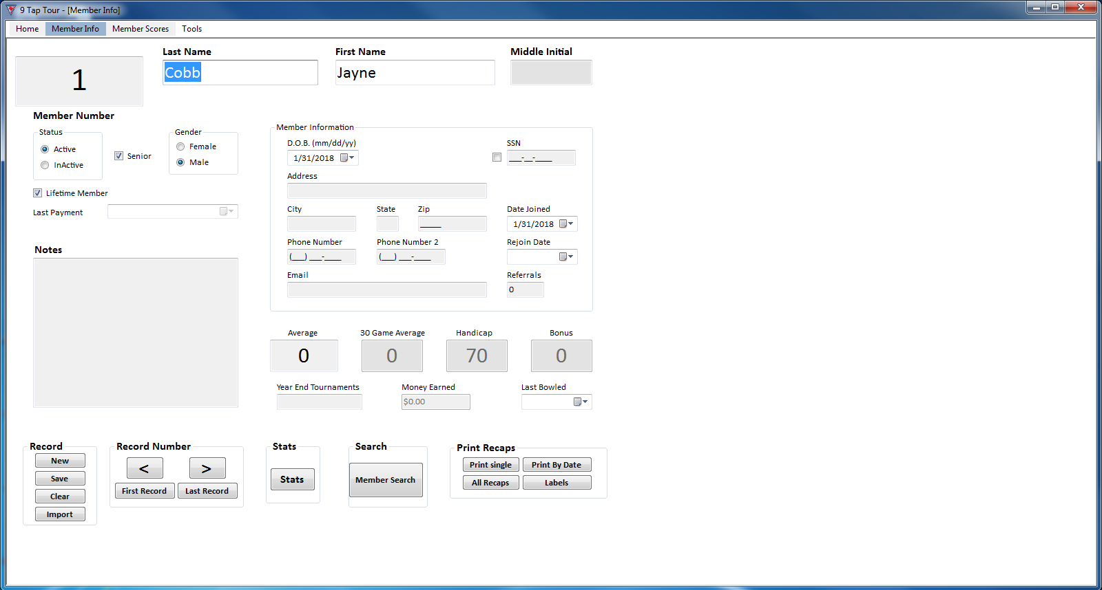
Figure 3: Member Information

Import Members
Note: If you are updating from the old version of 9-Tap, please see Chapter 5, Conversion Program.
In the Record box, click on the “Import” button. The import file window will open (see figure 10). Click on the Excel file to be imported to 9-Tap, then click “Open”. The member information will import to the member database.

New Members
On the 9-Tap Tour start page, click on either the button or tab labeled “Member Info”. The Member Info screen will appear. In the “Record” box, click on the button labeled “New”. The Member Info form will clear, and a new member number will appear in the “Member Number” field. Click in the field labeled “Last Name”. The cursor will appear, and the background will change color from grey to yellow. Type the member’s last name, then tab over to the next field and type the required information. Repeat the process until all the fields are filled. In the “Status” box, click on the status designator that best describes the member’s status, either “Active” or “Inactive”. Then click on the senior designator if the member is over 50 years old, and finally click on the member’s gender. If the new member wants their average score from another league as part of their data, tab through until you are in the “Average” field, then enter the new member’s average. Enter the date of the member’s last payment. If applicable, enter any notes in the note field. When the form is complete, click on the “Save” button in the Record box. The member information will automatically save to the database.

Figure 4: Member Information

Updating a member.

Clicking on the “Member Search” button displays the member search screen (figure 7). This is where 9-Tap member’s information may be searched for by either member number, name, average, handicap, or bonus. The cursor will automatically appear in the “Number” field. To initiate a search, enter the member number, then press the enter or “Search”. The rest of the form will auto-populate. The user may refine the search by entering the member first and last name, then press enter or click the “Search” button. The search results will display in a data box on the search screen. To display all members in the database, leave the fields blank then press enter or click on the “Search” button. Click on the member whose information that needs updating, then click “Select”. The member’s information will display on the Member Info screen. Make the necessary updates to the member’s information. Then click “Save”. The updates will be saved to the member database.

Stats
Clicking on the “Stats” button displays a member’s individual stats screen. From this screen, the 9-Tap user can correct or update member statistical information or create a pdf copy of the player stats to print and/or save. The example below is blank because there are no stats for that member.
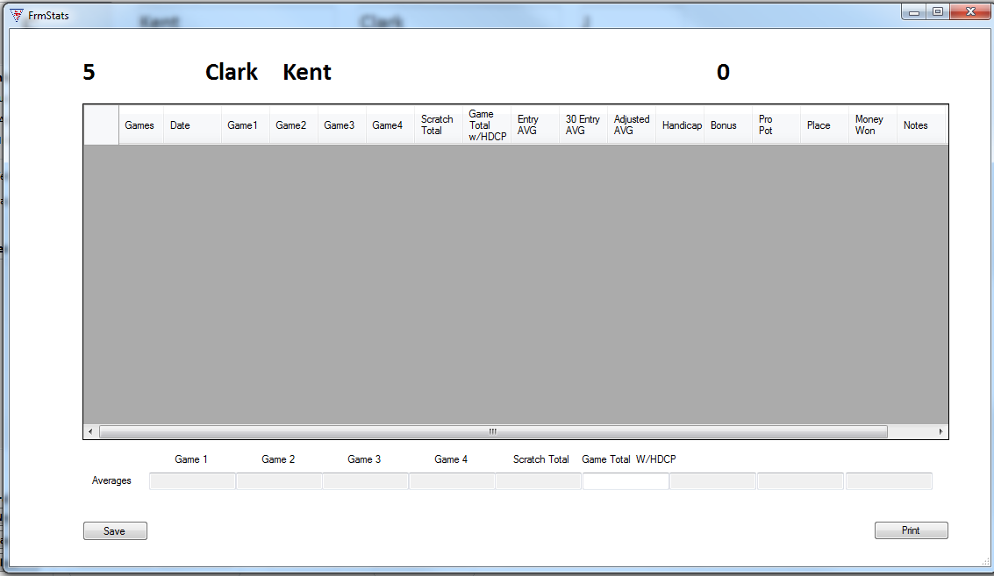
Figure 5: Stats Form

Member Search
Clicking on the “Member Search” button displays the member search screen. From here member records are made available to display, and/or update. Do not check “Advance View” if “Search” has not already been clicked.
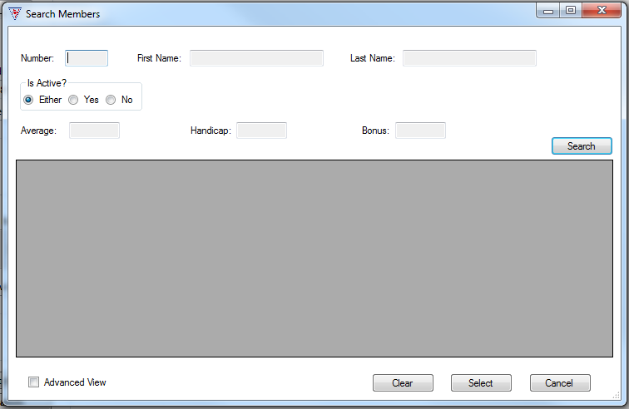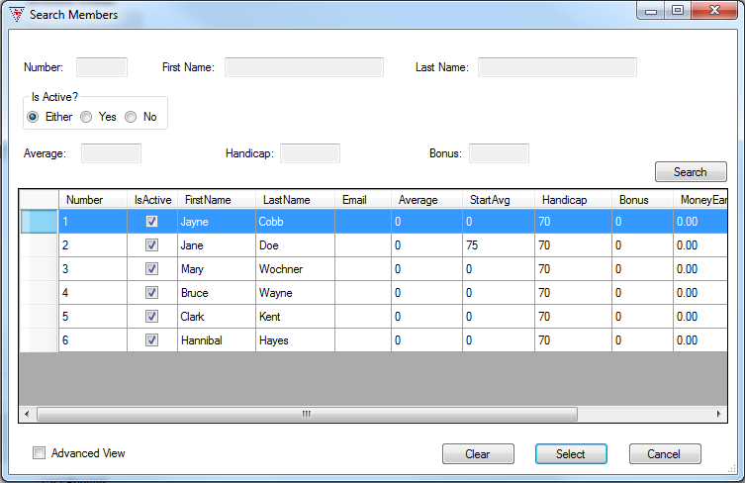
Figure 6: Member search, blank and with results

Print Recaps
The “Print Single” and “Print Tournament” buttons open the computer’s print dialog, where a copy of the desired data can be printed and/or saved as a pdf file. The “Print by Date” button opens the print by date screen, from where a date range can be set to print and/or save multiple tournaments.
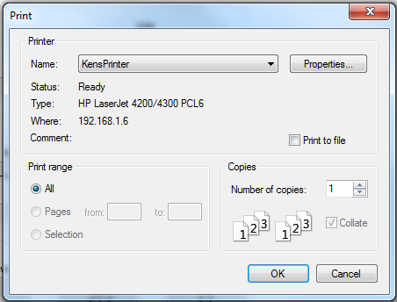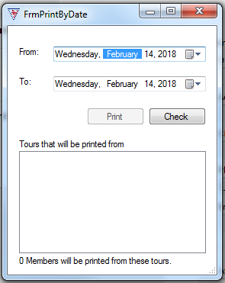
Figure 7: basic printer dialog, Print by Date form.

Import
The “Import” button opens the file screen, from where an existing Excel file of member information is imported to 9-Tap.
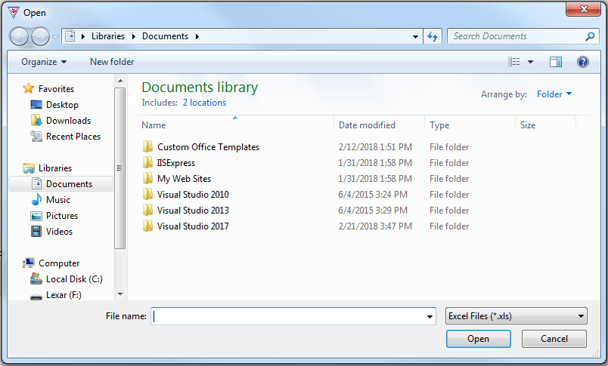
Figure 8: Importing existing player information

Member Scores
If the tournament has five (5) or fewer participants, DO NOT USE PROGRAM. Keep track of player data manually.
Clicking on either the Member Scores button or tab displays the Member Scores screen, where tournaments are created and where member scores are entered. A tournament must be created before the member scores can be entered. See Create/Update Tournament.
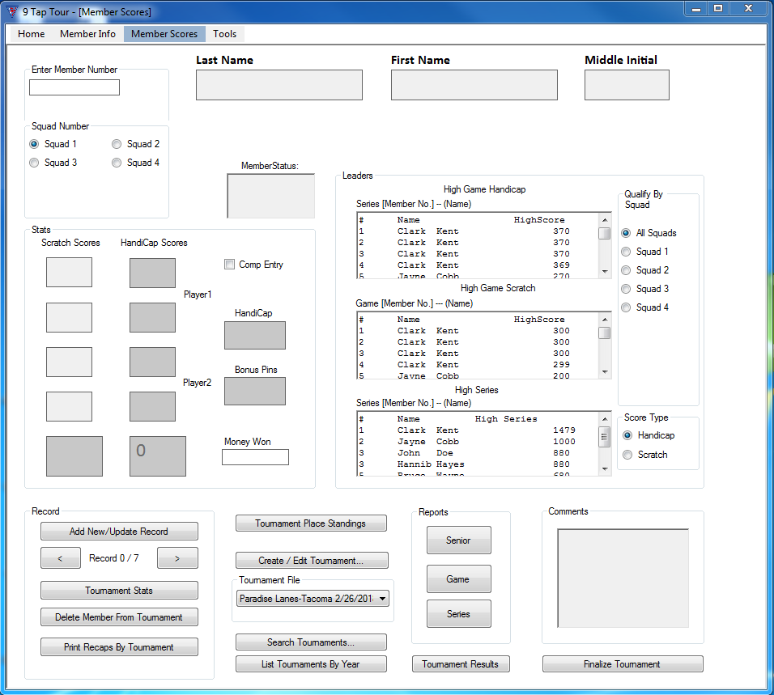
Figure 9: Member Scores
From the Tournament File drop down menu, pick the tournament for which you are entering member scores. Click in the “Enter Member Number” and type the member number of the member your need to input data, then press enter. The form will auto-populate the rest of the fields. In the box labeled “Qualify By Squad”, click on the squad to which the member belongs. In the Stats field, enter the bowler’s first scratch score in the first Scratch Scores field. Use a three-digit format. 9-Tap will then auto-tab to the next score field. Continue entering the member scores until the final Scratch Scores field has been filled in. Double check the entries for accuracy. Then click the “Add New/Update Record” button. The member scores are now saved to the database.

Tournament Stats
Clicking on the “Tournament Stats” button displays the Tournament Statistics screen. This displays the statistics for each member participating in a given tournament. From here a copy of it can be printed and/or saved by clicking print and then selecting the ques in the print dialog box for your computer.
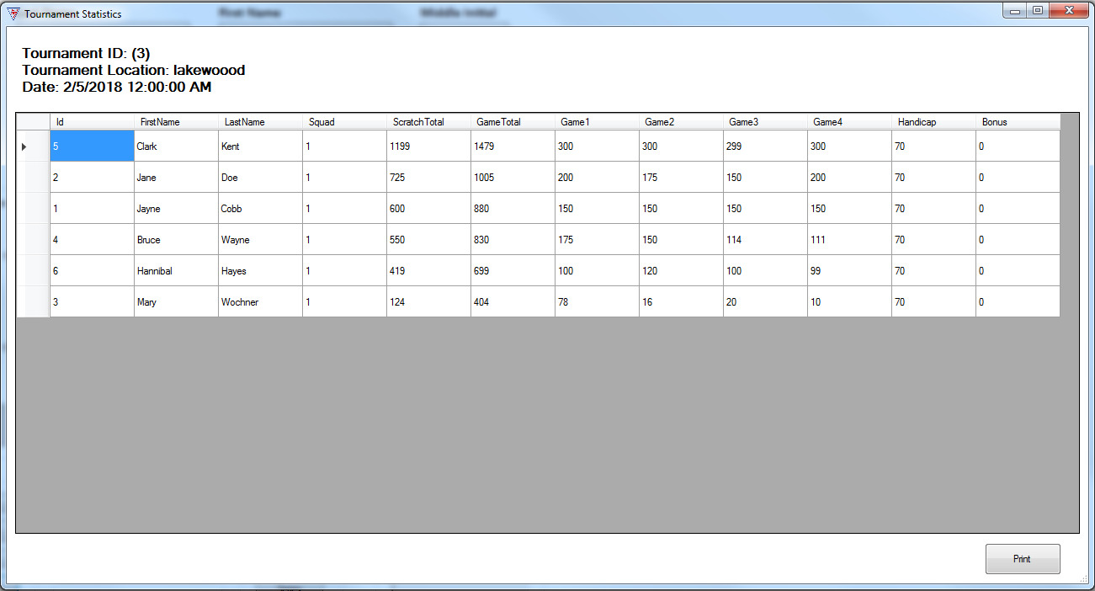
Figure 10: Tournament Stats Form

Print Recaps By Tournament
In the Member Scores screen, clicking on the “Print Recaps By Tournament” button displays the print dialog, from where a recap can be printed or saved.

Figure 11 Print Dialog

Tournament Place Standings
From the Member Scores screen, clicking the “Tournament Place Standings” button displays the Tournament Place Standings screen for the current tournament. It lists the bowlers in member number order.
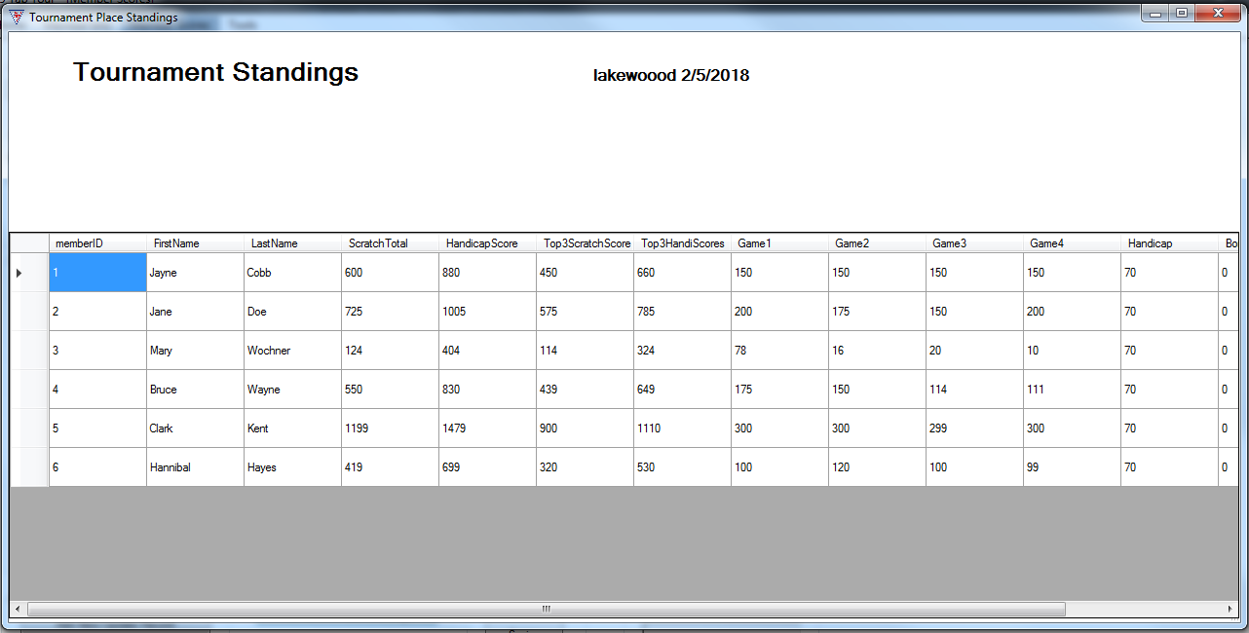
Figure 12: Tournament Place Standings

Create/Edit Tournament
From the Member Scores screen, clicking on the “Create/Edit Tournament…” button displays the New Tournament screen. Select the tournament date. Fill in the name of the bowling center in the Location field. Put the name of the event in the Event field. List the sponsors in the Sponsors field. DO NOT CHECK THE DOUBLES BOX. If it’s a three out of four tournament, check the “3 out of 4” box. Fill in the number of squads in the Number of Squads field. The default is 4. Any necessary tournament notes should be entered in the Notes field. Double check the entries for accuracy. Click “Create Tournament” to save the entry.
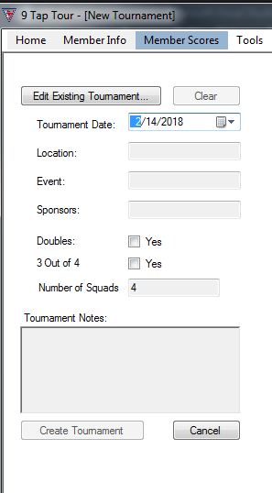
Figure 13: Create/Edit Tournament Form

To Update an Existing Tournament
Click on the “Create/Edit Tournament” button. On the New Tournament screen, click “Edit Existing Tournament…” This will bring up the “Search Tournaments” screen (figure 14). See Search Tournaments for the search function. Click on the tournament that requires editing, then revise whatever information that needs revision and save the entry.

Search Tournaments
Tournaments can be searched by location, event, or tournament date. This function is accessed through either the “Edit Existing Tournament” button on the New Tournament screen, or by the “Search Tournaments…” button on the Member Scores screen.
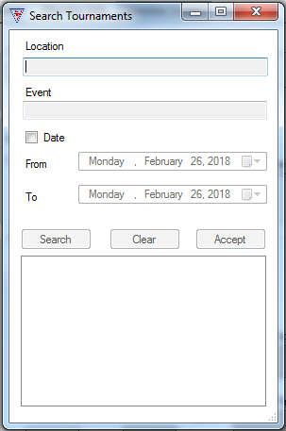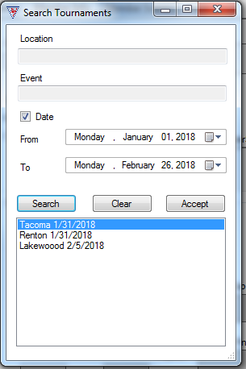
Figure 14: Tournament Search Forms

Search by Location

To search a tournament by location, enter the name of the bowling center in the “Location” field. Then click “Search”. Click on the tournament, then click “Accept”.

Search by Event
To find a tournament by event, enter the name of the event in the “Event” field, then click “Search”. Click on the tournament from the list, then click “Accept”.

Search by Date
To find a tournament by date, check the “Date” box. Then choose the date range with the “From” and “To” date fields. Then click “Search”. Choose the tournament from the list, then click “Accept”.

List Tournaments by year
The “List Tournaments By Year” button displays the screen that lists Tournaments by Year. To display tournaments for a year, choose the year from the drop down menu, the tournaments from that year will appear.
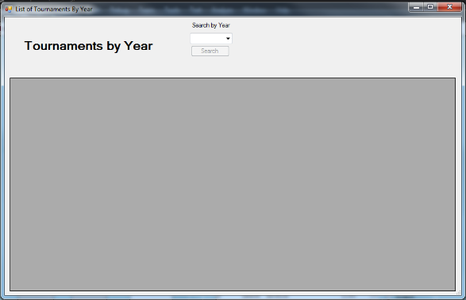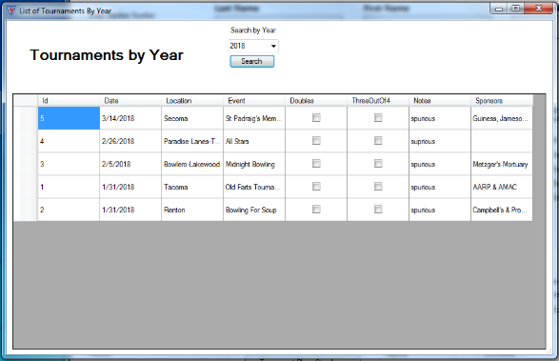
Figure 15: Tournaments by Year

Reports
In the Reports field, you can access the member scores reports through either the “Seniors”, or “Game”, or “Series” buttons. Clicking the appropriate button for the needed report will open the Member Scores Reports dialog. Enter the number of top places in the field and click “Print”. This goes to the print dialog where it can be printed to pdf and saved or printed directly.
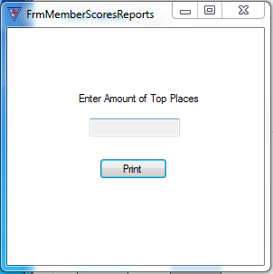
Figure 16 Member Scores Reports screen

Tournament Results
The “Tournament Results” button, on the Member Scores screen, launches the Tournament Results Screen. This screen displays how the members have placed, the member name, handicap, total score, and earnings. If the player won money, it is entered under earnings. The changes can then be saved to the database by clicking the “Save Changes” button. Also the tournament results can be exported to an Excel file by clicking the “Export To Excel” button.
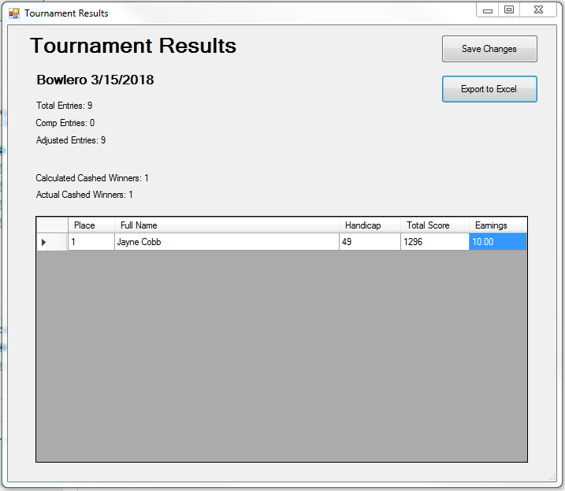
Figure 17 Tournament Results screen

Comments
On the Member Scores Screen, comments regarding the tournament can be entered in the Comments field.

Finalize Tournament
On the Member Scores screen, the “Finalized Tournament” button launches the Finalize Tournament screen. The tournament director uses this screen to finalize the member scores for the selected tournament. The director determines if the scores are valid. If needed the director can uncheck the “Valid Score” box for the respective score so it is not included in calculating the bowler’s average. The director then enters the adjusted average in the ADJ AVG field. The Adjusted Average determines the member’s handicap for the next tournament in which they are competing. Once the information has been validated, the director checks off the “Director Check” boxes. Then “Finalize” is clicked and the information is saved to the database.
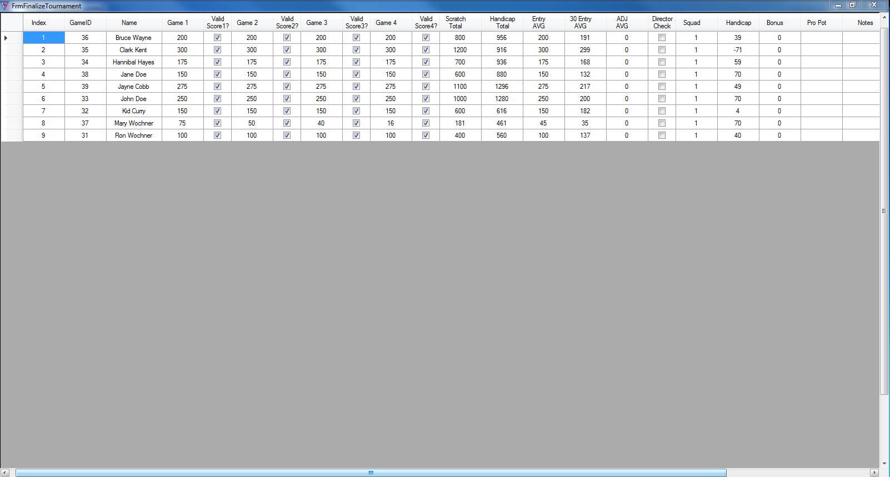
Figure 18 Finalize Tournament Screen

Tools
Under Tools you will find the Update Inactive Members screen. Pick the date to find which members haven’t bowled for more than 180 days. You can click the check box by the names of the players to update to inactive status. Click “Update” to update the member information.
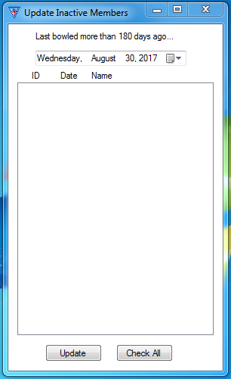
Figure 19: Update Inactive status screen

Chapter
4

9-tap tour

Troubleshooting

Troubleshooting 9-Tap

WARNINGS:
If the tournament has five (5) or fewer participants, DO NOT USE PROGRAM. Keep track of player data manually.
Doubles tournaments are not supported by the software at this time.
LEAVE DOUBLES UNCHECKED ON THE NEW TOURNAMENT SCREEN/DIALOG.
Do not start a new tournament before the current tournament you are working on has been finalized.

Screen “splitting” on resize
When resizing the 9-Tap program the screen may split into individual screens contained within the main program display screen.
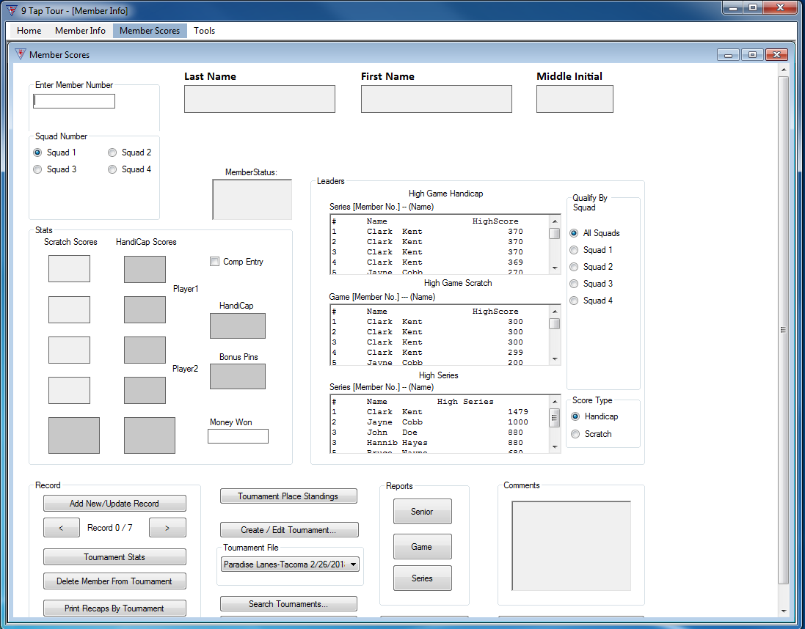
Figure 20 Showing split screen error

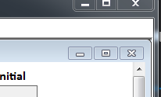
If the display splits, you can click maximize for the individual screens. They will return to normal. You can then continue working with the program.
Figure 21 Inner screen maximize

ReadMe File
The 9 Tap Tour program contains a ReadMe file where you can view updated program information. We strongly encourage you to take the time look over this file to get information on changes made after this manual went to print.
To view this file, double-click on it in the 9 Tap Tour directory found on your hard drive (usually C:\Program Files\9TapTour\docs\readme_en.txt). You can also view the ReadMe file by clicking on the Start button on your Windows taskbar, then on Programs, then on 9 Tap Tour, then on View Readme.txt.

Chapter
5

9-tap tour

Conversion Program

Conversion Program
Conversion from old version of 9-Tap program for the Las Vegas and Hawaii regions. (Talk to Xavier to get outline/details of the steps. Have emailed him 3/14/18)

Chapter
6

9-tap tour

General Information

General Information

Main Menu
Launch 9 Tap Tour. Once it’s running you should see the Main Menu screen. To enter bowler information or scores there are two main ways to get there, the tabs across the top and the left hand buttons.
The top tabs are:
- Home—this tab takes you back to the Main Menu.
- Member Info—this tab takes you to the Member Information form.
- Member Scores—this tab takes you to the Member Scores Form. From there, you can access Tournament creation and editing functions.
- Tools—this tab takes you to the active/inactive member update dialog.
The left hand buttons are:
- Member Info—Left click on this to go to the member information form. Here is where new member information is entered and saved. Player statistics can be found here too. Also importing member information from Microsoft Excel files is done here
- Member Scores—accesses the Member Scores form. From there, access Tournament forms
- About—About the 9Tap Tour
- Exit—exits the 9Tap Tour program
- Region—drop down menu to pick location. Default is “local”.
- Add Region—goes to “Add Region” dialog.

Member Info
On the Member Info screen you can enter a new, update an existing member, or import existing member information from an Excel file.
- Member Number—the member number auto generates.
- Last Name—member’s last name. Required field.
- First Name—member’s first name. Required field.
- Middle Initial—member’s middle initial.
- Member Information area.
  - D.O.B.—member’s date of birth, mm/dd/yyyy format.
  - SSN—member’s social security number, not displayed by default. To show the member’s SSN, check the box to the left of the field.
  - Address—member’s street address.
  - City—member’s city.
  - State—member’s state.
  - Zip—member’s zip code.
  - Email—member’s email.
  - Date Joined—date the member joined.
  - Rejoin Date—date the member rejoined.
  - Referrals—track number of bowlers referred by the member. Once they have five confirmed referrals, the member becomes a lifetime member. A confirmed referral has joined the tour and bowled in three tournaments.
- Average—where the member’s average displays. For a new member, where her average can be entered, with proof of the average from another league.
- 30 Game Average—member’s average over the last 30 games he’s bowled.
- Handicap—member’s handicap, calculated by the program.
- Bonus—bonus pins. If the member gets bonus pins, this is where they are entered.
- Year End Tournaments
- Money Earned—prize money earned by the member from tournaments.
- Last Bowled—date member last bowled.
- Record section.
  - New—starts a new record.
  - Save—saves member information to the database.
  - Import—imports member information from an excel file.
- Record Number section. For navigation between records by record number.
  - <—goes one record back
  - >—goes one record forward
  - First Record—goes to first record
  - Last Record—goes to last record
- Stats section
  - Stats— this button brings up currently selected member’s statistics.
- Search section
  - Member Search—this button brings up member search screen, used to search for member records.
- Print Recaps section
  - Print Single—this button launches your computer’s print dialog. Prints a single member’s record.
  - Print By Date—this button brings up the print by date dialog screen.. Prints a range of records by date.
  - Print By Tournament—this button launches your computer’s print dialog. Prints member record by tournament.

Member Scores
The Member Scores screen is where the members’ scores recaps are entered into the database. It’s also where tournaments are created and edited. In order to enter scores, a tournament must be created and selected.
- Enter Member Number—the bowler’s member number is entered here.
- Last Name—after the member number is entered, this field auto-populates with the member’s last name.
- First Name—after the member number is entered, this field auto populates with the member’s first name.
- Middle Initial—after the member is entered, this field auto populates with the member’s middle initial.
- Squad Number—pick the squad the member bowled in for this tournament.
- Member Status—after the member number is entered, this field auto-populates with the member’s active/inactive status. Scores can only be entered for an active member.
- Stats section
  - Scratch Scores—where the member’s four scratch scores are entered. The total is automatically calculated and displayed after the fourth score.
  - Handicap Scores—the member’s adjusted scores from her bowling handicap are automatically calculated and displayed.
  - Comp Entry—this is checked if the member had a comped entry in the tournament.
  - Handicap—the member’s bowling handicap, auto displayed.
  - Bonus Pins—if the member has bonus pins, this is where they would be displayed.
  - Money Won—if the member wins money, it is displayed here. The winnings are entered on the Tournament Results Screen.
- Leaders section
  - High Game Handicap—displays the tournament standings by handicap high scores.
  - High Game Scratch—displays the tournament standings by high game scratch scores.
  - High Series—displays the tournament standings by high series scores.
  - Qualify By Squad—picks which squads are displayed.
  - Score Type—picks whether scores are displayed by handicap or scratch.
- Records section
  - Add New/Update Record—after the member’s scratch scores have been entered and checked for accuracy, this button adds them to the tournament. Before a tournament has been finalized, a member’s scores can be updated.
  - “<”—this button goes one record back.
  - “>”—this button goes one record forward.
  - Tournament Stats—this button displays the current tournament’s stats.
  - Delete Member From Tournament—this button will, before a tournament has been finalized, delete a member from the tournament.
  - Print Recaps By Tournament—this button launches the print dialog. Prints out the tournament recaps.
- Tournaments section
  - Tournament Place Standings—this button displays the current tournaments place standings.
  - Create/Edit Tournament—this button launched the New Tournament screen. From there you can create a new or edit an existing tournament.
  - Tournament File—a drop down menu display from which to pick a tournament.
  - Search Tournaments—this button launched the Tournament Search screen.
  - List Tournaments By Year—this button launches the List Tournaments by Year Screen.
- Reports Section. The buttons here launch the Member Scores Reports screen. You can chose what the reports contain by way of the buttons.
  - Senior—this button pulls member scores from those 50 years and older that bowled in the tournament.
  - Game—this button pulls member scores by game from the tournament.
  - Series—this button pulls member scores by series from the tournament.
- Tournament Results—this button launches the Tournament Results screen. You can view the results, enter member earnings from the tournament, if any, and update the database or save it to an Excel file.
- Comments section—comments about the tournament can be entered in this field.
- Finalize Tournament—this button launches the Finalize Tournament screen. The Tournament director can verify member scores and adjust member averages, if necessary. Once the information has been verified, the director can finalize the results to the database.

Tools
The update member status screen is launched from the tools tab.

About
Clicking the “About” button on the Main Menu launches the About 9-Tap screen.

Exit
Clicking the “Exit” button exits the program.

Index

About, 32, 37
About 9 Tap Tour, 4
Add Region, 11, 32
Average, 13, 24, 33
Bonus, 33, 35
Comments, 23, 37
Comp Entry, 35
Conversion Program, 30
Create/Edit Tournament, 9, 20, 36
Delete Member From Tournament, 36
Edit Existing Tournament…, 20
Exit, 11, 32, 37
Finalize Tournament, 23, 37
General Information, 32
Handicap, 33, 35, 36
High Game, 36
High Series, 36
Home, 32
import existing, 16, 32
Import Existing Members, 12
Last Bowled, 34
List Tournaments By Year, 22, 37
Main Menu, 5, 11, 32, 37
Member Info, 9, 11, 12, 14, 32
Member Number, 17, 33, 35
Member Scores, 9, 11, 17, 18, 19, 20, 21, 22, 23, 32, 35
Member Scores Reports, 22, 37
Member Search, 13, 15, 34
Member Status, 35
Menus Guide, 5, 10
Money Earned, 34, See Money Won
Money Won, 35
New Members, 12
Print Recaps, 16, 34
Print Recaps By Tournament, 18, 36
Qualify By Squad, 36
Quick start, 5
Quick Start, 7
ReadMe File, 28
Record, 9, 12, 17, 18, 34, 36
Region, 11, 32
Reports, 22, 37
Score Type, 36
Search by Date, 21
Search by Event, 21
Search by Location, 21
Search Tournaments, 21, 37
Squad Number, 17, 35
Stats, 14, 17, 34, 35
system requirements, 7
Tools, 25, 32, 37
Tournament File, 17, 36
Tournament Place Standings, 19, 36
Tournament Results, 23, 35, 37
Tournament Stats, 18, 36
Tournaments, 36
Troubleshooting, 5, 26, 27
Updating Members, 13
Year End Tournaments, 34

