Volume
1
9-Tap TOUR

User Manual
9-Tap tour

User Manual
© 9-Tap Tour
PO Box 931
Sumner, WA 98390
Phone 253.987.7975
Email: rob1@9taptour.com

Table of Contents
About 9 Tap Tour INC 4
Dedication: 5
What is 9-Tap? 5
A good place to start 5
Quick start guide 5
Troubleshooting 5
Menus Guide 5
Quick Start Guide 7
What are the system requirements to run 9-Tap? 7
How do I install 9-Tap? 7
How do I Launch 9-Tap? 8
How do I import existing members? 8
How do I enter a new player? 8
How do I create a tournament? 8
How do I enter a bowler’s scores? 8
Main Menu 10
Member Info 11
Import Existing Member 11
New Members 11
Updating Members 13
Stats 14
Member Search 15
Print Recaps 16
Import 16
Member Scores 17
Tournament Stats 18
Print Recaps By Tournament 18
Tournament Place Standings 19
Create/Edit Tournament 20
To Update an Existing Tournament 21
Search Tournaments 21
Search by Location 21
Search by Event 21
Search by Date 22
List Tournaments By Year 22
Reports 23
Tournament Results 24
Comments 24
Finalize Tournament 26
Tools 31
Troubleshooting 9-Tap 34
WARNINGS: 34
Screen “splitting” on resize 34
ReadMe File 36
Conversion Program 39
General Information 41
Main Menu 41
Member Info 41
Member Scores 43
Tools 46
About 46
Exit 46
Index 47
Glossary …………………………………………………………40

Chapter
1

9-Tap tour

Welcome

About 9 Tap Tour INC
Welcome to the 9 Tap Tour Program. 9-Tap Tour, INC. is a unique, fun and professionally run tournament. Members enjoy our “Beat the Board” format, with four games per squad. Yet the fun, big payouts, special pots and the 9-Tap version of bowling itself, brings new excitement to tournaments.
Approximately one bowler in every 5 entries will cash. Other optional ways to cash are: 9-Tap Jackpot, Progressive Pot, high game pots, brackets, scratch game and series pot, and more depending on where & when you bowl these “Side Pots” may vary from time-to-time. 9-Tap TOUR also has BIG ‘Added money' Quarterly Championships, specials, promotions and doubles tournaments. Each Quarterly Tournament may have eligibility requirements for members who bowl during that Quarter.
Prize money is paid at the Tournament site at the conclusion of each tournament. The tournament winner, low to cash score, and new progressive pot totals will be posted on our web site, available immediately after each tournament. Past results are also available on our web site.
Our rules, which default to USBC in many areas, protect our members and ensure fair play. We are proud to be USBC Certified.
First place and prize fund moneys are based on the number of entries and will vary depending on where you bowl. Special Added money & Quarterly tournaments will pay higher amounts. Regional or National tournaments (in 9-Tap's future), will have much higher amounts.
Our goal is to provide an enjoyable experience for all of our members, with a fair opportunity for both low and higher average bowlers. 9-Tap TOUR INC appreciates your participation. We hope you will enjoy our tournaments and if you do please refer us to other bowlers. We ask for, and welcome comments and suggestions.
THANK YOU!
Rob Victor - Director
Steve Freeman – Director

Dedication:
Who did the work?

What is 9-Tap?
9-Tap is a purpose built, full featured bowling tournament management software system with a variety of different functions.
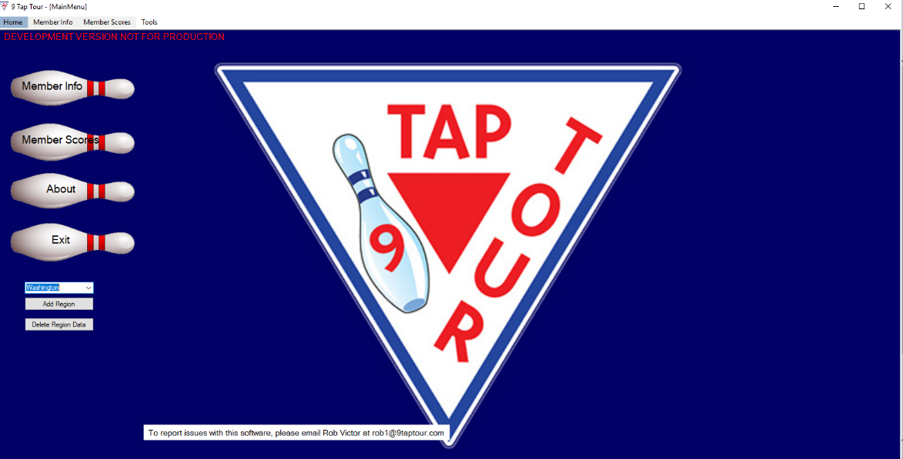
Figure 1: 9-Tap Main Menu

A good place to start

Quick start guide
You can find this on page 7.

Troubleshooting
You can find this on page 33.

Menus Guide
An in depth explanation of the program menus can be found starting on page 10.

Chapter
2

9-Tap tour

Quick Start Guide

Quick Start Guide

Helpful Tips TO GET 9-Tap UP AND RUNNING.

What are the system requirements to run 9-Tap?
The system requirements: Windows 7 and above. 13MB free disk space. Optimized for 1366 X 768 screen resolution. USB port. Dot matrix and ink/laser-jet printers. Microsoft Excel must be installed on the computer for the 9-Tap Tour program to work.

How do I install 9-Tap ?
- Start Windows and exit all other applications.
- Insert the 9 Tap Tour USB drive into your computer’s USB port. Or navigate to the download site. Download 9-Tap.exe.
- If the file manager dialog does not appear, click the Start button on your Windows taskbar, then click Run. Type D:\Setup and click on OK. (Note: If your removable USB drive is assigned a letter other than D, use that letter.)
- The installation wizard will now run.
- The next window will prompt you to shut down all other running programs before starting the 9 Tap Tour installation process. Do this and then click “Next” to continue.
- End User License agreement. Read the agreement, and if you agree to the terms and conditions choose “I agree.” Then click the “I Agree” button to continue the installation process.
- Next, choose an install location for the program. Either accept the default location or choose another location. Once you’re satisfied with your choice, click “Next” to continue installing.
- Select a Start Menu Folder for 9 Tap Tour. Either accept the default location or choose another. If you don’t want a Start Menu folder to be created check the box “Do Not Create A Start Menu Folder”. Once you are satisfied with your selection click the “Next” button to continue.
- Select the shortcuts you want created. Choose to create shortcuts on the Desktop, Quick Launch Toolbar, or neither. Once you are satisfied with your selection click on the “Next” button to continue.
- The 9 Tap Tour will now begin installing. When the “Install complete” message displays, click the “Next:” button to continue.
- The 9 Tap Tour program has now been successfully installed. Choose “Run 9 Tap Tour” to immediately launch the program, or “View ReadMe.txt” to view the ReadMe file where you can view updated program information made after the game manual was printed.

How do I Launch 9-Tap?
Double click on the desktop icon or go to the program in the system menu and click on it. This will launch 9-Tap.

How do I import existing members?
On the Member Info screen, find the import button. Click on it. When the file picker screen comes up, navigate to the Excel file you need to import. Select it and click OK Also see the Conversion Program chapter.

How do I enter a new player?
On the Member Info screen, Click “New” button. A new blank record will display. Start filling in the player’s information, first and last name are required at time of creation. Save the record by clicking “Save”. Refer to “New Members” under the Member Info section of the manual for more detailed information.

How do I create a tournament?
On the Member Scores screen, click on the “Create/Edit Tournament …” button. This launches the New Tournament screen. Use the Tournament Date field to enter the date of the tournament. Fill in the Location field with the name of the bowling alley. Enter the name of the event in the Event field. Enter the sponsors in the Sponsors field. If appropriate, check the 3 out of 4 box. Enter the number of squads in the Number of Squads field. If needed enter notes on the tournament in the Notes field. Double check your information, then click “Create Tournament”.

How do I enter a bowler’s scores?
On the Member Scores screen, in the Tournament Files section, select a tournament from the drop-down menu. Once the tournament is selected, enter the member’s number and click enter. The player information and status will auto-populate. Select which squad they bowled in. Enter the player’s scratch scores in a three-digit format. 9-Tap will tab through as the scores are entered. Before clicking “Add New/Update Record” double check that the entered scores are correct.

Chapter
3

9-Tap tour

Menus Guide

Main Menu
When launching 9-Tap, the user will be greeted by the main menu of the program. The varying functions of the program may be accessed here. From the top of the window there are tabs for Home, Member Info, Member Scores, and Tools. To the left most of the window are buttons for Member Info, Member Scores, About, and Exit. Below these buttons is a dropdown list for the region of 9-Tap, the Add Region button, and the Delete Region button. Clicking a tab or a button will take the user to the part of the program specified. Clicking About will display information regarding the 9-Tap tournament.

An indepth look at the 9-Tap program
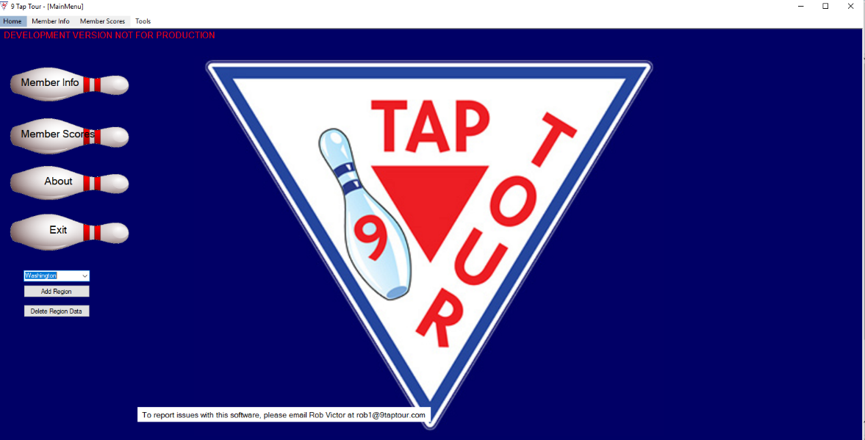
Figure 2: Main Menu

Regions
9-Tap is currently divided into two separate regions, those two being Washington state and Hawaii. As 9-Tap expands more regions may be added to the program. A region can be added to the program by clicking the Add Region button. This will open a window for the region’s name to be entered into. Pressing the Submit button in this window will add the region to the 9-Tap database. If a mistake was made in creating a region, or a region needs to be dropped from 9-Tap there is the Delete Region Data button. Clicking this button will open a prompt to delete the last region added to 9-Tap from its database. Note that the button will not delete the currently selected region from the drop down menu, but the region which was most recently added to 9-Tap.

Member Info
The Member Info screen is where new players are entered; member information is updated; and member information can be imported from Excel files.
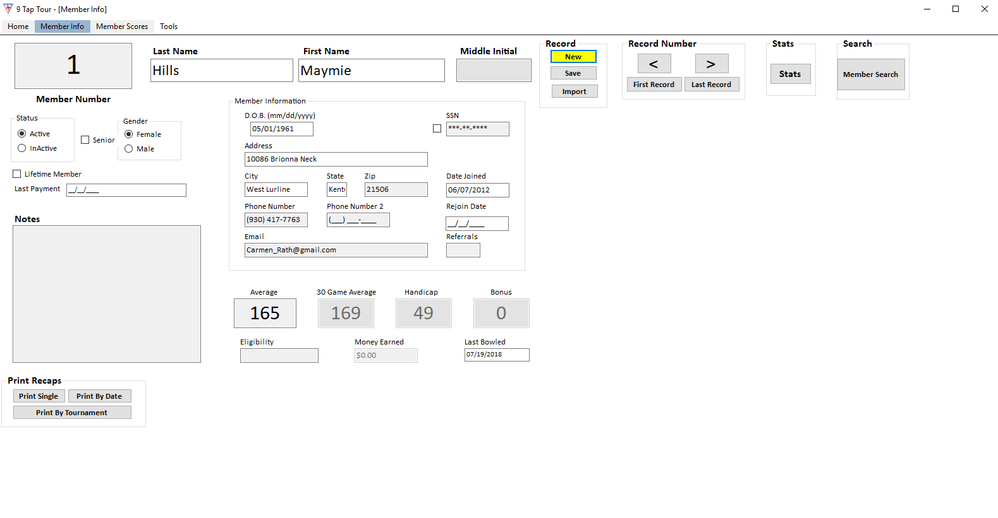
Figure 3: Member Information

Import Existing Member
In the Record box, click on the “Import ” button. The import file window will open, see figure 10. Choose the Excel file to be imported, double checking it’s the correct member’s file, then click “Open”. The member information will now be imported to the member database. If you are updating from the old version of 9-Tap, please see Chapter 5, Conversion Program.

New Members
To add a new member, begin by clicking the Member Info button you’ll see when the 9-Tap program is opened. This will take you to the Member Info form. Immediately to the right of the box labeled Middle Initial, there is the Record box. Click the New button to be prompted if you’d like to add a new member into the 9-Tap database. Once the New button is clicked, begin to fill out the information for the specified member. Note that the first and last name are the only fields explicitly required before a member is added into the database. Information can be added in or updated for member at any time from the Member Info page. Data can be quickly entered into the form by pressing tab on the keyboard. The following data can be entered and logged in the database in this tab order:
- First name, last name, middle initial.
- Member status: whether the member active or inactive.
- Gender: gender of the member, male or female.
- Lifetime member checkbox: whether the member is a lifetime member or not.
- Last Payment: Date of last payment for membership
- Record box: the New and Save buttons respectively
- D.O.B. : Date of birth
- SSN: Social Security number. Hidden and can be unhidden by clicking the checkbox next to SSN.
- Address: Home address of the member
- City: City in which the member lives
- State: State in which the member lives.
- Zip code: The zip code of the member
- Phone number : Phone number of the member
- Phone number 2 : a second phone number of the member
- Email: the email address of the member
- Date joined: date the member joined 9-Tap
- Rejoin Date: date the member rejoined 9-Tap if they were inactive
- Referrals: number of referrals the member has made toward lifetime membership
- Player average: the player’s average
- Eligibility: Eligibility for what?
- Last bowled: the date the member last played in a bowling game

The following fields are not able to be tabbed into:
- Senior checkbox: used to confirm if the member is a senior.
- Notes: notes for the member.

The following fields are calculated automatically or otherwise unable to be modified in Member Info:
- 30 game average: the player’s calculated average over the last 30 games played.
- Handicap: the player’s handicap, defaults to 70 and is calculated by the player’s current average.
- Bonus: Total number of bonus pins?
- Money earned: the amount of money the player has earned in their time with 9-Tap.

After the desired or required information is input into the form, click the Save button in the Records section of the form to be prompted to save a new member into the 9-Tap database. If the last name or first name aren’t entered then the user will be prompted to enter them. Empty name boxes will be highlighted in red.

Figure 4: Member Information

Updating Members
Click on the “Member Search ” button. The member search screen will display (figure 6). Members can be searched by number, name, average, handicap, or bonus. Enter the search parameters and click “Search”. The results display at the bottom of the screen. To display all members in the database, leave the fields blank and click “Search”
Select the member to be updated and click “Select”. The member will now be displayed on the Member Info screen. Make updates to the member’s information. Then click “Save”. The updates will be saved to the member database. When switching between Members using the Record Number navigation buttons, the changes made if any will be saved.

Stats
The “Stats” button brings up a member’s individual stats. From this screen, the Director can correct information, if necessary, and save. Or the player stats can be printed to a pdf to save then printed to have a hard copy. If a member has won a tournament their bonus pin field will be shaded red to indicate that their pins have been reset.
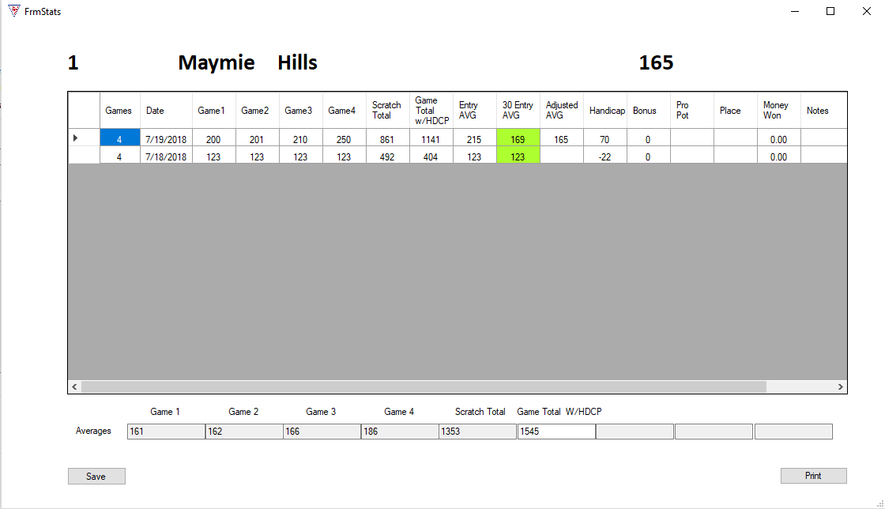
Figure 5: Stats Form

Member Search
Clicking on the “Member Search ” button will display the member search screen. The member search button is located furthest right of the Member Info form. From here you can search the member records and select a record to display or update. Do not check “Advance View” if “Search” has not already been clicked.
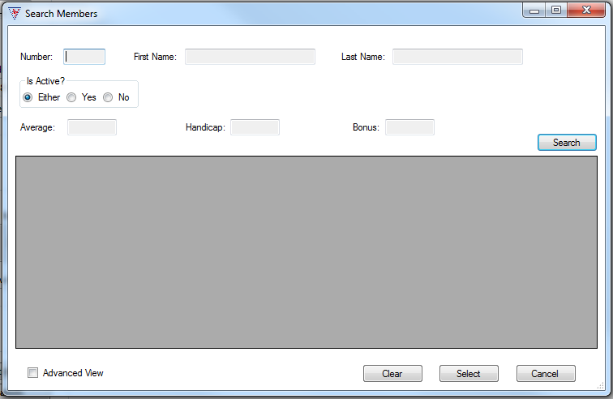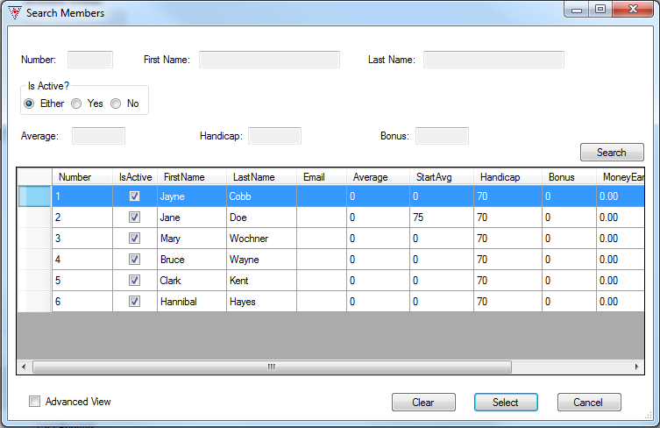
Figure 6: Member search, blank and with results

Print Recaps
The “Print Single” and “Print Tournament” buttons go directly to your computer’s print dialog. You can then “print to pdf” to save the information as a pdf file. The “Print by Date” button opens the print by date screen. You can enter a date range to print multiple tournaments from here.
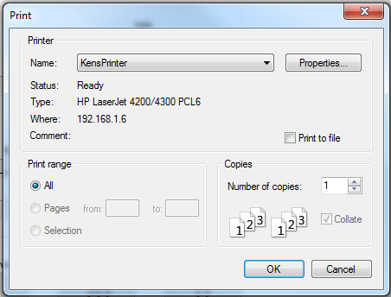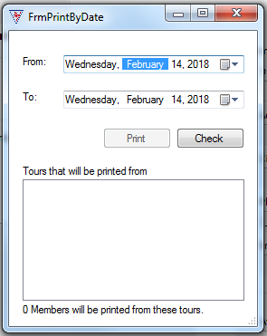
Figure 7: basic printer dialog, Print By Date form.

Import
The “Import ” button brings up the file screen. This is used to import existing player information from an Excel file.
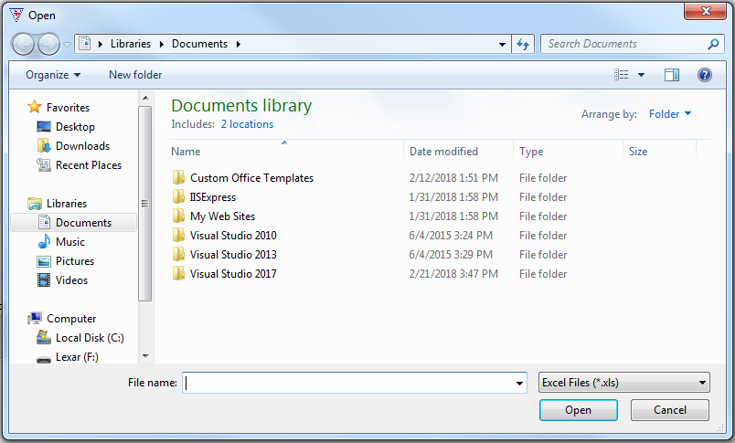
Figure 8: Importing existing player information

Member Scores
The member scores screen is where tournaments are created, and member scores are entered. A tournament must be created before the member scores can be entered. See How to create or edit a tournament.
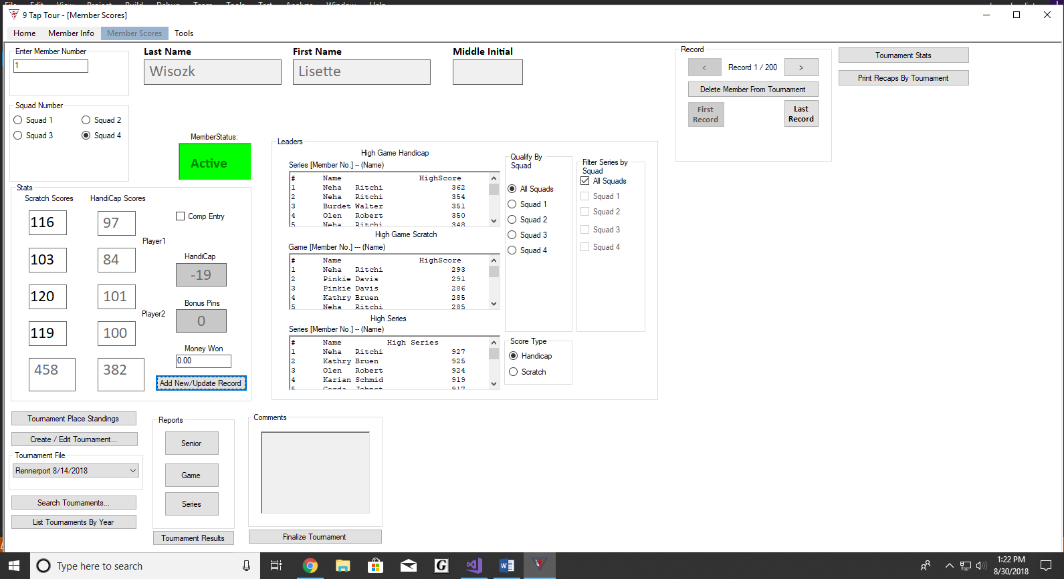
Figure 9: Member Scores
From the Tournament File drop down menu, pick the tournament for which you are entering member scores. Enter the member number in the Enter Member Number field and click “Enter”. The member’s last, first, middle initial, and status should auto populate. Pick the squad that he bowled in from the Squad Number field. In the Stats field, if the member has been comped into the tournament, be sure to check the Comp Entry box. Enter the bowler’s first scratch score in the first Scratch Scores field. Use a three-digit format. 9-Tap will then auto-tab to the next score field. Continue entering the member scores until the final Scratch Scores field has been filled in. Double check the entries for accuracy. Then click the “Add New/Update Record” button. The member scores are now saved to the database.
The Director may navigate through Member Scores via the Record navigation section of the Member Scores tab. Record navigation is located to the right of the form. From here you may navigate member records with the arrow buttons or to the first and last record in the database using the respective buttons.

Comments
On the Member Scores Screen, comments regarding the tournament can be entered in the Comments field.

Tournament Stats
To the right of the member record navigation buttons on the Member Scores screen clicking the “Tournament Stats ” button brings up the Tournament Statistics screen. This shows the basic statistics for the tournament. From here you can print a copy of it by clicking print and following the print dialog for your computer.
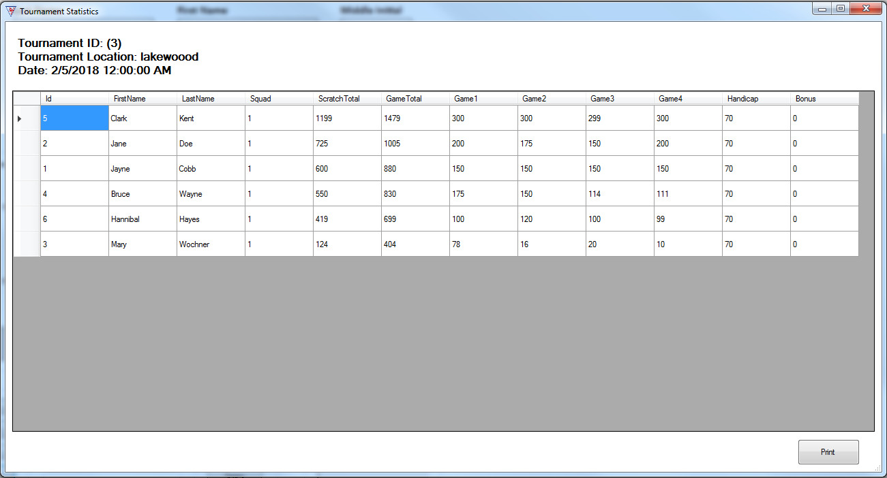
Figure 10: Tournament Stats Form

Print Recaps By Tournament
Below the Tournament Stats button on the Member Scores screen, the “Print Recaps By Tournament” button goes directly to the print dialog. From there you can print the recap or save it by “printing to pdf”.

Figure 11 Print Dialog

Tournament Place Standings
From the Member Scores screen, clicking the “Tournament Place Standings” button brings up the Tournament Place Standings screen for the current tournament. It lists the bowlers in member number order.
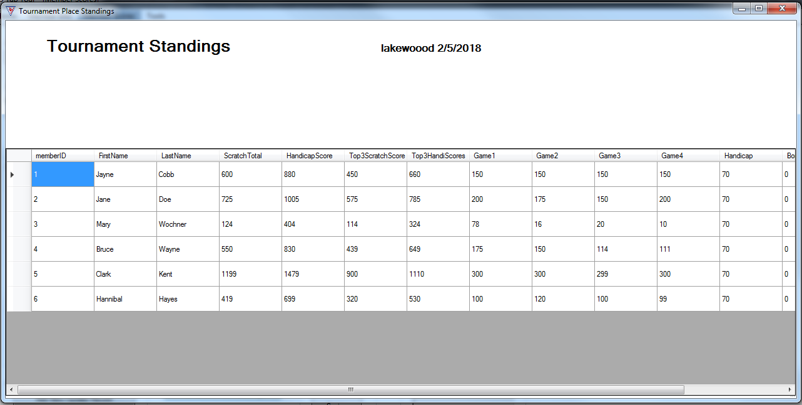
Figure 12: Tournament Place Standings

How to create or edit Tournament
Before scores can be added into a tournament, a tournament needs to be created first. This can be done from the Member Scores tab. To begin, click the Create/Edit Tournament button located below the Stats section. This will open a form to create a tournament.
Populate this form with the following information: the location of the tournament, the name of the tournament, and any sponsors that support the tournament. The date will default to today’s date. If the tournament is a 3 Out of 4 tourney, then check the appropriate box. Finally, enter the number of squads and any notes for the tournament. Review these fields again if necessary for accuracy and if the user wants to clear the entire form and start over, there is a Clear button at the top of the form. Once all of the information is proofread, click the Create Tournament button at the bottom of the form to add the tournament to the 9-Tap database.
There are some additional details to note when it comes to creating a tournament. If the squads box is empty or is not between one and eight, the user will be prompted to input the required information when they click the Create Tournament button. The only requirements to create a tournament are the location of the tournament and the number of squads in the tournament. Event and Sponsors may be left blank.
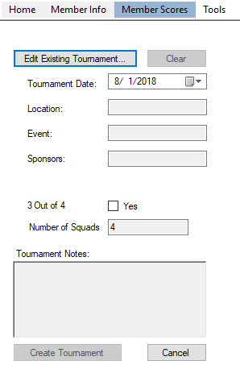
Figure 13: Create/Edit Tournament Form

How to Update an Existing Tournament
Click on the “Create/Edit Tournament” button. On the New Tournament screen, click “Edit Existing Tournament…” This will bring up the “Search Tournaments” screen, figure 14. See Search Tournaments for the search function. Once the tournament to edit has been selected, you can then edit the pertinent information and save the entry.

Search Tournaments
Tournaments can be searched by location, event, or tournament date. This function can be reached by either the “Edit Existing Tournament” button on the New Tournament screen; or by the “Search Tournaments…” button on the Member Scores Screen.
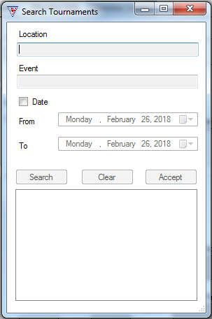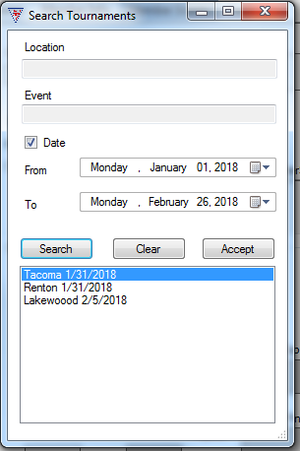
Figure 14: Tournament Search Forms

Search by Location
To search a tournament by location: Fill in the name of the bowling center in the Location field. Click “Search”. Choose the tournament. Click “Accept”.

Search by Event
To find a tournament by event: Fill in the name of the event in the Event field. Click “Search”. Choose the tournament you need from the displayed list. Click “Accept”.
Searching by event and location can be done with just a letter found in the name of the location or the event. For example, there are two tournaments: one in San Francisco, and another in Seattle. Entering “S” in the search bar will yield both of these in the results.

Search by Date
To find a tournament by date: Check the Date box. Pick the date range to search with the From and To date fields. Click “Search”. Choose the tournament you need from the list. Click “Accept”.

List Tournaments By Year
The “List Tournaments By Year” button displays the Tournaments by Year screen. Choose a year from the drop down menu. The tournaments from that year will be displayed.
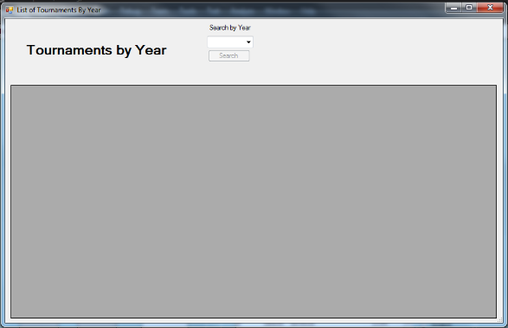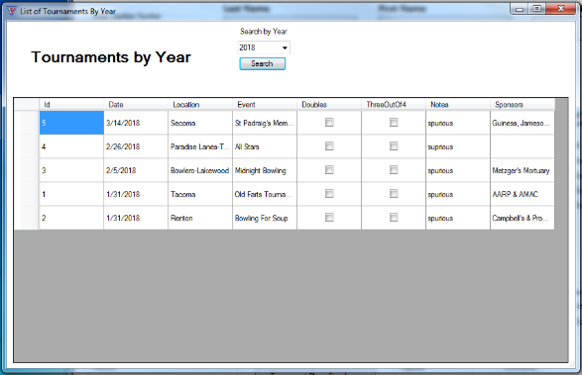
Figure 15: Tournaments by Year

Reports
In the Reports field, you can access the member scores reports by way of their respective buttons “Seniors”, “Game”, and “Series”. Clicking the appropriate button for the needed report. This will bring up the Member Scores Reports dialog. Enter the number of top places in the field and click “Print”. This goes to the print dialog where it can be printed to pdf and saved or printed directly. After a squad has bowled, you can use this to print off the results so far in the tournament.
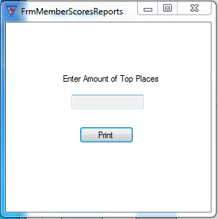
Figure 16 Member Scores Reports screen

Print Series by Squad
To print a Series report displaying specific squads indicate what squads should be displayed on the printout using “Filter Series by Squad” checkboxes on the member scores screen before clicking the “Series” print button. The Series printout will say which squads are displayed at the top of the printout and the players will be ordered by score.
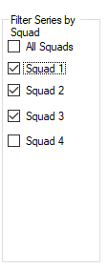
Figure 16b Filter Series by Squad with four squad tournament

Tournament Results
The “Tournament Results” button, seen in Figure 17 on the Member Scores screen launches the Tournament Results screen. The form’s data will automatically be saved into the database upon closing the form or pressing the Export to Excel button. Figure 17a illustrates the Tournament Results window which contains every player which participated in a tournament as well information for that player. This information is as follows going left to right on the form: The player’s placement in the tournament, the player’s full name, their handicap, their total score, their earnings from the tournament, and their earnings from the progressive pot.
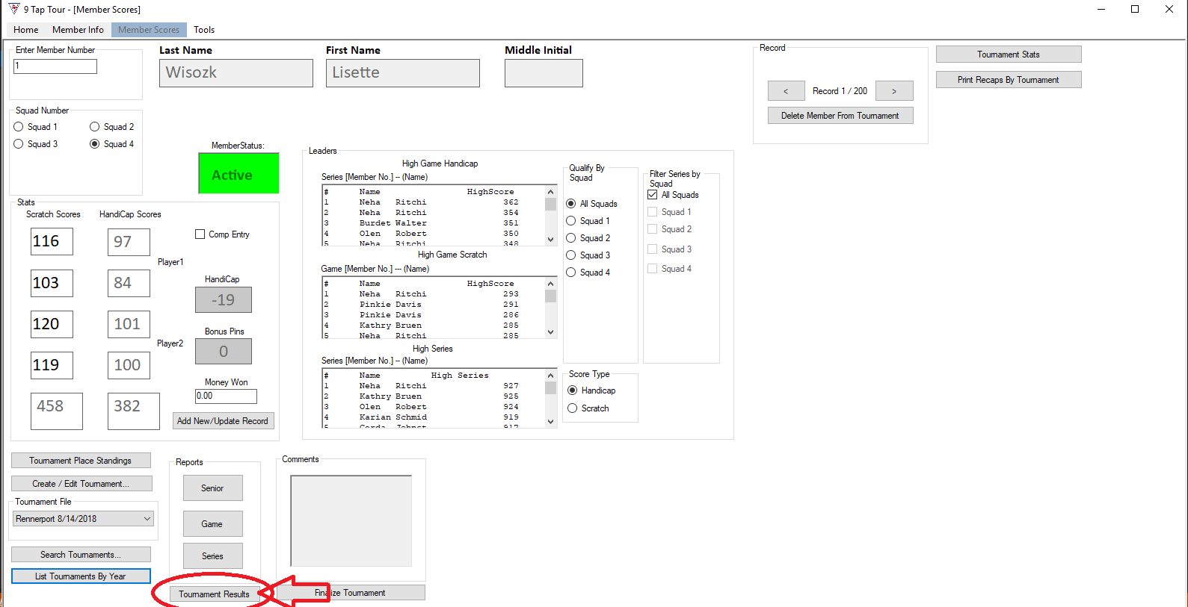Figure 17 the location of the Tournament Results button in Member Info
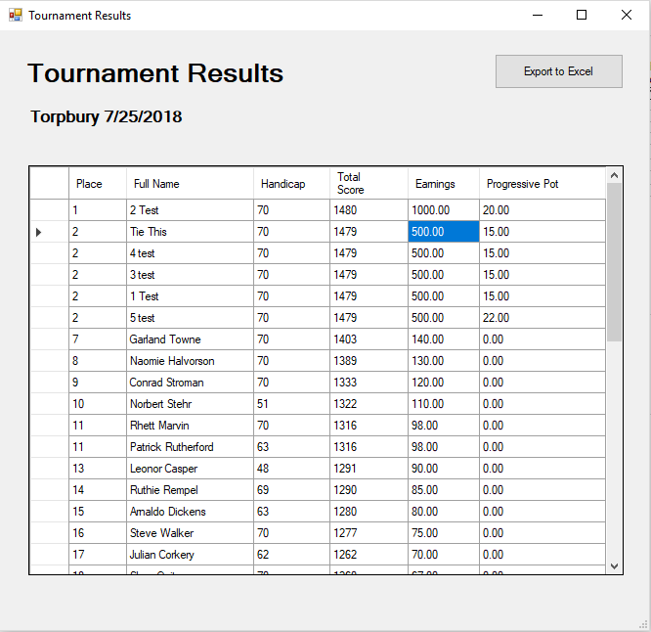
Figure 17a Tournament Results screen

Exporting results to Excel
The tournament results can be saved to an Excel file that is used by the 9-Tap Director to issue checks for player earnings and for keeping information on file. To begin the process of exporting, press the Export to Excel button on the Tournament results form. You’ll be prompted to select a folder to save the Excel file to. Once a location is selected to store the Excel file, click the Save button on the folder selection window and a confirmation of the file save will appear.
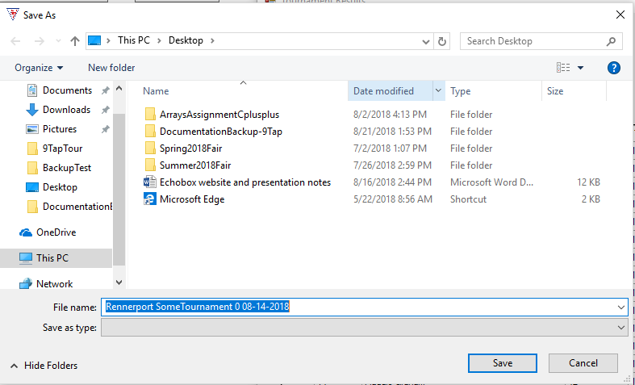Figure 17b the navigation window for exporting the Tournament Results Excel file.

Note: The program will save the Tournament Results Excel file to a default location on the PC if the folder selection window is closed or if the cancel button is clicked on the window. This default location is the Documents folder in Windows. This is seen in the Windows Directory as: This PC > Documents. Otherwise, the user may navigate to any location in which they wish to store the Excel file.

The Tournament Results Excel File
The tournament results Excel file contains all of the information for the tournament. This information includes the date and name of the tournament, the total payout for the tournament, the placement of each bowler, and information for each bowler. Bowler information is as follows: their placement in the tournament, their name, their handicap, their total score, and their payout. Below the player information there are fields in the Excel file for tournament pots. These include the Progressive pot total, 9-Tap jackpot total, scratch series/game pot, side pots, champion shirt, and high game pots.
The very bottom of the Excel program contains tabs. The tab labeled Results is the tab selected by default containing tournament results. The tabs labeled 1st, 2nd, 3rd, 4th, 5th… are checks for players to cash provided they have winnings.
The first half of the Results Excel file containing player information is illustrated in Figure 17c, the second half of the Results Excel file containing side pot information is illustrated in Figure 17d, and an example of a player’s check is illustrated in Figure 17e.
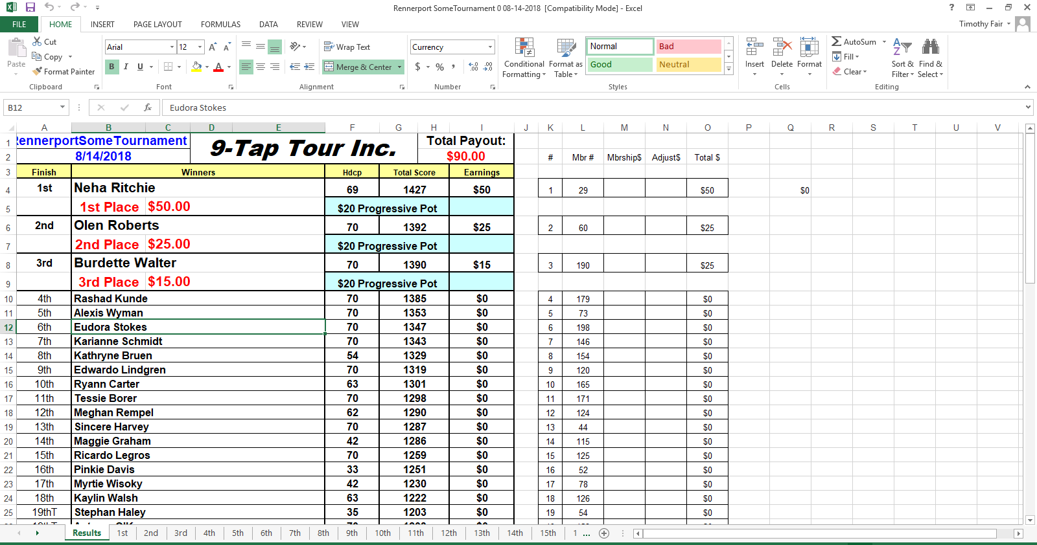Figure 17c Player information in Tournament Results Excel file

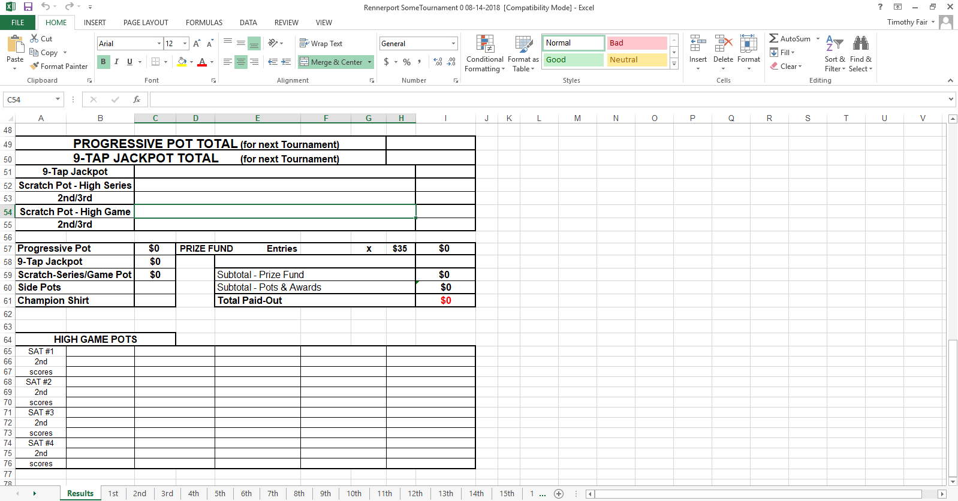Figure 17d Side Pot information in Tournament Results Excel file

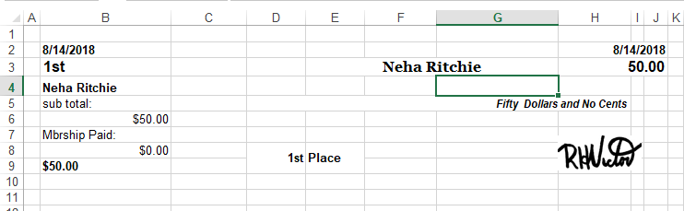Figure 17e a player’s check in the Tournament Results Excel file

Finalize Tournament

Finalize Tournament Basics
After all of the recaps for the tournament are entered into the Member Scores tab, they need to be reviewed and finalized by the Director of the tournament. To begin this process click the Finalize Tournament button located underneath the Reports section on the Member Scores screen. Once the Finalize Tournament window is open, it is up to the Director to review each player’s recap before finalizing the tournament.

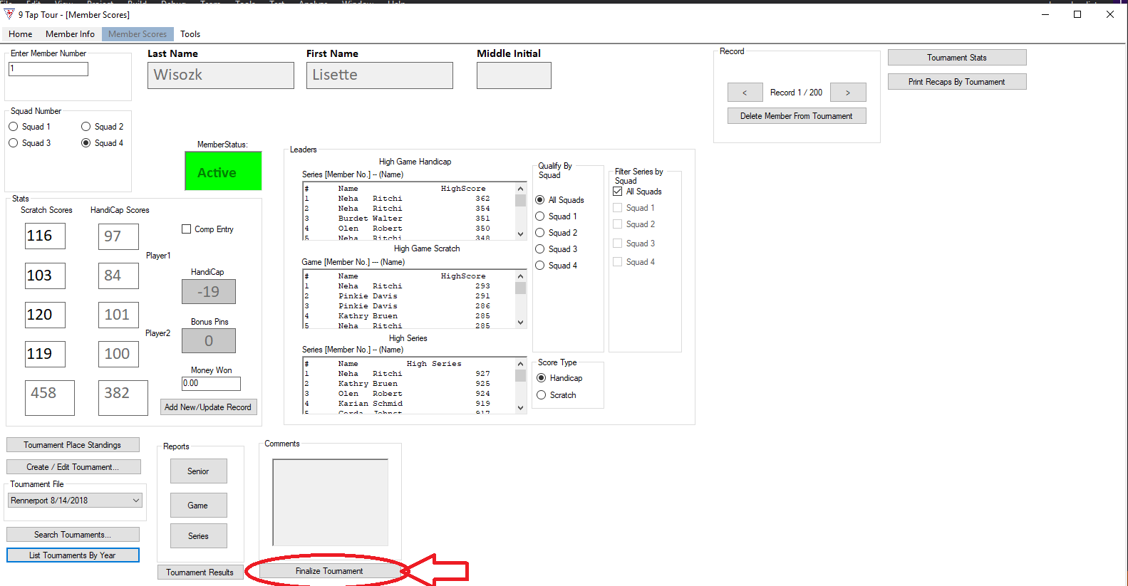Figure 18: location of Finalize Tournament button.

Understanding the Finalize Tournament layout
The layout of the window is split into two sub windows, one above, and one below. The color of a cell determines a few things. A red cell is a score that has been invalidated by the Director, while an orange cell is a score that is 50 or more below a player’s average score for a given game; lastly, a blue cell means it has been selected. Furthermore, furthest left are empty cells which denote a few things which allow for better visibility. A black arrow in the leftmost corner means something in that row is selected, while a pencil means something in that row is currently being edited. Clicking the leftmost cell will highlight the entire row in blue, and clicking the top leftmost cell will highlight everything.
The Director may also modify some of the cells if it is required. The following cells can be modified by double clicking them: Scratch Total, Handicap Total, Entry AVG, ADJ AVG, Pro Pot, and Notes.
The data in the table can also be organized. Clicking one of the columns such as Name or Scratch Total will reorder the data by descending, and clicking once more will reorder it by ascending; however, columns with checkboxes in them cannot be reordered. In addition to this, any cell or combination of cells that are highlighted can be copied by pressing the ctrl and c buttons on the keyboard while cells are highlighted. Checkboxes such as Valid Score, or Director Check will be pasted in text as True or False.
The bottom sub window contains information for a selected player. Every game the selected player has participated in will be displayed here. In addition to this, the date the game was played and the player’s place in the tournament are displayed as well. Between the two sub windows you’ll see the index of the selected player on the left, their name in the middle, and their starting average on the right. This second sub window can be organized like the above one. Game scores, adjusted average, notes, and the date can be modified here. Changing a score will not automatically recalculate the scratch total in the lower sub window.

Finalizing a tournament
In order for the tournament to be finalized the Director needs to check every one of the Director Check boxes to confirm that they’ve inspected that player’s recap. This means modifying scores, averages, adding a bonus or a pro pot, and adding any notes that may be needed for a particular player. Manually adjusting the average is also required. After all of this is done, the Director checks off the Director Check box for that player. Once all of the boxes are checked, the tournament can be finalized by clicking the Finalize button at the bottom of the form. If it so happens that the Director fails to check a player’s box, upon attempting to finalize the tournament that box will be highlighted in red.

The Finalize Tournament window
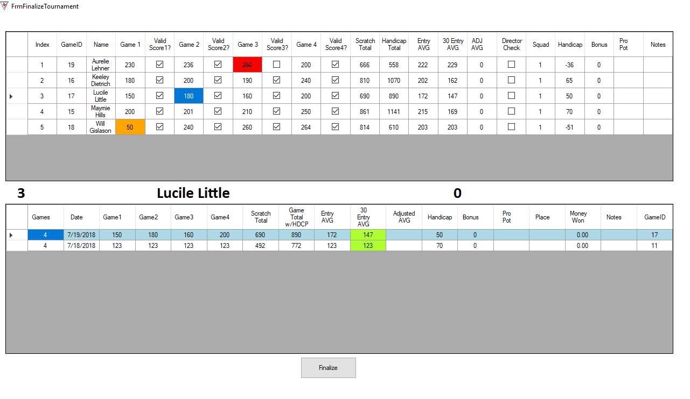
Figure 18a Finalize Tournament Screen
Referring to Figure 18, the topmost window displays a wide array of information for each player in the given tournament.
Going from left to right this information is as follows:
- Index – the index of the player in the database.
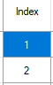
- GameID – the game identifier for the tournament.
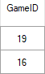
- Game 1-4 and ValidScore 1-4 - that player’s score for each game they played, and a checkbox used to determine whether that player’s score is valid for that set of pins. E.G. a sandbagged score will be unchecked and thus invalidated.
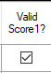
- Scratch Total – The player’s total score before handicaps are taken into account.
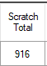
- Handicap Total – The player’s total score after handicaps are taken into account.
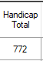
- Entry AVG – The average for the current entry of the player.
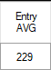
- 30 Entry AVG – The average for the last 30 entries of the player.
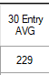
- ADJ AVG – Adjusted Average. An average that must be manually entered by the Director.
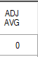
- Director Check – Checkbox to confirm a Director has checked and validated a player’s score.
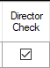
- Squad – The squad of this player’s game.
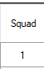
- Handicap – The player’s current handicap.
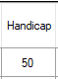
- Bonus – Current player’s bonus.
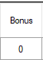
- Pro Pot – Needs work
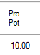
- Notes – notes on the current player.
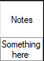

Tools
Under Tools you will find miscellaneous tools which may be helpful in making use of the program simpler. The current options include Backup Database, Restore Database, and Update Inactive Members. Click the Tools tab to open a drop down menu with these three options.

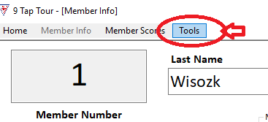
Figure 19: location of Tools tab.

Backup Database
The first option from the drop down Tools menu will allow the user to back up the database. Once the backup database option is selected, it will prompt the user to select a folder to store a .BAK file of the current 9-Tap database to. A user may also create a new folder by selecting the Make New Folder button. Once a new folder has been created or one has been selected, press the OK button to back up the database. A prompt confirming the backup will appear, clicking OK will bring the user back to 9-Tap.

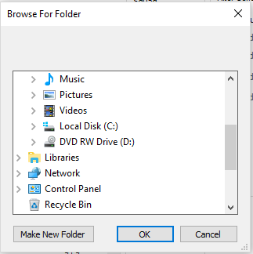
Figure 19a: Window to select folder to backup database to.

Restore Database
The second option from the drop down Tools menu allows the user to restore the 9-Tap database from a .BAK file they’ve created using the Backup Database tool described above. Clicking on the Restore database tool under the tool menu will bring up the file explorer. From here, navigate to the folder a previous .BAK file has been stored and highlight it to select it. Click the Open button in the file explorer to restore the database from the .BAK File. The user will be prompted to restart the program.

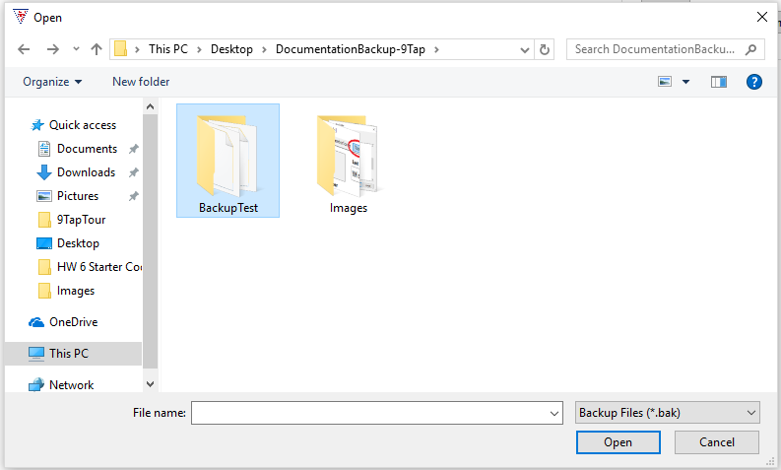
Figure 19b: Window to navigate to backup file to restore database.

Update Inactive Members
Under the tools tab, the third tool is for updating the active status of members. Members who have not participated in a tournament for more than 180 days may be deemed inactive. Upon opening the form, a date picker will be defaulted to 180 days ago from today’s date. Below this date picker a list of players in the database who have been inactive will appear. Click on all of the members you’d like to change to inactive and select the update button to be prompted to update their active status. The check all button beside the update button should select all of the members displayed in the list for a quick update, although at this time it does not work.
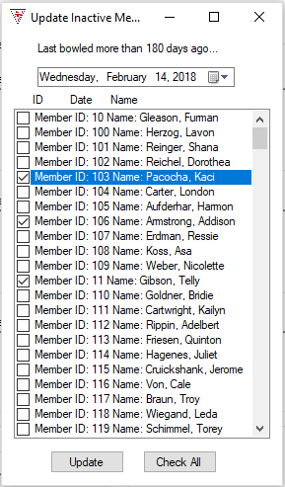
Figure 19c: Update Inactive status screen

Chapter
4

9-Tap tour

Troubleshooting

Troubleshooting 9-Tap

WARNINGS:
If the tournament has five (5) or fewer participants, DO NOT USE PROGRAM. Keep track of player data manually.
Doubles tournaments are not supported by the software at this time. LEAVE DOUBLES UNCHECKED ON THE NEW TOURNAMENT SCREEN/DIALOG.
NOTE: the Doubles Checkbox has been omitted from the program for now.
Do not start a new tournament before the current tournament you are working on has been finalized.
On the Member Scores screen, as you are entering the member for the first time; if the member has been comped into the tournament, make sure the Comp Entry box has been checked before clicking the “Add New/Update Record button. This cannot be adjusted after the member’s scores have been entered and saved.

Screen “splitting” on resize
When resizing the 9-Tap program the screen may split into individual screens contained within the main program display screen.
NOTE: As of 7/30/2018 the program no longer splits into other windows as described above.
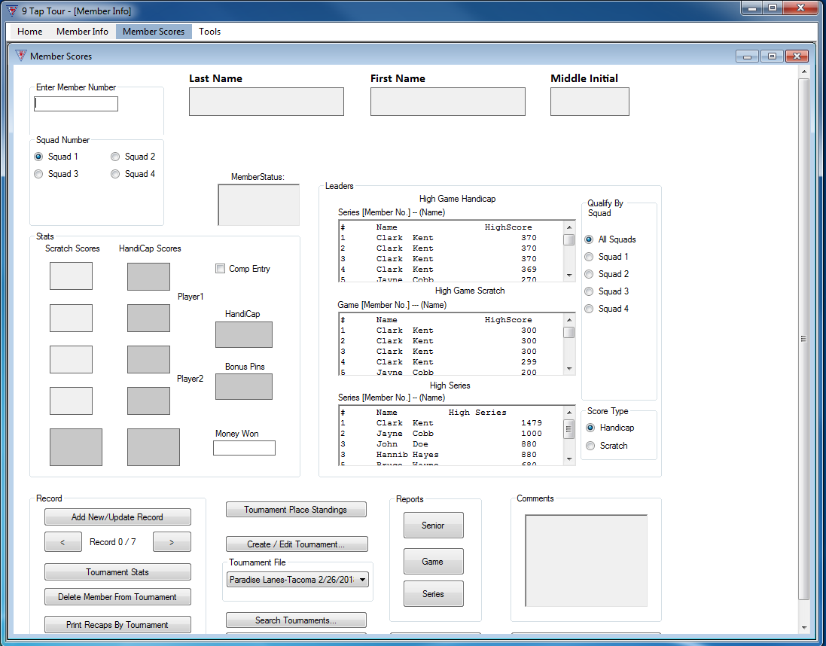
Figure 20 Showing split screen error

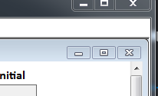
If the display splits, you can click maximize for the individual screens. They will return to normal. You can then continue working with the program.
Figure 21 Inner screen maximize

ReadMe File
The 9 Tap Tour program contains a ReadMe file where you can view updated program information. We strongly encourage you to take the time look over this file to get information on changes made after this manual went to print.
To view this file, double-click on it in the 9 Tap Tour Directory found on your hard drive (usually C:\Program Files\9TapTour\docs\readme_en.txt). You can also view the ReadMe file by clicking on the Start button on your Windows taskbar, then on Programs, then on 9 Tap Tour, then on View Readme.txt.

Member Info layout shifting
When creating a new member in the Member Info tab, the layout of the form will change. When clicking the New Member button to add a new member to the database the form will reload with a different layout. Everything to the right of the Record section of the form will be moved to the bottom of the form. The sections of the form which are affected are as follows: Record Number navigation, the Stats button, and the Member search button. Leaving the Member Info tab and returning to it will reset the layout. The following figures, 21a and 21b illustrate these changes.

Figure 21a: Member Info with unchanged layout.
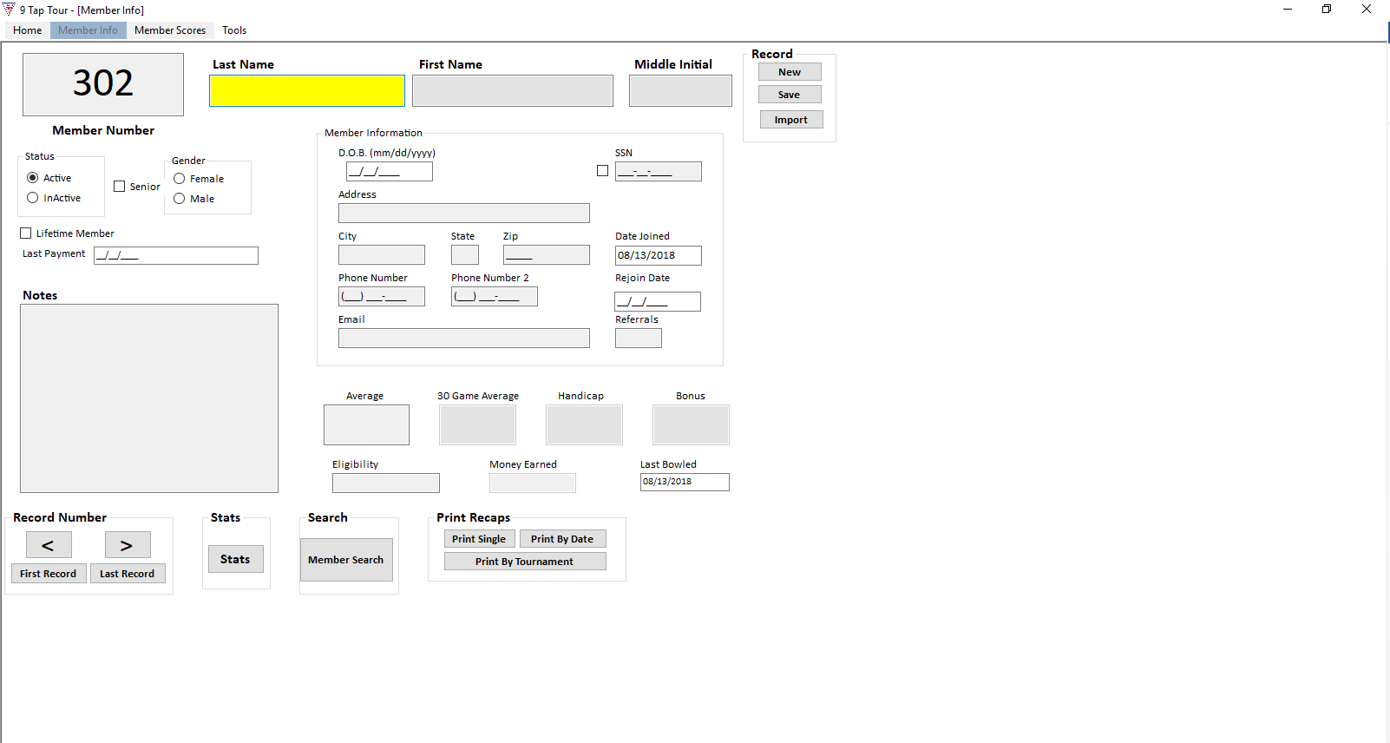

Figure 21b: Member Info with changed layout.
Chapter
5

9-Tap tour

Conversion Program

Conversion Program
Conversion from old version of 9-Tap program for the Las Vegas and Hawaii regions. (Talk to Xavier to get outline/details of the steps. Have emailed him 3/14/18)
For changing to this new version of the software. The conversion program imports member information and member statistics. This process can take over four hours depending on your computer. First the .dat member file is imported. Then the Excel files for the members are imported.
If you are pressed for time you can import just the .dat files. Then, as needed, use the “Import” button on the member information screen to import individual members.
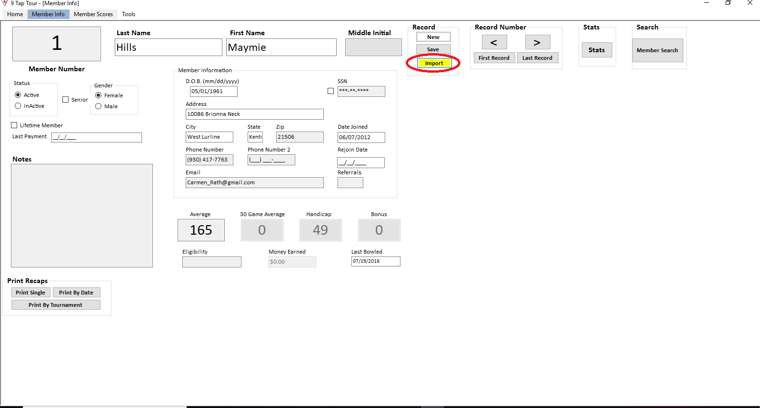
Figure 22 - Highlighted in red is the import button to begin conversion.

Chapter
6

9-Tap tour

General Information

General Information

Main Menu
Launch 9 Tap Tour. Once it’s running you should see the Main Menu screen. To enter bowler information or scores there are two main ways to get there, the tabs across the top and the left-hand buttons.
The top tabs are:
- Home—this tab takes you back to the Main Menu.
- Member Info—this tab takes you to the Member Information form.
- Member Scores—this tab takes you to the Member Scores Form. From there, you can access Tournament creation and editing functions.
- Tools—this tab takes you to the active/inactive member update dialog.
The left-hand buttons are:
- Member Info—Left click on this to go to the member information form. Here is where new member information is entered and saved. Player statistics can be found here too. Also importing member information from Microsoft Excel files is done here
- Member Scores—accesses the Member Scores form. From there, access Tournament forms
- About—About the 9Tap Tour
- Exit—exits the 9Tap Tour program
- Region—drop down menu to pick location. Default is “local”.
- Add Region—goes to “Add Region” dialog.
- Delete Region Data— Prompts user to delete ALL region data.

Member Info
On the Member Info screen you can enter a new, update an existing member, or import existing member information from an Excel file.
- Member Number—the member number auto generates.
- Last Name—member’s last name. Required field.
- First Name—member’s first name. Required field.
- Middle Initial—member’s middle initial.
- Member Information area.
  - D.O.B.—member’s date of birth, mm/dd/yyyy format.
  - SSN—member’s social security number, not displayed by default. To show the member’s SSN, check the box to the left of the field.
  - Address—member’s street address.
  - City—member’s city.
  - State—member’s state.
  - Zip—member’s zip code.
  - Email—member’s email.
  - Date Joined—date the member joined.
  - Rejoin Date—date the member rejoined.
  - Referrals—track number of bowlers referred by the member. Once they have five confirmed referrals, the member becomes a lifetime member. A confirmed referral has joined the tour and bowled in three tournaments.
- Average—where the member’s average displays. For a new member, where her average can be entered, with proof of the average from another league.
- 30 Game Average—member’s average over the last 30 games they’ve bowled.
- Handicap—member’s handicap, calculated by the program.
- Bonus—bonus pins. If the member gets bonus pins, this is where they are entered.
- Year End Tournaments
- Money Earned—prize money earned by the member from tournaments.
- Last Bowled—date member last bowled.
- Record section.
  - New—starts a new record.
  - Save—saves member information to the database.
  - Import—imports member information from an excel file.
- Record Number section. For navigation between records by record number.
  - <—goes one record back
  - >—goes one record forward
  - First Record—goes to first record in database
  - Last Record—goes to last record in database
- Stats section
  - Stats — this button brings up a window containing the selected player’s statistics.
- Search section
  - Member Search —this button brings up member search screen, used to search for member records.
- Print Recaps section
  - Print Single—this button launches your computer’s print dialog. Prints a single member’s record.
  - Print By Date—this button brings up the print by date dialog screen.. Prints a range of records by date.
  - Print By Tournament—this button launches your computer’s print dialog. Prints member record by tournament.

Member Scores
The Member Scores screen is where the members’ scores recaps are entered into the database. It’s also where tournaments are created and edited. To enter scores, a tournament must be created and selected.
- Enter Member Number —the bowler’s member number is entered here.
- Last Name —after the member number is entered, this field auto-populates with the member’s last name.
- First Name —after the member number is entered, this field auto populates with the member’s first name.
- Middle Initial —after the member is entered, this field auto populates with the member’s middle initial.
- Squad Number —pick the squad the member bowled in for this tournament.
- Member Status —after the member number is entered, this field auto-populates with the member’s active/inactive status. Scores can only be entered for an active member.
- Stats section
  - Scratch Scores —where the member’s four scratch scores are entered. The total is automatically calculated and displayed after the fourth score. Entering a score will automatically send the cursor to the next score to be entered.
  - Handicap Scores—the member’s adjusted scores from their bowling handicap are automatically calculated and displayed.
  - Comp Entry—this is checked if the member had a comped entry in the tournament.
  - Handicap—the member’s bowling handicap, auto displayed.
  - Bonus Pins—if the member has bonus pins, this is where they would be displayed.
  - Money Won—if the member wins money, it is displayed here. The winnings are entered on the Tournament Results Screen.
- Leaders section
  - High Game Handicap—displays the tournament standings by handicap high scores.
  - High Game Scratch—displays the tournament standings by high game scratch scores.
  - High Series—displays the tournament standings by high series scores.
  - Qualify By Squad—picks which squads are displayed.
  - Score Type—picks whether scores are displayed by handicap or scratch.
- Records section
  - Add New/Update Record—after the member’s scratch scores have been entered and checked for accuracy, this button adds them to the tournament. Before a tournament has been finalized, a member’s scores can be updated.
  - “<”—this button goes one record back.
  - “>”—this button goes one record forward.
  - Tournament Stats —this button displays the current tournament’s stats.
  - Delete Member From Tournament—this button will, before a tournament has been finalized, delete a member from the tournament.
  - Print Recaps By Tournament—this button launches the print dialog. Prints out the tournament recaps.
- Tournaments section
  - Tournament Place Standings—this button displays the current tournaments place standings.
  - Create/Edit Tournament—this button launched the New Tournament screen. From there you can create a new or edit an existing tournament.
  - Tournament File—a drop down menu display from which to pick a tournament.
  - Search Tournaments—this button launched the Tournament Search screen.
  - List Tournaments By Year—this button launches the List Tournaments by Year Screen.
- Reports Section. The buttons here launch the Member Scores Reports screen. You can choose what the reports contain by way of the buttons.
  - Senior—this button pulls member scores from those 50 years and older that bowled in the tournament.
  - Game—this button pulls member scores by game from the tournament.
  - Series—this button pulls member scores by series from the tournament.
- Tournament Results—this button launches the Tournament Results screen. You can view the results, enter member earnings from the tournament, if any, and update the database or save it to an Excel file.
- Comments section—comments about the tournament can be entered in this field.
- Finalize Tournament—this button launches the Finalize Tournament screen. The Tournament Director can verify member scores and adjust member averages, if necessary. Once the information has been verified, the Director can finalize the results to the database.

Tools
Contains tools to back up a 9-Tap database, restore the database from a backup, and a tool to mark inactive players in the database.

About
Opens a window with a description of the 9-Tap tournament.

Exit
Closes the 9-Tap program.

Index

About, 40, 45
About 9 Tap Tour, 4
Add Region, 11, 40
Average, 41
Bonus, 41, 43
Comments, 25, 45
Comp Entry, 43
Conversion Program, 38
Create/Edit Tournament, 9, 21, 22, 44
Delete Member From Tournament, 44
Edit Existing Tournament…, 22
Exit, 11, 40, 45
Finalize Tournament, 26, 45
General Information, 40
Handicap, 41, 43
High Game, 43
High Series, 43
Home, 40
import existing, 17, 40
Import Existing Members, 12
Last Bowled, 41
List Tournaments By Year, 23, 44
Main Menu, 5, 11, 40, 45
Member Info, 9, 11, 12, 14, 40
Member Number, 18, 40, 42
Member Scores, 9, 11, 18, 19, 20, 22, 24, 25, 40, 42
Member Scores Reports, 24, 44
Member Search, 14, 16, 42
Member Status, 43
Menus Guide, 5, 10
Money Earned, 41, See Money Won
Money Won, 43
New Members, 12
Print Recaps, 17, 42
Print Recaps By Tournament, 19, 44
Qualify By Squad, 43
Quick start, 5
Quick Start, 7
ReadMe File, 35
Record, 9, 12, 18, 41, 42, 44
Region, 11, 40
Reports, 24, 44
Score Type, 43
Search by Date, 23
Search by Event, 22
Search by Location, 22
Search Tournaments, 22, 44
Squad Number, 18, 43
Stats, 15, 18, 42, 43
system requirements, 7
Tools, 30, 40, 45
Tournament File, 18, 44
Tournament Place Standings, 20, 44
Tournament Results, 25, 43, 45
Tournament Stats, 19, 44
Tournaments, 44
Troubleshooting, 5, 32, 33
Updating Members, 14
Year End Tournaments, 41

Glossary
Pot A sum of money a player wagers during a game.
Progressive Pot A jackpot which increases each time the game is played and the jackpot is not won.
USBC United States Bowling Congress
HDCP Handicap
Comp/Comped Complimentary entry into a tournament. A player who has been comped does not need to pay the fee to enter into the tournament

