Volume
1
9-TAP TOUR

User Manual
9-tap tour

User Manual
© 9-Tap Tour
PO Box 931
Sumner, WA 98390
Phone 253.987.7975
Email

Table of Contents
Setup and Installation 1
Installation of 9-Tap program 1
Start Program 2
Main Menu Options 2
How to Generate a Table of Contents 3
How to Create an Index 3
Member Information Form 3
Tools 3
Tournaments 4
How to Create a Document 4
Region 4
Index 4

Chapter
1

9-tap tour

Welcome

About 9 Tap Tour INC
Welcome to the 9 Tap Tour Program. 9-Tap Tour, INC. is a unique, fun and professionally run tournament. Members enjoy our “Beat the Board” format, with four games per squad. Yet the fun, big payouts, special pots and the 9-Tap version of bowling itself, brings new excitement to tournaments.
Approximately one bowler in every 5 entries will cash. Other optional ways to cash are: 9-Tap Jackpot, Progressive Pot, high game pots, brackets, scratch game and series pot, and more depending on where & when you bowl these “Side Pots” may vary from time-to-time. 9-TAP TOUR also has BIG ‘Added money' Quarterly Championships, specials, promotions and doubles tournaments. Each Quarterly Tournament may have eligibility requirements for members who bowl during that Quarter.
Prize money is paid at the Tournament site at the conclusion of each tournament. The tournament winner, low to cash score, and new progressive pot totals will be posted on our web site, available immediately after each tournament. Past results are also available on our web site.
Our rules, which default to USBC in many areas, protect our members and ensure fair play. We are proud to be USBC Certified.
First place and prize fund moneys are based on the number of entries and will vary depending on where you bowl. Special Added money & Quarterly tournaments will pay higher amounts. Regional or National tournaments (in 9-Tap's future), will have much higher amounts.
Our goal is to provide an enjoyable experience for all of our members, with a fair opportunity for both low and higher average bowlers. 9-TAP TOUR INC appreciates your participation. We hope you will enjoy our tournaments and if you do please refer us to other bowlers. We ask for, and welcome comments and suggestions.
THANK YOU!
Rob Victor - Director
Steve Freeman - Director

Dedication:
Who did the work?

What is9-Tap?
9-Tap is a purpose built, full featured bowling tournament management software system with a variety of different functions.
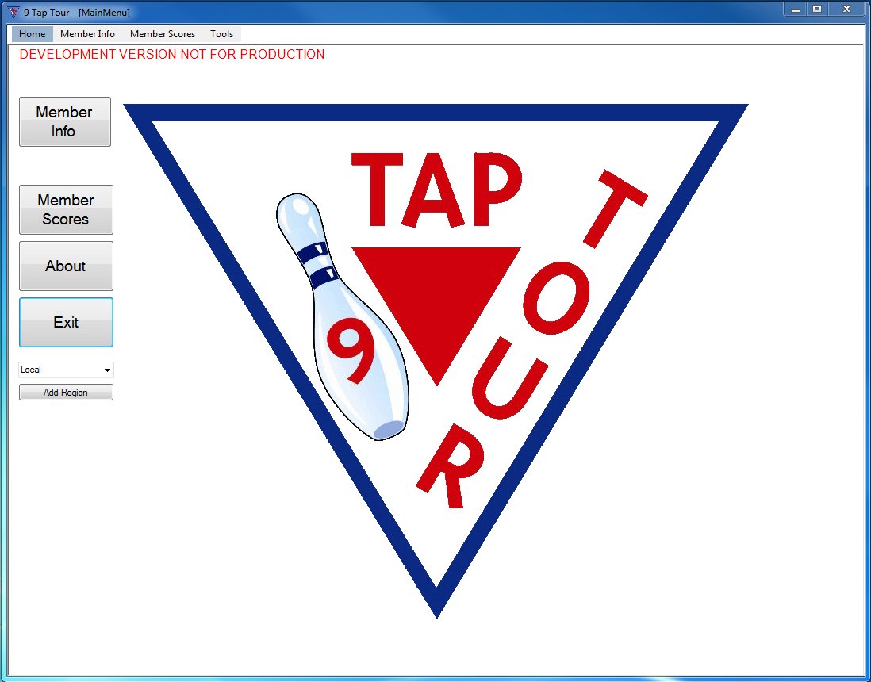
Figure 1: 9-Tap Main Menu

A good place to start

Quick start guide
You can find this on page #

Troubleshooting
You can find this on page ##

Menus guide
Familiarization guide .longwinded?

Chapter
2

9-tap tour

Quick Start

Quick Start Guide

hELPFUL GUIDELINES TO GET 9-tAP UP AND RUNNING.

What are the system requirements to run 9-Tap?
The system requirements to run the 9-tap software are as follows: Windows 10, (Windows 8, or Windows 7). Storage: how much? USB port. Dot matrix and ink/laser-jet printers. Microsoft Excel must be installed on the computer for the 9-Tap Tour program to work.

How do I install 9-Tap?
- Start Windows and exit all other applications.
- Insert the 9 Tap Tour USB drive into your computer’s USB port.
- If the file manager dialog does not appear, click the Start button on your Windows taskbar, then click Run. Type D:\Setup and click on OK. (Note: If your removable USB drive is assigned a letter other than D, use that letter.)
- The installation wizard will now run.
- The next window will prompt you to shut down all other running programs before starting the 9 Tap Tour installation process. Do this and then click “Next” to continue.
- End User License agreement. Read the agreement, and if you agree to the terms and conditions chose “I agree.” Then click the “I Agree” button to continue the installation process.
- Next, chose an install location for the program. Either accept the default location or choose another location. Once you’re satisfied with your choice, click “Next” to continue installing.
- Select a Start Menu Folder for 9 Tap Tour. Either accept the default location or chose another. If you don’t want a Start Menu folder to be created check the box “Do Not Create A Start Menu Folder”. Once you are satisfied with your selection click the “Next” button to continue.
- Select the shortcuts you want created. Chose to create shortcuts on the Desktop, Quick Launch Toolbar, or neither. Once you are satisfied with your selection click on the “Next” button to continue.
- The 9 Tap Tour will now begin installing. When the “Install complete” message displays, click the “Next:” button to continue.
- The 9 Tap Tour program has now been successfully installed. Choose “Run 9 Tap Tour” to immediately launch the program, or “View ReadMe.txt” to view the ReadMe file where you can view updated program information made after the game manual was printed.
- Start Windows and exit all other applications.
- Insert the 9 Tap Tour USB drive into your computer’s USB port.
- If the file manager dialog does not appear, click the Start button on your Windows taskbar, then click Run. Type D:\Setup and click on OK. (Note: If your removable USB drive is assigned a letter other than D, use that letter.)
- The installation wizard will now run.
- The next window will prompt you to shut down all other running programs before starting the 9 Tap Tour installation process. Do this and then click “Next” to continue.
- End User License agreement. Read the agreement, and if you agree to the terms and conditions chose “I agree.” Then click the “I Agree” button to continue the installation process.
- Next, chose an install location for the program. Either accept the default location or choose another location. Once you’re satisfied with your choice, click “Next” to continue installing.
- Select a Start Menu Folder for 9 Tap Tour. Either accept the default location or chose another. If you don’t want a Start Menu folder to be created check the box “Do Not Create A Start Menu Folder”. Once you are satisfied with your selection click the “Next” button to continue.
- Select the shortcuts you want created. Chose to create shortcuts on the Desktop, Quick Launch Toolbar, or neither. Once you are satisfied with your selection click on the “Next” button to continue.
- The 9 Tap Tour will now begin installing. When the “Install complete” message displays, click the “Next:” button to continue.
- The 9 Tap Tour program has now been successfully installed. Choose “Run 9 Tap Tour” to immediately launch the program, or “View ReadMe.txt” to view the ReadMe file where you can view updated program information made after the game manual was printed.

How do I Launch 9-Tap?
Screen shots of desktop icon & system menu
Double click on the desktop icon or go to the program in the system menu and click on it.

How do I import existing members?
On the Member Info screen, Find the import button. Click on it. When the file picker screen comes up, navigate to the Excel file you need to import. Select it and hit OK.

How do I enter a new player?
On the Member Info screen, Click new. A new blank record will display. Start filling in the player’s information, at a minimum his first and last name. Save the record.

Chapter
3

9-tap tour

Menus and Forms Guide

Start Menu
Craft beer sartorial copper mug tbh jianbing, locavore VHS salvia +1 vegan gluten-free kogi pug vexillologist affogato. Fanny pack palo santo proident blog bespoke commodo tilde hammock taiyaki wayfarers gentrify. Cardigan ugh slow-carb, ea DIY hot chicken commodo godard. Lorem sint qui 3 wolf moon enim voluptate, velit veniam. Fanny pack man bun helvetica viral, edison bulb cliche jianbing.

Figure 2: Main Menu

Tools
Craft beer sartorial copper mug tbh jianbing, locavore VHS salvia +1 vegan gluten-free kogi pug vexillologist affogato. Fanny pack palo santo proident blog bespoke commodo tilde hammock taiyaki wayfarers gentrify. Cardigan ugh slow-carb, ea DIY hot chicken commodo godard. Lorem sint qui 3 wolf moon enim voluptate, velit veniam. Fanny pack man bun helvetica viral, edison bulb cliche jianbing.
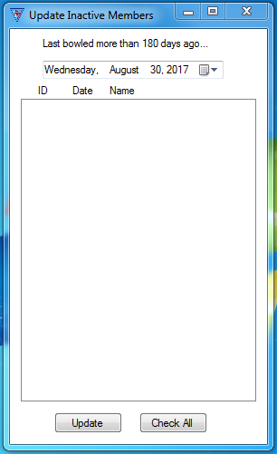
Figure 3: Under Tools, Update Inactive status

Member Info Form
Craft beer sartorial copper mug tbh jianbing, locavore VHS salvia +1 vegan gluten-free kogi pug vexillologist affogato. Fanny pack palo santo proident blog bespoke commodo tilde hammock taiyaki wayfarers gentrify. Cardigan ugh slow-carb, ea DIY hot chicken commodo godard. Lorem sint qui 3 wolf moon enim voluptate, velit veniam. Fanny pack man bun helvetica viral, edison bulb cliche jianbing.
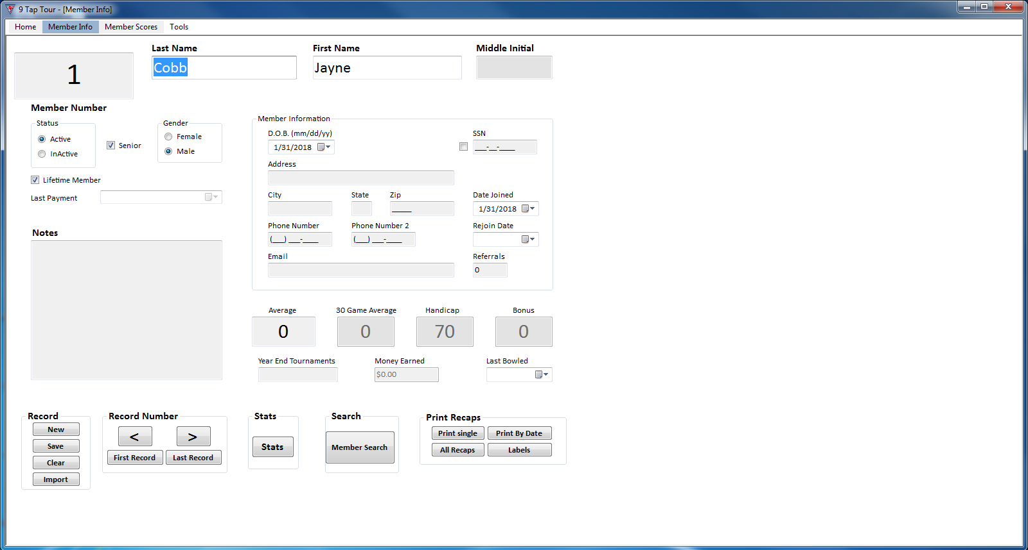
Figure 4: Member Information

Stats
Craft beer sartorial copper mug tbh jianbing, locavore VHS salvia +1 vegan gluten-free kogi pug vexillologist affogato. Fanny pack palo santo proident blog bespoke commodo tilde hammock taiyaki wayfarers gentrify. Cardigan ugh slow-carb, ea DIY hot chicken commodo godard. Lorem sint qui 3 wolf moon enim voluptate, velit veniam. Fanny pack man bun helvetica viral, edison bulb cliche jianbing.
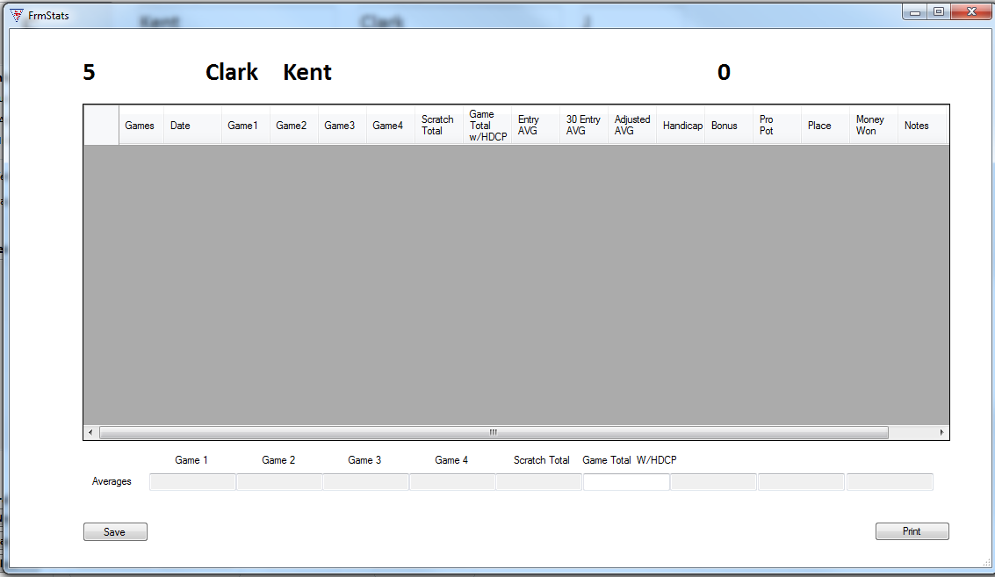
Figure 5: Stats Form

Member Search
Craft beer sartorial copper mug tbh jianbing, locavore VHS salvia +1 vegan gluten-free kogi pug vexillologist affogato. Fanny pack palo santo proident blog bespoke commodo tilde hammock taiyaki wayfarers gentrify. Cardigan ugh slow-carb, ea DIY hot chicken commodo godard. Lorem sint qui 3 wolf moon enim voluptate, velit veniam. Fanny pack man bun helvetica viral, edison bulb cliche jianbing.
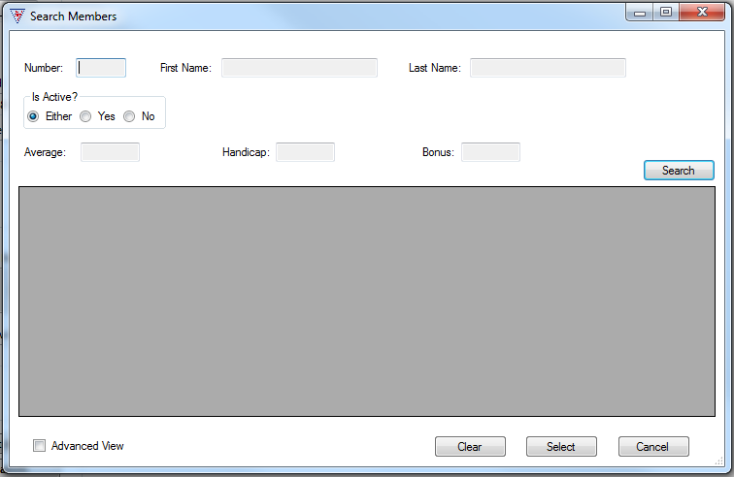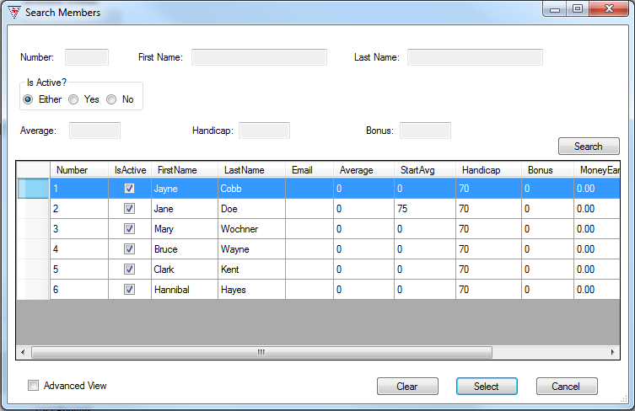
Figure 6: Member search, blank and with results

Print Recaps
Craft beer sartorial copper mug tbh jianbing, locavore VHS salvia +1 vegan gluten-free kogi pug vexillologist affogato. Fanny pack palo santo proident blog bespoke commodo tilde hammock taiyaki wayfarers gentrify. Cardigan ugh slow-carb, ea DIY hot chicken commodo godard. Lorem sint qui 3 wolf moon enim voluptate, velit veniam. Fanny pack man bun helvetica viral, edison bulb cliche jianbing.
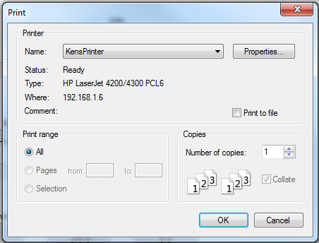
Figure 7: basic printer dialog

Labels
Craft beer sartorial copper mug tbh jianbing, locavore VHS salvia +1 vegan gluten-free kogi pug vexillologist affogato. Fanny pack palo santo proident blog bespoke commodo tilde hammock taiyaki wayfarers gentrify. Cardigan ugh slow-carb, ea DIY hot chicken commodo godard. Lorem sint qui 3 wolf moon enim voluptate, velit veniam. Fanny pack man bun helvetica viral, edison bulb cliche jianbing.
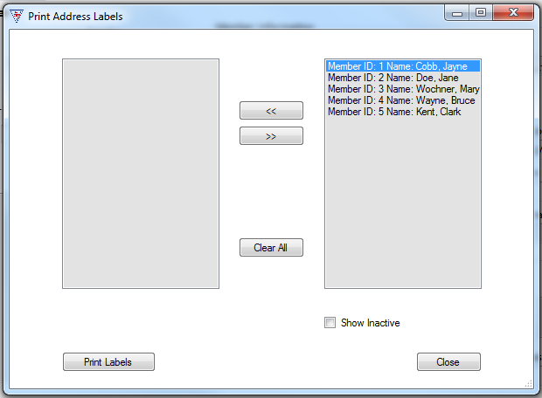
Figure 8: Print Labels Dialog

Import
Craft beer sartorial copper mug tbh jianbing, locavore VHS salvia +1 vegan gluten-free kogi pug vexillologist affogato. Fanny pack palo santo proident blog bespoke commodo tilde hammock taiyaki wayfarers gentrify. Cardigan ugh slow-carb, ea DIY hot chicken commodo godard. Lorem sint qui 3 wolf moon enim voluptate, velit veniam. Fanny pack man bun helvetica viral, edison bulb cliche jianbing.
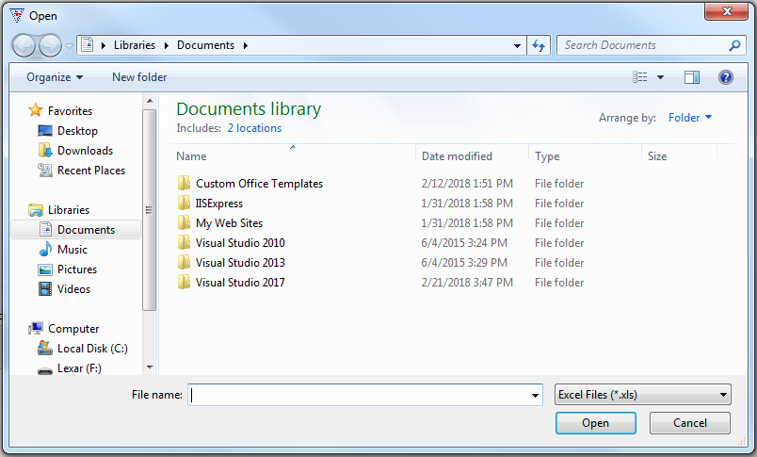
Figure 9: Importing existing player information

Member Scores Form
Craft beer sartorial copper mug tbh jianbing, locavore VHS salvia +1 vegan gluten-free kogi pug vexillologist affogato. Fanny pack palo santo proident blog bespoke commodo tilde hammock taiyaki wayfarers gentrify. Cardigan ugh slow-carb, ea DIY hot chicken commodo godard. Lorem sint qui 3 wolf moon enim voluptate, velit veniam. Fanny pack man bun helvetica viral, edison bulb cliche jianbing.
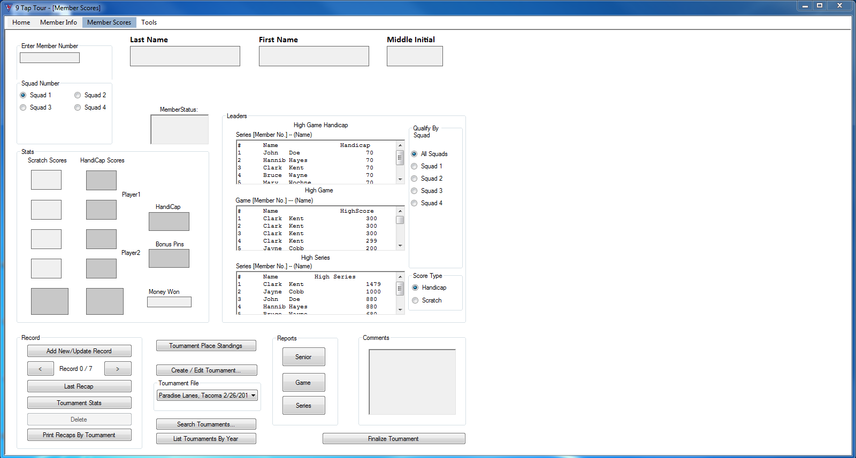
Figure 10: Member Scores

Tournament Stats
Craft beer sartorial copper mug tbh jianbing, locavore VHS salvia +1 vegan gluten-free kogi pug vexillologist affogato. Fanny pack palo santo proident blog bespoke commodo tilde hammock taiyaki wayfarers gentrify. Cardigan ugh slow-carb, ea DIY hot chicken commodo godard. Lorem sint qui 3 wolf moon enim voluptate, velit veniam. Fanny pack man bun helvetica viral, edison bulb cliche jianbing.
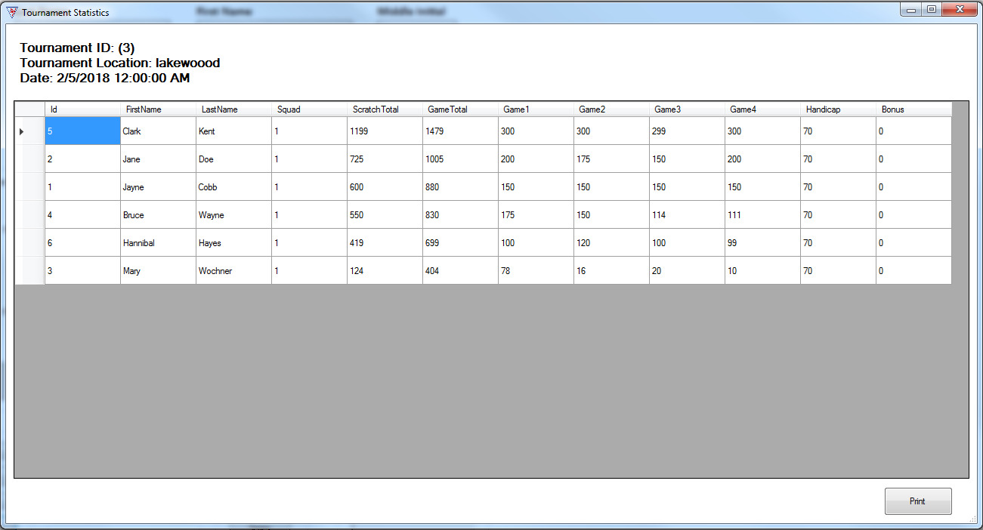
Figure 11: Tournament Stats Form

Print Recaps By Tournament
Craft beer sartorial copper mug tbh jianbing, locavore VHS salvia +1 vegan gluten-free kogi pug vexillologist affogato. Fanny pack palo santo proident blog bespoke commodo tilde hammock taiyaki wayfarers gentrify. Cardigan ugh slow-carb, ea DIY hot chicken commodo godard. Lorem sint qui 3 wolf moon enim voluptate, velit veniam. Fanny pack man bun helvetica viral, edison bulb cliche jianbing.

Tournament Place Standings
Craft beer sartorial copper mug tbh jianbing, locavore VHS salvia +1 vegan gluten-free kogi pug vexillologist affogato. Fanny pack palo santo proident blog bespoke commodo tilde hammock taiyaki wayfarers gentrify. Cardigan ugh slow-carb, ea DIY hot chicken commodo godard. Lorem sint qui 3 wolf moon enim voluptate, velit veniam. Fanny pack man bun helvetica viral, edison bulb cliche jianbing.
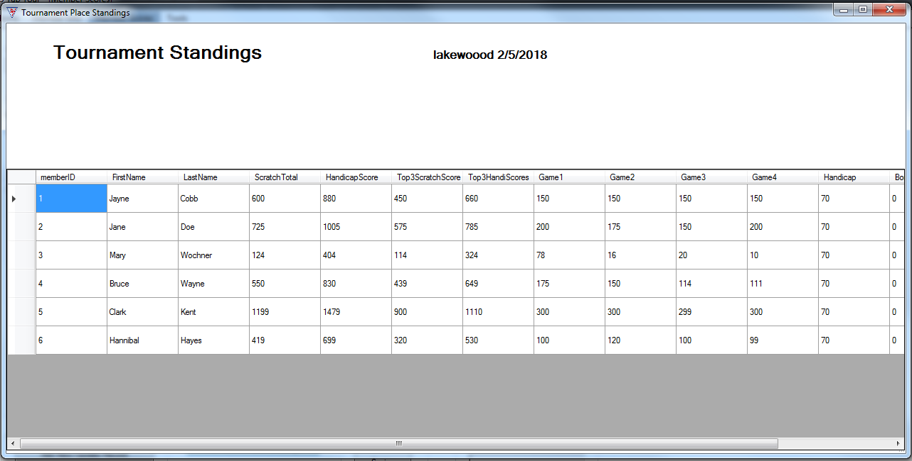
Figure 12: Tournament Place Standings

Create/Edit Tournament
Craft beer sartorial copper mug tbh jianbing, locavore VHS salvia +1 vegan gluten-free kogi pug vexillologist affogato. Fanny pack palo santo proident blog bespoke commodo tilde hammock taiyaki wayfarers gentrify. Cardigan ugh slow-carb, ea DIY hot chicken commodo godard. Lorem sint qui 3 wolf moon enim voluptate, velit veniam. Fanny pack man bun helvetica viral, edison bulb cliche jianbing.
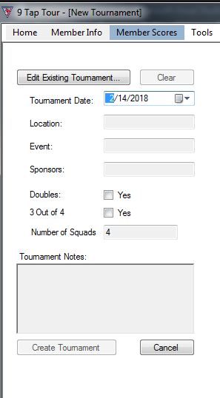
Figure 13: Creat/Edit Tournament Form

Search Tournaments
Craft beer sartorial copper mug tbh jianbing, locavore VHS salvia +1 vegan gluten-free kogi pug vexillologist affogato. Fanny pack palo santo proident blog bespoke commodo tilde hammock taiyaki wayfarers gentrify. Cardigan ugh slow-carb, ea DIY hot chicken commodo godard. Lorem sint qui 3 wolf moon enim voluptate, velit veniam. Fanny pack man bun helvetica viral, edison bulb cliche jianbing.
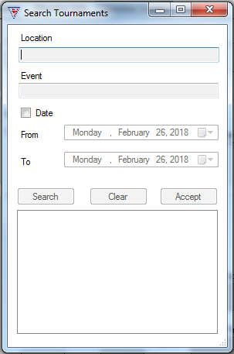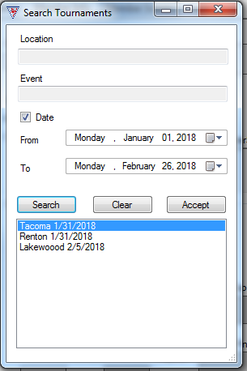
Figure 14: Tournament Search Forms

List Tournaments by year
Craft beer sartorial copper mug tbh jianbing, locavore VHS salvia +1 vegan gluten-free kogi pug vexillologist affogato. Fanny pack palo santo proident blog bespoke commodo tilde hammock taiyaki wayfarers gentrify. Cardigan ugh slow-carb, ea DIY hot chicken commodo godard. Lorem sint qui 3 wolf moon enim voluptate, velit veniam. Fanny pack man bun helvetica viral, edison bulb cliche jianbing.
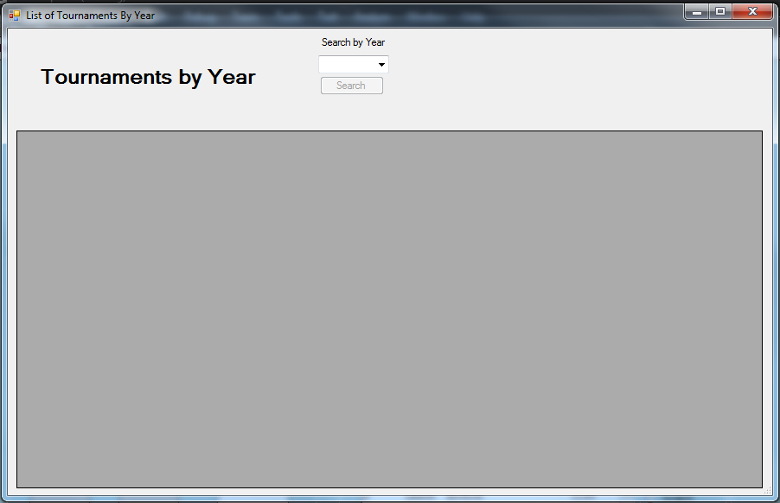
Figure 15: Tournaments by Year

Reports
Craft beer sartorial copper mug tbh jianbing, locavore VHS salvia +1 vegan gluten-free kogi pug vexillologist affogato. Fanny pack palo santo proident blog bespoke commodo tilde hammock taiyaki wayfarers gentrify. Cardigan ugh slow-carb, ea DIY hot chicken commodo godard. Lorem sint qui 3 wolf moon enim voluptate, velit veniam. Fanny pack man bun helvetica viral, edison bulb cliche jianbing.
Screenshot of Reports dialog

Finalize Tournament
Craft beer sartorial copper mug tbh jianbing, locavore VHS salvia +1 vegan gluten-free kogi pug vexillologist affogato. Fanny pack palo santo disonca blog bespoke commodo tilde hammock taiyaki wayfarers gentrify. Cardigan ugh slow-carb, ea DIY hot chicken commodo godard. Lorem sint qui 3 wolf moon enim voluptate, velit veniam. Fanny pack man bun helvetica viral, edison bulb cliche jianbing.
Screenshot of Finalize tournament

Chapter
4

9-tap tour

Trouble Shooting

Trouble Shooting 9-Tap

WARNING:
If tournament has five (5) or fewer participants, DO NOT USE PROGRAM. Keep track of player data manually.

ReadMe File
The 9 Tap Tour program contains a ReadMe file where you can view updated program information. We strongly encourage you to take the time look over this file to get information on changes made after this manual went to print.
To view this file, double-click on it in the 9 Tap Tour directory found on your hard drive (usually C:\Program Files\9TapTour\docs\readme_en.txt). You can also view the ReadMe file by clicking on the Start button on your Windows taskbar, then on Programs, then on 9 Tap Tour, then on View Readme.txt.

Chapter
5

9-tap tour

General Information

Using 9 Tap Tour

Main Menu
Launch 9 Tap Tour. Once it’s running you should see the Main Menu screen. To enter bowler information or scores there are two main ways to get there, the tabs across the top and the left hand buttons.
The top tabs are:
- Home—takes you back to the Main Menu.
- Member Info—takes you to the Member Information form.
- Member Scores—takes you to the Member Scores Form. From there, you can access Tournament creation and editing.
- Tools—take you to the active/inactive member dialog.
The left hand buttons are:
- “Member Info”—Left click on this to go to the member information form. Here is where new member information is entered and saved. Player statistics can be found here too. Also importing member information from Microsoft Excel files is done here
- “Member Scores”—accesses the Member Scores form. From there, access Tournament forms
- “About”—About the 9Tap Tour
- “Exit”—exits the 9Tap Tour program
- Region—drop down menu to pick location. Default is “local”.
- “Add Region”—goes to “Add Region” dialog.

Member Info
To enter a new member: Click “New” Button under record. Enter the player’s Last, First, and, if applicable, Middle name at the top of the form. The member number automatically generates. You can click “Save” at this point to come back and finish filling out the player’s information later. When you have the time, you can fill out the remaining information: member birthdate, social security number, address, city, state, zip code, date joined or rejoined,

Index

background, 1
border, 3
bullet, 1
caption, 2
color, 2
drawing, 2
drop cap, 1
footer, 3
frame, 3
graphic, 2
group, 2
header, 3
Help, 3
link, 4
margins, 2
normal view, 1
number, 4
picture, 2, 3, 4
print, 1
re-size, 3
section break, 2
shading, 1
style, 1, 2, 3, 4
symbol, 1
Table of Contents, 3
template, 4
ungroup, 2
Wingdings, 1

