IPO.ONE
  - OFFICIAL WHITEPAPER

The Native Credit & Obligation Protocol for the Human-Agent Economy
One kernel. Dual-native access. Continuous intelligence. Interoperable capital and settlement.

IPO.ONE enables humans and autonomous Agents to build portable credit, access competitive lender-funded offers, and carry verified performance across applications, institutions and rails.

FOUNDATIONAL PROPOSITION
Credit should be programmable, portable and progressively earned. IPO.ONE coordinates identity, evidence, intelligence, authorization, obligations, capital and settlement, without requiring IPO.ONE to become the balance-sheet lender.

FOUNDING EDITION | JULY 2026

Foundational Thesis and Scope
The next economy will be shaped by humans and autonomous Agents acting in the same markets. IPO.ONE provides the native credit and obligation protocol for that mixed economy: one deterministic kernel through which both can establish responsibility, connect permitted evidence, access competing external capital, create bounded obligations, settle across interoperable rails and convert verified performance into better future terms. This whitepaper defines the founding product thesis, protocol architecture, commercial entry strategy, risk boundaries and evidence-gated roadmap. It is not an offer of credit or securities, or legal or investment advice.

Six Founding Commitments
IPO.ONE is built around six enduring commitments:
- Dual-native by design. Humans and autonomous Agents are equal first-class Subjects; their entry paths normalize into the same canonical credit objects, obligations and state transitions.
- External capital, neutral coordination. Banks, fintechs, Originators, private credit and on-chain facilities provide capital; IPO.ONE provides intelligence, routing, evidence and canonical state.
- Continuous intelligence, bounded authority. Verified outcomes improve credit conditions and capital allocation, while lender-approved policy and the deterministic kernel remain the execution boundary.
- Rail-agnostic from inception. Traditional and on-chain environments are native execution domains connected through replaceable, monitored adapters.
- Portable progress. Responsible economic behavior becomes reusable credit history, allowing previously invisible humans and Agents to earn better access over time.
- Evidence before expansion. Product scope, capital and autonomy scale only when real cohorts demonstrate demand, safety, fairness, resilience and positive risk-adjusted economics.
Interpretive category | Meaning
Protocol requirement | A compatibility, accountability or safety rule that implementations must preserve.
Target system | A staged system capability; not a representation that every component is already deployed.
Commercial hypothesis | A market, pricing or risk proposition that must be validated with real cohorts and partners.
Illustrative threshold | A provisional evidence gate to be calibrated by product, jurisdiction, borrower protection and risk appetite.

Abstract
IPO.ONE is a dual-native credit and obligation protocol designed from first principles for the human–Agent economy. Humans and autonomous Agents are equal first-class Subjects of one canonical system: each can establish identity and responsibility, connect permitted evidence, request credit, receive an explainable offer, create a bounded Obligation, repay through an approved rail and carry verified performance forward.
Account access alone does not complete financial inclusion. The World Bank reports that 79% of adults globally now have an account, while only 56% can reliably access extra money in an emergency; 84% of adults in low- and middle-income economies own a mobile phone. Many economically active people still lack a trusted mechanism that converts lawful cash flow and repayment into portable credit. Autonomous Agents face the parallel structural gap: they can transact, but usually lack portable credit state, explicit responsibility, bounded authority and a standardized path to borrow against verified future payment capacity. [1]
IPO.ONE implements Single Kernel, Dual Entry. Human applications and embedded interfaces, and Agent-native protocols including APIs, SDKs, MCP and A2A, enter through separate adapters but normalize into the same Subjects, Principals, Intents, Credit Profiles, Offers, Authorizations, Obligations, Repayment Events and Credit States. Product, legal and risk differences are expressed through versioned policy profiles rather than separate protocol forks.
The Credit Intelligence Network is a core product plane. It continuously learns from verified cash flow, repayment, utilization, execution quality, Mandate compliance, disputes, recoveries, rail performance and economic outcomes. It automatically improves risk estimates, score calibration, eligibility, capacity, tenor, pricing, next-best interventions and capital routing at individual, cohort and network levels. Models may observe, forecast and propose; only lender-approved policy inside the deterministic kernel may authorize exposure or alter financial state.
The protocol is rail-agnostic and supports traditional and on-chain environments from inception. External providers perform KYC/KYB and provide evidence; licensed Originators, lenders and capital facilities supply regulated credit and funds. Multi-Rail Adapters execute account binding, transaction submission, event observation, finality confirmation and reconciliation without making the kernel dependent on a bank, chain, wallet, payment protocol or Agent runtime.
The first PMF wedge remains cash-flow-backed productive credit for digitally observable humans and autonomous businesses with limited traditional credit history. The long-term objective is a neutral, continuously improving protocol through which humans and Agents build portable credit and multiple off-chain or on-chain capital providers compete to finance qualified obligations.
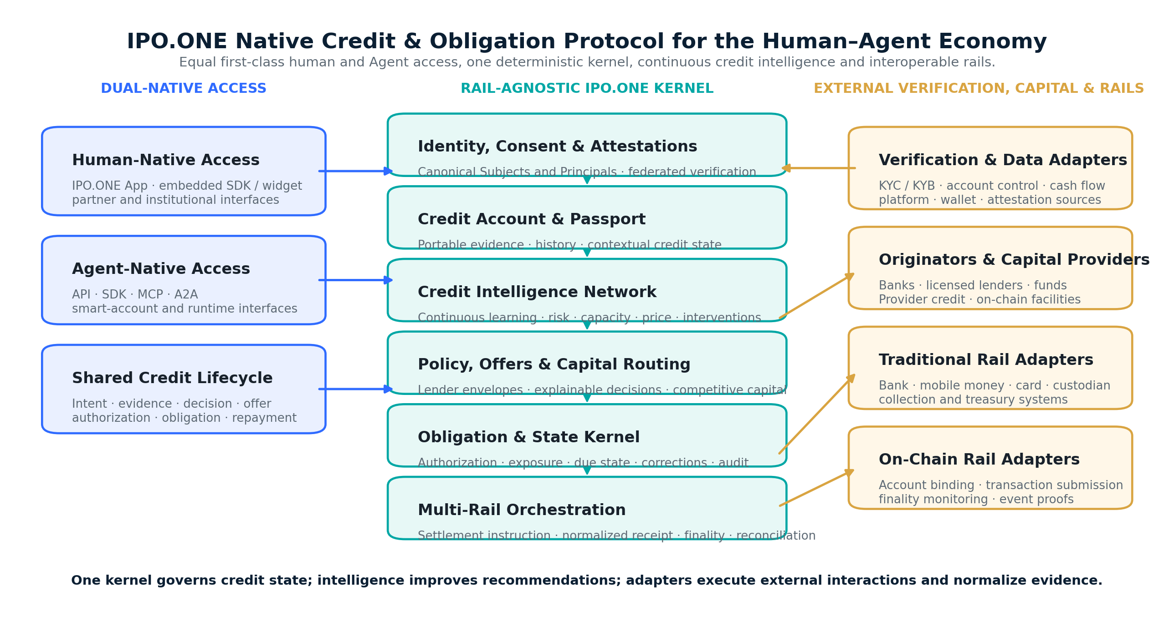
Figure 1 — IPO.ONE uses Single Kernel, Dual Entry: humans and Agents share canonical credit state, continuous intelligence and rail-agnostic execution.

Contents
Part | Focus | Sections
I — Product and Market Thesis | Why credit access remains fragmented; what IPO.ONE is and is not. | 1–4
II — Borrowers, Lenders and Product Journeys | Human, Agent and capital-provider workflows; product surfaces. | 5–9
III — Credit Protocol and Intelligence | Canonical objects, scoring, decisioning, routing, obligations and learning. | 10–17
IV — Commercialization and Network Evolution | PMF, economics, moat, roadmap and non-goals. | 18–22
Appendices | Object model, formulas, pilot scorecard, interoperability API, glossary and references. | A–E

READING SHORTCUT
Investors can read the Executive Summary, Sections 2–4, 18–21 and the Conclusion. Product and technical teams should continue through Sections 10–17.

Executive Summary

Mission
Build the native credit and obligation layer for an economy in which humans and autonomous Agents participate on equal protocol terms—including Subjects without traditional credit files—and improve access through verified performance.

Core product
IPO.ONE combines two coordinated planes: a deterministic Credit and Obligation Kernel that preserves authority, exposure and state; and a governed Credit Intelligence Network that continuously improves profiles, scores, terms, interventions and capital allocation. A Credit Account and Passport, Offer and Capital Router, canonical repayment ledger and Multi-Rail Adapter layer complete the product system.

Single Kernel, Dual Entry
Humans and Agents are equal first-class Subjects. Human interfaces and Agent-native protocols provide two entry classes, while one internal kernel preserves the same object model and state transitions. Identity assurance, authority, consumer protection, underwriting and legal responsibility differ through versioned adapters and policy profiles—not separate kernels.

Core intelligence
The Credit Intelligence Network continuously learns from verified individual, cohort and network outcomes. It improves credit conditions, limits, tenor, pricing, behavioral recommendations, anomaly controls and lender matching for both humans and Agents, while remaining subordinate to consent, fairness, lender policy and deterministic execution.

Role separation
Function | IPO.ONE role | External role
Interaction | Normalize human applications and Agent messages into canonical Intent, evidence and authorization objects. | Apps, platforms, Agent runtimes and protocols such as MCP or A2A provide the external interaction environment.
Identity / KYC / KYB | Orchestrate consent; reference signed attestations; store minimum necessary status. | Qualified identity provider or regulated lender performs verification and screening.
Credit assessment | Produce explainable profile, score, affordability, recommended limit, tenor and risk price. | Lender owns risk appetite and legal approval; may delegate decisions inside a pre-approved policy.
Loan capital | Match requests to Capital Mandates and monitor exposure. | Bank, fintech, MFI, private credit, Provider credit or on-chain facility supplies funds.
Contract / disclosures | Embed workflow, standardized data and audit receipts. | Licensed Originator or lender provides legally required agreement, disclosures and servicing.
Funding / settlement | Create rail-neutral instructions; normalize receipts, finality and reconciliation. | Traditional or on-chain rail executes the transaction; custodians, processors or chain infrastructure provide external finality evidence.
Credit history | Maintain portable, consented performance evidence and Credit State. | Partners may consume proofs under purpose-limited permissions.

First market wedge
Cash-flow-backed productive credit for digital earners and autonomous businesses. The protocol supports both borrower types from inception while initial products may use distinct verification and lender-policy profiles.

Why IPO.ONE can win
The durable moat is a compounding Credit Intelligence Network built on portable evidence, repeated repayment and execution outcomes, lender policy integrations, dual-native distribution, compliance adapters, capital performance and multi-rail reconciliation. Its advantage comes from better verified outcomes and coordination—not from one opaque score, one balance sheet or one chain.

Product truth
ONE KERNEL. DUAL ENTRY. MANY LENDERS. MANY RAILS. CONTINUOUSLY IMPROVING CREDIT.
A human or Agent should be able to establish credit once, compare qualified external capital, receive safer and better terms as verified performance accumulates, and carry that progress forward without being locked to one application, lender, blockchain or settlement network.

PART I — Product and Market Thesis

1. Financial Inclusion Beyond Account Access
Traditional underwriting is optimized for people and companies with bureau files, formal payroll records, collateral and long banking histories. Millions of economically active users instead generate evidence through mobile money, marketplace earnings, merchant sales, platform work, bank transactions, wallets and repeated digital payments. Their problem is not necessarily an absence of economic activity; it is the absence of a trusted mechanism that converts activity into portable credit evidence.
Digital identity can reduce onboarding friction when assurance levels are understood and matched to risk. FATF guidance notes that reliable digital ID can make identification easier, cheaper and more secure, and can expand access for people who lack traditional documentation. [2] Identity verification is necessary, but it is not a substitute for affordability or credit assessment.
The human–Agent economy requires one credit architecture for two native subject classes. For humans, it must convert lawful alternative evidence into fair, portable access. For Agents, it must resolve responsibility, permitted use, repayment capacity, execution quality and reusable performance. Neither class should be treated as an afterthought or forced into a separate semantic system.

2. Positioning: Native Credit and Obligation Protocol for the Human–Agent Economy
Layer | Positioning
Historical thesis | A new native protocol layer is required when humans and autonomous Agents increasingly share economic networks, capital and execution environments.
Long-term vision | Universal credit and obligation infrastructure for the human–Agent economy.
Protocol principle | Single Kernel, Dual Entry: equal first-class Subjects, one canonical lifecycle, specialized adapters and policy profiles.
Core product planes | Deterministic Credit and Obligation Kernel plus a governed, continuously improving Credit Intelligence Network.
Primary function | Coordinate identity, authority, evidence, decisioning, capital matching, obligation state, settlement, portable performance and continuous optimization.
Interaction environments | Human applications and embedded SDKs; Agent APIs, SDKs, MCP, A2A and compatible machine protocols.
Execution environments | Traditional financial rails and blockchain / on-chain rails supported natively through replaceable adapters.
First PMF | Cash-flow-backed productive credit for digitally observable human and Agent borrowers.
Default balance-sheet position | Protocol, intelligence and router; external lenders and facilities provide capital.

IPO.ONE is not merely an add-on to a payment network, lending stack or blockchain. Those systems move funds or originate products; IPO.ONE defines the shared credit and obligation coordination layer they do not provide. Intent states what is sought, evidence and intelligence assess capacity, lender policy creates authority, the Obligation records commitment, and adapters execute across external environments without changing core semantics.

3. Product Thesis in One Sentence
PRODUCT THESIS
Humans and autonomous Agents enter through native interfaces; lenders bring regulated origination and capital; IPO.ONE’s single kernel and Credit Intelligence Network turn identity, authority, evidence and intent into explainable offers, canonical obligations, rail-neutral settlement and continuously improving credit state.

4. Single Kernel, Dual Entry
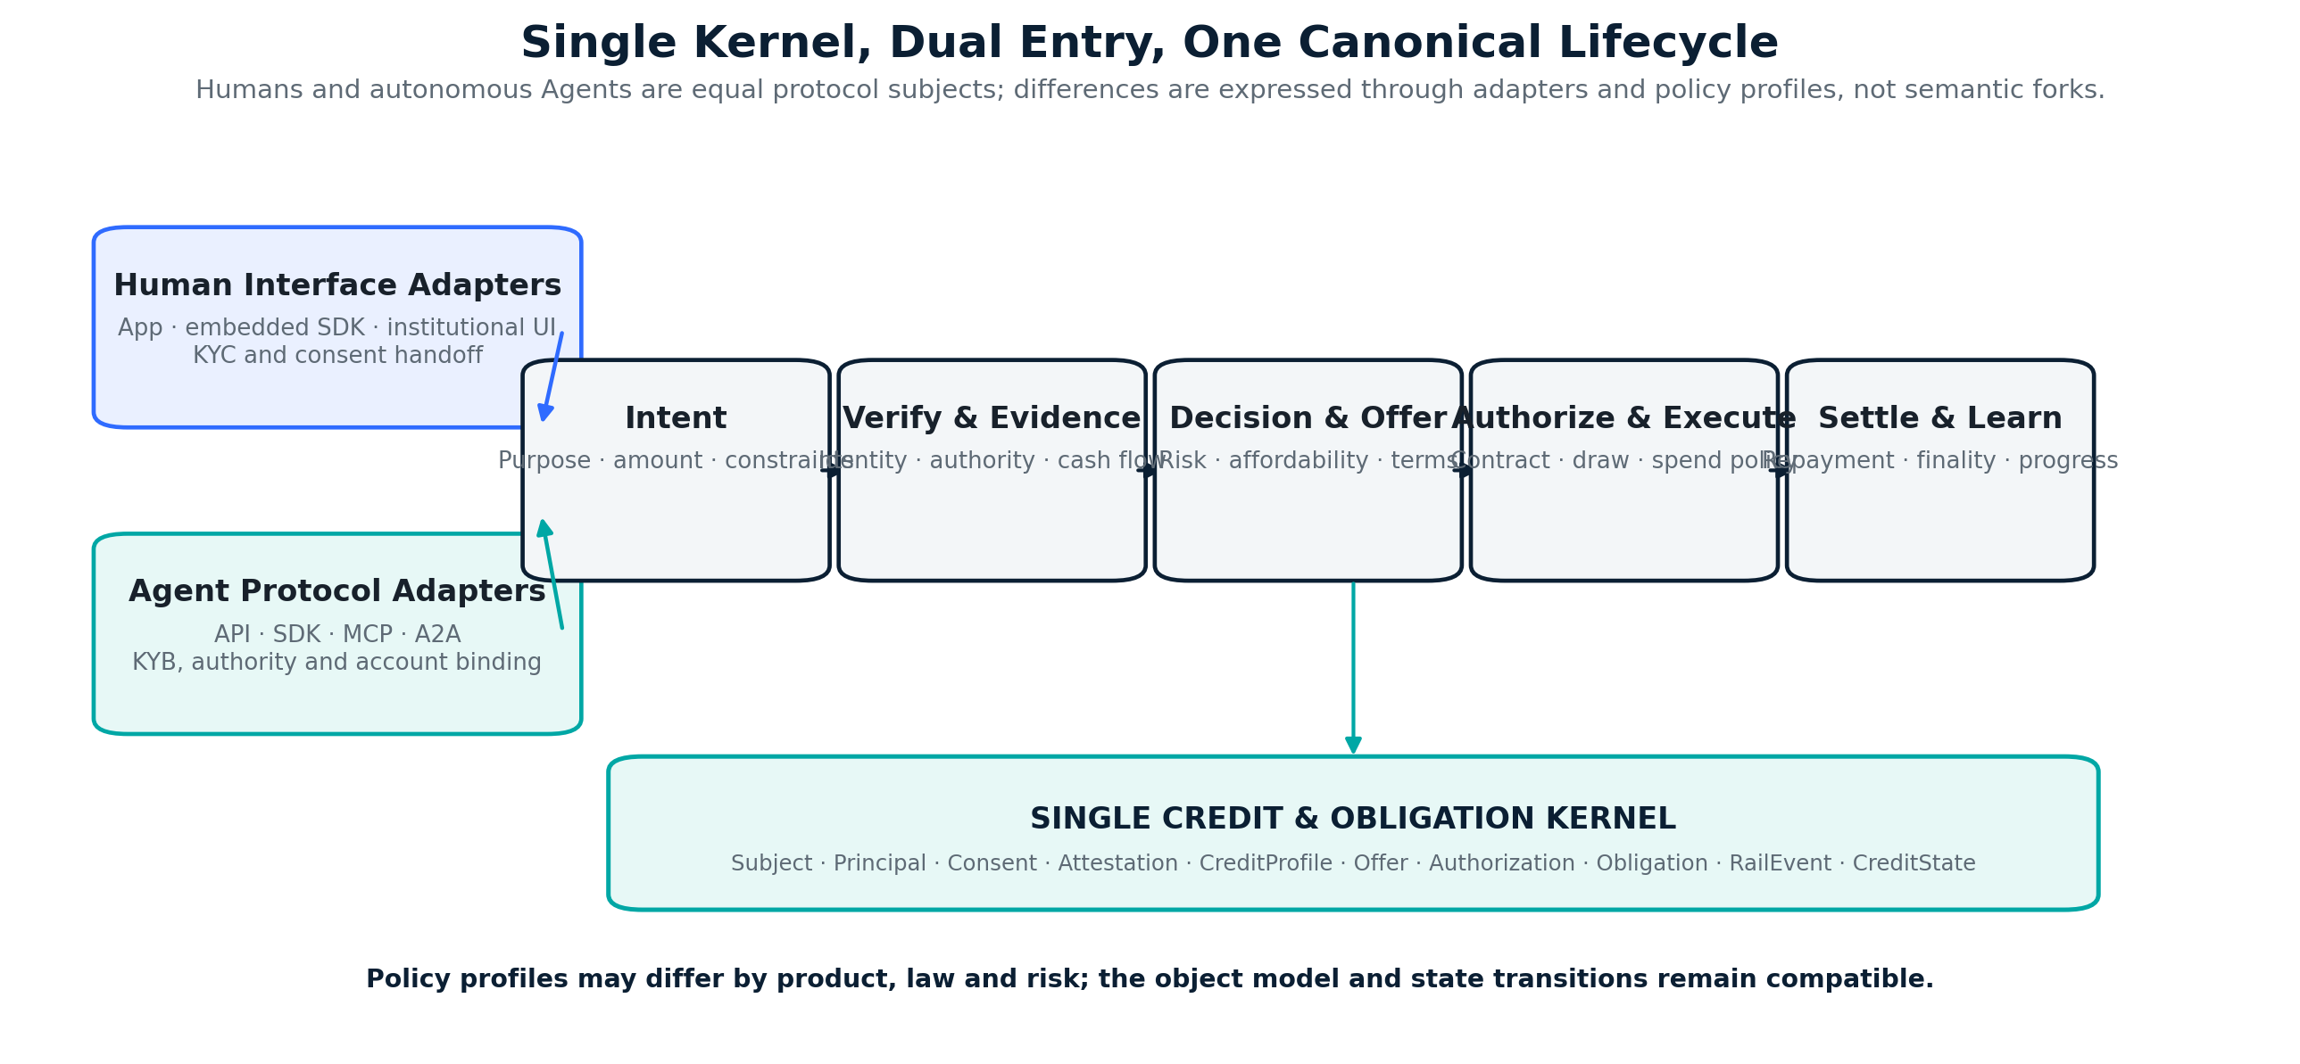
Figure 2 — Single Kernel, Dual Entry: human and Agent protocols differ at the edge while canonical credit, obligation and learning state remain shared.
Dimension | Human-native profile | Agent-native profile | Shared kernel
Interaction | IPO.ONE App, embedded SDK, partner or institutional interface. | API, SDK, MCP, A2A, Agent runtime or smart-account interface. | Both normalize into CreditIntent, evidence, offer, authorization and obligation objects.
Identity and authority | KYC, consent and applicable legal capacity. | KYB, signer authority, Principal relationship, Agent identity and account binding. | VerificationAttestation and PrincipalRelationship use the same canonical structure.
Policy | Product, affordability, consumer-protection and jurisdiction profile. | Mandate, purpose, budget, sponsor and commercial-credit profile. | Versioned LenderPolicy and Authorization enforce product-specific constraints.
Execution environment | Traditional or on-chain account chosen by the borrower, lender and product. | Traditional account, wallet, smart account or service-provider account. | Multi-Rail Adapters map all receipts and finality into RailEvents.
Output | Credit Account, offers, Obligation, repayment state and portable performance. | Same. | One recomputable CreditState and audit trail.

Equal first-class status does not mean identical underwriting or identical law. It means the protocol never treats humans as a legacy mode or Agents as a bolt-on. It preserves one identity, credit, obligation, settlement and learning ontology, while adapters and policy profiles express the real differences in verification, authority, protection, liability and risk.

PART II — Borrowers, Lenders and Product Journeys

5. Human Credit Access
Human access is one native entry into the protocol, not a legacy compatibility layer. People may apply through the IPO.ONE Credit App or an embedded partner interface; the official application is a direct channel and product laboratory, while embedded distribution remains the scaling model. The journey uses the same canonical credit and obligation lifecycle as Agent access.
1. The borrower submits a Credit Intent containing amount, purpose, desired tenor, repayment source and permitted settlement preferences.
2. The borrower grants purpose-limited consent to external KYC and selected evidence connections.
3. A qualified provider or Originator completes required checks; IPO.ONE receives a signed status and provenance reference rather than unnecessary raw documents.
4. IPO.ONE constructs a Credit Profile from verified cash flow, stability, existing obligations, repayment history, fraud signals and evidence confidence.
5. The Decisioning Engine produces an explainable eligibility result and recommended capacity, tenor, controls and indicative risk price.
6. The Offer Router matches the request to eligible lender policies and presents qualified terms using a common comparison model.
7. The selected lender or Originator issues required disclosures and agreement; a Multi-Rail Adapter coordinates funding through the approved traditional, on-chain or hybrid path.
8. Normalized repayment and settlement events update the Credit Account, regardless of which supported rail executed the transfer.

6. Agent Credit Access
Agent access is the second native entry into the same protocol, not a machine wrapper around human forms. Agents use structured APIs, SDKs, MCP, A2A and compatible machine protocols that normalize into canonical objects. The system does not assume that an Agent is an independent legal person; a verified Principal or Operator establishes authority, liability, budgets and repayment sources under the applicable policy profile.
1. The responsible Operator or Principal completes the required identity, KYB and authority checks.
2. The Agent is bound to an account, wallet, smart account or platform identity and receives a machine-readable Mandate.
3. The Agent submits a Credit Intent and, where execution is multi-step or restricted, an Execution Plan with budget, Providers, fallback behavior and evidence criteria.
4. IPO.ONE validates plan, mandate, existing exposure, repayment capacity, lender policy and Provider eligibility.
5. The Router obtains Provider-funded terms, lender-funded capacity or a sponsor-backed line under the same CreditOffer model used for human credit.
6. An Authorization permits only approved resources, amounts, counterparties, time windows and settlement environments.
7. Usage or drawdown creates an Obligation; Multi-Rail Adapters may pay a Provider or transfer value through a traditional or on-chain environment.
8. Repayment, finality and productive outcomes update the relevant Agent and Principal Credit States without confusing execution identity with legal responsibility.

7. Lender, Originator and Capital-Provider Journey
Capital providers should not need to adopt a new balance sheet or surrender control. They publish a machine-readable Lender Policy or Capital Mandate and choose how much decision authority to delegate.
Decision mode | IPO.ONE action | Lender / Originator control
Advisory scoring | Return Credit Profile, risk, affordability, recommended terms and reasons. | Partner makes the final decision manually or in its own system.
Delegated decisioning | Automatically approve, decline or step-up when a request fits a signed policy envelope. | Partner pre-approves policy, caps, pricing grid, exceptions and audit rights; remains legal credit provider.
Request for offer | Route a standardized application to multiple eligible lenders and rank returned offers. | Each lender returns binding or conditional terms under its own mandate.

A Capital Mandate defines jurisdiction, subject type, product, currency, amount, tenor, pricing bounds, required evidence, verification standard, concentration, recourse, reserve, permitted rails, finality requirements, asset representation and servicing obligations. Funds may remain in a lender account, regulated custodian, escrow, smart contract or permissioned facility until a qualified offer is accepted.
Capital source | Best initial use
Banks / licensed nonbanks | Human consumer, sole-proprietor or SME credit under local law.
Microfinance / impact lenders | Inclusive productive credit with defined social and risk objectives.
Private credit / fintech facilities | Short-duration, data-rich receivables and working-capital programs.
Provider / vendor trade credit | Agent services, inventory, software and other controlled-use value.
On-chain capital facilities | Digital-asset, stable-value or tokenized funding for eligible obligations where legal rights, custody, evidence and servicing are defined.

8. End-to-End Borrower-to-Capital Lifecycle
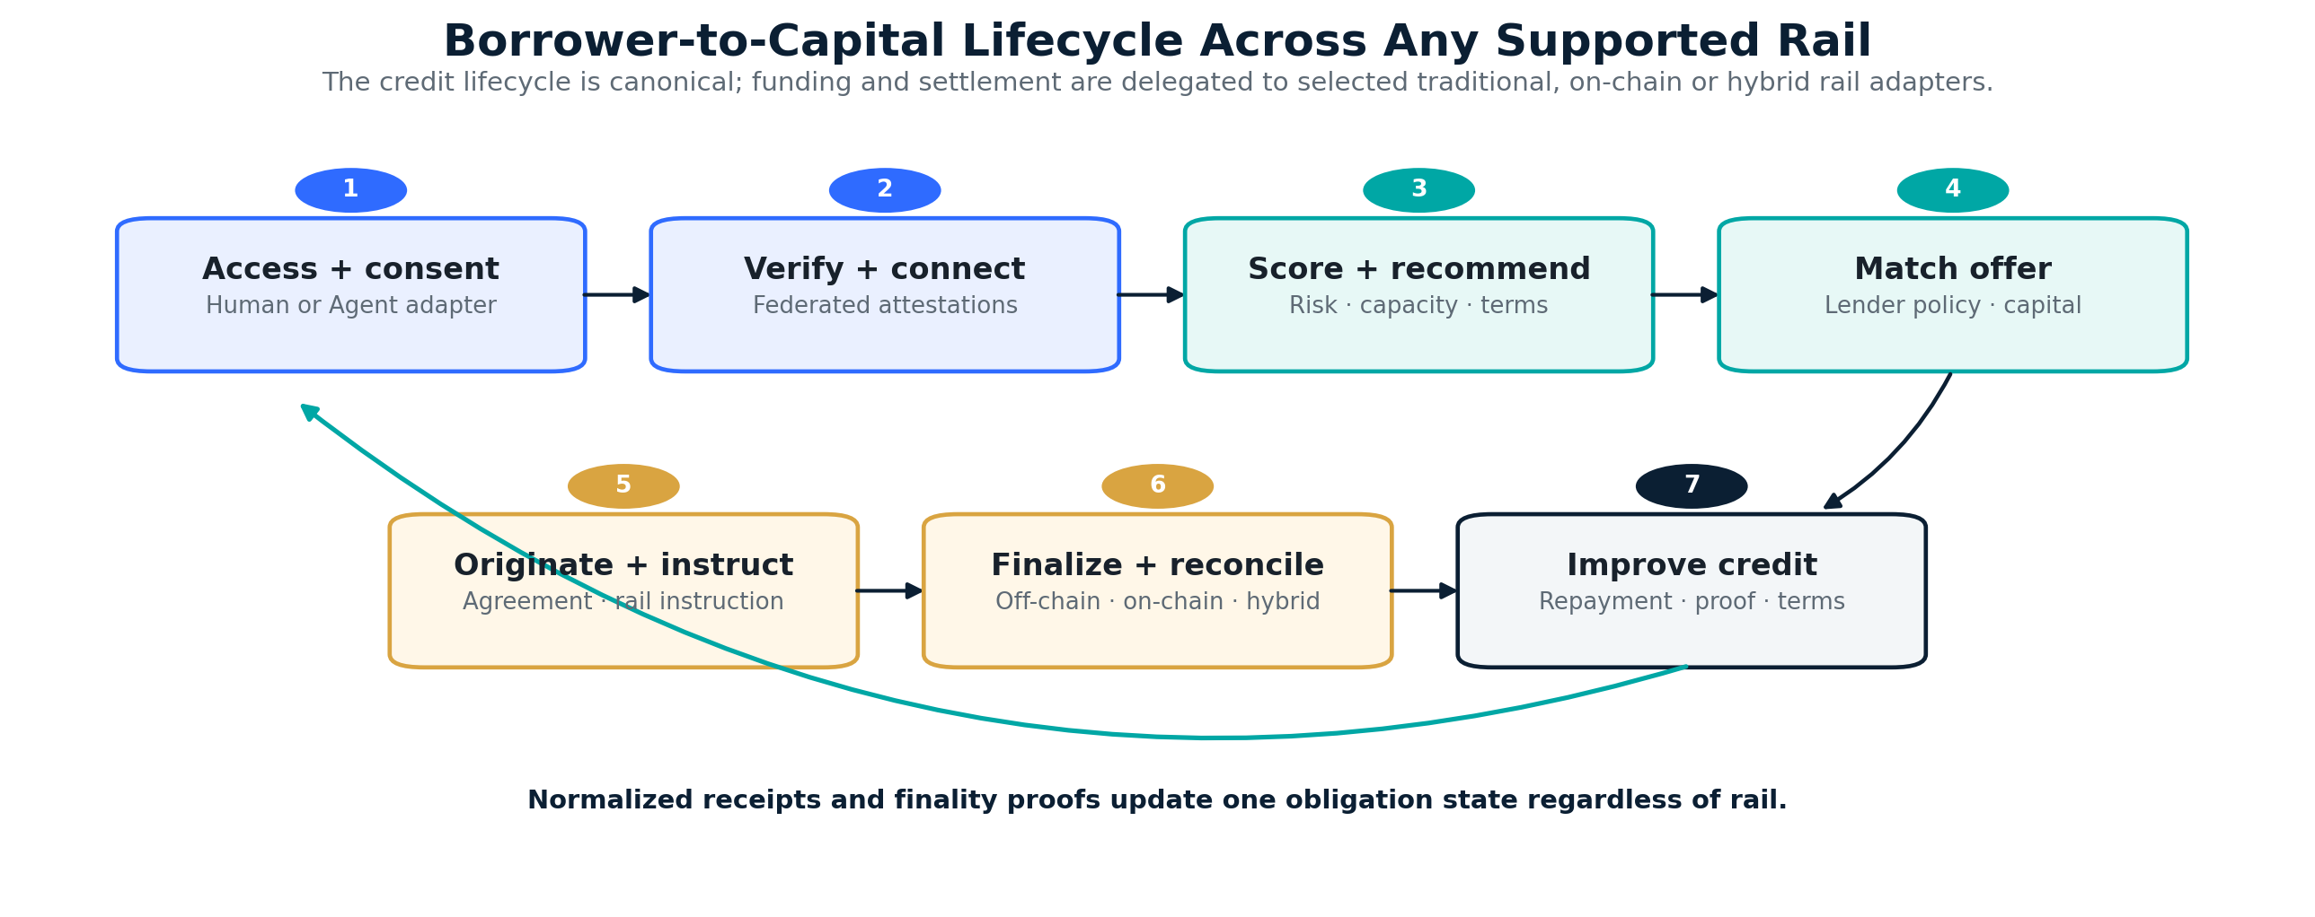
Figure 3 — A single application becomes a matched obligation whose funding and settlement state is consistent across traditional, on-chain or hybrid rails.
The central design principle is “apply once, verify once where legally reusable, compare qualified offers, settle through any approved rail and carry performance forward.” Reuse remains subject to consent, credential validity, lender policy, rail finality and jurisdiction.

9. Product Surfaces: One Platform, Role-Specific Interfaces
Surface | Primary user | Core workflows
IPO.ONE Credit App | Human borrowers | Credit Intent, consent, KYC handoff, evidence connections, score factors, offer comparison, settlement status, repayment and disputes.
Embedded Credit SDK / Widget | Platforms and marketplaces | White-label eligibility, offer, contract handoff, disbursement state, repayment and rail status.
Agent Credit API / MCP / A2A | Agents, Operators and developers | Machine eligibility, plan validation, Authorization, drawdown, settlement status and repayment.
Lender / Originator Console & API | Banks, fintechs, MFIs and regulated partners | Policy configuration, exceptions, pricing, adverse-action reasons, loan tape, servicing and permitted rails.
Capital / Facility Console | Off-chain and on-chain facilities | Mandates, asset eligibility, reserves, exposure, concentration, performance, settlement and waterfall.
Multi-Rail Gateway | Lenders, facilities, wallets, Agents and treasury systems | Account binding, transaction submission, finality query, event subscription, evidence anchoring and reconciliation.
Risk & Operations Console | IPO.ONE and delegated operators | Models, policies, overrides, incidents, portfolio monitoring, rail exceptions, reconciliation and audit.

These are role-specific surfaces over the same canonical objects, event ledger and policy engine. Every external interaction protocol—including human application APIs, MCP, A2A and blockchain protocols—is handled by an adapter and normalized before it can affect internal credit or obligation state.

PART III — Credit Protocol and Intelligence

10. The I–P–O Model and Intent-to-Credit Lifecycle
IPO.ONE retains its original Identity–Payment–Obligation model while using Intent as the request envelope. The model is subject-neutral and rail-neutral.
Primitive | Question answered | Protocol role
Identity | Who is acting, who authorized the action, and who is responsible? | Resolve Human, Organization, Agent and Machine Subjects, Principals, accounts and attestations through compatible profiles.
Intent | What value is requested, for what purpose and under what constraints? | Represent a Credit Intent and optional Execution Plan for any subject type.
Payment / Settlement | How does value move, obtain finality and reconcile? | Issue rail-neutral instructions and normalize traditional, on-chain and hybrid receipts; do not reinvent the rails.
Obligation | What future commitment exists? | Create canonical terms, exposure, repayment, delinquency, default, dispute and recovery state independent of rail.
Evidence | What actually happened? | Bind verification, cash flow, execution, settlement and performance to provenance-aware events and finality proofs.

A Credit Intent becomes a Credit Request, one or more Credit Offers, an accepted agreement reference, a funded Obligation and ultimately a Repayment or Loss outcome. Plan Validation is available to any complex or restricted-use intent, not only to Agents. Rail-specific technical finality is recorded separately from legal discharge, which remains governed by the applicable agreement and law.

11. Canonical Credit Account and Credit Passport
The Credit Account is the canonical state for a Subject. The Credit Passport is the borrower-controlled, selectively disclosed representation of that state. It enables progress and portability without placing raw identity or transaction data on a public ledger.
Component | Content
Identity assurance | Verification status, issuer, assurance level, timestamp, expiry and revocation.
Cash-flow evidence | Income, revenue, inflow stability, concentration, seasonality and reachable repayment source.
Credit behavior | Applications, approvals, utilization, on-time payment, DPD, cure, restructuring, disputes and recovery.
Credit Profile | PD, affordability, fraud risk, stability, evidence confidence and product-specific eligibility.
Borrower-visible progress | Credit Tier, major positive/negative factors, connected data, open obligations and improvement actions.
Settlement provenance | Rail instructions, normalized receipts, finality proofs, partial settlements, reversals and reconciliation state.
Portable proofs | Purpose-limited attestations derived from verified behavior without requiring raw data or a public-chain history.

W3C Verifiable Credentials 2.0 provides a useful issuer–holder–verifier pattern for portable claims, with explicit security and privacy considerations. IPO.ONE may use compatible credentials off-chain or in on-chain verification flows where they improve interoperability, while each lender remains responsible for its own business rules. [3]

12. External KYC/KYB, Consent and Data Architecture

12.1 KYC/KYB is federated, not duplicated
Qualified identity providers, platforms or regulated lenders perform KYC/KYB. IPO.ONE stores the minimum necessary result, issuer, assurance level, status, timestamps, purpose and revocation reference. Raw identity documents should remain with the responsible party unless a specific legal or operational need requires otherwise.

12.2 Consent is a protocol object
A Consent Grant specifies which data may be accessed, for what decision, by which party, for how long, whether it may be used for model training, and how it can be revoked. Reuse of verification or performance evidence is never assumed merely because it is technically available.

12.3 Dual-native evidence profiles
Human verification and evidence adapters | Agent / organization verification and evidence adapters
Identity, lawful cash-flow and repayment attestations from approved financial, platform or public sources. | Organization and signer verification, Agent identity and account binding, lawful cash-flow, usage, mandate and repayment attestations.
Stability, concentration, seasonality, existing obligations and correction history expressed through the shared EvidenceEnvelope. | Principal quality, concentration, usage, execution, revenue capture and liability structure expressed through the same EvidenceEnvelope.

Both evidence profiles map into one canonical evidence ontology so the kernel, audit system and Credit Intelligence Network can operate consistently. Human and Agent feature sets remain domain-specific where law, meaning or risk differs; cross-learning is permitted only when validated, lawful, explainable and beneficial to the relevant product.

12.4 Data that should not become the default
- Unconsented contact lists, private messages or social content.
- Sensitive characteristics or proxies that cannot be lawfully and demonstrably justified.
- Persistent device, wallet or chain surveillance unrelated to fraud, account control or the declared underwriting purpose.
- Opaque third-party scores without provenance, correction and permitted-use controls.

13. Credit Intelligence, Decisioning, Offers and Capital Routing
The Credit Intelligence Network is a core product plane, not an auxiliary scoring service. It converts verified outcomes into continuously improving credit profiles, score calibration, terms, behavioral guidance, portfolio controls and capital allocation, while the deterministic kernel preserves policy and state. It produces multiple explainable outputs rather than relying on one opaque number.
Output | Purpose
IPO Credit Profile | Multidimensional view of identity, affordability, repayment, stability, fraud, context and evidence confidence.
Product Risk Score | Normalized product- and horizon-specific indicator used for eligibility and monitoring; versioned and explainable.
Credit Progress Tier | Borrower-visible T0–T5 progression that rewards verified data and repayment without claiming universal truth.
Recommended terms | Limit, tenor, repayment schedule, required controls and indicative risk price.
Monitoring signals | Fraud, overextension, cash-flow deterioration, concentration, model drift, rail reliability and intervention recommendations.

The protocol does not require one universal score range. A product may display a normalized IPO Credit Score for usability, but the binding decision uses probability of default, affordability, fraud, evidence confidence, facility limits and legal policy. A high score cannot override an unaffordable payment.

13.1 Decision formulas
EXPECTED LOSS
EL = PD × LGD × EAD

PD estimates default probability over the relevant horizon; LGD estimates economic loss after recoveries; EAD estimates exposure at default. All are product-, jurisdiction- and cohort-specific.
RECOMMENDED CAPACITY
Limit* = max(0, min(AffordabilityCap, CashFlowCap, PolicyCap, FacilityCap) × EvidenceConfidence × StressHaircut − ExistingExposure)

INDICATIVE RISK PRICE
Price* = Cost of Capital + Expected Loss + Operations / Compliance + Capital Charge + Margin, subject to lender policy and law.

13.2 Explainability and decision rights
- Every decision records policy, model, data snapshot, reason codes, confidence and responsible lender.
- Borrowers can inspect major factors, correct data and appeal where required.
- IPO.ONE may auto-decide only inside a lender-signed policy envelope; the lender or Originator remains accountable for the credit product.
- Sparse evidence reduces capacity and autonomy rather than creating false precision.

13.3 Offer and Capital Router
The Offer and Capital Router converts one standardized Credit Request into eligible, transparent and fundable offers without privileging a specific balance sheet or rail.
1. Normalize Subject, evidence, requested terms, jurisdiction and permitted settlement environments.
2. Filter Capital Mandates by legal eligibility, verification standard, product, currency, amount, tenor, risk band, concentration and rail requirements.
3. Run delegated policies or send a request-for-offer to eligible lenders and facilities.
4. Validate total cost, disclosures, funding availability, asset eligibility, custody and finality conditions.
5. Rank offers by borrower utility: eligibility, total cost, approval certainty, speed, flexibility and product fit—not by platform revenue alone.
6. Record the selected lender, policy, price, capital source, permitted rail and reasons in an immutable Offer Receipt.

13.4 Financeable and Tokenized Credit Assets
An eligible Obligation may remain an off-chain loan or receivable record, or it may be represented as an on-chain verifiable asset when the legal right, evidence, custody, transfer restrictions, servicing and investor eligibility are defined. Tokenization is an optional representation and distribution mechanism; it does not create the legal claim, improve weak asset quality or permit duplicate financing.
The Capital Router can match eligible obligations to off-chain facilities or On-chain Capital Facilities under the same mandate framework. Rail and asset form are selection attributes alongside risk, duration, jurisdiction, currency, concentration, total cost and borrower protection.

14. Single Kernel, Dual Entry and Replaceable Adapters
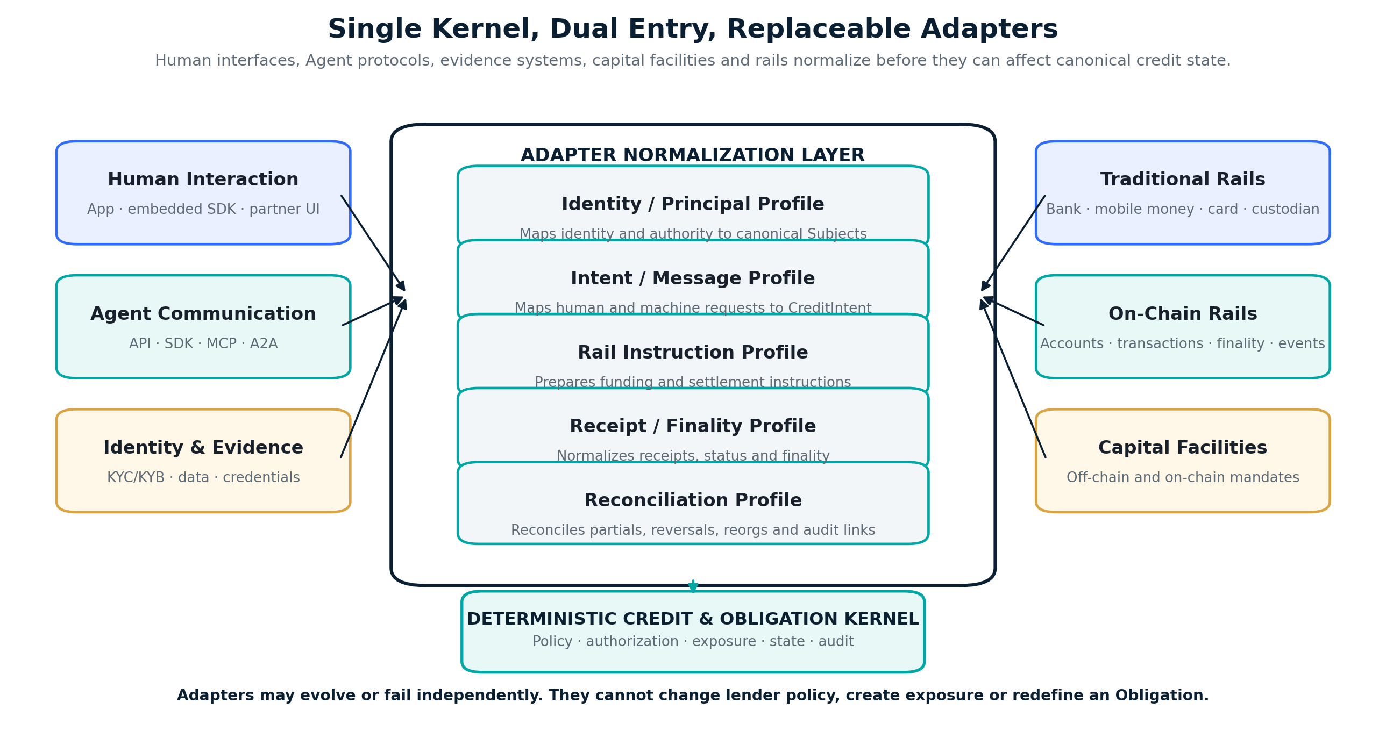
Figure 4 — Single kernel, dual entry and replaceable adapters: every external interface, protocol, evidence source, capital facility and rail maps into canonical objects and events.

14.1 Stable deterministic kernel
The kernel owns canonical Subjects, Principals, Intents, Credit Profiles, Offers, Authorizations, Obligations, Credit States, policy versions and audit events. Human and Agent entry paths converge here. The kernel does not call a specific bank, chain, wallet, Agent protocol or identity vendor directly, and it does not fork state semantics by subject type.

14.2 Adapter classes
Adapter class | Responsibilities
Human Interaction Adapters | Map applications, embedded workflows and institutional interfaces into canonical Intent, Consent, evidence, offer and disclosure objects.
Agent Communication Adapters | Map API, SDK, MCP, A2A and compatible machine messages into canonical Intent, Plan, Mandate, Authorization and status objects.
Identity and Evidence Adapters | Bind accounts, ingest KYC/KYB, authority, account-control and behavioral attestations, refresh status and preserve provenance.
Multi-Rail Adapters | Execute traditional or on-chain account binding, instruction preparation, transaction submission, event observation, finality, partial reconciliation, reversal and correction.
Capital Facility Adapters | Register off-chain or on-chain mandates, reserve or allocate capital, receive standardized asset data and report performance.
Proof and Attestation Adapters | Anchor or verify commitments, credentials, revocations, execution evidence and purpose-limited performance proofs.

14.3 Multi-Rail Adapter contract
A Multi-Rail Adapter provides a common control surface for account binding, instruction preparation, transaction submission, event observation, finality confirmation, reconciliation and correction. Each adapter translates rail-specific evidence into normalized RailEvents. The kernel determines whether those events satisfy the applicable settlement policy; the adapter cannot alter credit terms or create exposure.

14.4 Protocol normalization
All external systems—including human interfaces, Agent communication protocols, payment networks and on-chain protocols—are transport, evidence or execution environments. Adapters normalize them into internal objects such as Subject, CreditIntent, ExecutionPlan, Authorization, SettlementInstruction, RailReceipt and FinalityProof. Blockchain environments may support both verifiable Agent execution and capital interaction, but they do not define a separate credit ontology. This normalization prevents integration-driven technical debt and preserves one long-lived kernel.

14.5 Failure isolation
- A rail outage, chain reorganization, processor reversal or Agent-protocol failure cannot silently finalize an Obligation.
- Adapters are versioned, monitored and replaceable; a failing adapter can be paused without changing the kernel.
- Canonical idempotency keys prevent duplicate funding or repayment effects across retries and multiple rails.
- Fallback rails require an explicit policy and cannot increase total authorized exposure.

15. Origination, Obligations, Servicing and Multi-Rail Settlement
After offer acceptance, the legal lender or Originator creates the agreement and disclosures. IPO.ONE stores references and canonical economic terms, not a claim that software overrides local law. The Obligation remains rail-independent while its funding and repayment can occur off-chain, on-chain or through a hybrid combination.
State | Meaning
Offered | Conditional or binding terms issued by an identified lender.
Accepted / Contracted | Borrower accepts; required agreement and disclosures completed.
Funding instructed | A rail-neutral instruction is created for an approved adapter and destination.
Pending finality | The rail has accepted or observed the transaction but applicable finality conditions are not yet satisfied.
Funded / Active | Required funding finality is confirmed; the Obligation is outstanding and restrictions are tracked.
Partially settled | A valid portion is reconciled, including combinations of traditional and on-chain receipts.
Due / Delinquent | Payment is due or past due according to the product-specific DPD definition.
Cured / Restructured | A delinquency is resolved or terms are lawfully modified.
Settled | Principal, interest and fees are fully reconciled and legally discharged under the applicable terms.
Reversed / Corrected | A chargeback, return, reorganization, duplicate or operational error is recorded through an additive correction event.
Defaulted / Written off | Loss state recorded with recovery and correction rights.

15.1 On-chain, off-chain and hybrid settlement
A single Obligation may settle entirely through a traditional rail, entirely through an on-chain rail, or through multiple partial payments across both. IPO.ONE aggregates only normalized, authenticated receipts and prevents the sum of recognized settlement from exceeding the valid Obligation amount.

15.2 Finality and legal discharge
On-chain finality may be evidenced by transaction inclusion, confirmation depth, protocol finality or a trusted attestation. Off-chain finality may be evidenced by a bank, processor, custodian, mobile-money or platform receipt. Technical finality is not automatically identical to legal discharge; the applicable agreement, reversal rights and law determine when an Obligation is legally settled.

15.3 Event sourcing and reconciliation
Every funding, repayment, refund, reversal, write-off and recovery event is authenticated, idempotent, amount-bounded and linked to its external receipt. Hybrid settlement is represented as multiple partial events against one Obligation. Corrections are additive and preserve the complete event trail.

16. Progressive Credit and the Credit Intelligence Network
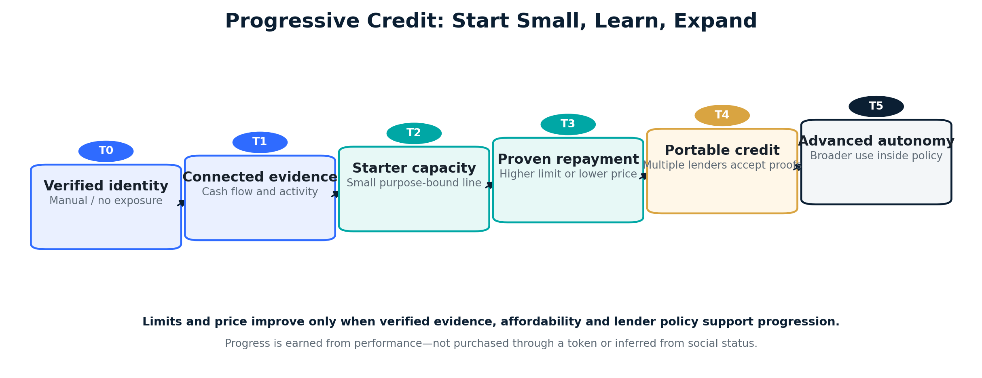
Figure 5 — Progressive credit allows thin-file humans and Agents to earn broader capacity and better terms from verified performance.
Inclusive credit should not infer large unsecured exposure from weak evidence. IPO.ONE begins with affordable, purpose-appropriate capacity, observes verified performance and expands only when evidence, borrower benefit and lender policy support progression. This principle is dual-native: the lifecycle is shared, while the relevant evidence and safeguards differ by Human or Agent policy profile.

16.1 Continuous optimization targets
Domain | Verified signals | Continuously optimized outputs
Human | Cash-flow stability, affordability, utilization, repayment, DPD, cure, complaints, corrections and response to interventions. | Eligibility, score calibration, limit, tenor, schedule, price, data requests and next-best credit-improvement actions.
Agent | Mandate compliance, execution reliability, task outcome, resource efficiency, Provider concentration, revenue capture, repayment and intervention response. | Capacity, per-Agent sub-limits, Provider scope, spend policy, reserve, tenor, price, settlement routing and autonomy level.
Network | Fraud and collusion patterns, attester quality, lender and Provider performance, rail reliability, macro drift, loss and capital utilization. | Model calibration, policy recommendations, monitoring thresholds, capital matching, concentration controls and fallback rules.

16.2 Credit Progress and Behavioral Optimization Loop
The system does not only evaluate Subjects; it should help them improve sustainable access. The loop is: observe verified behavior; diagnose limiting factors; recommend a transparent next-best action; obtain the required consent or Mandate authority; apply a bounded intervention; measure the causal result; and update Credit State and future recommendations. The objective is not to maximize borrowing. It is to improve repayment capacity, productive outcomes, credit health and long-term access at an appropriate cost.
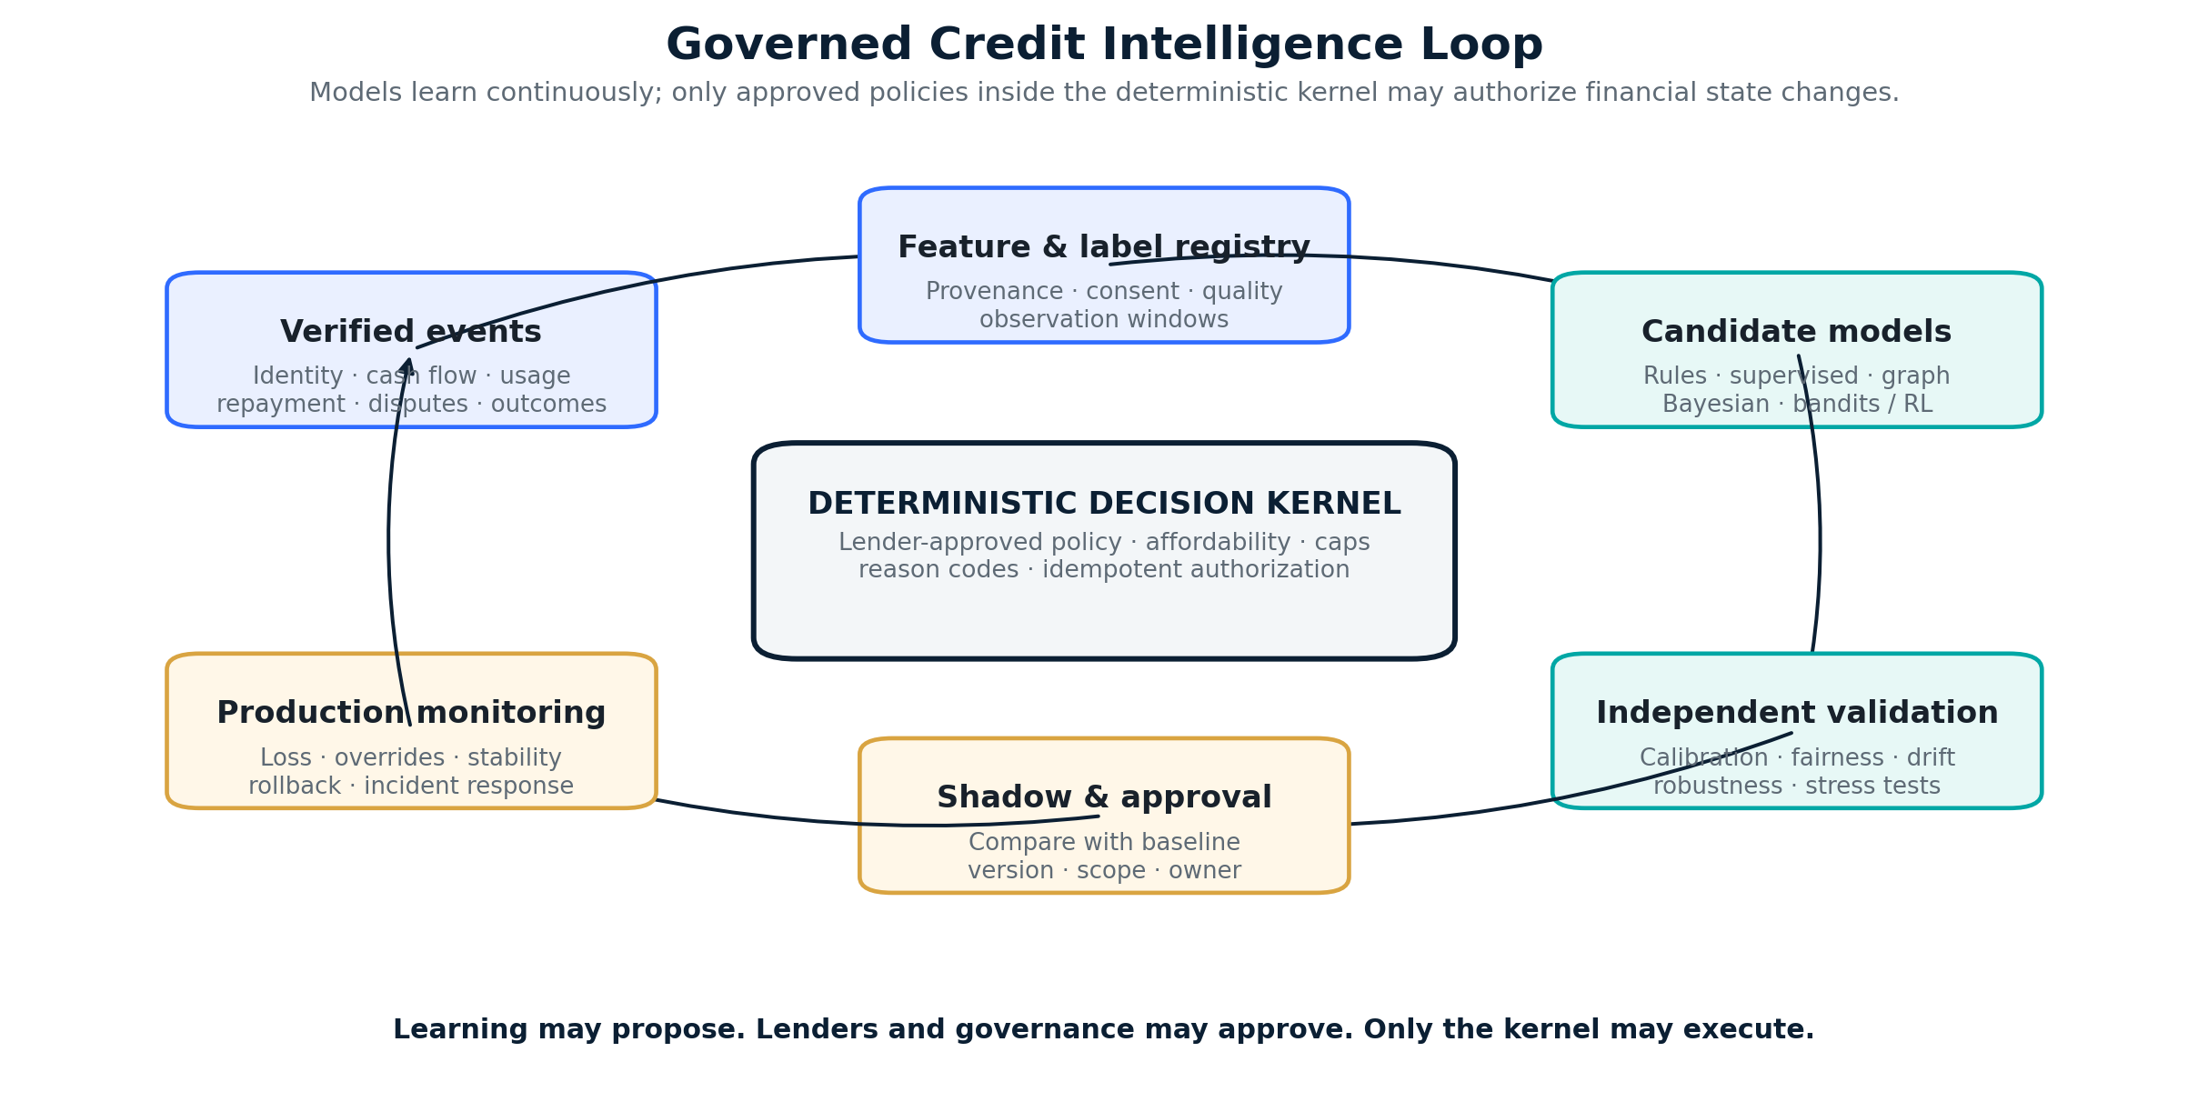
Figure 6 — The Credit Intelligence Network learns continuously from verified outcomes, but only lender-approved deterministic policy may authorize financial state changes.

16.3 Three learning scopes
Scope | May learn | Boundary
Individual | Cash-flow stability, repayment pattern, execution quality, preferred interventions, Mandate compliance and response to prior recommendations. | Purpose limitation, consent, explainability, correction rights and no hidden universal profile.
Cohort | Patterns across comparable Subjects, Providers, products, tasks, tenors, jurisdictions and economic contexts. | Minimum cohort size, fairness and stability tests, temporal validation and no invalid extrapolation.
Network | Fraud rings, attester quality, systemic drift, capital performance, rail reliability, portfolio correlation and cross-platform outcomes. | Aggregation, access control, privacy-enhancing methods, independent governance and domain separation where required.

16.4 Self-improvement without uncontrolled autonomy
Candidate techniques may include deterministic scorecards, supervised learning, graph methods, Bayesian updating, causal inference, anomaly detection, contextual bandits and constrained reinforcement learning. NIST’s AI RMF provides a useful reference for trustworthiness, governance and monitoring. [4]
- Data ingestion, monitoring, model training and recommendation generation may be automated; deployment authority remains versioned and governed.
- Models may score, forecast, diagnose and propose; only approved lender policies may authorize, price or expand exposure.
- Every production model and feature set has a version, scope, owner, provenance, independent validation, rollback path and monitoring threshold.
- Exploration is limited by explicit exposure, fairness, customer-harm and loss budgets; material deterioration triggers automatic fallback.
- Human and Agent models share a canonical ontology and learning infrastructure, while domain-specific features and protections remain separated unless transfer is validated, lawful and explainable.
- No model may rewrite protocol invariants, move funds, conceal the responsible lender or optimize solely for borrowing volume or platform revenue.

17. Safety, Fairness, Privacy and Governance

17.1 Credit and protocol invariants
- No credit exposure without a valid Subject, responsible Principal and applicable lender policy.
- No automated approval outside the lender’s signed decision envelope.
- No Obligation without accepted terms, bounded Authorization and a unique state transition.
- No adapter may directly change credit terms, create exposure or redefine canonical state.
- No funding or settlement becomes final until the applicable rail-finality profile is satisfied.
- No partial or hybrid settlement may cause recognized value to exceed the valid Obligation amount.
- No tokenized representation may duplicate or exceed the underlying legal or economic claim.
- No repayment, refund, reversal or write-off may be counted twice.
- No model may directly move funds, change protocol invariants or hide the responsible lender.
- No cross-purpose data reuse without a valid Consent Grant.

17.2 Inclusive-finance safeguards
- Affordability and repayment capacity constrain limits even when predictive risk appears low.
- Borrowers see total cost, lender identity, schedule, conditions and material reason codes before acceptance.
- Policies monitor repeat borrowing, rollovers, debt stacking and signs of harmful overextension.
- Data correction, complaint and appeal routes are measurable product requirements.
- Fairness tests examine approval, pricing and loss outcomes; proxy features require explicit review.
- IPO.ONE does not sell raw personal data as the core business model.

17.3 Privacy and credentials
Sensitive identity, bank, device, wallet, contract and behavioral data should remain under controlled governance and data-minimization rules. Portable proofs disclose the minimum fact required for a decision. Public chains may anchor commitments, finality receipts or revocation registries, but should not become a repository of raw personal or commercially sensitive data.

17.4 Regulated roles
Role | Responsibility boundary
IPO.ONE | Credit infrastructure, decision technology, routing, canonical state, evidence and audit; not automatically lender, broker, servicer or custodian in every jurisdiction.
KYC/KYB provider | Performs identity and screening within its assurance and contractual scope.
Originator / lender | Owns regulated approval, contract, disclosures, capital, servicing or delegated oversight as applicable.
Capital provider | Funds eligible obligations under a defined facility or mandate and bears agreed economic risk.
Platform / data provider | Supplies permitted evidence and distribution; cannot silently redefine credit state.
Rail or chain adapter provider | Executes external instructions and reports status or finality; cannot approve credit or mutate canonical state.
On-chain capital facility | Provides capital or receives eligible asset representations under defined legal, custody, investor and servicing terms.

PART IV — Commercialization and Network Evolution

18. Product-Market Fit: One Wedge, Dual-Native Pilots
The shared wedge is cash-flow-backed productive credit for digitally observable borrowers. Human and Agent pilots use one kernel and one settlement model, while verification, legal, lender-policy and risk profiles remain independently calibrated.

18.1 Human pilot
One country, one distribution platform, one licensed Originator, one product, one currency and a small number of capital providers. Target users are thin-file digital earners or micro-businesses with verifiable platform or merchant cash flow. The initial product should finance a productive use such as software, equipment or working capital rather than unrestricted high-cost cash.

18.2 Agent pilot
Verified B2B Operators and approved digital-service Providers. Limits are sponsor-backed, Provider-funded or financed by a closed facility; uses are restricted to approved compute, APIs, data and tools.

18.3 Quantified pilot gates — illustrative, to be calibrated by product
Domain | Minimum evidence to expand
Human demand | ≥1,000 KYC-complete applicants and ≥300 funded borrowers within the pilot window; ≥40% are thin-file or lack a usable bureau score.
Human speed | Median decision <5 minutes after complete data; median disbursement <24 hours where partner rails permit.
Human performance | On-time payment ≥95%; 30+ DPD ≤5%; net credit loss ≤3%; fraud loss ≤0.5%.
Human progression | ≥50% of eligible good payers receive a higher limit or lower price after three completed cycles; median total borrowing cost falls ≥10% for the comparable next offer.
Human protection | Complaint rate <1%; verified data-correction / appeal cases resolved within 5 business days; no material unexplained disparity.
Agent adoption | ≥3 live Providers, ≥30 active Operators and ≥$100,000 monthly credit-enabled volume.
Agent performance | On-time settlement ≥97%; net loss ≤1%; unauthorized or fraud loss ≤0.25%; paid Provider or Operator renewals.
Capital network | ≥2 independent capital sources; ≥60% of qualified requests match at least one offer; no single source exceeds 50% of funded exposure.
Rail integrity | 100% of funded and repayment events reconcile to authenticated receipts; zero duplicate settlement effects; tested recovery from at least one adapter failure or delayed-finality scenario.
Economics | Positive risk-adjusted contribution after funding cost, expected loss, fraud, servicing, compliance and partner revenue share.

Failure to meet these gates should trigger product redesign, not narrative expansion. A high application count without repayment, customer renewal or positive risk-adjusted contribution is not PMF.

19. Business Model
Revenue line | Payer | Rationale
Platform / API subscription | Lender, Originator, Provider or distribution partner | Access to decisioning, policy, workflow, reporting and integration.
Credit decision / offer-routing fee | Lender or partner; borrower only where transparent and lawful | Eligibility, delegated decisioning and lender marketplace orchestration.
Origination / transaction fee share | Originator or capital partner | Successful funded obligation; disclosed in total cost where applicable.
Servicing / reconciliation fee | Lender, facility or Provider | Payment state, DPD, collections events, reconciliation and audit.
Facility and capital-routing fee | Capital provider | Eligibility, allocation, reporting, reserves and waterfall administration.
Passport verification / institutional analytics | Authorized verifier | Purpose-limited proofs and portfolio intelligence; no sale of raw personal data.

IPO.ONE should not depend on earning an undisclosed interest spread or funding loans from its own treasury. It may participate economically through transparent fees and risk-sharing arrangements only where aligned, capitalized and legally appropriate.

20. Durable Moat and Compounding Network Effects
Moat layer | How it compounds
Credit Account and Passport | Each verified repayment creates portable evidence and reduces repeated underwriting.
Credit Intelligence Network | Verified human and Agent outcomes continuously improve scoring, terms, interventions, fraud controls and capital matching.
Outcome dataset | Real approval, utilization, execution quality, Mandate compliance, DPD, cure, loss and productive-use outcomes improve models and policy.
Lender policy network | More mandates increase approval options, price competition and capital resilience.
Distribution integrations | One platform can bring many thin-file humans or Agents; switching requires replacing deeply embedded workflow and evidence.
Cash-flow and servicing connections | Repayment observation and collection control improve loss, liquidity and lender confidence.
Compliance adapters | Reusable KYC, consent, disclosure, adverse-action and audit controls reduce market expansion friction.
Capital performance | Standardized assets and transparent vintages attract additional off-chain and on-chain facilities.
Multi-rail interoperability | One canonical state across traditional and on-chain rails reduces reconciliation cost, settlement fragmentation and technical lock-in.

The moat is not one proprietary score, model, chain or payment rail. It is the compounding interaction among canonical credit history, verified human and Agent outcomes, lender policies, distribution, compliance, capital performance and multi-rail state. As this network grows, IPO.ONE can improve decisions and liquidity without forcing participants into one closed balance sheet or technical environment.

21. Evidence-Gated Roadmap
Phase | Product outcome | Gate to proceed
0 — Foundation | Single-kernel canonical objects, dual-native entry profiles, Consent, external KYC/KYB adapters, Agent Communication Adapters, rule-based risk, lender policy, Offer, Obligation, repayment ledger and Multi-Rail Adapter contract. | Security, reconciliation, legal-role mapping, 3–5 design partners, complete data contracts, and sandbox proof of both Human and Agent entry plus traditional and on-chain rail profiles.
1A — Human Credit Pilot | One embedded or direct Human Credit product with a licensed Originator and external capital; settlement may use any approved rail. | Section 18 Human demand, protection, repayment, rail-integrity and unit-economic gates.
1B — Agent Credit Pilot | Purpose-bound credit for verified Operators and Providers through Agent-native interfaces; settlement may use traditional or on-chain accounts. | Section 18 Agent adoption, execution, loss, renewal and rail-integrity gates.
2 — Multi-Lender, Multi-Rail Credit Network | Offer marketplace, delegated decisioning, portable Credit Passport, multiple capital mandates, production-grade adapters and L2–L3 intelligence in shadow or lender-approved policy envelopes. | At least two active lenders per qualified segment; measurable approval or price improvement; calibrated model lift; complete cross-rail reconciliation without higher loss or harmful disparity.
3 — Bounded Adaptive Credit Intelligence | L4 continuous optimization of limits, tenor, pricing, interventions, fraud controls and capital routing for Human and Agent profiles within explicit policy and loss budgets. | Independent validation, stable out-of-sample performance, zero policy-envelope breaches, explainable borrower benefit, fairness thresholds, rollback readiness and positive risk-adjusted economics.
4 — On-Chain Capital and Native Settlement Expansion | On-chain capital-facility adapters, native finality monitoring, eligible tokenized credit-asset representation, custody controls and hybrid settlement. | Reconciled cohorts, stable loss, legally valid asset structure, positive contribution, no duplicate claims and concentration control.
5 — Cross-Platform, Cross-Market and Network Intelligence | External acceptance of proofs, additional Originators, platforms, Agent environments and settlement rails, with L5 privacy-preserving network intelligence. | Privacy, revocation, fairness, servicing, finality and jurisdiction controls proven in each market; measurable network-level improvement without invalid cross-domain transfer.
6 — Universal Human–Agent Credit and Obligation Protocol | Humans, organizations, Agents and machines use one evolving intent-to-credit lifecycle with competitive capital across interoperable rails. | Sustained network utility, resilient governance, high-quality evidence, independent standard adoption and durable borrower benefit.

21.1 Intelligence maturity
L4 and L5 are evidence-gated product capabilities, not launch claims. Advancement requires sufficient data quality, independent validation, borrower benefit and safe rollback.
- L0 — Deterministic rules, manual review and complete event capture.
- L1 — Descriptive analytics, scorecards, borrower progress guidance and anomaly alerts.
- L2 — Predictive models in shadow mode with calibration, fairness and outcome-quality tests.
- L3 — Model-assisted decisions inside lender-approved policy envelopes.
- L4 — Bounded adaptive optimization of terms, interventions and routing with explicit exploration, fairness, harm and loss budgets.
- L5 — Privacy-preserving network intelligence across Humans, Agents, Providers, lenders, rails and markets; no autonomous protocol rewrite.

22. Strategic Non-Goals
- IPO.ONE is not required to become the balance-sheet lender or raise a public liquidity pool before asset quality exists.
- IPO.ONE is not a global consumer cash-loan app launching in many jurisdictions at once.
- IPO.ONE is not a KYC company; it federates qualified verification and preserves provenance.
- IPO.ONE is not an opaque universal score that ignores product, purpose, affordability or jurisdiction.
- IPO.ONE is not a payment-rail or blockchain replacement; traditional and on-chain environments are first-class adapter categories.
- IPO.ONE is not an unrestricted Agent cash wallet; early Agent credit is sponsor-linked and purpose-bound.
- IPO.ONE does not sell raw personal data or require a speculative token to manufacture activity before PMF.
- IPO.ONE does not allow Credit Intelligence models, Agent protocols or rail adapters to rewrite credit rules, move funds without authorization, optimize for harmful over-borrowing or expand exposure outside approved policy.

Conclusion
The next credit system cannot be designed only for the institutional workflows of the past or only for autonomous software at the edge. Humans and Agents will increasingly share markets, services, capital and settlement environments. They need one native credit and obligation protocol that recognizes both as first-class Subjects while preserving the legal, identity and risk distinctions that matter.
IPO.ONE provides that common layer without requiring one balance sheet, one application, one chain or one rail. Single Kernel, Dual Entry keeps the architecture coherent. External KYC/KYB and regulated lenders preserve role accountability. Multi-Rail Adapters connect traditional and on-chain environments. Canonical Obligations and Credit Passports make performance portable.
The Credit Intelligence Network makes the system evolutionary rather than static. Verified human and Agent behavior continuously improves risk assessment, conditions, capacity, pricing, interventions and capital routing. Yet the boundary remains explicit: intelligence may learn and propose; lenders and governance approve; only the deterministic kernel executes.
IPO.ONE’s long-term role is therefore larger than a lending interface and more disciplined than an autonomous lender. It is the rail-agnostic, continuously improving credit and obligation protocol layer on which an inclusive human–Agent economy can build durable trust, competitive capital access and accountable economic autonomy.
END STATE
A trustworthy human or Agent can establish identity and responsibility, connect permitted evidence, receive an explainable and appropriately priced credit decision, transact through any approved traditional or on-chain rail, improve through verified behavior, and carry the resulting credit history across applications, lenders and economic environments.

Appendix A — Canonical Objects
Object | Definition
Subject | Human, Organization, Agent or Machine whose credit activity is represented.
PrincipalRelationship | Link to the person or entity granting authority or bearing legal/economic responsibility.
ConsentGrant | Purpose, data scope, recipient, duration, training permission, revocation and audit state.
VerificationAttestation | Externally issued KYC/KYB, account-control or evidence result with assurance, provenance, expiry and revocation.
CreditIntent | Subject-neutral request for amount, purpose, tenor, restrictions, repayment source and permitted execution environments.
ExecutionPlan | Optional bounded task, purchase or resource plan linked to a complex or restricted-use Intent.
CreditProfile | Multidimensional risk, affordability, fraud, stability, evidence confidence and reason factors.
CreditLine | Bounded capacity under a specific lender, policy, product and responsible party.
LenderPolicy / CapitalMandate | Machine-readable eligibility, pricing, verification, concentration, capital, rail, finality and servicing rules.
CreditOffer | Terms issued by an identified lender, including total cost, conditions, permitted rails and expiry.
Authorization | Context-bound permission to draw, spend or settle under an accepted offer and policy.
Obligation | Canonical future commitment with amount, terms, lender, obligor, state and rail-neutral settlement route.
SettlementInstruction | Rail-neutral command specifying amount, destination, purpose, adapter profile and idempotency key.
RailReceipt | Authenticated external status or transaction record normalized by a Multi-Rail Adapter.
FinalityProof | Evidence that the rail-specific technical finality policy has been satisfied.
RepaymentEvent | Reconciled value, cure, recovery, refund, reversal, correction or write-off applied to an Obligation.
CreditState | Recomputable current exposure, settlement, DPD, performance, score and progress tier.
PerformanceProof | Purpose-limited, selectively disclosed evidence of verified behavior.
TokenizedCreditAsset | Optional on-chain representation of an eligible legal or economic claim; never a duplicate source of that claim.
OnchainCapitalFacility | Capital mandate executed through an on-chain environment under defined legal, custody, investor and servicing controls.

Appendix B — Decision and Portfolio Formulae
Measure | Illustrative formulation | Use
Expected Loss | EL = PD × LGD × EAD | Credit economics, reserve and policy calibration.
Risk-adjusted contribution | Fees + financing revenue − funding cost − EL − fraud − servicing − compliance − partner share | Determines whether growth creates economic value.
Recommended limit | min(affordability, cash-flow, policy and facility caps) × confidence × stress haircut − exposure | Prevents score-only overextension.
Capital utilization | Average funded exposure / committed facility capital | Measures capital efficiency.
Offer match rate | Qualified requests receiving ≥1 compliant offer / qualified requests | Measures lender-network liquidity.
Progression rate | Good payers receiving improved limit or price / eligible good payers | Measures whether credit history creates inclusion.

Appendix C — Pilot Scorecard
Category | Human pilot | Agent pilot
Distribution | One platform or IPO.ONE App plus one embedded partner. | Three or more digital-service Providers.
Regulated / responsible party | One licensed Originator and one or more capital mandates. | Verified Operator / sponsor; Provider or commercial lender.
Use of proceeds | Productive, cash-flow-linked and bounded. | Approved APIs, data, compute and tools.
Initial limit | Small starter limit determined by affordability and evidence. | Purpose-bound aggregate line with per-Agent sub-limits.
Core outcomes | Approval, price, DPD, loss, progression, complaints and partner renewal. | Volume, pre-funding reduction, settlement, loss, Provider uplift and renewal.
Stop conditions | Harmful overextension, unexplained disparity, loss above threshold, weak paid demand. | Unauthorized spend, unclear liability, loss above threshold, no Provider value.

Appendix D — Interoperability API and Rail Glossary

D.1 Illustrative API Surface
Domain | Illustrative operations
Identity and interaction | create_subject, bind_principal, register_attestation, normalize_agent_message, grant_consent
Credit and offers | submit_credit_intent, submit_plan, check_eligibility, request_offers, accept_offer, authorize_draw
Rail orchestration | bind_external_account, prepare_settlement, submit_transaction, get_rail_status, query_finality
Evidence and reconciliation | record_rail_receipt, anchor_evidence, reconcile_partial, record_reversal, apply_correction
Capital facilities | register_capital_mandate, submit_eligible_asset, reserve_capital, allocate_facility, monitor_exposure
Trust and audit | issue_performance_proof, export_decision_receipt, reconstruct_credit_state, verify_finality_proof

D.2 Glossary
Term | Definition
Multi-Rail Adapter | A replaceable integration component that maps external account, transaction, status, finality and reconciliation behavior into canonical IPO.ONE events.
On-chain Settlement | Funding or repayment executed in a blockchain environment and recognized only after the applicable technical-finality and legal-settlement conditions are met.
Hybrid Settlement | Settlement of one Obligation through multiple partial events across traditional and on-chain rails, reconciled into one canonical state.
Tokenized Credit Asset | An on-chain representation of an eligible credit claim or participation, subject to legal rights, transfer, custody, evidence and servicing requirements.
Onchain Capital Facility | A capital program whose commitment, allocation or funding is executed through an on-chain environment under a defined Capital Mandate.
Agent Protocol Adapter | An adapter that maps MCP, A2A or another machine communication protocol into canonical Intent, Plan, Authorization and status objects.

Appendix E — Selected References
[1] World Bank, The Global Findex Database 2025. Accessed July 2026.
[2] Financial Action Task Force, Guidance on Digital ID, 2020. Accessed July 2026.
[3] W3C, Verifiable Credentials Data Model v2.0, W3C Recommendation, 15 May 2025. Accessed July 2026.
[4] NIST, Artificial Intelligence Risk Management Framework and Playbook. Accessed July 2026.
[5] Coinbase Developer Platform, x402 Overview. Accessed July 2026.
[6] Centrifuge Documentation, institutional-grade onchain asset-management infrastructure. Accessed July 2026.
[7] Maple Documentation, institutional and digital-asset lending platform. Accessed July 2026.
References describe relevant standards, market infrastructure and design precedents. They do not imply partnership, endorsement or equivalence.

