|  |  |
| --- | --- |
|  | **MINISTRY OF EDUCATION AND TRAINING** |

|  |  |
| --- | --- |
| **FPT UNIVERSITY** | |
| CAPSTONE PROJECT DOCUMENT | |
| **MOBILE DATING APPS** | |
| **SE07.B – GROUP 12** | |
| **Group Members** | |  |  |  | | --- | --- | --- | | Phạm Văn Thắng | Team Leader | SE61092 | | Man Huỳnh Khương | Team Member |  | | Lê Văn Hùng | Team Member |  | | Vũ Nhật Anh Khoa | Team Member |  | |
| **Supervisor** | Nguyễn Huy Hùng |
| **Capstone Project code** |  |

- Ho Chi Minh City, May/2015 -

*This page is intentionally left blank*

Table of Contents

A. Report No.1 Introduction 6

1. Project Information 6

2. Introduction 6

3. Current Situation 6

4. Problem Definition 6

5. Proposed Solution 6

5.1 Feature functions 6

5.2 Advantages and disadvantages 7

6. Functional Requirements 7

7. Role and Responsibility 7

B. Report No.2 Software Project Management Plan 8

1. Problem Definition 8

1.1 Name of this Capstone Project 8

1.2 Problem abstract 8

1.3 Project Overview 8

2. Project Organization 10

2.1 Software Process Model 10

2.2 Roles and responsibilities 10

2.3 Tools and Techniques 11

3. Project Management Plan 12

3.1 Software development life cycle 12

3.2 Sprint Backlog 12

3.3 Product Backlog 12

4. Coding Convention 13

**List of Tables**

*Table 1: Roles and Responsibilities* 8

*Table 2: Project Role and Responsibility* 12

**List of figures**

*Figure 1: SCRUM Overview Diagram* 11

**Definition, Acronyms, and Abbreviations**

|  |  |
| --- | --- |
| **Name** | **Definition** |
| MDA | Mobile Dating Apps |
|  |  |

# Report No.1 Introduction

## Project Information

* **Project Name:** Site Builder for Product Catalogue
* **Project Code:** MDA
* **Product Type:** Mobile application
* **Start Date:** May 11, 2015
* **End Date:** September 3, 2015

## Introduction

These days, the number of mobile phone devices is rapidly increasing and various applications aiding people’s need for socializing have been being released. However, there have not been many dating services releasing for Vietnamese based customers. The existing Vietnamese dating applications currently lack of various convenient and exciting features. Therefore, we are passionate to create a new stimulating dating application. This application, while retaining crucial features of a basic dating app, will provide reliable means to meet new people matching ones’ interests that are more advanced than other Vietnamese dating services.

## Current Situation

Zalo, Beetalk and Ketnoi.vn are the three most popular dating service applications in Viet Nam. Despite their popularities, they do not provide a wide range of features.

* Zalo is best known for its voice messaging and free to use. However, the app has limited finding features and no matching function.
* Beetalk allows users to find others users who are using the app nearby. Like Zalo, the app doesn’t have any matching features. It only let users browse through different profiles.
* Ketnoi.vn despite being a well-known dating website in Viet Nam, it is web-based only, and users have to go through a complicated process to connect with new friends.

## Problem Definition

Although many social mobile applications mentioned above introduce a lot of features, they do not provide matching function. They also don’t do well on location based searching, as they only show people who are nearby but not where they are on the map. Moreover, dating applications with better features are not yet available in Viet Nam’s market.

## Proposed Solution

### Feature functions

MDA is a mobile based social application developed to enhance users’ experiences. Its main feature is to help users make new friends who are matched with them base on the similarity on their profiles. MDA will automatically retrieve information found on users’ current social accounts (Facebook, Google+) and connect users with their friends who also use this app from their contact lists.

MDA supports basic social communication functions such as chat or find new friends. It also uses location based service to define users’ surrounding friends who will be visible on the map. Furthermore, MDA gives users opportunities by suggesting people they might want to meet based on their friend connections.

### Advantages and disadvantages

* Advantages:
* Make easier to find suitable friends.
* Enhance interface and users’ experience with integrated map.
* High customized for Vietnamese.
* Disadvantages:
* Require a large number of users to work well.
* Only support android system at this time.

## Functional Requirements

Function requirements of the system are listed as below:

* Mapping current account and friend list from social network (Facebook, Google+)
* Show current location map and display friends nearby user.
* View friend’s profile.
* Suggest friends who users might want to meet base on friend connection.
* Real-time chat with available friends.
* Notify when event occurs.
* Administrator controller dashboard.

## Role and Responsibility

|  |  |  |  |  |
| --- | --- | --- | --- | --- |
| **No** | **Full Name** | **Role** | **Position** | **Contact** |
| **1** | Nguyễn Huy Hùng | Supervisor | Instructor | hungnh@fpt.edu.vn |
| **2** | Phạm Văn Thắng | Developer | Leader | thangpvse61092@fpt.edu.vn |
| **3** | Man Huỳnh Khương | Developer | Member |  |
| **4** | Lê Văn Hùng | Developer | Member |  |
| **5** | Vũ Nhật Anh Khoa | Developer | Member |  |

*Table 1: Roles and Responsibilities*

# Report No.2 Software Project Management Plan

## Problem Definition

### Name of this Capstone Project

Mobile Dating Apps (MDA).

### Problem abstract

Currently in Viet Nam, there are no dating applications that can do an excellent job of matching people with similar interests and location-based searching function. Therefore, we determine to develop dating service application as a solution to solve this problems.

Our product, while emphasizing on finding nearby friends and matching features, will show to users where their friends are on the map. In addition, users’ information will be collected from their social media accounts like Google+ and Facebook. Basic communication functions such as chat, manage friends will be done thoroughly.

### Project Overview

#### Current Situation and Disadvantages

People who are actively using social media have switch from using their personal computers to more convenient gadgets like tablets and smartphones. With Viet Nam’s smartphone owners as of 2014 has hit 21 to 22 million (1), dating service has grown into a very promising market, with 10% of smartphone users are using location based dating app (2).

However, current dating services for Vietnamese customers:

* Have limited searching feature.
* Users have to go through an abundant list of profiles just to find only a few people that are compatible to them.
* Do not connect users to their other social accounts.
* Web-based dating services are less convenient than application-based services.

#### The Proposed System

##### Web Site

**Administrator controller dashboard:**

* Admin can view and manage status of the accounts (active or deactivate)
* Admin can view reported profile which violated user’s rule.

**Web service:**

* Mid-tier between website and mobile application.
* Execute and process request from website and mobile application.

##### Mobile Application

**Unauthorized User:**

* People who use the application can sign up for new account.

**User:**

* Users can log out of their profiles
* Users can connect their accounts from other social network platforms (Facebook, Google+)
* Users can show their current location on map and the nearby users as well as their friends
* Users can view others’ profile.
* Users can use matching function to find compatible friends.
* Users can send chat with their friends
* Users will receive notification from new events (new chat messages, new friend requests, etc.)
* Users will receive notification if a friend is near to their places.
* Users could block others users or remove other users from their friends lists.

#### Boundaries of System

* Only support Android system at the moment

#### Development Environment

##### Hardware requirement

For mobile:

|  |  |  |
| --- | --- | --- |
| Mobile | Minimum Requirements | Recommended |
| Internet Connection | 2 Mbps | 4 Mbps |
| Operating System | Android 4.4 | Android 5.0 |
| Hardware | GPS supported | GPS supported |
| Memory | 1GB | 2GB |

For server:

|  |  |  |
| --- | --- | --- |
| Windows | Minimum Requirements | Recommended |
| Internet Connection | Cable, Wi-Fi (4 Mbps) | Cable, Wi-Fi (8 Mbps) |
| Operating System | Window Server 2008 | Window Server 2008 |
| Computer Processor | Intel® Xeon ® 1.4GHz | Intel® Xeon ® Quad Core (12M Cache, 2.50 GHz) |

##### Software requirement

* Windows 7/8/8.1: operating system and platform for deployment
* Android Studio 2.1: use to code client application
* IntelliJ IDEA 14.1.3: use to code web service.
* Genymotion 2.4.0: use to run and test Android app.
* Neo4j Graph database: use to create and manage database for the system
* Github: use for source control
* StarUML: used to create models and diagrams.
* Skype: use for meeting and conservation between group members

## Project Organization

### Software Process Model

In this project, we decided to use the Scrum model for developing.

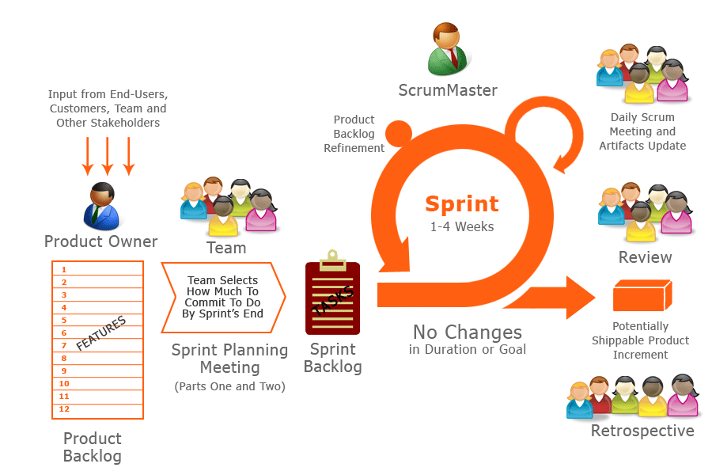

*Figure 1: SCRUM Overview Diagram*

Because of the project characteristics, we decide to make progress in series of sprints which are time boxed iterations in one week. At the beginning of one sprint, through sprint planning meeting, all team members will discuss together to define sprint backlog which is suitable to be completed within a week. Daily meeting and online conference are used to manage all activities and issues troubleshoot. At the end of sprint, product owner and developer team will review completed product to figuring out the necessary changes for products.

### Roles and responsibilities

|  |  |  |  |  |
| --- | --- | --- | --- | --- |
| No. | Full name | Team Role | Scrum Team Role | Responsibilities |
| **1** | Nguyễn Huy Hùng | Supervisor | Product Owner | * Outline work in scrum backlog * Answer question and deliver direction |
| **2.** | Phạm Văn Thắng | Team Leader | Scrum Master | * Facilitate productivity – maximize team performance * Complete all individual work |
| **3.** | Man Huỳnh Khương | Team Member | Scrum Team Member | * Commit individual product on time * Support each other to complete team work |
| **4** | Lê Văn Hùng | Team Member | Scrum Team Member | * Commit individual product on time * Support each other to complete team work |
| **5** | Vũ Nhật Anh Khoa | Team Member | Scrum Team Member | * Commit individual product on time * Support each other to complete team work |

*Table 2: Project Role and Responsibility*

### Tools and Techniques

Front-end technologies: HTML5, CSS3, JavaScript, jQuery, AJAX.

* Back-end technologies:
  + Website: Java EE
  + Web service: Java + Jersey
  + Third-party libraries:
* Mobile: Android Lollipop 5.0
* Web Server: Installed Tomcat 7.0.34.
* Database Management System: Neo4j Graph Database.

## Project Management Plan

### Product Backlog

|  |  |  |  |
| --- | --- | --- | --- |
| Project: Mobile Dating Application | | | |
|
| ID | **User Story** | **State** | **Priority** |
| 1 | As an unauthorized user, I want to create a new profile as User role |  |  |
| 2 | As an unauthorized user, I want to Login as User role. |  |  |
| 3 | As an unauthorized user, I want to Login as Admin role. |  |  |
| 4 | As a User, I want to Logout. |  |  |
| 5 | As an Admin, I want to Logout. |  |  |
| 6 | As a User, I want to connect to my other social accounts and add my friend to my profile |  |  |
| 7 | As a User, I want update my profile information (interests, gender, location, etc.) |  |  |
| 8 | As a User, I want to view other people profiles |  |  |
| 9 | As a User, I want search new friends who are compatible with me |  |  |
| 10 | As a User I want to add new friend to my list |  |  |
| 11 | As a User, I want to view list of my current friends |  |  |
| 12 | As a User, I want to remove a profile from my friends list |  |  |
| 13 | As a User, I want to block a profile from seeing me again |  |  |
| 14 | As a User, I want to view my current location |  |  |
| 15 | As a User, I want to view list of people around me |  |  |
| 16 | As a User, I want to view my friends’ locations on map. |  |  |
| 17 | As a User, I want to view nearby users who are compatible to me |  |  |
| 18 | As a User, I want to see all profiles that are compatible with me |  |  |
| 19 | As a User, I want to see profiles that have common friends with me |  |  |
| 20 | As a User, I want to chat with my friends |  |  |
| 21 | As a User, I want to view my chat history |  |  |
| 22 | As a User, I want to receive notification when a friend is nearby |  |  |
| 23 | As a User, I want to receive notification when someone has chatted with me or someone has requested to be my friend. |  |  |
| 24 | As an Admin, I want to view Users on my system |  |  |
| 25 | As an Admin I want to change a User status (active/deactivate) |  |  |

### Sprint Backlog

All sprints details are placed in Sprint Backlog folder at GitHub repository.

### All Meeting Minute

All meeting minute are placed in Meeting Minute at GitHub repository.

## Coding Convention

Use Java coding convention to develop website, web service and mobile app.

Summary:

* Naming Convention:
  + Use camel case for both variable and function name.
  + Use Pascal case for class name.
* Indentation:
  + Avoid lines longer than 80 characters, since they are not handled well by many terminals and tools.
* Declaration:
  + One declaration per line is recommended since it encourages commenting.
  + In absolutely no case should variables and functions be declared on the same line.
  + Do not put different types on the same line.
* Code Examples:
  + Follow “Code Conventions for the Java TM Programming Language, by Sun Microsystems, rev April 20, 1999” (3).

Reference:

1. Tech in Asia, September 2014, Viet Nam’s smartphone users number *<https://www.techinasia.com/oops-vietnam-22-million-smartphone-users-33-million>*
2. The Guardian, February 2015, location-based dating app user percentage *<http://www.theguardian.com/technology/2015/feb/17/mobile-dating-apps-tinder-two-thirds-men>*
3. Sun Microsystems, 1999, Java Style Coding Convention <http://www.oracle.com/technetwork/java/codeconventions-150003.pdf>