|  |  |
| --- | --- |
|  | **MINISTRY OF EDUCATION AND TRAINING** |

|  |  |  |
| --- | --- | --- |
| **FPT UNIVERSITY** | | |
| CAPSTONE PROJECT DOCUMENT | | |
| **MOBILE DATING APPS** | | |
| **SE07.B – GROUP 12** | |
| **Group Members** | |  |  |  | | --- | --- | --- | | Phạm Văn Thắng | Team Leader | SE61092 | | Man Huỳnh Khương | Team Member |  | | Lê Văn Hùng | Team Member |  | | Vũ Nguyễn Anh Khoa | Team Member |  | |
| **Supervisor** | Nguyễn Huy Hùng |
| **Capstone Project code** |  |

- Ho Chi Minh City, May/2015 -

Table of Contents

A. Report No.1 Introduction 6

1. Project Information 6

2. Introduction 6

3. Current Situation 6

4. Problem Definition 6

5. Proposed Solution 6

5.1 Feature functions 6

5.2 Advantages and disadvantages 6

6. Functional Requirements 6

7. Role and Responsibility 6

B. Report No.2 Software Project Management Plan 8

1. Problem Definition 8

1.1 Name of this Capstone Project 8

1.2 Problem abstract 8

1.3 Project Overview 8

1.4 Software Process Model 8

1.5 Roles and responsibilities 9

1.6 Tools and Techniques 10

2. Project Management Plan 10

2.1 Software development life cycle 10

2.2 Phase Detail 10

3. Coding Convention 10

**List of Tables**

Table 1: Roles and Responsibilities 7

Table 2: Project Role and Responsibility 9

**List of figures**

Figure 1: SCRUM Overview Diagram 8

**Definition, Acronyms, and Abbreviations**

|  |  |
| --- | --- |
| **Name** | **Definition** |
| MDA | Mobile Dating Apps |
|  |  |

# Report No.1 Introduction

## Project Information

* Project Name: Site Builder for Product Catalogue
* Project Code: MDA
* Product Type: Mobile application
* Start Date: May 11, 2015
* End Date: September 3, 2015

## Introduction

Nowadays, making friends and dating based on internet is simple and easy because of development of technology. Many applications have been published for supporting such as facebook, twitter, etc. But users just can add friends who they have known. So, MDA is an application that support users to making friend, talking together, dating with people around them bases on hobbies, personalities, etc.

## Current Situation

Below are some comparison applications and users behaviors:

* Applications (Facebook, Twitter): Beside sending message, look up user’s profile, they also have function adding new friends without categories.
* Users want find someone who they want to meet, make friends, or date around them with same hobbies, personalities, etc.

## Problem Definition

Below are the advantages and disadvantages of current applications:

* Advantages:

+ Easy to use.

+ Provide users quick access to information about user’s profile.

* Disadvantages

+ Cannot support user finding near friends who have same hobbies, personalities.

## Proposed Solution

The application uses GPS for tracking user location to search around friends who use application. User can send message to talk for making friend.

### Feature functions

* Users can send message based on chatting.
* Users can search friend around them.
* Alert users when their friend is near.

### Advantages and disadvantages

- Advantages:

* Providing users supporting for searching friend around with many categories.

- Disadvantages:

* Users must have suitable mobile device and internet connection is required in a while for keeping personal data in local database for analyzing user’s behavior.

## Functional Requirements

Function requirements of the system are listed as below:

* .

## Role and Responsibility

|  |  |  |  |  |
| --- | --- | --- | --- | --- |
| **No** | **Full Name** | **Role** | **Position** | **Contact** |
| **1** | Nguyễn Huy Hùng | Supervisor | Instructor | hungnh@fpt.edu.vn |
| **2** | Phạm Văn Thắng | Developer | Leader | thangpvse61092@fpt.edu.vn |
| **3** | Man Huỳnh Khương | Developer | Member |  |
| **4** | Lê Văn Hùng | Developer | Member |  |
| **5** | Vũ Nguyễn Anh Khoa | Developer | Member |  |

Table 1: Roles and Responsibilities

# Report No.2 Software Project Management Plan

## Problem Definition

### Name of this Capstone Project

Mobile Dating Apps (MDA).

### Problem abstract

.

### Project Overview

#### Current Situation and Disadvantages

.

#### The Proposed System

.

#### Boundaries of System

* .

#### Development Environment

##### Hardware requirement

##### Software requirement

### Software Process Model

In this project, we decided to use the Scrum model for developing.

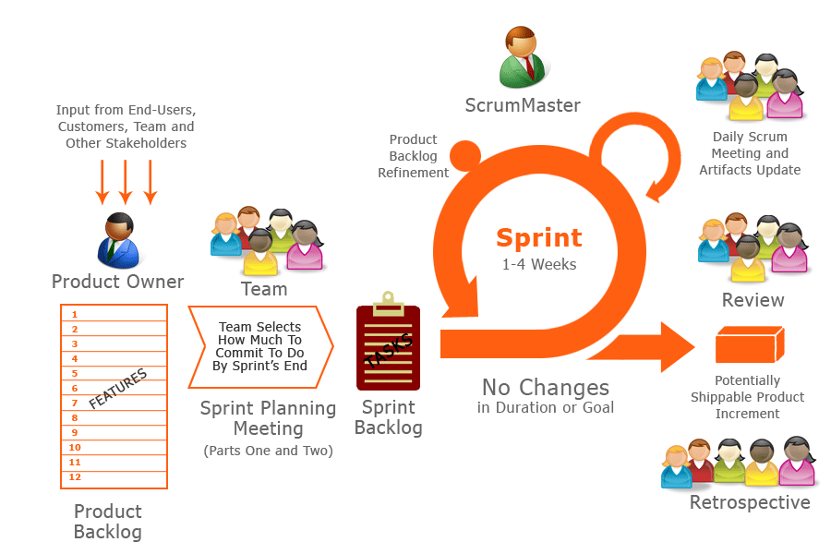

Figure 1: SCRUM Overview Diagram

Because of the project characteristics, we decide to make progress in series of sprints which are time boxed iterations in one week. At the beginning of one sprint, through sprint planning meeting, all team members will discuss together to define sprint backlog which is suitable to be completed within a week. Daily meeting and online conference are used to manage all activities and issues troubleshoot. At the end of sprint, product owner and developer team will review completed product to figuring out the necessary changes for products.

### Roles and responsibilities

|  |  |  |  |  |
| --- | --- | --- | --- | --- |
| **No.** | **Full name** | **Team Role** | **Scrum Team Role** | **Responsibilities** |
| 1 | Nguyễn Huy Hùng | Supervisor | Product Owner | * Outline work in scrum backlog * Answer question and deliver direction |
| 2. | Phạm Văn Thắng | Team Leader | Scrum Master | * Facilitate productivity – maximize team performance * Complete all individual work |
| 3. | Man Huỳnh Khương | Team Member | Scrum Team Member | * Commit individual product on time * Support each other to complete team work |
| 4 | Lê Văn Hùng | Team Member | Scrum Team Member | * Commit individual product on time * Support each other to complete team work |
| 5 | Vũ Nguyễn Anh Khoa | Team Member | Scrum Team Member | * Commit individual product on time * Support each other to complete team work |

Table 2: Project Role and Responsibility

### Tools and Techniques

## Project Management Plan

### Software development life cycle

Every sprint begins with sprint planning meeting, in which the Product Owner and team discuss the prioritized tasks in product backlog then add that tasks to sprint backlog. Once the time team commit sprint backlog, Product Owner can’t add more task.

During daily meeting, team have online meeting to update task status, discuss solution to challenges. It happens each day of the sprint.

At the ending of the sprint, that have a sprint review meeting, in which team present it works to the Product Owner. Project Owner decides each task is met acceptance criteria or not. If a task isn’t accepted, it’s rejected as incomplete.

All team also gather after end of each sprint to share what worked, what didn’t, and how processes could be improved. This meeting is called the sprint retrospective meeting.

### Phase Detail

#### Phase 1: Sprint 1

## Coding Convention

This project is applied some coding convention rules as listed below.