|  |  |
| --- | --- |
|  | **MINISTRY OF EDUCATION AND TRAINING** |

|  |  |  |
| --- | --- | --- |
| **FPT UNIVERSITY** | | |
| CAPSTONE PROJECT DOCUMENT | | |
| **MOBILE DATING APPS** | | |
| **SE07.B – GROUP 12** | |
| **Group Members** | |  |  |  | | --- | --- | --- | | Phạm Văn Thắng | Team Leader | SE61092 | | Man Huỳnh Khương | Team Member |  | | Lê Văn Hùng | Team Member |  | | Vũ Nguyễn Anh Khoa | Team Member |  | |
| **Supervisor** | Nguyễn Huy Hùng |
| **Capstone Project code** |  |

- Ho Chi Minh City, May/2015 -

Table of Contents

A. Report No.1 Introduction 6

1. Project Information 6

2. Introduction 6

3. Current Situation 6

4. Problem Definition 6

5. Proposed Solution 6

5.1 Feature functions 6

5.2 Advantages and disadvantages 6

6. Functional Requirements 6

7. Role and Responsibility 6

B. Report No.2 Software Project Management Plan 8

1. Problem Definition 8

1.1 Name of this Capstone Project 8

1.2 Problem abstract 8

1.3 Project Overview 8

1.4 Software Process Model 8

1.5 Roles and responsibilities 9

1.6 Tools and Techniques 10

2. Project Management Plan 10

2.1 Software development life cycle 10

2.2 Phase Detail 10

3. Coding Convention 10

**List of Tables**

Table 1: Roles and Responsibilities 7

Table 2: Project Role and Responsibility 9

**List of figures**

Figure 1: SCRUM Overview Diagram 8

**Definition, Acronyms, and Abbreviations**

|  |  |
| --- | --- |
| **Name** | **Definition** |
| MDA | Mobile Dating Apps |
|  |  |

# Report No.1 Introduction

## Project Information

* Project Name: Mobile Dating Apps
* Project Code: MDA
* Product Type: Mobile application
* Start Date: May 11, 2015
* End Date: September 3, 2015

## Introduction

. Nowadays, online dating is growing strongly. Especially when the smartphone appeared and flourished internet then this trend is increasing. Seize the strong demand of the market has pretty much done social networks still appear not meet the demand and quality. With these conditions, we were dealt with more developed mobile application called Mobile Dating Apps (MDA).

MDA developed with the main objective is to find the ideal lover. With the proliferation of smartphones and internet powerful it can be resolved very large market demand. Also by just whacked the exact needs of product quality should be increased.

## Current Situation

. Itweb WeAresocial cited reports from the habits and behaviors of today's internet users Vietnamese 2014 :

* Vietnam with a population of over 92 million people
* There are over 36 million Internet users
* As of May 1/2014 has 20 million Facebook accounts for 22% of the population.
* On the phone has more than 134 million registered mobile subscribers.
* Rates of social network penetration is 38% of the total population
* Duration average users on the social network is 2h23 minutes.
* Percentage of users who use the application on your phone Social Media 58%
* Percentage of users who use the service and the location is 25%.

Of users of social networking on mobile:

* Registered number using broadband to 17.6 million people
* Percentage of subscribers of mobile broadband at 19% of the total population
* Number of users using social networks on the phone makes up 17 million people
* Of users on Mobile Social Networking 18%

## Problem Definition

. Below are disadvantages of current applications:

* Propose less precise dating purposes of users
* Map function without real time

## Proposed Solution

### Feature functions

. MDA is mobile dating application and make friends. Applications us with the main objective is to help the user can increase search capabilities of the user exactly. Also helps users interact more time and utilities.

### Advantages and disadvantages

- Advantages:

* Propose more precise dating purposes of users
* Map function can real time

- Disadvantages:

* Only mobile
* Regional viet nam

## Functional Requirements

Function requirements of the system are listed as below:

* Create user profile. This feature should connect automatically to current user account on other social sites [Facebook, Google+, Twitter]
* Manage friend list.
* Scan near-by locations to find people around the user
* Matching user’s interest and profile with others
* Suggest user’s people they might want to meet based on their friend’s connections
* Real time chat & notification when events happen

## Role and Responsibility

|  |  |  |  |  |
| --- | --- | --- | --- | --- |
| **No** | **Full Name** | **Role** | **Position** | **Contact** |
| **1** | Nguyễn Huy Hùng | Supervisor | Instructor | hungnh@fpt.edu.vn |
| **2** | Phạm Văn Thắng | Developer | Leader | thangpvse61092@fpt.edu.vn |
| **3** | Man Huỳnh Khương | Developer | Member |  |
| **4** | Lê Văn Hùng | Developer | Member |  |
| **5** | Vũ Nguyễn Anh Khoa | Developer | Member |  |

Table 1: Roles and Responsibilities

# Report No.2 Software Project Management Plan

## Problem Definition

### Name of this Capstone Project

Mobile Dating Apps (MDA).

### Problem abstract

.

### Project Overview

#### Current Situation and Disadvantages

.

#### The Proposed System

.

#### Boundaries of System

* .

#### Development Environment

##### Hardware requirement

##### Software requirement

### Software Process Model

In this project, we decided to use the Scrum model for developing.

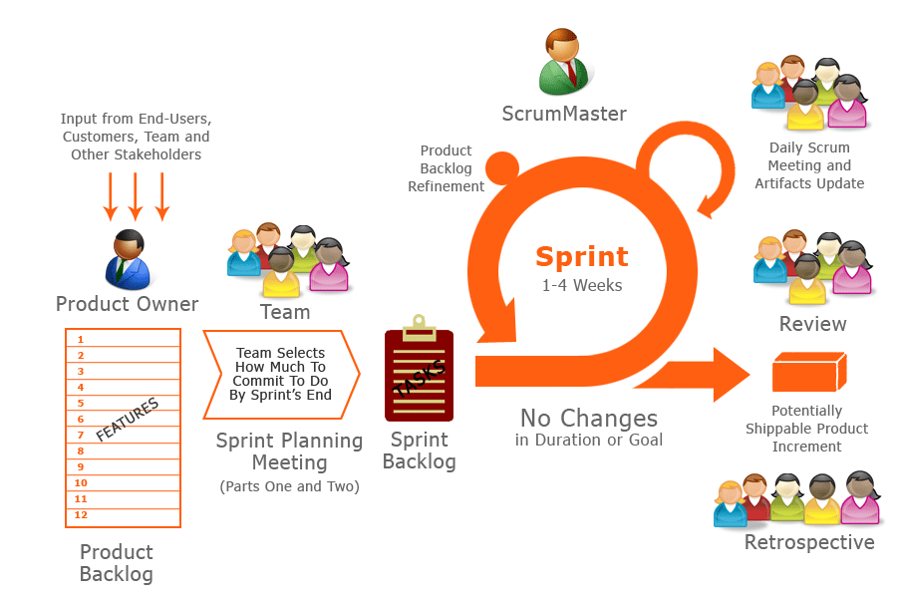

Figure 1: SCRUM Overview Diagram

Because of the project characteristics, we decide to make progress in series of sprints which are time boxed iterations in one week. At the beginning of one sprint, through sprint planning meeting, all team members will discuss together to define sprint backlog which is suitable to be completed within a week. Daily meeting and online conference are used to manage all activities and issues troubleshoot. At the end of sprint, product owner and developer team will review completed product to figuring out the necessary changes for products.

### Roles and responsibilities

|  |  |  |  |  |
| --- | --- | --- | --- | --- |
| **No.** | **Full name** | **Team Role** | **Scrum Team Role** | **Responsibilities** |
| 1 | Nguyễn Huy Hùng | Supervisor | Product Owner | * Outline work in scrum backlog * Answer question and deliver direction |
| 2. | Phạm Văn Thắng | Team Leader | Scrum Master | * Facilitate productivity – maximize team performance * Complete all individual work |
| 3. | Man Huỳnh Khương | Team Member | Scrum Team Member | * Commit individual product on time * Support each other to complete team work |
| 4 | Lê Văn Hùng | Team Member | Scrum Team Member | * Commit individual product on time * Support each other to complete team work |
| 5 | Vũ Nguyễn Anh Khoa | Team Member | Scrum Team Member | * Commit individual product on time * Support each other to complete team work |

Table : Project Role and Responsibility

### Tools and Techniques

## Project Management Plan

### Software development life cycle

Every sprint begins with sprint planning meeting, in which the Product Owner and team discuss the prioritized tasks in product backlog then add that tasks to sprint backlog. Once the time team commit sprint backlog, Product Owner can’t add more task.

During daily meeting, team have online meeting to update task status, discuss solution to challenges. It happens each day of the sprint.

At the ending of the sprint, that have a sprint review meeting, in which team present it works to the Product Owner. Project Owner decides each task is met acceptance criteria or not. If a task isn’t accepted, it’s rejected as incomplete.

All team also gather after end of each sprint to share what worked, what didn’t, and how processes could be improved. This meeting is called the sprint retrospective meeting.

### Phase Detail

#### Phase 1: Sprint 1

## Coding Convention

This project is applied some coding convention rules as listed below.