|  |  |
| --- | --- |
|  | **MINISTRY OF EDUCATION AND TRAINING** |

|  |  |  |
| --- | --- | --- |
| **FPT UNIVERSITY** | | |
| CAPSTONE PROJECT DOCUMENT | | |
| **MOBILE DATING APPS** | | |
| **SE07.B – GROUP 12** | |
| **Group Members** | |  |  |  | | --- | --- | --- | | Phạm Văn Thắng | Team Leader | SE61092 | | Man Huỳnh Khương | Team Member |  | | Lê Văn Hùng | Team Member |  | | Vũ Nhật Anh Khoa | Team Member |  | |
| **Supervisor** | Nguyễn Huy Hùng |
| **Capstone Project code** |  |

- Ho Chi Minh City, May/2015 -

Table of Contents

A. Report No.1 Introduction 6

1. Project Information 6

2. Introduction 6

3. Current Situation 6

4. Problem Definition 6

5. Proposed Solution 6

5.1 Feature functions 6

5.2 Advantages and disadvantages 6

6. Functional Requirements 6

7. Role and Responsibility 6

B. Report No.2 Software Project Management Plan 8

1. Problem Definition 8

1.1 Name of this Capstone Project 8

1.2 Problem abstract 8

1.3 Project Overview 8

1.4 Software Process Model 8

1.5 Roles and responsibilities 9

1.6 Tools and Techniques 10

2. Project Management Plan 10

2.1 Software development life cycle 10

2.2 Phase Detail 10

3. Coding Convention 10

**List of Tables**

Table 1: Roles and Responsibilities 7

Table 2: Project Role and Responsibility 9

**List of figures**

Figure 1: SCRUM Overview Diagram 8

**Definition, Acronyms, and Abbreviations**

|  |  |
| --- | --- |
| **Name** | **Definition** |
| MDA | Mobile Dating Apps |
|  |  |

# Report No.1 Introduction

## Project Information

* Project Name: Site Builder for Product Catalogue
* Project Code: MDA
* Product Type: Mobile application
* Start Date: May 11, 2015
* End Date: September 3, 2015

## Introduction

As the result of the rapid advancement of mobile phone technology, online dating services quickly switch trend from web-based dating to mobile dating. Various applications aiding people’s need for socializing have been released. However, there have not been many dating services releasing for Vietnamese based customers. The existing Vietnamese dating applications currently lack of various convenient and exciting features. Therefore, we are passionate to create a new stimulating dating application. This application, while retaining crucial features of a basic GPS dating app, will provide reliable means to meet new people matching ones’ interests that are more advanced than other Vietnamese dating services.

## Current Situation

Zalo and Beetalk are the three most popular dating service applications in Viet Nam. Despite their popularities, they do not provide a wide range of features.

* Zalo is best known for its voice messaging and are free to use. However, the app has limited friends matching and finding features.
* Beetalk allows users to find others users who are using the app nearby. However, the app likewise doesn’t have any matching features. It only let users browse through different profiles.

## Problem Definition

Vietnamese based customers dating service applications currently provide no matching function. They also don’t do well on GPS based searching, as they only show people who are nearby but not where they are on the map. Moreover, dating applications with better features are not yet available in Viet Nam’s market.

## Proposed Solution

### Feature functions

* Gathering users’ information from popular social network services: Facebook, Twitter and Google+. Users’ likes or following pages/people from those services can be imported into the system, helping it match users more efficiently.
* Automatically adding friends that are also use the app from Facebook, Twitter and Google+.
* Matching people based on their interests. Users are provided a powerful filter to quickly find people they are really interested in.
* Suggest user’s people they might want to meet based on their friend’s connections
* Finding nearby users and also filter them by choice.
* Listing users on map so user can find their friends better.
* Real time chat & notification when events happen
* Supporting stickers, voice chatting, sending files and videos.
* Users can clean their message windows, or can find their conservation from the chat history.
* Supporting users to manage their friend list.

### Advantages and disadvantages

- Advantages:

* Collect a great deal of information in a shorter time.
* Easier to find suitable friends.
* Convenient searching function that lists users on a map.

- Disadvantages:

* Requires a large number of users to work well.
* For the limited time of this project development
* Only support android system at this time

## Functional Requirements

Function requirements of the system are listed as below:

* User Profile
* View and change the personal information.
* View other users’ public information.
* Synchronize information from social networks.
* Matching
* Filter by ages, genders, interests.
* Search nearby users.
* Filter by matching other information.
* Friend list.
* Chat.
* Event Notifications..

## Role and Responsibility

|  |  |  |  |  |
| --- | --- | --- | --- | --- |
| **No** | **Full Name** | **Role** | **Position** | **Contact** |
| **1** | Nguyễn Huy Hùng | Supervisor | Instructor | hungnh@fpt.edu.vn |
| **2** | Phạm Văn Thắng | Developer | Leader | thangpvse61092@fpt.edu.vn |
| **3** | Man Huỳnh Khương | Developer | Member |  |
| **4** | Lê Văn Hùng | Developer | Member |  |
| **5** | Vũ Nhật Anh Khoa | Developer | Member |  |

Table 1: Roles and Responsibilities

# Report No.2 Software Project Management Plan

## Problem Definition

### Name of this Capstone Project

Mobile Dating Apps (MDA).

### Problem abstract

.

### Project Overview

#### Current Situation and Disadvantages

.

#### The Proposed System

.

#### Boundaries of System

* .

#### Development Environment

##### Hardware requirement

##### Software requirement

### Software Process Model

In this project, we decided to use the Scrum model for developing.

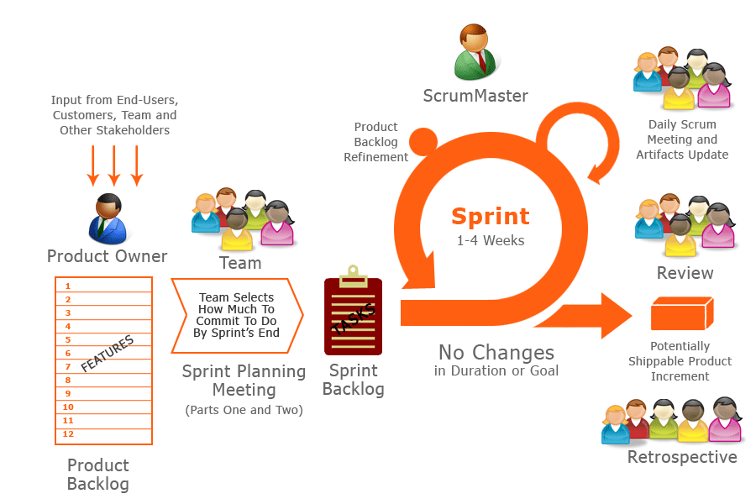

Figure 1: SCRUM Overview Diagram

Because of the project characteristics, we decide to make progress in series of sprints which are time boxed iterations in one week. At the beginning of one sprint, through sprint planning meeting, all team members will discuss together to define sprint backlog which is suitable to be completed within a week. Daily meeting and online conference are used to manage all activities and issues troubleshoot. At the end of sprint, product owner and developer team will review completed product to figuring out the necessary changes for products.

### Roles and responsibilities

|  |  |  |  |  |
| --- | --- | --- | --- | --- |
| **No.** | **Full name** | **Team Role** | **Scrum Team Role** | **Responsibilities** |
| 1 | Nguyễn Huy Hùng | Supervisor | Product Owner | * Outline work in scrum backlog * Answer question and deliver direction |
| 2. | Phạm Văn Thắng | Team Leader | Scrum Master | * Facilitate productivity – maximize team performance * Complete all individual work |
| 3. | Man Huỳnh Khương | Team Member | Scrum Team Member | * Commit individual product on time * Support each other to complete team work |
| 4 | Lê Văn Hùng | Team Member | Scrum Team Member | * Commit individual product on time * Support each other to complete team work |
| 5 | Vũ Nguyễn Anh Khoa | Team Member | Scrum Team Member | * Commit individual product on time * Support each other to complete team work |

Table 2: Project Role and Responsibility

### Tools and Techniques

## Project Management Plan

### Software development life cycle

Every sprint begins with sprint planning meeting, in which the Product Owner and team discuss the prioritized tasks in product backlog then add that tasks to sprint backlog. Once the time team commit sprint backlog, Product Owner can’t add more task.

During daily meeting, team have online meeting to update task status, discuss solution to challenges. It happens each day of the sprint.

At the ending of the sprint, that have a sprint review meeting, in which team present it works to the Product Owner. Project Owner decides each task is met acceptance criteria or not. If a task isn’t accepted, it’s rejected as incomplete.

All team also gather after end of each sprint to share what worked, what didn’t, and how processes could be improved. This meeting is called the sprint retrospective meeting.

### Phase Detail

#### Phase 1: Sprint 1

## Coding Convention

This project is applied some coding convention rules as listed below.