Technical Report: Cryptocurrency and Fiat Currency Converter
SDN150S Software Design 1 – Mini Project
Prepared for: Management
Group: [group name] | Members: [names and student numbers]
Date: November 2026

1. Introduction
Management requested a Java program that converts ten cryptocurrency pairs, for example BTC/ETH and BTC/LTC. This report explains how the team designed, implemented and tested the solution: a Swing desktop converter. The team also extended the scope to include South African rand (ZAR) and US dollar (USD) markets, in the style of exchanges such as Luno, because users commonly move between cryptocurrency and local currency.
The final application supports 23 markets across six cryptocurrencies (BTC, ETH, LTC, XRP, ADA, SOL) and two fiat currencies. It validates input, swaps conversion direction and shows a unit price with every result. The report covers the design approach, engineering method, tools, pseudocode, a UML class diagram, test results and limitations. The complete source code is in Appendix A.

2. Sub-questions
The project was broken into five questions, each answered in the sections indicated:
Q1. Which software design approach suits a small, well-defined desktop utility? (Section 3.1)
Q2. How can one conversion method serve ten crypto pairs plus fiat markets without duplicated logic? (Section 3.4)
Q3. How should invalid input be handled so the program never crashes? (Section 3.4)
Q4. How should the interface present results so users can trust them? (Section 3.4)
Q5. How can correctness be demonstrated? (Section 4)

3. Discussion

3.1 Software design approach (Q1)
The team chose object-oriented design. The problem has clear nouns (a market, a rate service, a window) and Java is class-based, so the structure of the code can mirror the structure of the problem (Schildt, 2018). The program has three classes with separate responsibilities: RatePair represents one market, RateService holds rates and performs conversion, and CryptoConverter is the graphical form. Separating presentation from logic means the conversion can be tested without the interface, and the source of rates can be replaced later without touching the form (Sommerville, 2016). Two alternatives were rejected: a single-class procedural program, which would mix interface and calculation code and be hard to maintain, and a full model–view–controller framework with interfaces, which is more machinery than this scope justifies.

3.2 Engineering method
The team used incremental development with short iterations (Sommerville, 2016). Iteration 1 built the ten-pair conversion logic. Iteration 2 added the Swing form. Iteration 3 added validation and testing. Iteration 4 added the ZAR and USD markets and the fiat spread. Each iteration ended with a working build committed to Git with a descriptive message, giving a traceable history and a safe point to return to (Chacon and Straub, 2014). Within each iteration the team followed the same cycle: requirements, design (pseudocode and UML), implementation, testing and documentation.

3.3 Skills and tools
Tools: the Java Development Kit and an IDE for coding and debugging; the javax.swing library for the interface (Oracle, no date); Git and a remote repository for version control; a UML drawing tool for the class diagram; and screen-recording software for the demonstration video. Skills: object-oriented programming, event-driven programming, defensive input validation, version control, technical writing and teamwork, including reviewing each other’s commits.

3.4 Implementation (Q2, Q3, Q4)
Constructors. RatePair(base, quote) stores a market. The RateService constructor loads the asset rates and builds the list of markets. The CryptoConverter constructor builds the form and registers its event handlers. Modifiers. Fields are private for encapsulation and exposed through public accessors. The spread and the ZAR rate are private static final constants, so they cannot change at runtime and are defined in one place. main is public static as the entry point. Control statements. for loops build the market list, if statements validate input and detect fiat currencies, try/catch handles number-format errors, and a ternary expression selects the conversion direction.
Conversion without duplication (Q2). Storing a rate for every pair would need a table that grows with every new coin. Instead, each asset stores its value in USD and any pair is computed as amount × fromUSD ÷ toUSD. Adding a coin is one line. When either side is fiat, the result is reduced by a 1% spread, modelling an exchange fee; this is a simplifying assumption, not a real fee schedule.
Validation (Q3). Three checks run before any calculation: the field is not empty, the text parses as a number, and the value is greater than zero. Each failure shows an error dialog and returns early, so invalid input never reaches the conversion method and the program does not crash.
Presentation (Q4). The form uses a dropdown of markets, a direction label that updates on every change, and a unit price line (for example, 1 BTC = x ZAR) beside the converted amount. Fiat amounts show two decimals and crypto amounts eight, matching how each is normally quoted. SwingUtilities.invokeLater starts the interface on the event dispatch thread, as Swing requires (Oracle, no date).

3.5 Pseudocode
START
LOAD usdValue for BTC, ETH, LTC, XRP, ADA, SOL, USD, ZAR
BUILD markets: 10 crypto pairs
FOR each coin: add coin/ZAR and coin/USD
add USD/ZAR
DISPLAY form with market list, amount field, buttons
reversed = false

ON Swap: reversed = NOT reversed; update direction label
ON Clear: empty amount, reset labels
ON Convert:
IF amount text is empty THEN error; STOP
TRY parse amount
CATCH not a number THEN error; STOP
IF amount <= 0 THEN error; STOP
IF reversed THEN from = quote, to = base
ELSE from = base, to = quote
result = amount * usdValue[from] / usdValue[to]
IF from or to is fiat THEN result = result * (1 - spread)
DISPLAY unit price and result
END

3.6 UML class diagram
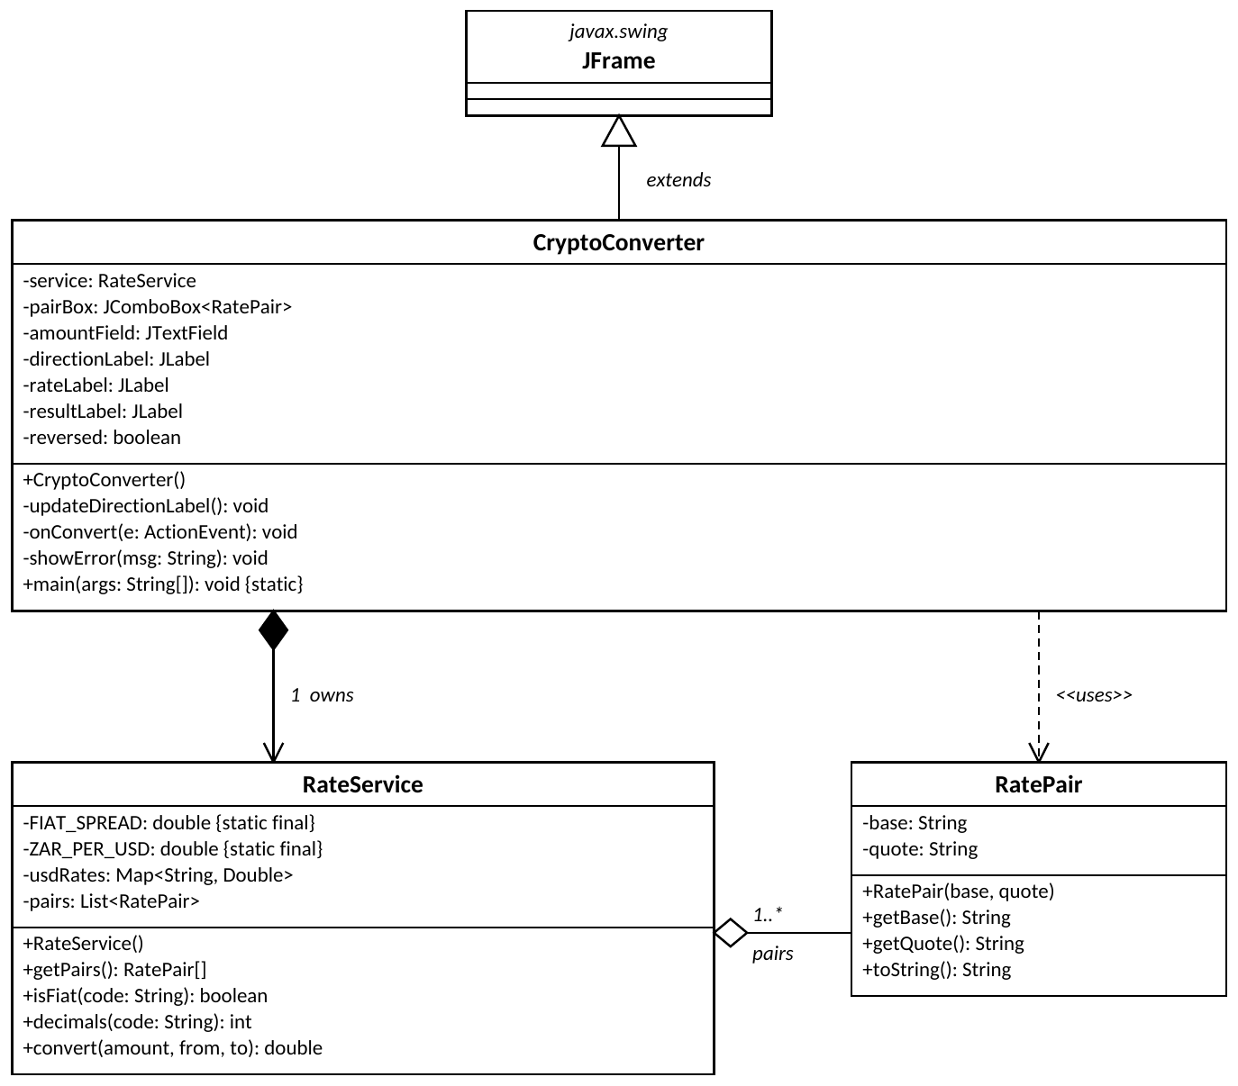
Figure 1. UML class diagram of the converter.

4. Results and analysis
Test cases were chosen to cover each kind of market and each validation rule. Expected values are hand-calculated from the sample rates (BTC 67,000; ETH 3,200; LTC 85; SOL 150 USD; 18 ZAR per USD) and compared with the amount shown by the form.
Table 1. Test cases and expected results.
Analysis. A single convert method serves all 23 markets, so a correction to the formula is made once. Validation is centralised before the calculation, so the failure cases above are handled in one place. The design meets the brief’s required concepts and keeps interface and logic separate.
Limitations. First, the rates are static sample values, so the program does not yet use current exchange rates; a live price feed behind RateService is the priority improvement. Second, double can introduce rounding error in monetary calculations, and BigDecimal is the recommended type for money (Bloch, 2018). Third, the 1% spread is an assumption. Fourth, testing was manual; automated JUnit tests of RateService would be straightforward because the logic is separate from the interface.

5. Conclusion
The team delivered a Java Swing converter covering the ten required cryptocurrency pairs plus ZAR and USD markets. An object-oriented, three-class design with incremental development kept the code readable, testable and easy to extend. The required concepts (constructors, modifiers, control statements and a Java frame form) are all used with input validation and comments. Management should treat the current version as a working prototype: live rates and BigDecimal arithmetic are needed before it is relied on for real conversions.

References
Bloch, J. (2018) Effective Java. 3rd edn. Boston: Addison-Wesley.
Chacon, S. and Straub, B. (2014) Pro Git. 2nd edn. New York: Apress.
Oracle (no date) Creating a GUI with Swing. Available at: https://docs.oracle.com/javase/tutorial/uiswing/ (Accessed: [date accessed]).
Schildt, H. (2018) Java: The Complete Reference. 11th edn. New York: McGraw-Hill Education.
Sommerville, I. (2016) Software Engineering. 10th edn. Harlow: Pearson.

Appendix A: Java source code (CryptoConverter.java)
import javax.swing.*;
import java.awt.*;
import java.awt.event.ActionEvent;
import java.util.ArrayList;
import java.util.LinkedHashMap;
import java.util.List;
import java.util.Map;

/**
* SDN150S Mini Project: Crypto + Fiat Converter (Luno-style).
* Markets: 10 crypto/crypto pairs, crypto/ZAR, crypto/USD, USD/ZAR.
* Classes: RatePair (model), RateService (logic), CryptoConverter (GUI).
*/

// ---------- Model: one supported market ----------
class RatePair {
private final String base; // e.g. "BTC"
private final String quote; // e.g. "ZAR"

// Constructor
public RatePair(String base, String quote) {
this.base = base;
this.quote = quote;
}

public String getBase() { return base; }
public String getQuote() { return quote; }

@Override
public String toString() { return base + "/" + quote; }
}

// ---------- Logic: rates, markets, conversion ----------
class RateService {
// Spread applied when either side is fiat (1%), similar to an exchange fee
private static final double FIAT_SPREAD = 0.01;
// Sample ZAR per 1 USD (replace with a live feed)
private static final double ZAR_PER_USD = 18.00;

// Value of 1 unit of each asset in USD (sample values)
private final Map<String, Double> usdRates = new LinkedHashMap<>();
private final List<RatePair> pairs = new ArrayList<>();

// Constructor: loads rates and builds the market list
public RateService() {
usdRates.put("BTC", 67000.00);
usdRates.put("ETH", 3200.00);
usdRates.put("LTC", 85.00);
usdRates.put("XRP", 0.55);
usdRates.put("ADA", 0.45);
usdRates.put("SOL", 150.00);
usdRates.put("USD", 1.00);
usdRates.put("ZAR", 1.00 / ZAR_PER_USD);

// The 10 required crypto pairs
String[][] cryptoPairs = {
{"BTC", "ETH"}, {"BTC", "LTC"}, {"BTC", "XRP"}, {"BTC", "ADA"},
{"BTC", "SOL"}, {"ETH", "LTC"}, {"ETH", "XRP"}, {"ETH", "ADA"},
{"ETH", "SOL"}, {"LTC", "XRP"}
};
for (String[] p : cryptoPairs) {
pairs.add(new RatePair(p[0], p[1]));
}

// Fiat markets: every crypto against ZAR and USD
String[] coins = {"BTC", "ETH", "LTC", "XRP", "ADA", "SOL"};
for (String coin : coins) {
pairs.add(new RatePair(coin, "ZAR"));
pairs.add(new RatePair(coin, "USD"));
}
pairs.add(new RatePair("USD", "ZAR"));
}

public RatePair[] getPairs() { return pairs.toArray(new RatePair[0]); }

public boolean isFiat(String code) {
return code.equals("ZAR") || code.equals("USD");
}

/** Number of decimals to display: 2 for fiat, 8 for crypto. */
public int decimals(String code) {
return isFiat(code) ? 2 : 8;
}

/** Converts amount of 'from' into 'to' using USD as the pivot. */
public double convert(double amount, String from, String to) {
Double fromUsd = usdRates.get(from);
Double toUsd = usdRates.get(to);
if (fromUsd == null || toUsd == null) {
throw new IllegalArgumentException("Unsupported currency");
}
double result = amount * fromUsd / toUsd;

// Apply spread on any fiat trade
if (isFiat(from) || isFiat(to)) {
result = result * (1.0 - FIAT_SPREAD);
}
return result;
}
}

// ---------- GUI: Swing frame form ----------
public class CryptoConverter extends JFrame {
private final RateService service = new RateService();
private final JComboBox<RatePair> pairBox;
private final JTextField amountField = new JTextField(12);
private final JLabel directionLabel = new JLabel(" Direction: BASE -> QUOTE");
private final JLabel rateLabel = new JLabel(" Rate: -");
private final JLabel resultLabel = new JLabel(" Result: -");
private boolean reversed = false; // false = BASE -> QUOTE, true = QUOTE -> BASE

// Constructor: builds the frame
public CryptoConverter() {
super("Crypto & Fiat Converter (BTC, ETH, LTC, XRP, ADA, SOL, ZAR, USD)");
setDefaultCloseOperation(EXIT_ON_CLOSE);
setLayout(new GridLayout(7, 2, 8, 8));

pairBox = new JComboBox<>(service.getPairs());
JButton convertBtn = new JButton("Convert");
JButton swapBtn = new JButton("Swap direction");
JButton clearBtn = new JButton("Clear");

add(new JLabel(" Market:"));
add(pairBox);
add(new JLabel(" Amount:"));
add(amountField);
add(swapBtn);
add(convertBtn);
add(clearBtn);
add(new JLabel(""));
add(new JLabel(" Info:"));
add(directionLabel);
add(new JLabel(" Price:"));
add(rateLabel);
add(new JLabel(" Output:"));
add(resultLabel);

// Event handlers
convertBtn.addActionListener(this::onConvert);
swapBtn.addActionListener(e -> {
reversed = !reversed;
updateDirectionLabel();
});
pairBox.addActionListener(e -> updateDirectionLabel());
clearBtn.addActionListener(e -> {
amountField.setText("");
rateLabel.setText(" Rate: -");
resultLabel.setText(" Result: -");
});

updateDirectionLabel();
setSize(560, 380);
setLocationRelativeTo(null);
}

/** Shows which currency is being converted into which. */
private void updateDirectionLabel() {
RatePair pair = (RatePair) pairBox.getSelectedItem();
String from = reversed ? pair.getQuote() : pair.getBase();
String to = reversed ? pair.getBase() : pair.getQuote();
directionLabel.setText(" Direction: " + from + " -> " + to);
}

/** Validates input, converts, and shows the result. */
private void onConvert(ActionEvent e) {
String text = amountField.getText().trim();

// Input validation (control statements)
if (text.isEmpty()) {
showError("Enter an amount.");
return;
}
double amount;
try {
amount = Double.parseDouble(text);
} catch (NumberFormatException ex) {
showError("Amount must be a number.");
return;
}
if (amount <= 0) {
showError("Amount must be greater than zero.");
return;
}

RatePair pair = (RatePair) pairBox.getSelectedItem();
String from = reversed ? pair.getQuote() : pair.getBase();
String to = reversed ? pair.getBase() : pair.getQuote();

double result = service.convert(amount, from, to);
double unitPrice = service.convert(1.0, from, to);

rateLabel.setText(String.format(" 1 %s = %." + service.decimals(to) + "f %s",
from, unitPrice, to));
resultLabel.setText(String.format(
" %." + service.decimals(from) + "f %s = %." + service.decimals(to) + "f %s",
amount, from, result, to));
}

private void showError(String msg) {
JOptionPane.showMessageDialog(this, msg, "Input error", JOptionPane.ERROR_MESSAGE);
}

public static void main(String[] args) {
SwingUtilities.invokeLater(() -> new CryptoConverter().setVisible(true));
}
}

