**SOCCER TRAINING SIMULATOR**

***By – Dhaval Patel, Kruneet Patel, Charvi Virani, and Michael Gallagher***

***DESCRIPTION***

This development project is about creating a system software that will provide an innovative training system for soccer players. The system creates an immersive experience that allows players to train in a simulated environment.

The main motive behind the development this simulator is to provide a similar experience to what the players would be facing while playing real soccer games. Also, this training simulation can be used to analyse the overall aspects of past games played by a particular player or team. This helps them to avoid those mistakes in future to avoid injury or increase their overall efficiency in actual live games. The statistical reports generated by the system about their individual profiles will track the performance measures of various aspects of their gameplay.

Training the right way before games is a very critical aspect for a sportsperson as it will help reduce injuries and improve the overall efficiency of a player during the actual games.

A diagram showing our system design is attached at the end.

***REQUIREMENTS***

The requirements our project includes the following:

* It should reflect real world scenarios.
* It should be user friendly and efficient to use.
* Measure the key traits of the player. The performance measures included in this are the average velocity of the shots taken during the session, the number of goals scored/saved, the scoring/conceding percentage, controlling ball with varying speeds, reaction time in seconds, accuracy of passes and shots taken, consistency, etc.
* Should be able to be personalized according to the traits of each player.
* The player himself and coach should be the only ones able to see a player’s statistics.

***DESIGN***

The system consists of a 4-sided physical box that encloses an artificial pitch. Once activated, the simulator fires in balls to a waiting player, who is then directed to settle and pass that ball into a specific quadrant of the box, dribble around physical obstacles, shoot at virtual goalkeepers, etc.

The system relies on an LED wall and automated 'ball boy', using fully-customisable system software to analyse performance and allow players to work on their skills. The software will have the ability to interact with existing databases and manage training sessions. Each player has their own system profile for training, enabling them to track details about their session and generate reports. This will allow developing and improving the players’ responsiveness, accuracy, speed and 360° vision in a system of individualised training within specific exercises.

Also, in conjunction to control-panel model, the power of virtual reality is incorporated to get insights about the gameplay of each player during the actual games he has played in past via using data from in-stadium cameras and other tracking systems. This will create a VR replay of the entire soccer match which can be seen using hardwares like Oculus, etc. Players (Wearers) can use simple controls to fast-forward to specific points of the game. Also, the player can switch to the perspective as a team-mate and see what he saw at the given moment.

***TESTING***

The system must be tested to ensure the following:

* All user options available in a scenario must be viable.
* Black box and White box testing will be necessary.
* Will need users to act as testers from clients to fully evaluate the product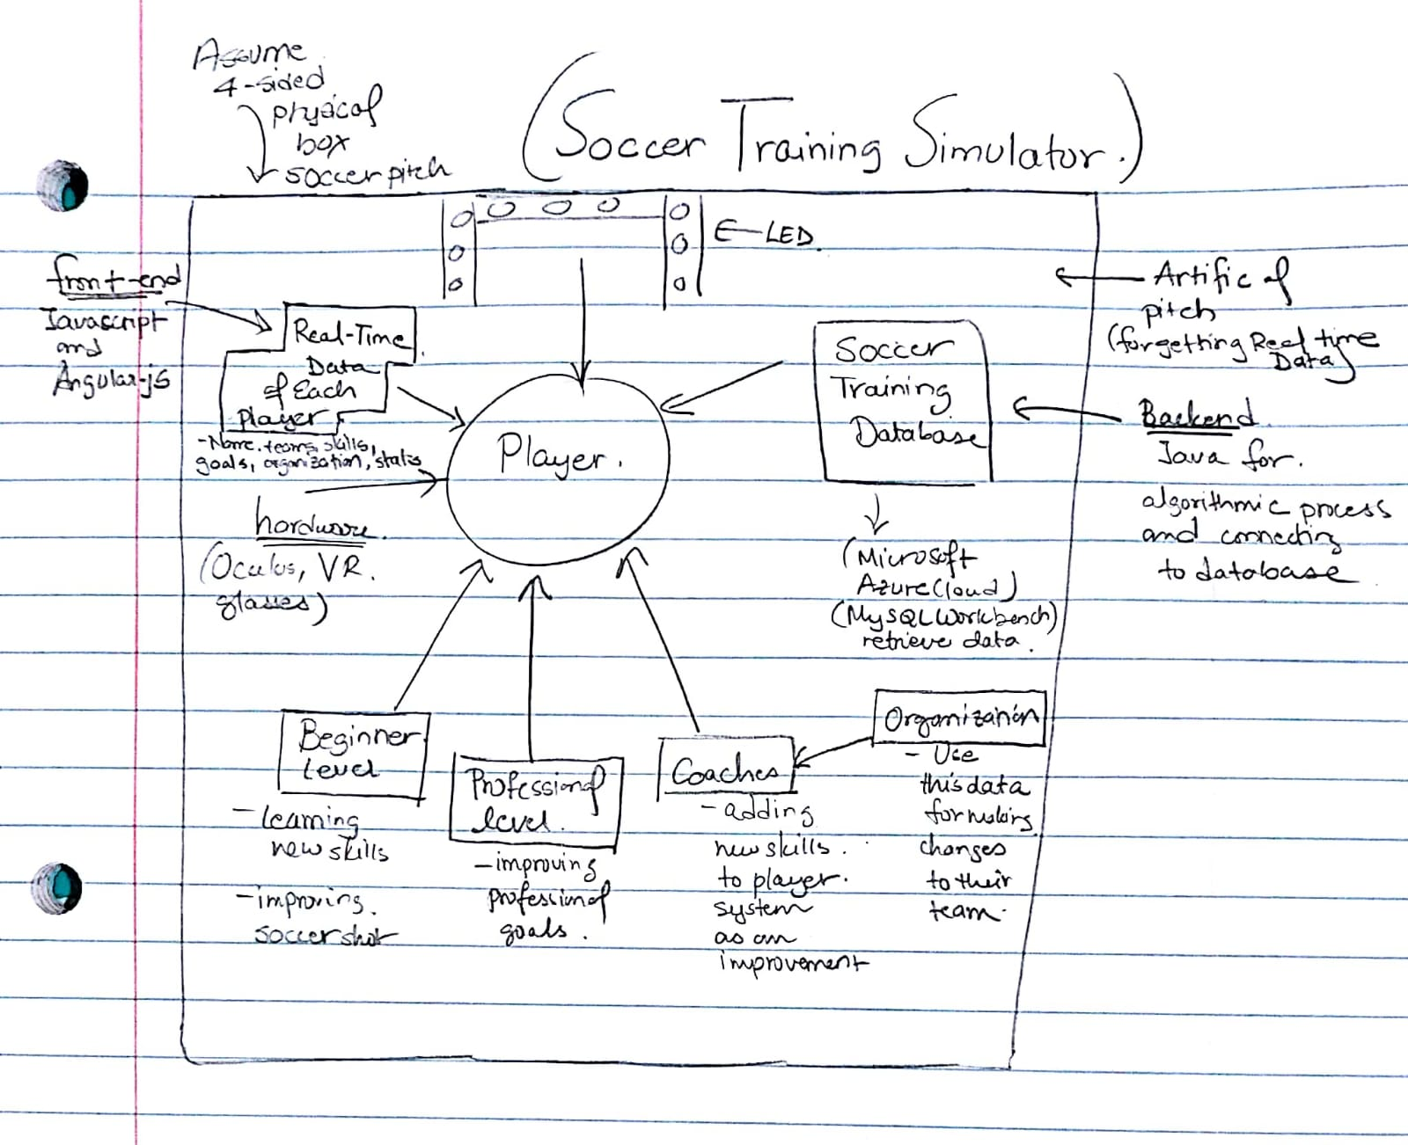

*Diagram showing design of our system*