**Project 1**

MIS 6360 - Agile Project Management

Group 4

Group Members: Evan Lott

Ishan Sharma

Chandra Sekhar Padhy

**Q1) a. Create the project described in table 1 in Microsoft Project and paste a screenshot of the bar (Gantt) chart of the project highlighting the critical path below. Please make sure all tasks are clearly labeled with their corresponding task name. Your Gantt chart should also include a summary task. DO NOT INCLUDE THE RESOURCE ASSIGNMENTS LISTED IN THE THIRD COLUMN OF TABLE 1.**

Ans:

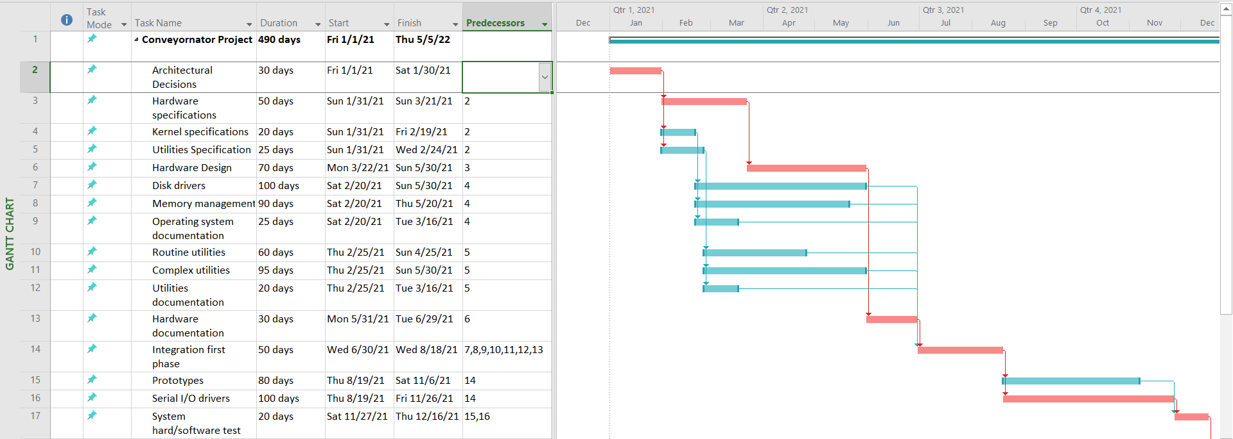

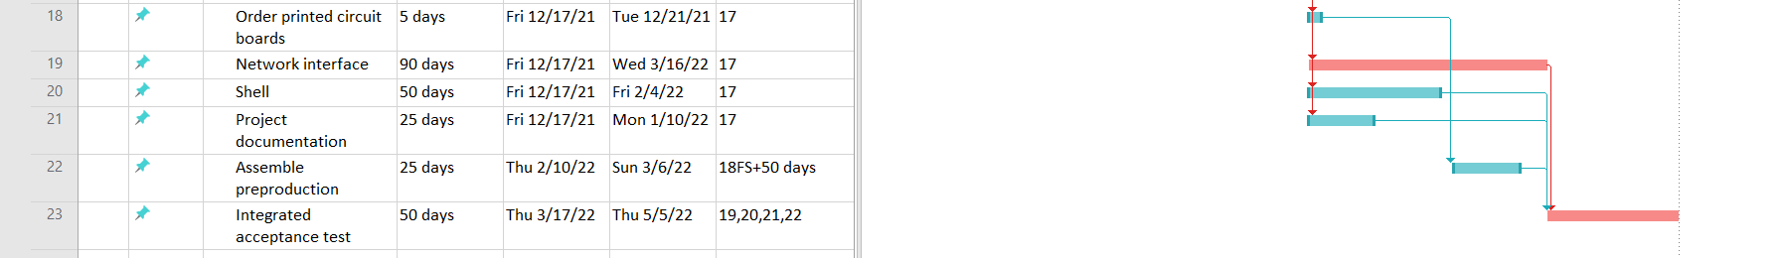

**b. Include a screenshot out of ES, LS, EF, LF, total slack and free slack in table form. The screenshot provided should also include a summary task for the project.**

Ans:

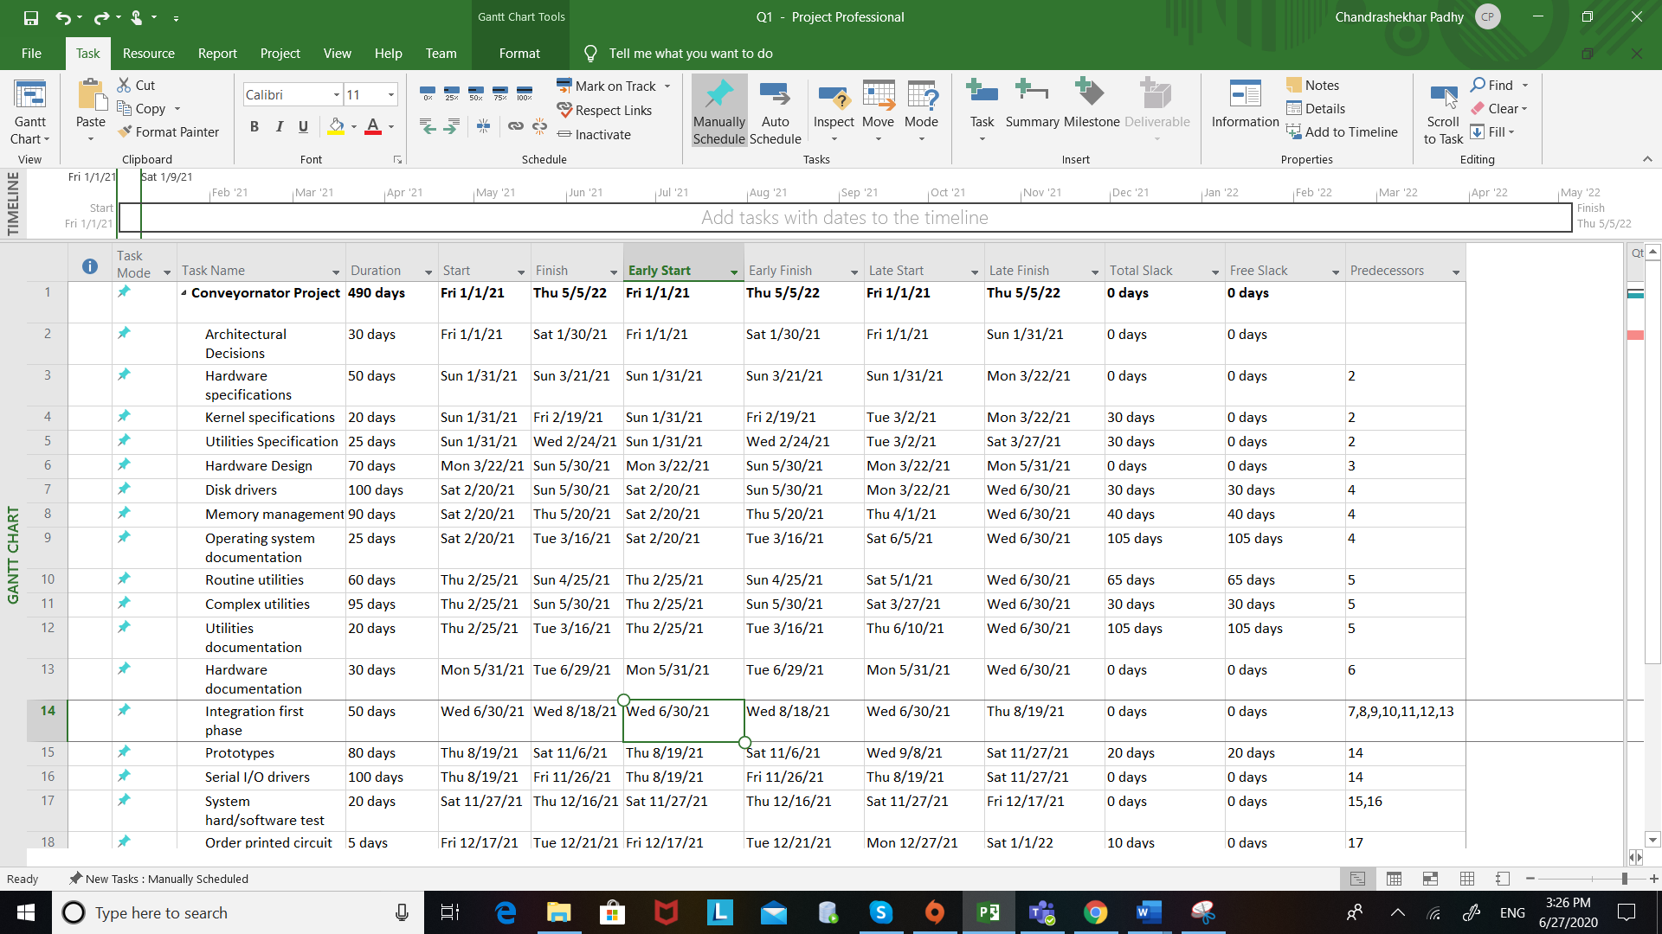

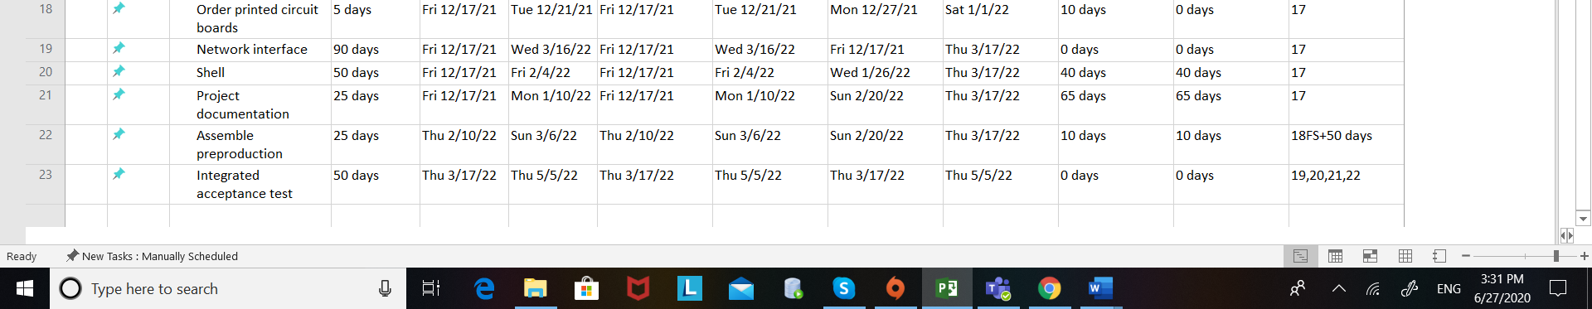

**c. What is the scheduled finish date?**

Ans: The Scheduled finish date is **5/5/2022**.



**d. How many days will the project take to complete?**

Ans: The Project would take **490** days to complete



**e. What percent of project activities are on the critical path**

Ans: There are a total of 9 project activities on the critical path. The total percentage is calculated as follows:

9/22 = 40.909%

**40.909%** of the project activities are on the critical path.

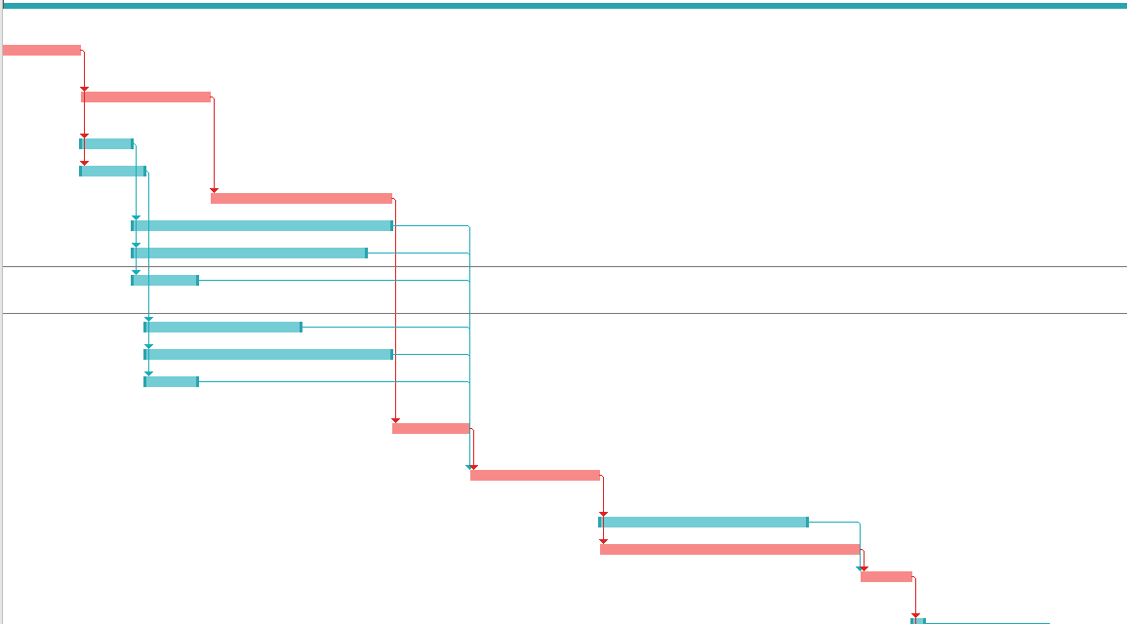

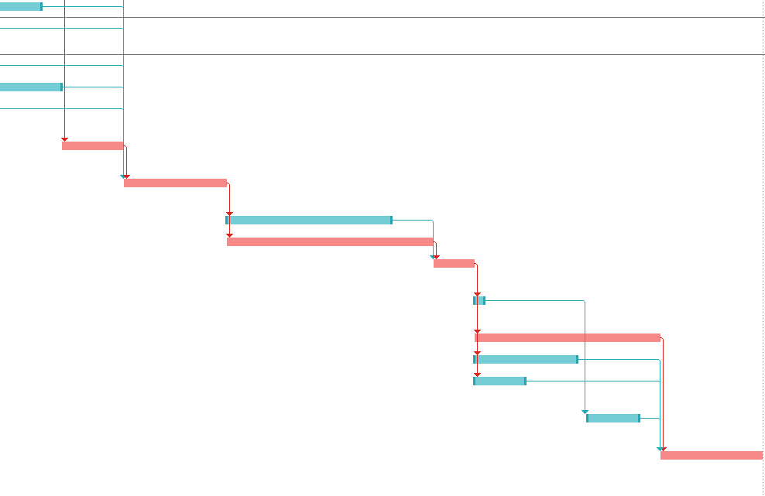

**f. What activity has the most total slack? What activity has the most free slack? Explain the difference between free slack and total slack.**

Ans: The tasks **Utility Documentation** and **Operating System Documentation** have the most free slack of 105 days.

Free slack refers to how much time a task can be delayed before a subsequent task — or the entire project itself — is likewise delayed,

while Total Slack is the amount of time in a schedule that a task can be delayed before the entire

project’s completion date is delayed.





**g. What is the total slack for the project as a whole? Use the summary task to help answer this question.**

Ans: The total slack for the project is **0 days**.



**h. Is it better to have a higher percentage of activities on the critical path or a lower percentage of activities on the critical path? Explain your answer.**

Ans: It is better to have a lower percentage of activities on the critical path as we need to finish the project within the finish date mentioned.

Less the number of activities on the critical path, better the chances of reducing the project deadline.

We need to lower the count of critical activities on the critical path as moving project tasks out of the critical path would help lower the duration of the project.

**i. Please find the Attached file**

**2)**

**a. After assigning resources, what is the total cost of the project?**

Ans: The total cost of the project is **$1,481,600.00**



**b. Which, if any, of the resources are over-allocated?**

Ans: The **Design**, **Development** and **Documentation** Resources are over-allocated.

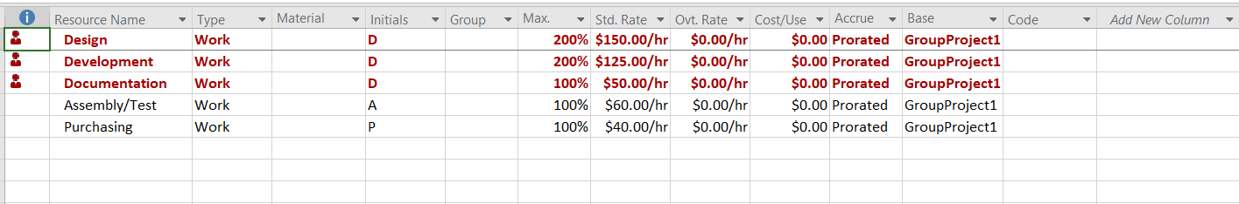

**c. Try to resolve the over-allocation problems without extending the duration of the project using the resource leveling feature of MS Project. To level resources without extending the duration of the project, make sure the check boxes for “Level only within available slack” and “Level manually scheduled tasks” are both selected. Also, assume “Leveling can adjust individual assignments on task”, “Leveling can create splits in remaining work”, and “Level resources with the proposed booking type” are deselected. See Figure 3 for the correct leveling settings? Which, if any, of the over-allocated resources are no longer over-allocated? Which, if any, of the resources are still over-allocated?**

Ans: The **Documentation** Resource is now not over-allocated after following the steps mentioned in question 2c.

Design and Development are still over-allocated.

Shared below is the screenshot of the remaining over-allocated resources.

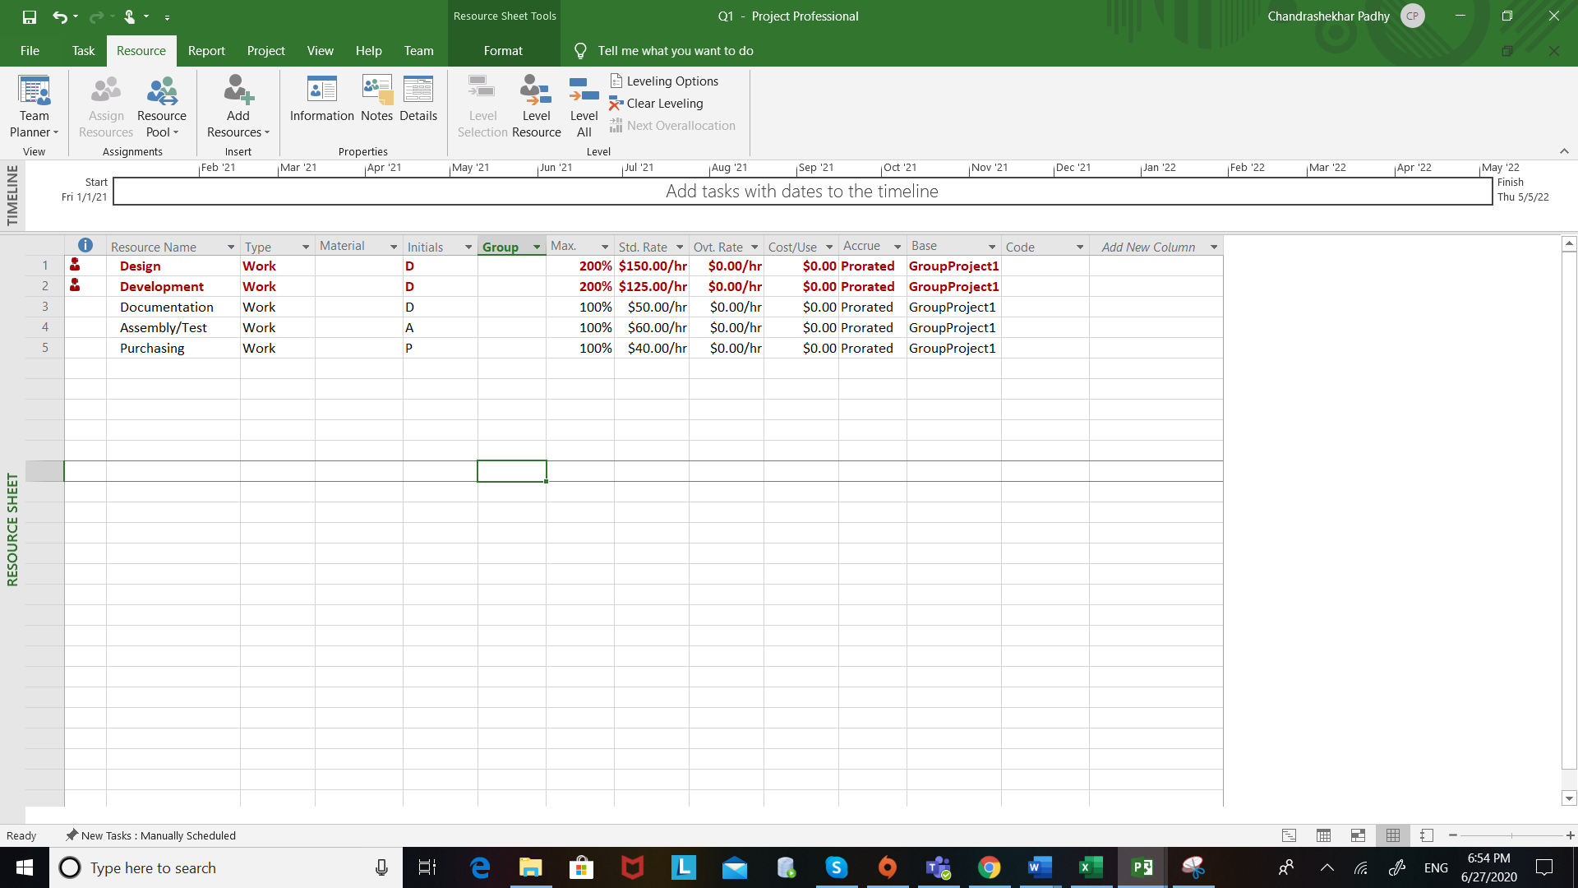

**d. Include a Gantt chart and schedule table after leveling only within available slack. Please include a summary task and make sure all tasks are clearly labeled with their corresponding task name.**

Ans:

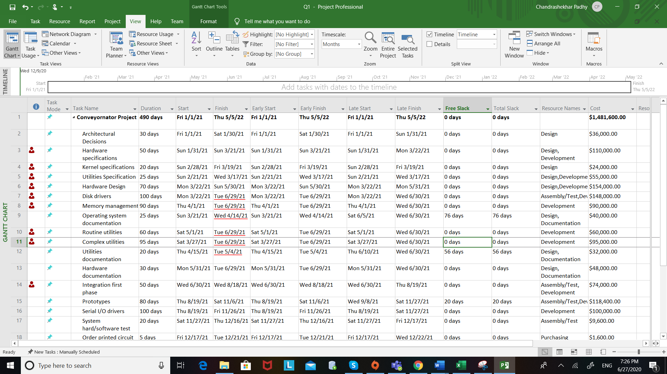

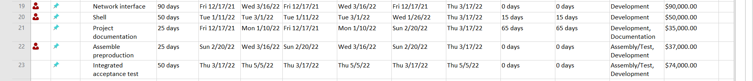

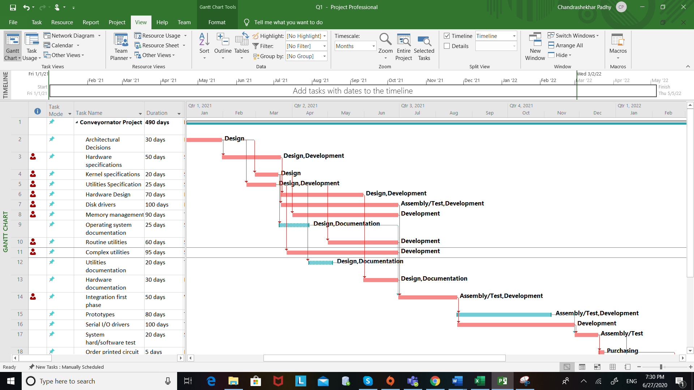

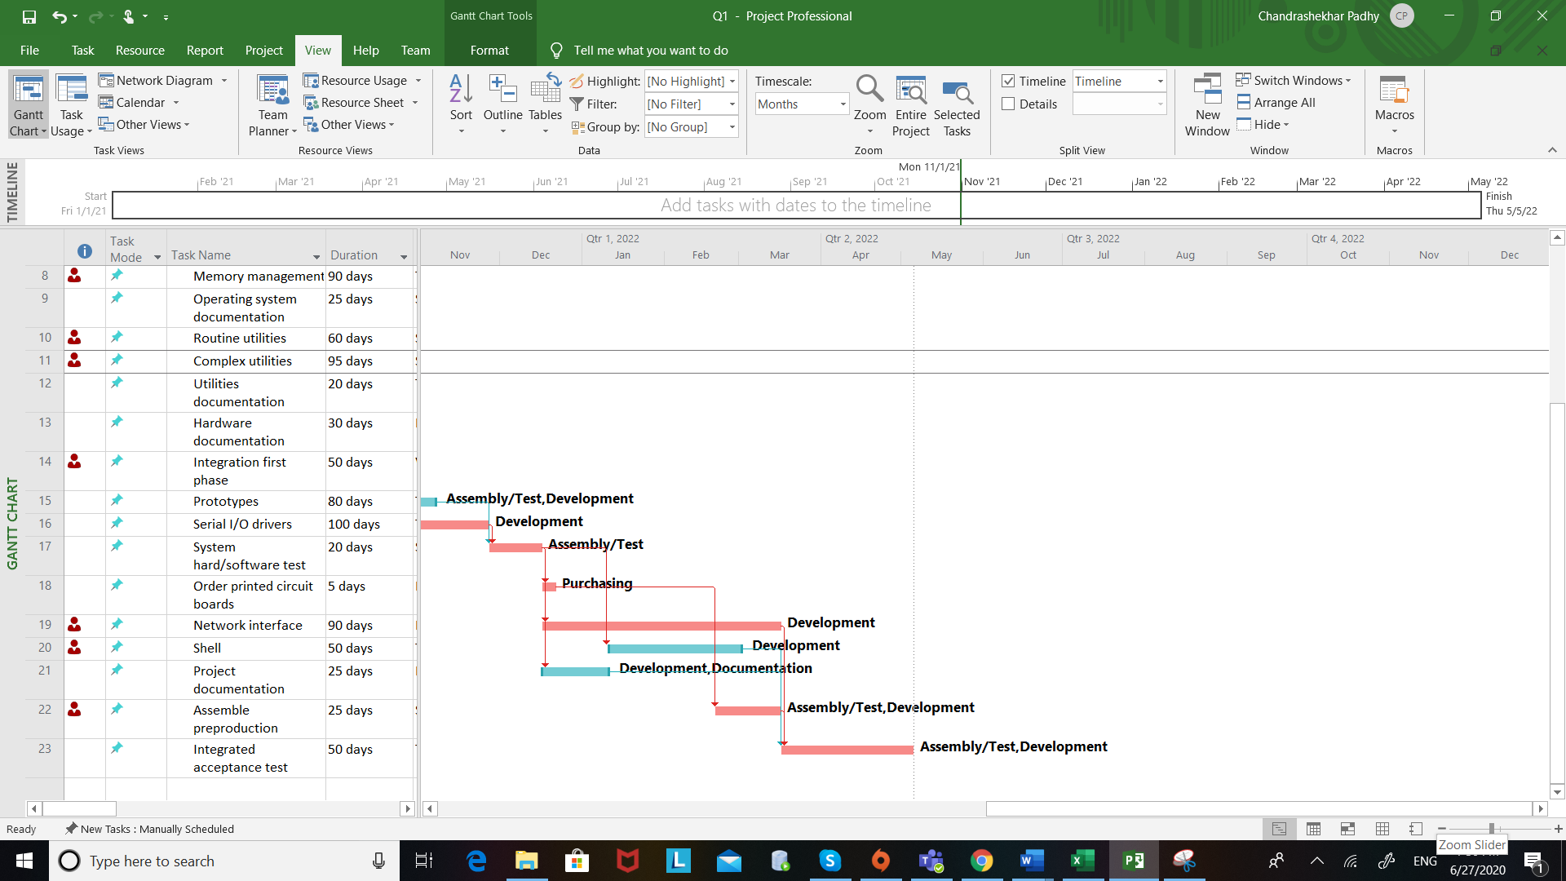

**e. What is the impact of leveling within slack on the percent of project activities on the critical path?**

Ans: The result is **17/22** tasks moving to the critical path as compared to the 9/22 before.

That results in 77.27% of activities on the critical path.

**f. Assume you cannot add additional resources and the project is resource constrained. How many days will the project take after resolving all over-allocation problems? What is the scheduled finish date?**

Ans: It would take a total of **650** days after resolving the over-allocation problem. The scheduled finish date is **10/12/2022**.



**g. How does the schedule in 2f compare to the schedule in Question 1? Why did the number of days to complete the project in 2f increase?**

Ans: The duration increases as a result of activities moving on/off from the critical path.

Since the number of resources remained the same, the end date had to be moved and hence the number of days/duration increased.



**h. What is the total cost of the project after resolving all over-allocation problems in step 2f? How does this cost compare with the cost in 2a?**

Ans: The total cost of the project remains the same, ie. $1,481,600.00



**i. Please find Attached the file for question 2 i.**

**Q3)**

1. **The project sponsor is not pleased with the duration of the project after resolving all resource overallocation issues and has requested that you make changes to the project to shorten it so that the project takes less than 365 days to complete. You may make any change to the project you want, but you need to clearly describe the change along the impact of the change to the project budget and schedule. You may ignore and/or change any of the assumptions listed on the first page when making your changes.**

**Use the table below and list the changes you would make to shorten the project. Clearly describe each change, the impact the change has on the overall project schedule, and the impact the change has on project cost.**

Ans:

Some of the changes are :

1. Increased the duration of Hours to be worked to 12 instead of 8.
2. Increased the work capability of resources : Design – 300%, Development – 300%, Documentation – 150%, Assembly/Test – 150%, Purchasing – 150%
3. Changed the work unit in hrs, to reduce the cost and thus affect the number of days to be worked.
4. Removed Serial I/O task and buy existing driver suite

1) Increased the duration of Hours to be worked to 12 instead of 8.

- Brought about a significant change in the project completion date.

- The days changed to 325.21 days from the 650 when all the resources were levelled.

- Resulted in saving around (650-326) 324 days

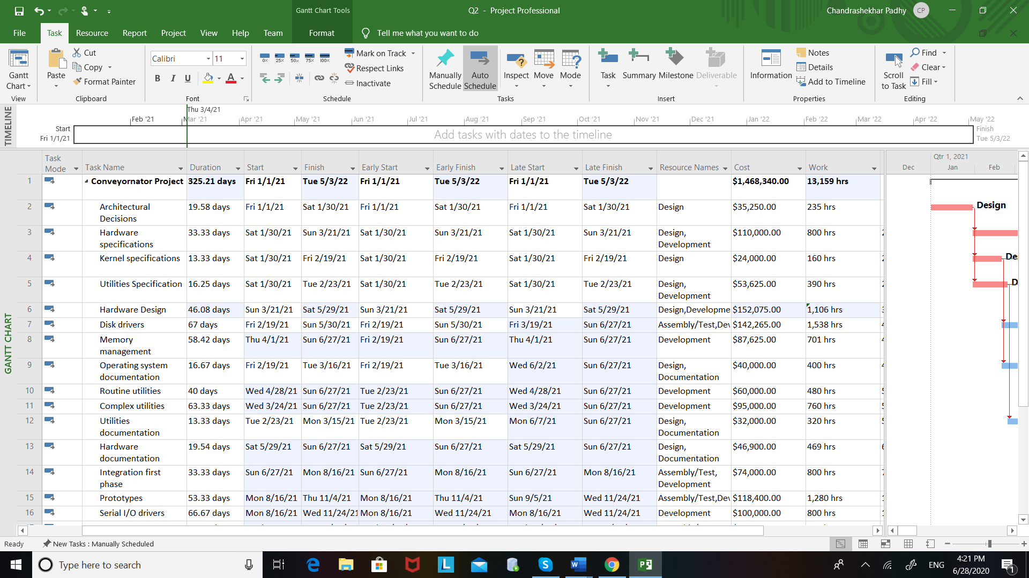

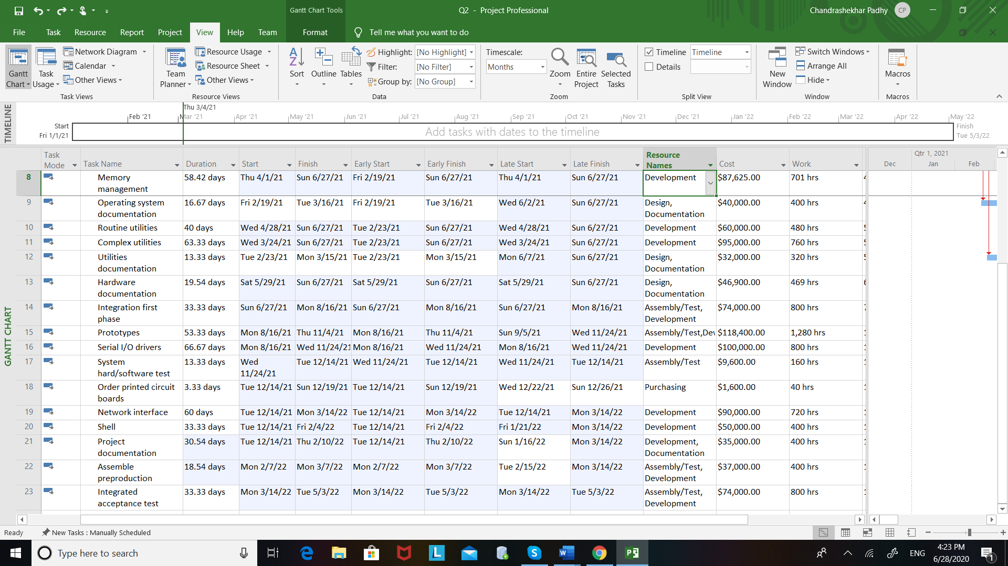

2) Increased the work capability of resources : Design – 300%, Development – 200%, Documentation – 200%, Assembly/Test – 150%, Purchasing – 150%

- This resulted in a total saving of around ($1,481,600 – $1,470,265) $11,335

- Development was overallocated

3) Changed the work unit in hrs, to reduce the cost and thus affect the number of days to be worked.

- Manually Adjusted the unit rates to cope with the increase in hours of resources so that the cost does not go up.

4) Removed Serial I/O task and buy existing driver suite

- Reduced duration to 311.88 days from 325.5 days

- Reduced total cost by $1,01,925 ($1,470,265 - $1,368,340)

- Work hours become a total of 12,359 hrs.



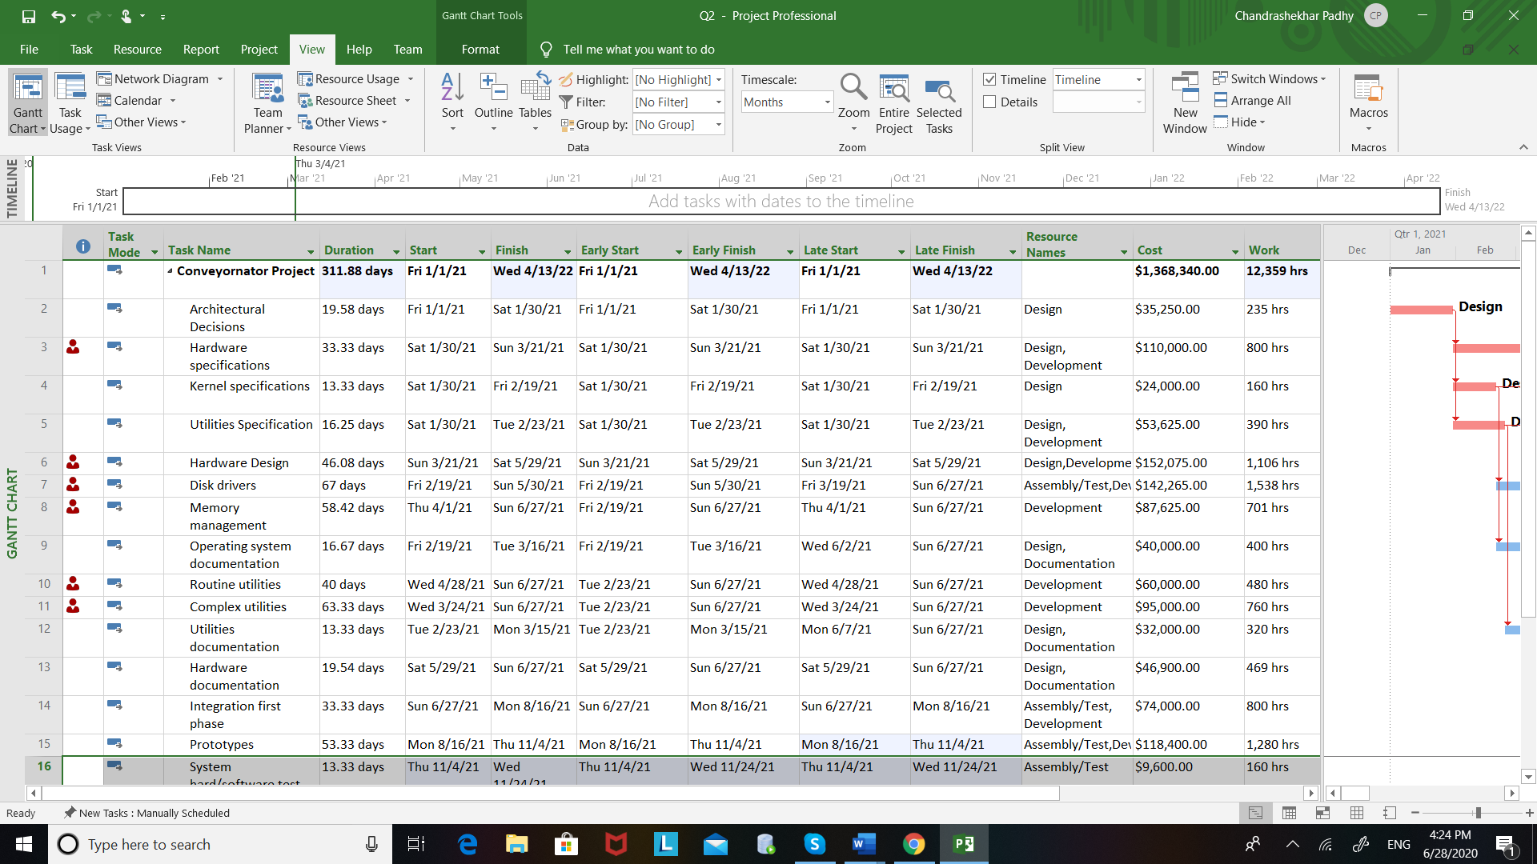

**Table for Changes 1,2 and 3 combined in one.**

|  |  |  |  |  |
| --- | --- | --- | --- | --- |
| **Activity** | **Description** | **Proposed Change for Reducing Overall Project Duration(Changes 1, 2 and 3)** | **Impact the Change has on Project Duration**  **(Number of days the overall project duration is decreased as a result of making the change)** | **Impact the change has on Project Cost (Does the project cost increase, decrease or stay the same as a result of making the change? Calculate and list the exact dollar amount associated with the change)** |
| 1 | Architectural Decisions | Changed from 30 to 19.58 days | 650-10.42 = 639.58  Decreased by 10.42 days | 36,000 – 35,250 = 750 |
| 2 | Hardware specifications | Changed from 50 to 33.33 days | Decreased the overall project by 16.67 days | None |
| 3 | Kernel specifications |  |  |  |
| 4 | Utilities Specification |  |  |  |
| 5 | Hardware Design | Changed from 70 to 46.67 days | Decreased the overall duration by 23.33 days | 154,000-152,075=1925 |
| 6 | Disk drivers | Changed from 100 to 67 days | Decreased the overall duration by 33 days | 148000 – 142265 = $5735 |
| 7 | Memory management |  |  |  |
| 8 | Operating system documentation |  |  |  |
| 9 | Routine utilities |  |  |  |
| 10 | Complex utilities | Changed from 95 to 63.33 days | Decreased the overall duration by 31.67 days | Resource allocation kept the amount same |
| 11 | Utilities documentation |  |  |  |
| 12 | Hardware documentation | Changed from 30 to 19.54 days | Decreased the overall duration by 10.46 days | 48,000-46,900 = 1100 |
| 13 | Integration first phase | Changed from 50 to 33.33 days | Decreased the overall project by 16.67 days | None |
| 14 | Prototypes | Changed from 80 to 53.33 days | Decreased the overall project by 26.67 days | 118400 total cost |
| 15 | Serial I/O drivers |  |  |  |
| 16 | System hard/software test | Changed from 20 to 13.33 days | Decreased the overall project by 6.7 days | None |
| 17 | Order printed circuit boards | Changed from 5 to 3.33 days | Decreased the overall project by 1.67 days | None |
| 18 | Network interface |  |  |  |
| 19 | Shell |  |  |  |
| 20 | Project documentation |  |  |  |
| 21 | Assemble preproduction | Changed from 25 to 18.54 days | Decreased the overall project by 6.46 days | None |
| 22 | Integrated acceptance test | Changed from 50 to 33.33 days | Decreased the overall project by 16.67 days | None |

**Table for Change No. 4 – Changes 1,2,3 included and similar to the previous table.**

Duration : 311.88

Total cost : $1,368,340

Work Hours : 12,359 hrs

|  |  |  |  |  |
| --- | --- | --- | --- | --- |
| **Activity** | **Description** | **Proposed Change for Reducing Overall Project Duration(Change 4)** | **Impact the Change has on Project Duration**  **(Number of days the overall project duration is decreased as a result of making the change)** | **Impact the change has on Project Cost (Does the project cost increase, decrease or stay the same as a result of making the change? Calculate and list the exact dollar amount associated with the change)** |
| 1 | Architectural Decisions | Remains Same |  |  |
| 2 | Hardware specifications |  |  |  |
| 3 | Kernel specifications |  |  |  |
| 4 | Utilities Specification |  |  |  |
| 5 | Hardware Design |  |  |  |
| 6 | Disk drivers |  |  |  |
| 7 | Memory management |  |  |  |
| 8 | Operating system documentation |  |  |  |
| 9 | Routine utilities |  |  |  |
| 10 | Complex utilities |  |  |  |
| 11 | Utilities documentation |  |  |  |
| 12 | Hardware documentation |  |  |  |
| 13 | Integration first phase |  |  |  |
| 14 | Prototypes |  |  |  |
| 15 | Serial I/O drivers | Removed | Removed | Removed |
| 16 | System hard/software test |  |  |  |
| 17 | Order printed circuit boards |  |  |  |
| 18 | Network interface |  |  |  |
| 19 | Shell |  |  |  |
| 20 | Project documentation |  |  |  |
| 21 | Assemble preproduction |  |  |  |
| 22 | Integrated acceptance test |  |  |  |

**b. What is the finish date of your revised project?**

Ans: The revised date is **4/13/2022**.

**c. What is the cost of your revised project? How does this cost compare to the cost in question 2?**

Ans: The cost of the revised project is $1,368,340.00 which is ($1,481,600.00 – $1,368,340.00) **$1,13,260** less than the amount in question 2.

**d. Please find attached the required file for question 3d.**