**Tips for fitting models in SAM**

General

- Some model configurations don’t work for some data sets. For example, for Atl. Herring, unique F’s for each age and unconstrained correlations fails to fit, but compound symmetry works.

Survey data

- The numbers directly beneath the survey start and end date are the sex code (always 1), effort code (always 1), and the start and end of the survey. With 0 meaning January 1 and 1.0 meaning December 31. For example, the values of 0.0 and 0.5 for the spring survey indicate that the survey takes place in the first half of the year.

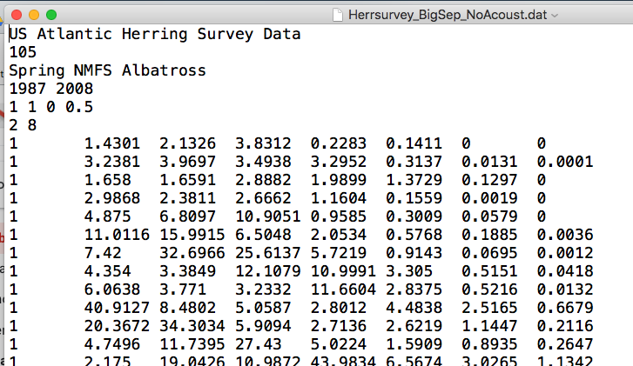

- setup.sam.data() will turn negative values into NAs.

Fishing mortality rates

If you couple fishing mortality rates ($keylogFsta) and TMB fails, try setting an identical coupling of F variances ($keyVarF).

Catchability

It’s called logFpar in SAM output.

Simulate

By default, simulate.sam() does not simulate new realizations of N-at-age and F-at-age unless the fit passed to is was called with sam.fit(…, sim.condRE = FALSE). So the uncertainty in the simulations is by default due to observation error only (in Catch and Survey indices).

If you want to see the N-at-age and F-at-age from the simulate.sam() you need to call simulate.sam(full.data = FALSE).

Plots

catchplot() will not show outlier observations if they happen to land outside the plot limits (which are set based on the fit).