PANEL METHOD AND INVERSE DESIGN OF NACA AIRFOILS

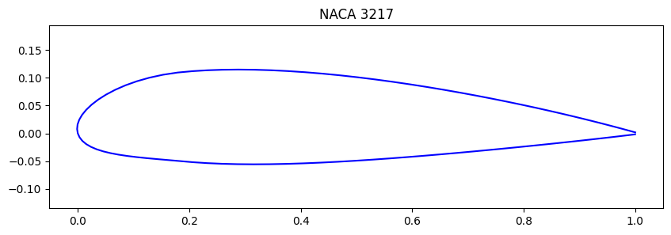

Lucas García Franco
Carlos Pesquero Cañizares




Contents
1. Mathematical Background 2
1.1. Influence coefficients $Aij$ 2
1.2. Kutta condition 5
1.3. Assembling the matrix $Aij$ 6
1.4. Lift coefficient 6
2. Implementation and Validation 6
2.1. Numerical model 6
2.2. Structure of the algorithm 6
2.2.1. Aerodynamic coefficients 7
2.3. Results with $N=100$ against XFOIL (inviscid) 8
2.4. Mesh convergence and choice of $Nopt$ 9
2.5. Results with $Nopt$ against XFOIL (inviscid) 10
3. Design Challenge: Inverse Design 11
4. Comparison with Viscous Analysis 11
5. References 12

Mathematical Background
The wedge-shaped profile is defined by the last digits of the ID number: $X=7, Y=3, Z=8$. These give the following profile constants [1]:
$$α=\left(1+0.3X\right)°=\left(1+0.3⋅7\right)°=3.1°$$
$$x_{v}=0.25+0.05Y=0.25+0.05⋅3=0.4$$
$$z_{v}=0.1+0.01Z=0.1+0.01⋅8=0.18$$
To apply the panel method to this simplified profile, it is first divided into panels $p_{i}$, nodes $N_{i}$ and control points $pc_{i}$.
The panels run clockwise from the trailing edge: panel 1 on the lower surface (trailing edge → leading edge), panel 2 from the leading edge to the vertex, and panel 3 from the vertex back to the trailing edge. All normals then point out of the profile, and the Kutta condition applies between panels 1 and 3.
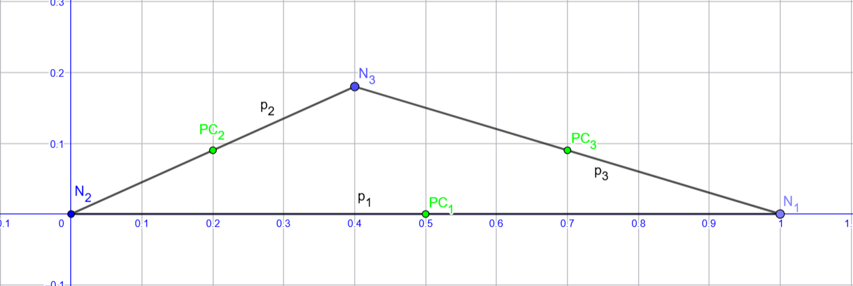
Figure 1: Wedge profile [2].

Influence coefficients $A_{ij}$
First, the distances and angles from each control point to the end nodes of the other panels are computed with these formulas:
 | $$r_{1}^{2}=x_{ij}^{2}+z_{ij}^{2}$$ | (1)
 | $$r_{2}^{2}={(x_{ij}-c_{j})}^{2}+z_{ij}^{2}$$ | (2)

 | $$θ_{1}= \tan^{-1}{\begin{aligned}\left(\frac{z_{ij}}{x_{ij}}\right); -π≤θ_{1 }≤π \\ \end{aligned}}$$ | (3)

 | $$θ_{2}= \tan^{-1}{\begin{aligned}\left(\frac{z_{ij}}{x_{ij}-c_{j}}\right); -π≤θ_{2 }≤π \\ \end{aligned}}$$ | (4)
Distances and angles are measured in the local axes of panel j (x along the panel, z along its outward normal). The angles are negative because the control points lie inside the profile, on the opposite side of the outward normal.
From panel 1:
- Pc2: $r_{1}=0.805$ $r_{2}=0.219$ $θ_{1}=-6.42º$ $θ_{2}=-155.77º$
- Pc3: $r_{1}=0.313$ $r_{2}=0.706$ $θ_{1}=-16.70º$ $θ_{2}=-172.67$º
From panel 2:
- Pc1: $r_{1}=0.500$ $r_{2}=0.206$ $θ_{1}=-24.23º$ $θ_{2}=-85.17º$
- Pc3: $r_{1}=0.706$ $r_{2}=0.313$ $θ_{1}=-16.90º$ $θ_{2}=-40.93$º
From panel 3:
- Pc1: $r_{1}=0.206$ $r_{2}=0.500$ $θ_{1}=-44.25º$ $θ_{2}=-163.30º$
- Pc2: $r_{1}=0.219$ $r_{2}=0.805$ $θ_{1}=-139.07º$ $θ_{2}=-169.72$º

Next come the coefficients of the velocity induced at the control point of panel i by the singularities on panel j, in the local axes of panel j.
- Source coefficients:
 | $$u_{qij}^{*}=-\frac{1}{2π}\ln\left(\frac{r_{2}}{r_{1}}\right)$$ | (5)

 | $$w_{qij}^{*}=\frac{θ_{2}-θ_{1}}{2π}$$ | (6)

- Vortex coefficients:
 | $$u_{γij}^{*}=\frac{θ_{2}-θ_{1}}{2π}$$ | (7)

 | $$w_{γij}^{*}=\frac{1}{2π}\ln\left(\frac{r_{2}}{r_{1}}\right)$$ | (8)

These coefficients give the induced velocity. They are first rotated from the local axes of panel j to global axes:
 | $$u_{qij}=q_{j}(u_{qij}^{*}cosθ_{j}-w_{qij}^{*}sinθ_{j})$$ | (9)
 | $$w_{qij}=q_{j}(u_{qij}^{*}sinθ_{j}+w_{qij}^{*}cosθ_{j})$$ | (10)

 | $$u_{γij}=γ(u_{γij}^{*}cosθ_{j}-w_{γij}^{*}sinθ_{j})$$ | (11)
 | $$w_{γij}=γ(u_{γij}^{*}sinθ_{j}+w_{γij}^{*}cosθ_{j})$$ | (12)

Adding the source and vortex contributions gives the velocities, equation (13):
 | $$\vec{V_{ij}}=\left(u_{q_{ij}}+u_{γ_{ij}} , w_{q_{ij}}+w_{γ_{ij}}\right)=(u_{ij} , w_{ij})$$ | (13)

Panel 1:
$$V_{11}=(-0.500γ, -0.500q_{1})$$
$$V_{21}=(-0.207q_{1}+0.415γ, 0.415q_{1}+0.207γ)$$
$$V_{31}=(0.129q_{1}+0.433γ, 0.433q_{1}-0.129γ)$$
Panel 2:
$$V_{12}=(0.198q_{2}-0.096γ, -0.096q_{2}-0.198γ)$$
$$V_{22}=(-0.205q_{2}+0.456γ, 0.456q_{2}+0.205γ)$$
$$V_{32}=(0.145q_{2}-0.008γ, -0.008q_{2}-0.145γ)$$
Panel 3:
$$V_{13}=(-0.230q_{3}-0.276γ, -0.276q_{3}+0.230γ)$$
$$V_{23}=(-0.223q_{3}-0.022γ, -0.022q_{3}+0.223γ)$$
$$V_{33}=(0.144q_{3}+0.479γ, 0.479q_{3}-0.144γ)$$

These induced velocities are then projected on the normal and the tangent of the receiving panel, equations (14) and (15).
 | $${\vec{V}}_{ij}∙\vec{n_{i}}=\left(u_{ij}, w_{ij}\right)\left(-sinθ_{i} , cosθ_{i}\right)=-u_{ij}sinθ_{i}+w_{ij}cosθ_{i}$$ | (14)
 | $$\vec{V_{ij}}∙\vec{τ_{i}}=(u_{ij}, w_{ij})∙(cosθ_{i}, sinθ_{i})=u_{ij}cosθ_{i}+w_{ij}sinθ_{i}$$ | (15)

$$\vec{n_{1}}=(0.000; -1.000)$$ | $$\vec{τ_{1}}=(-1.000; 0.000)$$
$$\vec{n_{2}}=(-0.410; 0.912)$$  $$\vec{n_{3}}=(0.287; 0.958)$$ | $$\vec{τ_{2}}=(0.912; 0.410)$$  $$\vec{τ_{3}}=(0.958; -0.287)$$
The projected velocities are:
Panel 1:
$$\vec{V_{11}}∙\vec{n_{1}}=0.500q_{1}$$ | $$\vec{V_{11}}∙\vec{τ_{1}}=0.500γ$$
$$\vec{V_{12}}∙\vec{n_{1}}=0.096q_{2}+0.198γ$$ | $$\vec{V_{12}}∙\vec{τ_{1}}=-0.198q_{2}+0.096γ$$
$$\vec{V_{13}}∙\vec{n_{1}}=0.276q_{3}-0.230γ$$ | $$\vec{V_{13}}∙\vec{τ_{1}}=0.230q_{3}+0.276γ$$
Panel 2:
$$\vec{V_{21}}∙\vec{n_{2}}=0.463q_{1}+0.018γ$$ | $$\vec{V_{21}}∙\vec{τ_{2}}=-0.018q_{1}+0.463γ$$
$$\vec{V_{22}}∙\vec{n_{2}}=0.500q_{2}$$ | $$\vec{V_{22}}∙\vec{τ_{2}}=0.500γ$$
$$\vec{V_{23}}∙\vec{n_{2}}=0.071q_{3}+0.212γ$$ | $$\vec{V_{23}}∙\vec{τ_{2}}=-0.212q_{3}+0.071γ$$
Panel 3:
$$\vec{V_{31}}∙\vec{n_{3}}=0.452q_{1}+0.001γ$$ | $$\vec{V_{31}}∙\vec{τ_{3}}=-0.001q_{1}+0.452γ$$
$$\vec{V_{32}}∙\vec{n_{3}}=0.034q_{2}-0.141γ$$ | $$\vec{V_{32}}∙\vec{τ_{3}}=0.141q_{2}+0.034γ$$
$$\vec{V_{33}}∙\vec{n_{3}}=0.500q_{3}$$ | $$\vec{V_{33}}∙\vec{τ_{3}}=0.500γ$$
Finally, the coefficients of the matrix $A_{ij}$ follow from these projections.
 | $$V_{n_{i}}=\sum_{j=1}^{N}{{\vec{V}}_{ij}∙{\vec{n}}_{i}+{\vec{V}}_{∞}∙{\vec{n}}_{i}}=0$$ | (16)

Equation (16), with $[{\vec{V}}_{∞}∙{\vec{n}}_{i}=-I_{i}$]:
 | $$\sum_{j=1}^{N}{a_{ij}q_{j}}+a_{i,N+1}γ=I_{i}$$ | (17)

Kutta condition
In a panel method for airfoils, the Kutta condition is what makes the flow leave the trailing edge smoothly, as it does in reality.
It requires the pressure on the upper and lower surfaces to be equal at the trailing edge, so the tangential velocities on panel 1 and panel N are equal in magnitude.
 | $$\left(V_{τ_{1}}+V_{∞τ_{1}}\right)+\left(V_{τ_{N}}+V_{∞τ_{ N}}\right)=0$$ | (18)

Therefore:
$$(-0.198q_{2}+0.230q_{3}+0.873γ-0.999)+(-0.001q_{1}+0.141q_{2}+0.986γ+0.941)=0$$
$$V_{τ_{1}}$$
$$V_{τ_{3}}$$

Assembling the matrix $A_{ij}$
With the Kutta condition and equation (17) the matrix $A_{ij}$ can be assembled:
Kutta
$$A_{ij}=\left[\begin{matrix}0.500 & 0.096 & 0.276 & -0.032 \\ 0.463 & 0.500 & 0.071 & 0.231 \\ 0.452 & 0.034 & 0.500 & -0.141 \\ -0.001 & -0.057 & 0.230 & 1.859\end{matrix}\right]$$

Lift coefficient
With a unit free-stream speed:
$$[I_{1}, I_{2}, I_{3}, I_{4}]=[0.054, 0.360, -0.339, 0.058]$$
The unknown $γ$ follows from equation (17): $γ=0.211$. The lift coefficient is then:
 | $$C_{l}=2γ\sum_{i=1}^{N}{L_{i}}$$ | (19)
where $L_{i}$ is the length of each panel, which gives $C_{l}=$ 0.873

Implementation and Validation

Numerical model
AI [3] was used as a programming aid. The Python code generates NACA 4-digit geometries, solves the potential flow with the panel method (lift and pitching-moment coefficients) and plots the pressure distribution along the chord.
The source code is linked in the Appendix.

Structure of the algorithm
The code first builds the geometry of the chosen NACA section for the required number of panels $(N)$. This report uses the NACA 3217, which has a maximum camber $f$ of $3\%$, maximum camber located at $xf$ of $20\%$ and a maximum thickness $t$of $17\%$.
Figure 2: Geometry of the NACA 3217 (N=100).

Aerodynamic coefficients
The panel method of Section 1 is implemented in the function resolver_perfil. It returns the solution vector: the source strength of each panel $(λ_{i})$ and the constant vortex strength $(γ)$.
From these, potential-flow theory gives the coefficients below, for $N=100$ panels, angle of attack $α=3.1°$ and no viscosity.
- Lift coefficient $\left(C_{l}\right)$.
Lift follows directly from the circulation (Kutta–Joukowski theorem).
 | $$C_{l}=2γ\sum_{i=1}^{N}{L_{i}}$$ | (19)
The result is $C_{l}=0.744$2.
- Pitching-moment coefficient $(C_{M_{c/4}})$
It is obtained by integrating the pressure forces about the theoretical aerodynamic center $(x=0.25c,y=0)$.
 | $$C_{M_{c/4}}=\sum_{i=1}^{N}{C_{p,i}L_{i}[\left(x_{c,i}-0.25\right)n_{y,i} -y_{c,i}n_{x,i}]}$$ | (20)
where $x_{c,i}$, $y_{c,i}$ are the panel midpoint coordinates and $n_{x,i}$, $n_{y,i}$ the components of its outward normal. The moment is positive nose-up, so a positively cambered section gives a negative (nose-down) value, as in XFOIL.
This gives $C_{M_{c/4}}=-0.0598$.
- Pressure distribution $(C_{p})$.
The non-dimensional tangential velocity $(V_{t,i})$ on each panel is the free-stream component plus the velocity induced by the singularities $(λ_{i},γ)$.
 | $$C_{p,i}=1-V_{t,i}^{2}$$ | (21)
It is plotted in Figure 3:
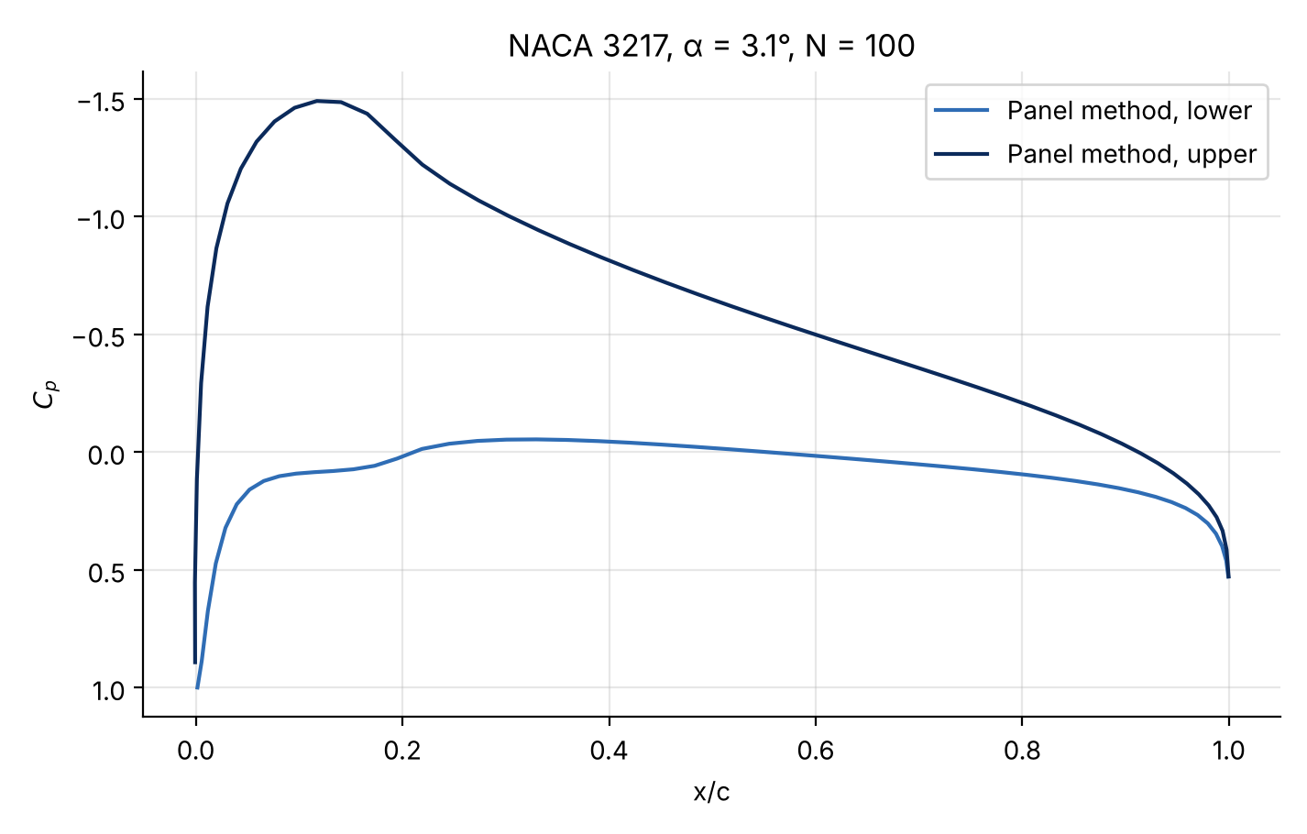
Figure 3: Pressure coefficient against $\frac{x}{c}$ for the NACA 3217, $N=100$.

Results with $N=100$ against XFOIL (inviscid)

Taking inviscid XFOIL as the reference, the error of the code is
 | $$ε=\frac{C_{x_{panels}}-C_{x_{xfoil}}}{C_{x_{xfoil}}}$$ | (22)
The results are in Table 1:
 | Panel method $N=100$ | XFOIL | Error $(ε)$ | Error $(\%)$
$$C_{l}$$ | $$0.7442$$ | 0.7373 | $$0.00936$$ | $$0.936\%$$
$$C_{M_{c/4}}$$ | -0.0598 | -0.0644 | $$-0.0714$$ | $$7.14\%$$
Table 1: Panel method with $N=100$against XFOIL.
The method uses constant-strength source panels, so local pressure gradients carry some error. For the lift coefficient $(C_{l})$, a sum of forces, the errors largely cancel and the difference is small ${(ε}_{C_{l} }≈1\%)$. The pitching moment $(C_{M_{c/4}})$, however, weights the same forces by their lever arm, which amplifies any error $(ε_{C_{M_{c/4}}}≈10\%)$.
To compare the pressure distributions $C_{p}$ along the chord, the code overlays both solutions (Figure 4), reading the XFOIL output for the NACA 3217 at $α=3.1°$.
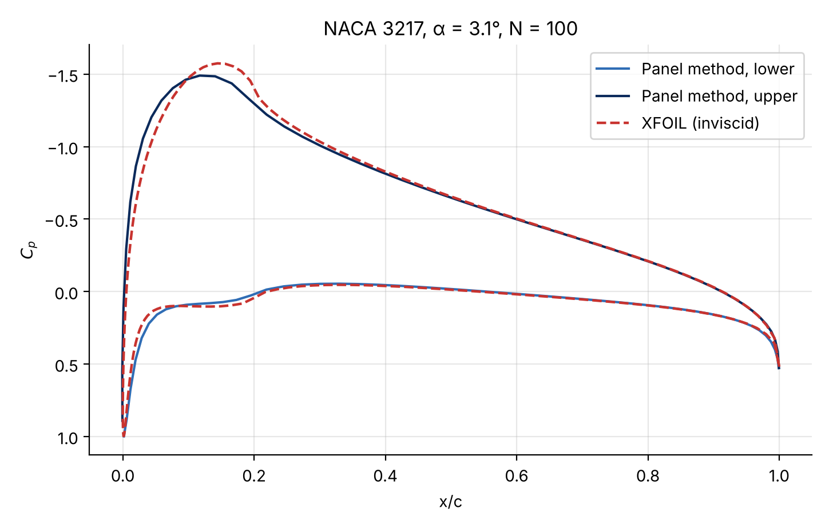
Figure 4: Pressure distribution from the panel method $(N=100)$ and from XFOIL.
Figure 4 shows close agreement between both pressure distributions $(C_{p})$. The upper-surface suction peak is at about $10\%$ of the chord, with $C_{p_{max}}≈-1.5$. The curves are practically identical in the pressure-recovery region, overlapping beyond $40\%$.

Mesh convergence and choice of $N_{opt}$

The convergence study starts at $N_{initial}=40$ panels and grows the mesh by $20\%$ per step, comparing the lift coefficient $C_{l}$ with the previous one:
 | $$ε_{rel}=\frac{C_{l_{i+1}}-C_{l_{i}}}{C_{l_{i}}}$$ | (23)
The tolerance is $ε_{rel}<0.01$, that is, below $1\%$.
Figure 5 shows the result:
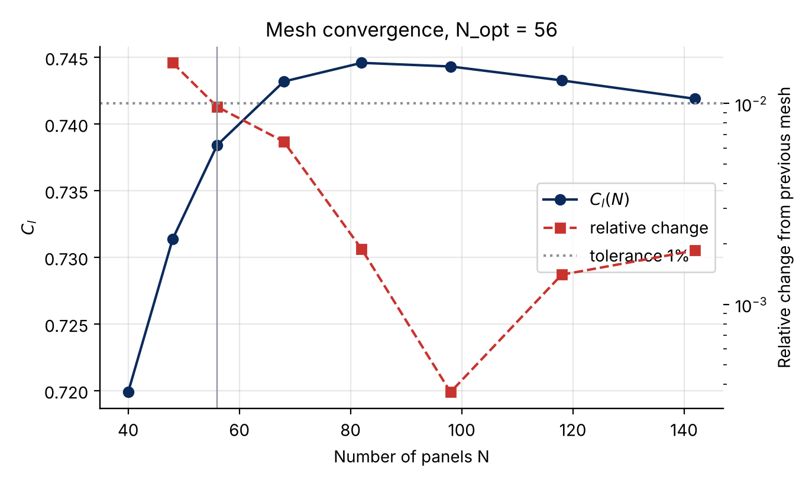
Figure 5: $C_{l}$ against the number of panels $(N)$ and its relative change
The solution settles before 60 panels. Dense meshes $(N≈100)$ reduce the error further but cost more computation. Since $N=56$ panels is the first mesh that meets the $1\%$ tolerance, it is taken as the optimal mesh $N_{opt}=56$.

Results with $N_{opt}$ against XFOIL (inviscid)

With $N_{opt}=56$ the comparison with XFOIL becomes:
 | Panel method $N_opt$ | XFOIL | Error $(ε)$ | Error $(\%)$
$$C_{l}$$ | $$0.7384$$ | 0.7373 | $$0.00149$$ | $$0.149\%$$
$$C_{M_{c/4}}$$ | $$-0.0584$$ | -0.0644 | $$-0.09317$$ | $$9.32\%$$
Table 2: Panel method with $N_{opt}=56$against XFOIL.
Table 2 shows a clear improvement in $C_{l}$ with $N_{opt}$, with the error down to $ε≈0.15\%$. This suggests that 56 panels are enough to integrate the pressure field and obtain a lift coefficient ${(C}_{l})$ very close to XFOIL's. The error in the pitching moment $(C_{M_{c/4}})$ grows to $ε=9.3\%$.
A caveat: Cl does not converge monotonically. It peaks near N ≈ 82 (0.7446) and then drifts down slightly (0.7419 at N = 142). The 0.15 % error at N = 56 is therefore partly a coincidence; the real difference from XFOIL is of order 1 %. Integrating the pressures instead of using the circulation gives Cl = 0.7212 at N = 56, an indication of the method's uncertainty.
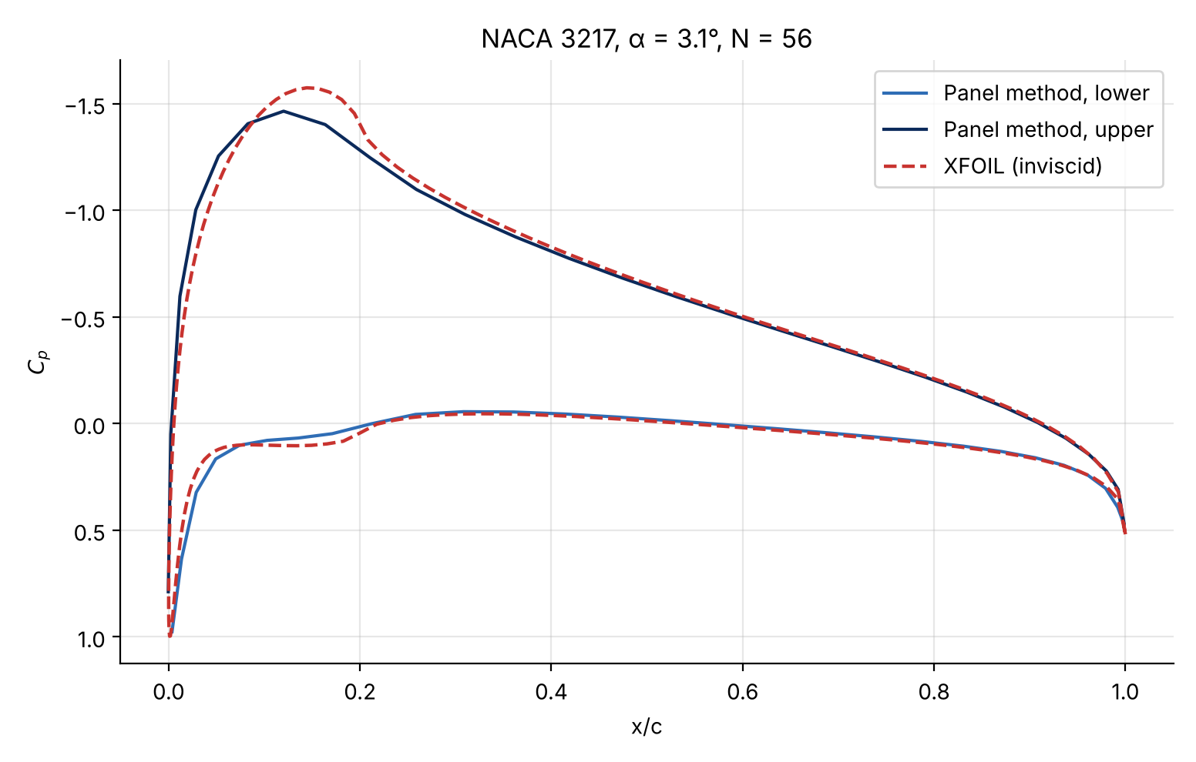
Figure 6: Pressure distribution from the panel method $(N_{opt}=56)$ and from XFOIL.
Figure 6 is practically identical to Figure 4. The only difference is that the panel-method curves are less smooth, because there are fewer panels.

Design Challenge: Inverse Design

To design a new NACA 4-digit section that raises the lift coefficient $(C_{l})$ by $20\%$ at zero angle of attack $α=0°$ over the original NACA 3217, an algorithm (optimized with the help of AI [3]) varies the geometric parameters of the section until the target is met while changing the pitching moment $(C_{M_{c/4}})$ as little as possible. The code is in the same notebook as Section 2 (links in the Appendix). The search keeps the sections whose Cl is within 0.015 of the target and, among them, picks the one whose moment changes least.
Physically, the parameter that matters most for this lift increase is the maximum camber $(f)$. A more asymmetric section changes the pressure distribution strongly, with more suction on the upper surface and more overpressure on the lower one. In potential-flow terms, more camber shifts the zero-lift angle, which increases the circulation $(Γ)$. The lift coefficient is directly proportional to this circulation:
 | $$C_{l}=2γ\sum_{i=1}^{N}{L_{i}=2Γ} with Γ=γ\sum_{i=1}^{N}{L_{i}}$$ | (24)
The position of the maximum camber ${(x}_{f})$ controls the pitching tendency $(C_{M_{c/4}})$. If most of the camber moves aft, the lift moves aft with it and produces a nose-down moment that would complicate trim and stability. The algorithm therefore cannot simply add camber; it must balance how much camber to add $(f)$ and where to place it $(x_{f})$ so that the redesigned section remains viable for stability.
The effect of the maximum thickness $(t)$ on lift is much smaller than that of camber. A thicker section makes the flow accelerate asymmetrically around it, which raises the circulation $(Γ)$ and hence the lift slightly. Being symmetric about the camber line, however, thickness changes the pressure difference much less than camber does.
For the NACA 3217 at $α=0°$ the lift coefficient is $C_{l_{base}}=0.3542$, and the pitching moment, which the redesign should keep, is $C_{M_{c/4_{base}}}=-0.0520$. The lift target is therefore $C_{l_{target}}≈C_{l_{base}}⋅1.2=0.4250$.
The search returns the NACA 4114, compared with the original in Figure 7.
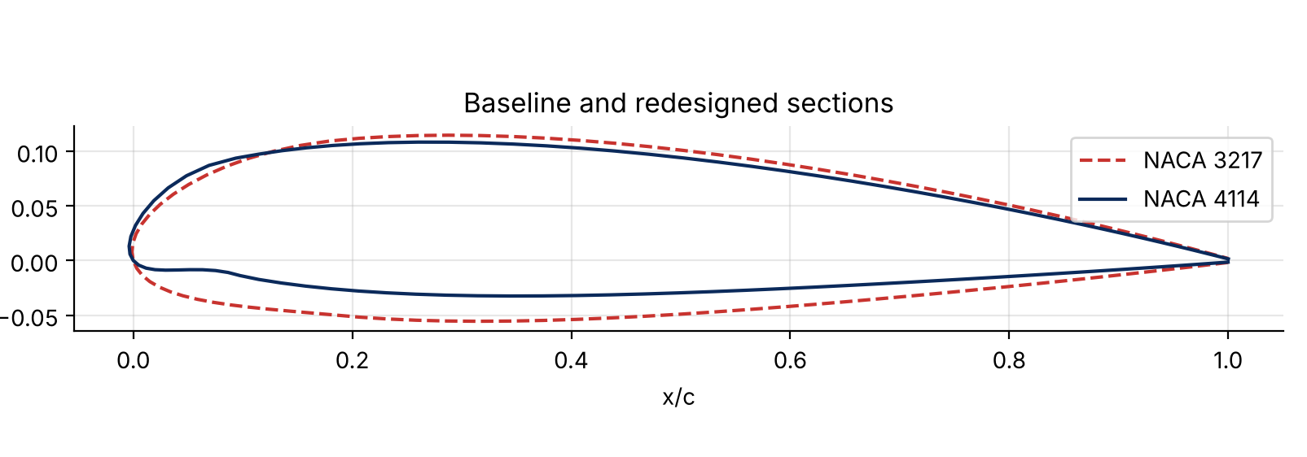
Figure 7: Redesigned NACA 4114 and baseline NACA 3217.
The redesigned section has $1$ percentage point more maximum camber $\left(f\right)$, from 3 % to 4 %. To offset the nose-down moment that this extra asymmetry brings, the algorithm has moved the position of maximum camber $x_{f}$ by $10\%$ of the chord towards the leading edge. The maximum thickness $\left(t\right)$ drops by $3\%$ of the chord (from 17 % to 14 %). This geometry gives a lift coefficient $C_{l_{opt}}=0.4355$ (at $α=0$), an increase of $23\%$ over the baseline, while the pitching moment stays at $C_{M_{c/4_{opt}}}=-0.0518$, a change of $0.3\%$ from the original. As a check, inviscid XFOIL gives Cl = 0.4332 for the NACA 4114 at α = 0°, within 0.5 % of the code.
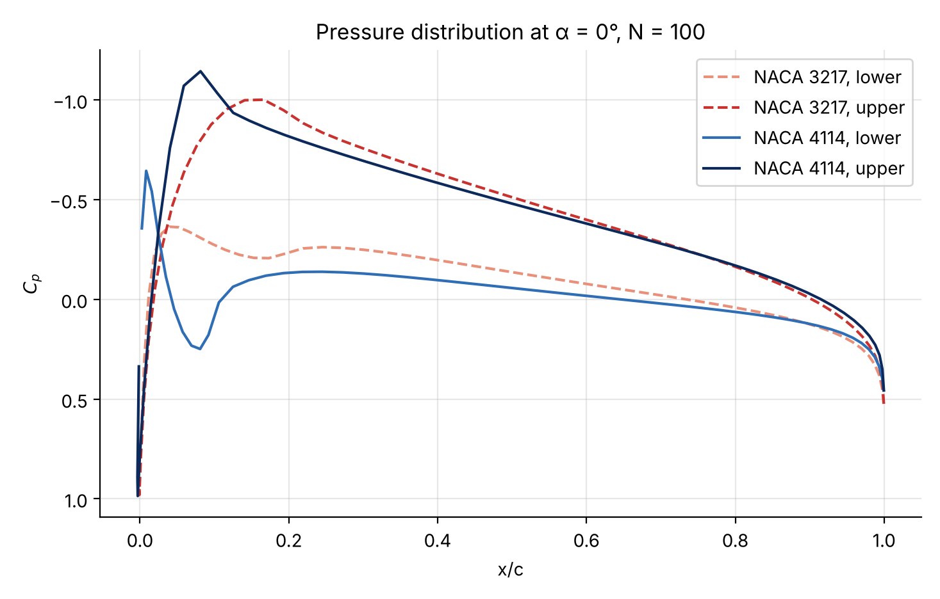
Figure 8: Pressure distribution along the chord of the redesigned NACA 4114 and the baseline NACA 3217.

Figure 8 shows the extra lift as a larger area between the lower- and upper-surface pressure curves. It comes from stronger suction on the upper surface $(C_{p}≈-1.1)$ very close to the leading edge. The peak moves forward, consistent with the maximum camber moving forward to $x_{f}=0.1⋅c$.

Comparison with Viscous Analysis

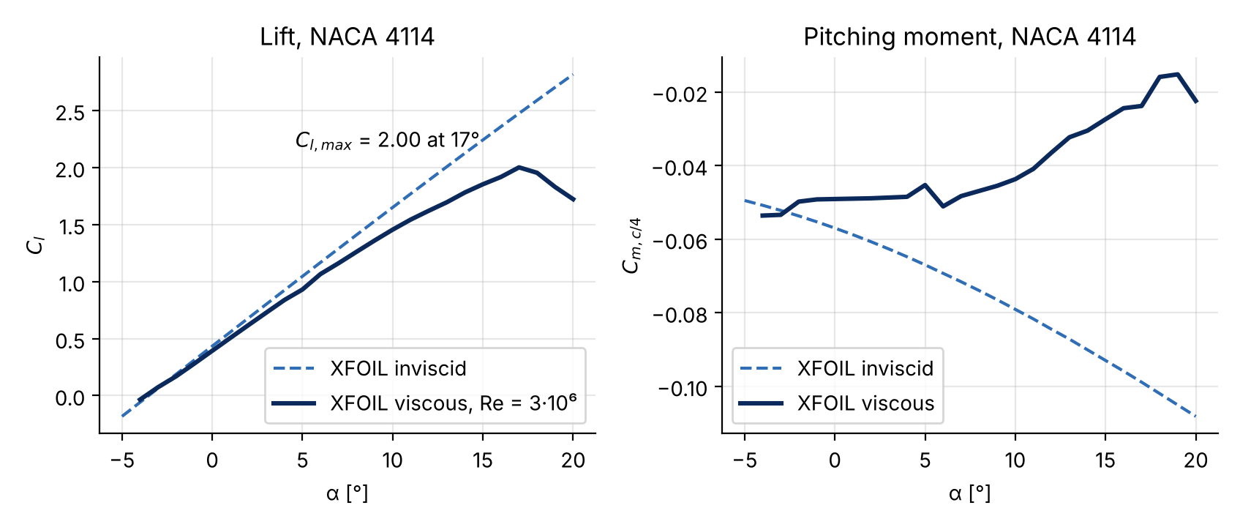
The NACA 4114 (the redesigned section of Section 3) was analysed in XFOIL, comparing an inviscid model with a viscous one at $Re=3⋅{10}^{6}$; the curves of $C_{l}$ and ${C_{m}}_{c/4 }$against angle of attack are shown in Figure 9.
Figure 9: $C_{l}$ and ${C_{m}}_{c/4 }$without and with viscosity.
Without viscosity, lift is linear in angle of attack over the whole range and no stall is predicted. The viscous analysis is more realistic: lift is roughly linear at low angles but reaches a maximum of $C_{l}≈2.0$ at $α≈{17}^{∘}$, after which it falls: the section stalls as the boundary layer separates.
The inviscid pitching moment $C_{M_{c/4}}$ becomes more negative almost linearly with $α$, while the viscous one is non-linear and less negative at high angles of attack, because viscosity redistributes the pressures.
In short, the inviscid model is useful for first estimates, but only a viscous analysis predicts stall and the non-linear moment, which an accurate aerodynamic characterization needs.

Appendix

- Source code:
The code generates airfoil geometries, solves the panel-method system for a given section and searches for a section with $20\%$ more $C_{l}$ while changing $C_{M_{c/4}}$ as little as possible. All figures were made with matplotlib.
The revised code, with the XFOIL data included and no Google Drive dependency, is on GitHub: https://github.com/CPesquero/panel-method-airfoil-design
Notebook: Google Colab

References

[1] R. Sant and L. Ayuso, “Airfoil design assignment: guide” (in Spanish), Universidad Politécnica de Madrid.
[2] “GeoGebra Classic”. Accessed 27 March 2026. [Online]. Available: https://www.geogebra.org/classic
[3] Google, Gemini. (2026). Google. [Large language model]. Available: https://gemini.google.com/

