COLLEGE OF INFORMATION TECHNOLOGY EDUCATION
WEB-BASED PAGEANT MANAGEMENT AND
SCORING SYSTEM

A Proposal
Presented to the Faculty of the
Information Technology Education Program
Ramon Magsaysay Memorial College
Pioneer Avenue, General Santos City

In Partial Fulfillment of the Requirements
For the subject Systems Analysis and Design

By :

Frenchie RM Labasa
Cristine Joy V. Plaida
Kent Eldrick B. Felicia
Adriel John Roquer

EXECUTION SUMMARY

CHAPTER I

INTRODUCTION

Background of the Study
Many pageant events still use manual ways like paper scoring sheets and spreadsheets. These methods take a lot of time, are hard to manage, and often cause errors in scores. A web-based system can make pageant management easier, faster, and more accurate by automating the scoring and tabulation process.
In the Philippines, pageants are very popular in schools, communities, and organizations. However, most pageant organizers still use manual processes for judging. This often leads to mistakes, slow result computation, and confusion during the event. A digital system will help improve fairness, accuracy, and consistency in scoring across different events in the country.
In addition to national challenges, around the world, many organizations are now using digital tools to manage events. Technology helps ensure transparency, data security, and faster operations. A web-based pageant system follows this global trend by using modern technology to make judging fair and reliable.
Moreover, local pageant organizers often face problems such as lack of manpower, limited time, and different judging criteria. Because of this, scores are sometimes mixed up or delayed. A centralized web system can help them manage everything in one place, making the process more organized and efficient.
Therefore, it is important to develop a web-based pageant management and scoring system now because more events need quick and accurate results. This system will help reduce human errors, speed up the scoring process, and improve trust among contestants, judges, and audiences.
Statement of the Problem
The study aims to solve the following problems:
- Manual scoring and tabulation cause errors and slow computation.
- Delays in collecting and combining scores affect the flow of the event.
- Scores are sometimes lost or misplaced due to paper-based recording.
- Organizers spend extra time rechecking scores to avoid mistakes.

Objectives of the Study
General Objective
To develop a web-based pageant management and scoring system that helps organizers and judges manage events, record scores correctly, and produce fair and accurate results.
Specific Objectives
- Develop a digital scoring system that allows judges to input scores per criterion. The system will automatically calculate the total and check for errors to ensure accuracy.
- Enable judges to submit scores in real time and automatically display the results on a dashboard to avoid delays and maintain a smooth event flow.
- Store all scores securely in one database with autosave and backup features to prevent data loss or missing records.
- Provide detailed reports showing scores per judge, round, and criterion to make reviewing and verification easier, clearer, and faster.

Significance of the Study
This study is significant because it enhances the overall management of pageant events by introducing a faster, more organized, and more accurate scoring and results system. By standardizing the judging process, the system promotes transparency and credibility, benefiting everyone involved in the event. It also serves as a practical learning tool that demonstrates how information systems can address real-world challenges, giving users firsthand experience on how technology reduces manual tasks and improves workflow. Ultimately, contestants, judges, organizers, and the community gain from fair, clear, and efficient results that improve the overall quality and trustworthiness of pageant events.

Scope and Delimitation
The system covers event setup, including rounds, criteria, and weights, and also manages contestants, judges, and organizers. It provides a secure scoring portal for judges to input scores, with automatic computation and real-time leaderboard display. In addition, it can generate printable and exportable reports and keep records of each scoring activity for reference. However, the system does not include features for ticketing, payments, or public voting. It is designed only for web use and does not have a mobile application version. A stable internet connection is required for proper operation.

CHAPTER II

METHODOLOGY

Data Gathering Techniques
This study utilized interviews as the primary data-gathering technique. The interview method was selected to obtain detailed insights from individuals with direct experience in pageant management and scoring.
  - Key Informant
The researchers conducted an interview with a key informant who has experience both as a pageant judge and a event organizer. This individual was purposely selected because of their involvement in pageant events and familiarity with the actual judging, scoring, and tabulation processes.
  - Purpose of the Interview
The interview aimed to gather information that would help in understanding the existing workflow and identifying the challenges in manual pageant scoring. Specifically, the interview focused on the following objectives:
- To understand the current process of event preparation, scoring, and result tabulation.
- To identify common problems in the manual scoring system, such as delays, confusion, and scoring errors.
- To determine the approximate amount of time spent in scoring and finalizing results during pageant events.
- To find out the types of errors that frequently occur in manual scoring and tabulation.
- To gather the respondent’s expectations for a digital or web-based system, including features that could make judging easier, faster, and more accurate.
  - Use of the Gathered Information
The information obtained from the interview served as the basis for defining the system requirements. It also ensured that the proposed Web-Based Pageant Management and Scoring System addresses real issues encountered in actual pageant events, such as delays, inaccuracies, and inefficient processes.

System Analysis Tools
To thoroughly define and visualize the proposed web-based pageant management and scoring system, the following analysis tools are employed:
- Decomposition Diagram
Breaks down the entire system into hierarchical modules (e.g., event setup, contestant management, scoring, reports). This ensures each functional area is clearly defined and manageable.
- Context Diagram
Presents a top-level view of the system, showing how external actors (judges, admin, contestants) interact with it. This clarifies system boundaries and data exchanges.

- Data Flow Diagrams (DFDs)
Detail how data moves between processes, data stores, and users from judges entering scores, to validation, storage, and report generation highlighting both logical and physical data handling.
- Wireframes
Provide early visual layouts of key screens such as the judge scoring interface, admin dashboard, and results display. These sketches help refine usability before development.

3. Research Design and Process Flow
The study follows a descriptive–developmental design. It is descriptive because it documents the current manual pageant scoring process and its issues; it is developmental because it proposes and models a web-based system as the solution based on gathered requirements.
Process Flow:
- Problem Identification - Review existing manual practices to pinpoint pain points (errors, delays, lack of transparency).
- Data Gathering – Conduct interviews with an experienced pageant judge/organizer to capture detailed workflows, issues, and expectations.
- Requirement Analysis – Translate interview insights into functional and non-functional requirements for the system.
- System Modeling - Produce the decomposition diagram, context diagram, DFDs, and wireframes to visualize architecture, data movement, and interfaces.
- Prototype Planning/Development – Outline or build a prototype that reflects the modeled features (scoring portal, reports, dashboards).
- Validation & Feedback – Present the design/prototype to stakeholders (organizer/judge) for feedback on usability and completeness.
- Documentation & Feasibility Assessment – Compile findings, design artifacts, and feasibility analyses (technical, economic, operational, etc.) for the feasibility study report.

CHAPTER III

PROJECT DESCRIPTION

Proposed System / Project Overview
The proposed Web-Based Pageant Management and Scoring System is an online platform designed to automate the scoring, tabulation, and management processes of pageant events. It replaces the traditional paper-based scoring and spreadsheet computations with a centralized, secure, and real-time digital system. The platform allows organizers to configure events, add judges and contestants, define criteria, and monitor scores as they are submitted.

Judges will use the system to input scores directly through their devices, while the system automatically computes totals, records data, and updates rankings instantly. Organizers can access dashboards, reports, and final results without manually combining scores. The system aims to improve accuracy, speed, fairness, and transparency, ensuring efficient event flow and reliable scoring outcomes.

System Features and Functions
- User Management
The system includes an admin-controlled user management module where administrators can create and manage accounts for judges and other authorized personnel. Role-Based Security (RBS) ensures that each user can only access features assigned to their role. This prevents unauthorized access to scoring interfaces, event configuration, or administrative settings, maintaining system integrity and security.
- Contestant and Judge Management
Administrators can register contestants by encoding their personal information, biography, background, and advocacy. Contestant records can be viewed and edited as needed. Judges can also be registered in the system by providing their information, experience, and background. This module ensures that all participants—both contestants and judges—are properly documented and organized before the event.
- Rounds and Criteria Management
The system allows administrators to create rounds by defining the round name, instructions, and settings such as elimination options. Rounds can be activated or deactivated, giving admins full control over when a round is open or closed for judging. Inside each round, the admin can add one or more criteria, provided the total weight of all criteria equals exactly 100%. Each criterion includes a weight, maximum score, and description to guide accurate and consistent judging.
- Automated Tally and Ranking Results
The system performs real-time computation of scores as soon as judges complete scoring for a specific round. Scores are automatically tallied based on criterion weight, and the system generates updated rankings for all contestants. This eliminates manual calculation, ensures accuracy, and speeds up result preparation during events.

- Reports and Printing
The system provides printable reports that include contestant scores, ranking summaries, and other event-related outputs. Administrators can generate reports per round or overall event results, making it easier to prepare documents for awarding, documentation, and post-event review.
- Personalized Event Customization and Event Management
The system supports visual customization to adapt to various event themes and branding requirements. The Administrator can modify the event’s appearance by updating the system logo, selecting preferred color themes, and adjusting font styles and sizes. In addition, the system includes event management features that allow the admin to create, modify, and organize multiple pageant events, including scheduling, assigning judges, and managing participants. This ensures that the system presentation and configuration align with the identity and requirements of each specific event or pageant.

Target Users and Beneficiaries
  - Event Organizers
Event organizers serve as the primary managers of competition activities. They are responsible for configuring event details, supervising contestant and judge registration, and monitoring the overall flow of the competition. Through the system, event organizers benefit from a more efficient and structured management process, reduced manual workload, and improved accuracy in preparing rounds, criteria, and scoring procedures. The system ensures that essential tasks—such as opening and closing rounds, generating reports, and overseeing judge progress—are performed with greater ease and reliability.
- Judges
Judges are the evaluators responsible for assessing contestant performance based on the event’s established criteria. The system provides them with an intuitive and organized scoring interface, allowing them to input scores accurately and consistently. Real-time validation, guided scoring descriptions, and automated calculations support judges in performing their duties without the risk of manual computation errors. This contributes to a more objective, transparent, and standardized evaluation process.
- Contestants
Contestants indirectly benefit from the system through a fair and transparent scoring environment. By automating score aggregation and ranking, the system minimizes human error and promotes impartiality in the assessment process. Contestants can be assured that their performance is evaluated according to predefined criteria and that results are generated free from bias or computation delays. This enhances their competition experience and strengthens their trust in the integrity of the event.
- The Institution / Organization
The institution, particularly the event organizers and committees of Ramon Magsaysay Memorial Colleges (RMMC), stands to gain significant operational and administrative advantages from the implementation of the system. It enhances the professionalism of institutional events by providing digital record-keeping, secure data management, and reliable result generation. Furthermore, it promotes organizational transparency, supports audit readiness, and contributes to the long-term improvement of event management processes. By adopting the system, the institution ensures that its competitions are conducted efficiently, fairly, and in alignment with modern technological standards.

System Architecture / Conceptual Framework

    - System Architecture
The Web system adopts a three-tier architecture, which separates user interfaces, application logic, and data storage. This structure enhances maintainability, security, and performance critical factors in evaluating the technical viability of the system.
Presentation Layer (Client Side)
The presentation layer consists of web-based interfaces accessible through standard browsers such as Chrome, Firefox, and Edge. Users, including event organizers, judges, and administrators, can view contestant profiles, enter scores, monitor real-time leaderboards, and generate reports. This layer ensures responsive design, intuitive navigation, and immediate feedback, which supports operational efficiency and reduces the risk of user errors during events.
Application Layer (Server Side)
The application layer contains the system’s core logic and operational processes. Developed using PHP frameworks such as CodeIgniter, it manages user authentication, sessions, role-based access, and scoring computations. It enforces validation rules, applies security protocols, and processes all user requests, including real-time updates of rankings, report generation, and audit logging. This layer ensures the system operates reliably while maintaining data accuracy and security.

Data Layer (Database)
The data layer stores all structured information, including contestant profiles, judges, scoring criteria, rounds, scores, and activity logs. Using MySQL, it ensures data integrity, secure storage, and fast retrieval for reporting and auditing purposes. This layer allows the system to maintain accurate records, support real-time operations, and provide traceable logs for accountability and transparency.

B. Conceptual Framework
Inputs
Information about contestants, registered judges and their assigned roles, event setup including rounds, criteria, and scoring weights, and the scores provided by judges.
Process
Data is first checked for completeness and accuracy and stored securely in the database. The system calculates individual scores for each criterion and round, combines them to produce overall totals, generates rankings according to the established rules, and records all user actions for auditing purposes.
Outputs
Detailed rankings per round, final overall standings and winners, complete scoring reports, audit logs for verification, and formatted reports ready for printing or digital export.

CHAPTER IV

FEASIBILITY ANALYSIS

Technical Feasibility
Hardware and Software Requirements
The proposed Web-Based Pageant Management and Scoring System is designed to operate in schools, institutions, or event-based environments. It can run on a standard web server setup such as XAMPP or LAMP/WAMP stacks. Recommended specifications include:
Server/Host Machine:
- Processor: Intel Core i3 or higher
- Memory: 8 GB RAM or more
- Storage: At least 500 GB HDD/SSD
Client Devices:
- Preferred devices: tablets and laptops for judges and administrators, ensuring mobility and ease of use during events
- Desktop computers can also be used for administrators or event organizers
- Modern web browsers such as Google Chrome, Mozilla Firefox, or Microsoft Edge
Software Requirements:
- Backend: PHP 8.1+ using a framework such as CodeIgniter 4
- Database: MySQL/MariaDB for storing rounds, criteria, scores, and user data
- Frontend: HTML5, CSS3, JavaScript
- Operating System: Any OS compatible with the chosen web stack (Windows for XAMPP, Linux for LAMP)
These technologies are widely accessible, cost-effective, and easy to deploy, making the system suitable for school events, institutional pageants, or community-based competitions.
Compatibility with Existing Systems
The system is web-based and does not require installation on client devices. It can operate:
- On local networks within schools or institutions for small-scale events
- On cloud hosting for broader access across multiple locations
- Alongside existing event management systems, intranet portals, or reporting tools
This ensures seamless integration with current workflows without requiring major infrastructure changes.
Availability of IT Infrastructure
Most schools and institutions already provide:
- Computer laboratories or administrative offices with desktops, laptops, or tablets
- Wi-Fi or LAN connectivity for networked access
- Backup power sources such as generators or UPS for continuity during events
The system’s minimal hardware and network requirements make deployment practical and achievable even in venues with standard IT infrastructure.

Economic Feasibility
Cost-Benefit Analysis
The proposed Web-Based Pageant Management and Scoring System is economically feasible because it reduces the reliance on manual processes such as paper-based scoring and spreadsheets. By automating score computation, ranking, and reporting, the system minimizes human errors, saves time for organizers and judges, and reduces administrative costs. These benefits outweigh the initial development and deployment expenses.
Estimated Budget
The estimated budget covers the following areas:
Implementation/Deployment Costs:
- Hosting or server setup for live events
- SSL certificates for secure connections
- Installation and configuration on client devices such as laptops or tablets
- Training and onboarding of event organizers and judges
Maintenance Costs:
- Regular system updates and bug fixes
- Database and server maintenance
- Technical support during events
- Backup and recovery operations
Return on Investment (ROI) / Savings Projection
The system provides a high return on investment through:
- Reduced time spent on manual score tabulation and report preparation
- Fewer errors and rework during events
- Faster generation of real-time leaderboards and final results
- Minimized paper and printing costs
The combination of operational savings, improved efficiency, and enhanced reliability ensures that the system delivers measurable economic benefits within a short period after deployment.

Operational Feasibility
System Usability and Accessibility
The proposed Web-Based Pageant Management and Scoring System is designed to be user-friendly and accessible. Judges, and administrators can access the system through modern web browsers on laptops or tablets. The interface is intuitive, responsive, and easy to navigate, allowing users to enter scores, monitor leaderboards, and generate reports with minimal training.
Impact on Users’ Productivity
By automating score computation, ranking, and reporting, the system significantly improves productivity for all users. Organizers can manage events more efficiently, judges can submit scores quickly and accurately, and administrators can generate real-time results without manual calculations. This reduces delays and allows more focus on the actual conduct of the pageant.
Organizational Readiness
The institution or event organizers are prepared to adopt the system. Basic IT infrastructure such as laptops, tablets, LAN/Wi-Fi, and web servers are already available. Users require minimal training due to the system’s intuitive design. The system’s modular and web-based nature ensures it can be implemented with existing organizational resources without disrupting ongoing operations.

Legal and Ethical Feasibility
Compliance with Data Privacy Laws
The proposed Web-Based Pageant Management and Scoring System complies with data privacy regulations, including the Data Privacy Act. Personal information of contestants, judges, and administrators is collected, stored, and processed securely. Access controls and encryption are implemented to ensure confidentiality and prevent unauthorized disclosure of sensitive data.
Intellectual Property Considerations
The system uses licensed or open-source frameworks and software components, ensuring proper respect for intellectual property rights. Any third-party libraries or tools integrated into the system are documented and used in accordance with licensing agreements, avoiding potential legal issues.
Ethical Use of Technology
The system promotes ethical use of technology by ensuring accurate, transparent, and fair scoring. Audit logs track all user actions, preventing manipulation of results. The system also ensures that event outcomes are generated impartially, supporting trust among contestants, judges, organizers, and the audience.

Schedule Feasibility
Development Timeline
The project follows a structured timeline with clearly defined milestones, including gathering requirements, system design, database setup, frontend and backend development, testing, deployment, and user training. A Gantt chart can be used to monitor progress and ensure timely completion.
Gant Chart
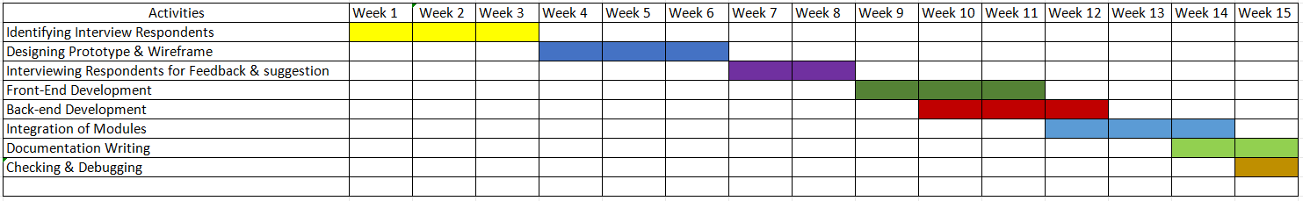

Environmental / Social Feasibility
The system supports environmental sustainability by reducing the use of paper and printing materials, minimizing waste, and promoting eco-friendly practices during events. At the same time, it contributes to community and institutional goals by promoting fairness, transparency, and accountability in pageant management, which enhances trust among contestants, judges, organizers, and audiences. Additionally, the system encourages digital literacy and the adoption of modern technology in institutional and community events, fostering innovation and efficiency in event management.

CHAPTER V

SYSTEM ANALALYSIS AND DESIGN DOCUMENTATION

Data Flow Diagram (DFD)

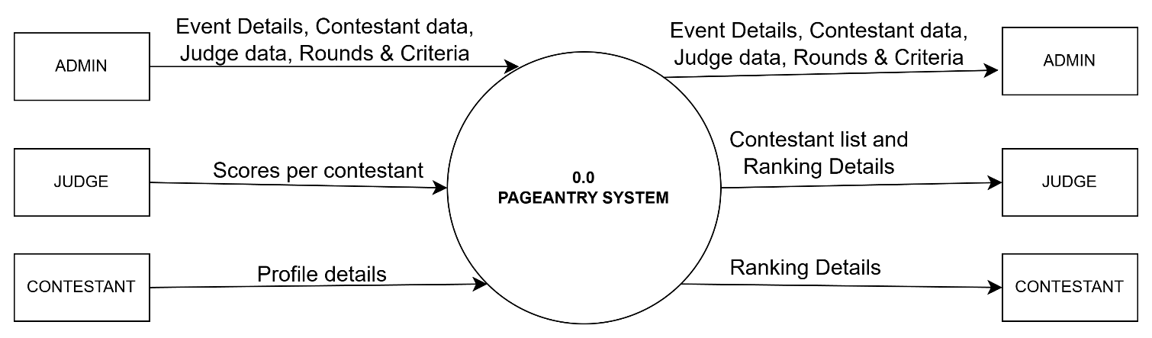

Level 0

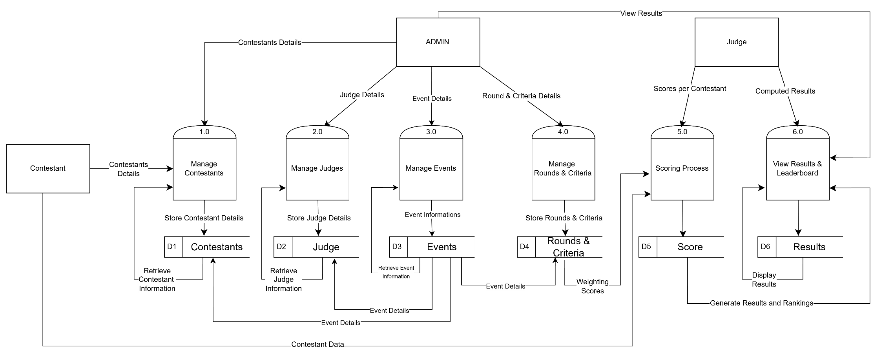

Level 1

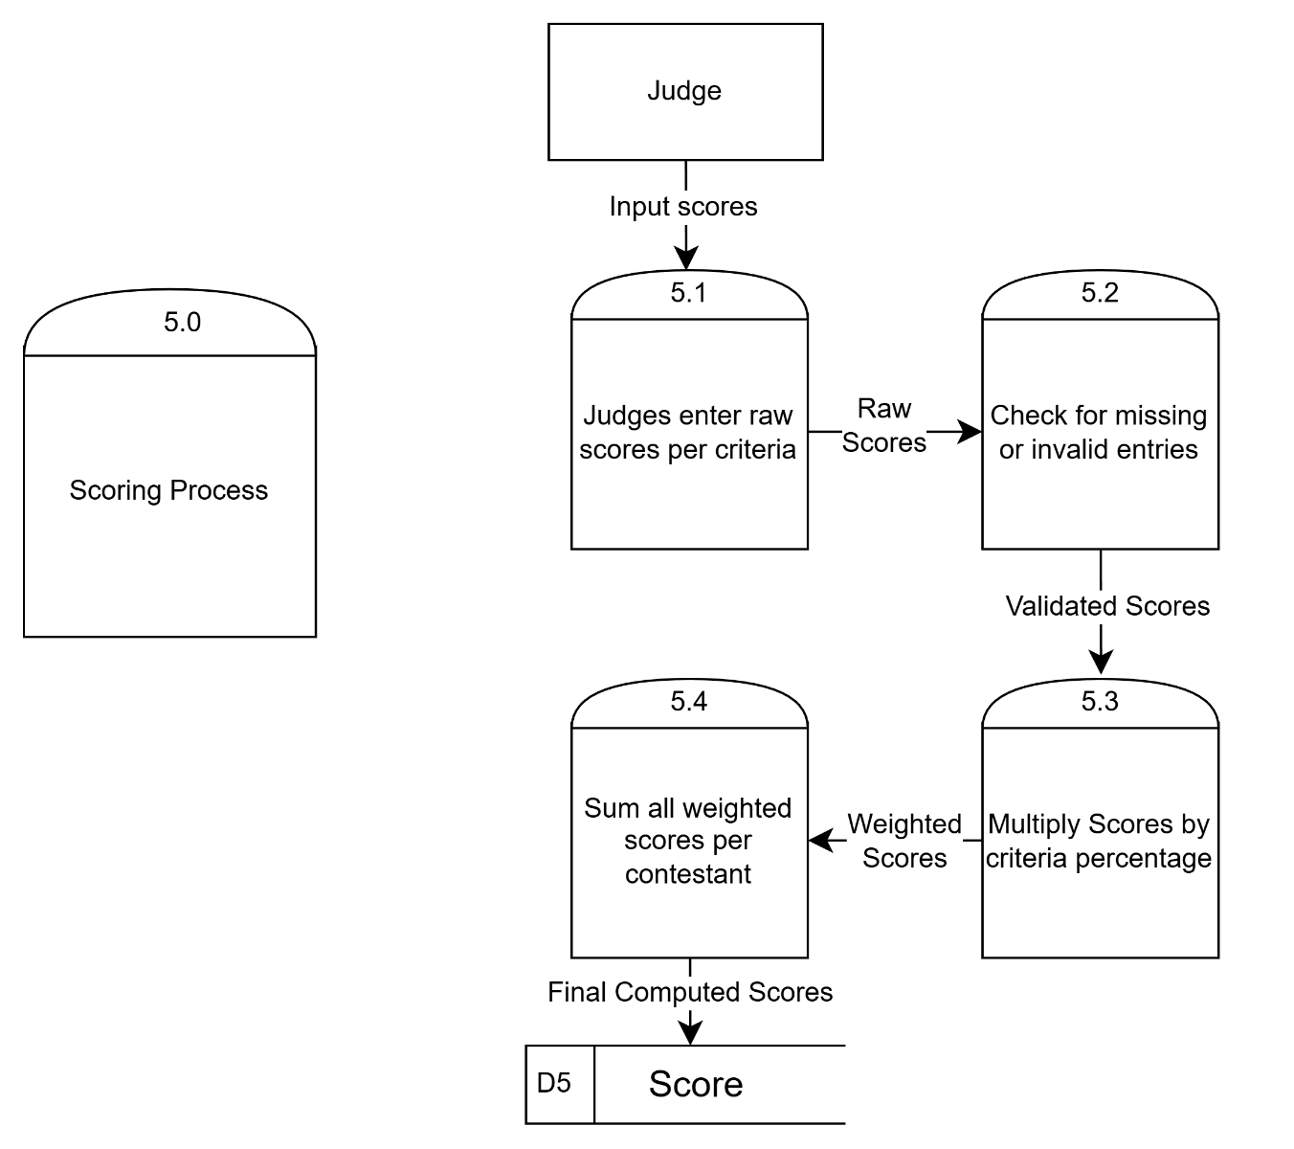

Level 2

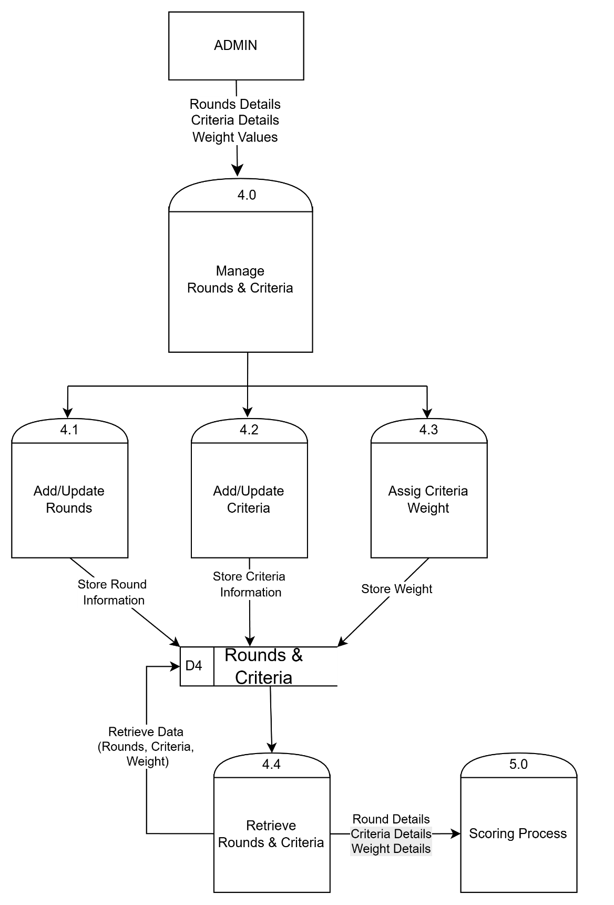

Level 3

Case Diagram

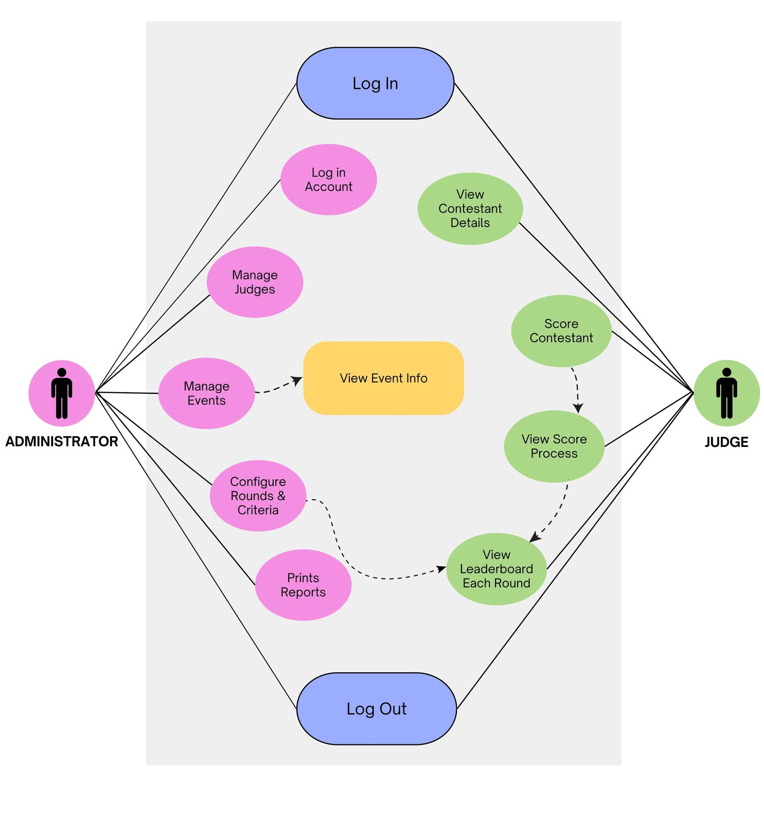

Table of Contents
EXECUTION SUMMARY 2
CHAPTER I 3
INTRODUCTION 3
1. Background of the Study 3
2. Objectives of the Study 4
3. Significance of the Study 5
4. Scope and Delimitation 5
CHAPTER II 6
METHODOLOGY 6
1. Data Gathering Techniques 6
2. System Analysis Tools 7
3. Research Design and Process Flow 8
CHAPTER III 10
PROJECT DESCRIPTION 10
1. Proposed System / Project Overview 10
2. System Features and Functions 10
3. Target Users and Beneficiaries 12
4. System Architecture / Conceptual Framework 14
CHAPTER IV 16
FEASIBILITY ANALYSIS 16
1. Technical Feasibility 16
2. Economic Feasibility 18
3. Operational Feasibility 19
4. Legal and Ethical Feasibility 20
5. Schedule Feasibility 21
6. Environmental / Social Feasibility 21
CHAPTER V 22
SYSTEM ANALALYSIS AND DESIGN DOCUMENTATION 22
• Data Flow Diagram (DFD) 22
• Case Diagram 26

