Art Appreciation
Name: Frenchie RM M. Labasa Course: BSIT-1 CN: 4009
ACTIVITY 1&2
Activity 1
Direction: choose an object that you have difficulty using. Make a plan to change the form of this object to make it more functional.
Use the following as format of your presentation.
Identify the object. Associate a picture for visualization.
Presentation of the Plan (in chronological and bulleted form)
- Paint Brush which is used for painting.
The Paint Brush which is used for painting is the object I have difficulty in using based on experience. Using a paintbrush can be hard because you need practice to get good at different strokes and techniques. The type of paint, surface, and quality of the brush also matter. It takes time to learn how to control the brush, be creative, and express yourself. Being patient is important, and having a comfortable setup helps too. Even though it might be tough at first, practicing regularly and learning from experienced artists can make using a paintbrush easier.
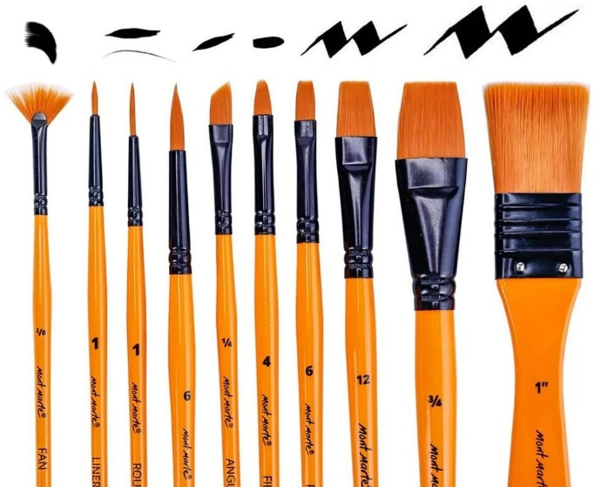
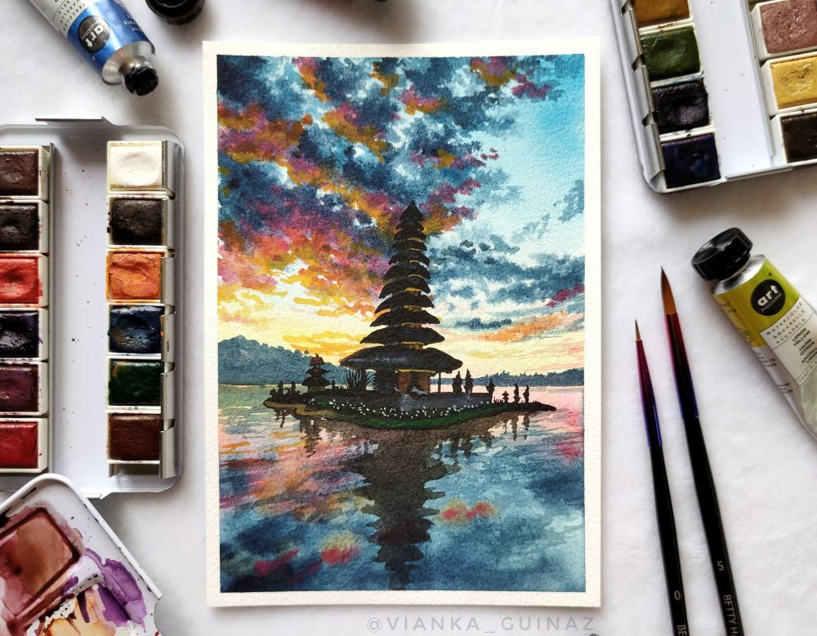

Painting
- Choosing Brushes. Pick the right brushes for your painting by thinking about their shape, size, and bristle type for the effects you want.
- Preparing Brushes. Before you start, make your brushes damp for watercolor or acrylic, or clean for oil painting.
- Sketching and Base Layers. Use big brushes for sketches or the first layers, covering more space quickly.
- Layering and Blending. Move to smaller brushes for adding layers, blending colors, and putting in details.
- Texture and Effects. Try different brushes for various textures and effects. Fan, flat, and round brushes each do different things.
- Cleaning Brushes. Keep brushes clean between colors to avoid mixing. Use water for water-based paints and the right solvents for oil paints.
- Drying Brushes. Make sure brushes are completely dry before using a new color to keep the paint right.
- Fine Details. Use small brushes for intricate details and precise lines to control the little parts of your painting.
- Maintaining Brush Shape. Store brushes the right way to keep their shape and work well. Maintaining Brush Shape.Don't leave them in water or solvents for too long.
- Experimentation. Try different brush techniques to find new ways to show your artistic ideas.
- Cleaning and Storage. After finishing your painting, clean brushes well, shape their bristles, and store them right to make them last longer.

Activity 2
Discuss the very important takeaways that you have learned from the lessons discussed.
Answer:
As we started the lessons in this subject, I have already learned new various things especially to the studies of humanities and arts. Engaging in the study of humanities allows us to delve into the essence of what it means to be human. It provides us a comprehensive understanding of people, their diverse cultures, and the various ways they express themselves through art, literature, and history. The significance of humanities becomes evident as it not only bridges the gaps between different cultures but also fosters a profound appreciation for our collective heritage. Through the lens of humanities, we gain insights into the historical, social, and artistic dimensions that have shaped human societies across time.
On the other hand, the lecture 2 also gave me a pure knowledge about arts. I am grateful to Sir Jodel because he made me realized me that art is not just a decoration, but it has a deeper meaning. This also gave me an idea that art is like a way of talking without words because it helps people share their feelings, thoughts, and different ways of looking at things. This new way of thinking about art has opened my eyes to the idea that it's not just something nice to look at; it's a powerful way for people to share and understand the interesting things about being human.
If I were asked about the most significant lesson in this subject so far, I would choose Lecture 2 since it showed me that art is like a special language, a form of storytelling that lets individuals express their unique experiences. This understanding has become a turning point for me, making me see art as a meaningful and impactful part of human expression. It has shaped the way I look at paintings, sculptures, and other forms of art, realizing that each piece carries a story waiting to be discovered.

