LABORATORY EXERCISE 9

SEARCH AND FILTERING SYSTEM

Learning Objectives
By the end of this laboratory exercise, students should be able to:
- Implement client-side search filtering using jQuery for dynamic user experience.
- Develop server-side search functionality using CodeIgniter's database queries.
- Create a responsive search interface using Bootstrap components.
- Integrate AJAX techniques to display search results without page reload.
- Understand the differences between client-side and server-side search approaches.

Prerequisite student experiences and knowledge
Before starting this exercise, students should have:
- Completed Laboratory Exercise 8 (Real-time Notifications with jQuery).
- Solid understanding of CodeIgniter's MVC architecture and database operations.
- Proficiency in writing jQuery and JavaScript code for DOM manipulation.
- Experience with AJAX requests and handling JSON responses.
- Familiarity with Bootstrap form components and grid system.
- Knowledge of SQL queries, particularly LIKE operators for search functionality.

Background
An effective search system is crucial for any Learning Management System (LMS) to help users quickly find relevant courses and content. This exercise focuses on implementing a dual-approach search system: client-side filtering for immediate feedback and server-side searching for comprehensive results. jQuery provides the tools for dynamic client-side filtering, while CodeIgniter's database class enables efficient server-side search using SQL LIKE queries. The combination creates a seamless user experience where search results update in real-time without page refreshes, enhancing the overall usability of the application.

Materials/Resources
- Personal Computer with Internet Access
- XAMPP/WAMP/LAMP server installed
- CodeIgniter Framework
- Visual Studio Code or any code editor
- Git and GitHub Account
- Web Browser (Chrome, Firefox, etc.)
Laboratory Activity
Step 1: Project Setup
- Open your existing ITE311-LASTNAME CodeIgniter project.
- Ensure your database has a courses table with sample data for testing search functionality.
- Verify that your course listing page is functional from previous exercises.

Step 2: Create Search Controller Method
- Navigate to your Course.php controller in app/Controllers/.
- Add a new method named search():
  - This method should accept GET or POST requests with a search term parameter.
  - Use CodeIgniter's Query Builder to search the courses table using LIKE queries.
  - Return the results as JSON for AJAX requests or render a view for regular requests.
- Implement the search logic
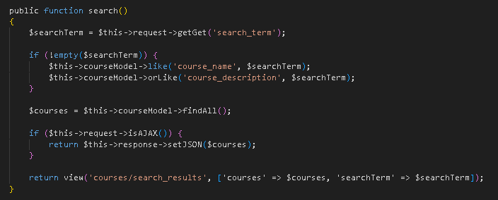

Step 3: Add Search Route
- Open app/Config/Routes.php.
- Add routes for the search functionality:
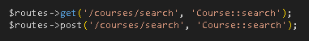

Step 4: Create Search Interface
- Modify your courses view file (app/Views/courses/index.php).
- Add a search form with Bootstrap styling
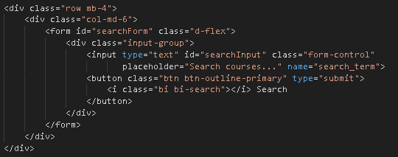

Step 5: Implement Client-Side Filtering with jQuery
- Add jQuery script for instant client-side filtering
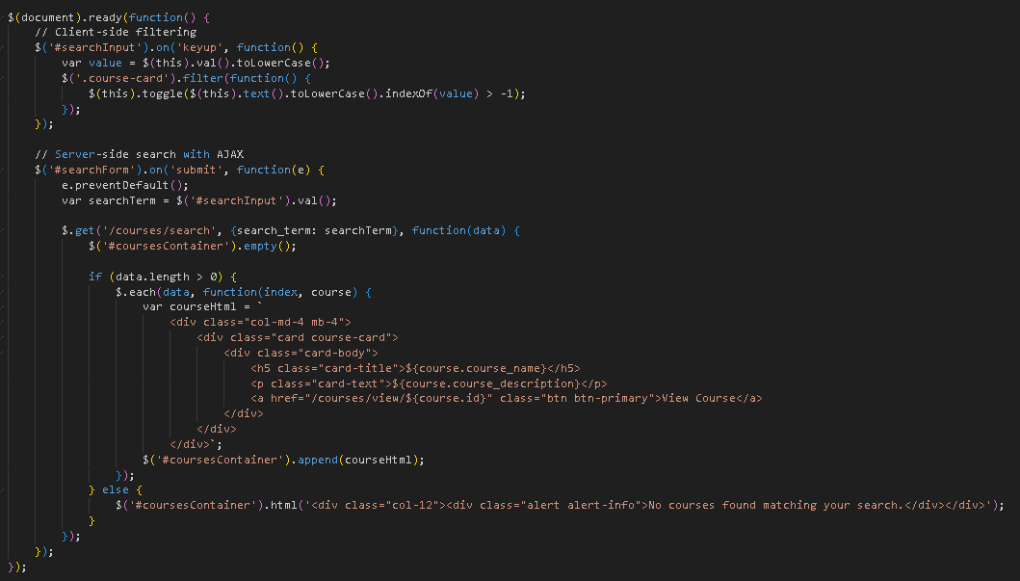

Step 6: Update Courses View Structure
- Modify your courses listing to work with the search functionality
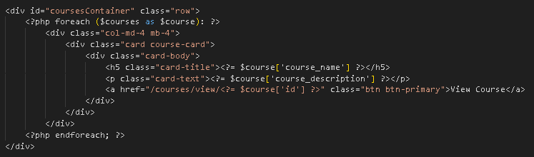
- To simulate real-time updates, you can set an interval to fetch notifications every 60 seconds (optional advanced task).

Step 7: Test the Search Functionality
- Load the courses page in your browser.
- Test the client-side filtering by typing in the search box courses should filter instantly.
- Test the server-side search by submitting the form results should load via AJAX without page refresh.
- Verify that both empty search results and successful searches display appropriate messages.

Step 9: Push to GitHub
- Stage and commit your search functionality
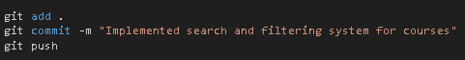

Output / Results
- Screenshot of the courses page with the search interface implemented.
- Screenshot showing filtered courses during client-side search.
- Screenshot of browser Developer Tools Network tab showing AJAX request to server-side search.
- Screenshot of search results displaying when no courses match the search term.
- Screenshot of GitHub repository with the latest commit.

QUESTIONS:
- What are the advantages and limitations of client-side filtering compared to server-side search?
Client-side filtering makes the page feel instant because once the list is loaded the browser can hide or show items right away, so the server doesn’t get hammered with every keystroke. It also keeps working even if the network drops, but it only works well when the dataset is small; huge lists slow the browser down and the data can get stale until you refresh. Server-side search always asks the database for the freshest results and can handle huge tables using indexes, yet each search needs a round-trip to the server so it’s slower and increases backend load. Combining both usually gives the best experience which is quick local filtering for small tweaks, plus server searches when you need accurate, up-to-date matches.
- How does using AJAX for search improve the user experience compared to traditional form submission?
Using AJAX for search keeps the page from reloading, so results appear right inside the list and the user doesn’t lose their scroll position. Because the browser only swaps the matching items, the page feels faster and more modern than waiting for a full reload. AJAX can also show spinners or “no results” messages immediately, giving better feedback while the query runs. Traditional form submissions are simpler, but they interrupt the flow with flashes and extra loading time.
- What security considerations should be taken when implementing search functionality with user input?
When we accept search text from users, we must always treat it as untrusted so it cannot break the system. On the server we should use prepared statements or the query builder to avoid SQL injection, and we should also escape any values we print back to the page to stop XSS. Rate limiting or CSRF protection helps block malicious scripts from spamming the search endpoint. Finally, we should validate that the current user is allowed to view the courses being returned, so sensitive data is not leaked through the search results.

Output / Results
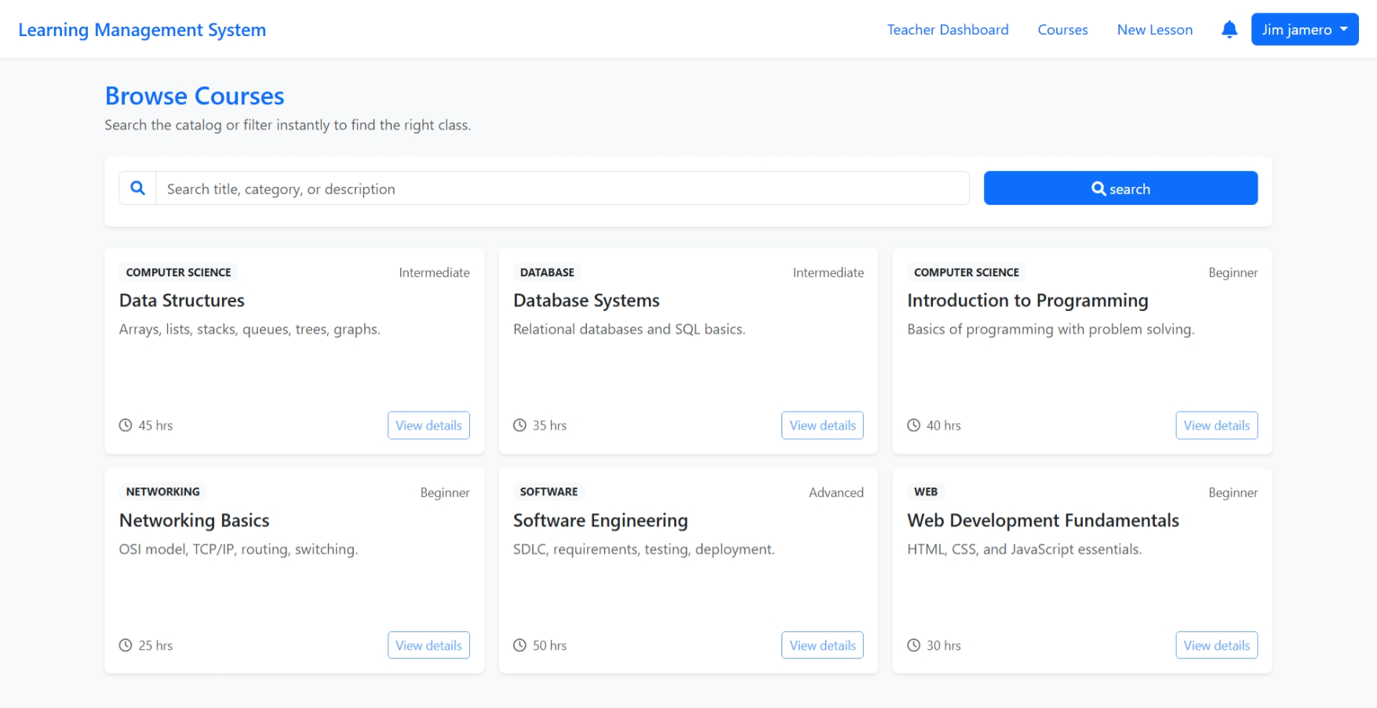
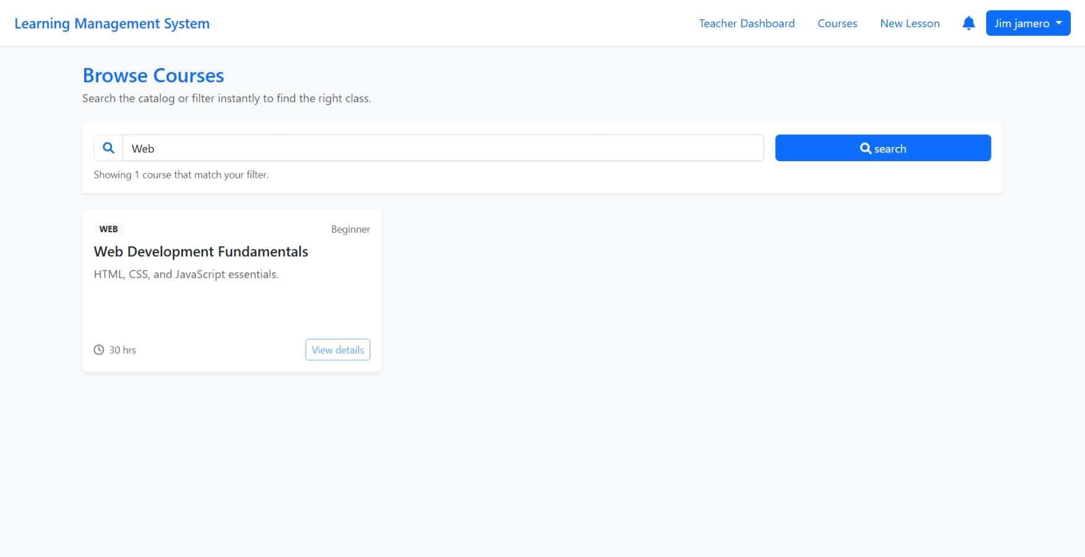
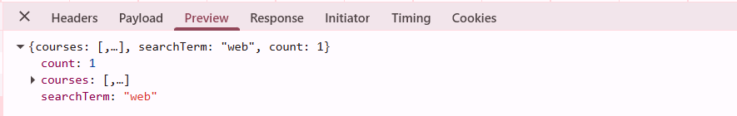
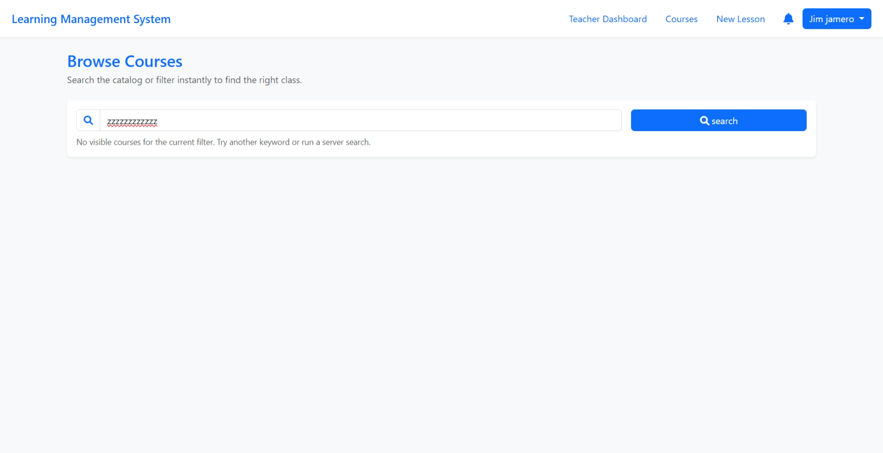

Conclusion
Building the search and filter functionality was the most eye-opening part of this lab because it required balancing instant feedback with reliable results. On the client side I wired a live filter tied to the course cards, so every keystroke immediately hides or shows matches—this made the page feel responsive and encouraged experimentation. To keep data accurate, the form also triggers an AJAX request to /courses/search, letting the backend rerun the database query and return a fresh JSON payload without forcing a full page reload. Stitching those layers together taught me how small UX touches, like updating the “Found X courses” message, help users understand what the system is doing. In the end I saw how thoughtful search design can turn a simple list into a navigable catalog that supports both quick scanning and deep exploration.

