Introduction to Programming

Outline of Topics
- Hardware/Software interface
- Layers of the Machine
- Kinds of Software

- Computer Languages
- Syntax, Semantics, Grammars
- What happens to your program?
- Compilation, Linking, Execution
- Program errors
- Compilation vs. Interpretation etc.

Software Categories
- System SW
- Programs written for computer systems
- Compilers, operating systems, …
- Application SW
- Programs written for computer users
- Word-processors, spreadsheets, & other application packages
A Layered View of the Computer
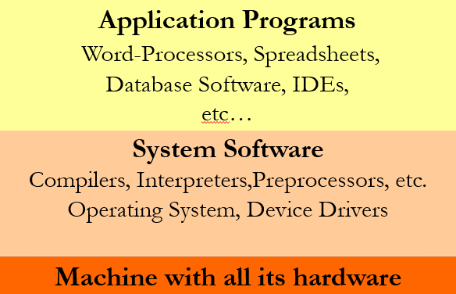

Operating System (OS)
- Provides several essential services:
- Loading & running application programs
- Allocating memory & processor time
- Providing input & output facilities
- Managing files of information
Programs
- Programs are written in programming languages
- PL = programming language
- Pieces of the same program can be written in different PLs
- Languages closer to the machine can be more efficient
- As long as they agree on how to communicate
- A PL is
- A special purpose and limited language
- A set of rules and symbols used to construct a computer program
- A language used to interact with the computer

Computer Languages
- Machine Language
- Uses binary code
- Machine-dependent
- Not portable
- Assembly Language
- Uses mnemonics
- Machine-dependent
- Not usually portable
- High-Level Language (HLL)
- Uses English-like language
- Machine independent
- Portable (but must be compiled for different platforms)
- Examples: Pascal, C, C++, Java, Fortran, . . .
Machine Language
- The representation of a computer program which is actually read and understood by the computer.
- A program in machine code consists of a sequence of machine instructions.
- Instructions:
- Machine instructions are in binary code
- Instructions specify operations and memory cells involved in the operation
Example:
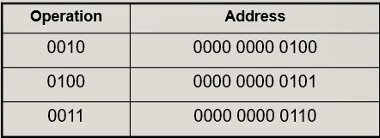

Assembly Language
- A symbolic representation of the machine language of a specific processor.
- Is converted to machine code by an assembler.
- Usually, each line of assembly code produces one machine instruction (One-to-one correspondence).
- Programming in assembly language is slow and error-prone but is more efficient in terms of hardware performance.
- Mnemonic representation of the instructions and data
- Example:
Load Price
Add Tax
Store Cost
High-level language
- A programming language which use statements consisting of English-like keywords such as "FOR", "PRINT" or “IF“, ... etc.
- Each statement corresponds to several machine language instructions (one-to-many correspondence).
- Much easier to program than in assembly language.
- Data are referenced using descriptive names
- Operations can be described using familiar symbols
- Example:
Cost := Price + Tax

Syntax & Semantics
- Syntax:
- The structure of strings in some language. A language's syntax is described by a grammar.
- Examples:
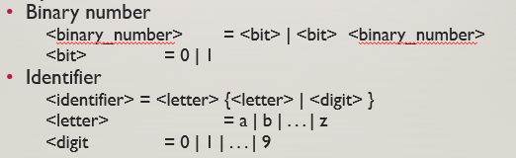

- Semantics:
- The meaning of the language

Syntax & Grammars
- Syntax descriptions for a PL are themselves written in a formal language.
- E.g. Backus-Naur Form (BNF)
- The formal language is not a PL but it can be implemented by a compiler to enforce grammar restrictions.
- Some PLs look more like grammar descriptions than like instructions.

Compilers & Programs
- Compiler
- A program that converts another program from some source language (or high-level programming language / HLL) to machine language (object code).
- Some compilers output assembly language which is then converted to machine language by a separate assembler.
- Is distinguished from an assembler by the fact that each input statement, in general, correspond to more than one machine instruction.

Compilation into Assembly L
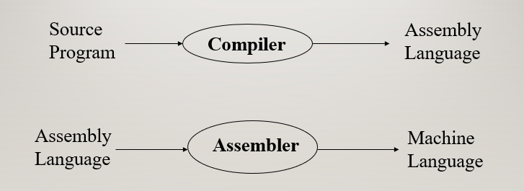

Compilers & Programs
- Source program
- The form in which a computer program, written in some formal programming language, is written by the programmer.
- Can be compiled automatically into object code or machine code or executed by an interpreter.
- Pascal source programs have extension ‘.pas’
- Object program
- Output from the compiler
- Equivalent machine language translation of the source program
- Files usually have extension ‘.obj’
- Executable program
- Output from linker/loader
- Machine language program linked with necessary libraries & other files
- Files usually have extension ‘.exe’

What is a Linker?
- A program that pulls other programs together so that they can run.
- Most programs are very large and consist of several modules.
- Even small programs use existing code provided by the programming environment called libraries.
- The linker pulls everything together, makes sure that references to other parts of the program (code) are resolved.

Running Programs
- Steps that the computer goes through to run a program:
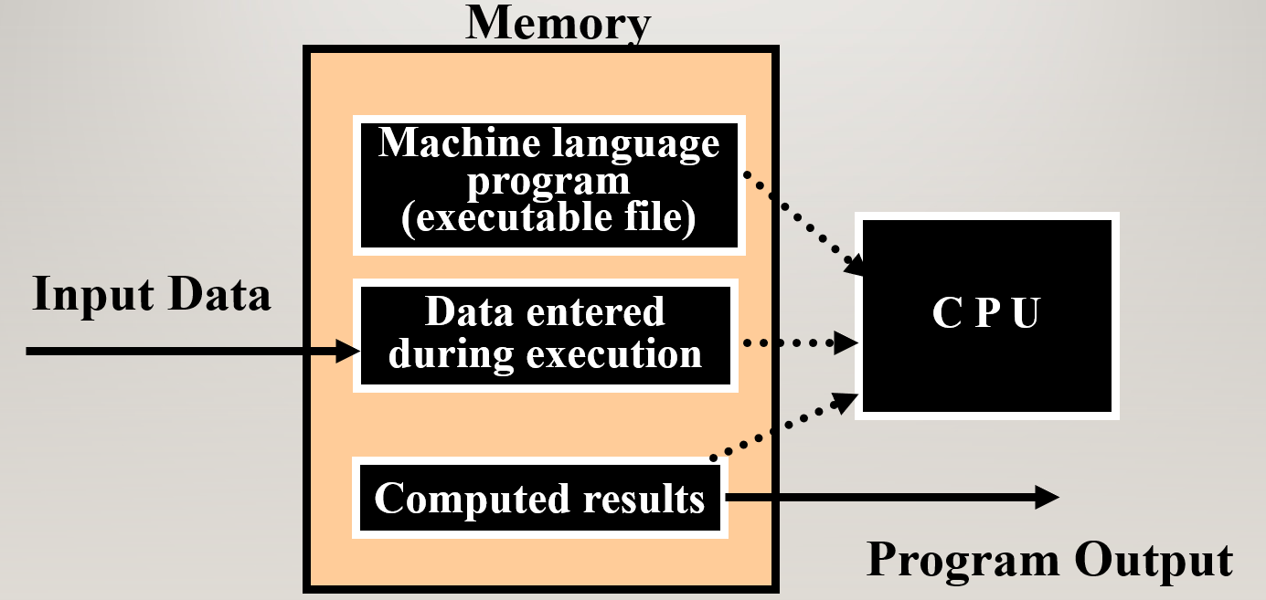

Program Execution
- Steps taken by the CPU to run a program (instructions are in machine language):
- Fetch an instruction
- Decode (interpret) the instruction
- Retrieve data, if needed
- Execute (perform) actual processing
- Store the results, if needed
Program Errors
- Syntax Errors:
- Errors in grammar of the language
- Runtime error:
- When there are no syntax errors, but the program can’t complete execution
- Divide by zero
- Invalid input data
- Logical errors:
- The program completes execution, but delivers incorrect results
- Incorrect usage of parentheses

Compilation
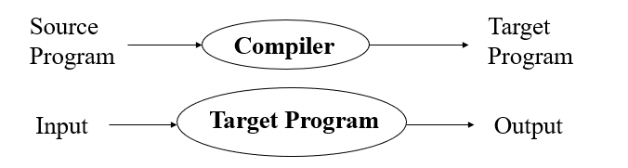

- Compiler translates source into target (a machine language program)
- Compiler goes away at execution time
- Compiler is itself a machine language program, presumably created by compiling some other high-level program
- Machine language, when written in a format understood by the OS is object code

Interpretation
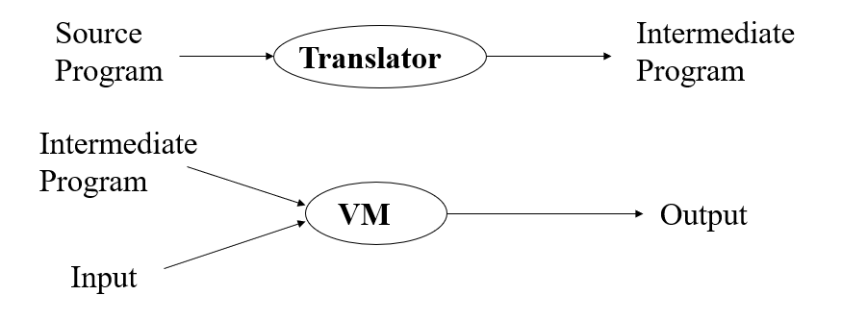

Compilation vs. Interpretation
- Compilation:
- Syntax errors caught before running the program
- Better performance
- Decisions made once, at compile time
- Interpretation:
- Better diagnostics (error messages)
- More flexibility
- Supports late binding (delaying decisions about program implementation until runtime)
- Can better cope with PLs where type and size of variables depend on input
- Supports creation/modification of program code on the fly (e.g. Lisp, Prolog)

Mixture of C & I
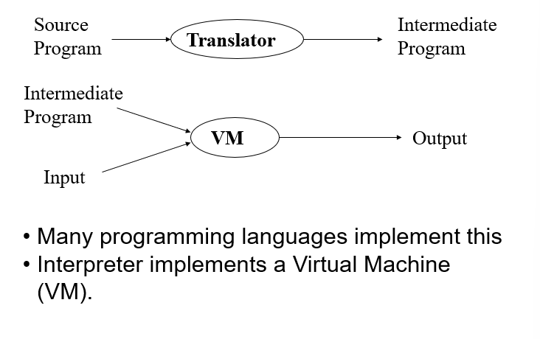

C/C++
