Journal of Geophysical Research: Solid Earth
Supporting Information for
Primary Pressure Scale of KCl B2 Phase to the Core-Mantle Boundary
Ning Ma¹, Tatsuya Sumita², Motohiko Murakami¹
¹Department of Earth Sciences, ETH Zürich, Zürich, Switzerland
²Geological Survey of Japan, National Institute of Advanced Industrial Science and Technology (AIST), Tsukuba, Ibaraki305-8567, Japan

Contents of this file

Texts S1
Figures S1 to S3
Tables S1 to S4

Introduction
In this Supplementary Information, the differential stress analysis of experimental samples under high pressures is described in Texts S1 and the results shown in Figure S1. In Figure S2, fitting of our $V_{L}-ρ$ at 300 K using Birch’s law yielded $V_{L}=-1.88\left(15\right)+2.60(4)ρ$, which is in good agreement with the slope of 2.67(13) reported by Campbell & Heinz (1992). Fitting Debye temperature and Grüneisen parameter as a function of molar volume was shown in Figure S3. In Table S1, the experimental results obtained in this study as well as the room temperature pressure-volume data from Walker et al. (2002), which are recalculated following the updated primary pressure scale proposed by Matsui et al. (2012) at 300 K, are summarized. The thermoelastic parameters of our primary pressure scale are shown in Table S2 in comparison to previous studies (Chidester et al., 2021; Dewaele et al., 2012; Tateno et al., 2019; Walker et al., 2002).
To make utilization of our primary pressure scale convenient, the KCl B2 phase EOS (i.e., volume-pressure relationship at 300 K) as well as thermal pressure as a function of temperature (i.e., P_{th}-T) are tabulated and shown in Table S3 and S4 respectively.

Text S1.
To evaluate the hydrostatic conditions during experiments, we made stress analysis using XRD results following the protocol described by (Murakami & Takata, 2019; Singh, 1993; Singh & Takemura, 2001). Nonhydrostaticity can be estimated through systematic deviation of individually measured from the mean (hydrostatic) lattice parameters. For cubic system, the uniaxial strain component $St$ can be estimated using the following expression
$$a_{m}\left(hkl\right)=M_{0}+M_{1}[3(1-\sin^{2}{θ})Γ\left(hkl\right)]$$
$$M_{0}=a_{p}\{1+(αt/3)(1-3\sin^{2}{θ})[S_{11}-S_{12}-(1-a^{-1})/{2G}_{v}]\}$$
$$M_{1}=-a_{p}αtS/3$$
$$Γ\left(hkl\right)=(h^{2}k^{2}+k^{2}l^{2}+l^{2}h^{2})/{(h^{2}+k^{2}+l^{2})}^{2}$$
$$S=S_{11}-S_{12}-S_{44}/2$$
$$St\sim -3M_{1}/(αM_{0})$$
Where $a_{m}\left(hkl\right)$ is lattice parameter (in Å) calculated from individual $hkl$, $θ$ is diffraction angle, $M_{0}$ and $M_{1}$ is the slope and intercept of the plot$a_{m}\left(hkl\right)$ and $[3(1-\sin^{2}{θ})Γ\left(hkl\right)]$ referred as $Γ$ plot. $a_{p}$ is the lattice parameter under hydrostatic condition that is approximated by measured mean lattice parameter, $α$ is a scaling parameter ranges from 0.5-1, here we adopt $α$ = 1.$G_{v}$ is shear modulus under isostrain conditions, $S_{ij}$ is the single crystal elastic compliance. Because $S_{ij}$ are not known for KCl B2 phases at high pressures we report only the uniaxial strain $St$ which has a nearly constant value of 0.06 independent of the experimental pressures (Figure S1). Our results are similar to that reported by Tateno et al. (2019) where the uniaxial stress was calculated from Pt diffraction pattern, is about 1.6(3) GPa at 104 GPa with a St=~0.055 for coexisting KCl. This indirectly suggests the uniaxial stress in this study is on the order of 1-2 GPa. 2D XRD mapping and multiple point diamond anvil pressure measurements in the sample chamber (Figure 2c and d) provides on the other hand more direct evidence that the pressure gradient across Brillouin measurement volume (~20 μm in diameter) is ~1.5 GPa.

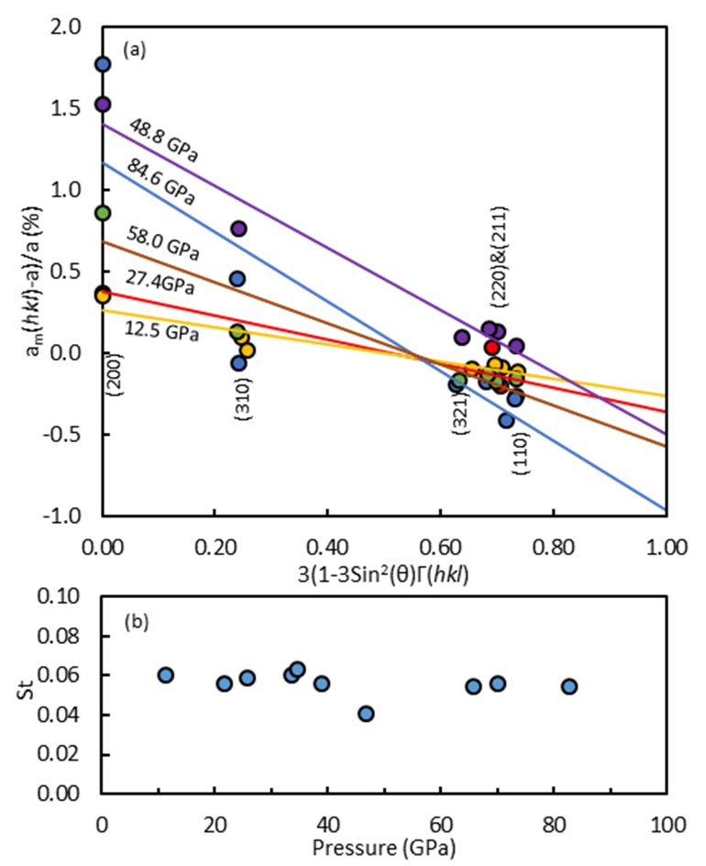
Figure S1. (a) Γ plot for KCl B2 phase diffraction data under high pressure. [a_{m}(hkl)-a]/a denoting deviation of lattice parameters (a_{m}) measured individually from d spacing, from the fitted mean lattice parameter (a). Γ is expressed as Γ (hkl) = (h²k² + k²l² + l²h²)/(h² + k² + l²)² . (b) Estimated differential strain component St measured for KCl B2 Phase.

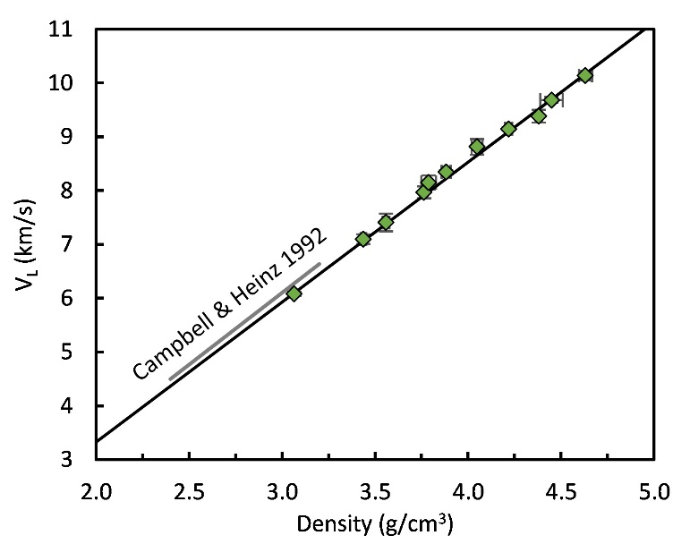

Figure S2. $V_{L}-ρ$ relation of KCl B2 phase at 300 K. Our Birch’s law fit yields $V_{L}=-1.88\left(15\right)+2.60(4)ρ$ which is in good agreement with the slope of 2.67(13) reported by Campbell & Heinz (1992).

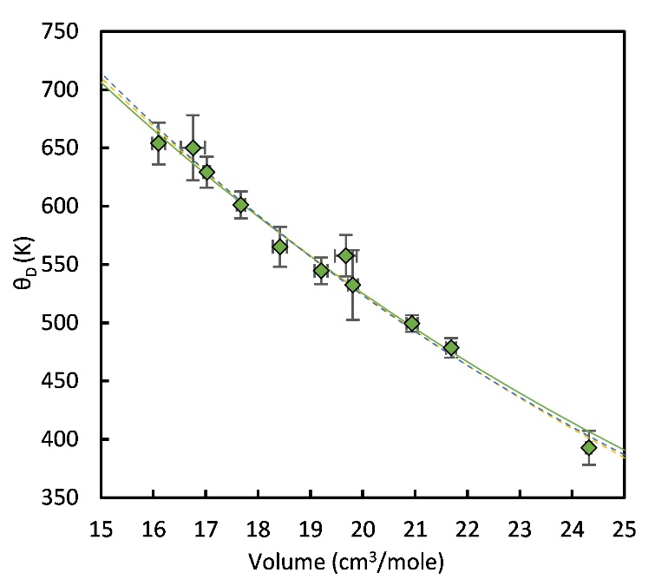

Figure S3. Experimentally determined Debye temperature $θ_{D}$ (K) as a function of volume (cm³/mol). Debye Temperature $θ_{D}$ (K) and Grüneisen parameter $γ_{0}$ can be fitted using the relation $θ_{D}\left[V\right]=A*Exp (-\frac{B}{q}V^{q})$ where q is an exponent found close to be and fixed at 1, fitting our experimental data yielded$A=θ_{D0}e^{{γ_{0}}/q}$ and $B=γ_{0}V_{0}^{-q}$ to be 1716(117) and 0.0592(35) respectively. Similar fitting when assuming q =0.9 (blue dashed line) or 1.1 (yellow dashed line) are shown for comparison.

Run# | Diamond Raman shift (cm⁻¹) | Diamond anvil Pressure (GPa) | ±  (GPa) | Molar Volume (cm³/mol) | ±  (cm³/mol) |  | v_{L}  (km/s) |  | ±  (km/s) |  | v_{T}  (km/s) | ±  (km/s) | K_{T}  (GPa) | ±  (GPa) | θ_{D}  (K) |  | ±  (K) |  | Pressure from present primary scale  (GPa) |  | ±  (GPa)
KCl 3 P1 | 1364.7 | 13.9 | 0.2 | 24.32 |  | 0.05 |  | 6.08 |  | 0.04 | 3.21 | 0.13 | 69.9 | 3.7 |  | 392.9 |  | 14.6 |  | 12.5 |  | 0.03
KCl 3 P2 | 1386.4 | 23.8 | 0.1 | 21.69 |  | 0.10 |  | 7.10 |  | 0.09 | 3.77 | 0.07 | 107.0 | 5.2 |  | 478.5 |  | 8.5 |  | 23.2 |  | 0.2
KCl 1 P1 | 1394.6 | 27.7 | 0.4 | 20.94 |  | 0.10 |  | 7.41 |  | 0.16 | 3.89 | 0.06 | 122.7 | 8.9 |  | 499.4 |  | 7.0 |  | 27.4 |  | 0.2
KCl 2 P1 | 1412.0 | 36.0 | 0.8 | 19.81 |  | 0.10 |  | 7.97 |  | 0.11 | 4.06 | 0.24 | 155.3 | 12.0 |  | 532.3 |  | 30.0 |  | 35.5 |  | 0.3
KCl 1 P2 | 1417.0 | 38.4 | 0.6 | 19.68 |  | 0.21 |  | 8.15 |  | 0.13 | 4.25 | 0.14 | 159.7 | 10.3 |  | 557.4 |  | 17.7 |  | 36.6 |  | 0.4
KCl 2 P2 | 1426.2 | 42.9 | 1.1 | 19.21 |  | 0.12 |  | 8.35 |  | 0.03 | 4.10 | 0.09 | 182.6 | 4.5 |  | 544.5 |  | 11.4 |  | 40.7 |  | 0.4
KCl 6 P1 | 1435.1 | 47.4 | 0.4 | 18.42 |  | 0.13 |  | 8.81 |  | 0.15 | 4.19 | 0.13 | 218.9 | 12.2 |  | 565.2 |  | 17.1 |  | 48.8 |  | 0.6
KCl 5 P1 | 1459.0 | 59.5 | 3.1 | 17.67 |  | 0.08 |  | 9.14 |  | 0.03 | 4.40 | 0.09 | 243.2 | 5.0 |  | 601.1 |  | 11.5 |  | 58.0 |  | 0.8
KCl 5 P2 | 1476.8 | 68.9 | 2.6 | 17.02 |  | 0.06 |  | 9.38 |  | 0.12 | 4.55 | 0.10 | 264.0 | 11.1 |  | 629.1 |  | 13.2 |  | 67.7 |  | 1.0
KCl 6 P2 | 1488.2 | 75.0 | 0.4 | 16.76 |  | 0.23 |  | 9.68 |  | 0.05 | 4.67 | 0.21 | 286.9 | 13.1 |  | 650.0 |  | 27.9 |  | 72.1 |  | 1.1
KCl 4 P1 | 1503.4 | 83.2 | 0.8 | 16.10 |  | 0.12 |  | 10.14 |  | 0.09 | 4.62 | 0.13 | 343.5 | 11.5 |  | 653.8 |  | 17.9 |  | 84.6 |  | 1.4
Walker et al. (2002) | Molar Volume (cm³/mol) | T  (K) |  | Pressure reported by Walker et al. (2002)  (GPa) |  |  |  | ±  (GPa) |  | Pressure recalculated after Matsui et al. (2012) at 300 K (GPa) |  |  | ±  (GPa) |  |  |  |  | Pressure from  present  primary scale  (GPa) |  |  |  | ±  (GPa)
Run 2 | 29.03 | 297.15 |  | 3.18 |  |  |  | 0.01 |  | 3.16 |  |  | 0.02 |  |  |  |  | 3.15 |  |  |  | 0.02
Run 1 | 28.65 | 296.15 |  | 3.63 |  |  |  | 0.02 |  | 3.61 |  |  | 0.03 |  |  |  |  | 3.64 |  |  |  | 0.01
Run 1 | 27.94 | 296.15 |  | 4.62 |  |  |  | 0.02 |  | 4.60 |  |  | 0.04 |  |  |  |  | 4.63 |  |  |  | 0.02
Run 1 | 27.45 | 296.15 |  | 5.46 |  |  |  | 0.04 |  | 5.43 |  |  | 0.05 |  |  |  |  | 5.40 |  |  |  | 0.03
Run 1 | 26.99 | 296.15 |  | 6.27 |  |  |  | 0.06 |  | 6.23 |  |  | 0.07 |  |  |  |  | 6.20 |  |  |  | 0.03
Run 1 | 26.67 | 296.15 |  | 6.91 |  |  |  | 0.06 |  | 6.86 |  |  | 0.08 |  |  |  |  | 6.80 |  |  |  | 0.04
Run 1 | 26.29 | 296.15 |  | 7.60 |  |  |  | 0.06 |  | 7.55 |  |  | 0.08 |  |  |  |  | 7.55 |  |  |  | 0.05
Run 1 | 26.05 | 296.15 |  | 8.14 |  |  |  | 0.05 |  | 8.08 |  |  | 0.07 |  |  |  |  | 8.07 |  |  |  | 0.05
V_{L}, V_{T}, K_{T} and θ_{D} are measured longitudinal and transverse acoustic velocities and calculated isothermal bulk modulus and Debye Temperature respectively.
“±” denotes uncertainty. Uncertainties of Diamond anvil Pressure, V_{L} and V_{T} are shown in 2 standard deviations.

Table S1. Summary of experimental results from this study and Walker et al. (2002) recalculated using primary pressure scale of Matsui et al. (2012) at 300 K.

References | Experimental  conditions | Pressure scale | V₀  (cm³/mol) | K_{T0} (GPa) | K₀' | G₀ (GPa) | G₀' | γ₀ | q | θ_{D0} (K) | αK_{T}  (GPa/K)
This study BM | up to 85 GPa, 300 K up to 4000 K MGD model | Primary | 32.48(9) | 21.33(70) | 4.836  (83) | 16.83(236) | 2.147(115) | 1.92(11) | 1.0* | 251(22) | 0.00295
This study Vinet | up to 85 GPa, 300 K up to 4000 K MGD model | Primary | 32.75(11) | 18.56(70) | 5.768(90) |  |  | 1.92(11) | 1.0* | 251(22) | 0.00295
Walker et al. (2002) BM | 3-8 GPa,  300-873 K | NaCl B1 EOS, Birch (1986) | 32.25 | 23.70 | 4.4 |  |  | 1.78 | 1.0* |  | 0.00275  (10)
Walker et al. (2002) BM  Refitted in this Study | 3-8 GPa, 300 K | NaCl B1 EOS primary scale,  Matsui et al. (2012) | 32.69  (55) | 19.12(53) | 5.503  (1566)
Dewaele et al. (2012) V | 2.6-165 GPa, 300 K | Ruby gauge, Dorogokupets & Oganov, 2007 | 32.82* | 17.20 | 5.89 |  |  | 1.47 | 1.0* |  | 0.00224  (MD)
Dewaele et al. (2012) BM | 2.6-165 GPa, 300 K | Ruby gauge, Dorogokupets & Oganov, 2007 | 32.82* | 19.94(14) | 4.832(28)
Tateno et al. (2019) V | up to 229 GPa at 300 K, 9-61 GPa, 1500-2600 K. | Pt EOS Sokolova et al. (2016) | 32.82* | 18.3(3) | 5.60(3) |  |  | 2.3(2) | 0.8(2) |  | 0.0037(1)
Tateno et al. (2019) V | up to 229 GPa at 300 K, 9-61 GPa, 1500-2600 K. | Pt EOS shock compression Holmes et al. (1989) | 32.82* | 18.3(3) | 5.77(4) |  |  | 1.8(2) | 0.7(3) |  | 0.0033(2)
Tateno et al. (2019) BM | up to 229 GPa at 300 K, 9-61 GPa, 1500-2600 K. | Pt EOS Sokolova et al. (2016) | 32.82* | 21.0(1) | 4.584(48)
Chidester et al. (2021) BM | 26-167 GPa, up to 2400 K | Pt EOS Dorogokupets & Oganov, 2007 Ruby gauge | 32.0(3) | 24(1) | 4.56(5) |  |  | 2.9(4) | 1.0(1)
Chidester et al. (2021) V | 26-167 GPa, up to 2400 K | Pt EOS Dorogokupets & Oganov, 2007 Ruby gauge | 34.3(5) | 13(1) | 6.2(1) |  |  | 3.4(4) | 1.0(1)
Numbers in parentheses indicate uncertainties in the last digit.
BM, Birch Murnaghan equation of state, V, Vinet equations of state. * indicates the parameter was fixed during fitting.

Table S2. Experimentally determined thermoelastic parameters for KCl B2 phase

V (cm³/mol) | P (GPa) | ± (GPa) | V (cm³/mol) | P (GPa) | ± (GPa) | V (cm³/mol) | P (GPa) | ± (GPa) | V (cm³/mol) | P (GPa) | ± (GPa)
32.48 | 0.00 | 0.06 | 27.80 | 4.85 | 0.02 | 23.10 | 16.72 | 0.13 | 18.40 | 49.01 | 0.45
32.40 | 0.06 | 0.06 | 27.70 | 5.01 | 0.02 | 23.00 | 17.12 | 0.13 | 18.30 | 50.16 | 0.47
32.30 | 0.12 | 0.06 | 27.60 | 5.16 | 0.02 | 22.90 | 17.52 | 0.14 | 18.20 | 51.33 | 0.48
32.20 | 0.19 | 0.06 | 27.50 | 5.33 | 0.03 | 22.80 | 17.93 | 0.14 | 18.10 | 52.54 | 0.50
32.10 | 0.26 | 0.05 | 27.40 | 5.49 | 0.03 | 22.70 | 18.35 | 0.14 | 18.00 | 53.77 | 0.52
32.00 | 0.33 | 0.05 | 27.30 | 5.66 | 0.03 | 22.60 | 18.78 | 0.15 | 17.90 | 55.04 | 0.53
31.90 | 0.40 | 0.05 | 27.20 | 5.83 | 0.03 | 22.50 | 19.22 | 0.15 | 17.80 | 56.34 | 0.55
31.80 | 0.48 | 0.05 | 27.10 | 6.01 | 0.03 | 22.40 | 19.67 | 0.15 | 17.70 | 57.68 | 0.57
31.70 | 0.55 | 0.05 | 27.00 | 6.18 | 0.03 | 22.30 | 20.13 | 0.16 | 17.60 | 59.05 | 0.59
31.60 | 0.63 | 0.05 | 26.90 | 6.37 | 0.04 | 22.20 | 20.59 | 0.16 | 17.50 | 60.45 | 0.61
31.50 | 0.71 | 0.05 | 26.80 | 6.55 | 0.04 | 22.10 | 21.07 | 0.17 | 17.40 | 61.89 | 0.63
31.40 | 0.79 | 0.05 | 26.70 | 6.74 | 0.04 | 22.00 | 21.56 | 0.17 | 17.30 | 63.37 | 0.65
31.30 | 0.87 | 0.04 | 26.60 | 6.93 | 0.04 | 21.90 | 22.06 | 0.17 | 17.20 | 64.89 | 0.67
31.20 | 0.95 | 0.04 | 26.50 | 7.13 | 0.04 | 21.80 | 22.57 | 0.18 | 17.10 | 66.45 | 0.69
31.10 | 1.03 | 0.04 | 26.40 | 7.33 | 0.05 | 21.70 | 23.09 | 0.18 | 17.00 | 68.05 | 0.72
31.00 | 1.12 | 0.04 | 26.30 | 7.53 | 0.05 | 21.60 | 23.62 | 0.19 | 16.90 | 69.69 | 0.74
30.90 | 1.20 | 0.04 | 26.20 | 7.74 | 0.05 | 21.50 | 24.17 | 0.19 | 16.80 | 71.37 | 0.77
30.80 | 1.29 | 0.04 | 26.10 | 7.95 | 0.05 | 21.40 | 24.72 | 0.20 | 16.70 | 73.11 | 0.79
30.70 | 1.38 | 0.04 | 26.00 | 8.17 | 0.05 | 21.30 | 25.29 | 0.20 | 16.60 | 74.89 | 0.82
30.60 | 1.47 | 0.03 | 25.90 | 8.39 | 0.06 | 21.20 | 25.88 | 0.21 | 16.50 | 76.71 | 0.85
30.50 | 1.57 | 0.03 | 25.80 | 8.61 | 0.06 | 21.10 | 26.47 | 0.21 | 16.40 | 78.59 | 0.88
30.40 | 1.66 | 0.03 | 25.70 | 8.84 | 0.06 | 21.00 | 27.08 | 0.22 | 16.30 | 80.52 | 0.91
30.30 | 1.76 | 0.03 | 25.60 | 9.07 | 0.06 | 20.90 | 27.70 | 0.22 | 16.20 | 82.50 | 0.95
30.20 | 1.86 | 0.03 | 25.50 | 9.31 | 0.06 | 20.80 | 28.34 | 0.23 | 16.10 | 84.54 | 0.98
30.10 | 1.96 | 0.03 | 25.40 | 9.55 | 0.07 | 20.70 | 28.99 | 0.24 | 16.00 | 86.64 | 1.02
30.00 | 2.06 | 0.03 | 25.30 | 9.80 | 0.07 | 20.60 | 29.65 | 0.24 | 15.90 | 88.79 | 1.05
29.90 | 2.16 | 0.03 | 25.20 | 10.05 | 0.07 | 20.50 | 30.33 | 0.25 | 15.80 | 91.01 | 1.09
29.80 | 2.27 | 0.02 | 25.10 | 10.31 | 0.07 | 20.40 | 31.03 | 0.26 | 15.70 | 93.29 | 1.13
29.70 | 2.38 | 0.02 | 25.00 | 10.58 | 0.08 | 20.30 | 31.74 | 0.26 | 15.60 | 95.63 | 1.17
29.60 | 2.49 | 0.02 | 24.90 | 10.84 | 0.08 | 20.20 | 32.47 | 0.27 | 15.50 | 98.05 | 1.22
29.50 | 2.60 | 0.02 | 24.80 | 11.12 | 0.08 | 20.10 | 33.22 | 0.28 | 15.40 | 100.53 | 1.26
29.40 | 2.71 | 0.02 | 24.70 | 11.40 | 0.08 | 20.00 | 33.98 | 0.28 | 15.30 | 103.08 | 1.31
29.30 | 2.83 | 0.02 | 24.60 | 11.68 | 0.09 | 19.90 | 34.76 | 0.29 | 15.20 | 105.71 | 1.36
29.20 | 2.95 | 0.02 | 24.50 | 11.97 | 0.09 | 19.80 | 35.56 | 0.30 | 15.10 | 108.42 | 1.41
29.10 | 3.07 | 0.02 | 24.40 | 12.27 | 0.09 | 19.70 | 36.38 | 0.31 | 15.00 | 111.21 | 1.46
29.00 | 3.19 | 0.02 | 24.30 | 12.57 | 0.09 | 19.60 | 37.22 | 0.32 | 14.90 | 114.08 | 1.52
28.90 | 3.31 | 0.01 | 24.20 | 12.88 | 0.10 | 19.50 | 38.08 | 0.33 | 14.80 | 117.03 | 1.57
28.80 | 3.44 | 0.01 | 24.10 | 13.19 | 0.10 | 19.40 | 38.96 | 0.34 | 14.70 | 120.08 | 1.64
28.70 | 3.57 | 0.01 | 24.00 | 13.51 | 0.10 | 19.30 | 39.86 | 0.35 | 14.60 | 123.21 | 1.70
28.60 | 3.70 | 0.01 | 23.90 | 13.84 | 0.11 | 19.20 | 40.78 | 0.36 | 14.50 | 126.45 | 1.76
28.50 | 3.84 | 0.01 | 23.80 | 14.18 | 0.11 | 19.10 | 41.72 | 0.37 | 14.40 | 129.78 | 1.83
28.40 | 3.97 | 0.01 | 23.70 | 14.52 | 0.11 | 19.00 | 42.69 | 0.38 | 14.30 | 133.22 | 1.90
28.30 | 4.11 | 0.02 | 23.60 | 14.87 | 0.11 | 18.90 | 43.68 | 0.39 | 14.20 | 136.76 | 1.98
28.20 | 4.25 | 0.02 | 23.50 | 15.22 | 0.12 | 18.80 | 44.69 | 0.40 | 14.10 | 140.41 | 2.05
28.10 | 4.40 | 0.02 | 23.40 | 15.58 | 0.12 | 18.70 | 45.73 | 0.41 | 14.00 | 144.18 | 2.13
28.00 | 4.55 | 0.02 | 23.30 | 15.96 | 0.12 | 18.60 | 46.80 | 0.43
27.90 | 4.70 | 0.02 | 23.20 | 16.33 | 0.13 | 18.50 | 47.89 | 0.44

Table S3. Tabulated P-V relationship for KCl B2 phase at 300 K using primary pressure scale established in this study.

T (K) | P_{th} (GPa) | T (K) | P_{th} (GPa) | T (K) | P_{th} (GPa) | T (K) | P_{th} (GPa) | T (K) | P_{th} (GPa) | T (K) | P_{th} (GPa) | T (K) | P_{th} (GPa) | T (K) | P_{th} (GPa)
300 | 0.00 | 790 | 1.43 | 1280 | 2.87 | 1770 | 4.32 | 2260 | 5.76 | 2750 | 7.21 | 3240 | 8.65 | 3730 | 10.10
310 | 0.03 | 800 | 1.46 | 1290 | 2.90 | 1780 | 4.34 | 2270 | 5.79 | 2760 | 7.24 | 3250 | 8.68 | 3740 | 10.13
320 | 0.06 | 810 | 1.49 | 1300 | 2.93 | 1790 | 4.37 | 2280 | 5.82 | 2770 | 7.27 | 3260 | 8.71 | 3750 | 10.16
330 | 0.09 | 820 | 1.52 | 1310 | 2.96 | 1800 | 4.40 | 2290 | 5.85 | 2780 | 7.30 | 3270 | 8.74 | 3760 | 10.19
340 | 0.11 | 830 | 1.55 | 1320 | 2.99 | 1810 | 4.43 | 2300 | 5.88 | 2790 | 7.32 | 3280 | 8.77 | 3770 | 10.22
350 | 0.14 | 840 | 1.57 | 1330 | 3.02 | 1820 | 4.46 | 2310 | 5.91 | 2800 | 7.35 | 3290 | 8.80 | 3780 | 10.25
360 | 0.17 | 850 | 1.60 | 1340 | 3.05 | 1830 | 4.49 | 2320 | 5.94 | 2810 | 7.38 | 3300 | 8.83 | 3790 | 10.28
370 | 0.20 | 860 | 1.63 | 1350 | 3.08 | 1840 | 4.52 | 2330 | 5.97 | 2820 | 7.41 | 3310 | 8.86 | 3800 | 10.31
380 | 0.23 | 870 | 1.66 | 1360 | 3.11 | 1850 | 4.55 | 2340 | 6.00 | 2830 | 7.44 | 3320 | 8.89 | 3810 | 10.34
390 | 0.26 | 880 | 1.69 | 1370 | 3.14 | 1860 | 4.58 | 2350 | 6.03 | 2840 | 7.47 | 3330 | 8.92 | 3820 | 10.37
400 | 0.29 | 890 | 1.72 | 1380 | 3.16 | 1870 | 4.61 | 2360 | 6.06 | 2850 | 7.50 | 3340 | 8.95 | 3830 | 10.39
410 | 0.32 | 900 | 1.75 | 1390 | 3.19 | 1880 | 4.64 | 2370 | 6.09 | 2860 | 7.53 | 3350 | 8.98 | 3840 | 10.42
420 | 0.35 | 910 | 1.78 | 1400 | 3.22 | 1890 | 4.67 | 2380 | 6.11 | 2870 | 7.56 | 3360 | 9.01 | 3850 | 10.45
430 | 0.37 | 920 | 1.81 | 1410 | 3.25 | 1900 | 4.70 | 2390 | 6.14 | 2880 | 7.59 | 3370 | 9.04 | 3860 | 10.48
440 | 0.40 | 930 | 1.84 | 1420 | 3.28 | 1910 | 4.73 | 2400 | 6.17 | 2890 | 7.62 | 3380 | 9.07 | 3870 | 10.51
450 | 0.43 | 940 | 1.87 | 1430 | 3.31 | 1920 | 4.76 | 2410 | 6.20 | 2900 | 7.65 | 3390 | 9.10 | 3880 | 10.54
460 | 0.46 | 950 | 1.90 | 1440 | 3.34 | 1930 | 4.79 | 2420 | 6.23 | 2910 | 7.68 | 3400 | 9.13 | 3890 | 10.57
470 | 0.49 | 960 | 1.93 | 1450 | 3.37 | 1940 | 4.82 | 2430 | 6.26 | 2920 | 7.71 | 3410 | 9.16 | 3900 | 10.60
480 | 0.52 | 970 | 1.96 | 1460 | 3.40 | 1950 | 4.85 | 2440 | 6.29 | 2930 | 7.74 | 3420 | 9.18 | 3910 | 10.63
490 | 0.55 | 980 | 1.99 | 1470 | 3.43 | 1960 | 4.88 | 2450 | 6.32 | 2940 | 7.77 | 3430 | 9.21 | 3920 | 10.66
500 | 0.58 | 990 | 2.02 | 1480 | 3.46 | 1970 | 4.91 | 2460 | 6.35 | 2950 | 7.80 | 3440 | 9.24 | 3930 | 10.69
510 | 0.61 | 1000 | 2.05 | 1490 | 3.49 | 1980 | 4.93 | 2470 | 6.38 | 2960 | 7.83 | 3450 | 9.27 | 3940 | 10.72
520 | 0.64 | 1010 | 2.07 | 1500 | 3.52 | 1990 | 4.96 | 2480 | 6.41 | 2970 | 7.86 | 3460 | 9.30 | 3950 | 10.75
530 | 0.67 | 1020 | 2.10 | 1510 | 3.55 | 2000 | 4.99 | 2490 | 6.44 | 2980 | 7.89 | 3470 | 9.33 | 3960 | 10.78
540 | 0.70 | 1030 | 2.13 | 1520 | 3.58 | 2010 | 5.02 | 2500 | 6.47 | 2990 | 7.92 | 3480 | 9.36 | 3970 | 10.81
550 | 0.72 | 1040 | 2.16 | 1530 | 3.61 | 2020 | 5.05 | 2510 | 6.50 | 3000 | 7.94 | 3490 | 9.39 | 3980 | 10.84
560 | 0.75 | 1050 | 2.19 | 1540 | 3.64 | 2030 | 5.08 | 2520 | 6.53 | 3010 | 7.97 | 3500 | 9.42 | 3990 | 10.87
570 | 0.78 | 1060 | 2.22 | 1550 | 3.67 | 2040 | 5.11 | 2530 | 6.56 | 3020 | 8.00 | 3510 | 9.45 | 4000 | 10.90
580 | 0.81 | 1070 | 2.25 | 1560 | 3.70 | 2050 | 5.14 | 2540 | 6.59 | 3030 | 8.03 | 3520 | 9.48
590 | 0.84 | 1080 | 2.28 | 1570 | 3.73 | 2060 | 5.17 | 2550 | 6.62 | 3040 | 8.06 | 3530 | 9.51
600 | 0.87 | 1090 | 2.31 | 1580 | 3.75 | 2070 | 5.20 | 2560 | 6.65 | 3050 | 8.09 | 3540 | 9.54
610 | 0.90 | 1100 | 2.34 | 1590 | 3.78 | 2080 | 5.23 | 2570 | 6.68 | 3060 | 8.12 | 3550 | 9.57
620 | 0.93 | 1110 | 2.37 | 1600 | 3.81 | 2090 | 5.26 | 2580 | 6.71 | 3070 | 8.15 | 3560 | 9.60
630 | 0.96 | 1120 | 2.40 | 1610 | 3.84 | 2100 | 5.29 | 2590 | 6.73 | 3080 | 8.18 | 3570 | 9.63
640 | 0.99 | 1130 | 2.43 | 1620 | 3.87 | 2110 | 5.32 | 2600 | 6.76 | 3090 | 8.21 | 3580 | 9.66
650 | 1.02 | 1140 | 2.46 | 1630 | 3.90 | 2120 | 5.35 | 2610 | 6.79 | 3100 | 8.24 | 3590 | 9.69
660 | 1.05 | 1150 | 2.49 | 1640 | 3.93 | 2130 | 5.38 | 2620 | 6.82 | 3110 | 8.27 | 3600 | 9.72
670 | 1.08 | 1160 | 2.52 | 1650 | 3.96 | 2140 | 5.41 | 2630 | 6.85 | 3120 | 8.30 | 3610 | 9.75
680 | 1.10 | 1170 | 2.55 | 1660 | 3.99 | 2150 | 5.44 | 2640 | 6.88 | 3130 | 8.33 | 3620 | 9.77
690 | 1.13 | 1180 | 2.58 | 1670 | 4.02 | 2160 | 5.47 | 2650 | 6.91 | 3140 | 8.36 | 3630 | 9.80
700 | 1.16 | 1190 | 2.61 | 1680 | 4.05 | 2170 | 5.50 | 2660 | 6.94 | 3150 | 8.39 | 3640 | 9.83
710 | 1.19 | 1200 | 2.63 | 1690 | 4.08 | 2180 | 5.52 | 2670 | 6.97 | 3160 | 8.42 | 3650 | 9.86
720 | 1.22 | 1210 | 2.66 | 1700 | 4.11 | 2190 | 5.55 | 2680 | 7.00 | 3170 | 8.45 | 3660 | 9.89
730 | 1.25 | 1220 | 2.69 | 1710 | 4.14 | 2200 | 5.58 | 2690 | 7.03 | 3180 | 8.48 | 3670 | 9.92
740 | 1.28 | 1230 | 2.72 | 1720 | 4.17 | 2210 | 5.61 | 2700 | 7.06 | 3190 | 8.51 | 3680 | 9.95
750 | 1.31 | 1240 | 2.75 | 1730 | 4.20 | 2220 | 5.64 | 2710 | 7.09 | 3200 | 8.54 | 3690 | 9.98
760 | 1.34 | 1250 | 2.78 | 1740 | 4.23 | 2230 | 5.67 | 2720 | 7.12 | 3210 | 8.56 | 3700 | 10.01
770 | 1.37 | 1260 | 2.81 | 1750 | 4.26 | 2240 | 5.70 | 2730 | 7.15 | 3220 | 8.59 | 3710 | 10.04
780 | 1.40 | 1270 | 2.84 | 1760 | 4.29 | 2250 | 5.73 | 2740 | 7.18 | 3230 | 8.62 | 3720 | 10.07

Table S4. Tabulated results of thermal pressure (P_{th}) relative to 300 K calculated using Mie-Grüneisen-Debye model at volume of 32.48 cm³/mol.

Reference

Chidester, B. A., Thompson, E. C., Fischer, R. A., Heinz, D. L., Prakapenka, V. B., Meng, Y., & Campbell, A. J. (2021). Experimental thermal equation of state of. Physical Review B, 104(9), 5–10. https://doi.org/10.1103/PhysRevB.104.094107
Dewaele, A., Belonoshko, A. B., Garbarino, G., Occelli, F., Bouvier, P., Hanfland, M., & Mezouar, M. (2012). High-pressure-high-temperature equation of state of KCl and KBr. Physical Review B - Condensed Matter and Materials Physics, 85(21), 1–7. https://doi.org/10.1103/PhysRevB.85.214105
Hrubiak, R., Smith, J. S., & Shen, G. (2019). Multimode scanning X-ray diffraction microscopy for diamond anvil cell experiments. Review of Scientific Instruments, 90(2). https://doi.org/10.1063/1.5057518
Murakami, M., & Takata, N. (2019). Absolute Primary Pressure Scale to 120 GPa: Toward a Pressure Benchmark for Earth’s Lower Mantle. Journal of Geophysical Research: Solid Earth, 124(7), 6581–6588. https://doi.org/10.1029/2019JB017635
Singh, A. K. (1993). The lattice strains in a specimen (cubic system) compressed nonhydrostatically in an opposed anvil device. Journal of Applied Physics, 73(9), 4278–4286. https://doi.org/10.1063/1.355786
Singh, A. K., & Takemura, K. (2001). Measurement and analysis of nonhydrostatic lattice strain component in niobium to 145 GPa under various fluid pressure-transmitting media. Journal of Applied Physics, 90(7), 3269–3275. https://doi.org/10.1063/1.1397283
Tateno, S., Komabayashi, T., Hirose, K., Hirao, N., & Ohishi, Y. (2019). Static compression of B2 KCl to 230 GPa and its P-V-T equation of state. American Mineralogist, 104(5), 718–723. https://doi.org/10.2138/am-2019-6779
Walker, D., Cranswick, L. M. D., Verma, P. K., Clark, S. M., & Buhre, S. (2002). Thermal equations of state for B1 and B2 KCl. American Mineralogist, 87(7), 805–812. https://doi.org/10.2138/am-2002-0701

