PsyCare 2.0 Real UI Screenshot Capture
Actual UI screenshots captured from the local running application.
Generated on: 06 June 2026
Screens captured: 31
Base URL: http://localhost:8001
Coverage goal: Cover the main UI states used by the sequence diagrams across client, admin, and counsellor workflows.

Note: the capture script only seeded browser-session values for language and client terms acceptance. The screens themselves come from the existing UI and in-app mock data.
The first screenshot intentionally shows the terms modal before acceptance; subsequent client screenshots show the accepted session state so the underlying pages are visible.

Coverage Overview
Each screenshot is mapped to the sequence-diagram or module flow it helps demonstrate.
01. Client Portal - Terms Acceptance Modal (/psycare/dashboard) - Initial client access and terms acceptance before using PsyCare.
02. Client Portal - Dashboard Emotion Tracker (/psycare/dashboard) - CT01 Log Daily Emotion, CT03 View Emotion History, dashboard entry point.
03. Client Portal - AI Chatbot Open With Risk Detection (/psycare/dashboard) - CT02 Chat with AI Counsellor and automatic risk flag trigger.
04. Client Portal - Services, Profile And Declaration (/psycare/perkhidmatan) - UM03 Manage User Profiles, DC01 View Declaration Form, DC02 Submit Declaration.
05. Client Portal - Appointment Request Entry (/psycare/permohonan) - AS01 Book Appointment entry choice between new booking and follow-up.
06. Client Portal - Smart Appointment Form (/psycare/permohonan) - AS01 Book Appointment and AS03 Book New Appointment form fields, slot selection, declaration notice.
07. Client Portal - Appointment Records (/psycare/rekod-temujanji) - AS02 Request Follow-Up appointment records and TA01 join-session entry point.
08. Client Portal - Follow-Up Appointment Form (/psycare/rekod-temujanji) - AS02 Request Follow-Up and linked AS03 follow-up booking form.
09. Client Portal - Psychometric Self-Assessment (/psycare/ujian-psikometrik) - SA01 Take Psychometric Test with available tests, questions, answers, draft and submit controls.
10. Client Portal - Resource Library (/psycare/resource-library) - ER02 Access Learning Materials, search, filter, and open resource behavior.
11. Client Portal - Peer Support Forum (/psycare/forum-sokongan) - PS01 Submit Forum Post, category selection, safety review, and post queue feedback.
12. Admin Portal - Dashboard (/admin/dashboard) - Admin entry point for appointment queue, resources, psychometric tests, and moderation work.
13. Admin Portal - Service Management (/admin/service) - Appointment service and counselling service setup used by scheduling flows.
14. Admin Portal - Counsellor PPsi Management (/admin/counsellor-ppsi) - UM01 Onboard Counsellor and counsellor profile maintenance.
15. Admin Portal - Counsellor Timetable (/admin/counsellor-timetable) - Counsellor timetable planning related to appointment slot setup.
16. Admin Portal - Client Information (/admin/client-information) - UM02 Find Client Profile and UM03 Manage User Profiles.
17. Admin Portal - Appointment Queue (/admin/appointments) - AS07 Verify Appointment, admin/counsellor review queue, and attendance access.
18. Admin Portal - Appointment Review Modal (/admin/appointments) - AS07 Verify Appointment review details, submitted client form snapshot, and approval controls.
19. Admin Portal - Attendance Record Modal (/admin/appointments) - TA02 Record Attendance, TA03 Scan Physical QR Code, TA04 Auto-log Attendance overview.
20. Admin/Counsellor Portal - Appointment Slot Manager (/counsellor/slots) - AS04 Manage Slots, AS05 Bulk Generate Slots, AS06 Import CSV Timetable.
21. Admin/Counsellor Portal - Slot Bulk Generation Summary (/counsellor/slots) - AS05 Bulk Generate Slots and draft slot change summary.
22. Admin Portal - Psychometric Materials (/admin/materials) - SA03 Manage Test, upload PDF, generate tests, and review current tests.
23. Admin Portal - Learning Materials (/admin/learning-materials) - ER01 Manage Resource Library and upload learning materials.
24. Admin Portal - Forum Moderation (/admin/forum) - PS02 Moderate Forum, filter posts, confirm actions, and moderation log.
25. Counsellor Portal - Dashboard (/counsellor/dashboard) - Counsellor entry point for appointments, caseload, tasks, and psychometric results.
26. Counsellor Portal - Appointment Records (/counsellor/appointments) - AS07 counsellor review, TA02 attendance access, and follow-up controls.
27. Counsellor Portal - Appointment Detail Modal (/counsellor/appointments) - AS07 counsellor approval details and submitted form review.
28. Counsellor Portal - Attendance Record Modal (/counsellor/appointments) - TA02 Record Attendance, TA03 QR attendance, and attendance participant editing.
29. Counsellor Portal - Flagged Client Caseload (/counsellor/caseload) - CT04 Investigate Flagged Client and CT03 emotion history from counsellor caseload.
30. Counsellor Portal - Intervention Tasks (/counsellor/tasks) - CT04 create intervention task and track counsellor follow-up work.
31. Counsellor Portal - Psychometric Results Triage (/counsellor/assessments) - SA02 View Triage Dashboard and submission review.

01. Client Portal - Terms Acceptance Modal
Route: /psycare/dashboard
Coverage: Initial client access and terms acceptance before using PsyCare.
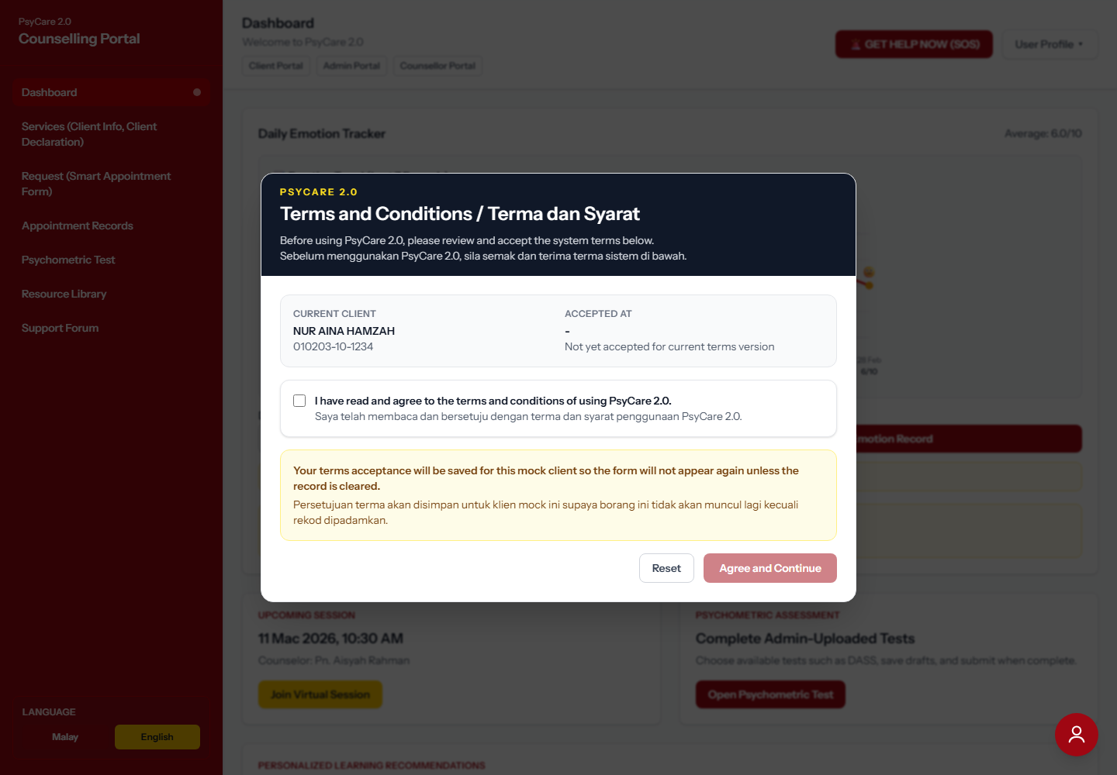

02. Client Portal - Dashboard Emotion Tracker
Route: /psycare/dashboard
Coverage: CT01 Log Daily Emotion, CT03 View Emotion History, dashboard entry point.
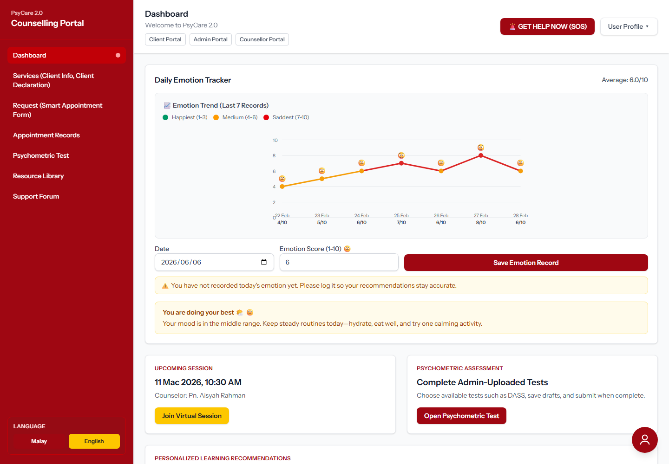

03. Client Portal - AI Chatbot Open With Risk Detection
Route: /psycare/dashboard
Coverage: CT02 Chat with AI Counsellor and automatic risk flag trigger.
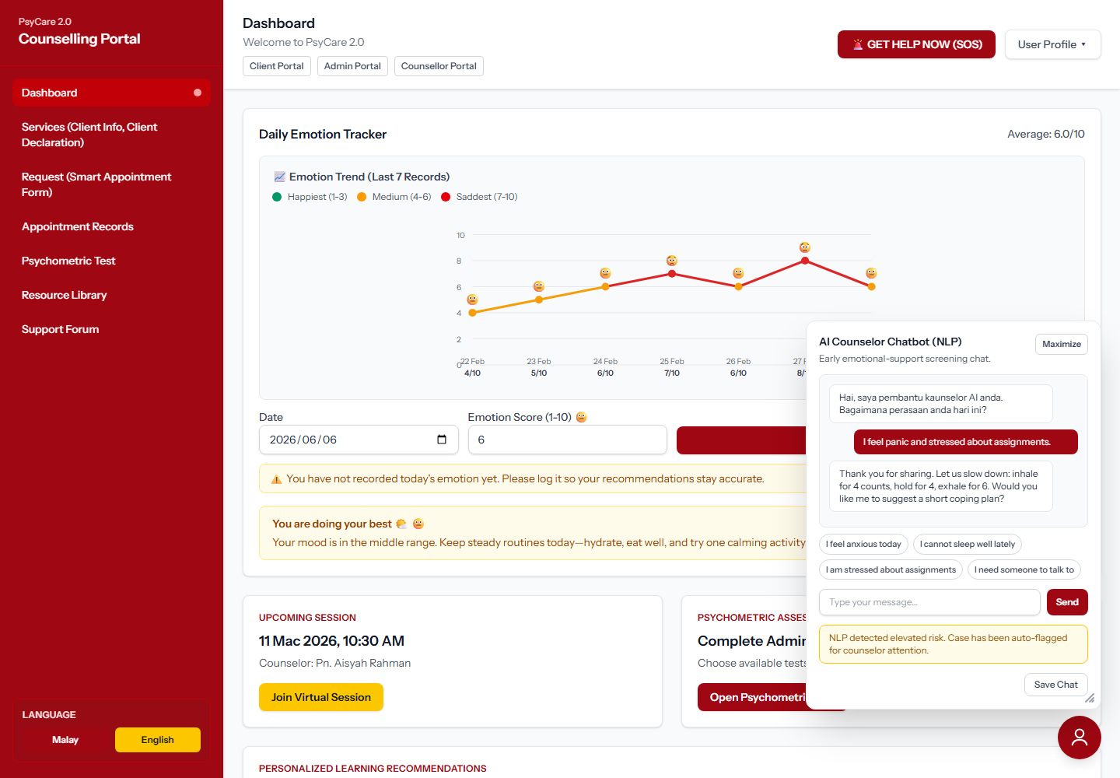

04. Client Portal - Services, Profile And Declaration
Route: /psycare/perkhidmatan
Coverage: UM03 Manage User Profiles, DC01 View Declaration Form, DC02 Submit Declaration.
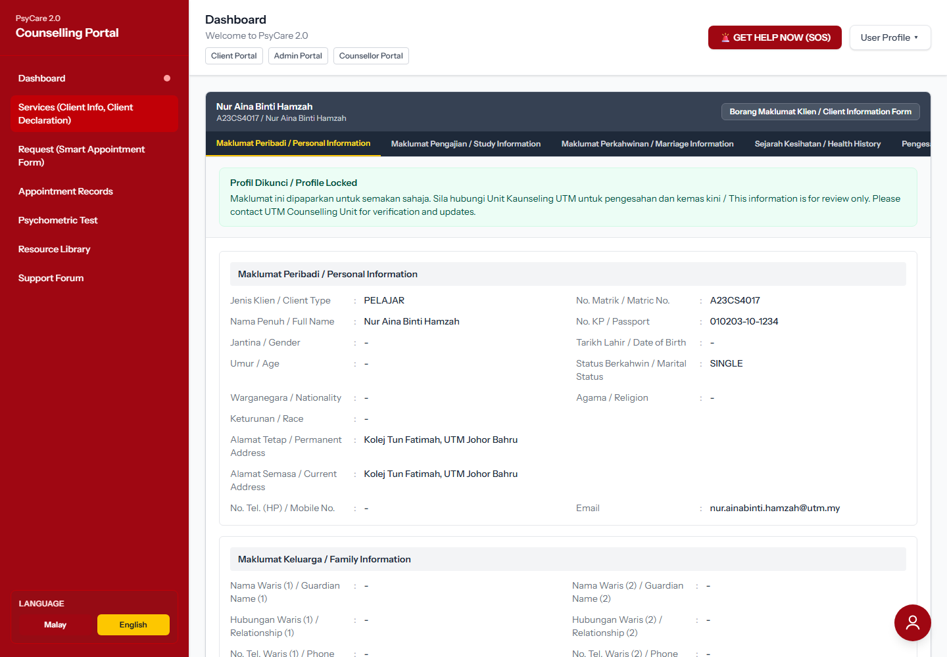

05. Client Portal - Appointment Request Entry
Route: /psycare/permohonan
Coverage: AS01 Book Appointment entry choice between new booking and follow-up.
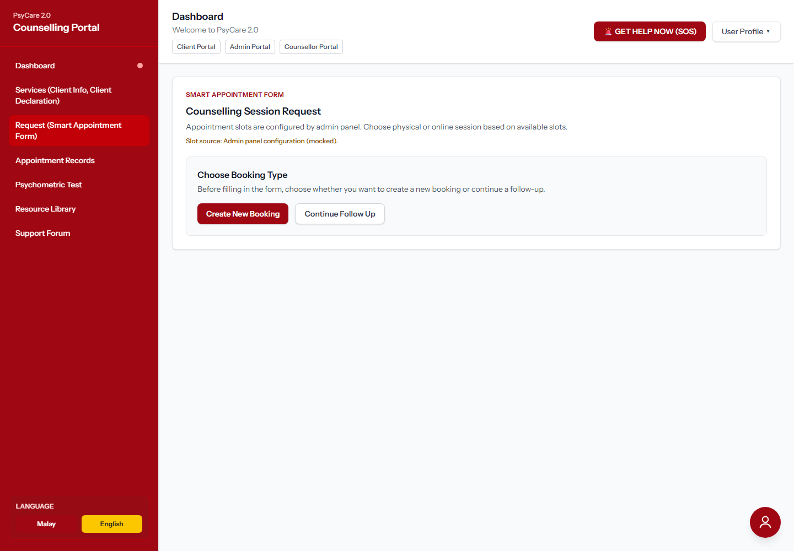

06. Client Portal - Smart Appointment Form
Route: /psycare/permohonan
Coverage: AS01 Book Appointment and AS03 Book New Appointment form fields, slot selection, declaration notice.
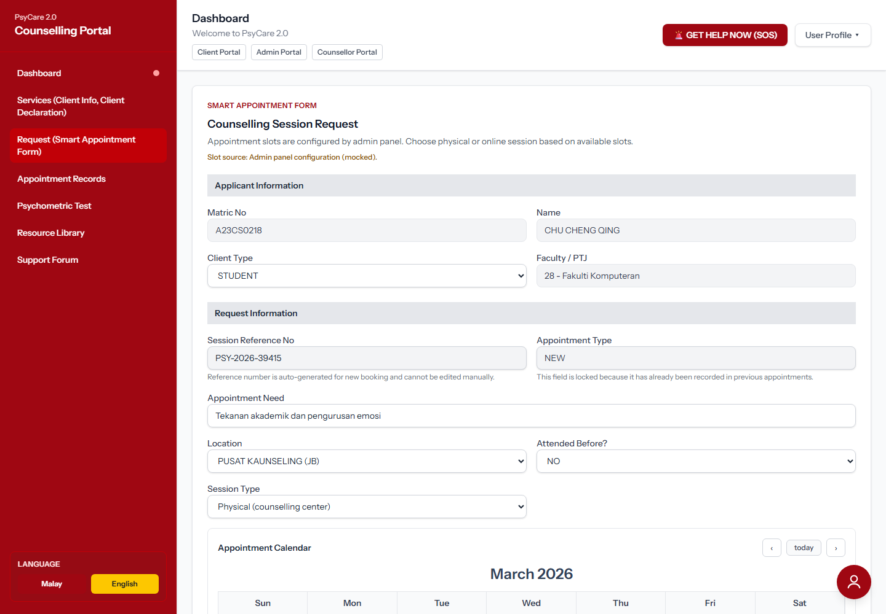

07. Client Portal - Appointment Records
Route: /psycare/rekod-temujanji
Coverage: AS02 Request Follow-Up appointment records and TA01 join-session entry point.
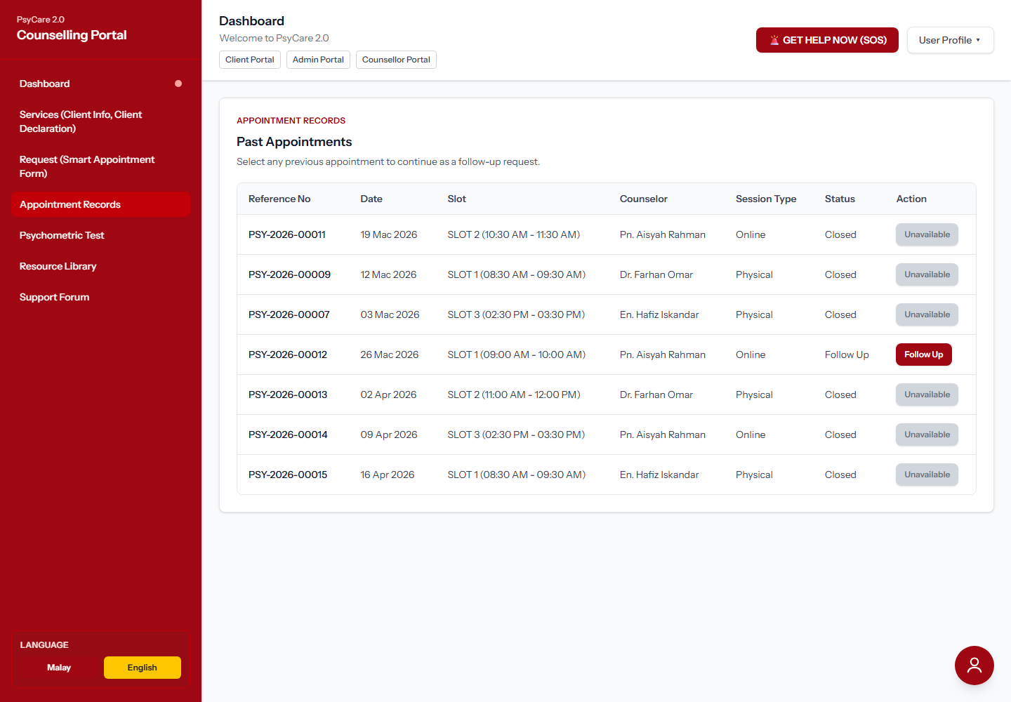

08. Client Portal - Follow-Up Appointment Form
Route: /psycare/rekod-temujanji
Coverage: AS02 Request Follow-Up and linked AS03 follow-up booking form.
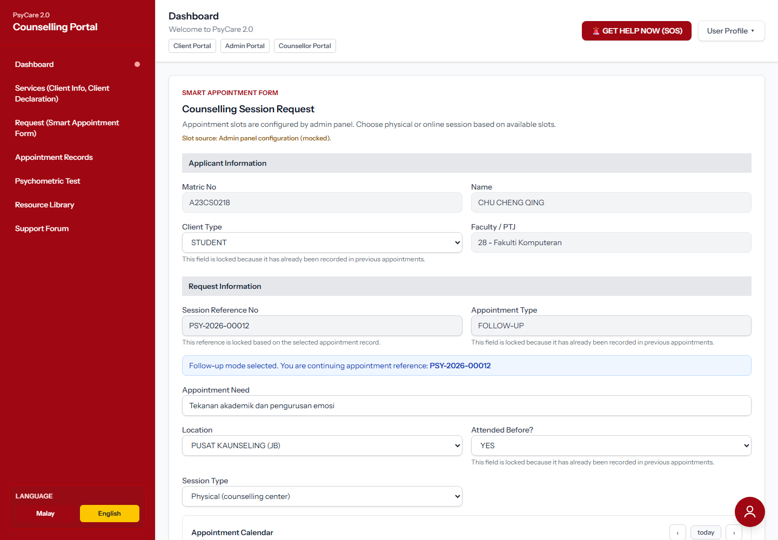

09. Client Portal - Psychometric Self-Assessment
Route: /psycare/ujian-psikometrik
Coverage: SA01 Take Psychometric Test with available tests, questions, answers, draft and submit controls.
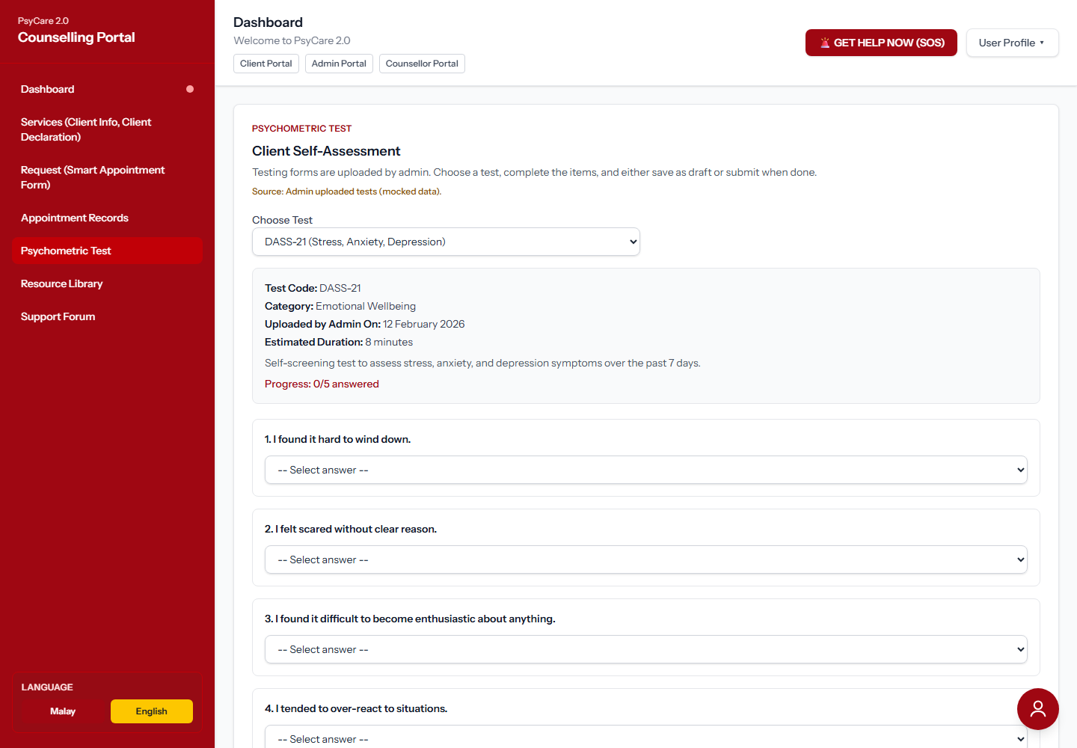

10. Client Portal - Resource Library
Route: /psycare/resource-library
Coverage: ER02 Access Learning Materials, search, filter, and open resource behavior.
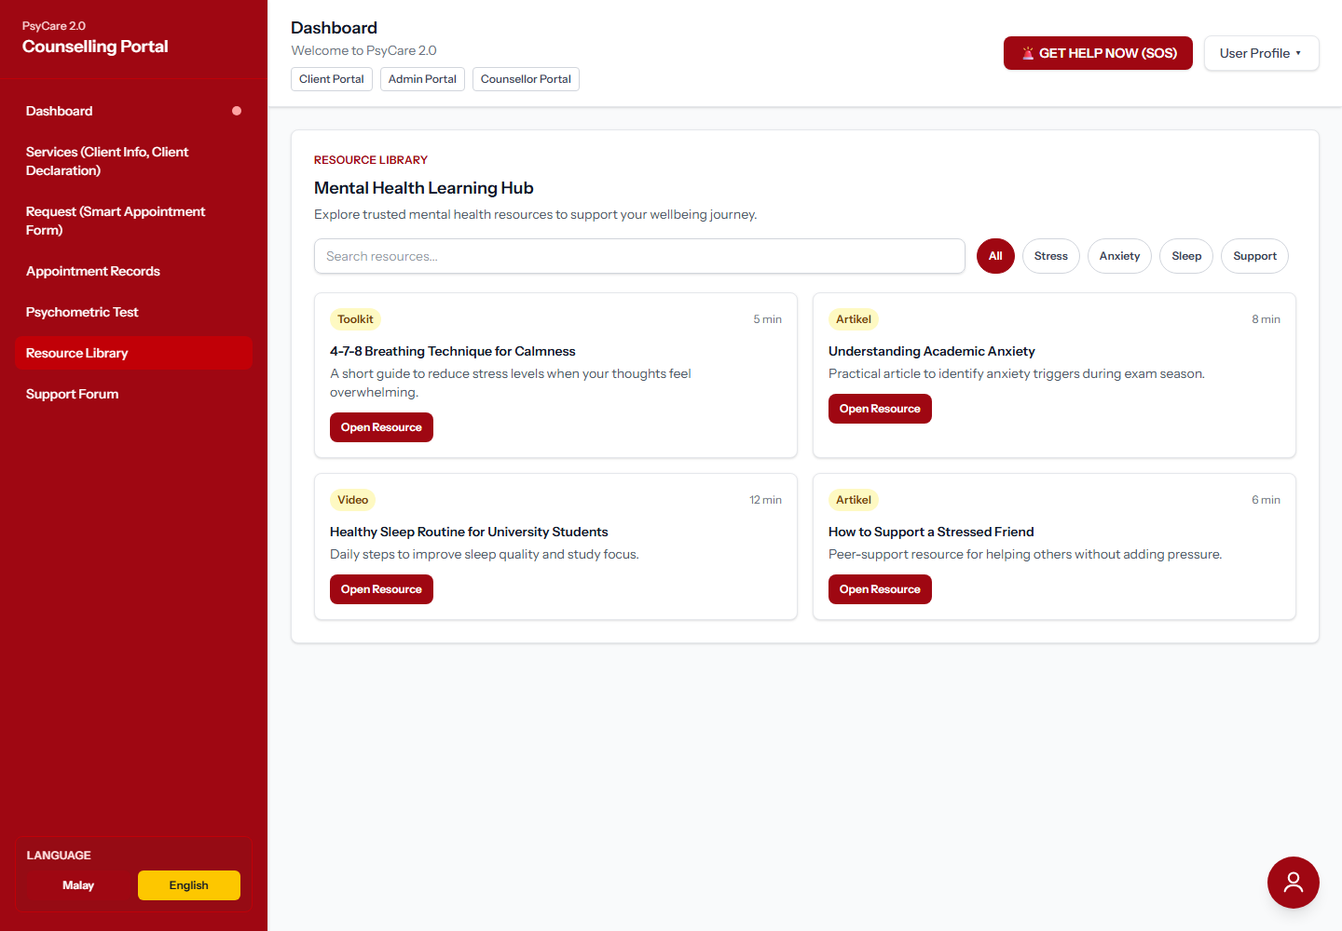

11. Client Portal - Peer Support Forum
Route: /psycare/forum-sokongan
Coverage: PS01 Submit Forum Post, category selection, safety review, and post queue feedback.
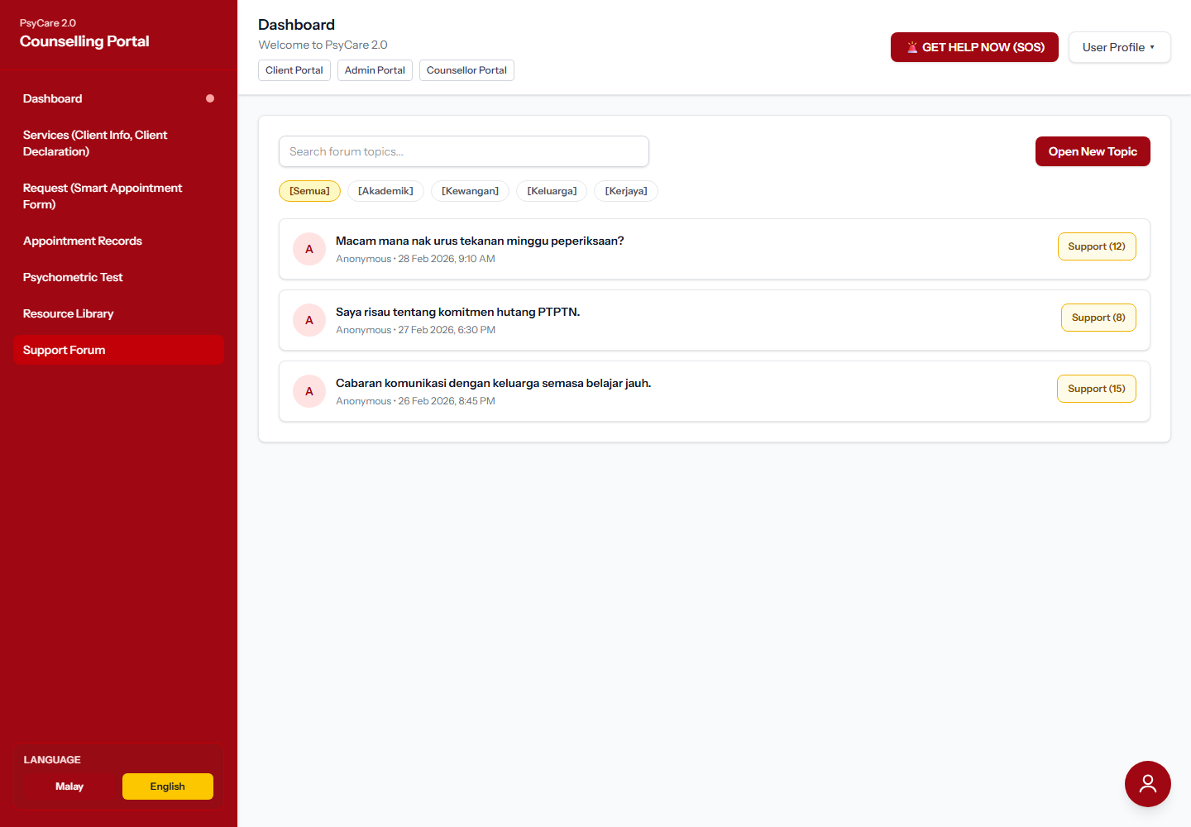

12. Admin Portal - Dashboard
Route: /admin/dashboard
Coverage: Admin entry point for appointment queue, resources, psychometric tests, and moderation work.
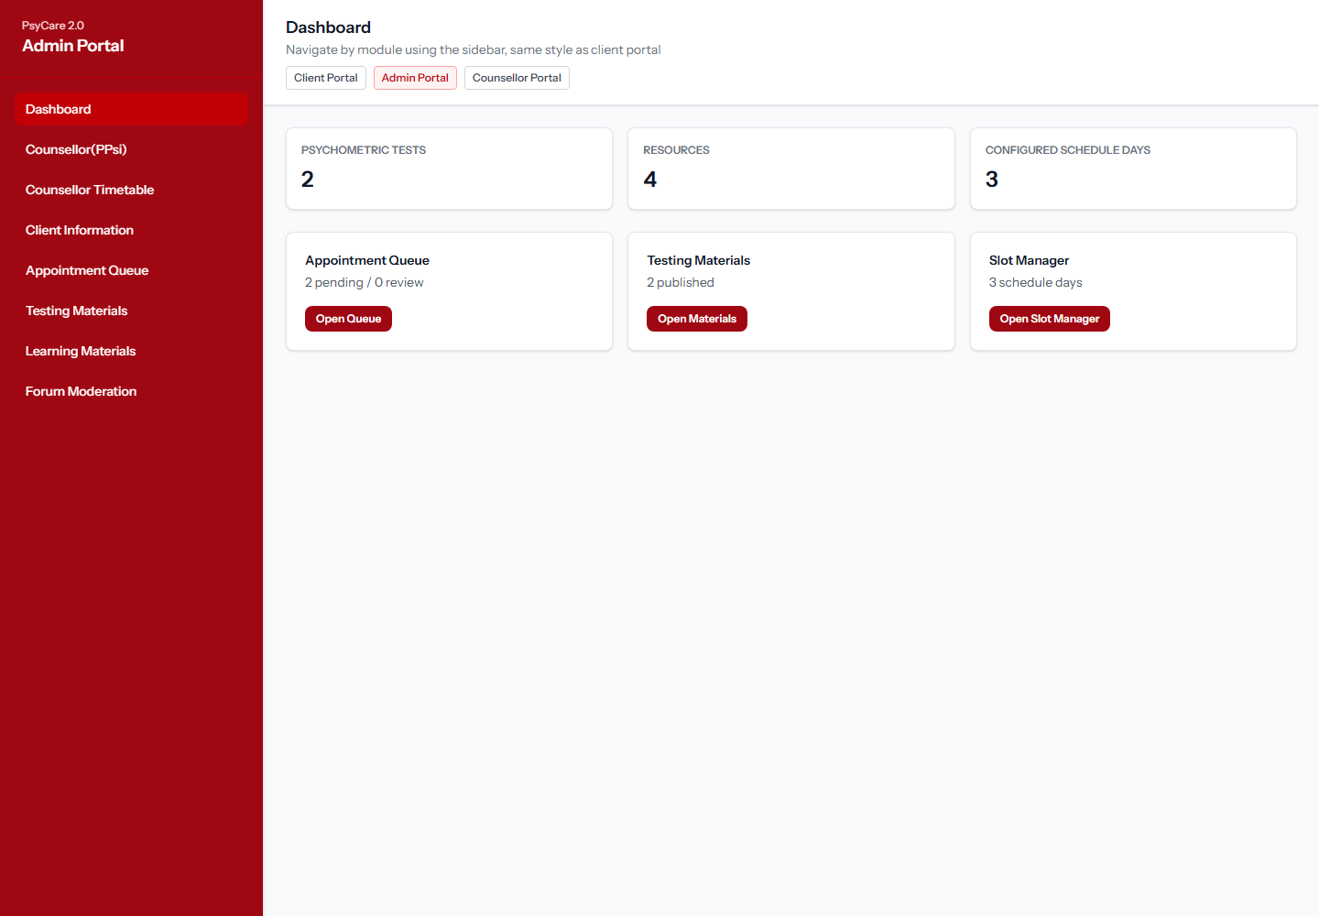

13. Admin Portal - Service Management
Route: /admin/service
Coverage: Appointment service and counselling service setup used by scheduling flows.
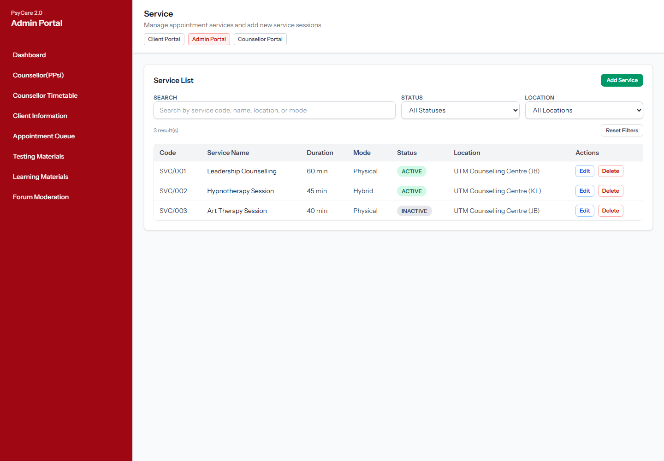

14. Admin Portal - Counsellor PPsi Management
Route: /admin/counsellor-ppsi
Coverage: UM01 Onboard Counsellor and counsellor profile maintenance.
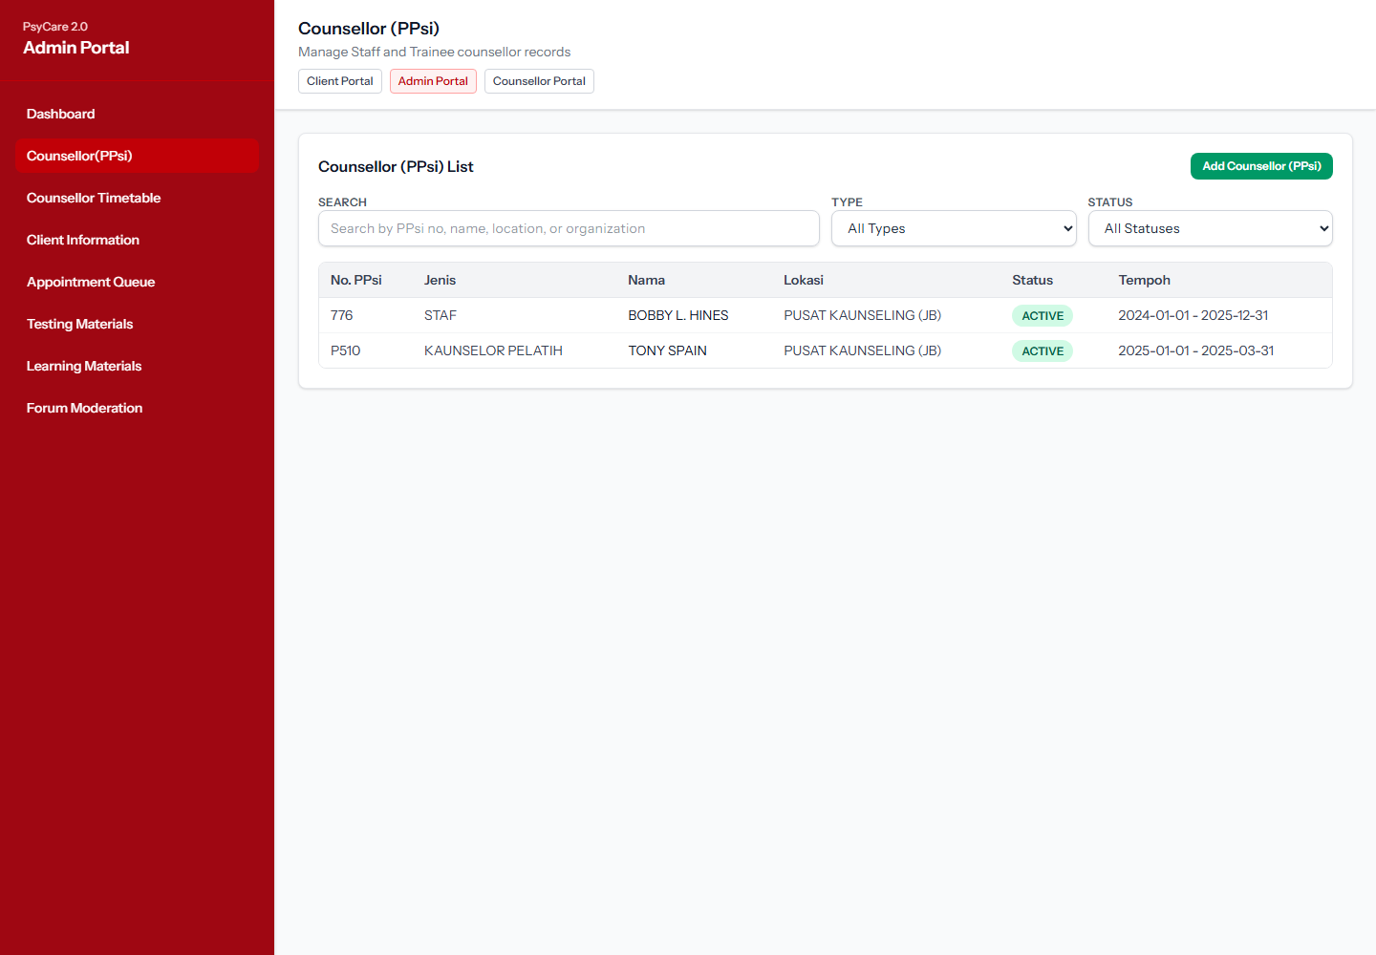

15. Admin Portal - Counsellor Timetable
Route: /admin/counsellor-timetable
Coverage: Counsellor timetable planning related to appointment slot setup.
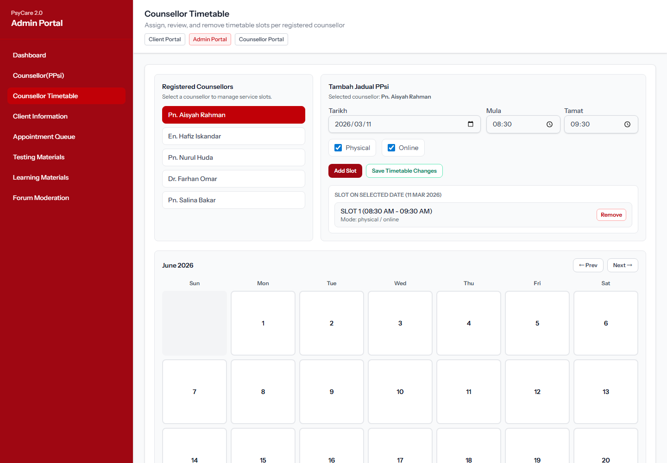

16. Admin Portal - Client Information
Route: /admin/client-information
Coverage: UM02 Find Client Profile and UM03 Manage User Profiles.
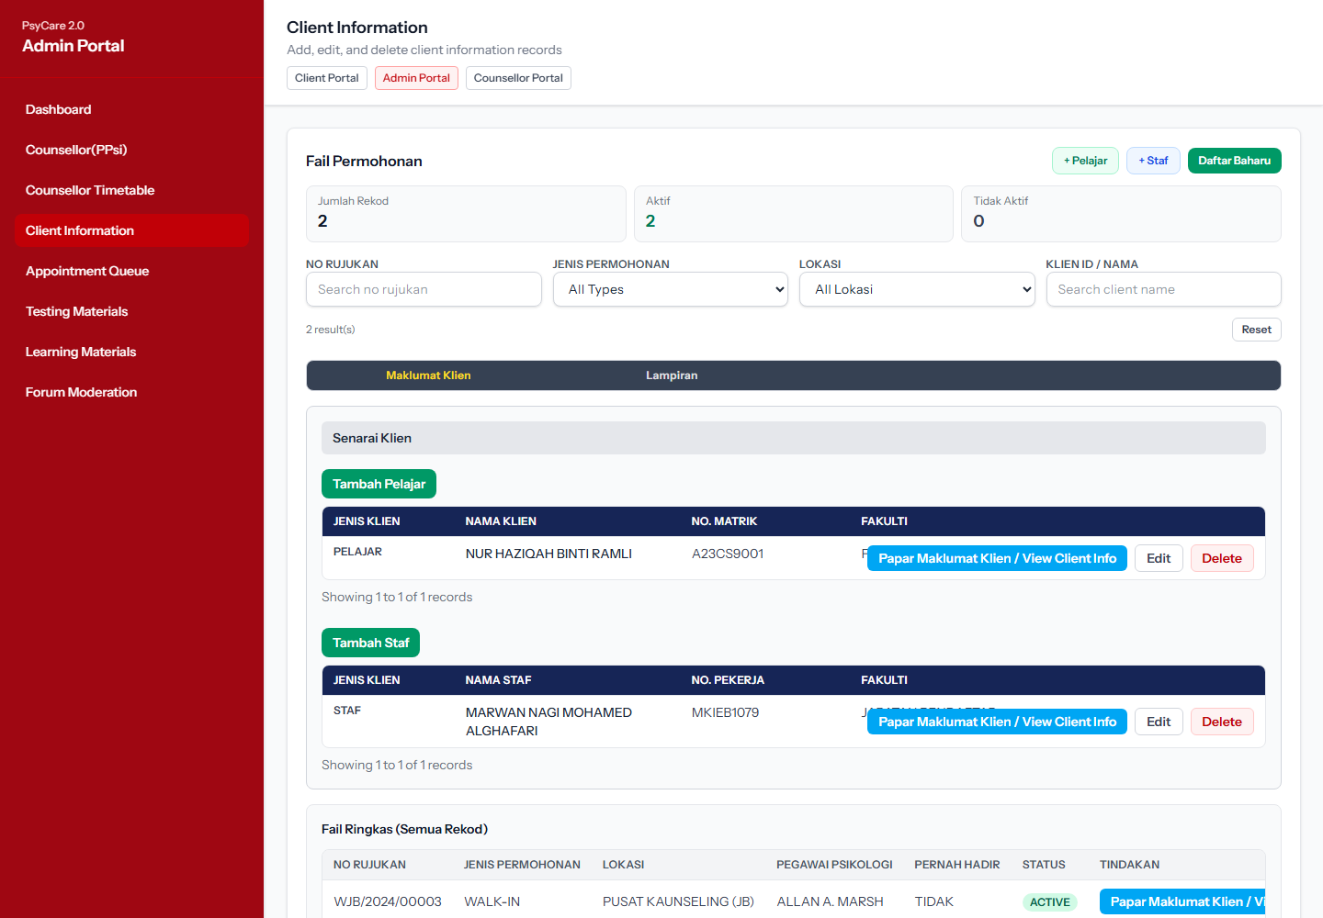

17. Admin Portal - Appointment Queue
Route: /admin/appointments
Coverage: AS07 Verify Appointment, admin/counsellor review queue, and attendance access.
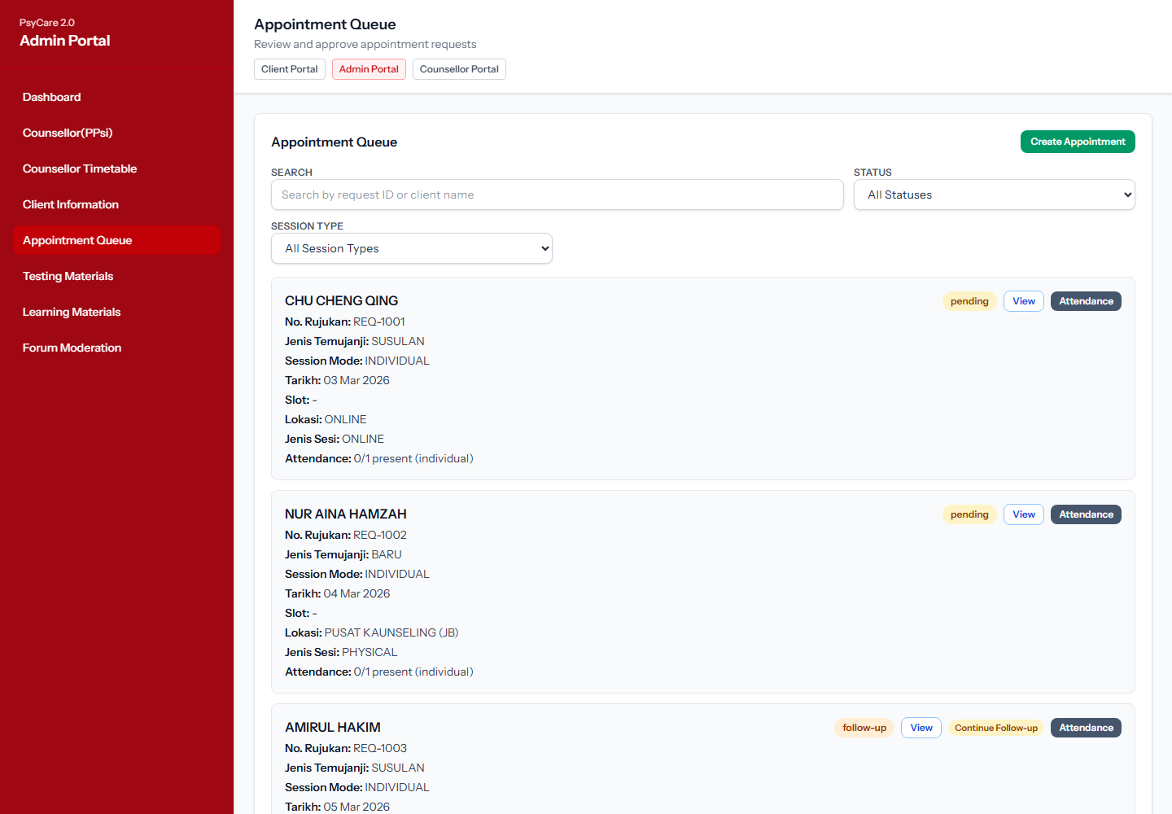

18. Admin Portal - Appointment Review Modal
Route: /admin/appointments
Coverage: AS07 Verify Appointment review details, submitted client form snapshot, and approval controls.
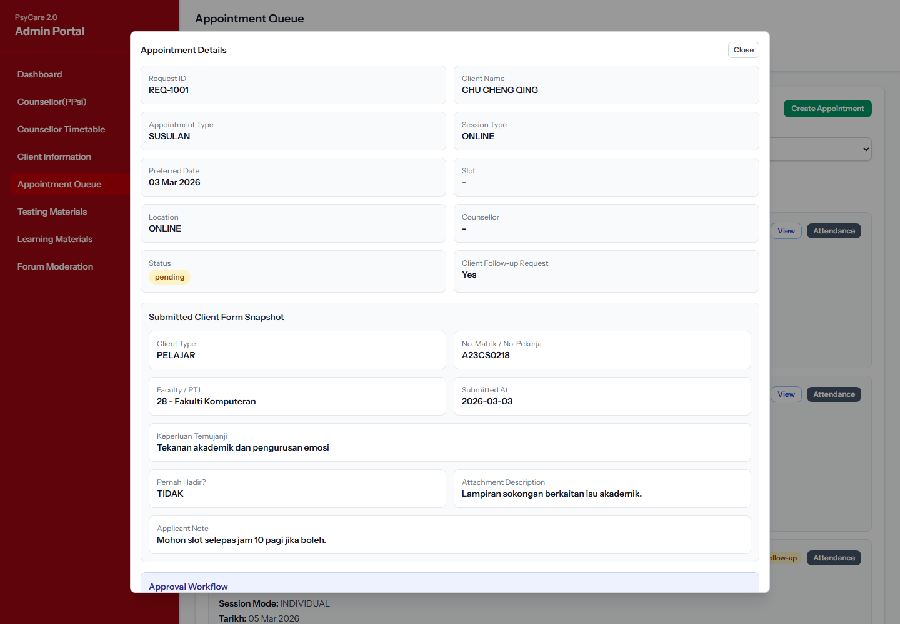

19. Admin Portal - Attendance Record Modal
Route: /admin/appointments
Coverage: TA02 Record Attendance, TA03 Scan Physical QR Code, TA04 Auto-log Attendance overview.
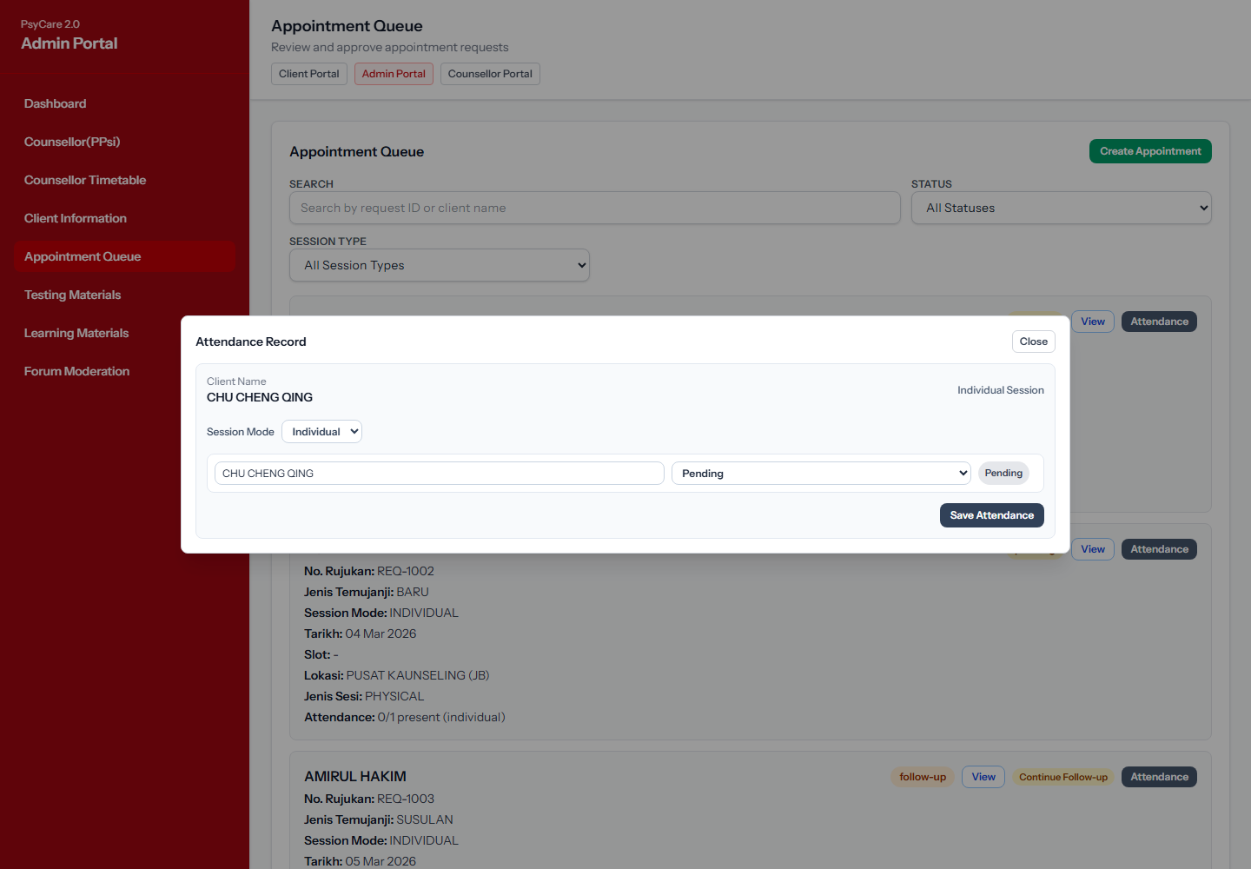

20. Admin/Counsellor Portal - Appointment Slot Manager
Route: /counsellor/slots
Coverage: AS04 Manage Slots, AS05 Bulk Generate Slots, AS06 Import CSV Timetable.
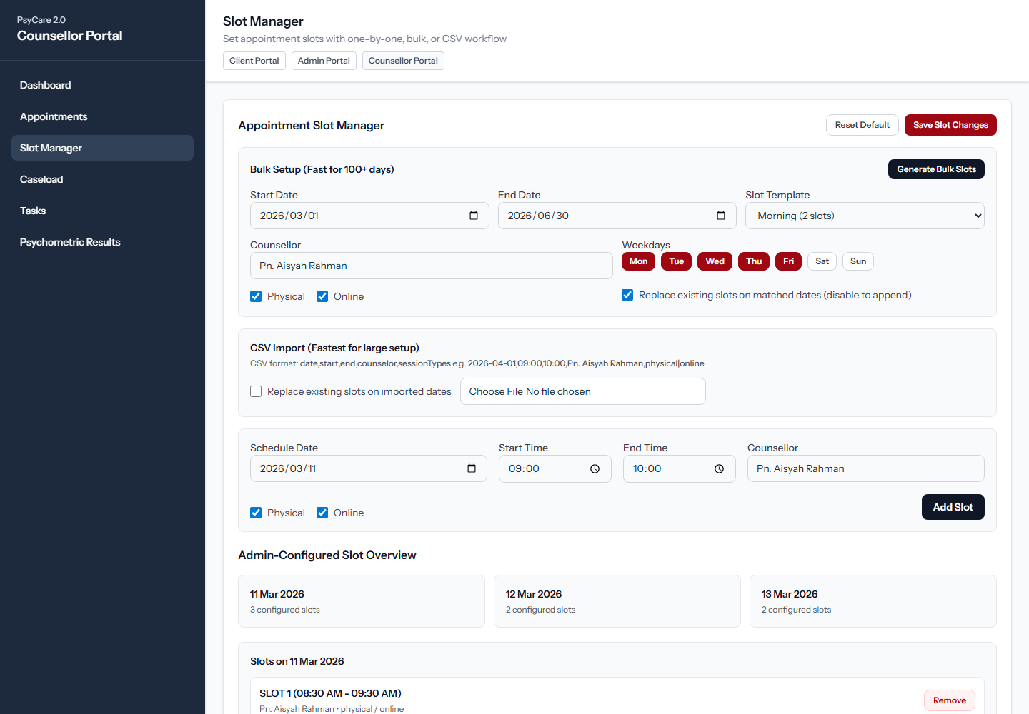

21. Admin/Counsellor Portal - Slot Bulk Generation Summary
Route: /counsellor/slots
Coverage: AS05 Bulk Generate Slots and draft slot change summary.
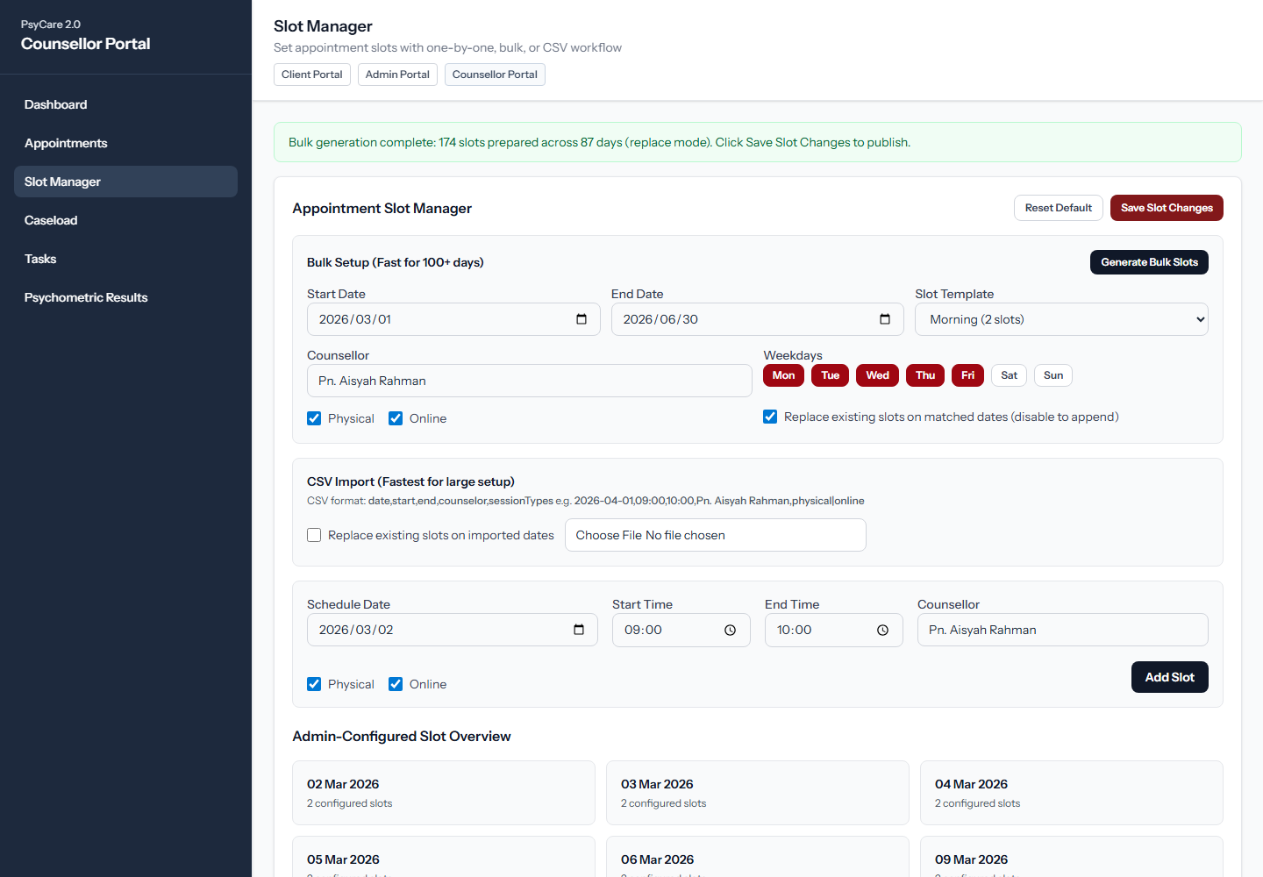

22. Admin Portal - Psychometric Materials
Route: /admin/materials
Coverage: SA03 Manage Test, upload PDF, generate tests, and review current tests.
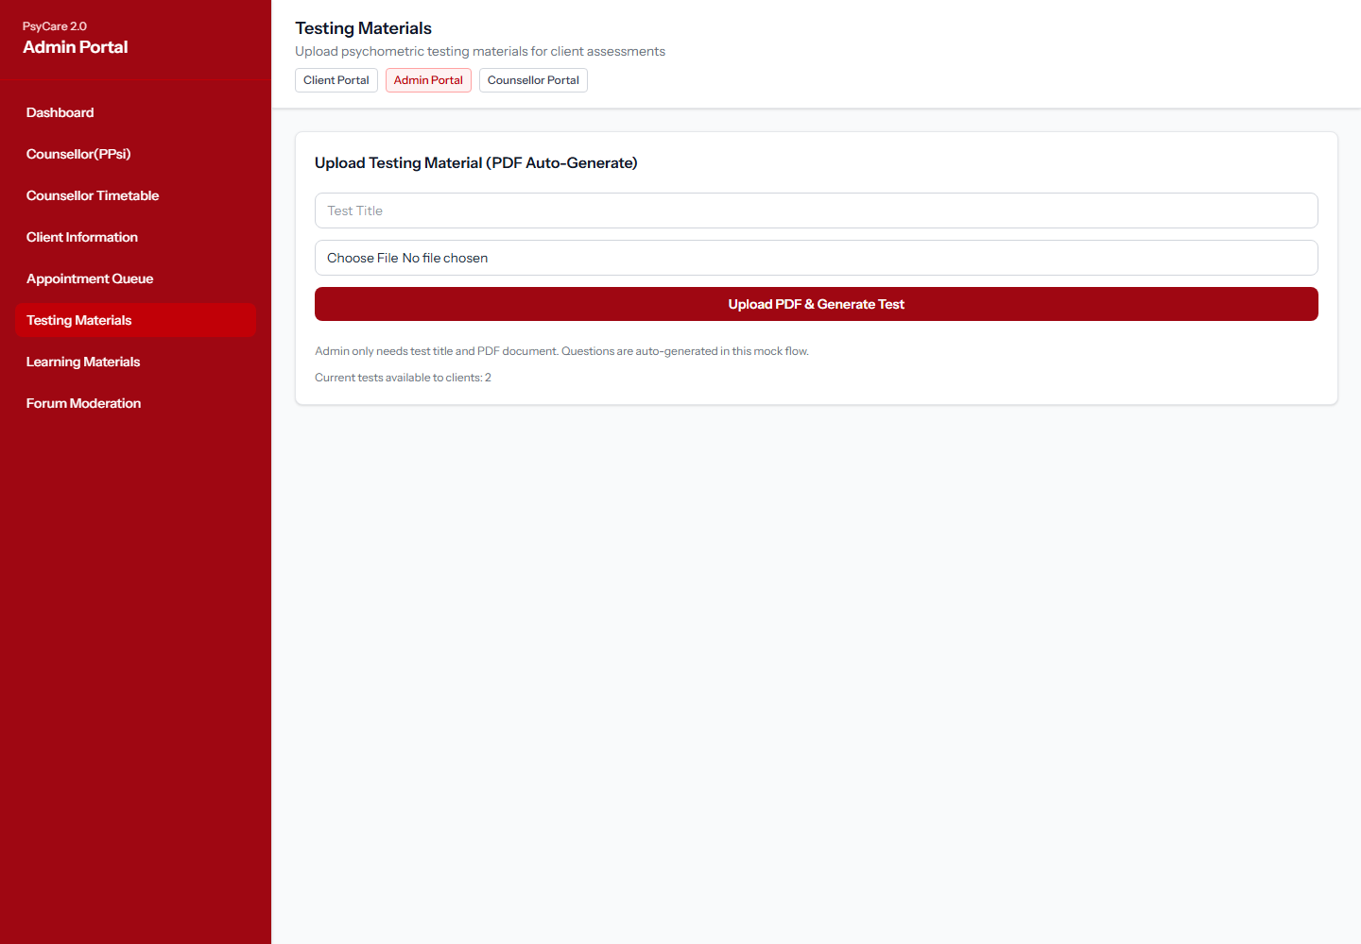

23. Admin Portal - Learning Materials
Route: /admin/learning-materials
Coverage: ER01 Manage Resource Library and upload learning materials.
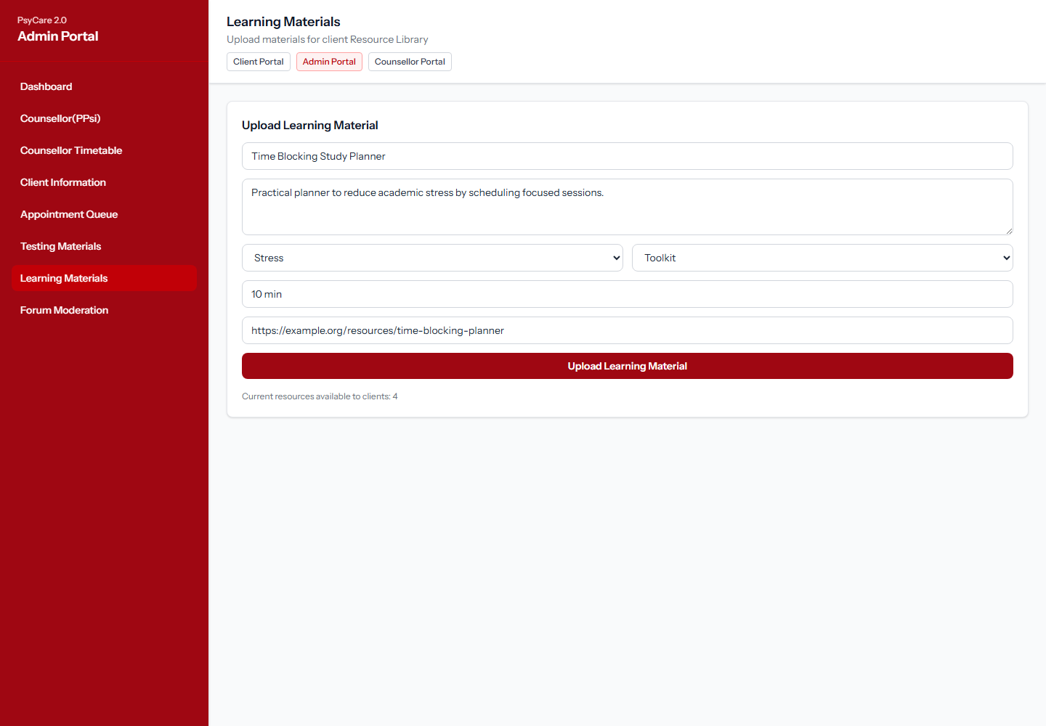

24. Admin Portal - Forum Moderation
Route: /admin/forum
Coverage: PS02 Moderate Forum, filter posts, confirm actions, and moderation log.
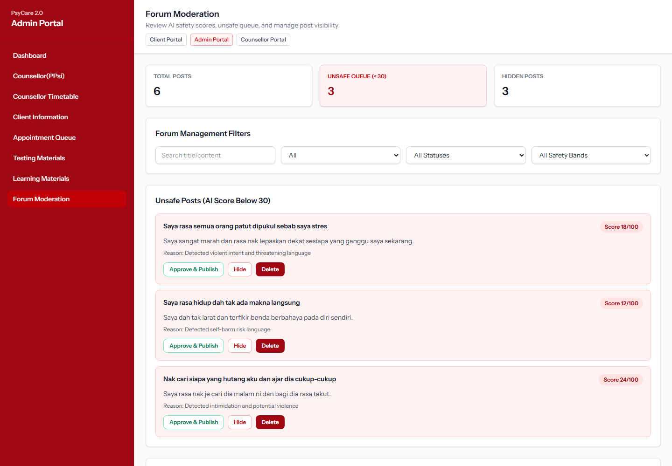

25. Counsellor Portal - Dashboard
Route: /counsellor/dashboard
Coverage: Counsellor entry point for appointments, caseload, tasks, and psychometric results.
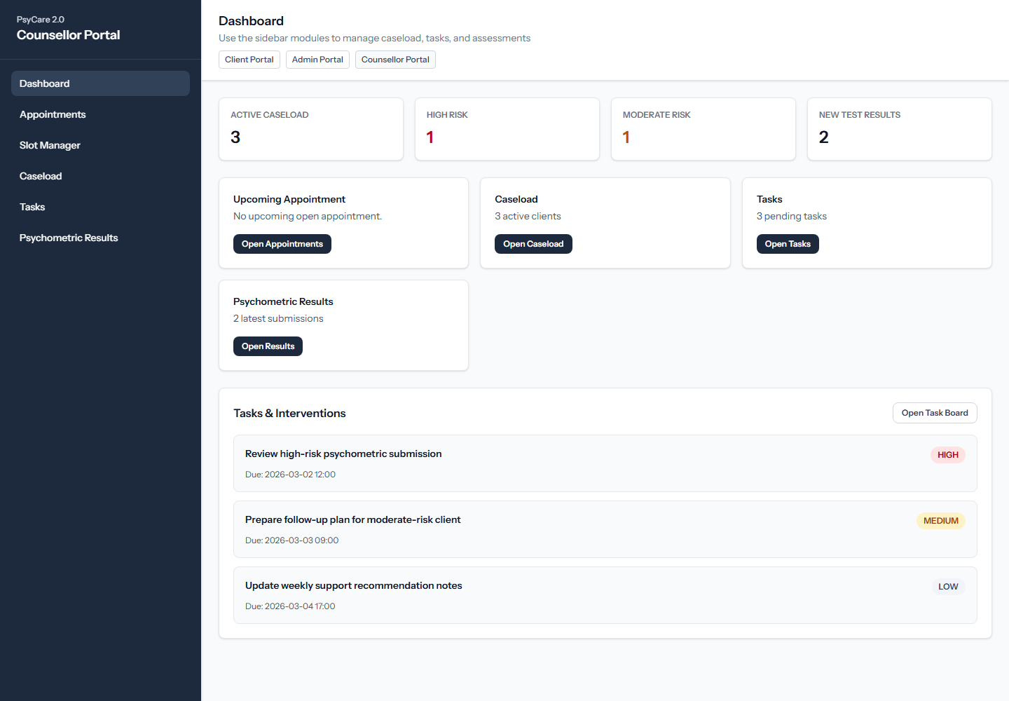

26. Counsellor Portal - Appointment Records
Route: /counsellor/appointments
Coverage: AS07 counsellor review, TA02 attendance access, and follow-up controls.
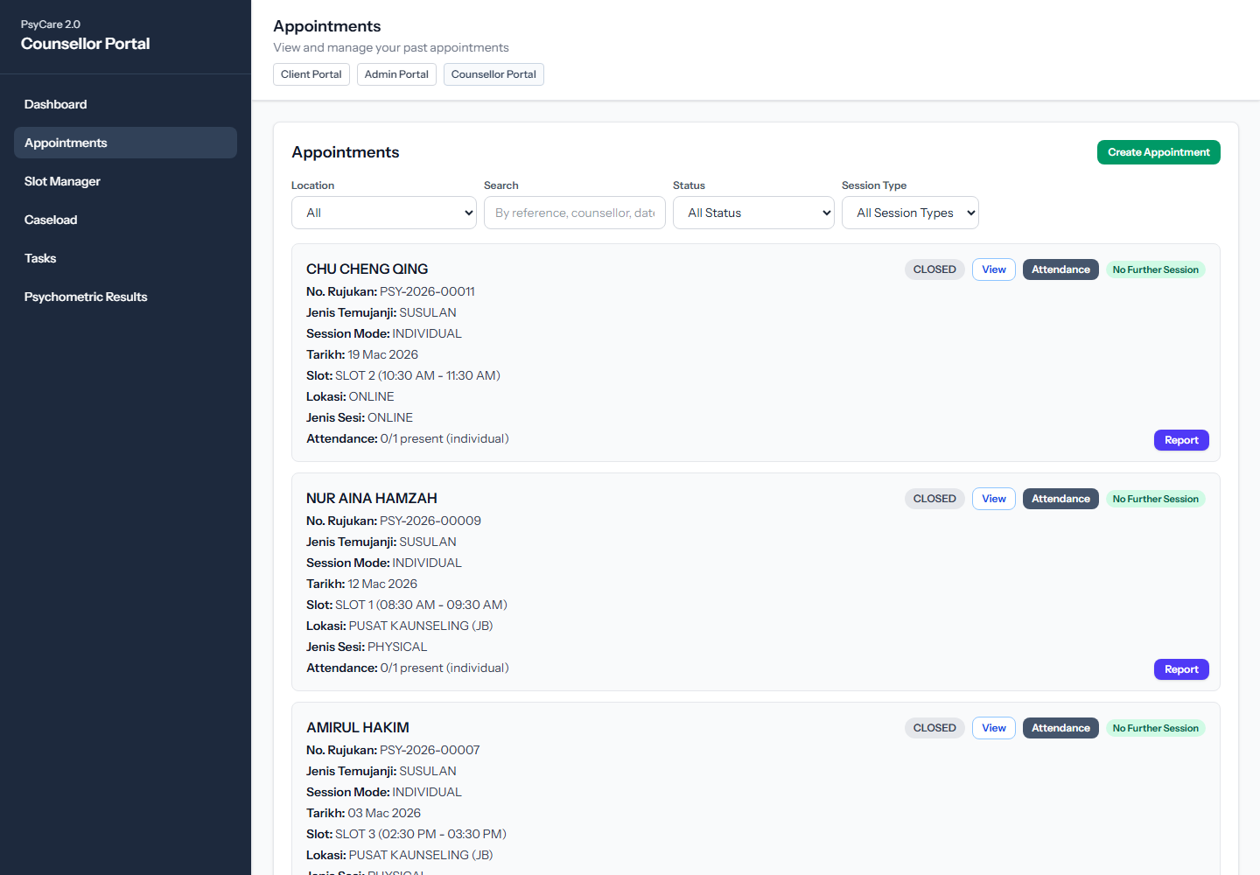

27. Counsellor Portal - Appointment Detail Modal
Route: /counsellor/appointments
Coverage: AS07 counsellor approval details and submitted form review.
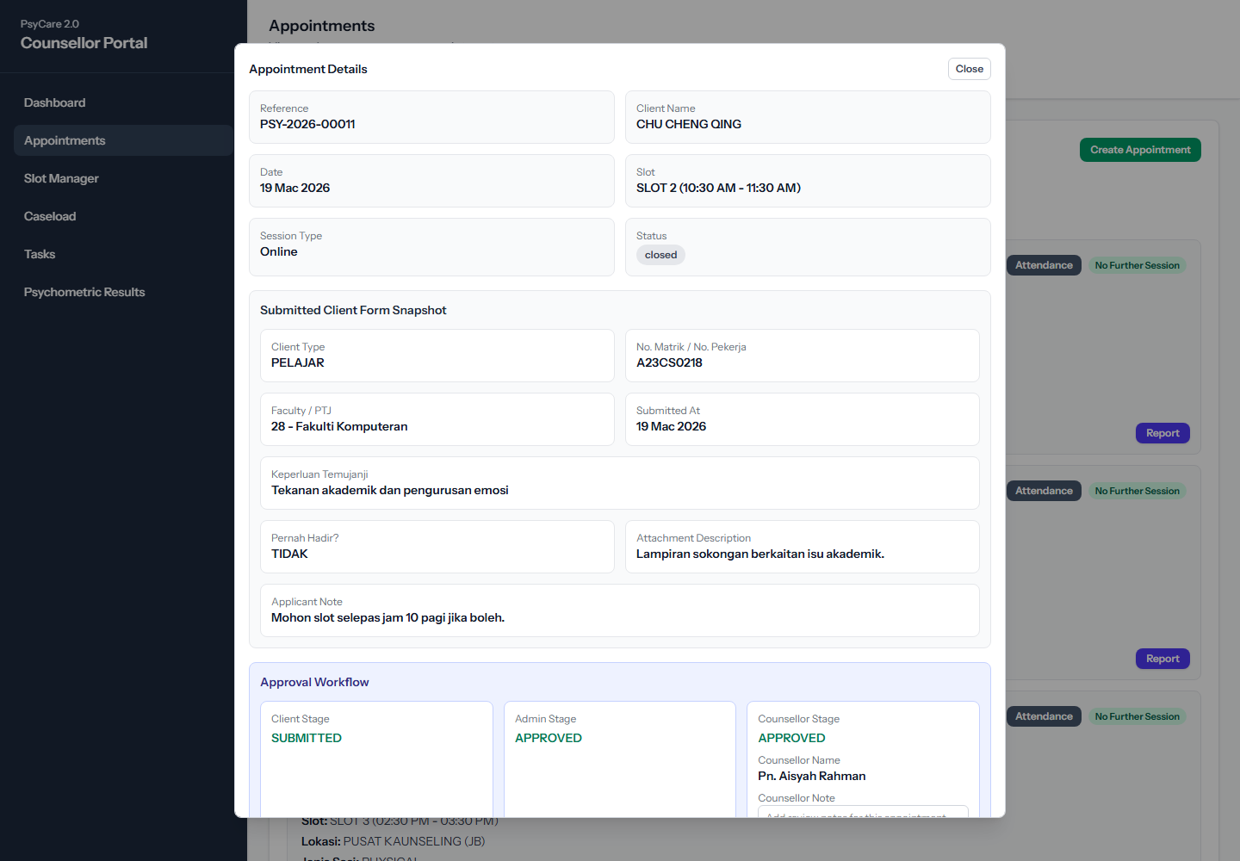

28. Counsellor Portal - Attendance Record Modal
Route: /counsellor/appointments
Coverage: TA02 Record Attendance, TA03 QR attendance, and attendance participant editing.
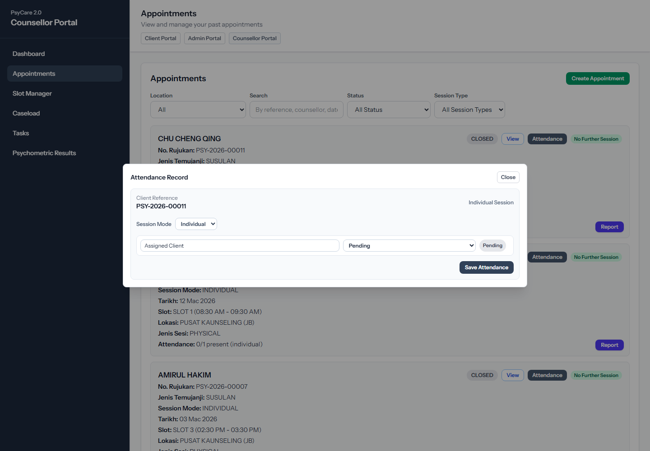

29. Counsellor Portal - Flagged Client Caseload
Route: /counsellor/caseload
Coverage: CT04 Investigate Flagged Client and CT03 emotion history from counsellor caseload.
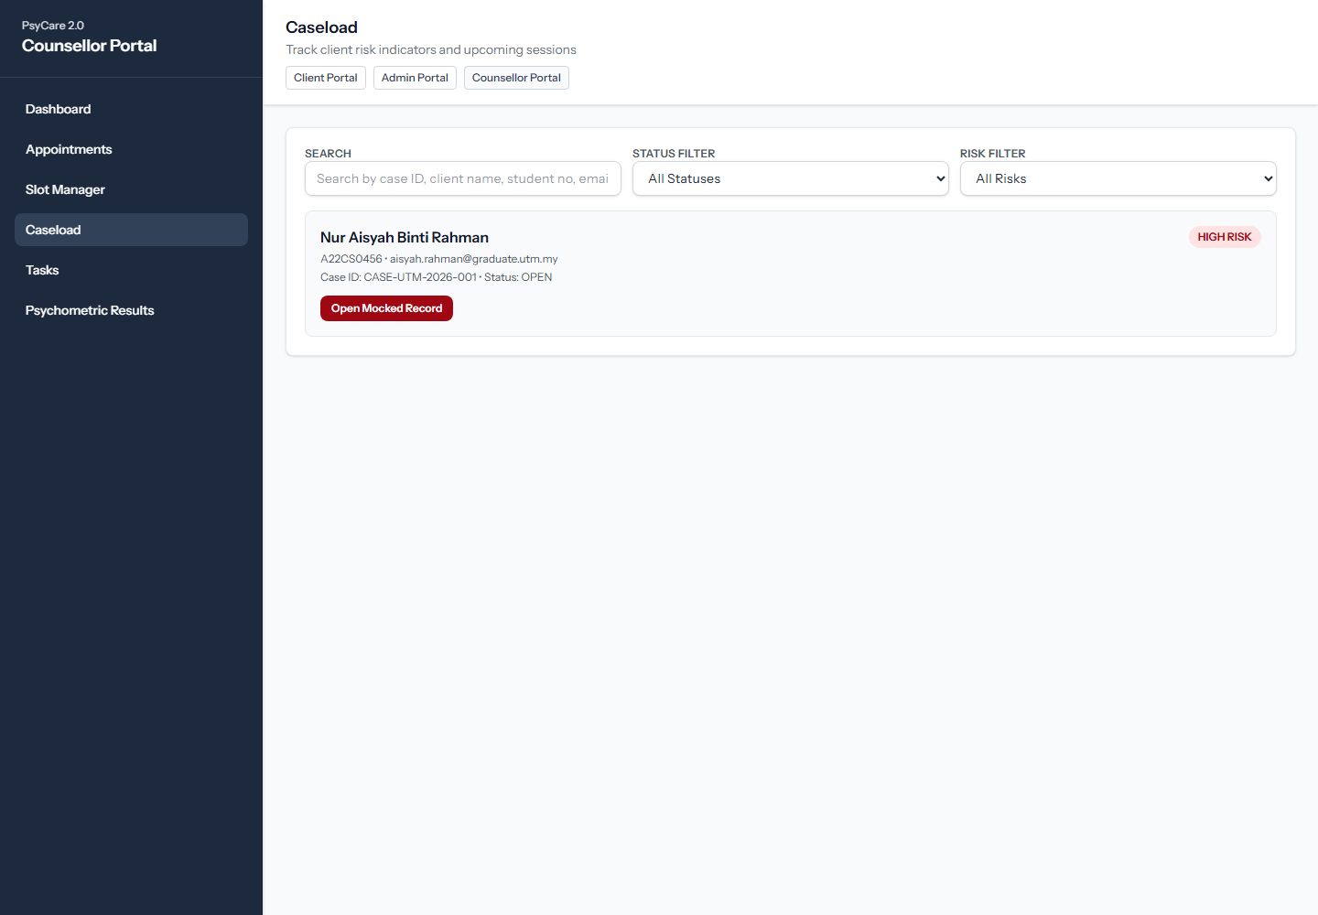

30. Counsellor Portal - Intervention Tasks
Route: /counsellor/tasks
Coverage: CT04 create intervention task and track counsellor follow-up work.
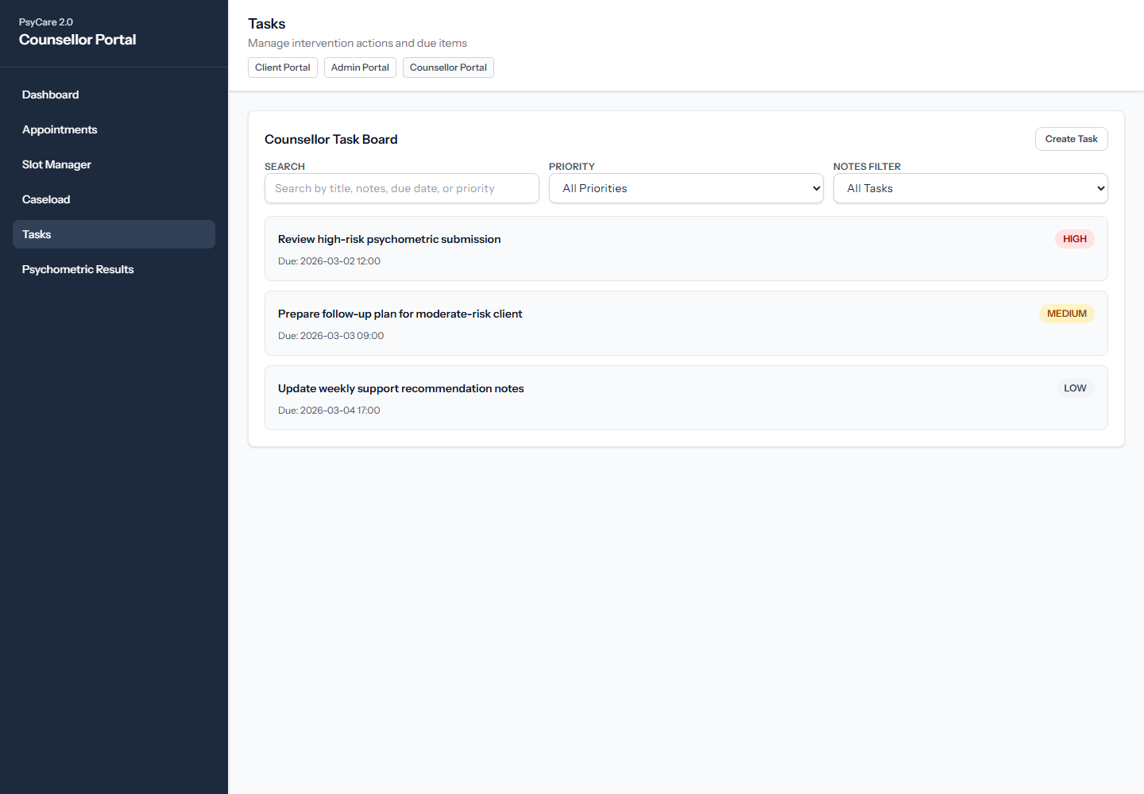

31. Counsellor Portal - Psychometric Results Triage
Route: /counsellor/assessments
Coverage: SA02 View Triage Dashboard and submission review.
