重庆第二师范学院
2019 届全日制本科生毕业论文
题 目 | 宜家在华的本土化策略研究
教学学院 | 外国语言文学学院
专业年级 | 2015级英语
学生姓名 |  | 学号 | 1410203137
指导教师 |  | 职称

2019 | 年 | 5 | 月

Research of Localization Strategy of IKEA in China

A thesis

submitted in partial fulfillment
of the requirements for the degree of Bachelor of Arts
in the School of Foreign Languages and Literatures
Chongqing University of Education

School: School of Foreign Languages & Literatures

Major: English

Grade: 2015

Name:

Student No.: 1410203137

Supervisor:

Date: May, 2019
Abstract: Since 1943, IKEA has become the world’s largest multinational home improvement retailer. IKEA’s prominence as an industry giant in the fierce global competition ascribes to its flexible strategies of localization. Through literature research, field investigation and data analysis, this paper will analyze IKEA’s localization strategy from four aspects of product, price, place and promotion. In the meantime, it will compare Chinese marketing strategies with Swedish ones so as to figure out what IKEA has changed for the Chinese market. In the end, this paper will illustrate the enlightenments IKEA has delivered to us, hoping to provide reference for other multinational companies.

Key words: IKEA; comparative analysis; localization strategy; 4P theory

摘要：自1943年到现在，宜家家居已成为全球最大的跨国家居零售企业。宜家能在全球激烈的竞争中脱颖而出成为行业巨头，不得不归功于其灵活多变的本土化经营策略。本文通过文献研究、实地调查和数据分析的方法，从4P市场营销理论的产品、价格、渠道、促销四个方面来分析宜家在华的本土化营销策略，并与其在瑞典总部营销策略进行对比研究，具体分析宜家为中国市场本土化做出了哪些改变以及它带给我们的启示，希望能为宜家及其他跨国企业提供借鉴。
关键词：宜家；对比分析；本土化策略；4P理论

Thesis Statement

This paper will analyse IKEA’s localization strategies in terms of product, price, place and promotion and the enlightenment IKEA has delivered to us.

Contents
- Introduction..........................................................................................................1
- Literature Review.................................................................................................1
2.1 Relevant Theories............................................................................................1
2.2 Relevant Research Status............................................................................... 3
- IKEA’s Marketing Strategies in its Domestic Market and in Chinese Market....4
  - Product..........................................................................................................4
    - Design....................................................................................................5
    - Food.......................................................................................................6
    - Service...................................................................................................6
  - Price...............................................................................................................8
    - Product Price..........................................................................................8
    - Delivery Price........................................................................................10
  - Place...............................................................................................................11
    - Selection of Location.............................................................................11
    - Multichannel Sales.................................................................................12
  - Promotion.......................................................................................................13
    - Catalogue................................................................................................13
    - Advertising.............................................................................................15
    - Special activities.....................................................................................15
    - Others......................................................................................................16
- Enlightenments......................................................................................................17
  - Product Improvement.....................................................................................17
  - Price Adjustment.............................................................................................17
  - Multichannel Sales..........................................................................................18
  - Optimization Services.....................................................................................18
  - Diverse Methods of Promotion.......................................................................18
- Conclusion.............................................................................................................18

Notes............................................................................................................................20
References....................................................................................................................21
Acknowledgements......................................................................................................23

- Introduction
In 1943, IKEA was founded in Sweden with the purpose of squeezing into the market with lower price products. Later, it gradually entered the home furnishing industry and developed itself into a world-famous chain group of home furnishing. Up to now, IKEA has become the world’s largest multinational home retailer with 355 stores in 29 countries and regions, including 26 in Mainland China. It is expected to expand its stores to 500 and provide IKEA products for more areas by 2020.
In recent years, with the acceleration of economic globalization and trade liberalization, the markets in developing countries such as China and India have grown steadily, where boast a growing number of middle classes with huge purchasing power. These potential customers are the key to IKEA’s development. IKEA’s prominence as an industry giant in the fierce global competition ascribes to its flexible strategies of localization.
In 1998, IKEA came into China and chose a self-support model in such a country that is completely unfamiliar and whose cultural environment is vastly different from its own. In order to adapt to Chinese market, IKEA has put forward some localization strategies because eliminating regional disparities plays a key role in realization of better development for IKEA in an all-round way.
Through literature research, field investigation and data analysis, this paper will analyze IKEA’s localization of marketing strategies based on 4P theory and compare it with that in Swedish headquarters, so as to figure out what IKEA has changed in terms of marketing strategies for the Chinese market and thus explore the enlightenment IKEA brings to us. IKEA has been successful in balancing globalization and localization, which can be seen at least from its yearly rising sales volume. Thus, to study IKEA’s localization can help other multinational corporation adjust their strategies as a reference.
- Literature Review
2.1 Relevant Theories
The marketing strategy is that the company organizes various business activities in a planned manner by taking into consideration the customer’s demands, purchasing power and the expectations of the business community. Marketing strategies are diverse and complex. In this paper we will use the 4P theory proposed by the American marketing expert Professor E.J. McCarthy. The famous 4P theory of marketing strategy combination is based on people’s marketing practice, namely, product, price, place and promotion. Product includes core products, physical products and extension products. A broad product can be a tangible entity or intangible service, technology and intelligence. Price means the strategies to set prices. There are many ways to set prices, such as competitive comparison, cost addition, and target profit. Enterprises aim at profitability, so pricing must take into account both sales efficiency and business efficiency. Place refer to the sales path from the producer to the terminal of consumers. Ordinary goods go through the links of agents, wholesalers, shopping malls or retail stores. Promotion is the strategy that aims to expand sales and attract customers. Advertising, public relations, and personnel promotion are factors that influence this strategy.
For multinational companies, when they enter a new market, some choose standardized marketing strategies, or standardization. Standardization means that companies provide the same products to all markets in different countries and regions around the world, and support these products globally with the same sales and promotion plans. The advantage is that it can save the company’s costs in many aspects, develop global standardized goods, and enhance the social awareness and reputation. It also enables companies to effectively control global marketing and achieve better marketing performance. However, in recent years, due to the development of economic globalization, more and more multinational companies are aware that the various disparities in different countries may lead to the failure of standardized marketing strategies, so they gradually tend to choose localized marketing strategies, or localization.
Localization can be another means of marketing. Localization refers to the strategy for enterprises to quickly adapt to the economic, cultural and political environment of the host country, dilute the mother country’s features and implement localization in terms of product, human resources, research and development and other aspects. Its essence is that all business activities of the enterprise are centered on the consumers, not on the preferences or habits of the company itself. On the one hand, it is beneficial for better meeting the needs of local consumers with the products produced by foreign companies. On the other hand, it can also help enterprises save the high costs of overseas dispatched personnel and transnational operations, integrate into local society, ease the tension of foreign capital invasion as well as increase employment and accelerate international integration.
2.2 Relevant Research Status
Domestic research on the localization of multinational corporations is a little later than that of foreign countries, but the relevant literature is also abundant. Regarding localization, most of the research holds a positive view towards it, and it is considered wise to adopt such strategy, which is beneficial to the development of the enterprise locally. There are many aspects involved in localization, such as brand culture, human resources, management, research and development and so on. Numerous articles on localization study the above aspects. But the articles that introduce the localization of marketing, especially the localization of IKEA’s marketing strategies, are relatively scarce.
Zhang Xuan (2013) pointed out that the success of marketing lied in whether companies can fully understand the characteristics of the target market and adopt effective marketing strategies. This was the spirit of localization as well as an important guarantee for the realization of the globalization strategy of a company. Every time a multinational company entered a new market abroad, it needed to consider whether to adhere to standardization or insist on localization. In this case, the author analyzed IKEA’s globalization strategy and localization dilemma. She finally drew a conclusion that if multinational companies want to achieve sustainable development overseas, they must pay attention to localization on the basis of globalization strategy.
Wang Yan (2013) believed that localization was a global trend and should be attached more importance. She analyzed the reason why multinational corporations implement localization strategy, and elaborated on such strategy in terms of human resources, products, markets, research and development, etc. It was pointed out that multinational corporations can help introduce new business ideas and methods, promote the technological level and enhance research and development capabilities in China as well as bring great hidden dangers to China’s economic security and intensify domestic employment conflicts to some extent.
Chen Yanhong and Jiang Qijun (2015) believed that the localization of human resources was the most important part of the localization strategy. After all, the development of enterprises would ultimately require talents. Corporations should inherit and renew the management concept of the parent company, strengthen the continuous development of localization of human resources, enhance the cultivation of local talents, and take advantage of the geographical advantages of the host country to gain localized competitive advantage.
However, Liu Jinxi and Jia Kai (2006) emphasized the importance of culture differences in marketing activities rather than human resources. Because only by formulating a marketing strategy that was consistent with local culture could corporations better meet the needs of the public.
This paper also focuses on localization, but the research content is not the same. Based on these previous literature, this paper has made some innovations, that is, detailed and comprehensive analysis of IKEA’s localization strategy from the perspective of marketing, and comparison with the marketing strategy of its Swedish headquarters, which has never been done before.
- IKEA’s Marketing Strategies in its Domestic Market and in Chinese Market
3.1 Product
IKEA’s product materials, product quality and services all follow the same set of standards. Such standardization can promote the establishment of corporate brand image and enhance the company’s social reputation. However, under such standards, due to various differences in many aspects between China and Sweden, in order to better integrate into the Chinese market, IKEA had to make some changes in design, food and service.
3.1.1 Design
- Store Design
The IKEA stores around the world are all large blue and white factories, but the model rooms inside are not the same. It depends on the different living conditions between Sweden and China. As a country that ranks among the top two most suitable countries for human habitation in the United Nations, Sweden is world-famous for its achievements in solving housing problems. As early as 1990, the per capita living space in Sweden was over 45 square meters, with an average of 2.3 people per house, basically eliminating homeless people. In 2000, the per capita living space rose to 90.6 square meters. However, in China, the per capita living area in 2018 is just 40 square meters, far lower than that in Sweden. Therefore, the model rooms of IKEA of Sweden are generally larger, and the items are more loosely placed. On the contrary, in China, the model rooms are generally compact, such as a single bedroom or kitchen, or a small apartment with a bedroom and bathroom.
- Product Design
The style of IKEA products adheres to the cultural traditions of Sweden. Its basic features are: Nordic, simple and practical, without any complicated decoration. In order to maintain a unified style throughout the world, IKEA only provides consumers with products with distinctive Nordic characteristics. However, besides this unified style, IKEA will also make some changes to adapt to local customs and habits, taking into account differences in every aspect between Sweden and China
Flora Li, the Country Sales Manager of China says, “We extend our efforts to fit the Chinese way of cooking and eating, such as adding Chinese chopsticks.” Although these chopsticks still follow the classical simple style as a whole, IKEA adds the elements of Chinese style to the details. For example, a big red chopstick that sells well. Red is a color popular with Chinese people because it is generally believed that red represents happiness and joy. A similar design is also available in the Year of the Rooster. IKEA launched a red rooster toy, which seems to be full of Chinese characteristics.
Besides, IKEA of Sweden usually has a very large area of plant areas and outdoor products, including benches that can be placed in the courtyard, electronic audio that can be used at family parties which is not sold in China because its high price and Chinese less preference to noisy family party.
3.1.2 Food
The Sweden restaurant of IKEA offers a wide range of specialties from different countries, most of which are in line with the tastes of the Swedes, such as Swedish meatballs, spaghetti Bolognese, salmon, cheesecake and so forth. In China, besides such food popular with the whole world, IKEA restaurants also offer special flavors that are in accordance with local tastes. For example, the IKEA store in Chongqing, China, provides customers with spicy skewers because of Chongqing people’s preference in spicy food. In China, around half of the food they offer is sourced locally. This allows them to meet regional or cultural taste preferences, source seasonal ingredients where applicable, while keeping a strong Swedish profile to offer a true taste of Sweden.
3.1.3 Service
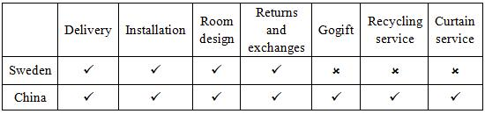

Fig.1 Services Offered by Stores in Sweden and China
(1) Paid Delivery
IKEA has consistently pursued the way of self-operation and self-installation in its globalization strategy. However, Chinese consumers have higher requirements for services, and they are not accustomed to transport or install furniture themselves. There are also external factors. For example, the proportion of private cars owned by Chinese people is not as high as foreigners in developed countries. In 2015, 520 in every 1,000 people in Sweden own private cars, compared to only 128 in China. For people who don’t have private cars, it is not convenient to transport large pieces of furniture home. In Sweden, people can put flat-panel homes on the roof of the car, which is not allowed in China. In this case, IKEA has first promoted paid delivery service in China, and then this service was adapted globally. China is the country that uses the most delivery and installation services, accounting for more than 40% of the world.
(2) Gogift
Gogift is a gift card that equivalent to some value and can be given to others as a present. Since it may be not easy to choose a gift from thousands of products in IKEA, Gogift will make you free from picking up an item. This card has several different pattern designs. The only thing you need to do is to choose one that you like, and then give to someone else you’d like to please.
The Swedish can’t enjoy this service because of their domestic regulations. The Swedish Ministry of Finance stipulates that for some legitimate reasons, gifts, especially to government officials or to foreign visitors shall not exceed 1% of the minimum amount of public insurance for the year as specified by the Swedish Taxation Office. In private companies, gifts are often a little expensive. However, any excessive gift-giving behavior, especially the actual attempt is to bribe someone, is difficult to escape the supervision of the Anti-Corruption Commission. In order to avoid the suspicion, some Swedish authorities have clearly stipulated that gifts will not be given to each other in foreign exchanges. Therefore, IKEA Sweden did not launch the Gogift service.
(3) Curtain Service
This service is only available in China, including curtain measurement, curtain track installation, fabric custom curtains, finished curtain length and width and fabric processing services. The Chinese do not like to do it by themselves in measuring, tailoring, and installing such complicated things; they are more willing to have professionals help. Since customers have demand, IKEA launched this service. The only customers need to do is to choose the right fabric style, and IKEA will provide follow-up processing and installation services.
(4) Recycling Service
The recycling rate in Sweden is as high as 97%. In Sweden, there is a separate garbage room on the ground floor or outside the door of each apartment building. The main categories are: newspapers, plastic products, metal, batteries, kitchen waste and so on. Garbage bins of various colors are marked with pictures. Even if you don’t know Swedish, you can throw your waste accurately into corresponding bins. In China, waste recycling has not been universally accepted and implemented. Therefore, IKEA has specially launched recycling services to facilitate customers’ ideas of discarding old items as well as to protect the environment.
This service aims at recycling old items. When a customer purchases a new mattress or sofa from IKEA and have it delivered, the staff can recycle the corresponding old product as long as the buyer asks for. If the removed product cannot be reused, IKEA will recycle it to minimize the impact on the environment. The cost of removing old furniture is 99 yuan per piece. IKEA promises not to make a profit in cleaning and recycling furniture.
3.2 Price
IKEA’s design has attracted a large number of customers, but many people only regarded IKEA as a place to relax, not a place to buy household items. The reason was that the price of IKEA was still high for ordinary people. Due to differences in exchange rates and living standards between Sweden and China, IKEA has become a home furnishing brand featured with high-price in China. It was inconsistent with the expectations to provide goods for “the many people”. As early as it entered China, IKEA did not adjust prices because IKEA believed that high prices would help establish a brand image and create a competitive advantage. However, later IKEA found that many consumers only idled at IKEA without purchasing, which led to a situation, that is, the passenger traffic was large but the sales volume was not enough. For this reason, IKEA adjusted its price strategy of both product and service according to Chinese consumption level.
3.2.1 Product Price
IKEA stores around the world adhere to the principle of “good quality with low price”. It aims to lower the price of the products while not let customers feel that they are bargains. The only way to do this is to reduce costs. In fact, reducing costs runs through the entire process of IKEA products, including the design, package, delivery part and so on. But in China, IKEA’s price cuts are unprecedented. During the 11 years from 1998 to 2009, the average price of IKEA products in the Chinese market fell by nearly 50%. In the past five years, the price has been lowered by 15%. “We’re really investing in lower prices, and this especially goes for basic everyday needs such as cooking, eating and bedroom products”, Flora Li, the Country Sales Manager of China says. It means most of the price cuts are daily necessities.
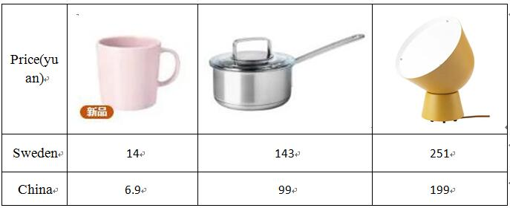
Fig.2 Price Comparison between IKEA of Sweden and China
For example, a kind of mug costing 20 Kr in Sweden, which is equal to 14 yuan, is sold at 6.9 yuan in China; a stainless steel pot costing 199 Kr in Sweden, which is equal to 143 yuan, is sold at 99 yuan in China; a table lamp costing 349 Kr in Sweden, which is equal to 251 yuan, is sold at 199 yuan in China. The price reduction of such commodities in China has something to do with the gap in the per capita income of the two countries. In 2017, Sweden’s per capita annual income was RMB 543,000, ranking second in the world; the average annual income of the Chinese is ranked 69th in the world, at 55,412.49 yuan, leading to the gap in consumption levels. There may be another reason for such price differences, that is, the cost of production in China is lower. Therefore, it is appropriate and necessary for IKEA to cut down the price of daily items.
For food, such as a cylindrical ice cream for 1 yuan, a hot dog for 5 yuan, these foods have never changed its price since the very beginning. In the fast food store like McDonald’s and KFC, the cylindrical ice cream at least sells at 6 yuan. This kind of price advantage is also one of the reasons that consumers like to visit IKEA. What’s more, IKEA membership can enjoy free coffee and refill for free on weekdays. This breath-taking price and preferential can only be found at IKEA, which is also a feature of IKEA.
3.2.2 Service Price
The service fees in China have been getting cheaper in recent years. When the delivery service was first launched, many people were unsatisfactory with the high price and dismissed the idea of having IKEA delivered. Later, IKEA adjusted its service price, and the current price is much lower than that of Sweden. Nowadays, it is received and afforded by many people to enjoy delivery, assembly and installation service of IKEA. Here we mainly compare the delivery prices in physical and online store between Sweden and China and figure out what IKEA has changed in terms of price for Chinese market.
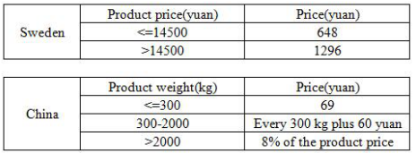

Fig.2 Delivery Price Sheet (Offline)
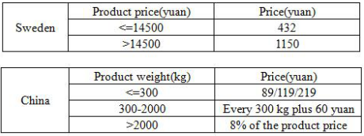

Fig.3 Delivery Price Sheet (Online)
By comparing the delivery conditions and expenses after purchasing goods from IKEA physical stores and online stores, it can be seen that the delivery cost in Sweden is based on the product price, while in China is based on the weight. It seems that there is no comparability under different conditions. But by comparing the price sheet, the delivery costs in China, on the whole, are lower than that in Sweden. For example, a sofa bed for two persons. Swedish store sells at12095 Kr (RMB 8554 yuan) while Chinese one sells at 7999 yuan. If you ask for the delivery service in the physical store and you live in the city, the shipping cost is 432 yuan and 89 yuan in Sweden and China respectively. This can prove that what the Chinese regional manager has said, “IKEA of China has relatively low prices in terms of delivery and installation”.
3.3 Place
IKEA of China ranks first in the purchasing countries all over the world, but the sales volume can’t even enter the top five. Therefore, in recent years, IKEA has continued to expand the number of stores in China. Considering the people flow, most IKEA stores are located at places with convenient transportation nearby.
What’s more, IKEA announced multichannel policies, including online store and PUP (Pick up & Order Point), to offer more accesses to IKEA goods. From production to distribution to sales, IKEA always keeps its own standard system. In China, in order to save costs, under the premise of fine quality, IKEA tends to choose domestic well-known suppliers to provide goods for stores. IKEA has also established a large warehouse in Shanghai. Most of the domestic goods are stored there and Malaysian warehouses, and eventually shipped to different stores.
3.3.1 Selection of Location
In Sweden and even the whole world, IKEA store always locates at the suburban area with spacious car parking and other amenities. In Sweden, consumers have private cars and they don’t have to worry about the traffic. In the meantime, they often choose the suburbs as the best place to live and relax. On the contrary, many Chinese consumers do not have private cars, if insisting on building IKEA store in suburban area, the inconvenient transportation with long-distance may hold back people’s desire to go there, leading to sluggish visits. That’s why convenient transportation matters for business stores in China. This can be proved by the location of the first Chinese standard store of IKEA – the Shanghai IKEA store, next to the bustling Xujiahui business district. The Beijing store is located on the edge of the Third Ring Road, which is also a convenient transportation area.
3.3.2 Multichannel Sales
In May, 2016, IKEA of China officially announced a multichannel policy. Besides the physical stores, IKEA opened another two channels of e-commerce and PUP(Pick up&Order), including one online store and three Pick up& Order center. In response to the growing popularity of online shopping in China, IKEA launched an online store. It allows consumers to reach IKEA products and services at any time and place as well as improve the brand’s awareness. By comparing the official websites in two countries, it can be found that Sweden’s official website homepage emphasizes aesthetics and creativity, while China’s highlights price-off promotion. This is because the Chinese are more sensitive to price and are more likely to be attracted by lower price.
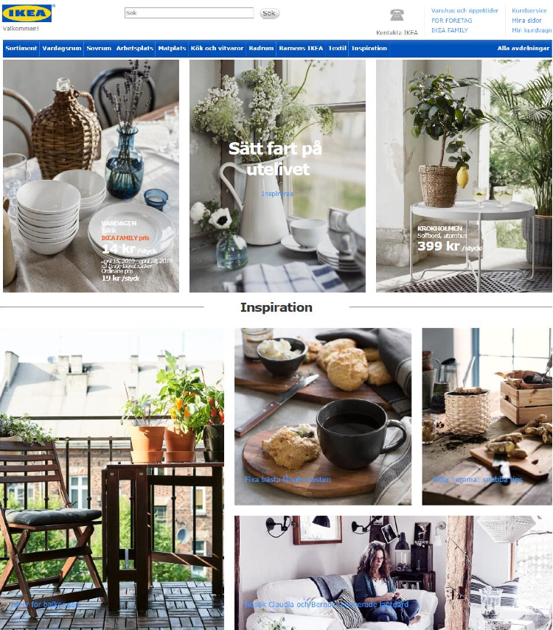
Fig.4 Homepage of IKEA of Sweden
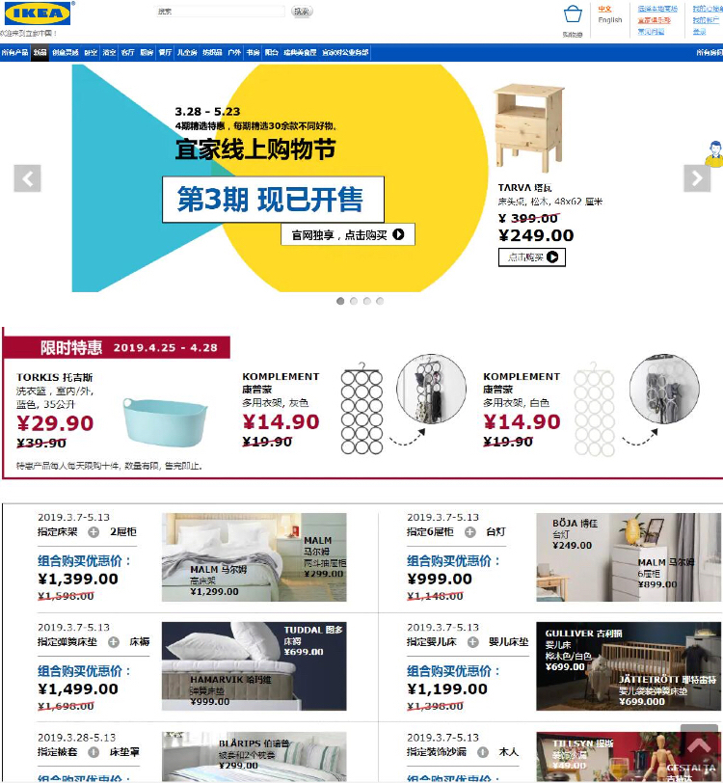
Fig.5 Homepage of IKEA of China
As for PUP, its initial purpose is to offer customers convenience and make them free from going to the crowded store. IKEA has noticed different consumption habits. Some customers are willing to take their good on their own, but most people require sending the goods home. Meantime, in order to avoid sales competition in different channels, the goods of PUP are from nearby physical store.
3.4 Promotion
IKEA’s promotional feature is that it almost never hires promotion personnel and makes very few ads. Compared to high-frequency advertising exposure, IKEA’s name is more spread through social networks or word of mouth, especially among youngsters. Compared to conceptual advertising, IKEA would rather spend its mind and money in a more realistic place. In other words, IKEA considers a physical store as the best marketing vehicle. Therefore, IKEA’s promotional strategy can usually be reflected in physical stores.
3.4.1 Buying Guides
Every September, IKEA will launch a brochure of their products as thick as the yellow pages of the phone called Buying Guides. The content of Buying Guides varies from countries and regions. For example, in Sweden, the Buying Guides divides products into different types according to their function, each of which has their own corresponding guides. But in China, it is the clue “family story” that runs through the whole brochure. The Chinese version is always divided into several families with different themes. Under the circumstances, IKEA will create a variety of life scenes and guide customers how to match. For example, under the theme "More Is Not A Problem", it mainly displays the products with storage function; under the theme “Limited Space, Unlimited Oneself”, it displays the products with distinctive colors and characteristics to show people’s personality. When IKEA has just come into China, the brochure at that time had a special feature, that is, the catalogue was covered with a downward arrow indicating a price cut just like the promotional leaflet you get in the supermarket. At that time, IKEA was inclined to simply and rudely mark the price of various products on the brochure. Even the copywriter also stress the low price. For example, an introduction to a desktop trolley at 129 yuan said: Once, I spent 129 yuan, only bought a very small bottle of perfume. IKEA believes that in this way can get rid of people’s doubts about purchasing.
In the 2005 edition of the product catalog, the China regional manager wrote on the first page: “In China, we have been working hard to reduce the price of our products”, showing that IKEA values the Chinese market and is willing to cut prices to attract customers. In order to attract customers, IKEA launched five different editions of the brochures in five periods of a year since 2007, each with 6.9 million copies, equivalent to more than 35 million free copies, which increases the target customer’s ownership rate from 40% to 80%. IKEA has been putting the bargains in the forefront and most conspicuous place of the brochure by the year of 2012. Things changed in 2013. When you opened the Buying Guides of 2013, the first thing you saw was: Welcome to a world full of creativity. At that time, with the economic development and income increase, most people did not have trouble in food and clothing and began to pursue the quality of life. Thus, from then on, IKEA no longer just emphasized low prices. In 2019, the preface of the brochure is "There are various new products and endless freshness. Even better, with affordable prices, these goods can be taken home with ease." This proves that even though the Buying Guides no longer focus on low price today, it still deserves to be mentioned.
All these show that when customers have slender income, IKEA would firstly focus on the products and emphasize the price advantages to quickly gain the trust of the target users. As economy develops and everyone lives better, IKEA would lay emphasis on passing the brand idea and philosophy instead of the products or prices so as to increase both the brand awareness and customer loyalty.
3.4.2 Advertising
In a mature market like Sweden, what IKEA usually does in an ad is to tell stories to increase the brand value. Advertisements are generally represented by scenes without much dialogue there. If it is not the IKEA logo appearing in the end, you may not know what the advertisement is about. However, in China, IKEA ads intend to focus on promoting sales. Based on this difference, IKEA have to make some changes. Advertisements in the Chinese market usually have plenty of well-designed narrations. The lens switching is like a picture-talking. Of course, the most important thing is the close-up shot of the knives, the tablet holder, the dishes, the product names and prices with conspicuous, bold fonts. The reason for such difference between the ads in the two countries is that in the Chinese market, IKEA still needs to explain to consumers what they are doing and what the style of the product is. “According to our experience, Chinese consumers are still more price-oriented, which is very obvious in the furniture industry”, said Liu Yang, vice president of digital network of LEO, in an interview by Curiosity Daily in 2015. Faced with such a growing market and a group of consumers who are sensitive to price, IKEA must try its best to place something that pleases customers in a time- limited advertising, such as price and product details.
3.4.3 Special Activities
At the end of 2014, IKEA hosted a pajama party in Shanghai. This is the first large-scale event of IKEA in China to convey the knowledge of home furnishings and storage. At the turn of seasons between autumn and winter, people will naturally have more time in the bedroom with a lot of heavy clothing needs storing. At the same time, the bedroom space is the center of IKEA’s FY2015. In the “Report of Urban People’s Home Life in China”, 50.4% of the respondents said they could not sleep immediately after going to bed, and 56% of the respondents thought their sleep quality remains to be improved. In IKEA’s view, it is a propaganda point to guide people to arrange the bedroom space more reasonably, help them choose the right bedding and create a reasonable sleeping atmosphere. Based on the above two points, IKEA organized such a gardening event in Shanghai to deliver useful information including collocation, interior lighting and storage in interactive games. Statistics shows that hundreds of people participated in this activity, through which more people realize the uniqueness of IKEA: not only selling houseware series, but also spreading the concept of home.
3.4.4 Others
(1) WeChat Official Account
As the most popular communication tool for Chinese people, WeChat is also a good channel for expanding publicity. IKEA has opened the WeChat official account, which includes the most basic services. With this account you can browse the Buying Guides, look up IKEA’s latest products, activities, VIP’s Special and services. If you are interested in a certain product, you can go to the online store via WeChat account to see more information.
(2) Dialect Copywriter
The IKEA store in Harbin, opened in 2018, uses a Northeastern accent and a local store design. This novel marketing approach has attracted many locals, not only increasing the flow of people, but also developing many potential customers, because as long as they enter the store, there will be chances to consume. Even a dollar of ice cream will achieve high returns.
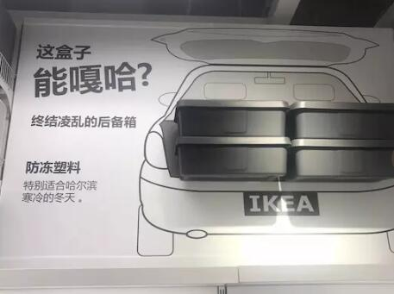
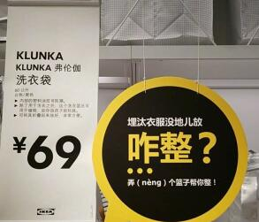

- Enlightenments
Through the analysis of the marketing strategies above, it can be seen that IKEA has its own knack in integrating into a new market abroad. Enterprises are suggested not to indiscriminately imitate the successful experience in the domestic market, but to take into account all factors of the local market and to apply localized strategies to adapt to the targeted market. IKEA is oriented to the needs of consumers and takes people’s comfort as the starting point. From the store’s layout, product design to after-sales service, it is based on the convenience, effectiveness and comfort of consumers.
Bring forth new ideas while operating existing marketing strategies so as to enhance the core advantages and maintain the competitiveness.
4.1 Product Improvement
The products of IKEA are globally unified. However, in China, slight adjustments are made according to the local family situation and lifestyle, such as some appearance and function adjustment. IKEA tells us that a retail store should be oriented to the needs of consumers. It is feasible to make products that are in line with the local’s habits and customs. At the same time, it is suggested that Chinese home furnishing enterprises make full use of China’s excellent traditional culture and combine them to form unique home features with Chinese characteristics.
4.2 Price Adjustment
As early as it entered China, IKEA kept a relatively high price of all products, thus leading to a situation that many consumers only idled at IKEA without purchasing. Later, IKEA made a compromise and adjusted its price comprehensively, and was finally acknowledged and received by the public. This tells us that when multinational companies enter a new market, the pursuit of profits should indeed not be rushed. More importantly, they must first adopt some strategies like overall price reduction to attract customers and expand brand awareness. Then they can adjust the price according to market as long as the company’s foundation is laid locally.
4.3 Multichannel Sales
IKEA tells us that it is high time to pursue profits when multinational companies develop steadily in new markets. They’d better consider expanding into sales channels to increase sales volume. According to the golden rule of the retail chain industry, only when the number of stores reaches a certain amount, can the sales volume increase and the cost reduce. Through online store, Pick up& Order centers and the expansion of physical store, customers have more accesses to IKEA products, which undoubtedly increases purchase opportunities.
4.4 Optimization Services
IKEA tells us that the added value of a product is sometimes more important than the value of the product itself. The added value of the product includes the convenience of delivery and installation, the comfortable sales and after-sales service. IKEA’s paid distribution, assembly and other services for the Chinese market can reduce customers’ worries after purchasing. However, in the long run, in order to further enhance the brand loyalty of local consumers, free on-site services should also be taken into consideration.
4.5 Diverse Methods of Promotion
IKEA maintains its characteristics. It does not hire promotional staff, thus gives customers a free and comfortable shopping experience. But it doesn’t mean that IKEA never makes promotions. In terms of creative promotion, from the launch of IKEA WeChat official account, customized advertisements to official homepages that are more in line with Chinese tastes, IKEA can easily catch people’s attention. Therefore, we can conclude that, compared with peddling commodities, tailor-made promotions that are in accordance with local needs and features can easily captivate customers.
In a word, multinational enterprises are suggested to adjust strategies according to the market instead of indiscriminately imitating the previous successful experience in their own country. In this way can enterprises form their own unique advantages and better integrate into the local market.
- Conclusion
Till now, IKEA has become a symbol of lifestyle in China. For many people, using products from IKEA has become a lifestyle like eating McDonald’s and drinking Starbucks coffee. Everything doesn’t happen at once. There are also ups and downs in the course of IKEA’s development in China. At the initial stage, considering the development gap between Sweden and China, IKEA turned its attention to the relatively wealthy class in the big cities. IKEA set its sights on Chinese white-collar workers who can’t afford the fancy goods that they want. IKEA tries to bring consumers a feeling – you can buy incredible bargains here, which are called “breath-taking items”.
To adapt to Chinese market, IKEA has made many changes. In product, IKEA insists the classical Nordic style featured with conciseness. For Chinese market, they launched chopsticks, rice bowls and toys with Chinese features. They also renew the menu of IKEA restaurant and promote dishes that attract local people. What’s more, IKEA promoted paid-delivery and installation and other services to meet customers’ demands. In price, IKEA has cut down the price of part of items as low as possible while leaving the margin of profits. Out of a psychology of snapping up bargains, customers without purchasing desire usually would like to buy at least one cheap item. In fact, this kind of act would create an amount of income, which fits in exactly with IKEA’s wish. In place, IKEA announced a multichannel policy, including the channel of e-commerce and PUP(Pick up & Order Point) so as to offer convenience to people who don’t want to idle in the crowded store. IKEA was also careful about its location because it would influence the people of flow. In promotion, without promotion personnel and much ads exposure, the name of IKEA is more spread through social networks or word of mouth, especially among youngsters. For brochure and ads, IKEA has made some changes to better cater to the local. And other promotions can usually be reflected in physical stores, such as discounts and dialect copywriter.
Although there still exist some problems in the quality of the products and the service and other aspects, we can’t not deny IKEA has spared no efforts to cater to Chinese customers by unceasingly adjusting their strategies.

References
- Bhutta,KhurrumS.Huq,Faizul. An integrated location,Production, distribution and in-vestment model for a multinational corporation[J].International journal of Production Economics, 2011 (86):74-77
- Bjokrman, Lngmar, Oslnad, Gregory E. Multinational corporations in China: responding to government pressures[J].Long Range planning,2008(31):436.
- Doherty G, Ennew CT. The marketing of pharmaceuticals: standardization or customization[J].Journal of Marketing Practice: Applied Marketing Science, 2005(3):39-50.
- Dong-Ik Choi. Localization of foreign multinational companies in Korea [J].Global Economic Review, 2004, 33 (3):89-93.
- Jerry McCarthy. Marketing[M], 1960:253-256.
- http://www.ikea.com/cn/zh/ (2019).
- https://www.ikea.com/se/sv/ (2019).
- IKEA GROUP YEARLY SUMMARY FY14[R]. 2014.
- IKEA GROUP YEARLY SUMMARY FY15[R]. 2015.
- 白嘉，张会新. 宜家（中国）的本土化营销战略[J]. 经济导刊，2010(6):42-43.
- 陈晓环.宜家与无印良品的本土化设计比较研究[J].河南教育学院学报（哲学社会科学版），2018(1):29-35.
- 杭永珏. “宜家”造型设计在中国市场的成功因素研究--探讨对中国同类设计的可借鉴之处[D]. 上海：上海交通大学，2007:26.
- 刘金喜，贾凯.浅谈跨国公司在华全方位营销本土化战略企业活力，2006(7):92-94
- 吴雪梅.运用成本领先战略提升企业核心能力——以宜家为例[J].价格理论与实践，2007(3):75-76.
- 宜家集团2016中国可持续发展报告[R]. 2016.
- 王晓辉.我国企业跨国经营存在的问题与对策[J].国际贸易问题，2013(3):34-37.
- 王彦.浅析跨国公司在华经营本土化战略[J].长春理工大学学报，2013,19(6):81-83
- 张璇. 当全球化遇上本土化——探析宜家的发展战略[J].中国市场，2013,45:74-75.
- 张艳.美国大众文化中国本土化的跨文化阐释——以中国大陆肯德基为例[J].新余学院学报，2014,19(6):120-122.
Acknowledgements
It is painstaking to write this paper. Thanks to the help of my classmates and teachers, I can finally make it. In particular, I would like to extend my deep appreciation to my supervisor, ***. With her tirelessly urge and pertinent suggestion, my paper worked out well. She charted the course for me and gave me confidence in finishing the paper even though numerous obstacles are in the way. Here, I would like to express my heartfelt thanks to my teachers and classmates.
At the same time, I would also like to thank the scholars for their monographs. Without the inspiration and help of these previous researches, I will not be able to complete the final edition of this paper. At this point, I would also like to thank my friends who provided much help in the process of typesetting and writing.
No one is perfect. Due to my limited knowledge, it is inevitable that there exist some defect in this paper. Please feel free to indicate any mistakes.

Notes ? Term explanation is from Roger A. Kerin‘s Marketing
Term explanation is from E.J. McCarthy’s Basic Marketing
Term explanation is from Li Qingman’s Marketing Standardization
Term explanation is from Wikipedia
Data is from Kdnet https://www.kdnet.net/.
Date is from IKEA GROUP YEARLY SUMMARY FY15

