Cluster Computing (2019) 22:S2517–S2525 <https://doi.org/10.1007/s10586-018-2329-2>



IoT based fall detection and ambient assisted system for the elderly

I. Chandra1 • N. Sivakumar2 • Chandra Babu Gokulnath2 • P. Parthasarathy2

Received: 11 February 2018 / Accepted: 28 February 2018 / Published online: 16 March 2018

© Springer Science+Business Media, LLC, part of Springer Nature 2018

Abstract

Falls are considered as risky for the elderly people because it may affect the health of the people. So, in the recent years many elderly fall detection methods has been developed. In the present years many fall detection method had been developed but it uses only accelerometer sensor to detect the fall. It may fail in finding in the difference between actual fall and fall like activities such as sitting fast and jumping. In the proposed approach I have suggested a fall detection algorithm to detect the fall of elderly people. Daily human activities are divided into two parts such as static position and dynamic position. With the help of tri-axis accelerometer proposed fall detection can detect four kinds of positions such as falling front, front backward, jumping and sitting fastly. Acceleration and velocity is used to determine kind of fall. Our algorithm uses accelerometer and gyroscope sensor to predict the fall correctly and reduce the false positives and false negatives and increase the accuracy. In addition to that our method is made out of low cost and it can be used in real-time.

Keywords Accelerometer · Gyroscope · Fall detection · Threshold acceleration · Long-lie · Short-lie · Detection period ·

Angular velocity

# Introduction

Falls are considered to be novel method for the elderly people. According to recent survey one in 54 people fall at least once in a year [1]. Falls are considered to be highly dangerous for the people working in high buildings and fire-fighters. So the fall detection has to be considered as dangerous [2]. Since the present fall detection method uses only accelerometer to detect the fall it may fail sometime to detect the fall. However with the help of acceleration and velocity the accuracy can be achieved and it reduce the false positives and false negatives. Some fall detection algorithms detect only fall and they don’t categorize kind of fall such as real fall and fall like activities. Much fall detection is in market and they are not used properly. Monitoring is important for the high aged group people and that can also be done by the humans but it’s not possible to look after them every time so there is a need of a machine the detects automatically [3]. Smart phones came into

& N. Sivakumar [knsksiva@gmail.com](mailto:knsksiva@gmail.com)

1 R.M.D Engineering College, Chennai, India

2 VIT University, Vellore, India

existence to detect the fall because it’s not requiring any additional method and it also light-weighted.

With the help of gyroscope sensor attached to the mobile it can detect the fall [4]. When both gyroscope and accelerometer sensor attached together it can increase the accuracy rate of fall detection. While gyroscope can detect the fall with the angle whereas accelerometer detects the fall with the help of acceleration.

In case of hospital increase in number of patients it becomes hard to do manual monitoring so there increases the number of fall. Some fall detection algorithm considers sleeping as also a fall so accuracy rate is low and the number of false positives increases. To improve the accu- racy of the detection some algorithm like used to detect the fall with the help of acceleration phase [5].

Our solution divides the daily human activities into two broad categories such as static position and dynamic position, with the help of tri-axis accelerometer combined with the gyroscope the accuracy can be achieved where accelerometer is using acceleration and gyroscope uses velocity angle to detect the fall [6].

S2518 Cluster Computing (2019) 22:S2517–S2525

# Related work

There are several methods used to detect the fall using motion sensor like the work done by Lopez et al. [7]. The work shows that fall can be detected with the help of motion of elderly people and its research says that detec- tion accuracy rate is 83.673%. Whereas there is number of false positives increases and that has to address. In the work done by Rawal et al. using a camera and the camera has been placed in the room that monitors the elderly people [8]. This camera takes the picture randomly and finds any change in the position of the elderly people. This produces good result in detecting the fall. However with the help of sensor detection can be possible.

Fall has been detected with the help of gyroscope and accelerometer sensor. In the work [9] uses accelerometer sensor to detect the fall and he uses tellos v chip with the computer. So the detection can be done only where the system is present. The work done by Manogaran et al. is using accelerometer and gyroscope where gyroscope uses its angle and accelerometer uses accelerometer uses acceleration to detect the fall [10].

Existing fall detection algorithms uses two sensors for fall detection the first one accelerometer sensor it uses the acceleration for the detection and the second one is gyro- scope sensor and its uses its velocity angle and if there is any change in the velocity angle it has considered as the fall in the system algorithm [11, 12].

A tri-axis accelerometer and it has been placed in the body of the people and based on the acceleration value the fall has been predicted by the system [13, 14]. It used the combination of accelerometer and gyroscope sensor and based on the acceleration and velocity values obtained the fall is been predicted. Varatharajan et al. [15] has studied the acceleration falls with the accuracy and the tied accelerometer on the hand, tie and waist and checked the acceleration and finds the accuracy. Manogaran et al. [16] used 2 tri-axis accelerometer and they tied it in hand and another one to leg and checks the threshold value of both the accelerometer and if the threshold value exceeds on both the accelerometer then it has been considered as the fall. With only the help of only acceleration sensor there may be increase in accuracy and increase in the false positives so the falls cannot be detected properly.

Thota et al. [17] uses three sensors in its work and the three sensors is tilt sensor, motion sensor and kilometric accelerometer to predict the acceleration and motion sensor monitors the motion of the elderly people. They detect the body falls based on the monitor sensor and detects the body orientation, and detects the motion [18]. Designed a model that uses a five step monitoring process and uses five accelerometers and attached to parts of the body even with

the clothes and detects the falls based the acceleration value obtained from the system. Philips’ Lifeline [19] use a hidden model uses a snooze button and that used to send an alert message to the sender and alerts them in case of fall is occurred [20, 21]. Developed a model by placing a accelerometer sensor in the boots and the results shows that its 83.34% and it produces false positives when placed in the end of the boot.

Thota et al. [22] used a wearable accelerometer and uses a hidden support vector machine algorithm to detect the accuracy and the false positives and detects the falls with the help of the system. Manogaran et al. [23] proposed a model to predict the accuracy and it achieved the sensi- tivity of 93% and specificity of 94%. [24] Proposed the new algorithm that uses a tri-axis accelerometer to predict the fall and it produced the result of 93%. They developed a mobile application for fall detection and its sends alert message whenever it predicts the fall is been occurred.

Manogaran et al. [25] developed a mobile application that is used as wearable device that sends the alert when the fall is predicted and sends the message to the contacts that has been stored and also sends the GPS location of the victim. The commonly used sensors are accelerometer, gyroscope sensor, motion, tilt sensor, infra-red, pressure sensor and the detection and detection algorithm varies from one sensor to the others. Lopez et al. [26] suggested a model that uses the axis of the body and uses threshold and angle of velocity to detect the fall. Manogaran et al. [27] designed a model and captures the random image and if there is any difference in the image it considers as a fall.

Wearable sensor that can be worn in the human body and detects the fall, about almost model present uses accelerometer to predict the model and remaining system uses accelerometer with combined of gyroscope sensor and predicts the fall Varatharajan et al. [28] placed a sensor in the foot and used tri-axial accelerometer and detects the threshold value from that it predicts fall occurred or not. Lopez et al. [29] Monitors the daily activity and fall has been detected and decision has taken based on the decision making algorithms. The accelerometer with the mobile phones detects the falls and uses algorithm such as support vector machined, supervised machine learning and logistic regression.

# Data acquisition

To get the acceleration values an flowchart has been used, and the data has been obtained with the accelerometer sensor. The accelerometer sensor uses acceleration and velocity to get the values and with help of these we can detect whether the fall is occurred. At this step with the

Cluster Computing (2019) 22:S2517–S2525 S2519

help of actions done by the volunteer and the actions like walking fast, running and sitting fast.

In this method, the research has been carried by per- forming the following body postures, like walking fast, sitting fast, jumping from the following body postures the acceleration data has been taken and with the help of acceleration sensor the fall has been checked whether it has occurred.

Whenever, there is a change in the body postures, the sensor sends the alert with the help the acceleration data has been taken with the help three co-ordinates XA, XB, XC.The acceleration data of the current body postures, is calculated using the formula,

X ¼ pXA þ XB þ XC

# Fall detection parameters

To detect the fall, five body positions has been performed using a volunteer, with the help of the sensor the body postures has been performed if there is any change in the position of the sensor then the sensor sends the alert message with help of that the amplitude values has been taken, The sum of them magnitude values is denoted as (SVEM), the difference in the magnitude values is denoted has (DFSVEM), acceleration angle is denoted as (!).

2

2

# Fall detection system

Fall detection method depends on the static and dynamic positions and sensors like accelerometer and gyroscope sensor placed in the human body, accelerometer uses acceleration and gyroscope uses velocity angle and the decision is taken with help of algorithm based function to detect the fall.

## Block diagram of fall detector

The block diagram possess main parts like (i) accelerome- ter and gyro sensor, (ii)Wi-Fi module, (iii) buzzer, (iv) snooze button. The accelerometer sensor is used to find the acceleration and gyroscope is used to detect the fall with the help of velocity angle and it maintains a threshold value if the value exceeds the limit it is considered as a fall. Secondly it consists of Wi-Fi module and that is used to transfer the message through internet. GPS module is used in sharing the location in case the fall is occurred the message from victim is sent to the contacts that have been already stored. There is a buzzer button it will give alarm when the fall occurred suppose it gives alarm for fall like activities the elderly people can off the buzzer button so the alert message will not be sent to the nearby people. The triaxial accelerometer is used to find the body postures. The

ASVEMðiÞ ¼ pA2

xðiÞ

þ AyðiÞ

þ AyðiÞ

angle information is obtained from the three axis and it

differs from different postures. The different value gener-

1ðiÞ ¼ tan—1

2

pA2

yðiÞ

þ AzðiÞ! ×

180

ated from the three axis is taken in different pins by

ADVEMðiÞ;

¼ ..AxðiÞ

A2xðiÞp

* Axði—1Þ

ΣΣ ..þ A

2

yðiÞ

p

* Ayði—1Þ

ΣΣ2

selecting only one signal at a time. The obtained signal is

converted in to digital format with the help of analog to digital converter, and then the obtained digital values are compared to the static threshold values present. The posi-

tions value obtained is delayed by 23% in order to reduce

þ ..AzðiÞ

* Azði—1Þ

ΣΣ1=2

the false positive produced.

Wi-Fi module is used to send an alert message to the

¼ A ¼ lðiÞ × A

nearby contacts of the elderly people and help them. The

GVEMðiÞ 90

SVEMðiÞ

messaging contacts are saved before. The micro controller

where I denotes the amplitude values that are x(i), y(i), z(i) that denotes the x-axis, y-axis and z-axis, the ! denotes the titled angle between the amplitude in the accelerometer sensor, and the fall is detected based on the accelerometer magnitude value.

and the Wi-Fi module is charged using an USB cable and the charge produced to the every parts of the controller.

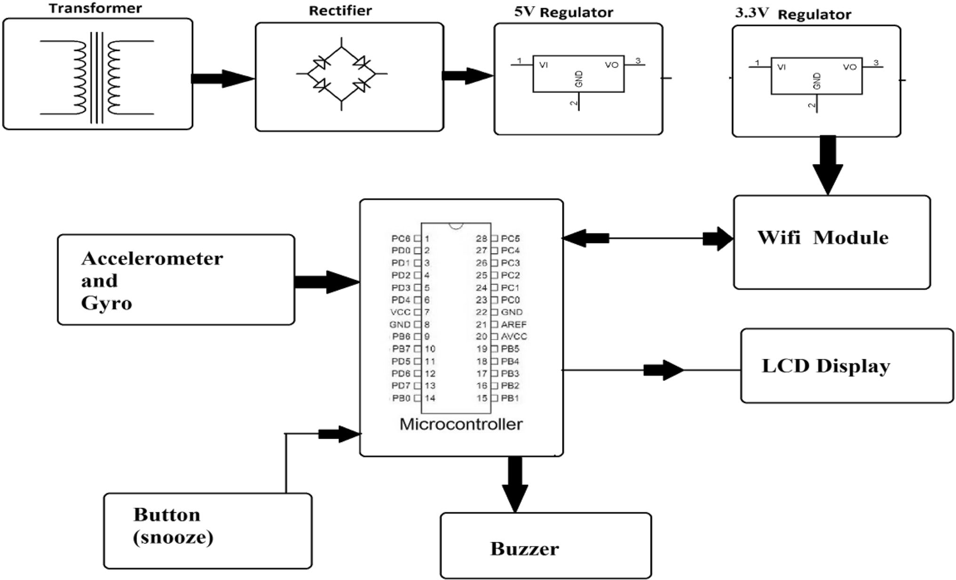S2520 Cluster Computing (2019) 22:S2517–S2525

## Data analysis

For each activity the acceleration values are stored. Each position has different values that are used to detect whether the fall is occurred or not. Based on the values obtained some important features to be shown are:

* + 1. In seating fast state the acceleration value is almost same. Because in seating the value does not change.
    2. In jumping state, the value of acceleration raises when he jumps up and acceleration value goes down when he comes down. The difference between the high and low is calculated and its twice the value.
    3. The value goes high when standing up and acceleration value comes down when he seats and the difference between maximum and minimum and the difference obtained is thrice of the value.

## Algorithm

Based on the value obtained, an algorithm for the fall detection is developed. The algorithm indicates the follow- ing steps the ports are checked and charged and analog to digital converter module has been placed to convert the

analog value. The global positioning system is configured in the block and its used to transfer the information from one system to the other. The basic analog values are obtained from the sensors and that analog value is converted to digital using analog to digital converter. Suppose a fall has been occurred the GPS module is used transfer the information with the elderly people place. Based on the analog values obtained and its compared with the pre-defined thresholds and if the value is greater than the threshold value and waits for some delay and fall is been detected.

Step 1. Initialize serial communication ports of microcontroller.

Step 2. Configure ADC and analog input channel. Step 3. Initialize GPS and GSM modules.

Step 4. Receive analog inputs from sensor.

Step 5. Receive location information from GPS.

Step 6. Compare the digital values of sensor signal with predefined thresholds. If acceleration is greater than the threshold go to step 7, else go to step 4.

Step 7. Wait for time t and again read acceleration values. Compare with same threshold again.

Step 8. Is fall detected? If yes go to step 9, go to step 4 if not. Step 9. Send text message to stored numbers, send alarming signal to indicators if the operating mode 1. Send only alarming signals to the indicators if mode 2.

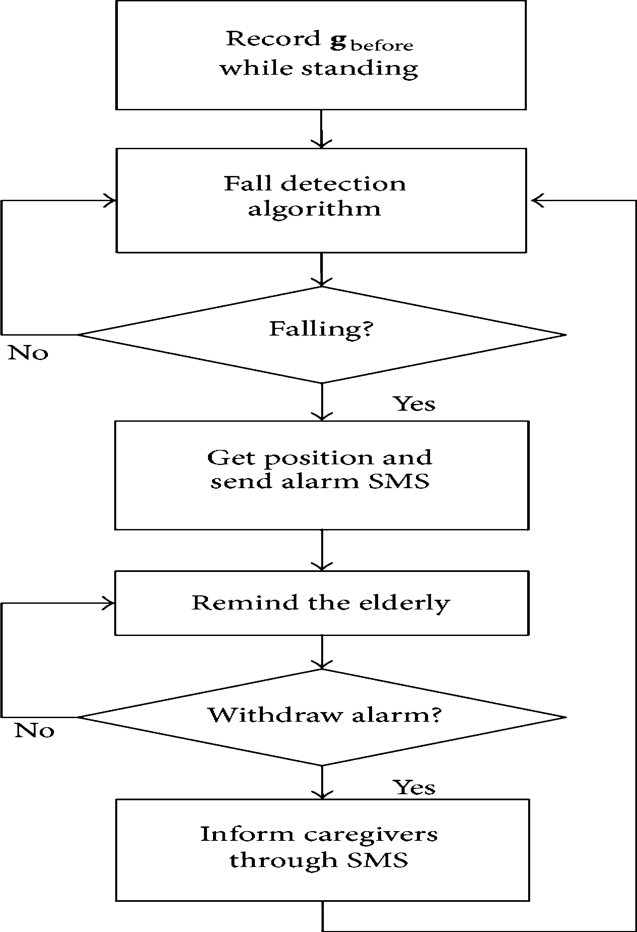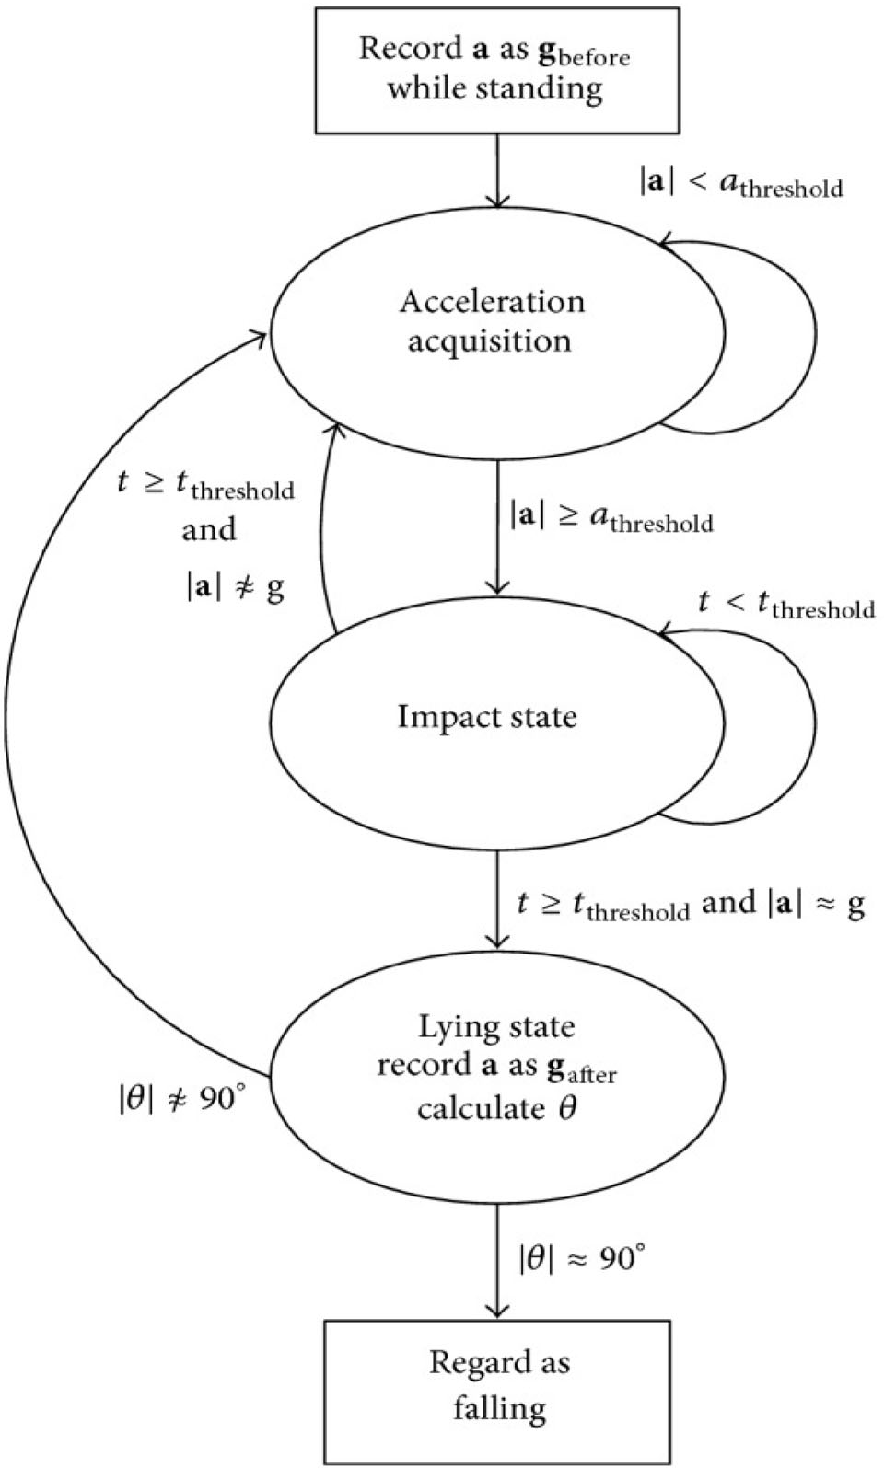Cluster Computing (2019) 22:S2517–S2525 S2521

## Selection of threshold voltage

The fall detection device is placed to the waist to note the value carefully and to be sensitive. The device gets the value of g before the motion there is no requirement for the device placement but for the threshold value the device has to be in static position *a*threshold means combined value magnitude acceleration and *t*threshold means oscillation time during the magnitude time *a.*

When the value from the three axis is obtained and the sum of acceleration value is calculated and it’s denoted as

|a|. when the fall of the elderly people is predicted the graph flucations will not stop until it reaches the value of

|a| [ *athresold.*

When the fall is predicted the value of acceleration will not remain constant with the time *tthreshold*. Then the acceleration of *a* is subdued as *agear*. At last the fall is predicted based on the rotation angle.

Based on the experimental result obtained, maintain the between value of true positive and true negative is bit risky process. In the algorithm the value between the false pos- itive and false negative is huge in order to maintain the threshold. The value of false positive and false negative should be correct the fall is predicted based on the threshold value. If the value is wrong then the fall is occurred and that could be dangerous for the elderly people.

In order to maintain the accuracy of true positive and false positive a additional layer is added to check the accuracy. The elderly people can come back to normal activities even after he is fallen. In that case the algorithm waits for same time to predict if he is not returning to the stable state then it is considered as fall.

S2522 Cluster Computing (2019) 22:S2517–S2525

# Experiment result and discussion

With fall detection algorithm extra feature called long-lie has been added to predict and detect the fall of elderly people. In order to get the true positive values a little false positives values has to be omitted. In order to get the fall detection values volunteers has been used in the first case the low detection value reduces and increases based on the body acceleration. The long lie period is calculated based on the time the elderly lie in the ground in order to say it’s a long lie state a delay in delay of 30 s is taken. The period of detecting varies from sensor to sensors and it indirectly depends on the body postures.

Varies experiments are carried out in order to get the proper results like the low threshold value, high threshold value, short long lie value and maximum long high value and the different values are obtained (Table 1).

From the above obtained values of short long-lie value and maximum long-lie values from the experimental val- ues. In order to make the fall decision the above proposed algorithm is changed. The elderly people have asked to perform the postures for a longer period of about 2.35 min. Each elderly people are asked different body positions like leaning forward, leaning backward, jumping and running and the results are obtained from the different body pos- tures of elderly people. Each elderly people are asked to do body positions for 5 or 6 times from that the algorithm detected number of falls and checks the true positives and true negatives and the fall has been detected (Table 2).

From the above table, the proposed algorithm achieves the true fall detection method at the rate of 95.5%. The total number of false positives is 12 and the number of false

positives after the long- lie check done is 1. In detection algorithm the false positives value is obtained when the elderly people is in motion and they are from the same human. When the extra feature like long- lie check is added the rate of false positives decreases.

In order to find the accuracy of proposed model and algorithm some experiments are performed. The accuracy is tested in three methods and that has been with the help of accelerometer and gyroscope sensor.

The first method is seating position. In case of seating body posture many method is failed to find the difference between seating and falling. In this method the difference is made with the help of accelerometer sensor. The second postures is running in that state also there is difficulty in finding the difference so the gyroscope sensor is used. In the third case falling has to be deducted for that both accelerometer and gyroscope sensor is used (Fig. 1).

This is the tri-axial accelerometer data from this threshold can be calculated when the fall occurs.

In order to find the accuracy of proposed model and algorithm some experiments are performed. The accuracy is tested in three methods and that has been with the help of accelerometer and gyroscope sensor.

The first method is seating position. In case of seating body posture many method is failed to find the difference between seating and falling. In this method the difference is made with the help of accelerometer sensor. The second postures is running in that state also there is difficulty in finding the difference so the gyroscope sensor is used. In the third case falling has to be deducted for that both accelerometer and gyroscope sensor is used (Fig. 2).

|  |  |  |  |  |  |
| --- | --- | --- | --- | --- | --- |
| Table 1 | Fall detection parameters |  | | | |
| No | Low detection (m/s2) | High detection (m/s2) | Detection period (s) | Low long lie (m/s2) | High long lie (m/s2) |
| 1 | 7.5 | 15.6 | 1.6 | 9.6 | 9.9 |
| 2 | 8.2 | 17.4 | 2.2 | 9.7 | 9.9 |
| 3 | 8.1 | 17.2 | 1.8 | 9.7 | 10.0 |
| 4 | 8.5 | 17.6 | 1.4 | 9.6 | 10.1 |
| 5 | 8.4 | 17.3 | 1.6 | 9.7 | 10.0 |

Table 2 Result when using for an extended period

|  |  |  |  |  |
| --- | --- | --- | --- | --- |
| Person | No. of falls | No. of detected falls | Number of false positives without long lie check | Number of false positives with long lie check |
| 1 | 5 | 5 | 5 | 1 |
| 2 | 5 | 4 | 3 | 0 |
| 3 | 6 | 6 | 0 | 0 |
| 4 | 5 | 5 | 0 | 0 |
| 5 | 6 | 4 | 3 | 0 |

Cluster Computing (2019) 22:S2517–S2525 S2523

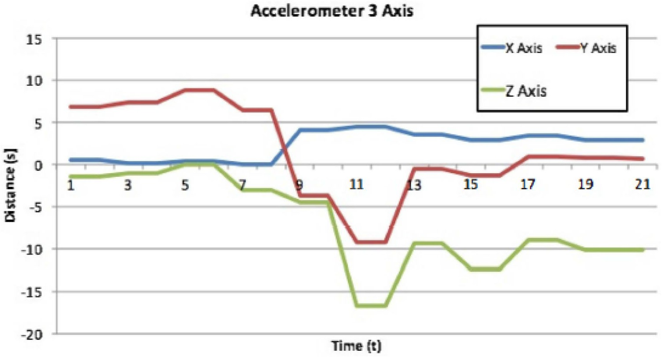Fig. 1 Accelerometer data raw

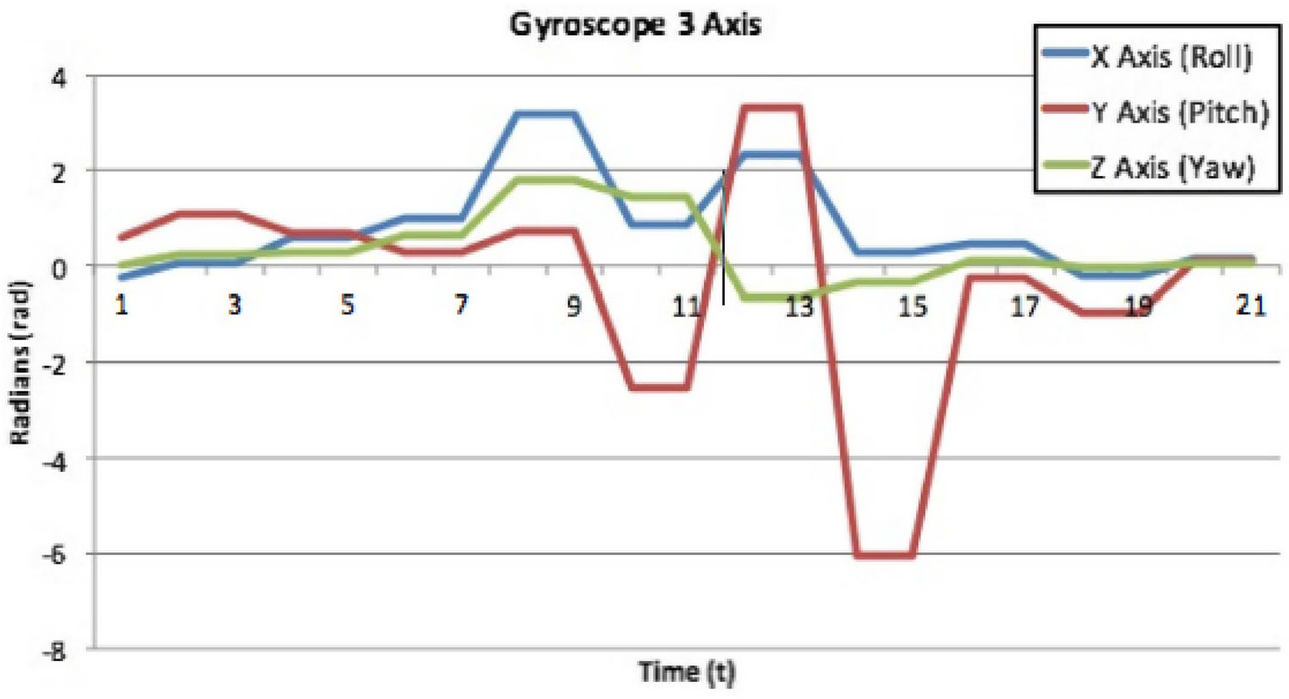Fig. 2 Gyroscope data raw

# Conclusion

In the proposed model, fall detection method has been proposed. From given data the false positive and true positive values are obtained with the help of extra feature called long-lie threshold value the number of false posi- tives is reduced and the accuracy rate achieved from the proposed model is 95.53%. When the elderly people fell the model will detect and activates the alarm. In addition to this algorithm has to be developed for detecting different kind of body postures or falls.

# References

1. Manogaran, G., Thota, C., Lopez, D., Vijayakumar, V., Abbas, K.M., Sundarsekar, R.: Big data knowledge system in healthcare.

In: Internet of Things and Big Data Technologies for Next Generation Healthcare (pp. 133–157). Springer International Publishing, Berlin (2017)

1. Kumar, P.M., Gandhi, U., Varatharajan, R., Manogaran, G., Jidhesh, R., Vadivel, T.: Intelligent face recognition and navi- gation system using neural learning for smart security in Internet of Things. Cluster Comput., 1–12 (2017)
2. Kumar, P.M., Gandhi, U.D.: A novel three-tier Internet of Things architecture with machine learning algorithm for early detection of heart diseases. Comput. Electr. Eng. (2017)
3. Gandhi, U.D., Kumar, P.M., Varatharajan, R., Manogaran, G., Sundarasekar, R., Kadu, S.: HIoTPOT: Surveillance on IoT devices against recent threats. Wirel. Pers. Commun., 1–16 (2018)
4. Kumar, P.M., Gandhi, U.D.: Enhanced DTLS with CoAP-based authentication scheme for the internet of things in healthcare application. *J. Supercomput.*, 1–21 (2017)
5. Priyan, M.K., Nath, C.G., Balan, E.V., Prabha, K.R., Jeyanthi, R.: Desktop phishing attack detection and elimination using TSO program. In: Smart Technologies and Management for Comput- ing, Communication, Controls, Energy and Materials (ICSTM),

S2524 Cluster Computing (2019) 22:S2517–S2525

2015 International Conference on (pp. 198–201). IEEE (2015, May)

1. Lopez, D., Manogaran, G., Jagan, J.: Modelling the H1N1 influenza using mathematical and neural network approaches. Biomed. Res. 28(8), 1–5 (2017)
2. Rawal, B.S., Vijayakumar, V., Manogaran, G., Varatharajan, R., Chilamkurti, N.: Secure disintegration protocol for privacy pre- serving cloud storage. Wirel. Pers. Commun., 1–17
3. Manogaran, G., Lopez, D.: Disease surveillance system for big climate data processing and dengue transmission. Int. J. Ambient Comput. Intell. (IJACI) 8(2), 88–105 (2017)
4. Manogaran, G., Lopez, D.: Disease surveillance system for big climate data processing and dengue transmission. Int. J. Ambient Comput. Intell. 8(2), 1–25 (2017)
5. Manogaran, G., Lopez, D.: Spatial cumulative sum algorithm with big data analytics for climate change detection. Comput. Electr. Eng. (2017)
6. Manogaran, G., & Lopez, D. (2017). A Gaussian process based big data processing framework in cluster computing environment. Cluster Comput., 1–16
7. Manogaran, G., Lopez, D., Thota, C., Abbas, K. M., Pyne, S., Sundarasekar, R.: Big data analytics in healthcare Internet of Things. In: Innovative Healthcare Systems for the 21st Century (pp. 263–284). Springer International Publishing, Berlin (2017)
8. Varatharajan, R., Vasanth, K., Gunasekaran, M., Priyan, M., Gao, X.Z.: An adaptive decision based kriging interpolation algorithm for the removal of high density salt and pepper noise in images. Comput. Electr. Eng. (2017)
9. Varatharajan, R., Manogaran, G., Priyan, M.K., Sundarasekar, R.: Wearable sensor devices for early detection of Alzheimer disease using dynamic time warping algorithm. Cluster Comput., 1–10 (2017)
10. Varatharajan, R., Manogaran, G., Priyan, M.K.: A big data classification approach using LDA with an enhanced SVM method for ECG signals in cloud computing. Multimed. Tools Appl., 1–21 (2017)
11. Manogaran, G., Varatharajan, R., Lopez, D., Kumar, P.M., Sun- darasekar, R., Thota, C.: A new architecture of Internet of Things and big data ecosystem for secured smart healthcare monitoring and alerting. Fut. Gener. Comput. Syst. (2017)
12. Thota, C., Sundarasekar, R., Manogaran, G., Varatharajan, R., Priyan, M.K.: Centralized fog computing security platform for IoT and cloud in healthcare system. In: Exploring the Conver- gence of Big Data and the Internet of Things (pp. 141–154). IGI Global (2018)
13. Manogaran, G., Vijayakumar, V., Varatharajan, R., Kumar, P.M., Sundarasekar, R., Hsu, C.H.: Machine learning based big data processing framework for cancer diagnosis using hidden markov model and GM clustering. Wirel. Pers. Commun., 1–18 (2017)
14. Lopez, D., Sekaran, G.: Climate change and disease dynamics—a big data perspective. Int. J. Infect. Dis. 45, 23–24 (2016)
15. Manogaran, G., Vijayakumar, V., Varatharajan, R., Kumar, P.M., Sundarasekar, R., Hsu, C.H. Machine learning based big data processing framework for cancer diagnosis using hidden Markov model and GM clustering. Wirel. Pers, Commun., 1–18 (2017)
16. Varatharajan, R., Manogaran, G., Priyan, M.K.: A big data classification approach using LDA with an enhanced SVM method for ECG signals in cloud computing. Multimed. Tools Appl. 1–21 (2017)
17. Thota, C., Sundarasekar, R., Manogaran, G., Varatharajan, R., Priyan, M.K.: Centralized fog computing security platform for IoT and cloud in healthcare system. In: Exploring the Conver- gence of Big Data and the Internet of Things (pp. 141–154). IGI Global (2018)
18. Manogaran, G., Lopez, D.: Health data analytics using scalable logistic regression with stochastic gradient descent. Int. J. Adv. Intell. Paradig. 9, 1–15 (2016)
19. Manogaran, G., Lopez, D.: A survey of big data architectures and machine learning algorithms in healthcare. Int. J. Biomed. Eng. Technol. 25(2–4), 182–211 (2017)
20. Manogaran, G., Thota, C., Lopez, D.: Human-computer interac- tion with big data analytics. In: HCI Challenges and Privacy Preservation in Big Data Security (pp. 1–22). IGI Global (2018)
21. Lopez, D., Manogaran, G.: Parametric model to predict H1N1 influenza in Vellore District, Tamil Nadu, India. In: Handbook of Statistics (Vol. 37, pp. 301–316). Elsevier, Amsterdam (2017)
22. Manogaran, G., Varatharajan, R., Priyan, M.K.: Hybrid recom- mendation system for heart disease diagnosis based on multiple Kernel learning with adaptive neuro-fuzzy inference system. Multimed. Tools Appl., 1–21 (2017)
23. Varatharajan, R., Manogaran, G., Priyan, M.K., Balas¸, V.E., Barna, C.: Visual analysis of geospatial habitat suitability model based on inverse distance weighting with paired comparison analysis. Multimed. Tools Appl., 1–21 (2017)
    1. Chandra received her B.E., degree in Electronics and Com- munication Engineering from Thiagarajar College of Engi- neering, Madurai Kamaraj University, Madurai in 1996, M.Tech., degree in Applied Electronics from Dr. M.G.R. University, Chennai in 2007, and Ph.D. degree from St. Peter’s University, Chennai in 2016. Presently, she is working as an Associate Professor in the Department of Electronics and Communication Engineering at

R.M.D Engineering College, Chennai. Her area of interest includes

wireless Communication, wireless Networks, Medical Image Pro- cessing, Soft Computing and Wireless Sensor Networks. She is having more than 19 years of teaching and research experiences. She is the Life Member of ISTE.

N. Sivakumar received his B.E. degree in Computer Science and Engineering from University of Madras and M.Tech. in Com- puter Science and Engineering from Dr. M.G.R. Educational and Research Institute, Chennai. He received his Ph.D. in Com- puter Science and Engineering from Anna University. He is currently working as an Asso- ciate Professor in the School of Information Technology and Engineering, Vellore Institute of Technology (VIT), Vellore,

Tamil Nadu, India. His area of interest includes Image Processing,

Artificial Intelligence, soft computing and Wireless Sensor Networks.

Cluster Computing (2019) 22:S2517–S2525 S2525

Chandra Babu Gokulnath is pursuing a Ph.D. in the School of Information Technology and Engineering, Vellore Institute of Technology University. He received my Bachelor of Engi- neering and Master of Engineer- ing degree from VelTech University and Vellore Institute of Technology University, respec tively. His current research inter- ests include Big Data Analytics, IoT, IoE, IoV in Healthcare. He has published number of interna- tional journals and conferences.

P. Parthasarathy is pursuing a Ph.D. in the School of Electrical and Engineering, Vellore Insti- tute of Technology University. He received his Bachelor of Engineering and Master of Engineering degree from Kongu Engineering College and Vellore Institute of Technology Univer- sity, respectively. His current research interests include Biosen sors, Thin film sensor for biomedical applications, Big Data Analytics, IoT, IoE, IoV in Healthcare. He has published

number of international journals and conferences.