Student ID: 2486071

Case Study: Rebecca Jenkins

Word Count: 3074

IMC Consultancy Report

# Company Overview

**Company Name:** CML Limited

**Years’ Operating:** 29

**Assets size:** 500,000 sq ft of secure UK centric, high quality warehousing

**No. Employees:** just under 500

**Product through-put:** 130 million items picked and packaged every year.

**Turnover**: 33.2M

**Net Assets**: 2.4M

**Core Values:**

* Agile
* Customer centric approach
* Understanding of the demands placed on their customer supply chain challenges
* Simple service, removing complexity

# Data feeding analysis:

1. Interview from Rebecca Jenkins
2. Company website
3. Google
4. Social Network
5. Various Research papers

# Section 1: An analysis of the company’s strategic position

## Overview

I will use 2 tools for the macro external environment analysis, PEST and SWOT.

Both are suited for the client’s industry requirements.

With most company’s the factors that fall into SWOT and PEST change as time goes on and the environment changes, so it’s not something you should perform once, it should be performed quiet frequently to keep up with the changing environment and hence your changing strategic position.

## PEST (External) Categorising the external issues facing the business.

Howard Thomas (2007) from an analysis of the environment and dynamics says:

“The external context of strategic decisions is very broad-ranging. It can include governments, competitors, technological and social change and the dynamics of buyer and supplier markets”

To help model the external context he advises a tool called PEST analysis (McGee et al., 2005, p. 13) which I have performed on CML and shown in Table 1:

Table 1

|  |  |  |
| --- | --- | --- |
|  | Opportunities | Threats |
| Political | Current government is pro-business.  Next election not until 2022. | Unstable government  Labour laws after Brexit  US-China Trade wars  Unrest in the middle east |
| Economic | Increased trade from outside EU.  Increased investment to help boost economy. | Interest rates going up  Labour costs going up  Consumer spending habits could change with the desire to reduce wastage.  Population growth after Brexit  Skilled Labour shortage  More tariffs after Brexit |
| Social | Be seen as environmentally friendly  Be seen as a force for good.  Get your message directly to the people.  Control public image. | Social media used for reviews  Company image under constant scrutiny  Consumer buying habits  Increase desire for work-life balance  Fake news |
| Technological | Artificial intelligence  Greater internet connectivity  Robotics  Greater internet speed | Cyber threats  Push for Driverless cars  3D printing, could reduce demand on Import Export |

## SWOT (Internal and External)

SWOT is an acronym for the word’s strengths, weaknesses, opportunities and threats.

As stated by Thomas J (2007) the three main components of SWOT can be described as follows:

1. Building upon Strengths (internal competences and capabilities – What we have).
2. Eliminating Weaknesses (lack of internal competences and capabilities – What we lack).
3. Exploit Opportunities (external positive circumstances – What we could get).
4. Mitigate the effects of Threats (external negative circumstances – What we could lose).

Strengths and Weaknesses consider internal factors that effect the company, things that you can impact and directly influence.

Opportunities and Threats consider external factors that affect the company’s position, things you can influence but not directly impact.

As you can probably guess, it’s a very powerful tool to get a good overview of a company’s current strategic position.

My SWOT Analysis for CML is shown in Table 2

Table 2

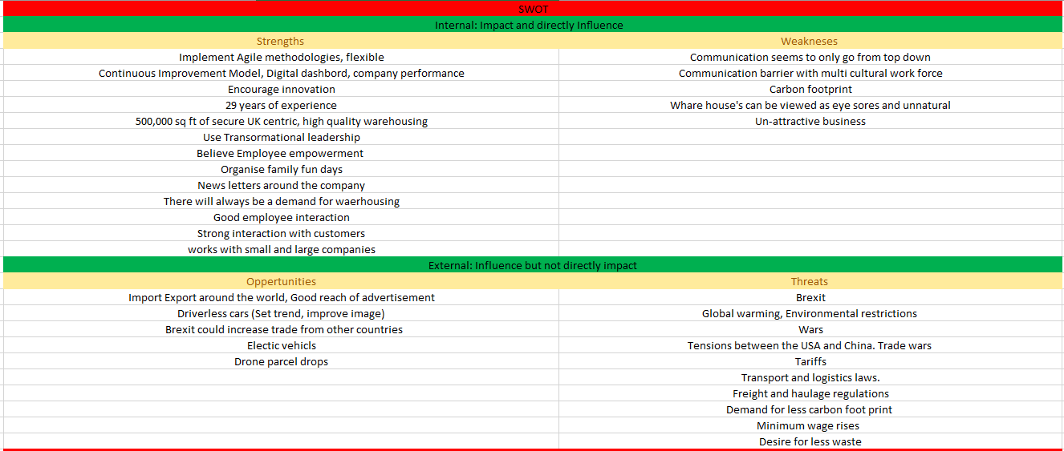

## Overview of results

In order of importance the main conclusions I have taken from my analysis are:

### 1. Lack of Communication.

Communication within the client organisation doesn’t seem to be taken too seriously. Too much focus on top down communication.

No mention of systems in place accept a hierarchy of Leadership etc.

### 2. Encourage more creativity

Creativity Is important to the client, they need to have innovative ways to satisfy individual customer needs. Rebecca points out the important of getting the teams opinion and ideas but doesn’t mention any systems in place to gather this information or utilise it on a regular basis.

### 3. Brexit.

Brexit is going to affect nearly every business within the UK, particularly business who Import and Export from the EU.

There is no way to stop these effects but you can plan for them so they are not so devasting. You cannot escape Brexit and it must be considered when thinking about the client’s options for the future.

### 4. Battery power.

Battery powered vehicles, factories, offices etc are to be the norm in the future. With fossil fuels falling out of favour it is a good idea to start thinking about how the client can set trends in this area by being innovative and proactive in switching over.

Technology must be embraced and utilised.

Keep an eye on the Battery technology and work being done on battery powered lorries etc. Being seen as one of the first to set this trend will be great for PR (Public Relations). Not only can battery power be sourced from renewable energy but the cars themselves will give out zero emissions. This in my opinion kills two birds with one stone, Helps combat climate change and improves the public image.

### 5. Climate change.

Climate change is a big topic at the moment with scientists all over the globe are painting a gloomy picture. This is an opportunity to be seen as force for good, and dare I say it... do what’s morally right... but capitalise on it.

### 6. Drone parcel delivery:

This along with autonomous vehicles seems to be the vision for Transportation and delivery of the future. It’s worth starting to think about this change to give the client a competitive edge, maybe investing in companies pioneering this technology and getting potential returns on that investment. You can also offer to trial them within your business

### 7. Autonomous vehicles:

To help drive down carbon emissions, congestion and improve efficiency there is a big driving force to get autonomous vehicles on the road.

This should be seen as an opportunity to be one of the first logistics company to embrace the change (which seems inevitable) putting the spot light on the company, increasing advertisement and improving their image.

### 8. Leadership.

The client currently implements the best leadership style for their business, Transformative Leadership, which by its definition involves the team in decision making.

This is perfect for the type of environment at CML where they have a lot of customers with different requirements. The people on the ground will know what will help improve the area they work in so as to satisfy the customer and improve efficiency.

This is in contrast to transactional leader ship where people are more dictated and told what to do. There is a place for both but the type of environment the client has within its ware houses, transformative seems better suiting.

From a board level being a transactional leader will be deemed more suitable as you have to make the tough decisions and to be seen as being capable of making them not constantly calling meetings to get everyone else opinion.

### 9. Un-Attractive business.

It was said and is widely known that the logistics and warehousing industry is not that appealing to work in. This could be an easy weakness to shore up, with a simple thing such as gym membership. This is not about having a “Good Looking” work force but about people’s persona and the way the project them self.

With a recent study from Kim E.S ( 2017) showing a clear link between happiness and exercise. This will help improve the company image.

### 10. USA-CHINA Trade wars:

This is relevant to the company as they have a lot of trade with china.

With the UK and USA being such close partners and the current President asserting his authority it could very likely lead to them asking the UK to trade with china in a certain manner potentially hindering their relationships.

## Overview of tools

The two tools I chose to do my analysis are widely used in strategic planning.

Both are good at making you think and view the environment that the client business lives within.

Both tools help in thinking up measures to overcome weakness and threats that potentially hold back a company from achieving their goals and objectives.

Another analysis tool would have been porters 5 forces but that is more focused on a particular industry and not a company.

I deemed it more beneficial due to my experience to concentrate on the companies and tools used for this than to look at the entire industry.

Although no tool suits all and there are some cross overs with both analysing external opportunities and threats to the business, SWOT and PEST both work well together with SWOT naturally leading on from PEST.

# Section 2: Recommendations to the organisation

From my analysis I have a few recommendations to make to the client.

My recommendations in Order of importance are:

## Improved Communication

I have chosen improved communication as an area to improve as I get the impression from the interview that this isn’t taken too seriously.

There is a lot of talk about getting the Boards opinion down to the shop floor but there isn’t much about the communication from the floor to the board.

They mention having family fun days etc which is an opportunity to talk to everyone but as we all know, people can act and feel different depending on the environment, family fun days may not make you feel like you can discuss it at that time, who wants to be negative on a fun day.

They also have a newsletter which personally I don’t think is very effective and I believe a lot of people do not read. You cannot be certain people are up to date just because you put it on a newsletter. Reading a news letter is by choice so it’s a poor way to get important information to your employees.

## Brexit Effects

There is a chance a lot more markets will open up which means more opportunities, but they must be planned for and ceased upon before competitors.

The Client has a lot of strengths to help Mitigate the effects, for example, they already have a lot of trade outside the EU with the East which should not be affected by BREXIT.

I recommend looking at existing relationships and see how they can be strengthened and then looking at new potential customers from the emerging markets.

## Improved Creativity

Create an environment to support creativity. Creativity within the client’s sector is important. Having bespoke requirements for each customer demands innovative thinking. This should be encouraged by creating a creative atmosphere and making people feel comfortable with sharing their ideas.

I recommend Creating the right environment for Creativity, remembering it is worth asking what setting your employees would like to do it in, for example casual, informal, food drinks, war rooms etc or maybe even just a forum where people, potentially anonymously, put their ideas.

# Section 3: Implementation of recommendations

## Improved communication

I would recommend an AGILE scrum practise to be used in the company. This entails 10 - 15 minute meetings every morning to talk about the issues the teams have had the day before, potential issues for today and then discuss the plan for the day’s work.

The leader of the scrum should take a Transformational Leadership approach so as to see what the employees would like to improve and how, not dictating things to them or making them feel like they do not have choice.

Then without just saying no or yes taking these issues to the next level (Scrum of Scrums) to seriously discuss the actions that can be taken to address them with the people with power to address them.

The results from this conversation should then be fed back to the team in the next scrum.

Let it be known that you care and your trying to resolve there issues, but if nothing can be done remember to take there feelings into consideration by letting them know you tried to resolve there issue but nothing can be done at the moment, if the situation changes let them know promptly so as to show genuine interest in how they feel etc.

## Brexit Effects

Work on your existing relationships, let them know that you value their product, even more so after Brexit.

Ask them what concerns they have about BREXIT, let them know you will look at there concerns and find potential solutions and contingency plans to reduce them.

Be Honest about you abilities, for example you cannot do much about tariffs and extra charges, but you may find ways to save them money in different ways.

Here you will benefit from Democratic leadership. Concentrating on the task at hand while including your team for potential solutions to the problems faced.

A leader seen to be with power and authority in times of crisis such as Brexit will encourage people to look to you for the answers... which you will have or you will get!

Be willing to work closer and attempt to be more flexible after Brexit.

Be honest about the effects.

## Improved Creativity

Hackathons are a good way to get employee interaction and contribution. Hackathons give a set time frame, usually between 2-3 days where the company asks its employees what new and innovative ideas they have and then they spend the rest of the time prototyping and attempting to make it a reality.

These events are known for bringing innovative ideas but also gives an opportunity to see how the teams are working together, team member interaction, who within your teams are leaders and the types of leadership styles they have.

Making notes of the Democratic, Autocratic, Transformational, and transactional leaders and thinking about the various environment’s that they could thrive in.

# Section 4: Critical Reflection

Here I will attempt to reflect on my experience on this module using the Gibbs Cycle.

The Gibbs reflection cycle is as follows:

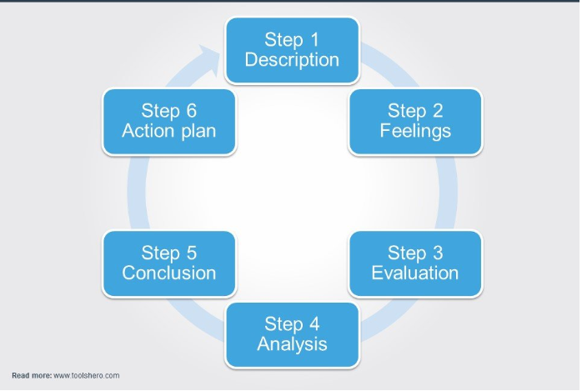

## Step 1: Description:

My task was to perform a strategic analysis on a chosen company/case study. The strategic analysis is meant to include topics covered in the workshops and can be expanded on by various reading material on Moodle and the CMI website.

## Step 2: Feelings

When I first started this module, I was sceptical about the sales pitch given by the module leaders. They claim it to be an advantage over other university’s but they too have their own initiatives like this, so from the start I was quite sceptical, and felt it may be a disadvantage as it has taken time away from my final project.

## Step 3: Evaluation

The workshops are good and force you to be a bit more outgoing and interact with people. But honestly it was hard to apply the topics they taught, and in the style they were taught, to the case studies.

The type of consultancy the workshops gave me an impression of are the ones with focus groups, team activities and just generally engaging with people.

This is in contrast to the actual assignment where we just had a video interview to watch and was more about the overall picture of the company instead of the intricacies of how the company operates and the interactions between people which a lot of the module concentrated on.

## Step 4: Analysis

Over all it is beneficial to think about the qualities needed by leaders in certain situations, the main important point being there is no size fits all. It’s beneficial to point out that everyone is different and react differently to various things and environments.

There also an important point that most people fall in to a set of categories, which I think is well illustrated with the different types of the “Six Thinking hats” and to be aware of these types and the environments they best operate makes a good leader.

## Step 5: Conclusion

I found the case study I chose to be less about the company and more about her opinion on the various topics we are meant to be analysing so was hard to get the information for a thorough investigation.

I found it quite hard to apply the topics discussed in this module to my chosen company.

The interview didn’t really cover much about the inner working of the company so I found it hard to comment particularly on the leadership and communication, with Rebecca talking more about the different types of Leadership and Communication instead of what is used within the company

The parts where she did talk about the leadership styles seemed more about her opinion on what the style actually mean, mainly transformative and transactional not about how they encourage transformative leadership within there company and where is used etc.

## Step 6: Action plan

I will take what I know with me when I’m next asked to work in a group.

Taking care to remember the various types of “hats” and understanding the importance of clear communication and engagement between them.

I will think about the leadership traits needed for the task that I’m given if I am chosen as leader, opting to be more of a Situational Leader, finding what works best in the current situation.

My opinion before this module and now is that everything needs to be evaluated for different situations. A Good leader is adaptable, knowing when to take time to plan discuss and include the team, and knowing when a decision needs to be made immediately etc and that ultimately the team depends on and looks to him to guide them to success. The only way you can do this is to look at what you have to work with (Team Members) and the environment they have to navigate.

Also communication is important and I think its reasonable (in England) to expect basic English but this should not be the main way of communication, opting more for diagrams, visuals and hands on demonstrations for the topic your trying to convey. Thinking of new innovative ways to get the message across.

# References

1. Howard Thomas, (2007) "An analysis of the environment and competitive dynamics of management education", Journal of Management Development, Vol. 26 Issue: 1, pp.9-21, https:// doi.org/10.1108/02621710710720040
2. McGee, J., Thomas, H. and Wilson, D. (2005), Strategy: Analysis and Practice, McGraw-Hill, New York, NY.
3. THOMAS J. CHERMACK, BERNADETTE K. KASSHANNA (2007), The Use and Misuse of SWOT Analysis and Implications for HRD Professionals
4. Kim, E.S., Kubzansky, L.D., Soo, J. et al. ann. behav. med. (2017) 51: 337. <https://doi.org/10.1007/s12160-016-9856-y>
5. McGee, J., Thomas, H. and Wilson, D. (2005), Strategy: Analysis and Practice, McGraw-Hill, New York, NY.