# Use case diagrams

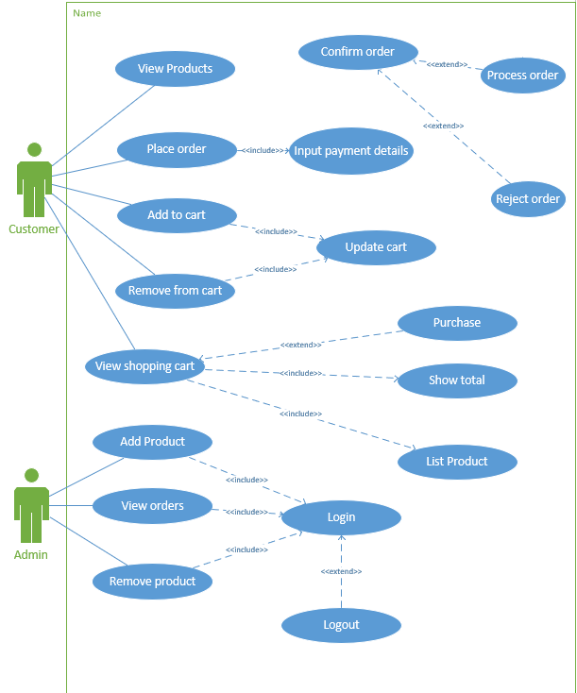

# Use Case Descriptions

# UC1: Display a list of available products for customers

|  |  |
| --- | --- |
| **Use case Desription** | |
| **Use-case field** | **Description** |
| **Use case name** | Display a list of available products for customers. |
| **Subject area** | Electronics product store |
| **Business event** | Potential order |
| **Actors** | Customer |
| **Scenario** | User visits website and is displayed with a list of products that are currently available. |
| **Pre-Conditions** | Allows the completion of use case:   * UC2 * UC3 * UC6   Products available to show |
| **Post-Conditions** | None |
| **User - System sequence** | |
| **User** | **System** |
| 1. **User arrives on index page.** | 1. **Returns a list of available products grouped by category.** |

# UC2: Allow customers to add products to a shopping cart

|  |  |
| --- | --- |
| **Use case Desription** | |
| **Use-case field** | **Description** |
| **Use case name** | Allow customers to add products to a shopping cart |
| **Subject area** | Electronics product store |
| **Business event** | Potential order |
| **Actors** | Customer |
| **Scenario** | User visits website and is displayed with a list of products that are currently available. |
| **Pre-Conditions** | None |
| **Post-Conditions** | Allows the completion of use case:   * UC6   Item added to shopping cart.  Allows the placing of an order. |
| **User – System sequence** | |
| **User** | **System** |
| 1. **User pushes Add Item** | 1. **The selected product is added to the shopping cart.** 2. **Item quantities updated.** 3. **Shopping cart total updated.** |
| **Reference Notes** | Viso UseCase page |

# UC3: Removal of items from the shopping cart

|  |  |
| --- | --- |
| **Use case Desription** | |
| **Use-case field** | **Description** |
| **Use case name** | Removal of items from the shopping cart |
| **Subject area** | Electronics product store |
| **Business event** | Potential order |
| **Actors** | Customer |
| **Scenario** | Use clicks remove on an item and the item is removed from the shopping cart. |
| **Pre-Conditions** | Item is in shopping cart |
| **Post-Conditions** | Item removed from shopping cart  Item quantities updated  Shopping cart total updated |
| **User - System sequence** | |
| **User** | **System** |
| 1. **User pushes remove item** | 1. **The item is removed from the shopping cart** 2. **Item quantities updated.** 3. **Shopping cart total updated.** |
| **Reference Notes** | Viso UseCase page |

# UC4: Customers can view a summary of all the items and quantities in the shopping cart

|  |  |
| --- | --- |
| **Use case Desription** | |
| **Use-case field** | **Description** |
| **Use case name** | Customers can view a summary of all the items and quantities in the shopping cart |
| **Subject area** | Electronics product store |
| **Business event** | Potential order |
| **Actors** | Customer |
| **Scenario** | User can focus in on the shopping basket, seeing the total price and the items he has added to the basket |
| **Pre-Conditions** | There are items in the basket |
| **Post-Conditions** | The customer is able to order the products |
| **User - System sequence** | |
| **User** | **System** |
| **1 The customer selects view cart.** | 1. **The customers current shopping cart is displayed** 2. **The item subtotals are displayed** 3. **The shopping cart total is showed** |

# UC5: Enable a customer to place an order and make payment by using fictious credit card details

|  |  |
| --- | --- |
| **Use case Desription** | |
| **Use-case field** | **Description** |
| **Use case name** | Enable a customer to place an order and make payment by using fictious credit card details |
| **Subject area** | Electronics product store |
| **Business event** | A shipping order is placed to the suppliers |
| **Actors** | Customer |
| **Scenario** | User visits website and is displayed with a list of products that are currently available. |
| **Pre-Conditions** | None |
| **Post-Conditions** | * User is presented with a confirmation message OR An unsuccessful message |
| **User - System sequence** | |
| **User** | **System** |
| 1. **User selects place order** 2. **The user Inputs credit car details and shipping address** 3. **The user selects confirm** | 1. **A page to enter the customers credit details is shown** 2. **Credit card details are checked and sent to the CreditCardService with a response returned.** 3. **A successful or unsuccessful message is shown** |

# UC6: Administrative interface is required to allow staff to view and track customers order, and also allow staff to add new products.

|  |  |
| --- | --- |
| **Use case Desription** | |
| **Use-case field** | **Description** |
| **Use case name** | Administrative interface is required to allow staff to view and track customers order, and also allow staff to add new products. |
| **Subject area** | Electronics product store |
| **Business event** | Potential order |
| **Actors** | Customer |
| **Scenario** | A user has logged in as administrator and now has access to   * Viewing orders placed * Adding products to the available products list * Removing products from the available products list |
| **Pre-Conditions** | The user is Authenticated  The user is Authorized to   * View orders placed * Add products to the available products list   Remove products from the available products list |
| **Post-Conditions** | Database has been updated if an operation has been performed |
| **User - System sequence** | |
| **User** | **System** |
| 1. **User logs in as an admin**   **3A. User selects view orders**  **3B User Select Add Product**  **5B User inputs details for a**  **new product and submits**  **3C User Select Remove Product**  **5C User selects multiple**  **Products from the list of**  **available products and submits** | 1. **Admin dashboard is shown**   **4A A list of orders is fetched from**  **the database and returned to the user**  **4B Interface to input a product**  **is returned**  **6B The product is added to**  **the database**  **4C A list of available products**  **is returned**  **6C The products are removed from the database** |

# UC7: Backend database should be update correctly in relation to order placed and products delivered

|  |  |
| --- | --- |
| **Use case Desription** | |
| **Use-case field** | **Description** |
| **Use case name** | Backend database should be update correctly in relation to order placed and products delivered |
| **Subject area** | Electronics product store database |
| **Business event** | Database updated |
| **Actors** | Customer |
| **Scenario** | User visits website and is displayed with a list of products that are currently available. |
| **Pre-Conditions** | User is Authenticated  User is Authorized |
| **Post-Conditions** | Database updated |
| **User - System sequence** | |
| **User** | **System** |
| 1. **User inputs database command** | 1. **Command is sent to the database server** 2. **Response is returned to the user** |

# Appendix:

## Template:

|  |  |
| --- | --- |
| **Use case Desription** | |
| **Use-case field** | **Description** |
| **Use case name** | An active verb phrase that describes a particular task. |
| **Subject area** | A use role or other grouping mechanism that can be used to group use cases. |
| **Business event** | A trigger that stimulates activity within the business. Many business events occur at the interface point between the business and one of the external entities with which it interacts. Business events must be observable. |
| **Actors** | The actor that initiates this use case and all users who participate in this use case. |
| **Scenario** | A description of the overview of the use case |
| **Pre-Conditions** | Constraints that must be met for the use case to be taken by the solution developer and used to create a workflow. This might include a required sequencing of use cases. For example, one or more other use cases might need to be performed successfully for this use case to begin. |
| **Post-Conditions** | Constraints that must be met after the sequence of the use case has completed. |