**Interview Based Questions – Hibernate**

1)

Q)

What is ORM?

A)

ORM is an acronym for Object/Relational mapping. It is a programming strategy to map object with the data stored in the database. It simplifies data creation, data manipulation, and data access.

-----------------------------------------------------------------------------------

2)

Q)

Explain hibernate architecture?

A)

Hibernate architecture comprises of many interfaces such as Configuration, SessionFactory, Session, Transaction, etc.

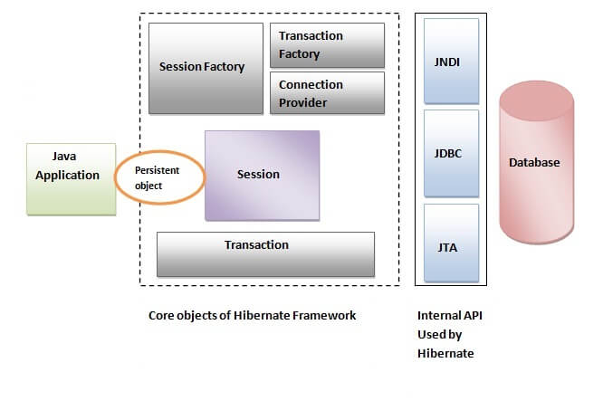

3)

Q)

What are the core interfaces of Hibernate?

A)

Configuration

SessionFactory

Session

Query

Criteria

Transaction

4)

Q)

Mention some of the advantages of using ORM over JDBC.

A)

ORM has the following advantages over JDBC:

Application development is fast.

Management of transaction.

Generates key automatically.

Details of SQL queries are hidden.

5)

Q)

Define criteria in terms of Hibernate.

A)

The objects of criteria are used for the creation and execution of the object-oriented criteria queries.

6)

Q)

How is SQL query created in Hibernate?

A)

The SQL query is created with the help of the following syntax:

Session.createSQLQuery(“sql query here…..”)

8)

What is the difference between session.save() and session.persist() method?

save() persist()

returns the identifier (Serializable) of the instance. Return nothing because its return type is void.

public Serializable save(Object o) public void persist(Object o)

9)

REFER NOTEPAD