**Error**: Actuator Not Working

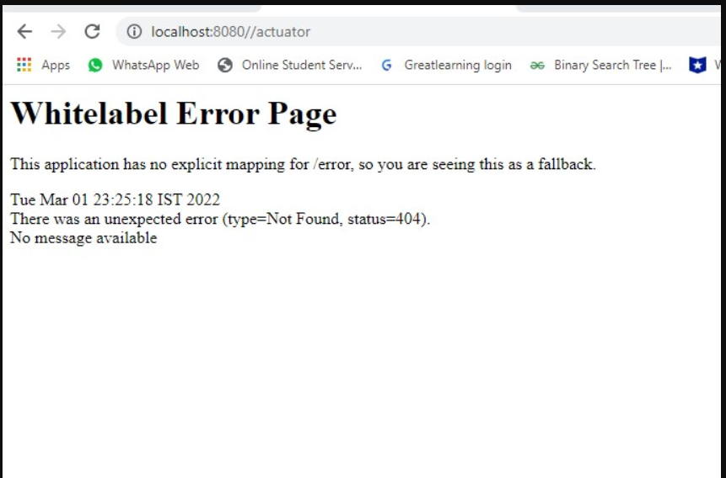

**Solution**

1. Make sure the URL is correct
2. The port no is correct
3. You are using only 1 ‘/’ after port no

**Incorrect** localhost:8080**//**actuator → notice two ‘/’ symbols

**Correct** localhost:8080/actuator

2) Avoid any typographical errors in the URL.

3) Sometimes the maven dependency doesn’t get updated in the project after downloading.

In order to update the project follow the following steps

i) Right-click on the spring boot project

ii) click on Maven (check bottom around 4th last option)

iii) Click on update Maven project

iv) check the force update of snapshots/releases box.

v) click on ok

vi) restart your project.

