Make sure that the component-scan base-package in **spring-mvc-demo-servlet.xml** is the same as your package structure in the project.

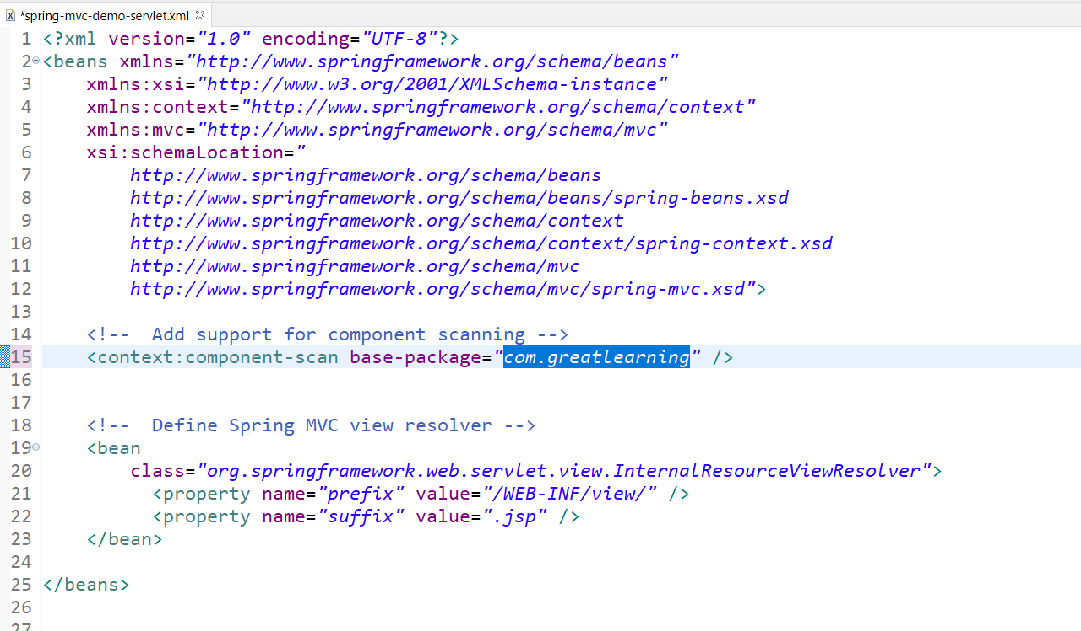

**Project Package structure**

**com.greatlearning.(followed by other name)**

