**Error**: localhost:8080/actuator/info not working

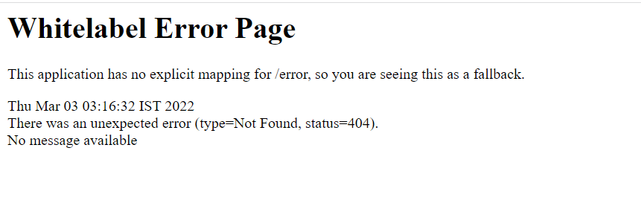

**Reason**

/info endpoint was supported in version 2.4.2, But in 2.5.0 it becomes hidden, so now you need to expose it manually.

You can check the documentation here → <https://github.com/spring-projects/spring-boot/wiki/Spring-Boot-2.5-Release-Notes#secure-info-endpoint>

**Solution**

1. Change the spring version to 2.4.2 in **pom.xml** file

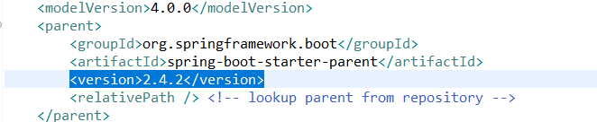

After that, clean the project (Click on project on top view, select clean , select the project and click on clean)

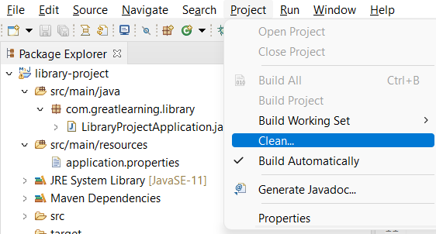

Once, you have clean the project, make sure to update the maven dependencies

In order to update the project follow the following steps

1. Right-click on the spring boot project
2. click on Maven (check bottom around 4th last option)
3. Click on update Maven project
4. check the force update of snapshots/releases box.
5. click on ok
6. restart your project.

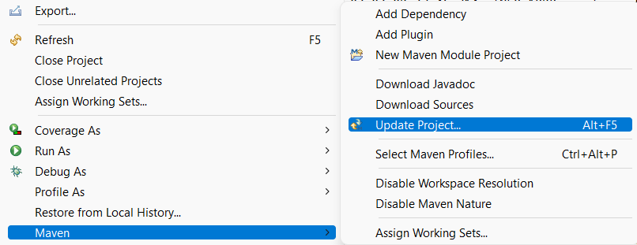

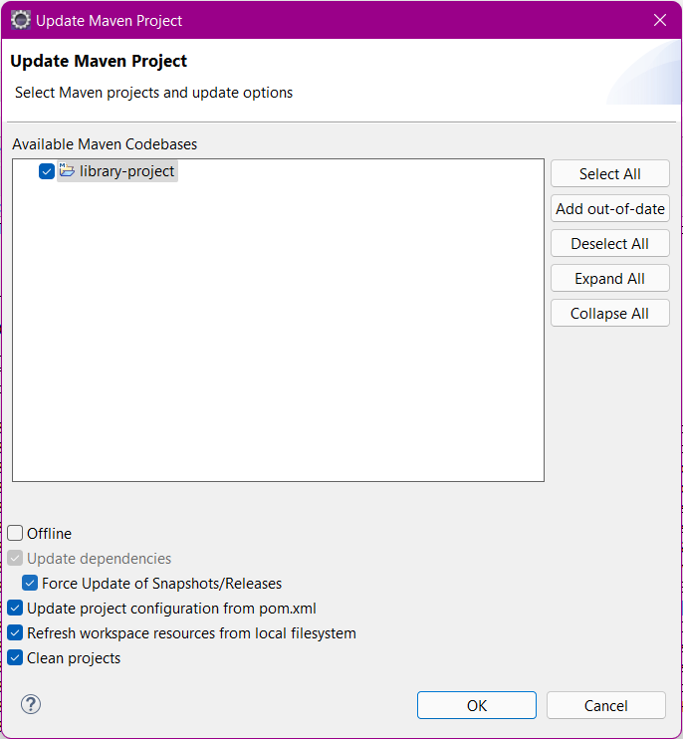

Solution 2 → Add the following properties to your application.properties file (note : the info values might still not be visible, as it works only for the remote machines/server in new version, hence, it is recommended to use the 2.4.2 versions)

management.endpoints.web.exposure.include=health,info,env,beans

management.info.env.enabled = true

