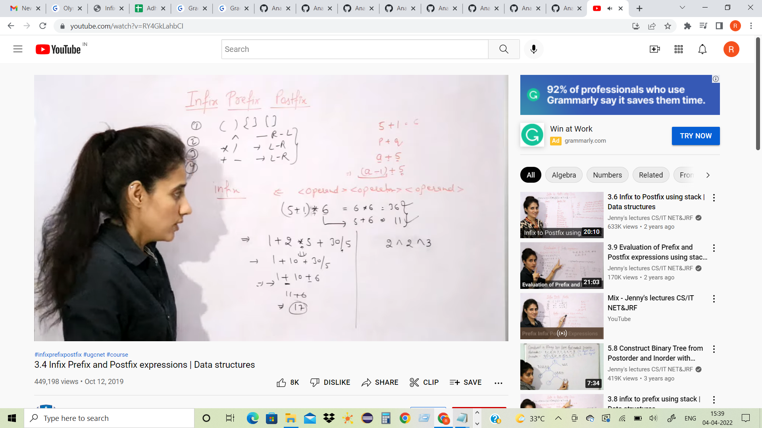

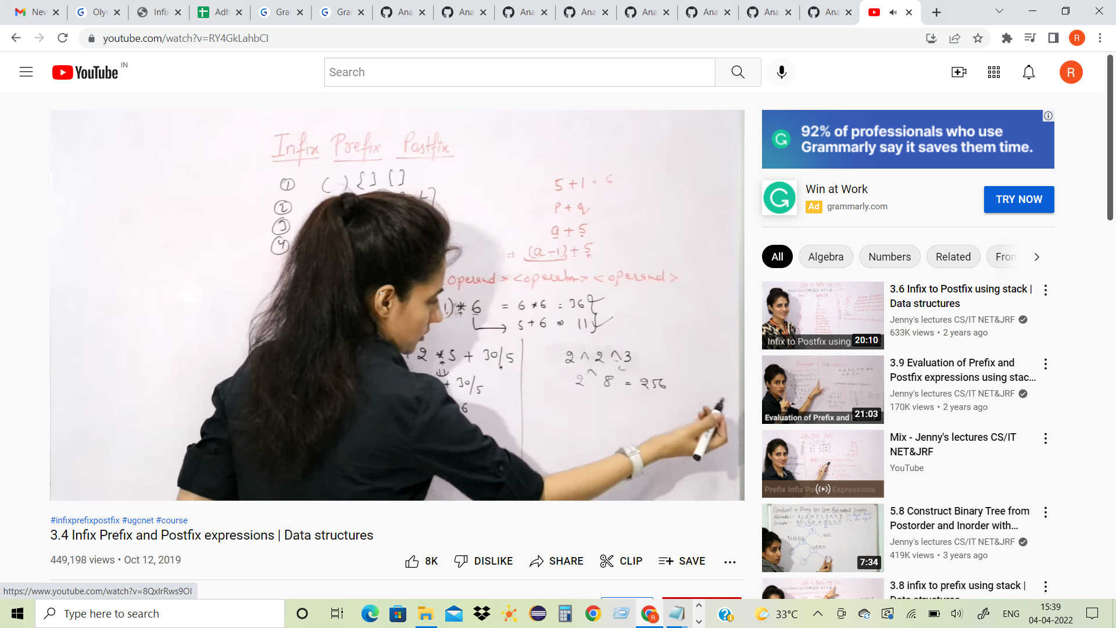

V+w\*x+(y\*z)

Order

V + (W \* X) +(y\*z)

Vwx\*+yz\*

<https://www.youtube.com/watch?v=PAceaOSnxQs>