O(n)

Time|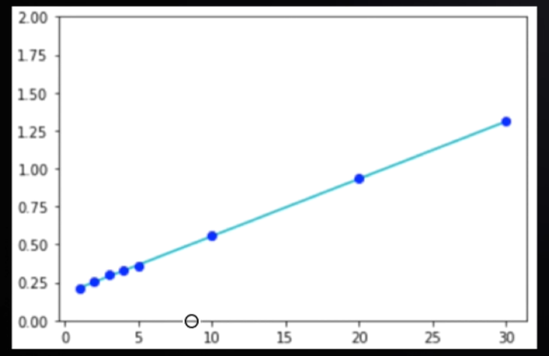

---- -SizeOfInput-Iterations

--------------------------------------------------------------------------

O(1)

O(log n)

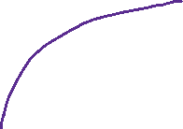

O(n2)

