Game Design Document

Fill up the following document

1. Write the title of your project

Box rebound

1. What is the goal of the game?

Get past the obstacles and go to the finish line

1. Write a brief story of your game.

A charater has to go through the obstacles and finish the fastest time

1. Which are the playing characters of this game?

* Playing characters are the ones who respond to the user based on the input from the user.
* Cars, monkeys, dinos, wizards, etc., are the playing characters in the game.

|  |  |  |
| --- | --- | --- |
| Number | Character Name | What can this character do? |
| 1 | Box | Using up arrow key to jump |
| 2 |  |  |
| 3 |  |  |
| 4 |  |  |
| 5 |  |  |
| 6 |  |  |
| 7 |  |  |
| 8 |  |  |

1. Which are the Non-Playing Characters of this game?

* Non-Playing characters are the ones that don't have an action or behavior when the user interacts with the game.
* Hurdles, stones, bananas, coins, etc., are non-playing characters in the game.

|  |  |  |
| --- | --- | --- |
| Number | Character Name | What can this character do? |
| 1 | spikes | Spikes can kill the main charater |
| 2 | Box | Box is to help the spikes to make obstacles |
| 3 | Check points | If the level is too long we can add check points |
| 4 |  |  |
| 5 |  |  |
| 6 |  |  |
| 7 |  |  |
| 8 |  |  |

Draw your imagination of this game. What does this game look like?

* Draw the game either on your computer or on paper.
* Add images of the game scenes to show each of the playing and non-playing characters at least once.

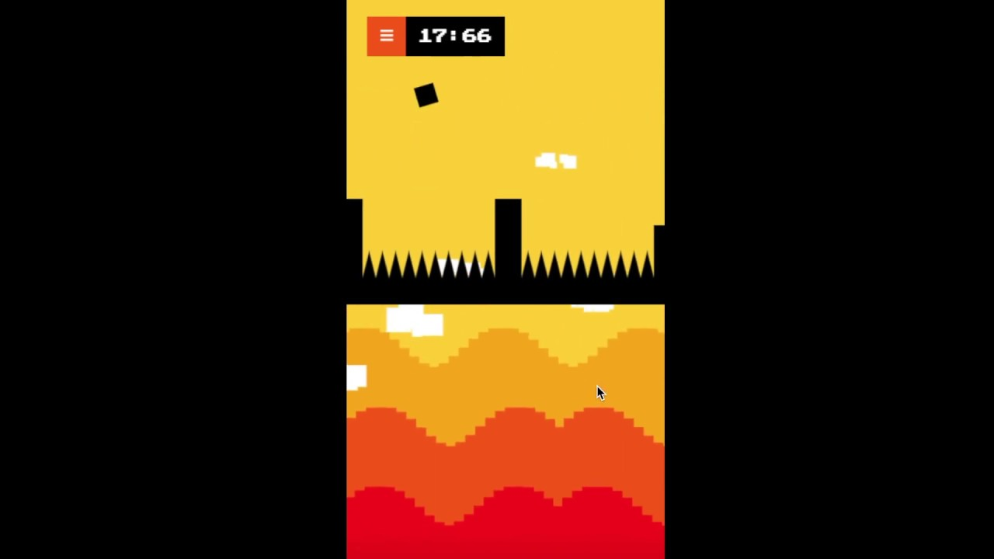

How do you plan to make your game engaging?

Every level gets harder