Program documentation for CRAVA

Odd Kolbjørnsen, Ragnar Hauge, Anne Randi Syversveen,
Bjørn Fjellvoll, and Pål Dahle
Norwegian Computing Center
March 31 2008

Theoretical background

The CRAVA program computes a Bayesian solution to the problem of seismic inversion. The solution presented is based on the theoretical work presented in Buland, Kolbjørnsen and Omre (2003). The objective is to obtain posterior distributions for V_{p}, V_{s} and D, that is, P-wave velocity, S-wave velocity, and density respectively.

The inversion in CRAVA is based on a linearized relationship between the model parameters and the AVA data. It accounts for spatial coupling both of the model parameters and the noise terms. The spatial coupling is imposed by correlation functions.
The program yields efficient computation and storage of the posterior distribution, and sampling from the posterior. It computes a lateral consistent and robust solution.

Amplitude versus angle (AVA) inversion can be used to extract information about the elastic subsurface parameters from the angle dependency in the reflectivity. Prior to a linearized AVA inversion, the seismic data must be processed to remove nonlinear relations between the model parameters and the seismic response. Important steps in the processing are the removal of the move out, multiples, and the effects of geometrical spreading and absorption. The seismic data should be pre-stack migrated, such that dip related effects are removed. After pre-stack migration, it is reasonable to assume that each single bin-gather can be regarded as the response of a local 1-D earth model. We further assume that wave mode conversions, inter-bed multiples and anisotropy effects can be neglected after processing. Finally, the pre-stack gathers must be transformed from offsets to reflection angles.

The CRAVA program utilizes the fact that the covariance function for a homogeneously correlated spatial variable is diagonalized by a Fourier transform. In the Fourier domain, the inversion problem can be solved independently for each frequency component. This reduces the complexity of the computations dramatically.

Input to the program

The input to the program is a model file. In the model file the user specifies commands and parameters relevant for each command. The commands are used for the following six tasks: 1) definition of the region under consideration, 2) description of the prior distribution, 3) description of the likelihood, 4) conditioning data, 5) description of output from the program, and 6) technical parameters. The commands are listed in Table 1 below. Table 1 also indicates which task or tasks of the six above that are covered by the commands. Detailed description of each command is given in the section “CRAVA-format of model file” below.

Command | Region | Prior | Likeli-hood | Cond.  Data | Out- put | Tech-nical
AREA | x
ANGULARCORRELATION |  |  | x
BACKGROUND |  | x
DEPTH | x
DEPTHSURFACES | x
ENERGYTHRESHOLD |  |  |  |  |  | x
FORCEFILE |  |  |  |  |  | x
FREQUENCYBAND |  |  |  |  |  | x
GIVESIGNALTONOISERATIO |  |  |  |  |  | x
KRIGING |  |  |  |  |  | x
LATERALCORRELATION |  | x | x
LOCALWAVELET |  | x | x
NSIMULATIONS |  |  |  |  | x
OUTPUT |  |  |  |  | x
PADDING |  |  |  |  |  | x
PARAMETERCORRELATION |  | x
PREDICTION |  |  |  |  | x
PREFIX |  |  |  |  | x
PSSEISMIC | x^{*)} |  | x | x
REFLECTIONMATRIX |  |  | x
SEED |  |  |  |  |  | x
SEGYOFFSET | x
SEISMIC | x^{*)} |  | x | x
SEISMICRESOLUTION |  |  |  |  |  | x
WAVELETLENGTH |  |  |  |  |  | x
WELLS |  | x |  | x
WHITENOISE |  |  | x

Table 1: Model file commands versus task

^{*)} If the AREA command is not active the lateral inversion area is identical to the area of the seismic.

The necessary data for a run is:
- Well data. Wells are given on ASCII RMS format. All wells must contain logs for TWT, density and Vp, and ideally also Vs. See command WELLS in appendix.
- Time surface. The time surface is given as a STORM binary surface. See command DEPTH in appendix.
- Seismic cube. The seismic is given on SEGY-format, either seisworks or charisma. The cube must have data for the entire inversion area. See command SEISMIC in appendix. Note that the cube may be shifted; this is indicated by using the command SEGYOFFSET.

Output from the program

Grids
The program has functionality for writing grids to STORM and SEGY format. Which of these formats that are used for output is determined by the model file. The names of the files have the following structure

<PREFIX><TYPE>_<Standard variable name>_<t/d>_<SimNr>.<file extension>

The PREFIX is given in the model file. TYPE is either 'BG' for background, ‘pred’ for prediction, or ‘sim’ for simulation for parameters, nothing for synthetic seismic, residuals and covariances. The standard variable name is given in the table below. t/d is either ‘Time’ for cubes where z direction is time and ‘Depth’ for cubes where z-direction is in depth. If the parameter is the result a a simulation, SimNr is the number of the simulation generated. The file extension is storm or segy for the two output formats respectively.

Standard variable name | Description
Vp | Vp
Vs | Vs
Rho | D
postCovVp | Posterior covariance for lnV_{p}
postCovVs | Posterior covariance for lnV_{s}
postCovD | Posterior covariance for lnD
postCrCovVpVs | Posterior cross covariance between lnV_{p} and lnV_{s}
postCrCovVpD | Posterior cross covariance between lnV_{p} and lnD
postCrCovVsD | Posterior cross covariance between lnV_{s} and lnD
residuals_<Deg> | Residuals seismic computed based on the estimates of V_{p}, V_{s} and D corresponding to the angle <Deg>
syntethic_seismic_<Deg> | Synthetic seismic computed based on the estimates of V_{p}, V_{s} and D for the angle <Deg>
Impedance | Posterior estimate of impedance, i.e. DV_{p}
Shear_Impedance | Posterior estimate of shear-impedance, i.e. DV_{s}
Vp_Vs_Ratio | Posterior estimate of Vp,Vs ratio, i.e. V_{p} /V_{s}
Poisson_Ratio | Posterior estimate of Poisson ratio
Lame_Mu | Posterior estimate of Lamé constant μ
Lame_Lambda | Posterior estimate of Lamé constant λ

Table 2: Interpretation of standard variable name in CRAVA

The SimNr entry increases from 1 to the number of simulations requested in the model file such that the first set of simulations have the standard variable names: “sim_Vp_1”, “sim_Vs_1” and “sim_Rho_1”. The second set has the standard variable names: “sim_Vp_2”, “sim_Vs_2” and “sim_Rho_2”, etc. The variable Deg corresponds to the angle of the angle gather. If the data are collected at 8° and 18° the standard variable name for the two sets of residuals are: “residuals_8” and “residuals_18”. If the prefix is given as: “CRAVA_”, the seismic cubes correspond to at 8° and 18°, and two simulations and residuals are requested, then the STORM files generated by the program are:

File names
CRAVA_pred_Vp_Time.storm
CRAVA_pred_Vs_Time.storm
CRAVA_pred_D_Time.storm
CRAVA_sim_Vp_Time_1.storm
CRAVA_sim_Vs_Time_1.storm
CRAVA_sim_D__Time_1.storm
CRAVA_sim_Vp_Time_2.storm
CRAVA_sim_Vs_Time_2.storm
CRAVA_sim_D_Time_2.storm
CRAVA_residuals_Time_8.storm
CRAVA_residuals_Time_18.storm
Table 3: Examples of output files from CRAVA

Wells
Crava filters well logs to background resolution and some assumed constant seismic resolution. The resulting wells are written to file if WELLS are specified as an option to the OUTPUT keyword. The well files are called

<PREFIX>Well_<well name>.rms

where <well name> is the name of the well as specified in the header of the well given as input to Crava.

Wavelets
If the keyword WAVELETS are specified after the OUTPUT keyword, Crava writes the wavelets that has been used to file. This is of particular interest if the wavelets have been estimated by Crava, or if Crava has been asked to energy-match the wavelets. The wavelet files are called

<PREFIX>Wavelet_<wavelet type>_<angle>_deg.asc

where the <wavelet type> is either Scaled or EnergyMatched, and <angle> is the angle of the AVA stack. The files are written using the Jason format.

Technical details

Time and memory use
The program has two options for memory use. One option is to keep all relevant grids in memory at the same time. The other option is to keep maximum one grid in memory.
Memory use
0
500
1000
1500
2000
2500
3000
3500
4000
4500
0
10
20
30
40
50
60
70
80
90
Million cells
MB
All Grids
One Grid
*)
)
*)
Figure 1: Memory use in the CRAVA program. Points with an *) are estimated.

Figure 1 shows how the memory use scales with the size of the simulation grid. The difference in memory use between the two approaches is a factor 12 corresponding to the number of grids that are needed at the same time. Extrapolation of the two curves indicates a low overhead such that a grid of 1 billion cells (109) use about 48 and 4 GB memory in the two approaches.

The program was tested on a Mobile Pentium 4 processor with a 2GHz clock and 512MB RAM. In the test case CRAVA performs the following tasks:

- Initialization: Two SEG-Y grids with seismic containing 11271 traces and 1625 samples per trace (74 MB), and three wells of 1.5, 1.5 and 1 MB are read and used to estimate the correlation of model parameters and seismic.
- Inversion: The inversion is performed in Fourier domain, back transformed and written to file.
- Simulation: One simulation is performed in Fourier domain, back transformed and written to file.
- Computation of posterior correlation: The posterior correlations are back transformed and written to file. (The solution in the Fourier domain is computed by the inversion.)
Figure 2: Run time in the CRAVA program. Times marked with an *) as estimated.
Total time
0
10
20
30
40
50
60
70
80
90
100
0
10
20
30
40
50
60
70
80
90
Million grid cells
minutes
All Grids
One Grid
*)
*)
Figure 2 shows how the total run time of CRAVA depend on the size of the simulation grid. Figure 3 and 4 show how the time is divided on inversion, simulation and computation of posterior covariance depending on grid size for all grids in memory and one grid in memory respectively.
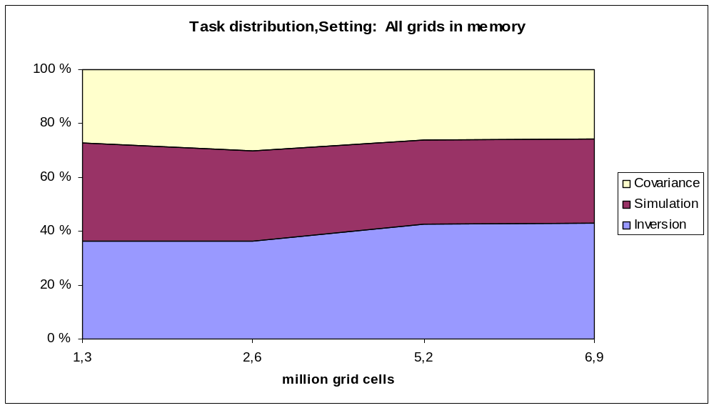
Figure 3: Time usage in CRAVA with all grids in memory.

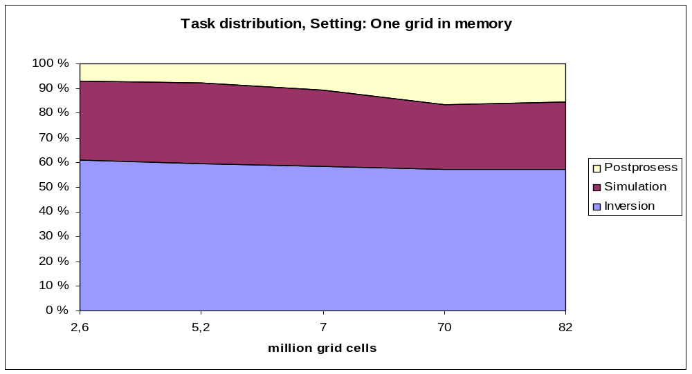
Figure 4: Time usage in CRAVA at most one grid in memory.

Input formats
SEG-Y format
The SEG-Y format is Seisworks and in-line, cross-line, x, and y are expected to be found in bytes 9, 21, 73, and 77, respectively. In the trace headers the UTM coordinates are read as integers and not floats (byte locations 73-76, and 77-8).

Note that all dead traces must be included so that the traces fill a regular grid.

Grids
Padding of grid
The Fast Fourier Transform (FFT) requires that the grid is defined on a torus, that is, the grid has cyclic boundaries. In order to avoid cyclic dependencies in the results, the region considered is extended in all three directions. The extension should be as large as the correlation length in the corresponding direction.

Let the original grid be of dimension n = n_{x} × n_{y} × n_{t} , let the corresponding padding fractions be p_{x}, p_{y}, p_{z}. The padded grid is of size n^{p} = n^{p}_{x} × n^{p}_{y} × n^{p}_{t} where n^{p}_{d} for d = x,y,t is the smallest integer that is larger than n_{d} p_{d} and that can be factored in the following manner; n^{p}_{d} = 2ª3^{b}5^{c}7e11^{f}13^{g}, with f+g ≤ 1.

Extension of grid
In lateral direction the extended grids are defined by mirroring the original grid around its boundaries, and apply tapering. In depth direction the extension of the seismic grid is read from file, and extension of the mean values are obtained by making a soft transition.

Tapering of grid
The taper function is displayed in Figure 5. For a point having the relative distance ║x║ to the original region the tapering weight is (1-║x║²)₊³ .
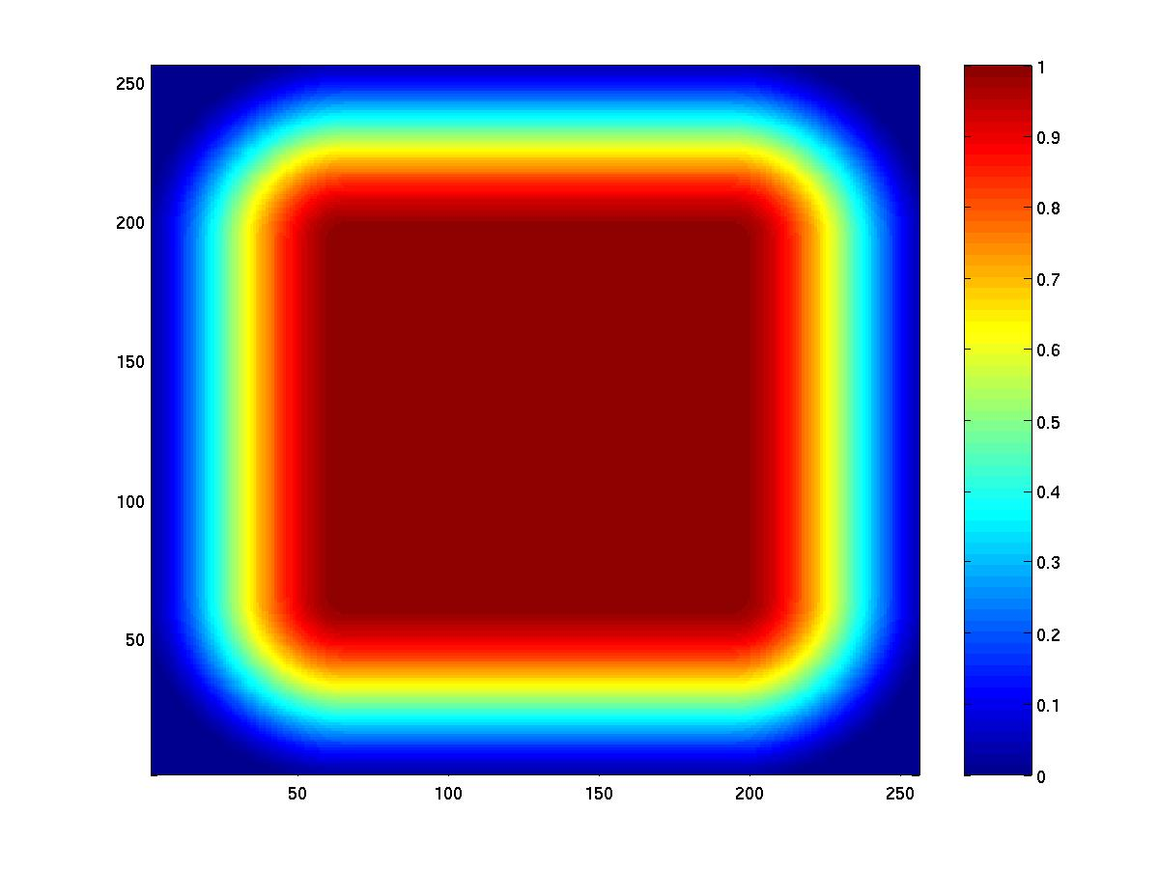
Figure 5: The tapering function

Estimation of variance
The parameter variance is estimated from well logs, with a standard method, see
Johnson and Wichern (1992), page 104.

Estimation of depth correlation
The time correlation is estimated from well logs, with an estimator that is positive definite, see Shumway (1988), page 26.

Estimation of lateral correlation.
Lateral correlation is either specified in the model file or estimated from the seismic.

Definition of parameter correlation
The parameters have identical correlation functions. The 3D parameter correlation is the tensor product of the 2D lateral correlation function and the 1D depth correlation estimated from the well log. The correlation between the parameters is given by the pointwise variance.

Definition of error correlation
The error correlation in depth is defined as a sum of the seismic wavelet convolved with it self, and the derivative of the wavelet convolved with it self. The 3D parameter correlation is the tensor product of the 2D lateral correlation function and the 1D depth correlation given by the wavelets. The dependency in angular direction is given as angular correlation in model file.

References
Buland A., Kolbjørnsen O. and Omre H. (2003); Rapid spatially coupled AVO inversion in the Fourier domain", GEOPHYSICS,VOL.68 NO.3;P.824-836

Johnson R.A. and Wichern D. W.; (1992) Applied multivariate statistical analysis, 3rd ed., Prentice-Hall

Shumway R.H. (1988); Applied statistical time series analysis, 2nd ed. Prentice-Hall.

White, R. E. (1984); Signal and noise estimation from seismic reflection data using spectral coherence methods, Proceedings of the IEEE, 72, geo, 1340-1356

CRAVA – format of model file

All information needed to run the program, such as model parameters, name of well observation files and seismic data files, must be specified in the model file. The model file contains different commands, some of them are necessary and some are optional.

Each command contains a number of parameters. The parameters must be entered in the exact order given in the documentation below. Each command is ended with a semicolon.
Note that a white space or line break must be in front of the semicolon. The order of the commands is not important. Lines starting with ! will not be read, and this can be used to add comments. Commands and parameters will be specified below. If the model file contains errors, messages will be written to screen before the program exits.
The model file syntax is identical for Unix and Windows, but file references are different, see examples in appendix.

- ANGULARCORRELATION
Optional command. Gives information about the dependence of the error term between seismic cubes, by defining a one-dimensional correlation function. One of the following correlation functions must be specified: genexp (general exponential) with parameters exponent and range; spherical with parameter range. The unit of the range is degrees.

Example of command and default setting:

ANGULARCORRELATION
genexp 1.0 10.0
;

- AREA
Optional command. Defines the simulation area. The parameters are x-origo, y-origo, length in x-direction, length in y-direction, angle of orientation, and sampling interval in x, y. The x-origo and y-origo coordinates are given as UTM coordinates with units [m]. Length and sampling interval are given in units [m]. Angle of orientation is given in degrees. If this command is not used, the simulation area is defined by the first seismic cube.

Example of command:

AREA
399504 7229600
2700 600
-23.6198
25 25
;

- BACKGROUND
Optional command. Gives information about the background models. Parameters are either file names (STORM or SEGY format), or real numbers to specify constant background models. The background model is specified for each of the three variables Vp, Vs, and density, in this order. The units are m/s, m/s, and g/cm³, respectively.

Example of command:

BACKGROUND
4479.79
VsBackground.segy
2.35
;

Alternatively, Crava can estimate the background model from available well data using kriging. If so, well data are filtered to a high cut frequency specified by the FREQUENCY keyword and the kriging is performed with a variogram specified by the VARIOGRAM keyword.

Example of command (and default setting):

BACKGROUND
FREQUENCY
6
VARIOGRAM
genexp 1.0 2000 2000 0.0
;

- DEPTH
Necessary command. Gives information about reservoir depth measured in time.
This command has two possible formats, one for constant thickness reservoirs, and one for top and bottom surfaces. The parameters are:
  - For constant thickness:
A subsurface, distance from the subsurface to the top of reservoir, thickness of reservoir, and sampling interval in depth direction. The subsurface is given as a binary storm grid, with depth given in terms of travel time, with unit [ms]. Distance to the top reservoir, thickness and sampling interval are all given in units [ms].
  - For surface-bounded reservoir:
Two subsurfaces and the number of grid cells between them. Subsurfaces are given as binary storm grids.

Examples of command:

DEPTH
surface.irap -350 500 4
;

DEPTH
top.irap bottom.irap 200
;

- DEPTHSURFACES
Optional command. Defines surfaces for converting inversion results to depth domain. When this command is specified, cubes are written in depth domain in addition to the default time domain. File names contain the strings “Depth” and “Time” to distinguish. If only depth cubes are wanted, the OUTPUT command can be given the keyword NOTIME. Note that depth cubes are not written if output format is SEGY. Only STORM cubes can be written in depth. Defined in the same way as command DEPTH.

- ENERGYTRESHOLD
Optional command. Without this command, only traces with no signal are interpolated, to avoid edge effects. By using this command, traces with energy below a given fraction of the mean trace energy will also be interpolated. This is done to fix local problems in the input seismic. This command takes one parameter, the fraction limit for interpolation. A limit of 0 is the same as not using this command.

Example of command:
ENERGYTRESHOLD
0.005
;

- FORCEFILE
Optional but recommended command. This command decides whether the program should try to run everything in memory, or use disk for temporary storage of grids. The command takes one parameter, a number that is either 0 (for memory) or 1 (for file). If this command is not specified, the program tries to determine whether there is enough memory to run internally, but this works fine only on PC, and not at all on SGI.

Example of command:

FORCEFILE
0
;

- FREQUENCYBAND
Optional command. Without this command, the inversion is frequency filtered at 5 and 55 Hz. By using this command, these limits can be changed. Note that the filtering applies only to the inversion, and not the realisation (which contains background+inversion+simulation+kriging). This command takes two arguments: The lower and upper frequency limits.

Example of command:
FREQUENCYBAND
4 60
;

- GIVESIGNALTONOISERATIO
Optional command. If this keyword is specified, the noise energy term for the SEISMIC command will be interpreted as signal-to-noise ratio instead.

- KRIGING
Optional command. If this command is given, predictions and simulations are conditioned to input well data. This is done by co-kriging using the posterior covariances and cross-variances. In order to make the program robust against large numbers of well data the kriging is performed in segments. The reservoir is divided into subgrids. For each subgrid, all the data in the subgrid and a surrounding volume are used for conditioning, but no data outside this volume. To avoid discontinuities at block edges, a posterior smoothing using the same covariances is performed at the edges. The keyword takes one parameter: The number of well data around a point to use when kriging. This parameter should typically be in the order of 200. If the number of well data is below 400, this number should be set to the number of welldata. If the final realisation looks blocky, increasing this number should help.

Example of command

KRIGING
200
;

- LATERALCORRELATION
Optional command. Gives information about the lateral correlation in seismic parameters and error, by defining a two dimensional correlation function. If not specified, the lateral correlation is estimated from seismic data. One of the following correlation functions can be specified: genexp with parameters exponent, range1, range2, angle. spherical with parameters range1, range2, angle. The unit of ranges is [m], the unit of angle is degrees.

Example of command (and default setting):

LATERALCORRELATION
genexp 1.0 1000 1000 0.0
;

- LOCALWAVELET
Optional command. Gives information about local shift and scale of wavelets. Note that this command only works when both top and base surface are given in command DEPTH. The parameters are given as maps on storm binary surface format. The order of the maps must be the same as the order of the seismic cubes under the SEISMIC command. If a wavelet should be left unmodified, use ‘*’ instead of filename. This command has two subcommands, SHIFT for time shift of wavelet, and GAIN for amplitude scaling. Either one or both (in any order) may be given.

Example of command (corresponds to first example of SEISMIC command):

LOCALWAVELET
SHIFT * sc25.storm
GAIN gain 15.storm gain25.storm
;

- NSIMULATIONS
Optional command. The only parameter is an integer being the wanted number of samples from the posterior. If not specified, sampling from posterior is not performed.

Example of command:

NSIMULATIONS
5
;

- OUTPUT
Optional command. Without this command, only simulation/predictions of Vp, Vs and density will be written, in STORM format. The parameters for this command are one or more of the following keywords:
  - STORM – output is written on STORM format.
  - SEGY – output is written in SEGY format. If given in addition to STORM, output is written in both formats.
  - CORRELATION – posterior correlations are computed and written to file.
  - RESIDUALS – seismic residuals are computed and written to file.
  - BACKGROUND – background model used by CRAVA.
  - WELLS – well data including frequency high cut filtered logs
  - WAVELET – wavelets used by CRAVA.
  - FACIESPROB – facies probability volumes are estimated for each of the facies given by the facies entry in the HEADER part of the WELLS command.

The rest of the keywords control output of specific parameters. The keyword corresponds to the parameter name. If none of these keywords are given, Vp, Vs and density are given as output, otherwise, only parameters mentioned here will be written. NOTIME indicates that cubes in time domain should not be written, and is used if we want only cubes in depth domain. Possible keywords are

  - VP
  - VS
  - RHO
  - LAMELAMBDA
  - LAMEMU
  - POISSONRATIO
  - AI
  - SI
  - MURHO
  - LAMBDARHO
  - VPVSRATIO
  - NOTIME

Example of command:
OUTPUT
STORM
RESIDUALS
AI
POISSONRATIO
FACIESPROB
;

- PADDING
Optional command. Padding is the degree of extension of the simulation volume during simulation of Gaussian random fields. The parameters given are three real numbers between 0 and 1 for padding in x-, y- and z direction. Default value is 0.5 for all three directions.

Example of command:

PADDING
0.6 0.6 0.3
;

- PARAMETERCORRELATION
Optional command. Defines the covariance matrix for the logarithmic parameters. Takes one argument, a filename. The file is expected to contain a covariance matrix, 3 by 3, in ASCII format. If this command is not used, the covariance matrix is estimated from well data.

Example of command:

PARAMETERCORRELATION
covmat.txt
;

- PREDICTION
Optional command. Prediction is written to file. No parameters.

Example of command:

PREDICTION
;

- PREFIX
Optional command. The only parameter is the prefix for the output files given from the program. The parameter is specified as text string. Default value is no prefix.

Example of command:
PREFIX
CRAVA_
;

- PSSEISMIC
Optional command. Specifies PS-seismic. This command has the same format as command SEISMIC.

- REFLECTIONMATRIX
Optional command. Without this command, the standard Aki-Richards approximation of the Zoeppritz equation is used. This command can be used to specify the coefficients used when computing reflections. The command takes one argument, a file name. This file should contain 3 columns, and as many rows as there are seismic angles. The first column contains the coefficient for the log derivative of Vp, the second for Vs, and the last for density. The format is standard ASCII.

Example of command:
REFLECTIONMATRIX
supergoodreflections.txt
;

- SEED
Necessary command. Gives information that is to be used in the
random number generator. Legal values are an integer or the name of a seed file. If a file name is given, the seed file will be updated after each run of the program.

Example of command:

SEED 5409665
;

- SEGYOFFSET
Optional command. Gives offset for SEGY cubes, both input and output. The offset is the same for all cubes. This means that input cubes are shifted dwon by this amount, and output shifted up. If not specified, all cubes are interpreted as starting at time 0 (no shift).
Example of command:

SEGYOFFSET
1000
;

- SEISMIC
Necessary command. Gives information about the seismic cubes and the corresponding angle, standard deviation of error noise, wavelet and scaling of wavelet. The seismic cubes are given as file names (SEGY format), the angles and standard deviations are real numbers, the wavelets are file names (ascii format) and the scaling factor is a real positive number. The unit of the angle is degrees; the units of seismic, wavelet and standard deviation can be chosen freely, but must be identical.

Example of command:

SEISMIC
seismic1.segy 15 1000.0 wavelet1.ascii 0.05 seismic2.segy 25 1500.0 wavelet2.ascii 0.04
;

Alternatively, CRAVA can estimate both wavelet and error noise if the entries for these are substituted with '*'. Similarly, if a '*' is used for the wavelet scale, CRAVA will choose a wavelet scale that makes the modelled data variance equal to the observed data variance.

Example of command for estimating wavlet and error :

SEISMIC
seismic1.segy 15 * * 1.0
seismic2.segy 25 * * 1.0
;

Alternatively, this command can be used to generate seismic. If the filenames are substituted with ‘?’, synthetic seismic at the given angles with the given wavelets and scaling will be generated. In this mode, the noise setting is irrelevant.

Example of command:

SEISMIC
? 15 1000.0 wavelet1.ascii 0.05
? 25 1500.0 wavelet2.ascii 0.04
;

- WAVELETLENGTH
Optional command. Gives the length of wavelet tapering. Affects wavelet estimation. The default value is 200ms.

Example of command:

WAVELETLENGTH
300
;

- WELLS
Necessary command. Gives information about well logs. The command contains an optional keyword HEADERS together with four parameters giving the name of the well logs used in the data analysis. The names should be given in the following order: time, DT (or Vp), density, DTS (or Vs) and facies. If CRAVA finds entries VP or LFP_VP, Crava assumes P-wave log otherwise it assumes DT log. Similarly, Crava assumes S-wave velocity if entries VS or LFP_VS are found. After the last parameter, a semicolon should be given. Then the names of the well files in rms-format should be given. The wells need not contain inverse S-wave velocity. Then a dummy name must be given as the last parameter in the HEADERS keyword. The other three logs must be present in the wells. If keyword header is not used, the names in the well files must be: TWT, DT, RHOB, DTS. The ordering of logs in the wells is not important, and the wells may contain other logs in addition to the logs used here. The units that should be used in the well logs are [ms], [µs/ft], [g/cm³], and [µs/ft] for time, inverse P-wave velocity, density and inverse S-wave velocity respectively.

Example of command:

WELLS
HEADERS
TWT DT RHOB DTS MAINFACIES;
wellfile1.rms
wellfile2.rms
;

- WHITENOISE
Optional command. The noise in the seismic consists of a coloured and a white component. This parameter determines the fraction of the noise that is white. Default value is 0.01.

Example of command:

WHITENOISE
0.1
;

Appendix A Windows-style model file

WELLS
P:\sand\user\ok\crava\Data\NO_6506_12-7.rms ! Global reference
Data\NO_6506_12-M-4_H.rms ! Local reference from P:\sand\user\ok\crava
Data\NO_6506_12-N-3_H.rms ! Local reference from P:\sand\user\ok\crava
;

DEPTH
Data\Coalmarker.irap -350 500 4
;

!AREA Not active (commented out)
!399504 7229600
!2700 600
!-23.6198
!25 25
!;

WHITENOISE
0.01
;

BACKGROUND
4479.5603 ! Constant background
2239.7802
2.535375
;

SEISMIC
Data\ST9905R02-NEAR.SGY 8 3000 Data\near_wavelet_8degs4ms.ascii 0.05
Data\ST9905R02-MID_ALIGN.SGY 18 3000 Data\mid_wavelet_18degs4ms.ascii 0.04
;

SEED
seed.file ;

ANGULARCORRELATION
genexp 1 10 ;

NSIMULATIONS
5
;

PADDING
0.5 0.5 1 ;

PREFIX
TestNR_
;

!Comment at EOF
Appendix B Unix-style model file

WELLS
/nr/project/sand/user/ok/crava/Data/NO_6506_12-7.rms ! Global reference
Data/NO_6506_12-M-4_H.rms ! Local references from
Data/NO_6506_12-N-3_H.rms ! /nr/project/sand/user/ok/crava/
;

DEPTH
Data/Coalmarker.irap -350 500 4
;

AREA
399504 7229600
2700 600
-23.6198
25 25
;

FORCEFILE
0
;

WHITENOISE
0.01
;

BACKGROUND
4479.5603
2239.7802
2.535375
;

SEISMIC
Data/ST9905R02-NEAR.SGY 8 3000 Data/near_wavelet_8degs4ms.ascii 0.05
Data/ST9905R02-MID_ALIGN.SGY 18 3000 Data/mid_wavelet_18degs4ms.ascii 0.04
;

SEED
seed.file ;

ANGULARCORRELATION
genexp 1 10 ;

NSIMULATIONS
5
;

PADDING
0.5 0.5 1 ;

PREFIX
TestNR_
;

!Comment at EOF

