Market – Data Exploration Log
Record what you check, what you find, and how you deal with it. Row counts below are from the supplied CSV files.

A. Database overview
Table | Rows | Columns | Unit of observation (one row = …) | Candidate key / notes
customers.csv | 82,570 | 5 |  | Records is not unique  Customer_id is unique, referts to ONE person  2,513 customers with multiple records  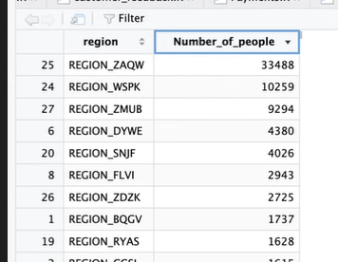
orders.csv | 82,570 | 8 | Most of the columns are dtm, and the ids and order status are char (strings). Which all make sens. None of them have missing registers. The ID’s are completly unique for orders and customers. | 97% of orders are in the COMPLETED status.  Some of the date column have NULL values, but it is an expected behaviour.  5 rows have been cancelled but have delivery date  7 rows have been completed but with no delivery timestamp.  The logical order for the dates:  purchase<approval<carrier<delivery  Was not followed by multiple registers in the table.  141 carrier before purchase  1109 carrier before approval  18 delivery before carrier  There are 10 duplicate orders. This can be proven when relating the order table to the order_items table, because they were made at hte exact same time and contain the same products.
order_items.csv | 93,519 | 7
products.csv | 29,389 | 9 |  | Name length and descrption length are not giving any relevant info, photo count also doesnt tell us anything.  There are no duplicate product ID’s.  Identifie lowest and highest categories  BestSeller product  All products were sold
sellers.csv | 2,983 | 4 |  | Inlcude top sellers  We dont have nulls  We dont have any seller that werent involved wihtin any sells  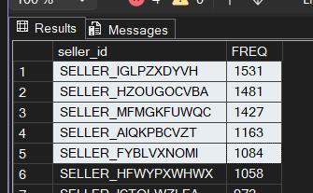
payments.csv | 86,345 | 5 |  | 2478 order_id are not unique  No null values across each column
customer_feedback.csv | 82,380 | 8 |  | Feedback crated column has no HH:MM:SS and answered hast it that way.  Feedback response time is not regular. It can take more than 500 days to reply. The concetration is between resanoble ammounts, too much outliers.

B. Data-quality checks
Table(s) | What I checked | What I found | Why it matters for analysis | How I handle it (in R)
1. Table dimensions and possible units of observation
Rows/columns per table; what one row represents; does it change after joining?
2. Identifiers and relationships between tables
Are IDs unique? Do keys match across tables (orphans, unmatched records)? One-to-one vs one-to-many?
3. Missing values
Which variables have NAs or blanks? Are they genuinely missing or structurally expected (e.g. undelivered orders)?
4. Duplicate or potentially duplicated records
Exact duplicate rows; repeated IDs; near-duplicates with small differences.
5. Unusual numerical or categorical values
Extreme/negative/zero values; impossible dates; inconsistent category spellings or labels.
6. Other issues that could affect later analysis
Wrong data types (e.g. timestamps or numbers read as text), inconsistent date ordering, payments vs item totals, etc.

