FSAR 2026 – Group Project
Submission #1: Project Scoping

Data Familiarization:

Table Dimensions:
Customers
Column | Type | Content | Observations
customer_record_id | Char | Identifier of a customer record (primary key). One record is created per order, so it is 1 : 1 with orders. | Unique: 82,570 values for 82,570 rows.  Matches orders exactly (every record has one order and vice versa).
customer_id | Char | Identifier of the actual person. Groups all records belonging to the same customer. | Not unique: 79,759 people hold 82,570 records.  2,513 customers (3.2%) have more than one record (max. 17), i.e. only ~3% are repeat buyers.
postal_area | Char | Coded postal area of the customer | 14,397 values; each maps to a single city.  Stored per record, not per person: 221 repeat customers change postal area between orders (likely different delivery addresses).
city | Char | Coded city of the customer | 4,032 values; 25 city codes appear in more than one region.
region | Char | Coded region of the customer | 27 regions, highly concentrated: REGION_ZAQW holds 42% of records (33,488 people); several regions have fewer than 100.

Orders
Column | Type | Content | Observations
order_id | Char | Unique identifier of an order (primary key). | Unique (82,570). Central link to order_items, payments and customer_feedback.  Possible duplicate checkouts: 235 groups where the same customer placed several orders in the same second; in 21 of them (43 orders) the orders contain the same product and value.
customer_record_id | Char | Identifier of the customer record of this order; links each order to its customer data. | Unique in orders (1 : 1 with customers); no unmatched keys.
order_status | Char | Current status of the order. | 8 statuses; 97% COMPLETED.  5 CANCELLED orders have a delivery date; 7 COMPLETED orders have none.
purchase_timestamp | Date | Time of purchase | Oct 2022 – Nov 2024. Sparse edge months (Oct 22: 8, Dec 22: 0, Jan 23: 1, Oct 24: 10, Nov 24: 2 orders) and a peak in Dec 2023.  Expected sequence purchase < approval < carrier < delivery is broken by 1,127 orders.
approval_timestamp | Date | Time of approval | 126 NULLs: 114 orders never approved (CANCELLED/PLACED) and 12 COMPLETED orders from Feb–Mar 2023 (recording gap).  INVOICE-paid orders are approved ~29 h after purchase vs <1 h for cards.
carrier_timestamp | Date | Time the order was given to the carrier | 1,497 NULLs, all for orders that never shipped.  1,109 orders reach the carrier before approval (80% of them in May, Jul and Aug 2024); 141 before purchase.
delivery_timestamp | Date | Time of delivery | 2,490 NULLs, structurally expected (in transit, cancelled, unavailable…).  18 deliveries before carrier handover. Median delivery time 10.2 days.
estimated_delivery_timestamp | Date | Promised delivery date | No NULLs. Always 00:00 → a date, not a time; lateness must be compared by date (6.8% late by date vs 8.1% by timestamp).  Median promise 23 days vs 10 days actual.

Order items
Column | Type | Content | Observations
order_id | Char | Order the item belongs to (foreign key). | Not unique (one order → 1–21 items); 90% of orders have one item.  641 orders have no items (mostly UNAVAILABLE / CANCELLED).
item_number | Int | Sequence of the item within the order. | Intended key order_id + item_number is not unique: 60 exact duplicate rows. Payments match the totals without them, so they are recording errors.
product_id | Char | Product sold (foreign key). | Quantity is shown by repeating lines, not a quantity column.  15 product_ids do not exist in products.
seller_id | Char | Seller fulfilling the item (foreign key). | All match sellers. 1,052 orders (1.3%) involve more than one seller.
shipping_deadline | Date | Deadline for the seller to ship the item. | Usually 2–19 days after purchase; 188 lines are over 30 days away (max. 1,056 days).
item_price | Num | Price of the item. | 1.16 – 9,218.73; median 103, strongly right-skewed (logs / robust statistics needed).
freight_cost | Num | Shipping charge of the item. | 320 lines with zero freight; on 3.7% of lines freight exceeds the item price.

Products
Column | Type | Content | Observations
product_id | Char | Unique identifier of a product listing (primary key). | Unique; every product was sold at least once. Best seller: PRODUCT_LBNEVWFZRC (421 item lines).
product_category | Char | Product category. | 533 NULLs.  78 labels for 73 real categories: 5 categories also appear misspelled (e.g. 'SPORTS AND RECREATION', 'home_linens_and_bath'), 24 products each → must be harmonised.  Top category by items: HOME_LINENS_AND_BATH (9,202); smallest: INSURANCE_AND_CONSUMER_SERVICES (2).
name_length / description_length / photo_count | Int | Length of listing name and description; number of photos. | Missing together with category for the same 533 products (one block of listings without metadata).  Of limited analytical value on their own.
weight_g | Num | Product weight in grams. | 2 NULLs; 4 products weigh 0 g.  6 products above 100 kg in boxes ≤ ~55 cm (max. 9,375,000 g = 9.4 t) → likely entry errors.
length_cm / height_cm / width_cm | Num | Product dimensions. | 2 NULLs (same products as weight); values plausible (2–118 cm).

Sellers
Column | Type | Content | Observations
seller_id | Char | Unique identifier of a seller (primary key). | Unique; no NULLs; every seller sold at least once.  Very long tail: top seller has 1,531 orders, 595 sellers (20%) only one; the top 10% of sellers generate 67% of revenue.
postal_area / city | Char | Coded postal area and city of the seller. | No NULLs.
region | Char | Coded region of the seller. | 22 regions, all also present among customers; 59% of sellers are in REGION_ZAQW.

Payments
Column | Type | Content | Observations
order_id | Char | Order being paid (foreign key). | Not unique: 2,478 orders are paid in several parts (up to 29), mostly CARD + DIGITAL_WALLET.  1 order has no payment. Must be summed per order before joining.
payment_sequence | Int | Number of the payment within the order. | order_id + payment_sequence is unique; 71 orders have gaps in the sequence.
payment_method | Char | Payment method. | CARD 74%, INVOICE 19%, DIGITAL_WALLET 6%, BANK_TRANSFER 1.5%, UNKNOWN 2 rows.  INVOICE behaves as pay-later: no instalments, approval ~29 h later.
installments | Int | Number of instalments. | Only CARD uses instalments (up to 24); 2 card payments have 0.
payment_amount | Num | Amount paid. | 6 payments of 0. Paid totals match item price + freight for 99.7% of orders; 10 orders were paid exactly 10× the amount due (likely decimal errors); other overpayments align with card instalments (interest).

Customer feedback
Column | Type | Content | Observations
feedback_id | Char | Identifier of a feedback record. | Not unique: 646 feedback_ids cover several orders; only feedback_id + order_id is unique.
order_id | Char | Order being rated (foreign key). | 453 orders have more than one feedback record, 166 with conflicting ratings → a rule is needed (e.g. latest).  645 orders have no feedback.
rating | Int | Customer rating (1–5). | J-shaped: 58% fives, 11.5% ones. Completed orders average 4.16; every other status ≤ 2.5 → treat as ordinal / binary.
has_title / has_comment / comment_length | Bool / Int | Whether a title / comment exists and the comment length. | Fully consistent. 76% of 1-star ratings carry a comment vs ~33% of 4–5 stars.
feedback_created_timestamp | Date | Date the feedback was created. | Stored as a date (no HH:MM:SS); 71 records at 01:00 in one month (time-zone artefact).  50 records dated before the purchase; 4,254 before delivery.
feedback_answered_timestamp | Date | Time the feedback was answered. | Never before creation. Median response 1.7 days, but long tail of outliers (max. ~519 days).

Relationship between tables and Identifiers:
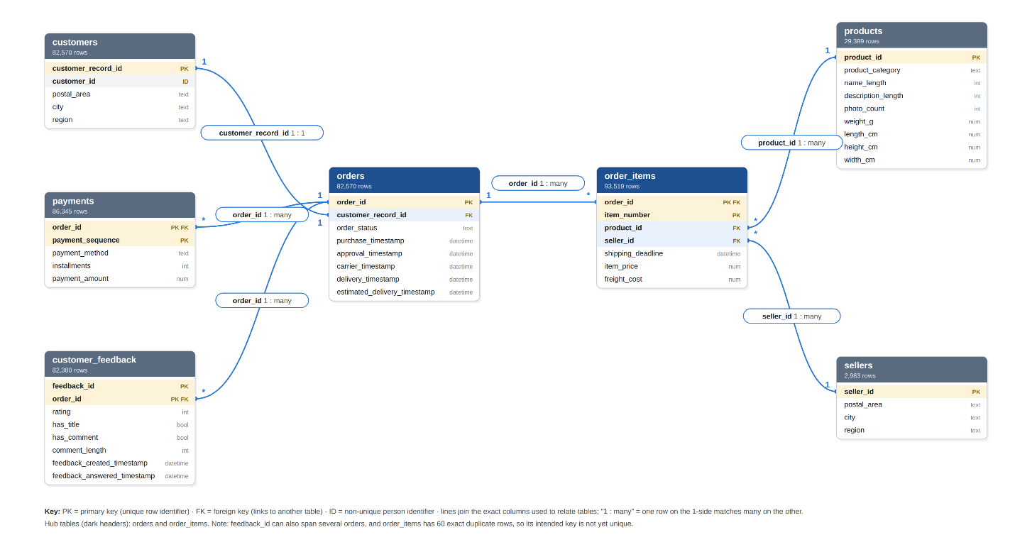
Relational column | Description | Tables where it appears
Join keys (link tables to one another)
order_id | Unique identifier of an order. Central link of the database: connects each order to its items, payments and feedback (one order → many rows in each). | orders (PK); order_items (FK); payments (FK); customer_feedback (FK)
customer_record_id | Identifier of a customer record. A new record is created for every order, so it is 1 : 1 with orders and stores the customer's location for that order. | customers (PK); orders (FK)
product_id | Unique identifier of a product listing. Links each item line to its category, listing information and physical dimensions. | products (PK); order_items (FK)
seller_id | Unique identifier of a seller. Links each item line to the seller that fulfilled it and the seller's location. | sellers (PK); order_items (FK)
Identifiers within a table (part of a composite key or grouping)
customer_id | Identifier of the actual person. Not unique: groups all customer records (orders) belonging to the same customer. | customers
item_number | Sequence of an item line within an order (1, 2, 3 …). Together with order_id it identifies an item line. | order_items
payment_sequence | Sequence of a payment within an order, for orders paid in several parts. Together with order_id it identifies a payment. | payments
feedback_id | Identifier of a feedback record. Not unique on its own: one feedback can cover several orders, so it is unique only together with order_id. | customer_feedback
PK = primary key (unique in that table); FK = foreign key (refers to the PK of another table).
Star structure. orders is the hub: customers join 1 : 1 on customer_record_id; order_items, payments and customer_feedback join 1 : many on order_id; products and sellers join to order_items. Only orders ↔ customers is 1 : 1.
Fan-out risk. Joining orders → items → payments → feedback without aggregating grows 82,570 orders to 98,987 rows and overstates revenue by 28.8%; each table must be aggregated to the unit of observation before joining.
Unmatched keys. 641 orders have no items, 1 has no payment, 645 have no feedback, and 15 sold product_ids are missing from products; every other key resolves.
Many-to-many links. Feedback ↔ orders (shared feedback_ids, several feedbacks per order) and orders ↔ sellers (1,052 multi-seller orders).

