FSAR 2026 – Group Project
Submission #1: Project Scoping

Data Familiarization:

Table Dimensions:
Customers
Column | Type | Content | Observations
customer_record_id | Char | An identifier that refers to the specific purchase made by a customer
customer_id | Char | A unique identifier (primary key) per customer | 2,513 customers have more than 1 recorc
postal_area | Char | Coded postal area of the customer
city | Char | Coded city of the customer
region | char | Coded Region of the customer

Orders
Column | Type | Content | Observations
Order_id | Char | This is a unique identifier (primary key). Only one can exist to identify each oreder uniquely. | There are 10 duplicate orders. This can be proven when relating the order table to the order_items table, because they were made at hte exact same time and contain the same products.
customer_record_id | Char | An identifier that refers to the specific purchase made by a customer. Useful for tying orders to specific customers.
Order_status | char | Contains the current status of the order. | 97% of orders are in the COMPLETED status.  5 rows have been cancelled but have delivery date  7 rows have been completed but with no delivery timestamp.
Purchase_timestamp | Date | Time of purchase | The logical order for the dates:  purchase<approval<carrier<delivery  Was not followed by multiple registers in the table.  141 carrier before purchase
Approval_timestapm | Date | Time of approval | 1109 carrier before approval
carrier_timestamp | Date | Time order was given to the carrier | 18 delivery before carrier
delivery_timestamp | Date | Time of delivery | Some of the date column have NULL values, but it is an expected behaviour.
estimated_timestamp | Date | Delivery estimation

Relationship between tables an Identifiers:
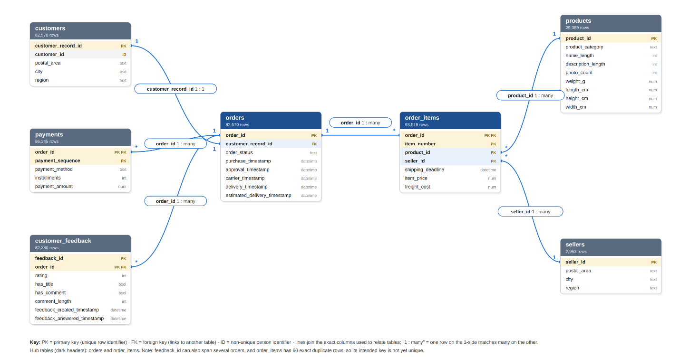
Relational column | Description | Tables where it appears
Join keys (link tables to one another)
order_id | Unique identifier of an order. Central link of the database: connects each order to its items, payments and feedback (one order → many rows in each). | orders (PK); order_items (FK); payments (FK); customer_feedback (FK)
customer_record_id | Identifier of a customer record. A new record is created for every order, so it is 1 : 1 with orders and stores the customer's location for that order. | customers (PK); orders (FK)
product_id | Unique identifier of a product listing. Links each item line to its category, listing information and physical dimensions. | products (PK); order_items (FK)
seller_id | Unique identifier of a seller. Links each item line to the seller that fulfilled it and the seller's location. | sellers (PK); order_items (FK)
Identifiers within a table (part of a composite key or grouping)
customer_id | Identifier of the actual person. Not unique: groups all customer records (orders) belonging to the same customer. | customers
item_number | Sequence of an item line within an order (1, 2, 3 …). Together with order_id it identifies an item line. | order_items
payment_sequence | Sequence of a payment within an order, for orders paid in several parts. Together with order_id it identifies a payment. | payments
feedback_id | Identifier of a feedback record. Not unique on its own: one feedback can cover several orders, so it is unique only together with order_id. | customer_feedback
PK = primary key (unique in that table); FK = foreign key (refers to the PK of another table).

