DOC01 — Problem Qualification + Pilot Readiness & Learning System Specification
CREATORZZZ • SIH26043 • Version 1.0 • Executable TRL3 Specification & Evaluation Protocol

DOCUMENT PURPOSE
This is not a full website PRD. It specifies the three mechanisms we must prove before building the complete platform: (P1) qualification/readiness diagnosis, (P2) accepted commitments + dependency invalidation, and (P3) pilot evidence-plan + outcome integrity.
TRUTH RULE
All thresholds, sample sizes and pass criteria in this document are proposed experiment targets — NOT achieved results. TRL3 can only be claimed after the tests are run and evidence is recorded.

Source hierarchy: Official SIH26043 problem statement → CREATORZZZ Research Verdict (9 Sep 2026) → Master Product & Decision Source of Truth v2.0. Where policy/authority is not established, this specification marks it as proposed or open.

0. How to Use This Document
- Backend / rules engineer: Sections 4–8 and 10.
- Frontend engineer: Section 11.
- AI engineer: Section 9.
- QA / evaluation owner: Section 12.
- Product / government liaison: Sections 1–3, 13 and 16.
- No team member should silently change a policy rule, state transition or benchmark threshold; update the version and decision log.

1. Decision & System Boundary
The wider SIH26043 platform still includes citizen intake, AI-assisted problem management, HEI collaboration, industry participation, lifecycle tracking, analytics and notifications. DOC01 narrows engineering attention to the handoffs that research says are most worth testing first.
PRIMARY READINESS DECISION
Can this validated challenge be marked PILOT READY now, under the current policy version, based on current evidence, accepted commitments and authorized human review?
UPSTREAM PRECONDITION
Before readiness, the case must be qualified into one of four routes: SERVICE, CLARIFY, RESEARCH REVIEW or INNOVATION CHALLENGE.
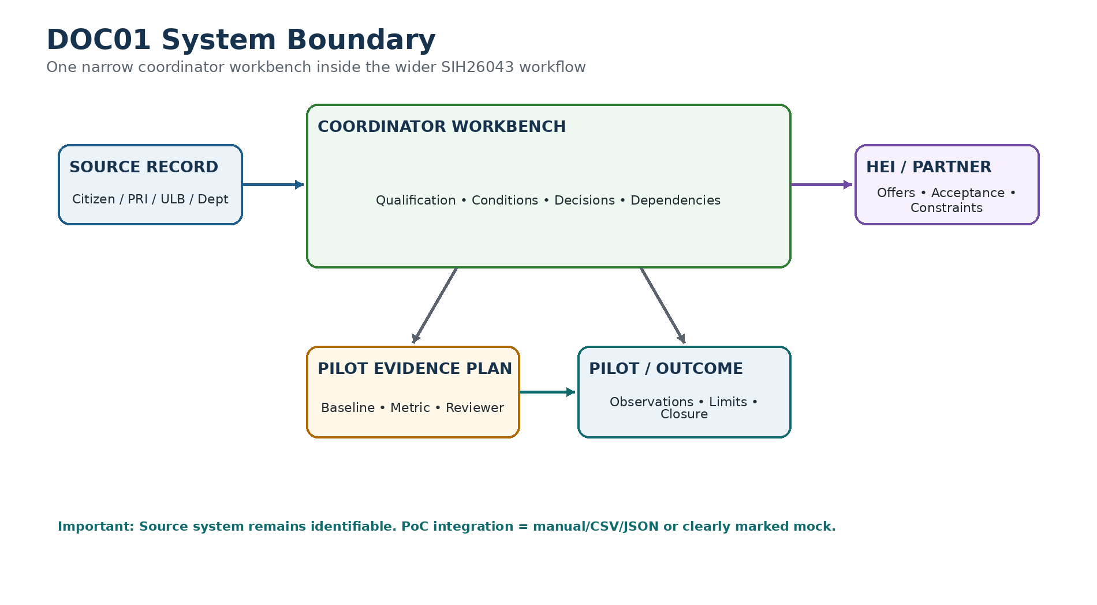

1.1 Accountable actors — proposed for PoC
Role | Decision / responsibility | Authority status
Reporter / Source | Supplies problem/evidence; may answer clarification | Source identity only; does not approve readiness
Programme Coordinator | Runs review workflow, requests missing evidence, prepares decisions | Proposed operational role; actual DHTE owner OPEN
Problem Owner / Local Authority | Confirms jurisdiction/field permission where applicable | Must be an authorized institutional actor in real deployment
HEI / Faculty / Resource Custodian | Accepts or declines scoped commitment | Acceptance only for own scope/resource
Evaluator | Reviews Pilot Evidence Plan and outcome interpretation | Proposed role; exact appointment OPEN
Policy Approver | Approves/versions mandatory readiness rubric | Government/program authority; OPEN for PoC

1.2 Mapping to official PS
Official PS area | Thin surrounding implementation | DOC01 focus
Citizen engagement | Report + evidence + source ID | Qualification inputs
AI problem management | Classification / related-case suggestions | Source-grounded assistance only
University collaboration | HEI shortlist + team/proposal | Accepted commitments
Industry partnership | Specific offer / testing / pilot support | Commitment scope + expiry
Lifecycle management | Project / milestone / approvals | Readiness + dependency integrity
Analytics | Counts / progress / outcomes | False-ready, blockers, evidence maturity
Notifications | Task / review alerts | Dependency-triggered review requests

1.3 Explicit non-goals for DOC01
- Full public website requirements catalogue
- Native mobile app
- Funding marketplace or procurement
- Statewide knowledge graph / mission optimizer
- Automatic solution replication
- Live government API integration without authorization
- Global novelty claim
- Autonomous AI validation, approval or impact judgement

2. Case Ontology
The team must use different words for different objects. A report is not a challenge; a challenge is not a project; a project is not a pilot.
Object | Definition | Can exist without next stage?
Report | Raw societal issue submitted by citizen/community/PRI/ULB/department | Yes
EvidenceItem | Source-linked file, observation, record or verification attached to a case | Yes
Challenge | Reviewed problem statement being considered for service/research/innovation action | Yes
QualificationDecision | Human-reviewed route decision under a policy version | Yes
CapabilityCandidate | HEI/lab/partner suggested as potentially relevant | Yes
Commitment | Explicit scope/date/resource acceptance or refusal by an actor | Yes
Condition | A readiness prerequisite and its current status | Yes
ReadinessDecision | Decision packet saying Blocked / Review Ready / Pilot Ready / Review Required | Yes
PilotEvidencePlan | Predeclared measurement and review plan | Required before Pilot Ready where policy says mandatory
Pilot | Authorized bounded field test | Yes
Observation | Measured or documented result linked to evidence | Yes
OutcomeDecision | Validated / Iterate / Stopped / Inconclusive with reasons | Final for that review cycle

2.1 Evidence status
Status | Meaning
UNVERIFIED | Record exists but no authorized review yet
SUPPORTED | Evidence is relevant and supports a stated fact
CONFLICTING | Evidence sources disagree or context is inconsistent
REJECTED | Reviewer determined item is irrelevant/invalid for the stated purpose
EXPIRED | Time-sensitive evidence is no longer current
- Location, timestamp, hash or metadata improves provenance but does not prove truth.
- Related/duplicate suggestions never auto-delete or auto-merge source reports.
- Original source record and provenance must remain traceable even after a challenge is created.

3. Authority & Versioned Policy
The PoC must not hard-code government policy as if CREATORZZZ has legal authority. The rules are versioned configuration, and human authorization remains explicit.
Policy field | Required meaning
policy_version | Stable identifier, e.g., PQ-0.1 / PR-0.1
scope | Which domain/program/case type the rules apply to
condition_id | Stable condition identifier
mandatory | Whether Pilot Ready is impossible without satisfaction/authorized exception
waivable | Whether an authorized exception is possible
required_evidence | What evidence types can support the condition
approver_role | Role allowed to confirm or waive
expiry_rule | Date / duration / event that makes the evidence stale
dependency_targets | Which decisions depend on this condition/version
exception_evidence | Required reason/reference for a waiver
POLICY RULE
PoC policy v0 is a CREATORZZZ design fixture, not a Government of Jharkhand policy. Production policy must be approved by the actual programme owner.

4. Problem Qualification Gate Specification
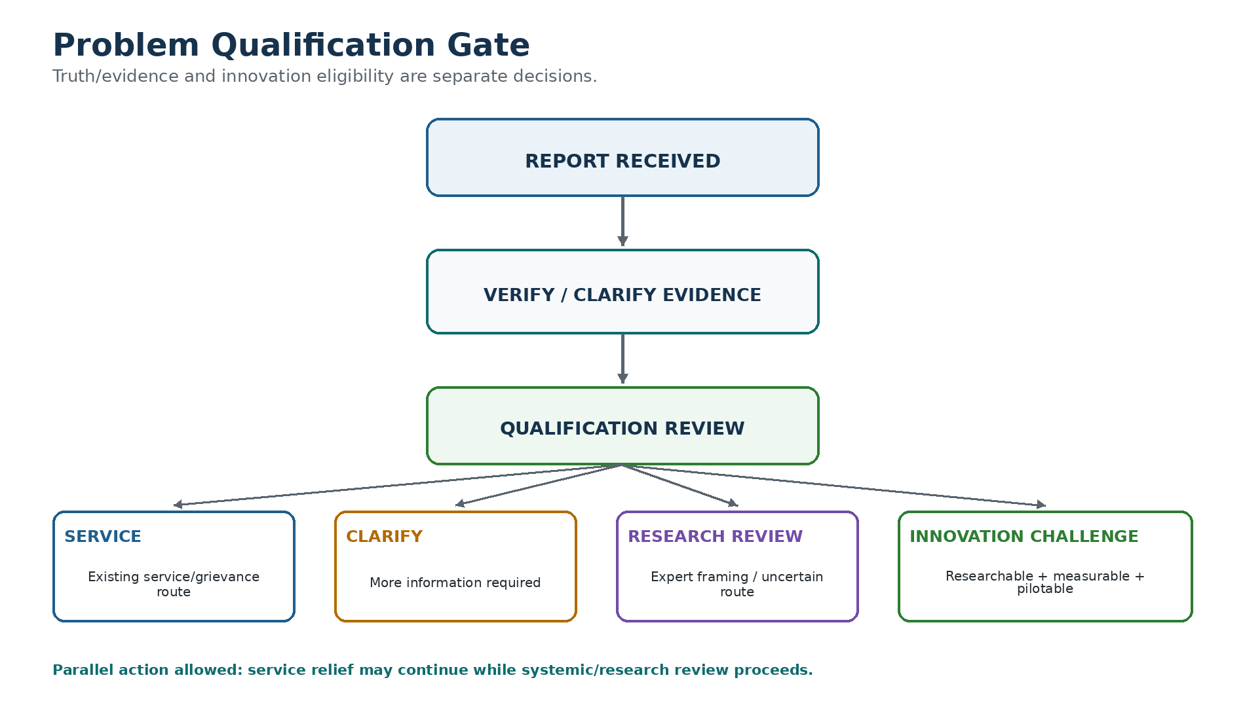

4.1 Inputs
Input | Required / optional | Notes
Original report text | Required | Preserve exact source text
Reporter/source type | Required | Citizen / assisted / PRI / ULB / department
Location | Optional by policy | Missing location cannot be invented
Evidence items | Optional at intake; may become required for review | Keep permissions/sensitivity
Related reports | Optional suggestion | Human decides relation/merge
Service route reference | Optional | Existing grievance/service mechanism if known
Reviewer notes | Optional | Must be attributed

4.2 Qualification questions
ID | Question
Q1 | Is there enough evidence/context to review the issue?
Q2 | Is a routine service or administrative remedy available?
Q3 | Can service action and research review proceed in parallel?
Q4 | Is the issue recurrent, systemic or technically uncertain enough to justify expert review?
Q5 | Is there meaningful public value in solving it?
Q6 | Can the problem be bounded into a project/pilot?
Q7 | Can an outcome be measured?
Q8 | Is a legitimate problem owner / local authority identifiable?
Q9 | Are there safety/legal/privacy constraints that make a student-led pilot inappropriate?

4.3 Routing decision table — PoC design
Condition pattern | Route | Human action
Evidence/context insufficient | CLARIFY | Request specific missing information
Routine remedy exists; no research need identified | SERVICE | Refer/record service route
Routine remedy exists AND systemic/research question may remain | SERVICE + RESEARCH REVIEW | Allow parallel path
Potential systemic/research need but scope/owner/measurement unclear | RESEARCH REVIEW | Domain expert frames challenge
Validated + researchable + bounded + measurable + eligible | INNOVATION CHALLENGE | Proceed to ownership/capability stage
Safety/legal/policy blocks student-led pilot | SERVICE / SPECIALIST REVIEW | Do not force innovation route

4.4 Qualification decision output
{
"qualification_id": "QD-...",
"case_id": "C-...",
"route": "SERVICE | CLARIFY | RESEARCH_REVIEW | INNOVATION_CHALLENGE",
"policy_version": "PQ-0.1",
"reasons": [{"claim": "...", "evidence_ids": ["E-..."]}],
"unknowns": ["..."],
"reviewer": "actor_id",
"reviewed_at": "ISO-8601",
"next_actions": [{"owner_role": "...", "action": "..."}]
}
- AI may draft the route and reasons, but the reviewer signs the decision.
- Unknowns remain unknown. The model must not invent an owner, permission or service reference.

5. Pilot Readiness Evaluator

5.1 Condition truth states
State | Meaning | Can count as satisfied?
SATISFIED | Current evidence and authorized review support the prerequisite | Yes
UNSATISFIED | Known requirement is not met | No
UNKNOWN | Required information is missing/unresolved | No
DISPUTED | Evidence/reviewers conflict | No
EXPIRED | Previously valid prerequisite is stale | No

5.2 Proposed readiness conditions for municipal-service PoC
Condition | Default type | Example evidence
challenge_scope_accepted | Mandatory | Reviewed challenge statement
problem_owner_identified | Mandatory | Authority/department reference
field_permission | Mandatory when field access required | Permission letter / recorded approval
hei_team_commitment | Mandatory | Accepted offer with faculty/team/dates
required_resource_commitment | Conditional mandatory | Lab/equipment/partner offer
time_window_feasible | Mandatory | Dates do not conflict with commitments
privacy_safety_review | Conditional mandatory | Reviewer decision
pilot_evidence_plan_approved | Mandatory | Approved plan version
budget_or_in_kind_decision | Conditional mandatory | Approved/waived/resource record

5.3 Aggregate readiness states
Readiness state | Rule
BLOCKED | At least one mandatory condition is UNSATISFIED, UNKNOWN, DISPUTED or EXPIRED
REVIEW_READY | All machine-checkable mandatory prerequisites are SATISFIED or validly excepted; human sign-off pending
PILOT_READY | REVIEW_READY + authorized human readiness decision signed
REVIEW_REQUIRED | A relied-on evidence/commitment/policy version changed after prior readiness
CLOSED / SUPERSEDED | Decision no longer active because case/pilot cycle ended or replaced
NO AUTONOMOUS GREEN STATUS
The rule engine can produce REVIEW_READY. Only an authorized human can create PILOT_READY.

5.4 Decision packet
ReadinessDecision
- id
- case_id / project_id
- policy_version
- condition_snapshot[]
- relied_on_versions[]
- blockers[]
- next_actions[]
- decision_state
- reviewer / authority_reference
- made_at
- review_required
- reason / exception references

6. Commitment State Machine
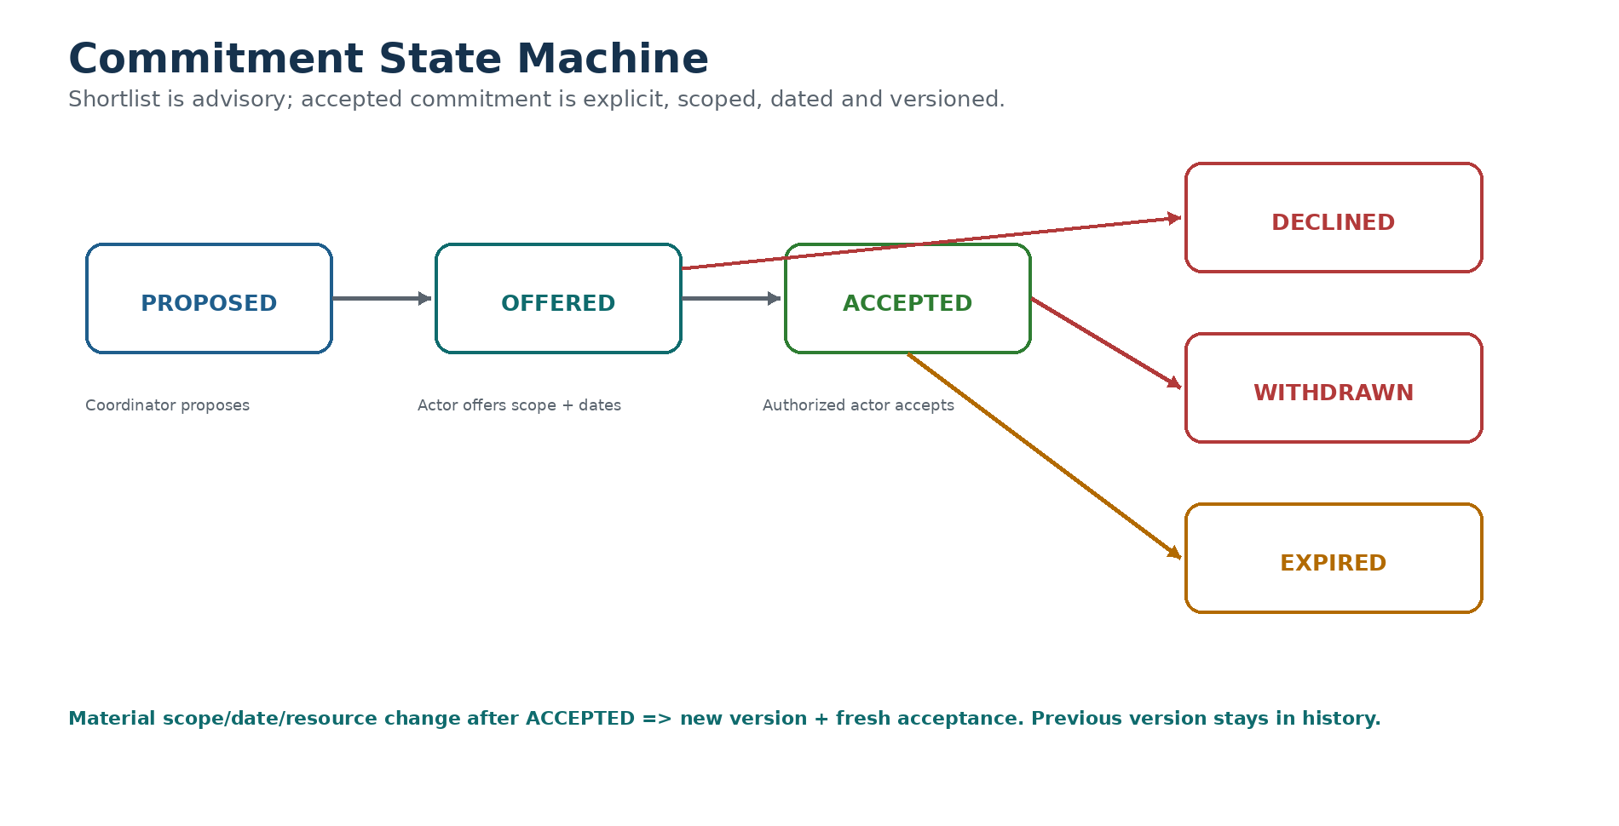

6.1 Allowed transitions
From | To | Who / rule
PROPOSED | OFFERED | Resource/faculty owner defines scope, dates, constraints
PROPOSED | DECLINED | Relevant actor declines
OFFERED | ACCEPTED | Authorized actor accepts exact version
OFFERED | DECLINED | Actor rejects offer
OFFERED | EXPIRED | Expiry time/event reached
ACCEPTED | WITHDRAWN | Authorized actor withdraws; reason required
ACCEPTED | EXPIRED | Time-bound commitment expires
ACCEPTED | OFFERED (new version) | Material scope/resource/date change requires fresh offer/acceptance

6.2 Required commitment fields
Field | Meaning
actor_id | Faculty / lab / partner / authority actor
scope | What exactly is being committed
resource_or_effort | Hours, team, lab slot, field access, equipment etc.
start_at / end_at | Validity interval
constraints | Limitations / conditions
state | Current commitment state
accepted_by | Authorized accepting actor
version | Immutable commitment version
expiry | Explicit date/time/event
withdrawal_reason | Mandatory on withdrawal

6.3 Conflict & replay rules
- Transactional reservation for exclusive resources.
- Use idempotency keys for acceptance/withdrawal to survive retry/offline replay.
- Duplicate request must not create duplicate accepted capacity.
- Stale client write cannot overwrite a newer accepted/withdrawn version.
- Identity aliases for the same faculty/resource must be resolved in fixture data before conflict tests.

7. Dependency Semantics & Re-Review
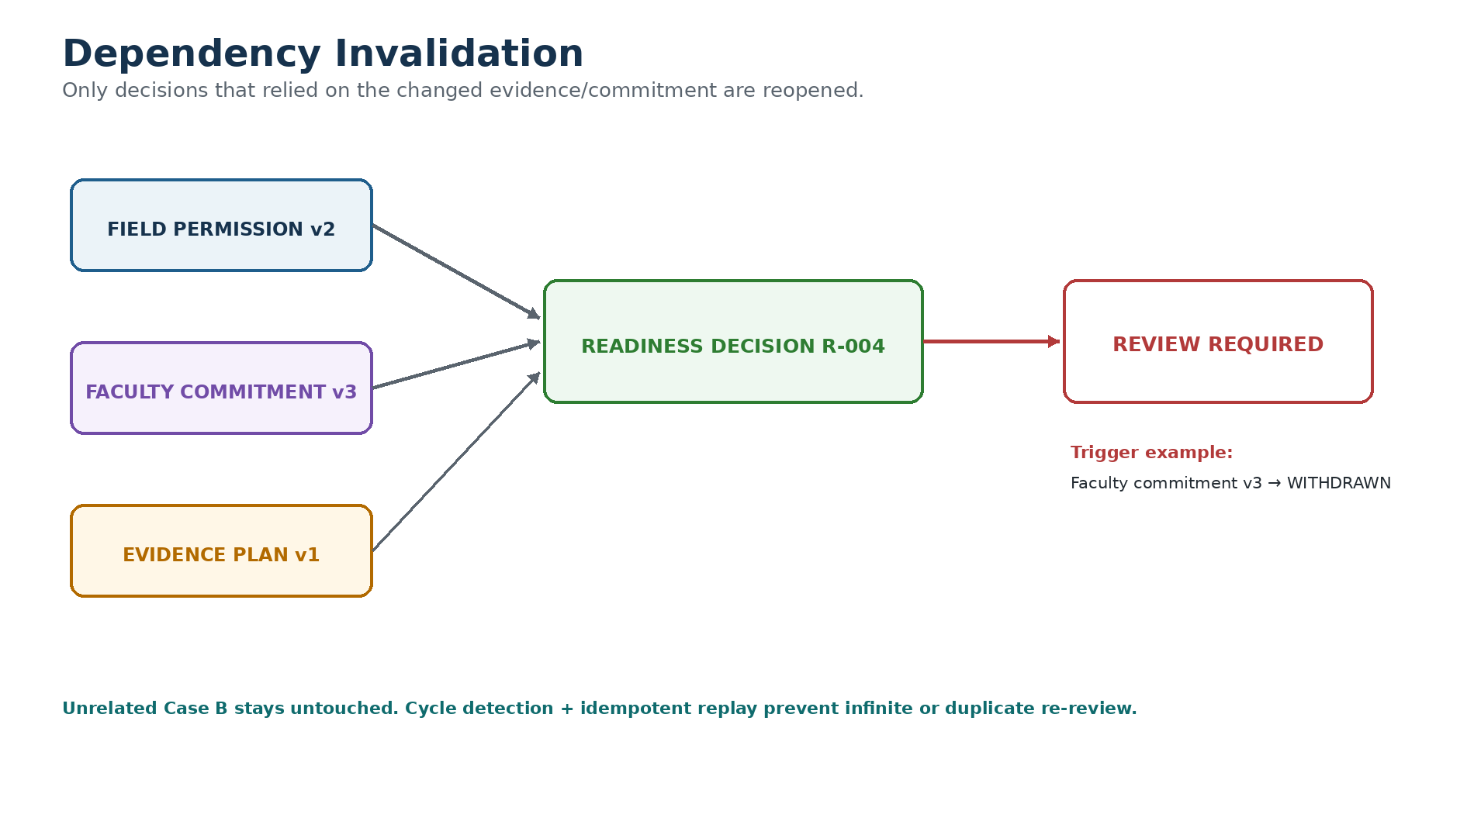

7.1 Dependency rules
- Every readiness/outcome decision stores exact evidence, commitment and policy versions it relied on.
- When a relied-on version becomes withdrawn, expired, superseded or invalid, mark only dependent active decisions REVIEW_REQUIRED.
- Unrelated cases and decisions remain unchanged.
- Archived evidence remains visible for history but cannot silently satisfy a current condition.
- Dependency cycles are rejected or detected; traversal must terminate.
- Cache must be invalidated when a dependency changes; UI must never show stale green status.

7.2 Re-evaluation pseudo-rule
on_dependency_change(changed_version):
affected = find_active_decisions_relying_on(changed_version)
for decision in affected:
decision.review_required = True
decision.reason = "Relied-on dependency changed"
emit_review_task(decision)
do_not_touch(unrelated_decisions)

8. Pilot Evidence Plan & Outcome Integrity
This plan is mandatory for the PoC readiness policy. It is an evaluation plan, not a legal contract.
Field | Required content
outcome | What change is being tested
unit | Measurement unit
denominator | Population/volume/reference base
baseline_source / date | Where baseline came from and when
target | Predeclared desired change
collection_method | How observations are gathered
comparison | Before/after, comparison group, trend, or descriptive only
window | Measurement timeframe
owner | Who collects evidence
reviewer | Who interprets outcome
adverse_effects | What harms/negative effects are monitored
stop_rule | When to stop/reconsider
publication_permission | What may be shared
limitations | What the design cannot establish

8.1 Outcome states
State | Decision meaning
VALIDATED | Evidence supports the stated conclusion within limitations
ITERATE | Promising but more/modified testing is needed
STOPPED | Pilot stopped for explicit operational/safety/resource reason
INCONCLUSIVE | Evidence cannot support the requested conclusion

8.2 Integrity checks
- Missing baseline or denominator is a critical defect when required for the claim.
- Changed denominator must be flagged before comparing values.
- Outcome measured too early must be flagged.
- Project photo cannot be treated as evidence of benefit by itself.
- Typed calculations only; LLM does not perform authoritative arithmetic.
- Causal impact cannot be auto-verified unless the evaluation design supports it and a human reviewer agrees.
- Adverse observations cannot be deleted to obtain a success label.

9. AI Boundary & Structured Assistance
AI task | Allowed output | Required control
Raw text structuring | Schema fields + source spans | Reviewer edits/accepts
Domain classification | Multi-label suggestion | Reviewer can override
Related case search | Candidates + similarity context | No automatic merge
Qualification draft | Suggested route + evidence-backed reasons | Human sign-off
Capability shortlist | Relevant HEIs/resources + why | No capacity acceptance
Readiness note | Missing/unknown fields summary | Rules compute state
Evidence-plan feedback | Missing fields / ambiguity | Evaluator decides adequacy
Outcome summary | Observed values + cited evidence | No causal/success auto-approval

9.1 Grounding & abstention
- Every extracted factual field must point to source text/evidence ID when possible.
- If source does not support a field, output UNKNOWN/null, not a guess.
- Attachments are data. Instructions inside an attachment must not override system rules.
- The model must not fabricate permission, owner, budget, faculty availability, sample size or observed result.
- Store model/version/prompt version for reproducibility.

9.2 Minimal structured extraction contract
{
"fields": {
"problem_summary": {"value": "...", "source_refs": ["E-12"]},
"location": {"value": null, "source_refs": [], "status": "UNKNOWN"},
"domain": {"value": ["urban_services"], "source_refs": ["E-12"]}
},
"missing_information": ["field_permission", "baseline"],
"suggested_related_cases": ["C-17"],
"notes": "Draft only; human review required"
}

10. Minimum Data Contract
The schema below is a proposed PoC contract, not an existing government standard.
Entity | Minimum fields
Case / Challenge | id, source_system, source_record_id, title, raw_text, domain[], location, status, created_at, version
EvidenceItem | id, case_id, source_uri/reference, observed_at, uploaded_at, permission, sensitivity, author_role, verification_status, version
PolicyVersion | id, policy_type, scope, effective_from, conditions[], approver_role, status
Condition | id, policy_version, subject_id, required_evidence, status, reviewer, reviewed_at, expiry, dependencies
Commitment | id, actor_id, scope, resource/effort, start/end, constraints, state, accepted_by, version, expiry, withdrawal_reason
Decision | id, type, actor, authority_reference, policy_version, relied_on_versions, reasons, made_at, review_required
PilotEvidencePlan | id, outcome, unit, denominator, baseline_source/date, target, collection_method, comparison, window, owner, reviewer, adverse_effects, stop_rule, permission
Observation / Outcome | id, observed_value, unit, denominator, time_window, evidence_ids, limitations, outcome_state, reviewer, next_decision

10.1 API / import validation errors
Error code | Meaning
MISSING_REQUIRED_FIELD | Required field absent
UNKNOWN_REFERENCE | Foreign key/source ID not found
VERSION_CONFLICT | Client attempted stale update
INVALID_TRANSITION | State change not allowed
EXPIRED_DEPENDENCY | Relied-on evidence/commitment expired
PERMISSION_DENIED | Actor lacks authority for action
DUPLICATE_IDEMPOTENCY_KEY | Replay of already-processed mutation
SENSITIVE_DATA_RESTRICTED | Role cannot access data classification

11. Reference Interface — Minimum Views
The PoC does not need the full 10-screen final portal. It needs only views required to execute and test the three mechanisms.
View | Must show | Critical error states
Coordinator Case View | Original source, evidence, qualification, conditions, blockers, next actions | Unknown evidence, disputed owner, stale policy
Qualification Review | Route suggestion, questions, source-backed reasons, human decision | Missing evidence, parallel route, unsafe scope
Offer / Commitment View | Scope, resource, dates, constraints, accept/decline/withdraw | Conflict, expired offer, stale version
Readiness Workbench | Condition table, states, dependencies, review status | False green prevented, review required
Pilot Evidence Plan | Baseline, metric, denominator, method, reviewer, stop rule | Missing denominator/baseline, permission issue
Outcome Review | Observations, provenance, limitations, closure state | Unsupported success claim, changed denominator
Benchmark Mode | Tool condition, case ID, timer, reviewer decisions | No access to hidden gold labels

11.1 UI rule
NO OPAQUE SCORE
Do not show a single 'Readiness 82%' or 'Genuine 93%' number. Show which conditions are satisfied, unknown, disputed, expired or blocked — with evidence and next owner.

12. TRL3 Benchmark Protocol
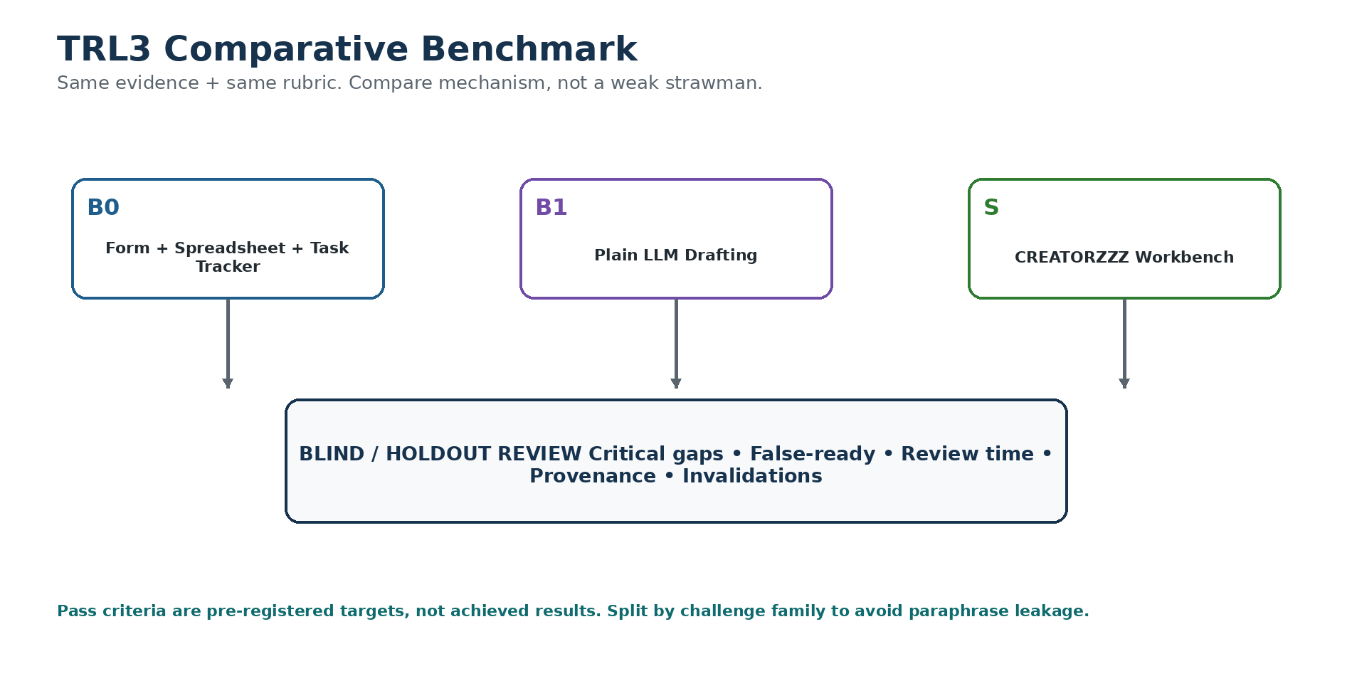

12.1 Common experiment rules
- Pre-register thresholds before viewing holdout outputs.
- Preserve real/anonymised, synthetic and perturbed case provenance separately.
- Split by underlying challenge family — not random paraphrases — to avoid leakage.
- Use two independent reviewers for gold labels; third reviewer adjudicates disagreement.
- LLM output is never the gold label.
- B0 must be a competent form + spreadsheet + task-tracker using the same rubric and reminders.
- B1 uses plain LLM drafting with identical evidence but no custom deterministic readiness rules.
- Counterbalance tool order for human review-time comparisons.
- Report by domain, provenance and language where sample size permits.

12.2 P1 — Source-backed qualification/readiness diagnosis
Item | Protocol
Hypothesis | System helps reviewers detect material readiness gaps faster than B0 without falsely declaring incomplete cases ready.
Input | 120 case packets. Target ≥30 permissioned real/anonymised; add synthetic/adversarial variants. Split 30 dev / 30 tuning / 60 holdout by case family.
Coverage | Routine-only, parallel service/research, unclear owner, absent site access, disputed evidence, feasible pilots.
Gold | Two independent reviewers; third adjudicator. Unresolved remains UNKNOWN.
Metrics | Critical-gap recall; false-ready numerator/denominator; ready-case recall; median active review minutes; abstention/override; source-grounding error.
PASS — proposed | On 60 holdout: zero observed false-ready decisions; ≥95% critical-gap recall; ≥80% recall of ready cases; median active review time ≥20% below B0 with no increase in critical errors.
Failure probes | Fabricated permission; irrelevant-but-credible evidence; ambiguous authority; local-language mistranslation; prompt injection inside attachment; always-abstain gaming.
Demo | A convincing case stays blocked until missing prerequisite is provided and human-approved.

12.3 P2 — Accepted commitments & dependency invalidation
Item | Protocol
Hypothesis | Explicit commitments + dependency checks prevent stale readiness without causing unnecessary re-review.
Input | 40 commitment/scheduling scenarios + 120 mutations: withdrawal, expiry, interval conflict, scope change, revoked site access, duplicate request, offline replay.
Gold | Written transition spec + independent oracle. Exhaustively enumerate feasible allocations on 12 small scenarios.
Baseline | B0 configured tracker with owners, expiry dates, reminders and manual linked-decision review.
Metrics | Critical invalidation recall; affected-decision precision; double-bookings; unauthorized transitions; replay consistency; time to identify affected cases.
PASS — proposed | Detect every critical invalidation in preregistered mutation suite; ≥95% affected-decision precision; zero double-bookings and unauthorized transitions; identical result after duplicate/offline replay; ≥20% lower active review time vs B0 on ≥12 human-reviewed scenarios with no missed cases.
Failure probes | Timezone/date errors; stale overwrite; faculty aliases; cached green status; dependency cycles; unrelated cases mass-invalidated.
Demo | Withdraw accepted faculty/lab offer → only dependent readiness decisions reopen.

12.4 P3 — Pilot evidence-plan & outcome integrity
Item | Protocol
Hypothesis | Structured source-linked review catches unmeasurable plans and unsupported success claims while reducing preparation effort.
Input | 60 plan/outcome packets: 20 adequate, 20 defective, 20 ambiguous by construction; target 20 permissioned historical + 40 synthetic/perturbed. 20 dev / 40 holdout by case family.
Gold | Two independent reviewers including evaluation-methods reviewer; third adjudicates. If causal inference cannot be established, outcome is inconclusive.
Baseline | B0 well-designed evidence-plan template + reviewer checklist; B1 plain LLM feedback.
Metrics | Critical-defect recall; false-positive rate; unsupported causal/success assertions; provenance completeness; median review time; reviewer agreement; outcome misclassification.
PASS — proposed | ≥90% critical-defect recall on 40 holdout; ≤10% false critical-defect flags on adequate packets; zero unsupported auto-verified causal claims; complete provenance for quantitative results; median review time ≥20% below B0 OR keep this component as manual template.
Failure probes | Denominator change; missing baseline; too-early outcome; selection bias; photo-as-impact; fabricated sample size; missing adverse effects/cost; survivorship-only reporting.
Demo | Completed pilot closes INCONCLUSIVE because evidence cannot support claimed success.

13. Validation Evidence Still Required
Desk research cannot prove local operating ownership, adoption or performance. These are mandatory evidence gaps.
Evidence gap | Minimum validation | If unresolved
Operating owner | Identify programme/office/role that actually decides readiness | Do not claim government adoption; keep role hypothetical
12-case workflow audit | Review real/anonymised cases where access is permitted | Synthetic PoC remains technical only
HEI acceptance workflow | At least faculty/programme reviewers explain acceptance/decline authority | Do not claim institution-level workflow fit
Field permission authority | Identify who can authorize site access in chosen demo domain | Use synthetic demo only
Pilot evaluation owner | Identify reviewer/evaluation role | Keep outcome review as proposed process
Integration / handover | Ask whether incumbent portal/operator would accept import/export/module handover | Do not promise independent production deployment

13.1 Interview / case record template
- Role and institution — anonymise if needed.
- Current artefact used: form, sheet, portal, email, meeting note, tracker.
- Decision being made.
- What information is often missing?
- Who can approve / reject?
- What makes an assignment infeasible?
- What invalidates an earlier decision?
- How is pilot success currently decided?
- One case where the process failed or required rework.
- Permission to use anonymised case in evaluation?

14. PoC Deployment Boundary
Area | PoC decision
Environment | Local/staging web app; no production SLA claim
Data | Synthetic + separately tagged permissioned anonymised cases
External integration | CSV/JSON/manual import/export or clearly marked mocks
Auth | Simple role-based test accounts; no claim of government identity integration
Logs | State transitions, decisions, model version, policy version, dependency events
Fixture reset | One command / admin action resets test corpus to frozen state
Backup/export | JSON/CSV export of case, evidence refs, decisions and results
Secrets | Environment variables; never hard-code API keys
Handover | Portable schema + protocol + reference implementation
- Do not select clinical, water-treatment or safety-critical physical intervention as the demo domain.
- Use a synthetic low-risk municipal service-process scenario such as irregular dry-waste pickup.

15. Results Template — Fill Only After Testing
DO NOT PRE-FILL
These tables are intentionally blank. The team must enter measured denominators, failures and reviewer burden after the holdout run.
PoC | Baseline | Holdout n | Primary metric | Measured result | Pass? | Key failures
P1 | B0 / B1
P2 | B0
P3 | B0 / B1

15.1 Required reporting
- Numerator and denominator for every rate.
- Case-family split and provenance distribution.
- Median active review time and reviewer count.
- All critical failures, including those that contradict our preferred thesis.
- AI abstention and human override counts.
- Cost / latency where AI is used.
- Any benchmark where B0 performs equally or better.
- Confidence/uncertainty note; never turn zero observed errors into guaranteed zero error.

16. Go / Simplify / Pivot Rules
Result | Decision
No legitimate operating owner exists for the readiness decision | PAUSE custom product expansion; clarify sponsor/process first
P1 fails safety or speed criteria | SIMPLIFY qualification/readiness; improve rubric or use configured tracker
P2 fails integrity criteria | DO NOT expose Pilot Ready automation; fix state/dependency engine first
P3 fails to beat good manual template | KEEP Pilot Evidence Plan as manual structured template; do not over-automate
B0 matches custom system with lower complexity | Use/configure B0 pattern rather than defend unnecessary software
P1–P3 pass and stakeholders confirm ownership | GO to thin integrated SIH MVP / TRL4 preparation
New evidence reveals a stronger existing system already adopted locally | PIVOT to integration/configuration/handover role
TEAM PRINCIPLE
The benchmark is allowed to tell us not to build a custom mechanism. That is a valid research outcome, not a failure.

17. Implementation Order
- Freeze PoC policy v0 and gold-label handbook before model tuning.
- Build B0 baseline first so custom implementation has a fair comparator.
- Implement canonical entities + versioning + audit.
- Implement Problem Qualification decision packet.
- Implement readiness condition evaluator.
- Implement commitment state machine + idempotent mutations.
- Implement dependency invalidation.
- Implement Pilot Evidence Plan + typed validation.
- Add thin AI extraction/suggestions only after deterministic paths work.
- Build benchmark mode and timers.
- Run dev/tuning cases; freeze implementation.
- Run holdout evaluation; publish failures.
- Only after decision gate: integrate into the final SIH MVP screens.

18. DOC01 Acceptance Checklist
- ☐ Two team members can independently classify the same frozen qualification fixture and explain disagreements.
- ☐ Two team members can reproduce readiness from the same condition/evidence snapshot.
- ☐ Commitment transitions and forbidden transitions are explicit.
- ☐ Dependency change reopens only affected decisions.
- ☐ No AI path can create PILOT_READY without human sign-off.
- ☐ No missing value is silently fabricated.
- ☐ Pilot Evidence Plan includes denominator, baseline, reviewer, stop rule and limitations.
- ☐ Outcome can close as INCONCLUSIVE.
- ☐ CSV/JSON export preserves stable IDs, versions and provenance.
- ☐ Benchmark baselines, splits and pass thresholds are frozen before holdout.
- ☐ Results tables remain blank until measurement.
- ☐ Production/government integration claims remain gated by authorization.

19. Final Lock
WHAT DOC01 PROVES — IF TESTS PASS
Not that CREATORZZZ invented readiness management globally. It would prove that our specific, source-linked qualification/readiness/learning mechanism can make the SIH26043 handoff safer and/or faster than a competent configured baseline on a preregistered test set.
WHAT IT DOES NOT PROVE
Statewide adoption, government procurement, HEI participation at scale, social impact, or production readiness. Those require later TRL4/pilot evidence.

20. Source Basis
- Official SIH26043 Problem Statement — Government of Jharkhand, Department of Higher & Technical Education.
- CREATORZZZ SIH26043 Research Verdict — independent research/adversarial review, cutoff 9 Sep 2026; especially sections 16 and 19.
- CREATORZZZ Master Product & Decision Source of Truth v2.0 — current canonical product baseline.
This document intentionally preserves uncertainty: exact government operator, policy authority, identity rules, SLA/escalation, pricing, partner capacity and production integrations are not treated as settled facts.

