DOC02 — Full Technical Build Handbook
SIH26043 • CREATORZZZ • MVP V1 • Hinglish Team Engineering Guide

PURPOSE
Ye document team ke liye actual build handbook hai. Isko padhkar Frontend, Backend, AI/Data, QA/DevOps aur Integration roles ko pata hona chahiye ki kya banana hai, kis API/data contract par kaam karna hai, kaunsi cheez lock hai aur kaunsi cheez abhi defer hai.
CURRENT BUILD DECISION
Internal hackathon ke liye full platform ka thin vertical slice build hoga. P1 Problem Qualification aur P3 Evidence Plan ko simple structured workflow rakhenge; P2 Commitment + Dependency Invalidation custom hero mechanism rahega. TRL3 report ke synthetic results ko product-performance claim nahi banaenge.
NORTH STAR
Har genuine problem innovation problem nahi hoti. Har innovation problem pilot-ready nahi hoti. Har completed pilot impact prove nahi karta.
Source basis: Official SIH26043 PS, DOC00 v2.0, DOC01 v1.0, Team Explainer v1.0, B0 workbook and TRL3 Technical Validation Report dated 10 Sep 2026.

0. Document Map — Team ko kya padhna hai
If you are... | Must read first | Then read
Team Lead / Integrator | 1, 2, 3, 16, 17, 18 | All acceptance criteria
Frontend Engineer | 3, 4, 10, 11, 12 | 5 APIs + 15 testing
Backend Engineer | 3, 5, 6, 7, 8 | 9 AI boundary + 15 testing
AI / Data Engineer | 6, 9, 14 | 5 API contracts + 15 tests
QA / Test Engineer | 7, 8, 11, 15 | 14 seed data + 18 DoD
DevOps / Deployment | 3, 6, 13, 15 | 17 integration plan
Product / Demo Owner | 1, 2, 4, 10, 14, 18 | 16 team workflow

0.1 What is already proven vs not proven
Area | Current evidence | Build consequence
P1 Qualification / readiness checks | Synthetic snapshot ties B0 on main checks; custom added 2 extra blockers | Keep simple; rules + human approval, no fancy AI claim
P2 Commitments / invalidation | Strongest synthetic integrity result: versioning, withdrawals, replay/conflict checks worked in the frozen suite | Build custom and make it the hero interaction
P3 Evidence plan / outcome | Synthetic checks tie B0 on main checks; one stop-vs-inconclusive modeling issue found | Structured template + deterministic validation; fix operational/evidence state separation
Human/real-world advantage | Not measured | No claim of workload reduction or government validation
Full MVP | Not validated yet | Build now for internal hackathon as Sample MVP V1

1. Final Product Scope — V1 mein exactly kya build karna hai
PRODUCT
Societal Innovation Collaboration Platform — with Problem Qualification Gate + Pilot Readiness & Learning workflow.

1.1 V1 main user story
1. Citizen/PRI/ULB ek societal issue evidence ke saath report karta hai.
2. Coordinator evidence review karke route decide karta hai: SERVICE / CLARIFY / RESEARCH REVIEW / INNOVATION CHALLENGE.
3. Innovation challenge ke liye relevant HEIs shortlist hote hain.
4. HEI/faculty explicit ACCEPT / CONDITIONAL / DECLINE karta hai — sirf match score nahi.
5. Pilot Readiness Workbench permissions, commitments aur evidence plan check karta hai.
6. Authorized human sign-off ke baad hi PILOT READY state aata hai.
7. Faculty/resource/permission later change hota hai to dependent readiness automatically REVIEW REQUIRED ho jata hai.
8. Pilot Evidence Plan aur observations ke basis par outcome VALIDATED / ITERATE / STOPPED / INCONCLUSIVE record hota hai.
9. Government dashboard blocker, next action aur honest outcome dikhata hai.

1.2 V1 mein kya intentionally nahi build karna
- Native mobile app
- Blockchain
- Payment/funding marketplace
- Multi-agent system
- Live Aadhaar/government SSO
- Live CPGRAMS/MyGov integration
- Statewide knowledge graph
- Mission portfolio optimizer
- Automatic causal-impact engine
- Full procurement/IP/legal workflow
- Huge industry marketplace
- 50-screen admin panel

2. Roles, Permissions & Product Responsibilities
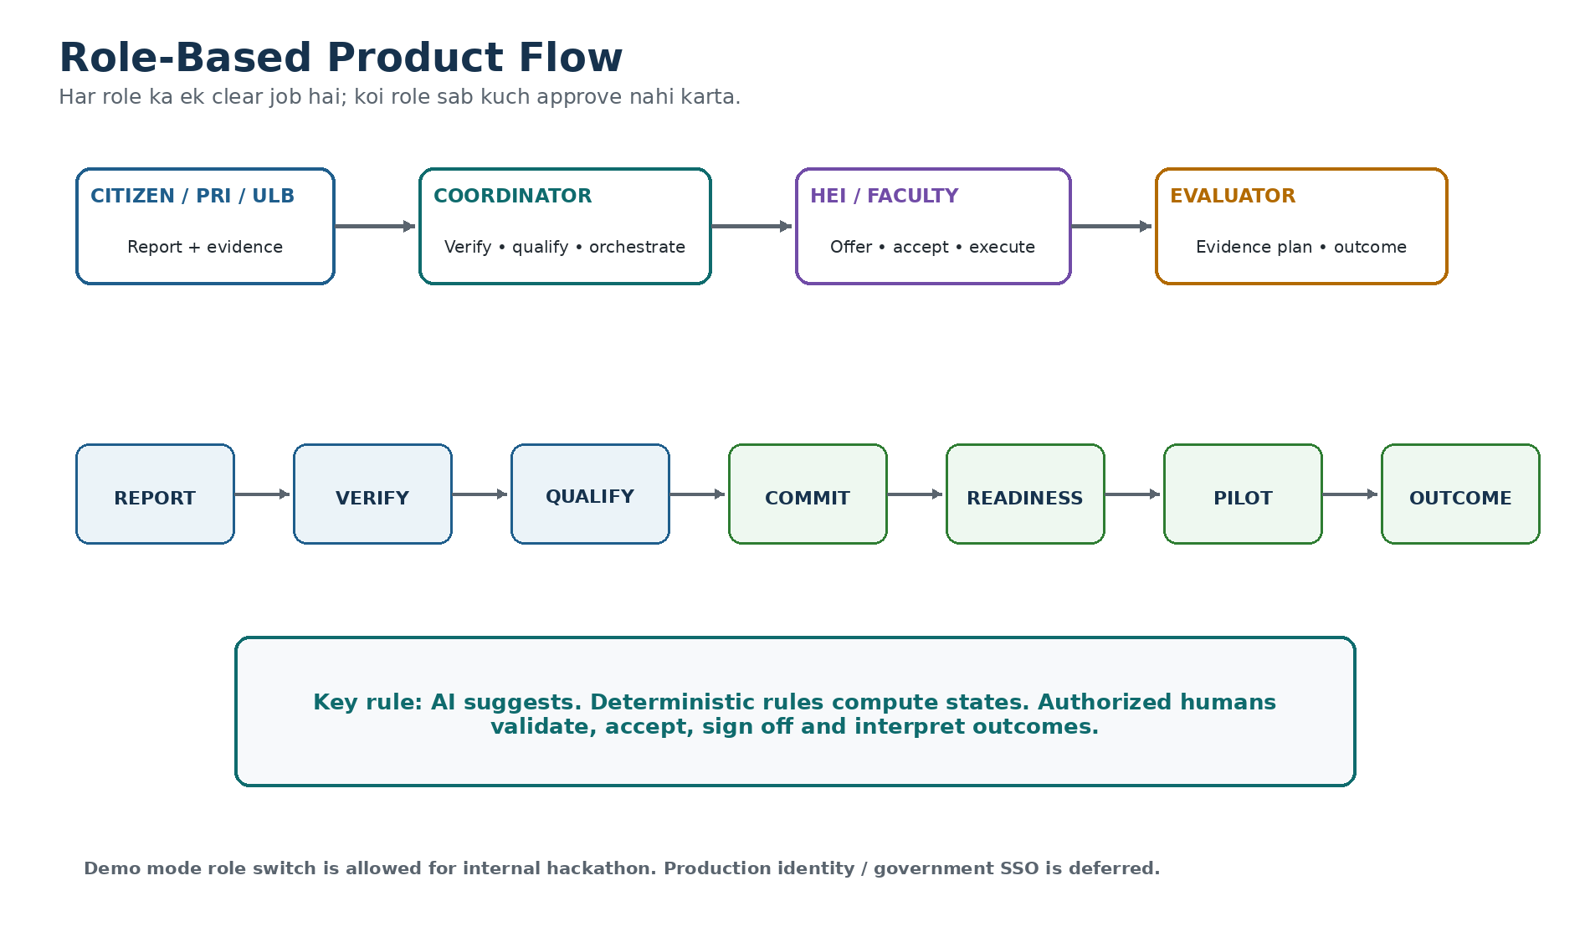
Figure 1 — Role-based product flow
Role | Can do | Cannot do in V1
Citizen / Community / PRI / ULB | Create report, attach evidence, answer clarification, view safe status | Approve route, assign HEI, mark Pilot Ready
Programme Coordinator | Review evidence, request clarification, approve qualification route, shortlist actors, manage next actions | Accept on behalf of HEI; fabricate permission; declare impact
Problem Owner / Department | Confirm jurisdiction/ownership, field permission where applicable | Accept HEI capacity; rewrite evaluation result
HEI / Faculty | View challenge, offer/accept/decline/withdraw scoped commitment, work on project | Self-mark government permission; approve own impact claim
Industry / Lab / Partner | Offer specific resource/test/mentoring commitment | Become mandatory funder by default
Evaluator | Approve evidence plan, review observations, record evidence conclusion | Change operational event history
State Admin | Read cross-case dashboard, manage demo/policy config in V1 | Bypass audit trail silently

2.1 Demo Mode vs Production Auth
- Internal hackathon: fast role switcher + seeded users allowed.
- Backend still receives actor_id + role and checks endpoint permission; UI role switch alone is not the authorization source.
- Production: OIDC/SSO/government identity is future integration and must not be claimed as implemented.

3. Technical Architecture
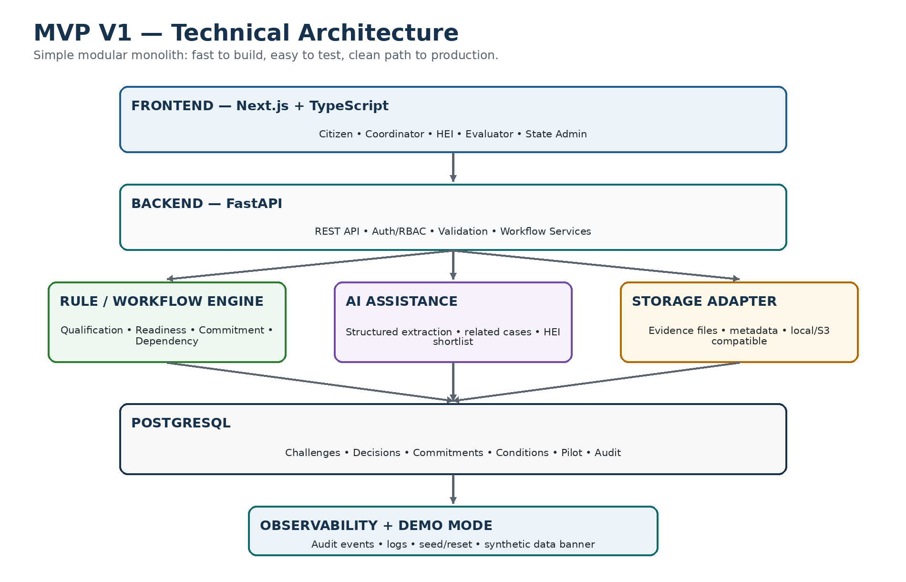
Figure 2 — MVP V1 architecture

3.1 Final stack recommendation
Layer | V1 choice | Why
Frontend | Next.js + React + TypeScript | Fast routing, component reuse, strong demo UX
UI | Tailwind CSS + small reusable component system; Lucide icons | Fast consistent styling; avoid template-looking screens
Forms | React Hook Form + Zod | Typed validation and good form UX
Server state | TanStack Query or simple fetch wrapper | Cache/invalidation for challenge/readiness updates
Backend | FastAPI + Pydantic | Python workflow logic + clean APIs
ORM / migrations | SQLAlchemy + Alembic | Relational model and migration discipline
Database | PostgreSQL | Single source for workflow/state/audit
Semantic search | pgvector OPTIONAL | Only related-case/HEI shortlist if time permits
Evidence storage | Local adapter in dev; S3-compatible adapter in deployed build | Avoid coupling; demo works without complex infra
AI | Provider-agnostic structured JSON call + deterministic mock fallback | AI is supporting, not system authority
Testing | pytest + FastAPI TestClient; Playwright for E2E | Protect P2 state changes and demo path
Deployment | Frontend host + Python API host + managed Postgres | Hackathon-friendly; portable later

3.2 Architecture principle
MODULAR MONOLITH
Code modules separate rakho, deployment single rakho. Abhi microservices se complexity badhegi, value nahi.

3.3 Request flow
Browser → Next.js UI → /api client → FastAPI Router → Service/Rule Engine → Repository → PostgreSQL
↘ AI Adapter (only when required)
↘ Evidence Storage Adapter

4. FRONTEND — Complete Build Specification

4.1 App shell
- Left sidebar on desktop; bottom/nav drawer on mobile.
- Top bar: current role, Demo/Synthetic badge, current case quick link, notifications.
- Demo role switch visible only in demo mode.
- Global search optional; do not block V1 on it.

4.2 Route map
Route | Role | Purpose
/report | Citizen/PRI/ULB | New societal issue submission
/inbox | Coordinator | Review queue + filters
/challenges/[id] | Coordinator/HEI/Evaluator | Challenge Passport + tabs
/challenges/[id]/qualification | Coordinator | Qualification questions + route approval
/challenges/[id]/collaboration | Coordinator/HEI | Capability shortlist + commitments
/challenges/[id]/readiness | Coordinator/Problem Owner/Evaluator | Conditions, blockers, sign-off
/projects/[id]/pilot | HEI/Coordinator | Milestones + evidence plan + observations
/projects/[id]/outcome | Evaluator | Outcome interpretation
/dashboard | State Admin/Coordinator | Synthetic demo analytics + blocker queue
/demo | Demo owner | Reset/advance golden scenario

4.3 Design system tokens
Token | Use
Navy / Slate | Primary text, headings, government trust
Blue | Navigation, neutral actions, links
Green | SATISFIED / ACCEPTED / PILOT READY / VALIDATED
Amber | UNKNOWN / WARNING / REVIEW REQUIRED
Red | UNSATISFIED / EXPIRED / WITHDRAWN / critical blocker
Purple | HEI/collaboration context
Neutral background | White/light gray cards; avoid glassmorphism

4.4 Reusable frontend components
- AppShell
- RoleSwitcher
- DemoDataBanner
- StatusBadge
- EvidenceCard
- EvidenceList
- Timeline
- QualificationQuestion
- RouteDecisionCard
- CapabilityCard
- CommitmentCard
- ConditionRow
- BlockerPanel
- NextActionCard
- PilotEvidenceForm
- ObservationTable
- OutcomeDecisionPanel
- AuditActivityItem
- MetricCard
- EmptyState
- ErrorState
- Skeleton
- ConfirmDialog
- Toast

4.5 Screen-by-screen acceptance
Screen | Must be visible | Must work
Report Challenge | problem, source, location, evidence, AI draft badge | validate form; submit; AI draft confirm/edit
Coordinator Inbox | ID, title, district/domain, route, status, owner, next action | filters; open case; synthetic label
Challenge Passport | original report, evidence, route, owner, commitments, readiness, activity | tab navigation; source links; history
Qualification | Q1-Q9 summary, AI suggestion, reasons, unknowns | human approve route; parallel SERVICE + RESEARCH allowed
Collaboration | HEI reason, capacity state, offer scope/dates | accept/conditional/decline/withdraw
Readiness | condition states, blockers, evidence refs, next owner | BLOCKED→REVIEW_READY→PILOT_READY; no score
Pilot | evidence plan, operational status, observations | typed validation; upload/link evidence
Outcome | operational status separate from evidence conclusion | VALIDATED/ITERATE/STOPPED/INCONCLUSIVE logic
Dashboard | real seeded counts, top blockers, next actions | click-through and refresh after state change

4.6 Responsive rules
- 1440/1280: two-column detail pages with sticky right summary.
- 768: stack secondary panels; tables become cards where needed.
- 390: no horizontal page overflow; actions remain 44px+; timeline/evidence cards stack.
- Long IDs/status labels must wrap or truncate with tooltip.
- Status meaning cannot depend only on color — label + icon + text.

5. BACKEND — Services, APIs & Workflow
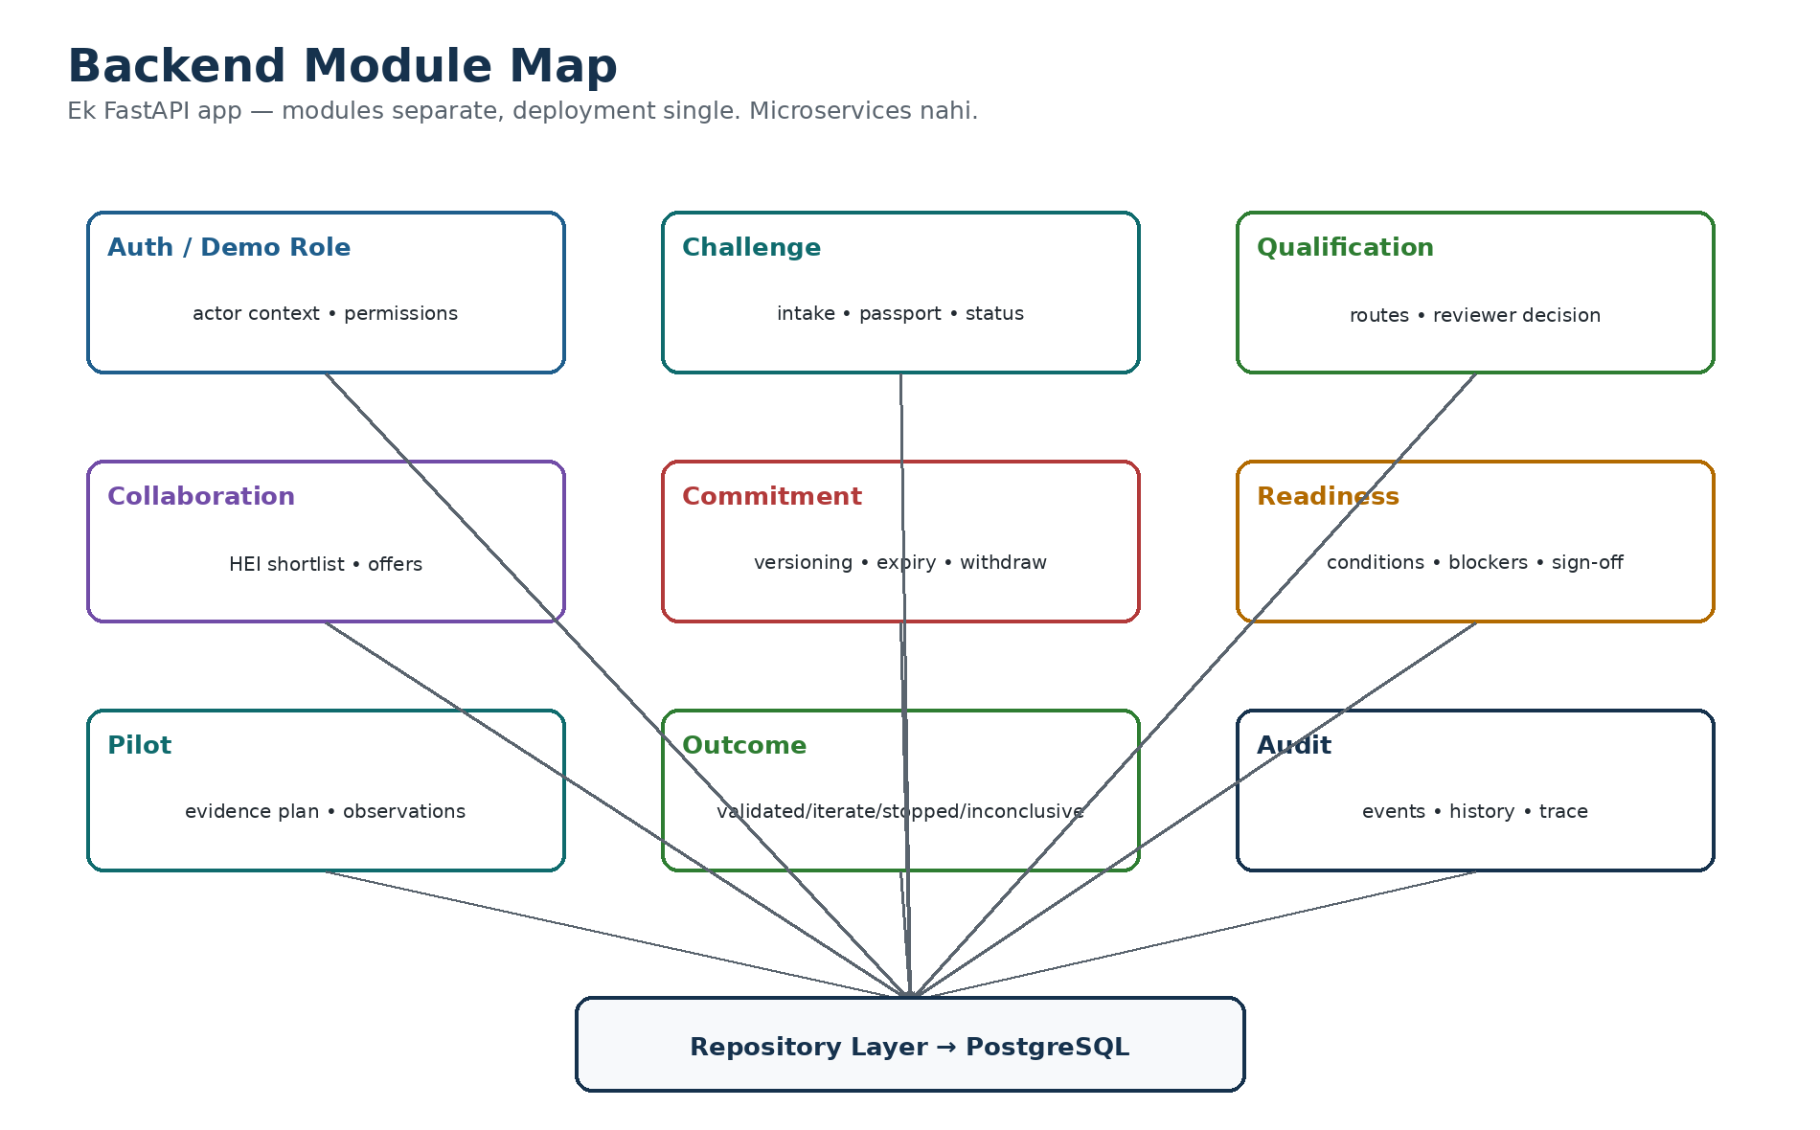
Figure 3 — FastAPI module map

5.1 Backend folder design
apps/api/app/
├─ main.py
├─ core/ # settings, auth context, errors
├─ models/ # SQLAlchemy models
├─ schemas/ # Pydantic request/response DTOs
├─ routers/ # HTTP endpoints
├─ services/ # business logic
│ ├─ qualification.py
│ ├─ commitment.py
│ ├─ readiness.py
│ ├─ pilot.py
│ ├─ outcome.py
│ └─ ai.py
├─ repositories/ # DB access only
├─ rules/ # deterministic policy functions
├─ integrations/ # AI/storage adapters
├─ seed/
└─ tests/

5.2 Backend golden rule
ROUTER ≠ BUSINESS LOGIC
Router request parse kare. Service use-case execute kare. Rules pure deterministic functions ho. Repository sirf DB read/write kare. Is separation se P2 tests reliable rahenge.

5.3 Core API contract
Method + endpoint | Role | What it does
POST /challenges | Citizen/PRI/ULB/Coordinator | Create report/challenge draft
GET /challenges | Coordinator/Admin | List/filter inbox
GET /challenges/{id} | Authorized roles | Challenge Passport aggregate
POST /challenges/{id}/ai-structure | Reporter/Coordinator | Generate draft structured fields
POST /challenges/{id}/qualification | Coordinator | Create versioned qualification decision
GET /capabilities?challenge_id= | Coordinator | Return explainable shortlist
POST /challenges/{id}/commitments | HEI/Partner/Coordinator | Create proposal/offer
POST /commitments/{id}/accept | Authorized actor | Accept exact version
POST /commitments/{id}/decline | Authorized actor | Decline
POST /commitments/{id}/withdraw | Authorized actor | Withdraw accepted commitment
GET /challenges/{id}/readiness | Authorized roles | Computed conditions + current decision
POST /challenges/{id}/readiness/sign-off | Coordinator/Evaluator | Create PILOT_READY human decision
PUT /projects/{id}/evidence-plan | HEI/Evaluator | Create/update versioned plan
POST /projects/{id}/observations | HEI/Coordinator | Add observed evidence-linked value
POST /projects/{id}/outcome-review | Evaluator | Record conclusion
GET /dashboard/summary | Coordinator/Admin | Demo metrics and blocker queues
GET /entities/{type}/{id}/activity | Authorized roles | Audit timeline
POST /demo/reset | Demo Admin | Reset synthetic scenario only

5.4 Response envelope
{
"data": {...},
"meta": {"request_id": "...", "version": 3},
"error": null
}
Error:
{
"data": null,
"error": {"code": "VERSION_CONFLICT", "message": "Commitment changed. Refresh and try again.", "details": {...}}
}

5.5 Important error codes
- VALIDATION_ERROR
- NOT_FOUND
- PERMISSION_DENIED
- INVALID_TRANSITION
- VERSION_CONFLICT
- EXPIRED_DEPENDENCY
- RESOURCE_CONFLICT
- DUPLICATE_IDEMPOTENCY_KEY
- EVIDENCE_REQUIRED
- DEMO_ONLY_ACTION

6. DATABASE — PostgreSQL Schema
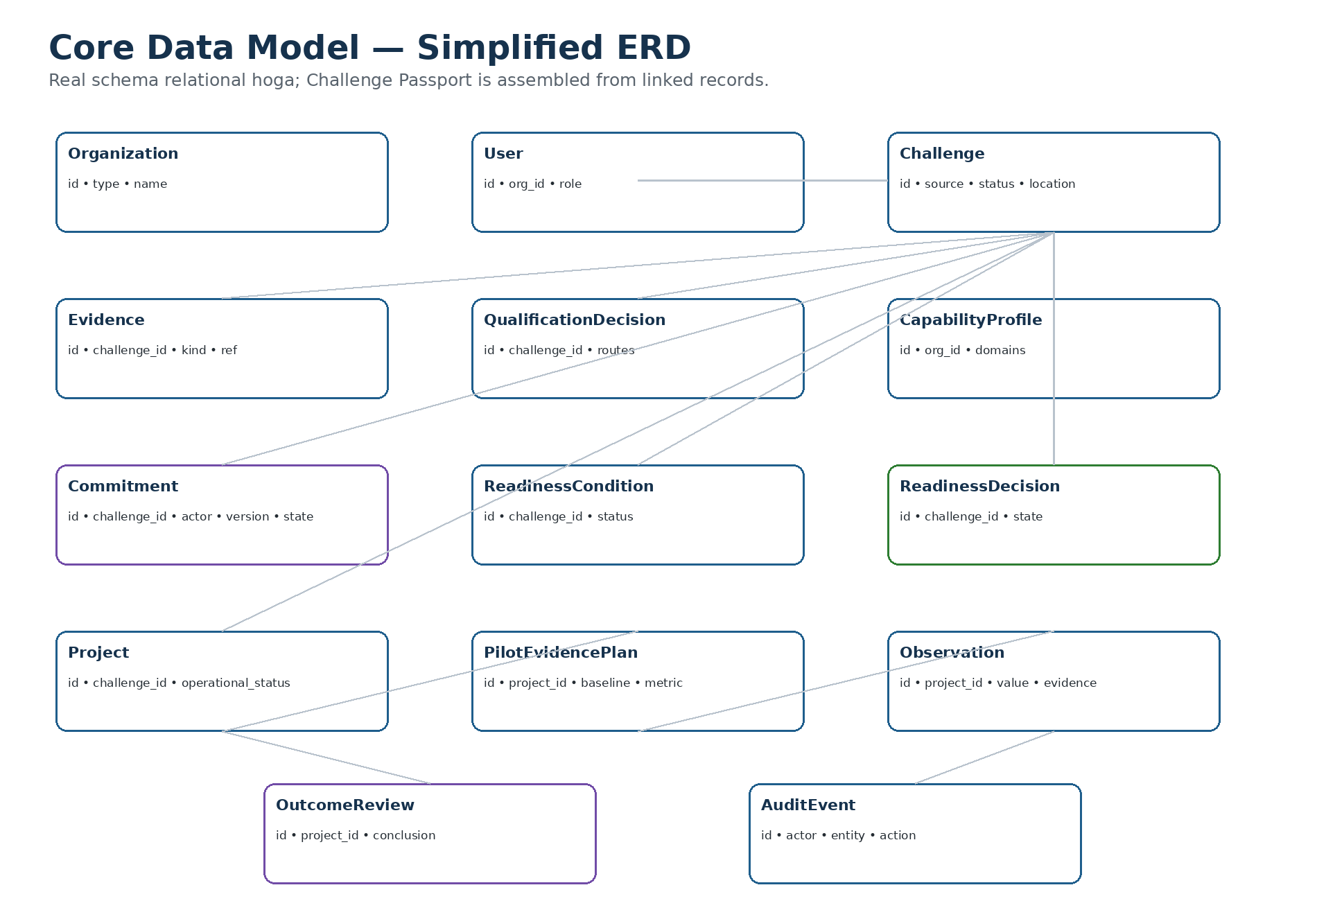
Figure 4 — Simplified core ERD

6.1 Core tables
Table | Important fields
organizations | id, type, name, jurisdiction, verification_status
users | id, organization_id, name, role, status
challenges | id, title, raw_text, structured_summary, domain, source_type, location_json, lifecycle_status, created_at, version
evidence_items | id, challenge_id/project_id, kind, storage_ref, observed_at, verification_status, sensitivity, metadata_json
qualification_decisions | id, challenge_id, routes_json, reasons_json, unknowns_json, policy_version, reviewer_id, version
capability_profiles | id, organization_id, domains_json, skills_json, facilities_json, availability_note
commitments | id, challenge_id, actor_id, scope, resource_effort, start_at, end_at, constraints_json, state, version, parent_version_id, expiry_at
readiness_conditions | id, challenge_id, condition_key, state, evidence_refs_json, reviewer_id, expires_at, version
readiness_decisions | id, challenge_id, state, policy_version, relied_on_refs_json, blockers_json, signer_id, review_required, version
projects | id, challenge_id, title, operational_status, team_json, start_at, end_at
pilot_evidence_plans | id, project_id, baseline, metric, unit, denominator, target, method, window_start, window_end, owner_id, reviewer_id, stop_rule, limitations, version
observations | id, project_id, metric, value, unit, denominator, observed_at, evidence_refs_json
outcome_reviews | id, project_id, evidence_conclusion, reason, limitations, reviewer_id, version
audit_events | id, actor_id, entity_type, entity_id, action, before_json, after_json, created_at, request_id
notifications | id, user_id, type, title, entity_ref, read_at

6.2 Critical enum separation
DO NOT MIX THESE
Project Operational Status: PLANNED / ACTIVE / COMPLETED / STOPPED. Evidence Conclusion: NOT_REVIEWED / VALIDATED / ITERATE / INCONCLUSIVE. Isliye STOPPED + INCONCLUSIVE valid combination hai.

6.3 Database rules
- Commitment versions immutable-style history rakhen; material edit = new version.
- Use optimistic concurrency: request carries expected_version.
- Accepted exclusive resource overlap par transaction-level conflict check.
- Audit event every important decision/state mutation ke saath same transaction mein create karo.
- Soft-delete only where needed; decisions/history physically delete mat karo in demo.
- Demo seed records synthetic flag carry karein.

7. STATE MACHINES — Team ke liye non-negotiable rules

7.1 Qualification routes
SERVICE | CLARIFY | RESEARCH_REVIEW | INNOVATION_CHALLENGE
Note: SERVICE + RESEARCH_REVIEW parallel ho sakte hain.

7.2 Commitment
PROPOSED → OFFERED → ACCEPTED
↘ DECLINED
OFFERED → EXPIRED
ACCEPTED → WITHDRAWN / EXPIRED
Material scope/date/resource change → new OFFERED version → fresh acceptance

7.3 Readiness
BLOCKED → REVIEW_READY → PILOT_READY
PILOT_READY + relied-on dependency changes → REVIEW_REQUIRED
REVIEW_REQUIRED + blockers resolved + new sign-off → PILOT_READY

7.4 Condition states
SATISFIED | UNSATISFIED | UNKNOWN | DISPUTED | EXPIRED

7.5 Outcome
Operational: PLANNED | ACTIVE | COMPLETED | STOPPED
Evidence: NOT_REVIEWED | VALIDATED | ITERATE | INCONCLUSIVE

8. HERO ENGINE — Commitment + Dependency Invalidation
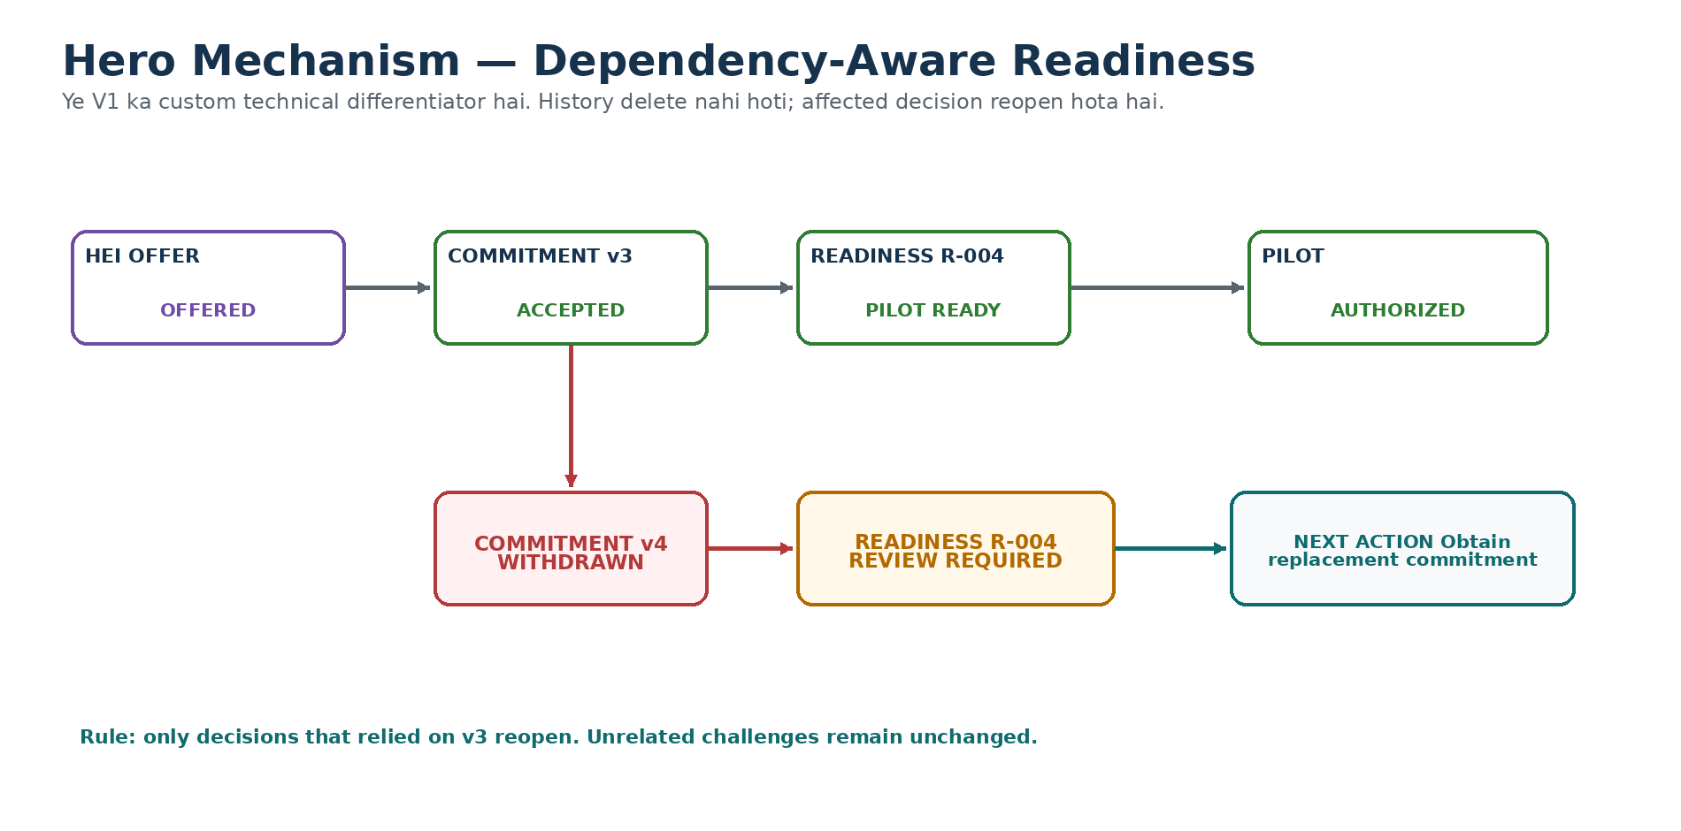
Figure 5 — P2 hero interaction

8.1 Why this gets custom engineering effort
TRL3 synthetic validation mein P2 custom logic sabse strong technical mechanism nikla. Isliye V1 mein isko real product behavior banaana hai; P1/P3 ko over-automate nahi karna.

8.2 Dependency model
ReadinessDecision R-004 relies_on:
- Commitment C-HEI-003 version 3
- Permission E-PERM-021 version 1
- EvidencePlan PEP-004 version 2
If C-HEI-003 v3 → WITHDRAWN:
- mark R-004.review_required = true
- create audit event
- create next-action task
- do NOT modify unrelated decisions

8.3 Idempotency & stale write
- Mutating endpoints accept Idempotency-Key.
- Same key + same payload => same saved result.
- Same key + conflicting payload => reject.
- Accept/withdraw requests include expected_version; stale client => VERSION_CONFLICT.
- Never let frontend-only state determine readiness.

8.4 P2 must-have tests
- Accepted commitment withdrawal reopens only dependent readiness
- Expiry event reopens dependent readiness
- Unrelated challenge unchanged
- Duplicate request does not duplicate mutation
- Stale version rejected
- Overlapping exclusive resource rejected
- Adjacent non-overlapping slots allowed
- Material scope change requires re-acceptance
- History still shows previous accepted version

9. AI / DATA — Supporting Intelligence

9.1 AI use cases in V1
Use case | Input | Output | Authority
Report structuring | raw Hindi/Hinglish/English text | JSON draft: summary/domain/missing fields | User/Coordinator confirms
Related case suggestion | challenge text + optional embeddings | top related cases + reason | Human decides relation
Qualification draft | reviewed fields | suggested route + source-grounded reasons | Coordinator approves
HEI shortlist | challenge capability needs + seeded profiles | ranked shortlist + explanation | HEI must explicitly accept
Evidence-plan helper | plan fields | missing/ambiguous fields | Evaluator decides
Outcome summary | observations/evidence | neutral summary + limitations | Evaluator sets conclusion

9.2 AI response rules
- JSON schema validation mandatory.
- Missing fact => null/UNKNOWN; model ko guess nahi karna.
- No fake severity/genuineness percentage.
- No autonomous PILOT_READY, permission, funding or outcome approval.
- Keep provider/model behind adapter so demo can fall back to deterministic mock.

9.3 Suggested AI adapter
class AIAdapter:
async def structure_report(report_text, evidence_refs): ...
async def suggest_qualification(case_snapshot): ...
async def shortlist_capabilities(challenge, profiles): ...
async def review_evidence_plan(plan): ...
Implementations:
- LiveLLMAdapter
- DemoMockAdapter

9.4 Dataset policy
- Dashboard/demo seed data clearly SYNTHETIC label karein.
- TRL3 fixtures test assets hain; unko production truth/data mat treat karo.
- No fake Jharkhand department/faculty identity presented as real.

10. UI/UX — Government-grade interaction rules

10.1 UX principles
- Status before decoration
- Every blocker ke saath reason + next owner + next action
- Original evidence accessible but sensitive fields role-gated
- No single readiness score
- No fake success confetti
- AI suggestion always visibly marked draft/suggestion
- Decision history visible
- Synthetic data banner persistent in demo
- Empty/error/expired states first-class screens

10.2 Key status copy
State | Recommended UI copy
BLOCKED | Not Pilot Ready — required conditions are incomplete or invalid.
REVIEW_READY | All required checks are complete. Authorized sign-off is pending.
PILOT_READY | Pilot authorized under the current evidence and commitments.
REVIEW_REQUIRED | A relied-on condition changed. Re-review is required before proceeding.
INCONCLUSIVE | Available evidence is not sufficient to support the claimed outcome.

10.3 Accessibility checklist
- 44px interactive target
- Visible keyboard focus
- Color + icon + text for status
- Form labels always visible
- Error text near field + summary
- Table header semantics
- Modal traps focus and returns focus
- Mobile screen no sideways page scroll
- Loading skeleton does not change layout dramatically

11. Detailed User Flows

11.1 Citizen flow
Report → AI draft → user edits/confirms → evidence upload → submit → acknowledgement → safe status

11.2 Coordinator flow
Inbox → open case → review evidence → request clarification OR approve route → identify owner → request HEI offers → monitor readiness → sign-off / block → audit trail

11.3 HEI flow
Invited challenge → inspect scope/evidence → OFFER / DECLINE → define faculty/team/dates/constraints → ACCEPT → project workspace → may WITHDRAW with reason

11.4 Evaluator flow
Review Pilot Evidence Plan → approve/request changes → inspect observations → record evidence conclusion + limitations

11.5 State Admin flow
Dashboard → filter blockers/outcomes → click case → inspect history → no direct silent override

12. API Payload Examples

12.1 Accept commitment
POST /commitments/C-102/accept
Headers:
Idempotency-Key: 7c...
Body:
{
"expected_version": 2,
"scope": "Faculty mentor + 4 student team",
"start_at": "2026-09-15T00:00:00+05:30",
"end_at": "2026-11-20T23:59:59+05:30",
"constraints": ["Field access required"]
}

12.2 Readiness response
{
"state": "BLOCKED",
"conditions": [
{"key":"hei_commitment","state":"SATISFIED","ref":"COM-33:v3"},
{"key":"field_permission","state":"UNKNOWN","ref":null},
{"key":"pilot_evidence_plan","state":"UNSATISFIED","ref":null}
],
"blockers": [
{"condition":"field_permission","owner_role":"PROBLEM_OWNER","next_action":"Upload/confirm permission"}
]
}

12.3 Withdraw + automatic invalidation
POST /commitments/COM-33/withdraw
{ "expected_version": 3, "reason": "Faculty unavailable" }
Side effects (same workflow):
1. COM-33 v4 = WITHDRAWN
2. dependent active readiness decision → REVIEW_REQUIRED
3. audit events created
4. next-action notification created

13. DEVOPS / DEPLOYMENT

13.1 Environments
Environment | Purpose | Data
local | team development | seed/synthetic only
preview | PR/branch visual review | resettable synthetic
staging/demo | internal hackathon | frozen golden demo dataset
production | future only after authorization | NOT part of current claim

13.2 Environment variables
DATABASE_URL=postgresql+...
JWT_SECRET=...
AI_PROVIDER=mock|live
AI_API_KEY=...
EVIDENCE_STORAGE=local|s3
S3_BUCKET=...
DEMO_MODE=true
CORS_ORIGINS=...

13.3 Local startup
# recommended
docker compose up -d db
cd apps/api && uvicorn app.main:app --reload
cd apps/web && npm run dev
python scripts/seed_demo.py

13.4 CI minimum
- Frontend typecheck + lint
- Backend pytest
- Database migration check
- P2 state-machine tests
- Playwright golden flow smoke test
- Build succeeds on clean environment

13.5 Logging
- Every API request gets request_id.
- Every mutation logs actor, entity, version, action, result.
- AI call log: use case, model, latency, token/cost if available — never store secrets.
- Demo reset is an audit event too.

14. SEED DATA & GOLDEN DEMO

14.1 Primary golden scenario
CASE
Irregular dry-waste pickup — synthetic municipal service-process scenario. Low-risk, easy to understand, good for qualification/readiness/outcome demo.
1. 3 related reports exist. AI structures one report and suggests related cases.
2. Coordinator keeps SERVICE route active and opens RESEARCH REVIEW.
3. Case becomes INNOVATION CHALLENGE after human qualification.
4. HEI A is highly relevant but DECLINES due to capacity.
5. HEI B offers conditionally and then ACCEPTS after field-access condition.
6. Readiness initially BLOCKED: permission/baseline missing.
7. Permission + approved evidence plan → REVIEW_READY → human sign-off → PILOT_READY.
8. Faculty commitment v3 withdrawn → system creates v4 WITHDRAWN → readiness automatically REVIEW_REQUIRED.
9. Replacement commitment restores readiness after new sign-off.
10. Pilot operational status becomes COMPLETED; before/after denominator differs → evidence conclusion INCONCLUSIVE.
11. Dashboard updates counts and top blocker/next-action queue.

14.2 Secondary records
- Streetlight maintenance recurrence
- School accessibility issue
- Public transport schedule issue
- Waste segregation process
- Public service processing delay
- Community facility access
- Water tanker scheduling (process-only, no treatment claim)
- Urban drainage complaint routed to service only

14.3 Demo reset
- One deterministic reset seeds the exact golden starting point.
- Demo step buttons may exist, but app remains interactive, not a slideshow.

15. TESTING & QA

15.1 Backend unit tests — P0
- Qualification route rules incl. SERVICE + RESEARCH parallel
- Readiness condition aggregation
- Human sign-off gate
- Commitment allowed/forbidden transitions
- Version conflict
- Idempotent accept/withdraw
- Exclusive resource conflict
- Dependency invalidation only affected decisions
- Operational status and evidence conclusion separation
- Evidence-plan validation missing baseline/denominator/window

15.2 API integration tests
- Create report → get passport
- Coordinator qualification permission check
- HEI accept only own offer
- Withdraw updates readiness
- Stale expected_version returns 409-like conflict
- Demo reset only in DEMO_MODE
- Audit event created with mutation

15.3 E2E demo test
Report → qualify → HEI decline → HEI accept → blocked readiness → satisfy blockers → sign-off → Pilot Ready → withdraw commitment → Review Required → replace → pilot complete → Inconclusive outcome → dashboard update

15.4 Visual QA matrix
Viewport | Must verify
1440 | all two-column layouts, side summary, tables
1280 | no clipping, nav still usable
768 | cards stack, filters/drawers usable
390 | forms/buttons/status readable, no page horizontal overflow

15.5 Bug priority
Priority | Examples
P0 | wrong readiness state; withdrawal does not reopen; unauthorized state change; data loss
P1 | broken form; wrong dashboard count; evidence link inaccessible; mobile action blocked
P2 | alignment, minor copy, animation polish

16. TEAM WORK SPLIT — Clear Ownership

16.1 Suggested 6-person SIH allocation
Role | Owns | Concrete deliverables | Must coordinate with
1. Tech Lead / Integrator | architecture, contracts, merges, end-to-end demo | repo setup; shared enums; integration; final demo branch | everyone
2. Frontend Lead — Core UX | design system + app shell + detail pages | AppShell; Inbox; Passport; Qualification; Readiness UI | Backend + Product
3. Frontend Engineer — Collaboration/Dashboard | HEI flow, Pilot/Outcome, Dashboard, responsive | Commitment cards; Pilot pages; Dashboard; mobile QA | Backend + QA
4. Backend Lead | FastAPI, DB, auth context, challenge/project APIs | models; migrations; routers; repositories; seed/reset | Frontend + Workflow
5. Workflow / AI Engineer | P2 engine, readiness rules, AI adapter | commitment versioning; invalidation; AI JSON; rule tests | Backend + QA
6. QA / DevOps / Demo Owner | tests, deployment, demo data, bug triage, evidence screenshots | CI; Playwright; staging; reset; demo script; release checklist | Tech Lead + all

16.2 If team members are fewer
- 4 people: combine Frontend 2+3; Backend 4+5; QA/DevOps under Tech Lead.
- 5 people: keep one Frontend lead, one Backend lead, one Workflow/AI, one QA/DevOps, one Tech/Product integrator.

16.3 Role boundaries
NO CROSS-EDIT CHAOS
Frontend engineer backend rule silently change nahi karega. Backend engineer UI status wording invent nahi karega. Workflow engineer schema change PR mein contract update karega. Tech Lead integration decision owner hoga.

17. REPO, GIT & TEAM WORKFLOW
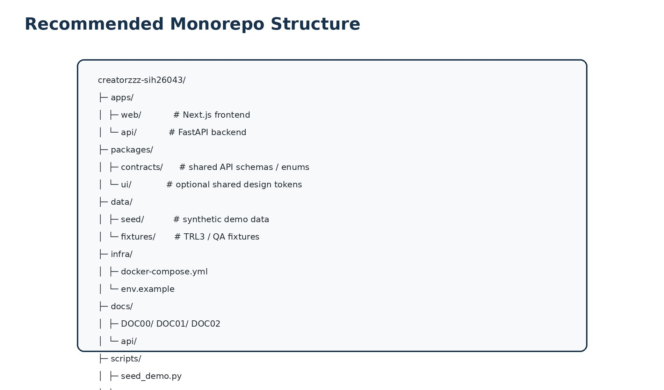
Figure 6 — Suggested monorepo layout

17.1 Branching
main = stable demo
develop = integration
feature/frontend-readiness
feature/backend-commitments
feature/ai-structure
fix/p2-invalidation

17.2 Pull request rule
- One logical feature per PR
- Screenshot for UI change
- Test output for backend rule change
- Schema/migration included with model change
- No direct push to main during final stabilization
- Tech Lead reviews cross-module contract changes

17.3 Shared contract discipline
- Enums/status names one canonical file/document se lo.
- API response fields rename karne se frontend + docs + seed update same PR mein.
- Do not duplicate business rules in frontend. Frontend may preview, backend is source of truth.

18. EXECUTION PLAN — Internal Hackathon Build

18.1 P0 build order
1. Repo + Postgres + FastAPI + Next app shell.
2. Seed users/organizations/challenge + synthetic banner.
3. Challenge create/list/detail APIs + UI.
4. Qualification simple workflow + human approval.
5. HEI shortlist seed + commitment state machine.
6. Readiness conditions + human sign-off.
7. P2 withdrawal/expiry → Review Required.
8. Pilot Evidence Plan + separate operational/evidence states.
9. Golden demo data + dashboard.
10. E2E test + responsive polish + deploy.

18.2 36-hour compressed plan
Window | Frontend | Backend/Workflow | QA/Data
0–6h | app shell + tokens + report/inbox | repo/db/models + challenge APIs | seed scenario + test checklist
6–12h | passport + qualification | qualification + auth context | API smoke tests
12–20h | HEI + readiness hero | commitment + invalidation + readiness | P2 adversarial tests
20–26h | pilot/outcome + dashboard | evidence plan/outcome APIs | golden E2E flow
26–32h | responsive + error states | bug fixes + audit | deploy + reset + screenshots
32–36h | final polish | freeze | rehearsal + fallback plan

18.3 Definition of Done — MVP V1
- ☐ All 7 main product areas are navigable.
- ☐ Golden scenario works without database hand-editing.
- ☐ Qualification requires human decision.
- ☐ HEI can accept/decline/withdraw explicit commitment.
- ☐ Pilot cannot become ready while mandatory condition unknown/expired/unsatisfied.
- ☐ Pilot Ready requires authorized sign-off.
- ☐ Withdrawal/expiry reopens only dependent readiness.
- ☐ STOPPED and INCONCLUSIVE can coexist.
- ☐ Dashboard updates after workflow mutations.
- ☐ Demo/Synthetic label is visible.
- ☐ No production/government integration is falsely implied.
- ☐ P0 automated tests pass.
- ☐ 390px and 1280px views are usable.
- ☐ Demo reset works.
- ☐ Readme allows another teammate to run locally.

19. Security, Privacy & Trust — V1
- Use synthetic data for internal hackathon; never upload real sensitive citizen data without permission.
- Backend endpoint permission checks; hiding a button is not authorization.
- Validate uploads: file type/size; store generated filename, not raw user filename as path.
- No secrets in repo; .env.example only.
- CORS allow only demo frontend origins.
- Rate-limit public report/AI endpoint if publicly deployed.
- Audit decision changes and commitment mutations.
- PII fields separate from public challenge summary.
- Demo role switch disabled outside DEMO_MODE.
- AI prompt injection: attachments are data; attachment text cannot override system instructions.

20. Dashboard Metrics — What to show / not show

20.1 Show
- Reports
- Qualified challenges
- Service routed
- Research review
- Innovation challenges
- Accepted commitments
- Blocked
- Review Ready
- Pilot Ready
- Review Required
- Validated / Iterate / Stopped / Inconclusive
- Top blockers
- Next action queue

20.2 Do not show as fake proof
- ₹ savings
- Statewide adoption
- Real citizen count if data is seeded
- Accuracy claims from synthetic fixtures as real-world accuracy
- Government endorsement
- Guaranteed social impact

21. Known Limitations — Team ko pata hone chahiye
Limitation | How to present
TRL3 synthetic validation only | Say synthetic conformance; independent validation pending
P1/P3 did not beat B0 in snapshot | We simplified them instead of overbuilding
P2 operational time advantage not measured | Call it technically strongest mechanism, not proven workload reduction
No real government integration | Use adapters/mocks and say integration needs authorization
No real HEI capacity registry | Use synthetic capability profiles
Identity/SLA/policy authority open | Treat as configurable policy; do not invent
Outcome causal inference not automated | Evaluator records conclusion and limitations

22. Team Handoff Checklist

22.1 Frontend → Backend expects
- API base URL
- OpenAPI/endpoint list
- Canonical status enums
- Error codes
- Seed user IDs/roles
- Demo reset endpoint

22.2 Backend → Frontend expects
- Request validation matching schemas
- Idempotency key on commitment mutations
- expected_version on versioned writes
- No local UI-only truth for readiness
- Actor context passed on all protected writes

22.3 AI → Product expects
- Structured JSON only
- Source-grounded reason if possible
- Unknown/null on unsupported fact
- Demo mock fallback
- No approval language

22.4 QA → Release expects
- P0 test suite green
- Golden E2E green
- Demo reset verified
- Synthetic banner visible
- No console/server critical errors
- Fallback screenshots/video ready

23. README Template — Repo mein ye mandatory hai
# CREATORZZZ — SIH26043
## What this MVP proves
Problem Qualification → Explicit Commitment → Pilot Readiness → Dependency Re-review → Evidence-backed Outcome
## What it does not claim
No government endorsement, production integration or real-world impact validation. Demo data is synthetic.
## Run locally
1. Copy .env.example to .env
2. Start PostgreSQL
3. Run API migrations + seed
4. Start FastAPI
5. Start Next.js
## Demo flow
See docs/demo.md
## Tests
Backend: pytest
Frontend/E2E: Playwright
## Architecture
See DOC02.

24. FINAL BUILD CONTRACT
WHAT WE WILL BUILD
A clean, working, role-based sample MVP that proves the complete challenge-to-pilot flow. P1 and P3 remain simple structured workflows. P2 commitment/version/dependency integrity gets custom engineering. AI assists but never owns authority.
WHAT WILL MAKE THIS MVP MEMORABLE
Judge sees Pilot Ready. Faculty/resource commitment is withdrawn. System automatically explains why readiness is no longer valid, reopens only the affected decision, preserves history, and asks for the next action. Later, a completed pilot with weak evidence is allowed to remain Inconclusive.
TEAM LINE
Assignment is not readiness. Completion is not impact.

25. Source & Decision Basis
- Official SIH26043 Problem Statement — requirements authority.
- DOC00 — Final Product & Decision Source of Truth v2.0 — current product baseline.
- DOC01 — Problem Qualification + Pilot Readiness & Learning System Specification v1.0 — rule/state/testing specification.
- Team Explainer v1.0 — simplified team interpretation.
- CREATORZZZ B0 Workflow workbook — competent baseline workflow.
- TRL3 Technical Validation Report, 10 Sep 2026 — synthetic conformance results and SIMPLIFY decision.
Where this document makes a new engineering choice (e.g., exact framework/package or repository layout), it is a V1 implementation recommendation, not an official government requirement.

